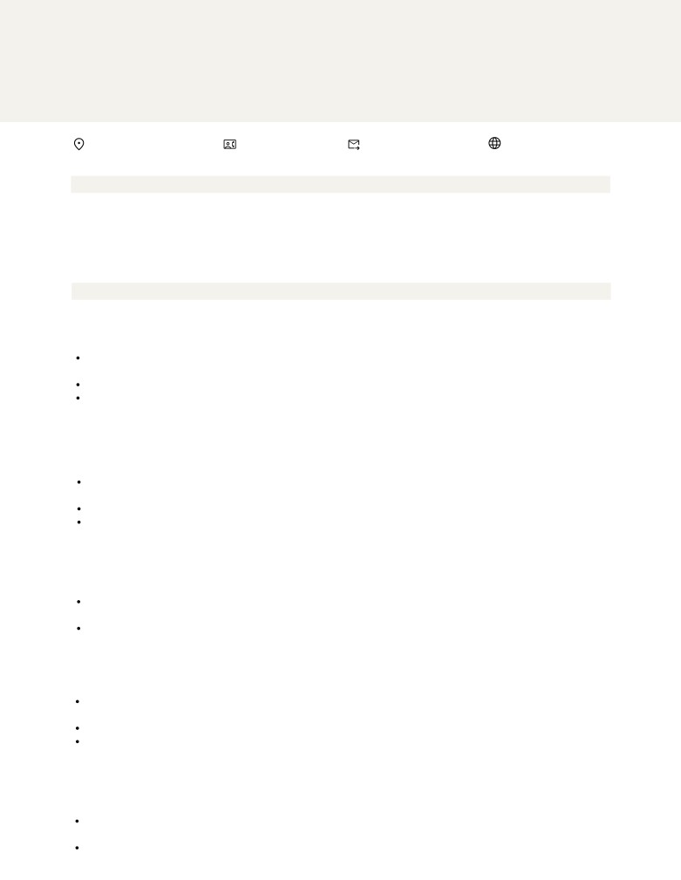
SUBERINE THOMAS
P R O F E S S I O N A L T I T L E

123 Garrison St., Freetown +123-456-7890 youremail@gmail.com www.yoursite.com

PROFESSIONAL SUMMARY

The career summary section of your resume is an opportunity to provide a brief overview of your professional experience, skills, and accomplishments. It should be a concise and compelling statement that highlights your unique value proposition as a candidate. Keep it short and sweet.

WORK EXPERIENCE

Job Title here Company Name | Location

2021-2022

One of the most difficult parts in writing a resume is composing the descriptions of your jobs, volunteer work, projects, and other relevant experiences.
Each description of your work history and volunteer experience should be clear and concise, yet descriptive.
Write what your responsibilities were, what skills you have developed, where your strengths lie, and what you have achieved.

Job Title here 2021-2022
Company Name | Location
Begin each item by stating the name of the place, location, dates, and job title (e.g. manager, volunteer) List experiences in reverse chronological order (most current experience first).
Describe your responsibilities in concise statements led by strong verbs.
Focus on those skills and strengths that you possess and that you have identified as being important to your field.

Job Title here 2021-2022
Company Name | Location
Be sure to vary your action words. You do not want all your descriptions to sound the same.
Use present tense for those activities which are ongoing and past tense for those with which you are no longer involved.
Avoid summarizing or describing what a company or organization you worked with did or does.

Job Title here 2021-2022
Company Name | Location
Begin each item by stating the name of the place, location, dates, and job title (e.g. manager, volunteer) List experiences in reverse chronological order (most current experience first).
Describe your responsibilities in concise statements led by strong verbs.
Focus on those skills and strengths that you possess and that you have identified as being important to your field.

Job Title here 2021-2022
Company Name | Location
Be sure to vary your action words. You do not want all your descriptions to sound the same.
Use present tense for those activities which are ongoing and past tense for those with which you are no longer involved.
Avoid summarizing or describing what a company or organization you worked with did or does.

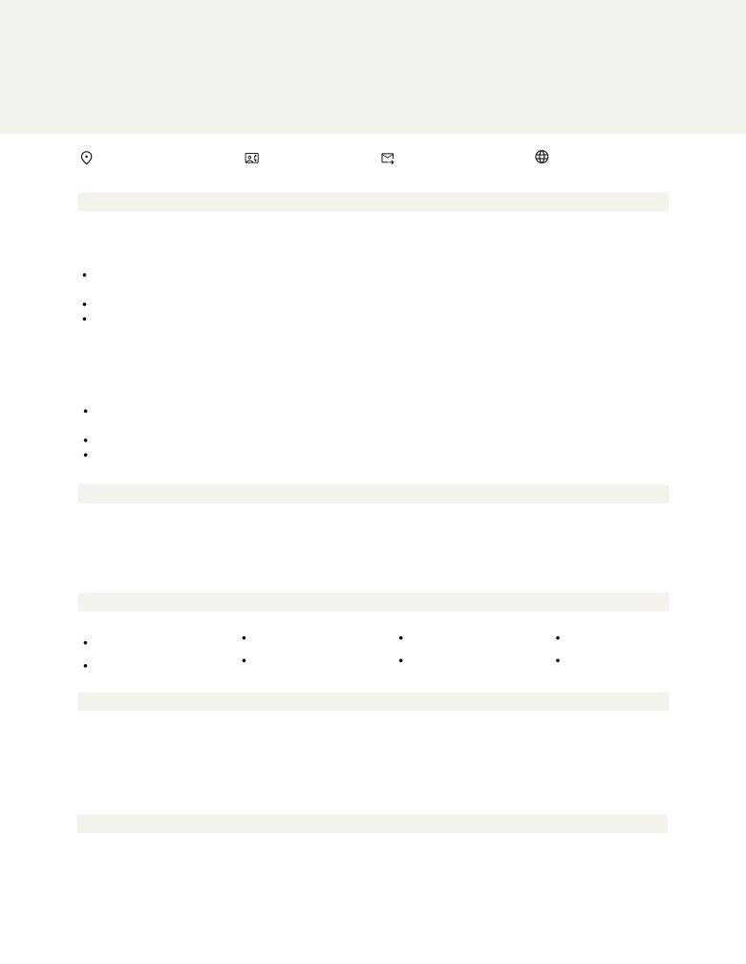
SUBERINE THOMAS
P R O F E S S I O N A L T I T L E

123 Garrison St., Freetown +123-456-7890 youremail@gmail.com www.yoursite.com

WORK EXPERIENCE (CONTINUED)

Job Title here 2021-2022
Company Name | Location
One of the most difficult parts in writing a resume is composing the descriptions of your jobs, volunteer work, projects, and other relevant experiences.
Each description of your work history and volunteer experience should be clear and concise, yet descriptive.
Write what your responsibilities were, what skills you have developed, where your strengths lie, and what you have achieved.

Job Title here Company Name | Location

2021-2022

Begin each item by stating the name of the place, location, dates, and job title (e.g. manager, volunteer) List experiences in reverse chronological order (most current experience first).
Describe your responsibilities in concise statements led by strong verbs.
Focus on those skills and strengths that you possess and that you have identified as being important to your field.

EDUCATION

Diploma/Degree Diploma/Degree Diploma/Degree Diploma/Degree
College/University College/University College/University College/University
2011 - 2014 2011 - 2014 2011 - 2014 2011 - 2014

SKILLS

Image Manipulation Character Design Figma
Graphic Design

UX/UI Design

CERTIFICATIONS

2011 - 2014
Name of Certificate
Name of Institute Location

AWARDS

2011 - 2014
Award Title
Awarding organization Location
Illustration Abobe InDesign Prototyping

2011 - 2014 2011 - 2014 2011 - 2014
Name of Certificate Name of Certificate Name of Certificate
Name of Institute Name of Institute Name of Institute
Location Location Location

2011 - 2014 2011 - 2014 2011 - 2014
Award Title Award Title Award Title
Awarding organization Awarding organization Awarding organization
Location Location Location


SUBERINE THOMAS
P R O F E S S I O N A L T I T L E

123 Garrison St., Freetown +123-456-7890 youremail@gmail.com www.yoursite.com

THANK YOU

August 8, 2023

Company Name
123 Address of the company

Dear [Mr./Ms. Name]:

It was a pleasure to meet you this afternoon. I appreciate you taking time out of your busy schedule to discuss the available position of [Position title] at [Company name], I enjoyed learning about the position as an industry leader, its mission statement and its plan to [company plans].
As we talked about in the interview, I have extensive experience in [industry-related job duties] including [relevant experience]. My proficiency in [hard skill] coupled with my robust [soft skill] has allowed me to make the following noteworthy accomplishments in my professional career [achievement] and [accomplishment].
Given my proven record of success, commitment to quality, and leadership capabilities. I. am confident that I can assist [Company Name] reach the company goal to [company goal].
[Optional Section] If you weren't able to discuss certifications. skills, or experience that makes you an ideal candidate during the interview, use this section to offer information about these qualifications. You can also use this section to clear up any misconceptions or discuss any point in the interview that you feel you didn't cover strongly enough.

Thank you again, [Mr./Ms. Name] for your time and attention.

I look forward to hearing from you regarding the next steps in the interview process. Please contact me if you require any additional information regarding my application.

Sincerely,
Your Signature

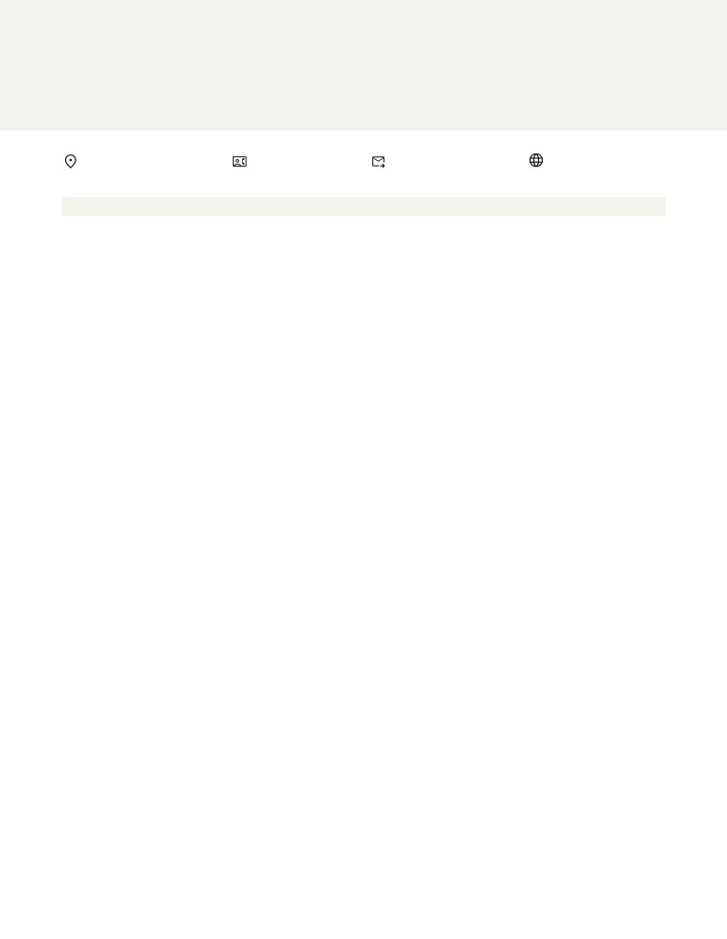
SUBERINE THOMAS
P R O F E S S I O N A L T I T L E

123 Garrison St., Freetown +123-456-7890 youremail@gmail.com www.yoursite.com

COVER LETTER
Dear Mr. Schumacher,
A cover letter allows you to professionally introduce yourself to a prospective employer. Your goal in writing your cover letter should be to encourage the employer to read your resume and consider you for a specific position.
Highlight your achievements, skills, experiences, and training that are relevant to the position you want to get. However, avoid simply repeating the information you included in your resume. Tailor your cover letter to each employer and job. Since you are applying for specific roles, give specific examples and events that demonstrate your ability to perform well if given the position.
Yes, you should maintain a professional air throughout the copy, however, an exceedingly formal tone may turn off those who read it. Remember to also show genuine enthusiasm for the job. You can think of it this way: it’s not a suit-and-tie event, but a smart casual gathering. Steer away from highly personal information and questions about the position. This includes talking about salary expectations and company benefits. Instead, reserve such inquiries for the actual interview.
Make sure you proofread your cover letter before sending it. There are various online tools that can help you catch minor grammatical or typographical errors. Additionally, make sure your cover letter is easy to read. Use a simple font like the one used here. Avoid walls of text, too. Dividing your letter into paragraphs makes it easy on the eyes and organizes the information you provide.

Best regards,
katen willams
SUBERINE THOMAS


SUBERINE THOMAS
P R O F E S S I O N A L T I T L E

123 Garrison St., Freetown

REFERENCES

NAME OF REFERENCE
Name of company, Date worked together
Address of the company www.website.com
+1 273 8192 182

NAME OF REFERENCE
Name of company, Date worked together
Address of the company www.website.com
+1 273 8192 182

NAME OF REFERENCE
Name of company, Date worked together
Address of the company www.website.com
+1 273 8192 182

+123-456-7890 youremail@gmail.com www.yoursite.com

NAME OF REFERENCE
Name of company, Date worked together
Address of the company www.website.com
+1 273 8192 182

NAME OF REFERENCE
Name of company, Date worked together
Address of the company www.website.com
+1 273 8192 182

