Handling vehicle taxes on vehicle trades

Background

In Denmark you pay a very high tax on vehicles. Up to 200 - 300% on a new vehicle.

This also has an influence when importing or exporting new/used vehicles to/from Denmark

This is therefore something we need to take care about in vehicle trade module.
Every time you buy a vehicle and import it to Demark you need to get it customs cleared.
Checked and then you get an invoice on tax amount. This should be added on the invoice as a separate line on the invoice when you sell it in Denmark
Also if you export a vehicle you can get it customs cleared.
Then you can apply to the state (Denmark) to have the tax paid back.
It has also something to do on which way we calculate the Diff Vat on used/old vehicles.
So my solution to this could be as described below. (Maybe you have a better solution)
And remember that all transactions in e-conomic, should be marked with the unique vehicle number

We need 4 more JobTypes
We now have 2 JobTypes on vehicle trade
- Reparationsarbejdstype
- Garantiarbejdstype
We need 4 more so orgs. can add costs correct, so they can be shown on a view on the vehicle.
View all transactions expenses and income on a vehicle in the trade system.
So we need the following 4 for now:
- Toldsyn
- Udlæg for nummerplader
- Udlæg for registreringsafgift
- Eksportgodtgørelse
It should be possible to select here on the dropdown:
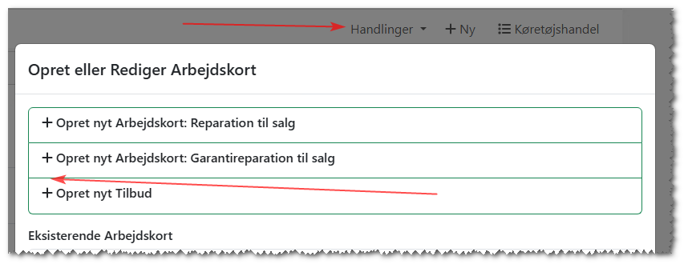
Then we can create 3 SKU called the same:
- Toldsyn
- Udlæg for nummerplader
- Udlæg for registreringsafgift
And add a Product Segment on them and map them to specific accounts in e-conomic

Change to Vehicle AddOn for handling these 4 JobTypes
On the AddOn we need to have these 3 JobTypes also so you can select which JobType it should use
- Toldsynarbejdstype
- Nummerpladearbejdstype
- Registreringsafgiftarbejdstype
- Eksportgodtgørelsearbejdstype
And also for these 4 a field where you can add account number, where it should be bookkeeped
Eg. like these:
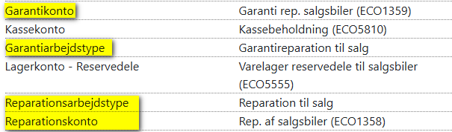
- Toldsynkonto
- Nummerpladekonto
- Registreringsafgiftkonto
- Eksportgodtgørelseskonto
Then when we finish the JC internally, we can bookkeep them on correct accounts in e-conomic

Then we can do this when we will invoice them = Sell the vehicle
Then we can create 3 SKU called the same:
- Toldsyn
- Udlæg for nummerplader
- Udlæg for registreringsafgift
And a Product Segment on them and map them to a specific account in e-conomic
Just to info:
Toldsyn should be sold WITH Vat
Udlæg for nummerplader should be sold WITHOUT Vat
Udlæg for registreringsafgift should be sold WITHOUT Vat

Use of the Registeringsafgift JobCard
It can be used both ways.
Both if you sell and if you buy a vehicle.
So it can be both a positive and a negative value.

On export a vehicle you can get it customs cleared
If you export a vehicle you can apply to the state (Denmark) to have the tax paid back.
But it can take several months, before you get the right value back.
In Demark Told & Skat has this homepage, where you can calculate the approximate value amount you will get back in tax = Eksportgodtgørelse. This should be added on the JC Eksportgodtgørelse described over here. Then you have something approximate value to calculate on, until we have the correct value. When you have the correct value you can change it on the JC and Finish it, so you will get this bookkeeped in e-conomic.
https://motorregister.skat.dk/dmr-kerne/registreringsafgift/beregnRegistreringsafgift?execution=e1s1
It would be very nice if we could have a link to this inside the vehicle trade system

Calculation Profit Margin Scheme (Used VAT Rules) – Second hand
As you already know, we use this calculation to calculate VAT when we sell vehicles after the profit margin roles. (Diff moms)
Moms Diff ((3.000,00 * 25) / 125) - ((1.000,00 * 25) / 125)
If we sell/export after this method inside EU we should deduct the “Eksportgodtgørelse” value in the calculation like this. In the most cases it will be a negative value we come up with. If it is negative it should be transferred to e-conomic as a “0” Zero
I am buying a car from a private person in Denmark for: |  | 50000,00
I will receive a refund of Eksportgodtgørelse fees: |  | 20000,00
I am selling it according to the Profit Margin VAT scheme.
To a private individual or company into EU to: |  | 55000,00
The Profit Margin VAT is then calculated as follows:
Sale price: |  | 55000,00
Eksportgodtgørelse tax refund |  | 20000,00
Amounts as Profit Margin VAT must be calculated according to: |  | 35000,00
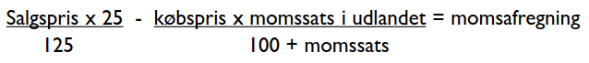

(((55000-20000) * 25) / 125) - ((50000 * 25) / 125) | Diff moms | -3000
(((55000-20000) * 25) / 125) - ((50000 * 25) / 125) | Diff moms | -3000

Warning if you sell a vehicle in DK
If you try to sell a vehicle that is NOT is bought and sold after this rule:
- Profit Margin Scheme (Used VAT Rules) – Second hand
Eg. bought in all other ways, it would be very nice if we could add a warning like this when we try to invoice it:
“Remember to add registreringsafgift on invoice if required”

Summary
With all this and this we already have, we can then show all expenses and income there has been on a vehicle in the Trade system. Report and overviews.
Then the workshop can decide themselves how precise they want the system should show this.

