Handling when a vehicle is exchanged for the purchase of another vehicle

Background
We need to change the way we handle, when we take a vehicle in exchange for the purchase of another vehicle.
I have now seen, how they do it in OE systems in Denmark (Dracar/Keyloop and Vitec Datamann)
They do it in the same way as CAC, so we need to do it in the same way in our Vehicle Trade V2.
Under here there is a small explanation how the do it.
- First they buy/add the vehicle they want to buy, as we already do now.
I have bought this add added it to the stock. (GPL002/EQ1)
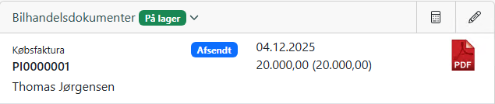
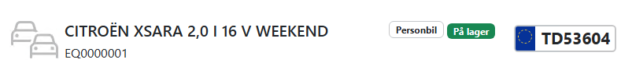

- Then an another customer wants to buy this vehicle, but he has another vehicle the org. should have in exchange for some of the value/money.
Then vehicle we should have in exchanged is in this example a Fiat 500.
Here is want is done in other Vehicle trade systems in DK.
- First the add the vehicle they should have in exchange in the system and leave it as a “Draft”
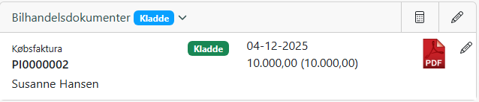
- Then they go to sell TD53604 to this customer
So they select the vehicle they want to sell(TD53604) and press “+ Faktura”
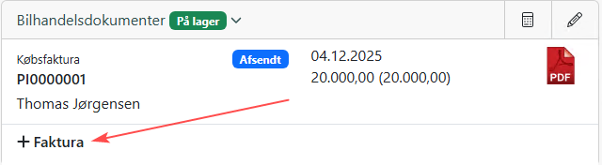
- On this page they now have the possibility/option to select the vehicle they should have in exchange, so we need a place where we can add it here on a tab or below: 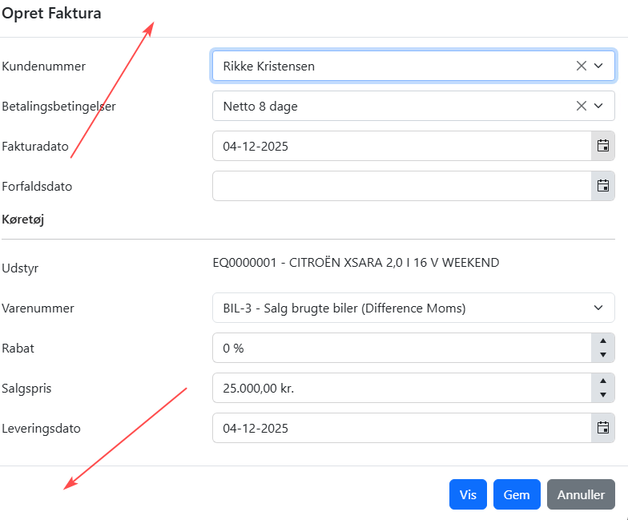
Or here under “Actions” or in a better way if you have this
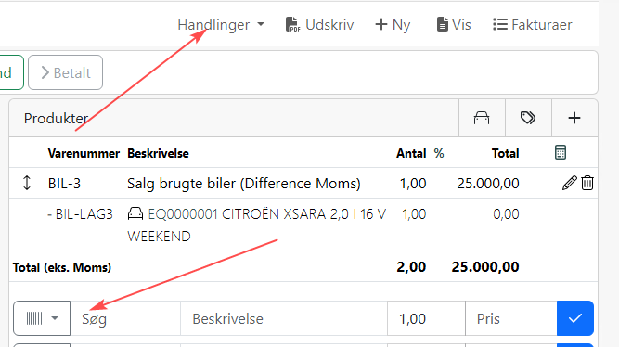
So all information regarding this vehicle will be on the invoice as well.
And the we should invoice this.
When we invoice this the vehicle we get in exchange(AD87686) should be added to stock and be bookkeeped. Then it should have status “In stock”

- Then we should get these transactions in the Cashbook in e-conomic
Here the vehicle is added to the stock on -11.000

And her deducted on the invoice to the customer:
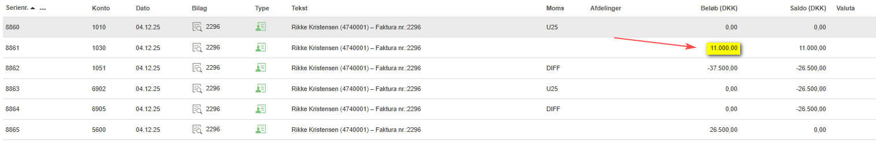

The invoice looks like this, but here should all information be on the vehicle we get in exchange
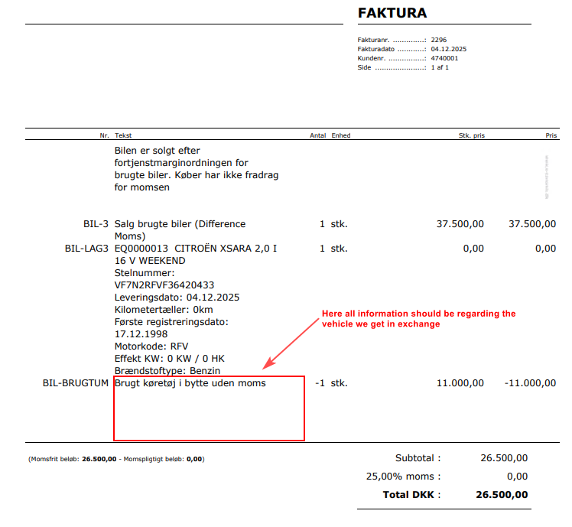
But I think you understand the flow here

