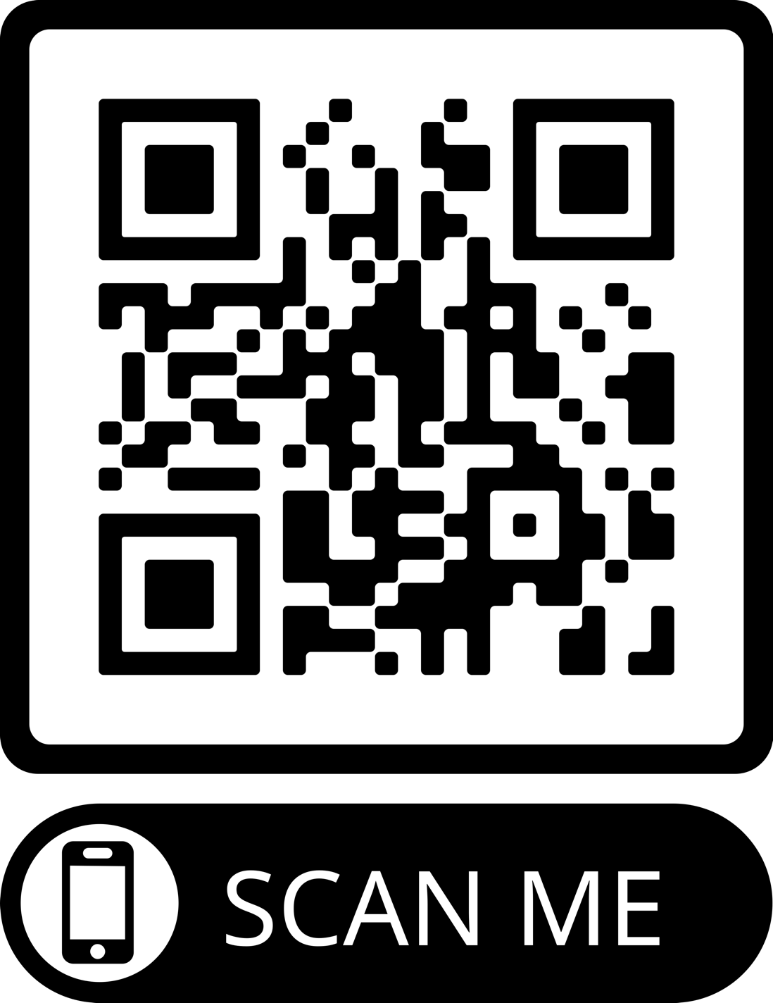

**https://github.com/bobdodd/ButtonMe**