Tetris Templates
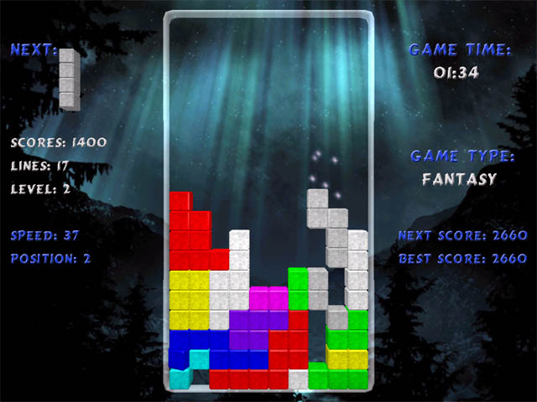
Figure 1
Design Language Sets
My interest in Tetris is to provide a practical example of my research in action. Tetris was chosen to be a challenge, especially the animation and timing elements. Part of the argument of chapter 7 in the thesis is that to be able to adapt content we need to understand the characteristics of the underlying content, and then match those characteristics to Design Language Sets (DLS) that describe coordinated groups of interaction modalities (think design patterns and web templates). This note looks at how I might use the CISNA Model to express DLSs that are useful in rendering Tetris.
Metaphor
The first thing to strike me in dealing with Tetris is the lack of standardised metaphors to express computer games. I’m so used to thinking in HTML for the Web that I feel almost naked without the familiar document metaphor of headings, paragraphs, pages, tables, divs, and spans to support me. Consequently, the first task would appear to be to try and sport some common presentation metaphors in games:
- “Cockpit”, and “Head-up display”.
The version of Tetris in Figure 1 above is a cockpit, in that the playing area is surrounded by instruments that help the user operate the game. With a head-up display, some part of the instrumentation would be overlaid on the visible playing area. If Figure 1 included the “ghost brick” that helps the user know where the current brick would land if left alone, then we would have a combination of cockpit and head-up display.
- “Immersive”, and “Observational”.
In an immersive game, the user would be at the centre of the action with a restricted field of view representing the “front” (or similar) view for the player; a first person shooter such as Duke Nukem would be a good example of this. In an observational game, the user is an omnipotent observer of the playing area; the user may need for practical purposes to zoom in and out, and to pan the view, but essentially the entire playing area and all the elements within it are visible to the user. Games such as Tetris, Pac Man, and Manic Miner (if you can remember that far back) are good examples of observational games. I refer to Manic Miner in that the game has many levels, but the whole of the playing area for the current level is visible to the user.
- “Sprite-based animation”.
Sprite-based animation exists when individual elements, or groups of elements are perceived by the user as appearing, moving within, or leaving the playing area. The bricks in Tetris are a good example of this. There appear to be a number of aspects of sprite-based behaviour (which are not mutually exclusive):
1. Game-influenced sprites; the flying aliens in Space Invaders are one example.
2. User-influenced sprites; the user-controlled gun in Spaces Invaders is one example.
3. Sprite-influenced sprites; flying aliens destroyed on contact with missiles.
4. Time-limited sprites; the missiles in Space Invaders are one example.
5. Morphing sprites; the up-down arms of the aliens in Space Invaders.
6. Translucent sprites; the “ghost-brick” in Tetris is one example.
7. Opaque sprites; the falling and fallen bricks in Tetris are examples.
8. Synchronized sprites; the movement of lines of aliens in Space Invaders.
9. Handshaking sprites; tessellation of bricks in Tetris is one example.
10. Pregnant sprites; exploding aliens in Space Invaders is one example.
11. Borg sprites; merging of Tetris bricks into the silhouette is one example.
The identified aspects of behaviour are certainly not mutually exclusive: A falling brick in Tetris is: game influenced (starting position, speed, terminating position); user influenced (left/right, rotate, hold); sprite influenced (terminating position); morphing (rotate); opaque; handshaking (quality of tessellation); pregnant (separating into individual squares once “locked”); borg (forming part of the silhouette once “locked).
Each aspect has individual properties, and potentially a life-cycle describable as a finite state model. In essence, an individual sprite may take on any aspect of behaviour as is appropriate to the life-cycle state that it has reached, and by implication also lose them. So, the sprite has a state model, and so may each aspect of behaviour.
- “Canvas-based”, “Grid-based” 2-D playing area.
A canvas-based 2-D playing area is one where the smallest movement of a sprite is the “pixel” resolution of the display; flying aliens, as the fall to earth in Space Invaders is one example of this. A grid-based 2-D playing area is one where sprites jump a noticeable distance as they move, emphasizing the grid-based nature of the playing surface; horizontal (and potentially vertical) movement in Tetris is a good example of this.
- “Canvas-based”, “Grid-based” 3-D playing area.
The 3-D equivalent to (d) above. Duke Nukem is one easy example of the canvas-based 3-D playing area; 3-D Tetris is one example of this.
- “Gravity”.
The idea that things fall downwards, rather than simply move towards the bottom of a screen. Typically you move a cursor down a screen, but potentially across a map at the same time. Tetris is another example where the bricks fall down the playing area; whilst you can play Tetris perfectly well horizontally, the metaphor is definitely falling bricks.
- “History”.
The effect of the last (n) user actions are remembered and potentially can be undone. For example being able to go back a move in Solitaire.
- “Elapsed time”.
Elapsed time is time played by the user since starting the game. It may be from selecting “start”, or from the user making the first move. An example of the former is Tetris, and of the latter is chess. Chess is a good example in that there are potentially multiple elapsed times to consider: for each player; for the game as a whole.

