Bob Downs | Image Capture and Manipulation (2014 Spring - A) - 27015/27014 | March 3, 2014

Creative Project 2

Lab Report



# Inspiration

I

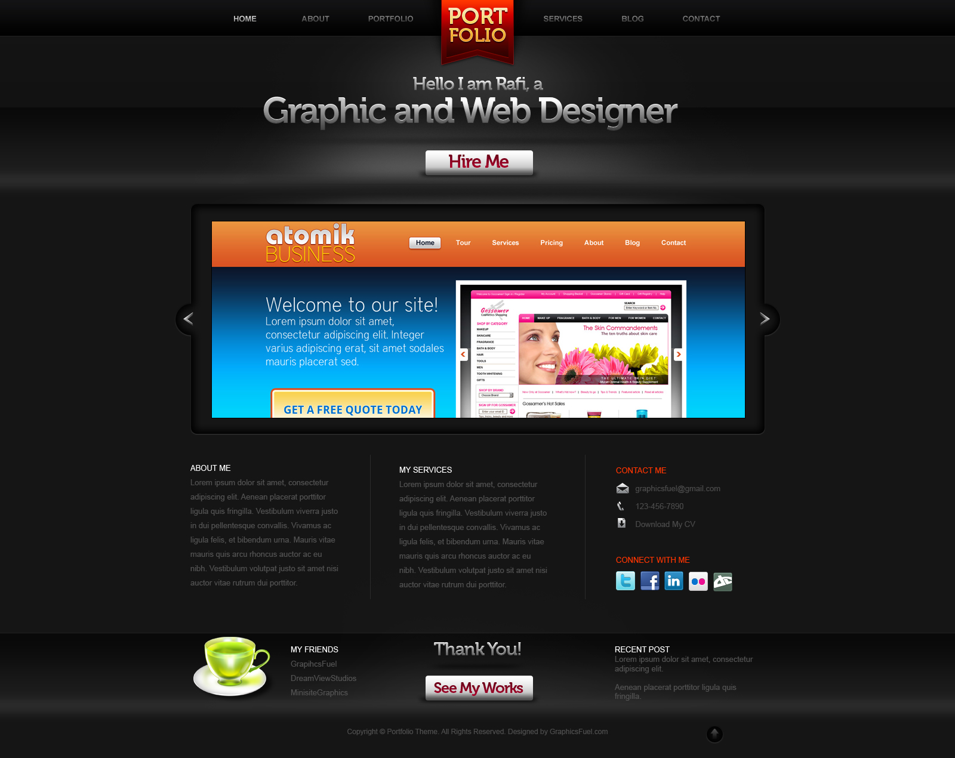decided to use Photoshop to create a website mockup for this project. To get some inspiration, I began by looking at <http://goo.gl/eSe9BT>.[1] After looking through several of the beautiful websites, I decided I really wanted to create a mockup of a photography portfolio website. Knowing I’d be using Photoshop for this, I Googled “psd web templates” and found <http://goo.gl/fwTEfu>. Once on that page, I used my browser’s “Find” function to search for the word “portfolio” and found <http://goo.gl/DjDl7P>. This page included a link to the PSD template in a ZIP archive. The page was nice enough to advise that the Museo font was included in the template, so I used CreativeCloud’s TypeKit link to install all Museo fonts on my machine and then I downloaded the ZIP archive and opened the PSD in Photoshop.

# Color Profile & Resolution

The PSD template opens with an “Untagged RGB (8bpc)” profile, so I converted it to the Working sRGB IEC61966-2.1 (8bpc) profile because it’s a website mockup, most likely to be displayed only on a computer monitor and not printed. I kept its width at 1600 because it uses a 960px grid design. I kept the 72 Pixels/Inch resolution because, again, it’s made for the monitor.

# Automation & Compositing

In order to use the nifty, new Generator (Automation) tool in Photoshop CC, I went through all of the layers (Compositing), renamed many of them from their default “Layer #” to something more descriptive, and added .png extensions to all of them so that assets would automatically be generated for me and updated automatically whenever I made any changes. This is a very nice feature that bypasses the tedious “slicing” of days gone by.

# More Compositing, Text *fx*, and Tasty Placeholders

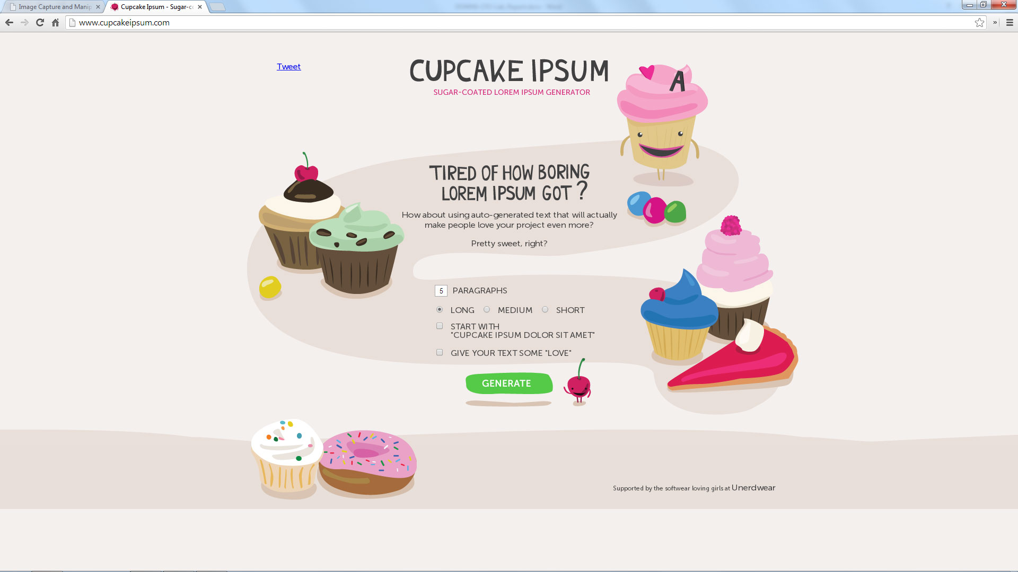Once I got to the layers that included placeholder (“lorem ipsum”) text, I decided to change that as well to make it my own, so to speak, and used <http://goo.gl/cknKBp> and <http://goo.gl/ysQzMM> to make things a little more “tasty”. Of course, I also changed the title of the site from “PORT FOLIO” to “PRO Photo” and the greeting in the header from “Hello I am Rafi, a / Graphic and Web Designer” to “Hello I am Bob, a / Photographer”. There was a sort of “highlight spotlight” layer for the greeting in the original template which I didn’t particularly care for, so I removed that. And, I wanted the text in the buttons at the top and bottom of the page (“Hire Me” and “See My Works”) to appear more “engraved”, so I added an “Inner Bevel / Chisel Soft” effect to the text on both buttons. I also didn’t care for the grammar of “See My Works”, so I took the “s” off, leaving my button to read “See My Work”.

# Challenges with Retouching & Adjustment Layers

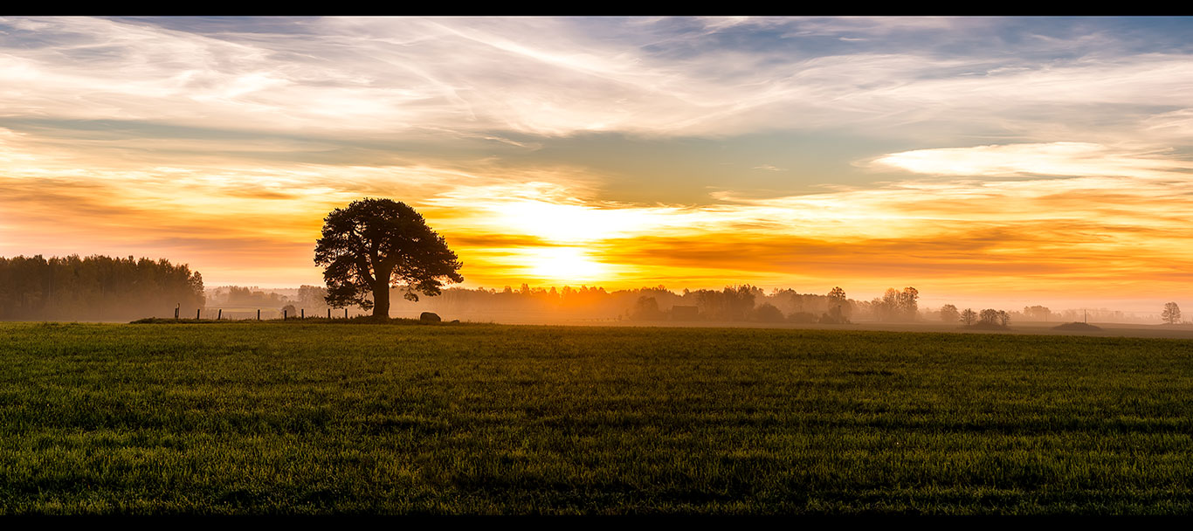Finally, to showcase my newfound knowledge of adjustment layers and layer masks, I used Google’s advanced search to look for a “stunning landscape” with “free to use or share” usage rights. I found a great looking landscape and downloaded it at <http://goo.gl/p8yOXt>. This original photo, however, is enormous at 12,000 pixels wide with 240 Pixels/Inch resolution. It also has black bars at the top and bottom. So, after some initial challenges with trying to remember how to go about it and getting some reassuring and excellent advice from my professor, I cropped out the black bars using the Crop Tool, maintaining the Original Ratio. Then, I used several Adjustment Layers to give the photo more “pop”, since it was being featured on what is supposed to be a mockup of a Photographer’s Portfolio. Then, I used Image Size to resize the photo, choosing the “1366 x 768 px 72 ppi” Fit To preset – this resulted in an image with dimensions of 1366 x 608 px 72 ppi. This resolution fit with the concept that the mockup will only be viewed on a monitor and not printed. I saved this new version of the photo in .PNG format.

After saving the new version of the photo, I placed it into the mockup and used Transform to scale the picture down to a size that filled both the height and width of the “slideshow-banner”, holding down Shift-Alt to make sure the original ratio was maintained and the picture’s dimensions didn’t get warped during the scaling. Finally, I used a Layer Mask to hide all but the portion of the photo that needed to fit within the “slideshow-banner”.

# Conclusion

This was a very rewarding project because I’m working hard to become a professional web designer. I understand from what I’ve read that using Photoshop to create mockups of websites is one of the first steps that most if not all professional web designers perform in order to get a client’s buy-in to the project before continuing on with the actual programming of the HTML, CSS, and JavaScript code used to get a browser to display the final website. So, I’m anxious to see whether this meets with my professor’s approval to know whether I should use it in my own portfolio website. My admittedly neophyte eyes are pretty pleased with the outcome, but I’m eager to know what a pro thinks.

# Files

1. DOWNS_CP2.JPG – Flattened JPEG of completed project
2. DOWNS_CP2.PSD – PSD file with layers intact
3. DOWNS_CP2b.JPG – Flattened JPEG of Stunning_Landscape_Photo
4. DOWNS_CP2b.PSD – PSD file with layers intact of Stunning_Landscape_Photo (Per email conversation with professor, to showcase above-referenced Retouching & Adjustment Layers.)
5. DOWNS_CP2-Lab_Report.DOCX – This Lab Report in MS-Word 2013 format

1. Hyperlinks have been shortened throughout (for easy reading) using Google URL Shortener.