Route Exporter User Guide
  - Plan trips Save routes Share links Keep a backup
Use Route Exporter to collect Google Maps routes into a named trip, view each leg on a map, and save the route lines and original links together. This guide covers the production app at https://rideplan.ebaugh.net.
A trip is a collection of legs. A leg can be a day’s ride, a local loop, or any separate route you want to keep together.
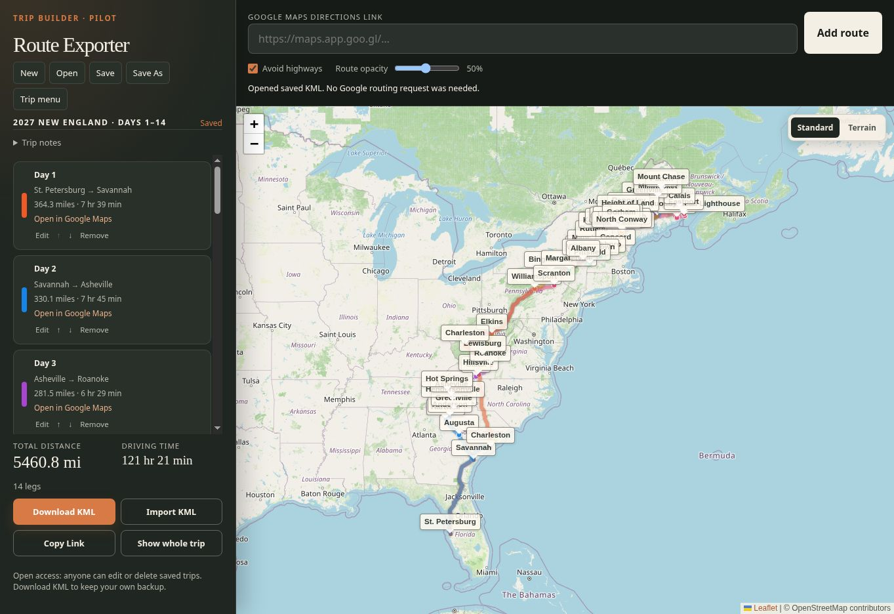
Figure 1. The trip list on the left and the route map on the right work together.

Your usual workflow
1. Open a saved trip, or choose New and add routes from Google Maps.
2. Use Save As to give a new trip or a separate version its own name.
3. Use Save when you want to update that same online trip.
4. Download KML for a personal backup, then use Copy Link to share the saved trip.
The app currently has open access. Anyone can change or delete online trips. Keep a downloaded KML copy of plans you want to preserve.
Screenshots show the September 23, 2026 release. The small “Pilot” heading is leftover wording on the production app.

Build and edit a trip

Add a route from Google Maps
1. In Google Maps, prepare driving directions with the start, destination, and any intermediate stops. Copy the directions link, rather than a link to a single place.
2. In Route Exporter, choose New or open the trip you want to extend. Paste the link into Google Maps directions link.
3. Check Avoid highways if wanted, then click Add route. Review the resulting line and repeat for the next leg.
The Avoid highways checkbox above the map applies to a route you add. To change an existing leg’s preference, use that leg’s Edit button.
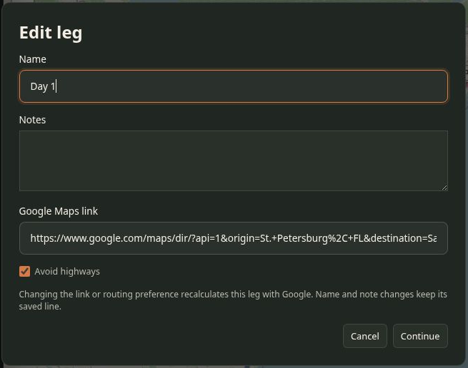
Figure 2. Edit a leg’s name, notes, original Maps link, or highway preference.

Name and arrange the legs
Click Edit on a leg, enter a name such as Day 1 and optional notes, then Continue. Name and note changes keep the existing route line. Changing the Maps link or Avoid highways recalculates that leg with Google. Save afterward to update the online trip.
Move legs with the up and down arrows or drag their cards. Reordering does not rename the legs, so adjust Day numbers yourself if needed. Remove takes a leg out of the open trip; Save makes that removal part of the shared version.
Check the calculated route before relying on it. Google may choose a different route from the one you viewed in Maps. Avoid highways is a routing preference, and driving times do not include your planned breaks.

Save open and share trips
Changes stay in the open page until you save. Save As creates a separate online trip; Save updates the trip you already opened. Give copies distinct names so they are easy to identify.
Control | What it does
New | Starts an empty trip. Save As after adding a route.
Open | Shows saved trips. Choose Open beside the trip you want.
Save | Updates the existing shared trip after confirmation. On an unsaved trip, asks for a name.
Save As | Creates a new trip with a separate link, leaving the original online trip intact.
Copy Link | Copies the link to the saved online trip. It is not a backup of its current contents.
Download KML | Downloads the current open trip, including edits you have not saved online.
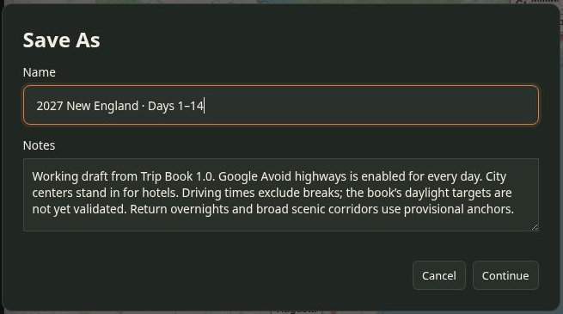
Figure 3. Save As names a new online trip and lets you add trip notes.

Share a saved trip
Save first, then click Copy Link and paste the link into your message. Recipients open the saved trip directly. Later saved changes appear at that same link; unsaved edits on your screen do not.
Use Trip menu → Rename / notes to change the trip title or notes, then Save. Renaming keeps the existing trip link working. Save As produces a different link.

Explore the map and keep backups

Use the map and leg list together
- Click a route line to highlight its matching leg and scroll the left list to it.
- Click the body of a leg card to select it and zoom the map to that route.
- Use Show whole trip to return to all legs. Pan and zoom the map to inspect details.
- Reduce Route opacity to make road names and numbers easier to see. The slider ranges from 15% to 90%; the selected leg is emphasized.
- Switch between Standard and Terrain for a different map background. Save to retain the map style and opacity with the trip.
- Use Open in Google Maps on a leg to reopen its original directions link. That link is separate from the app’s Copy Link for the whole trip.

Download a personal backup
1. With the desired trip open, click Download KML.
2. Keep the file in a folder you can find again. Add a date to its filename if you want several versions.
3. Download another copy after meaningful changes. A shared link alone cannot protect against later edits or deletion.
The KML keeps route coordinates and waypoints, plus the app’s leg names, notes, colors, highway preferences, distances and times when available, original Google Maps links, and map settings. Opening a saved trip or importing this KML uses the stored geometry without recalculating routes with Google.

Restore or import a trip
1. Choose Import KML and select your .kml file. Save or download the current open work first if you need to keep it.
2. Review the imported trip. Import replaces the open trip in the page; it does not merge legs into the current trip.
3. Choose Save As to put the imported trip online. It receives a new link, which you can share with Copy Link.
Route Exporter’s own KML gives the most complete round trip. Other KML files with route lines and points can also load, but may lack Maps links, driving times, or distances. Other mapping apps may ignore Route Exporter’s extra metadata. The current import limit is 4 MB; use .kml rather than a compressed .kmz file.

Manage saved trips and solve common problems
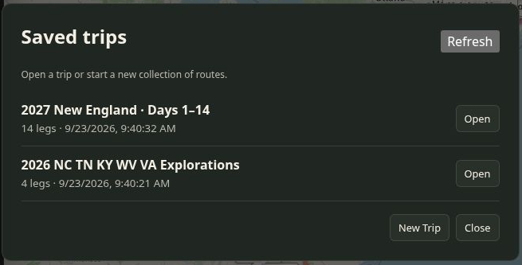
Figure 4. The opening list shows each saved trip, its leg count, and its last saved time.

Find or delete an online trip
Open the home page or click Open to see the saved collection. Click Refresh if a recent save is missing. A direct trip link skips this list and opens the named trip.
To delete a trip, open it and choose Trip menu → Delete saved trip, then confirm. This removes the online copy for everyone. Your open copy remains available to Download KML or Save As. There is no recycle bin in the app; a downloaded backup is your recovery path.

If something does not work
What you see | What to do
A save conflict | Someone changed or deleted the online trip after you opened it. Use Save As or Download KML to preserve your work, then reopen the shared version.
Storage unavailable | Keep the page open and Download KML. Retry saving when the connection or service is available.
A missing or deleted trip | Open the saved list and Refresh. If it is gone, import your KML backup and Save As. Share the new link.
A route will not add | Check that you copied driving directions. Try the full Google Maps URL if a shortened link fails. Read the status message beneath the input.
Distance or time unavailable | Imported KML may not contain those values. The stored line can still be displayed and saved.
Changes are not visible to others | Save the trip. If you used Save As, share its new Copy Link rather than the original trip’s link.
Before leaving a planning session: Save the intended online version, Download KML, and copy the correct trip link. Use https://rideplan.ebaugh.net for normal work; pilot and production have separate saved collections.

