Capstone Full Report

Ethan Motta
Mesa Community College
CIS 480: Data Analytics and Programming Capstone
Dr. Kashihara
November 22nd, 2025

Summary of Hypotheses and Results
Null Hypothesis (H₀) – There is no relationship between temperature and electricity demand.
Result: Rejected H₀
Meaning: There is a positive relationship between population and electricity demand.
A Pearson correlation test found a strong positive relationship between temperature and demand:
- Pearson r: 0.7693924424882356,
- p-value: <1e-16
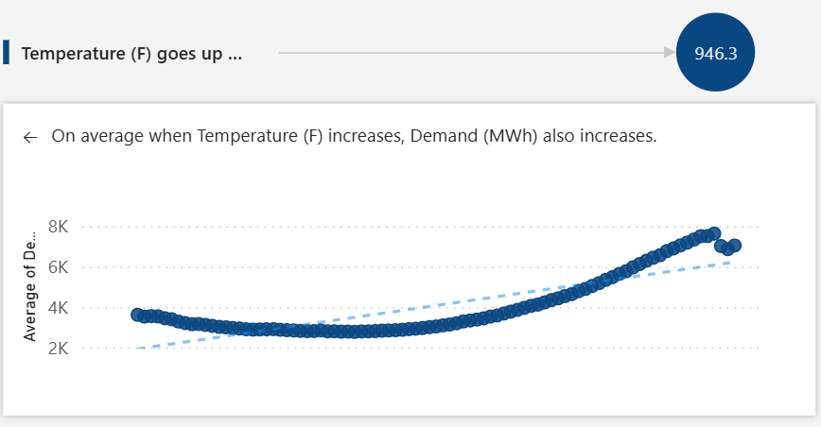

Null Hypothesis (H₀) – There is no relationship between population and electricity demand.
Result: Rejected H₀
Meaning: There is a very strong correlation between Arizona population and electricity demand:
- Pearson r: 0.913140966718925
- p-value: 0.0005836238163712237
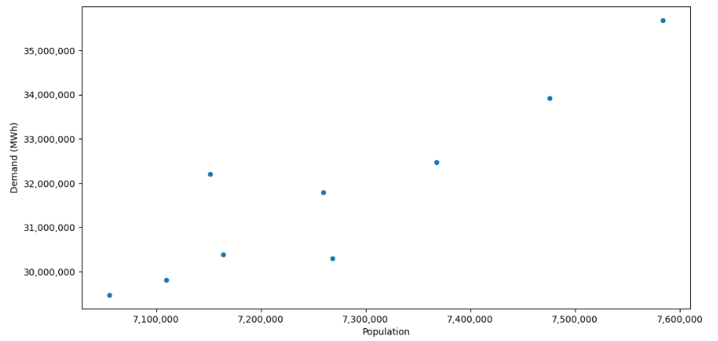

Null Hypothesis (H₀) – There is no relationship between the season and energy demand.
Result: Rejected H₀
Meaning: Different seasons have more demand, such as Summer having the most demand.
For example, Summer on average has a higher difference in demand versus Fall, Spring and Winter.
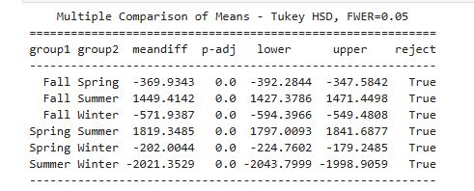

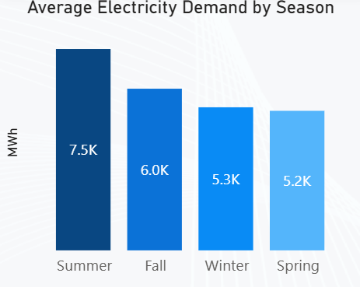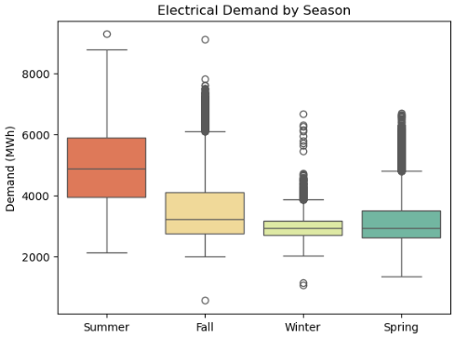

Project Summary and Reflection
Quick overview:
My project specifically focused on SRP’s customer electricity demand hour-by-hour. The eia.gov provides an Hourly Electric Grid monitoring system. I downloaded data from November 2015 to October 31st, 2025. The data set is 90,407 rows. The main columns that I focused on are the amount of power generated and the demand of power (MWh). As well as the datetime of each value.
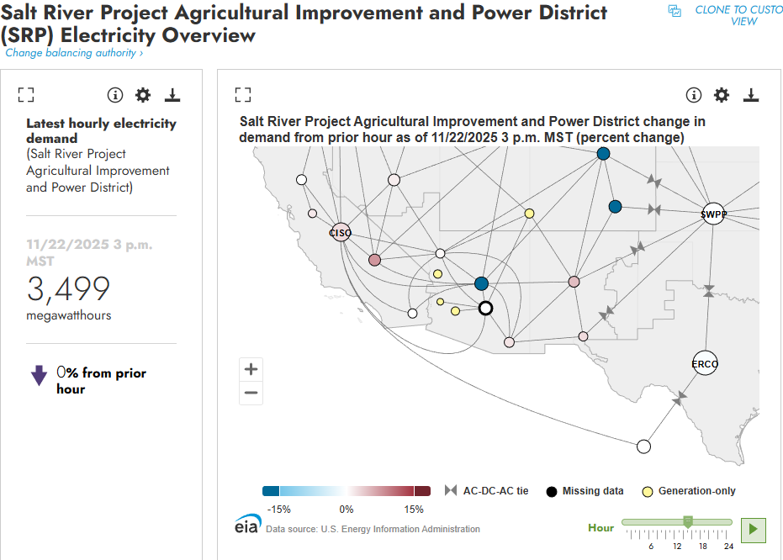

Major Challenges:
The first major challenge is the dataset was missing values. I discovered that the data had a sheet called “Known Data Issues” which contained the actual imputed demand data along with the real data. I utilized this sheet by removing the filter of known data issues as 0 and 1 and using the adjusted columns, but some data was still missing:
- Demand (MWh): 673 missing values
- Demand Forecast (MWh): 5975 missing values
- Net Generation (MWh): 697 missing values

I tried forward and backfill methods to impute missing values, but that didn’t capture seasonality, nor did basic linear regression. Instead, I utilized a GradientBoostingRegressor to impute the missing data. All of this is contained in my cleaning_data script. After using that, it was a lot more accurate and captured seasonality properly:
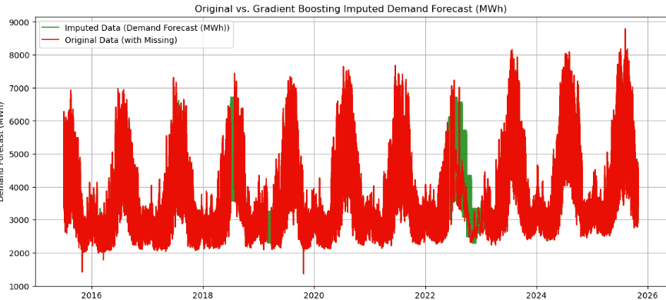
The second major challenge was obtaining the temperature data. I utilized the University of Arizona metrology network for this: https://azmet.arizona.edu/past-data.
Initially, I was using the data preview and download tool, but for some reason their time stamps aren’t consistent (instead of 00:00:00 they would do 23:59:59). Utilizing their legacy database fixed this, but I had to manually copy 10 years of data into a csv. I then joined the two datasets (SRP electricity demand) and temperature data.
Key findings:
Electrical demand peaks during certain hours (later in the day):
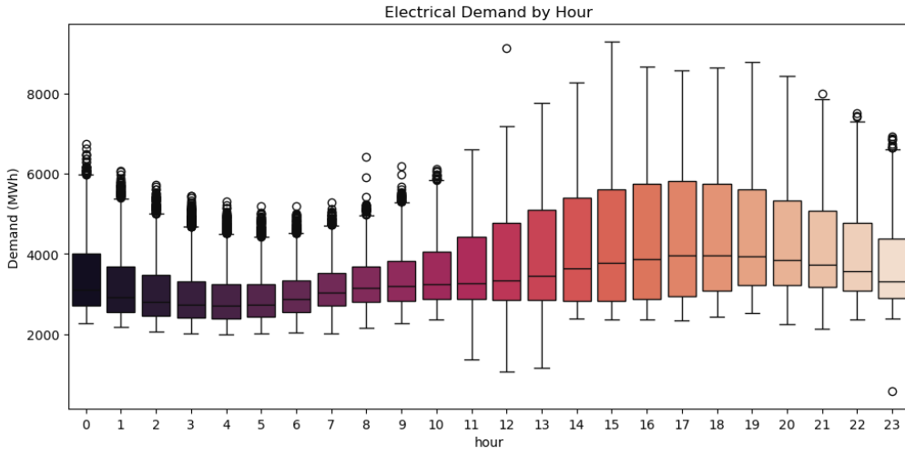

Electrical demand has a seasonal trend:
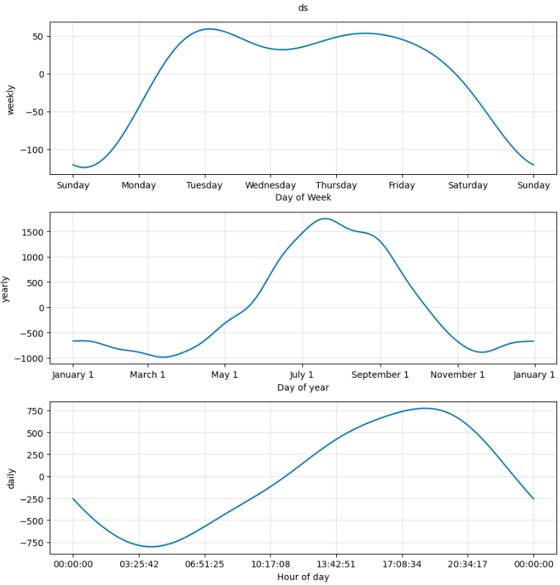
Lessons learned throughout the process:
I learned that choosing the correct predictive model matters a lot and tuning hyperparameters matters. For example, I utilized an XGBoost regressor for one of my models. It ended up OK, until I added lag features, removed features, tuned hyperparameters, added temperature, etc. However, a lag feature of 1 hour isn’t realistic because the eia.gov provides predictions 24 hours into the feature. Therefore, a lag feature of only 24 hours was used for my data. I could have tuned it more and switched lag features, but this showed me how important it was. Also, it was very difficult to predict future values using this type of model. Instead, I built a model using ARIMA and Prophet, which made it way easier to predict future values.
I also learned that most datasets are not cleaned and might be difficult to find in the first place. I took me a while to find the right datasets I wanted for my analysis. Digging around and obtaining the data is half the battle.
Contribution to the future:
This project was a great step forward in learning about ML models and predictive analysis. Since it was a time series data set, I learned a lot about seasonality, and since this dataset had yearly, monthly and daily seasonality it was a great example of how the EDA process is essential before building predictive models.
This will also help me with my honors project, which is also a time series focused project that will help my team at SRP. This also helps with my professional development because I am hoping to get a full-time position as a data analyst/scientist. I utilized real world data to gain a deeper understanding of electricity demand; I will highlight on the next page all the real-world implications my capstone has. I will certainly mention this project in future interviews.
Real-World Implications
The practical impact of my project is analyzing electrical demand across SRP’s grid.
Electricity is essential in our daily lives; without power we would be unable to function as a society. On a more granular level, blackouts and brownouts can be dangerous, especially in hotter summer months. In addition to this, customer service is a high priority for SRP.
The reason I mentioned all these factors is because understanding future demand is very important to generate enough power to meet customer demand. This can help SRP coordinate how much power to generate, the type of fuel, and expansion projects. Predicting 24 hours into the future mainly helps with the first two points, which are generating power and the type of fuel and whether it’s cheaper and more efficient to buy power from another company or state:
“SRP generates electricity from a mix of renewable sources like solar, geothermal, biomass, wind and hydropower. To ensure our ability to always meet high demand for power, including during Arizona’s hot summers, we also rely on traditional generation sources, such as coal and natural gas. These sources are the reliability backbone of the power grid.” (SRP, 2025)
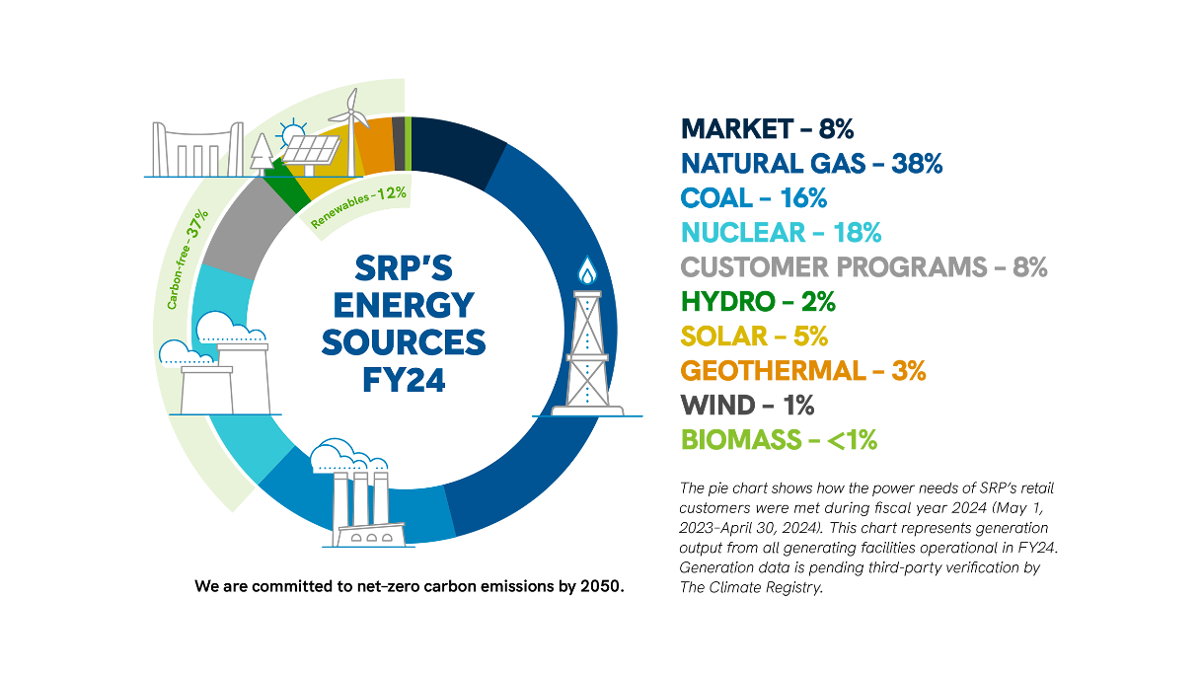
The eia.gov found that the following factors contribute to an increasing demand:
- Geographic location and climate
- Type of home and its physical characteristics
- Number, type, and efficiency of energy-consuming devices in the home and the amount of time they are used
- Number of household members

This generation data shows us a clear trend:
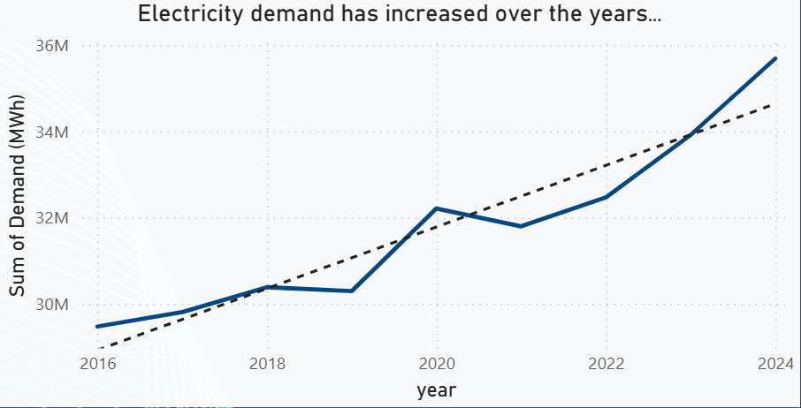

So, why is this important for SRP?
Power companies need to prepare for the ever-increasing power demand. This is across all factors, specifically for the commercial (AI datacenters) and residential sectors (increasing population).
Therefore, expansion projects like the Coolidge Expansion Project help to meet this demand:
“The proposed Coolidge Expansion Project (CEP) is needed to cost-effectively and reliably meet the significant near-term increase in energy needs in SRP's service territory, which is located in one of the fastest-growing regions in the nation.” (SRP, 2025)
That’s why it’s very important for SRP to understand future electricity demand from customers. Relying on the same infrastructure can overload generation stations, causing inefficiencies for power generation.
Justifying building a new generation plant isn’t easy, it requires a lot of data analysis, mapping out the location, but building a new generation station also has more benefits than just helping meet demand, SRP mentions that “the CEP includes quick-starting (10 minutes) and fast-ramping power generation resources that can smooth out these fluctuations and ensure SRP delivers consistent, reliable power. Resources like Coolidge Generating Station are critical as we continue to bring online thousands of megawatts of new solar and wind as well as batteries in the years ahead. With this project and other strategic resource additions, more than 75% of energy delivered to SRP customers will come from carbon-free resources by 2035. Our diversified energy portfolio taps into the most efficient, available and cost-effective mix of generation resources.” (SRP, 2025)
I quickly glossed over how my project can specifically help with meeting customer generation demand, and it can help a lot with informing the public about these issues. SRP already has a strong understanding, but maybe some other power companies or states underestimate how important it is to keep up with increasing demand. It’s also worth mentioning that the overall picture of my project helps, but the seasonality most likely won’t translate over to other states, such as Alaska where energy demand is most likely a lot different (Winter is probably instead of Summer for example).
The eia.gov allows us to track future demand 24 hours ahead, with great accuracy. If this wasn’t already done by them, it would be essential to build a model to do this. This project is a great baseline to understand the data itself and then build the models from that information.
My goal to expand this project to help SRP is to utilize an API to pull this data in directly and try to compile a ML model that can be more accurate than the EIA’s predictions. That way we can get a great idea of how much power demand we can expect in the next 24 hours. This is easier said than done and requires building a very complex model. I have not utilized an API key yet, but that is something that is also on my list to learn after going through this data.
Conclusion
This project is directly related to the utility industry (specifically power demand and generation) across SRP’s grid. It helped me focus on learning seasonality in time series data, building ML and predictive models, choosing the right features, building lag features, tuning hyperparameters, and just gaining industry knowledge that can help build into my future data analyst/scientist role.

Works Cited
eia. (2025, July 17). Arizona Profile Analysis. Retrieved from eia.gov: https://www.eia.gov/state/analysis.php?sid=AZ
SRP. (2025, May 13). Coolidge Expansion Project. Retrieved from srpnet.com: https://www.srpnet.com/grid-water-management/grid-management/improvement-projects/coolidge-expansion-project
SRP. (2025). SRP power generation sources. Retrieved from srpnet.com: https://www.srpnet.com/grid-water-management/grid-management/power-generation-stations

