My groundbreaking paper: Introduction

First Author[1]

Second Author[2]

Many-more Authors[3]

From the generator of random text: She travelling acceptance men unpleasant her especially entreaties law. Law forth but end any arise chief arose. Old her say learn these large. Joy fond many ham high seen this. Few preferred continual sir led incommode neglected. Discovered too old insensible collecting unpleasant but invitation.

## Footnotes

Some text[4].

Also, some text[5]. And then even more.

## Citing & Referencing

Let’s cite Simon (2001) and his work (Simon 2001) but by using nocite in the header we will include all publications in the specified file in the References section.

## Equations

Inline and .

On a separate line:

## Including Plots

You can also embed plots, for example:

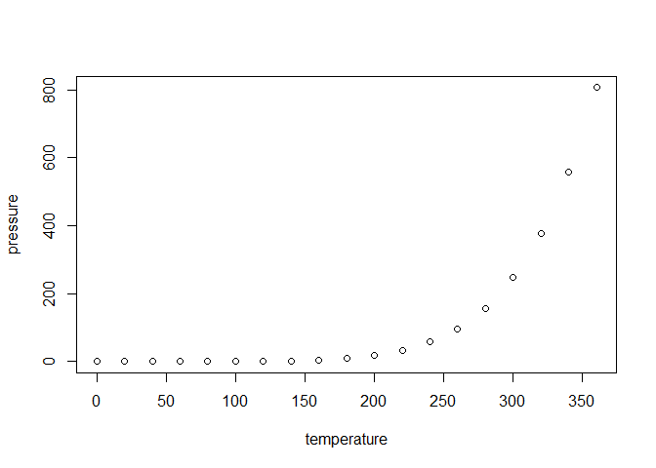

1. See, this is a caption.

Note that the echo = FALSE parameter was added to the code chunk to prevent printing of the R code that generated the plot.

## Including tables

1. My caption

| Temperature | Pressure |
| --- | --- |
| 0 | 0.0002 |
| 20 | 0.0012 |
| 40 | 0.0060 |
| 60 | 0.0300 |
| 80 | 0.0900 |
| 100 | 0.2700 |

## Including regression tables

It doesn’t look so dashing as {stargazer}, but still not that bad.

1. Regression table, Temperature is dependant variable.

|  | Estimate | Standard Error | t value | Pr(>|t|) |  |
| --- | --- | --- | --- | --- | --- |
| (Intercept) | 132.791 | 19.943 | 6.658 | 0.0000 | *** |
| pressure | 0.380 | 0.079 | 4.788 | 0.0002 | *** |
| *Signif. codes: 0 <= '***' < 0.001 < '**' < 0.01 < '*' < 0.05 < '.' < 0.1 < '' < 1* | | | | | |
|  | | | | | |
| Residual standard error: 75.56 on 17 degrees of freedom | | | | | |
| Multiple R-squared: 0.5742, Adjusted R-squared: 0.5492 | | | | | |
| F-statistic: 22.93 on 17 and 2 DF, p-value: 0.0002 | | | | | |

## Referring to the coefficients

Temperature is a dependant variable, and Pressure is the independant. Adjusged R2 is 0.55, which indicates a considerable linear relationship.

## You deserved it

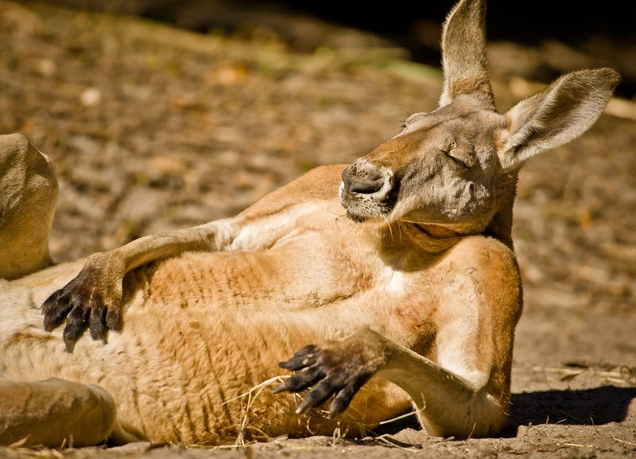

1. Kangaroos are a must

## References are included automatically at the end of the document

Busygina, Irina, and Mikhail Filippov. 2015. “The Calculus of Non-Protest in Russia: Redistributive Expectations from Political Reforms.” *Europe-Asia Studies* 67 (2): 209–23. <https://doi.org/10.1080/09668136.2014.1002679>.

Colton, Timothy J., and Michael McFaul. 2000. “Reinventing Russia’s Party of Power: ‘Unity’ and the 1999 Duma Election.” *Post-Soviet Affairs* 16 (3): 201–24. <https://doi.org/10.1080/1060586X.2000.10641486>.

Simon, G. 2001. “Russia and Ukraine Ten Years After the Fall of the Communist Regimes: Similarities and Differences.” *Russian Politics & Law* 39 (6): 74–79. <https://doi.org/10.2753/RUP1061-1940390674>.

Whitefield, Stephen. 2002. “Political cleavages and post-communist politics.” *Annual Review of Political Science* 5 (1): 181–200.

1. Affiliation, [email@email.com](mailto:email@email.com)
2. Affiliation, [email@email.com](mailto:email@email.com)
3. Affiliation, [email@email.com](mailto:email@email.com)
4. Footnote text
5. More footnotes.