Data Infrastructure at LinkedIn

LinkedIn Data Infrastructure Team

Abstract— LinkedIn is among the largest social networking sites in the world. As the company has grown, our core data sets and request processing requirements have grown as well. In this paper, we describe a few select data infrastructure projects at LinkedIn that have helped us accommodate this increasing scale. Most of those projects build on existing open source projects and are themselves available as open source. The projects covered in this paper include: (1) Voldemort: a scalable and fault tolerant key-value store; (2) Databus: a framework for delivering database changes to downstream applications; (3) Espresso: a distributed data store that supports flexible schemas and secondary indexing; (4) Kafka: a scalable and efficient messaging system for collecting various user activity events and log data.

1. Introduction

LinkedIn is logically divided into three fairly traditional tiers of services: a data tier that maintains persistent state including all user data, a service tier that implements an API layer capturing the logical operations of the website, and a display tier that is responsible for translating APIs into user interfaces including web pages and other user-facing applications such as “sharing” widgets on external sites or mobile application content. These tiers are physically run on separate hardware and communicate via RPC.

The service tier and display tier are both largely stateless—all data and state comes only from transient caches and underlying data systems. As a result the request capacity of these stateless services can be increased by randomly balancing the load over an increased hardware pool. Likewise failures are handled trivially by removing the failed machines from the live pool. The key is that since there is no state in these tiers, all machines are interchangeable.

This is a common strategy for simplifying the design of a large website: state is pushed down into a small number of more general data systems which allows the harder problem of scaling stateful systems to be solved in as few places as possible. The details of these systems differ, but they share some common needs. Data volume generally requires partitioning data over multiple machines, and requests must be intelligently routed to the machine where the data resides. Availability requirements require replicating data onto multiple machines to allow fail-over without data loss. Replicated state requires reasoning about the consistency of data across these machines. Expansion requires redistributing data over new machines without downtime or interruption.

LinkedIn’s core data systems are (a) live storage, (b) stream systems, (c) search, (d) social graph, (e) recommendations, and (f) batch computing. We will give a brief overview of each of these areas, and dive into more detail on a few selected systems.

1. LinkedIn’s Site Architecture

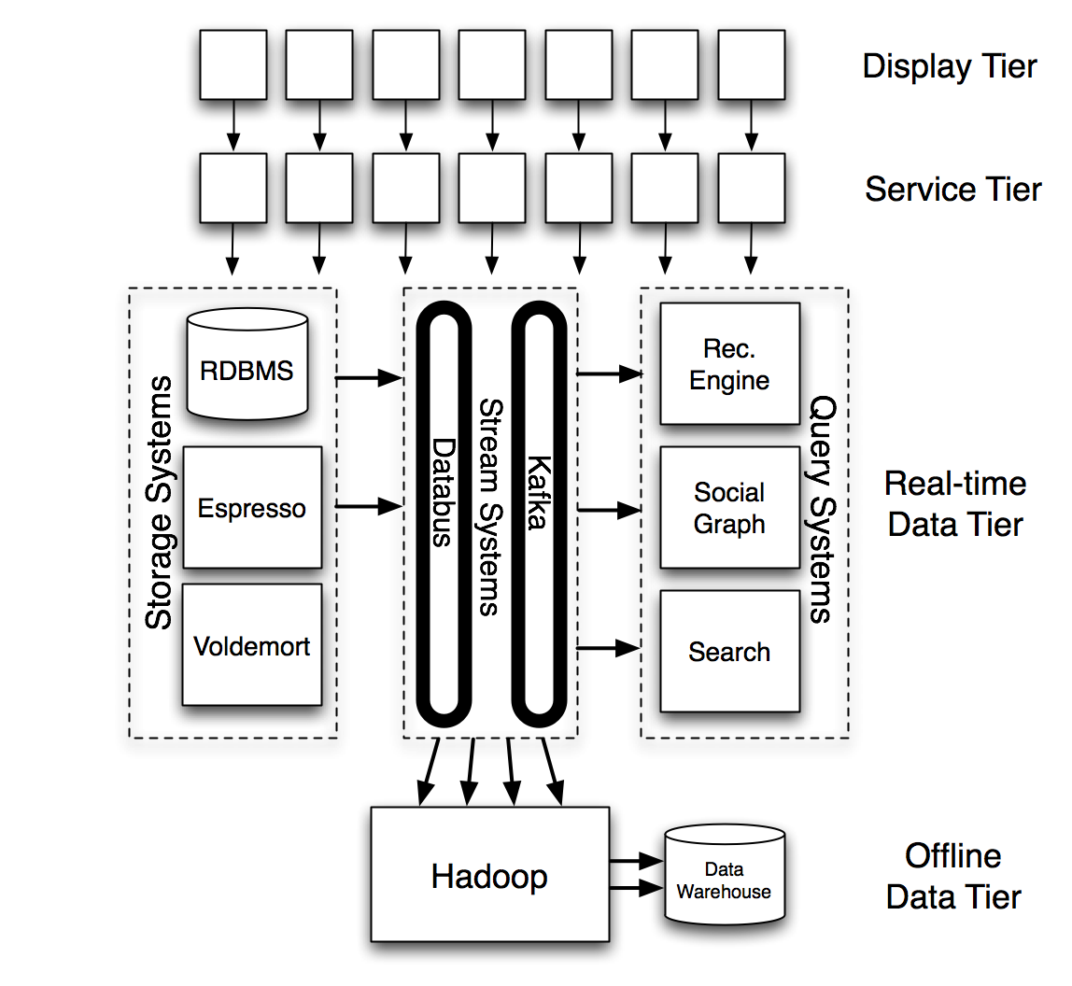

**Figure I.1** A very high-level overview of LinkedIn’s architecture, focusing on the core data systems.

Live storage systems are simply variations on traditional OLTP databases, though high request load and large data volume have forced a trade-off to disallow more complex queries to enable horizontal scalability. Live storage systems are the workhorse of web applications serving the majority of data requests that make up the user experience. We describe two storage systems in the later sections, one aimed at providing primary data storage with rich query capabilities and a timeline consistency model (Espresso) and one aimed at providing simple, fast, eventually consistent key-value access (Voldemort).

Batch processing consists of large-scale offline data processing jobs that run on a fixed schedule, say, hourly, daily, or weekly. Much of the most complex algorithmic data processing work is offloaded to this setting. LinkedIn’s batch processing workloads divide into two major categories. The first is production batch processing jobs whose purpose is to generate data sets that will be served to users on our website. The second is analytical processing aimed at business intelligence or producing internal reports. LinkedIn’s production batch processing runs entirely on Hadoop. It uses a workflow containing both Pig and MapReduce jobs and run through a central scheduler. LinkedIn’s analytical batch processing runs on a combination of traditional relational data warehouse and the Hadoop system. Analytical Hadoop access is primarily Hive and Pig queries.

Recommendation systems and social search systems are both closely related. These systems are concerned with matching rich structured data to users in a highly personalized way. The search system powers people search, which is a core feature for LinkedIn, but also handles search over all other LinkedIn content (including verticals for jobs, groups, and companies). The recommendation system matches relevant jobs, job candidates, connections, ads, news articles, and other content to users. The queries to these systems are orders of magnitude more complex than traditional systems since they involve ranking against complex models as well as integration of activity data and social features.

The social graph powers the social features on the site off a partitioned graph of LinkedIn members and their attribute data (such as companies or groups). Its purpose is to serve low-latency social graph queries. Examples of queries include showing paths between users, calculating minimum distances between users, counting or intersecting connection lists and other social functionality. This is one of the backbones of the site, processing over 100k graph queries per second and acting as one of the key determinants of performance and availability for the site as a whole.

Stream systems provide feeds of data to applications and many of the other data systems mentioned above. These feeds can be used either for processing or notification purposes. Stream systems enable near real-time processing of data as is needed for email, newsfeed systems, and other core parts of the site that do their work asynchronously from user actions. In addition, the very presence of these use-case specific data systems puts special emphasis on the stream-oriented systems; they serve as a central replication layer that transports updates to all relevant subscriber systems. For example the social graph, search, and recommendation systems subscribe to the feed of profile changes, and our newsfeed features are built on top of member activity and status feeds. Such feeds are also pulled into the batch systems for offline processing. In this paper we describe LinkedIn’s two stream systems: Databus which handles database stream replication and Kafka, which handles general pub/sub, user activity events and log data.

For brevity we will give detailed coverage only of the stream and storage systems in the remaining sections.

1. Voldemort

Project Voldemort is a highly available, low-latency distributed data store. It was initially developed at LinkedIn in 2008, in order to provide key-value based storage for read-write data products like “Who viewed my profile”, thereby acting an alternative to our primary storage Oracle system. Over time it has also been adapted to serve static read-only data produced in offline bulk systems like Hadoop. Voldemort was open-sourced in January 2009 and has seen widespread adoption by various other companies for applications that require high availability and low latency. At LinkedIn, Voldemort powers various components of our real time recommendation products, network updates, and rate limiting system. We currently house around ten clusters, spanning more than a hundred nodes. Some of the new additions to the system also allow Voldemort to work on nodes sitting in multiple datacenters. This, along with the ability to add nodes without downtime, has helped us scale Voldemort to handle tens of thousands of requests a second.

Voldemort can best be categorized as a distributed hash table (DHT). But unlike previous DHT works (like Chord [SMK+01]), it has been designed to have relatively low node membership churn i.e. few changes in cluster topology. Instead it has been designed for frequent transient and short-term failures, which are very prevalent in production datacenters [FLP+10]. This also allows us to store the complete topology metadata on every node instead of partial “finger tables” as in Chord, thereby decreasing lookups from O(logN) to O(1). Overall, Voldemort’s design and architecture has been heavily inspired by Amazon's Dynamo [DHJ+07], a highly available and eventually consistent key-value store that powers Amazon’s shopping cart.

1. Architecture

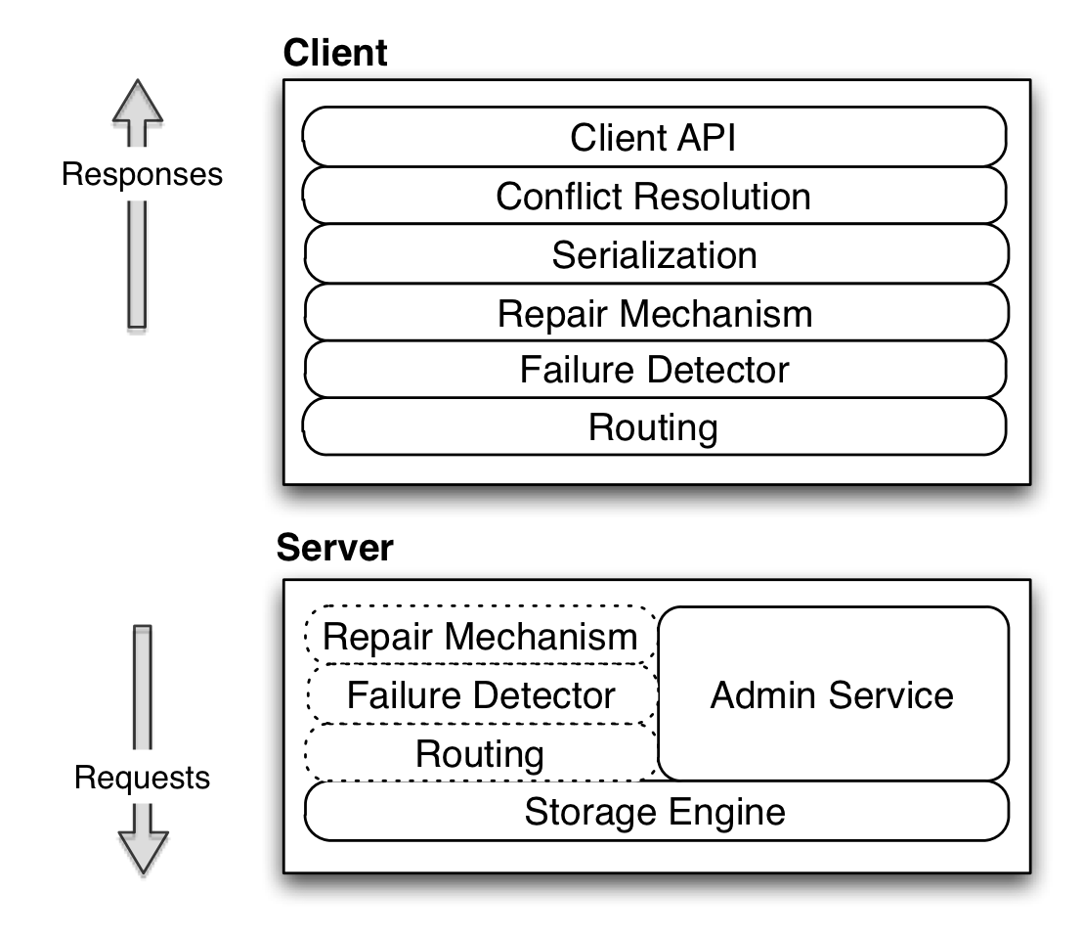

**Figure II.1** Pluggable architecture of Voldemort

We will start by explaining some of the key terms used to describe our system. A Voldemort cluster can contain multiple nodes, each with a unique id. All the nodes in the cluster store the same number of stores - which correspond to database tables. Every store has its set of configurations, including - replication factor (N), required number of nodes which should participate in read (R) and writes (W) and finally a schema (key and value serialization formats). Keys for the same store are hashed to a hash ring - a representation of the key space split into equal sized logical partitions. Every node in a cluster is then responsible for a certain set of partitions.

Figure II.1 shows the pluggable architecture of Voldemort. Most of the modules have their functionality similar to those described in Amazon's Dynamo paper. Every module in the architecture implements the same code interface thereby making it easy to (a) interchange modules. For example, Voldemort supports both server and client side routing by moving the routing and associated modules (b) test code easily by mocking modules.

**Client API and Conflict Resolution**: Starting from the top of the architecture our client has the API described in Figure II.2. As a Dynamo implementation, Voldemort differs from the conventional master-slave replicated systems, in that any replica of a given partition is able to accept a write. As a result, it is possible for divergent version histories to form on multiple nodes during failures / partitions. As shown in our API, we use vector clocks [LAM78] to version our tuples and delegate the conflict resolution of concurrent versions to the application. Methods 3) and 4) of the API allow the user to run a transform on the value on the server side. For example, if the value is a list, we can run a transformed get to retrieve a sub-list or a transformed put to append an entity to your list, thereby saving network bandwidth.

The use of vector clocks also allows us to support some form of optimistic locking on the client side. Two concurrent updates to the same key results in one of the clients failing due to an already written vector clock. This client is thrown a special error, which can trigger a retry with the updated vector clock. This retry logic can be encapsulated in the *applyUpdate* call and can be used in cases like counters where “read, modify, write if no change” loops are required.

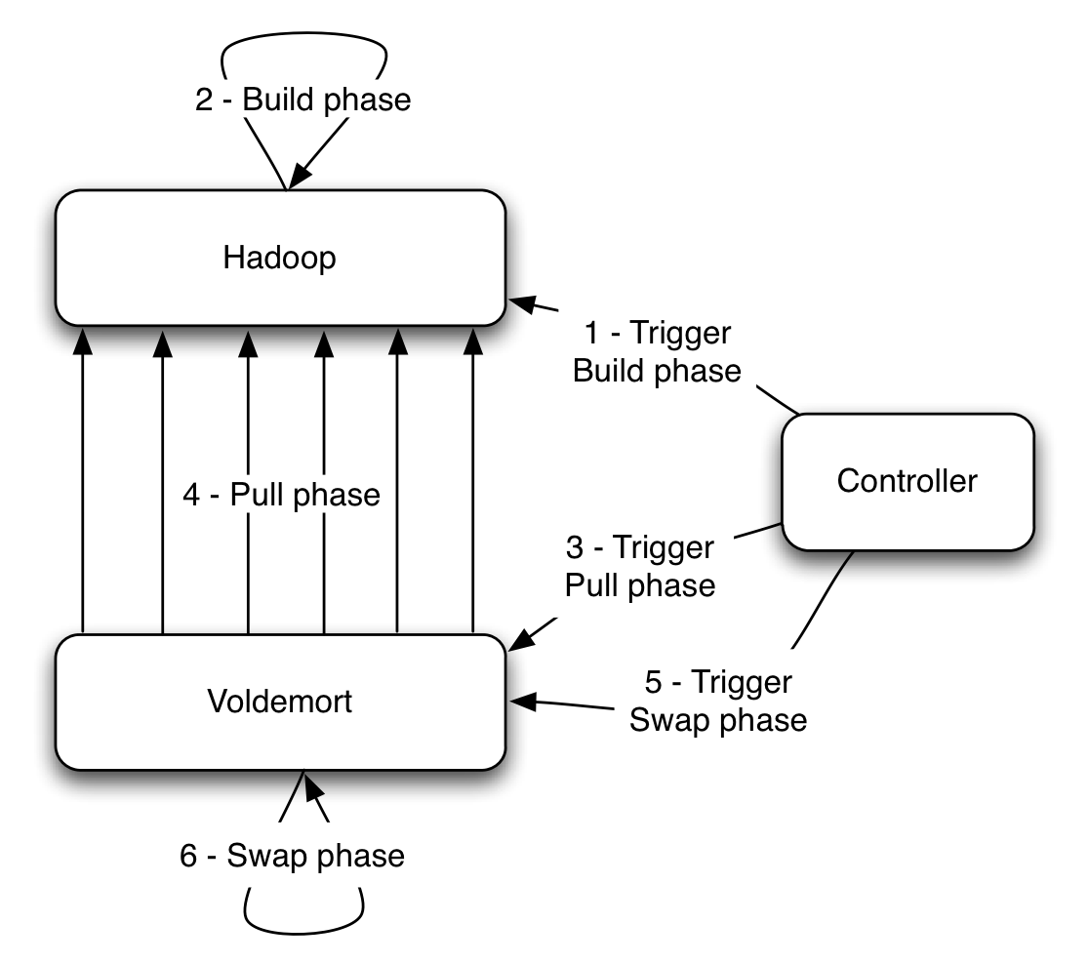

**Figure II.3** Steps to complete the three phases of the data cycle to get “read-only” data into Voldemort from Hadoop

**Repair mechanism**: This module is responsible for reconciling the inconsistent versions of the same key. We adopted the two repair mechanisms highlighted in the Dynamo paper viz. read repair and hinted handoff. Read repair detects inconsistencies during gets while hinted handoff is triggered during puts.

1) VectorClock<V> **get** (K key)  
2) **put** (K key, VectorClock<V> value)  
3) VectorClock<V> **get** (K key, T transform)  
4) **put** (K key, VectorClock<V> value, T transform)  
5) **applyUpdate**(UpdateAction action, int retries)

**Figure II.2** Client API for Voldemort

**Failure Detector**: Due to frequent transient errors, it is important that the routing module maintain an up-to-date status of each storage node’s availability. By using this knowledge during request routing, we can also prevent the client from doing excessive requests to a server that is currently overloaded. We support various failure detectors, but the most commonly used one marks a node as down when its “success ratio” i.e. ratio of successful operations to total, falls below a pre-configured threshold. Once marked down the node is considered online only when an asynchronous thread is able to contact it again.

**Routing**: This module of Voldemort employs a simple implementation of consistent hashing to perform replication. A key is hashed to a logical partition, after which we jump the ring till we find N-1 other partitions on different nodes to store the replicas. Using this non-order preserving partitioning scheme prevents formation of hot spots.

Since our routing layer is pluggable we also plugged in a variant of consistent hashing algorithm that supports routing in a multiple datacenter environment. For the same, we group nodes into logical clusters called 'zones', which in turn are defined by a proximity list of distances from other zones. The routing algorithm now jumps the consistent hash ring with an extra constraint to satisfy number of zones required for the request.

**Storage Engine**: Out of the various storage engine implementations supported by Voldemort, the most commonly used ones are BerkeleyDB Java Edition (BDB) [OBS99] (for read-write traffic) and a custom read-only storage engine (for static offline data).

The custom read-only storage engine was built for applications that require running various multi-stage complex algorithms, using offline systems like Hadoop, to generate their final results. By offloading the index construction also to the offline system we do not hurt the performance of the live indices. The storage engine data layout, on Voldemort nodes, consists of compact index and data files stored in versioned directories per store, with every new data deployment resulting in a new versioned directory. Storing multiple versions of the complete dataset allows the developers to do instantaneous rollbacks in case of data problems. The complete data pipeline to get this static data into Voldemort is co-ordinated by a controller. Figure II.3 shows the various phases of the data pipeline and their order of execution - (a) Build phase - We take the output of complex algorithms and generate partitioned sets of data and index files in Hadoop [WHI09]. These files are partitioned by destination nodes and stored in HDFS. An index file is a compact list of sorted MD5 of key and offset to data into the data file. To generate these indices, we leverage Hadoop’s ability to sort its values in the reducers. Finally a search on the Voldemort side is done using binary search. (b) Pull phase – Voldemort gets notified of the location of the output of the build phase and starts a parallel fetch from HDFS into a new versioned directory for the store. (c) Swap phase – On completion of the pull the controller co-ordinates an atomic swap across all the nodes by closing the current index files and memory mapping the new index files. Instead of building complex caching structures, memory mapping the files delegates the caching to the operating system’s page-cache.

**Admin Service**: In addition to the above stack, every node also runs an administrative service, which allows the execution of privileged commands without downtime. This includes the ability to add / delete store and rebalance the cluster without downtime. Rebalancing (dynamic cluster membership) is done by changing ownership of partitions to different nodes. We maintain consistency during rebalancing by redirecting requests of moving partitions to their new destination.

1. Usage at LinkedIn

At LinkedIn we have ten Voldemort clusters – nine of which serve BDB backed read-write traffic (six of which are running across two datacenters) while one serves custom read-only storage engine backed traffic. The total number of stores, across all these clusters, is 231 – 124 of which are read-only. Our largest read-write cluster has a usage pattern of around 60% reads and 40% writes. This cluster does around 10K queries per second at peak with average latency of around 3 ms. Similarly read-only cluster does around 9K reads per second with an average latency of less than a ms. Voldemort also successfully handles varying data sizes for the stores – our smallest store is around 8 KB while the largest one is around 2.8 TB for read-only and 1.4 TB for the read-write cluster.

We will now highlight two applications in LinkedIn that use Voldemort. The first example is that of read-write stores used to run “Company Follow” – a feature on LinkedIn that allows the user to get a feed of company updates by following it. This uses two stores to maintain a cache-like interface on top of our primary storage Oracle – first one stores member id to list of company ids followed by the user and the second one stores company id to list of member ids that follow it. Both stores are fed by a Databus (described in Section III) relay and are populated whenever a user follows a new company. Since it is used as cache, having inconsistent values across stores is not a problem. Both the stores have a Zipfian distribution for their data size, but still manage to retrieve large values with an average latency of 4 ms.

The second example is a link prediction problem used to generate “People You May Know” on LinkedIn. This application is powered by a single store that is backed by the custom read-only storage engine. The store saves, for every member id, a list of recommended member ids, along with a score. Due to continuous iterations on the prediction algorithm and the rapidly changing social graph, most of the scores change between runs. Some of the optimizations that we run on the read-only cluster include (i) throttling the pulls (ii) pulling the index files after all the data files to achieve cache-locality post-swap. This has helped us achieve an average latency in sub-milliseconds for this store.

Some of the future work that we will be working on includes – faster rebalancing, an update stream which consumers can listen to and new index formats to optimize the read-only store performance.

1. Databus
   1. Motivation

Modern Internet-based systems are increasingly facing the difficult challenge of performing complex processing over large amounts of valuable data with strict upper bounds on latency. For example, at LinkedIn, we have to continuously maintain indexes and statistical models over many aspects of the online professional identity of our constantly increasing user base of 120+ million. These indexes and models facilitate the discovery of new opportunities for our members. Other use cases include database replication for read scalability, data standardization, and query result pre-computation and caching.

At LinkedIn, we have built Databus, a system for change data capture (CDC), that is being used to enable complex online and near-line computations under strict latency bounds. It provides a common pipeline for transporting CDC events from LinkedIn primary databases to various applications. Among these applications are the Social Graph Index, the People Search Index, Read Replicas, and near-line processors like the Company Name and Position Standardization.

Databus contains adapters written for Oracle and MySQL, two of the primary database technologies at use at LinkedIn, and a subscription API that allows applications to subscribe to changes from one or more data sources. It is extremely easy to extend it to add support for other kinds of data sources (transaction log providers).

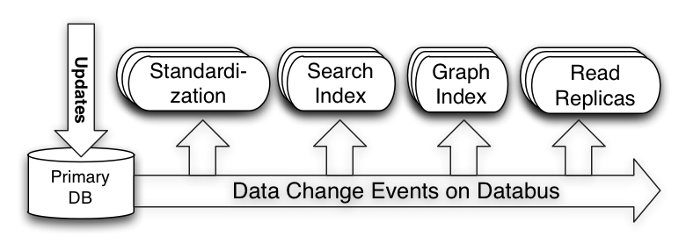

Figure III. Databus at LinkedIn

* 1. Problem Definition

Next, let us discuss what the important requirements for Databus are.

1. Strong timeline consistency

To avoid having the subscribers see partial and/or inconsistent data we need to capture:

* Transaction boundaries: a single user’s action can trigger atomic updates to multiple rows across stores/tables. e.g. an insert into a member’s mailbox and update on the member’s mailbox unread count
* The commit order of the primary database
* All changes

1. User-space processing

By “user-space processing”, we refer to the ability to perform the computation triggered by the data change outside the database server. This is in contrast to traditional database triggers that are run in the database server.

Moving the computation to user space has the following benefits:

* Reduces the load on the database server
* Decouples the subscriber implementation from the specifics of the database server implementation
* Enables independent scaling of the subscribers

1. Support for long look-back queries

Typically, subscribers are interested only in recent changes that they have not processed yet. Yet, there are occasions when subscribers may want to read older changes.

* If they have suffered a performance hiccup or they have been taken down for maintenance;
* New subscribers are added to increase capacity might need to initialize their state and get a recent snapshot of the database;
* All clients need to re-initialize their state because of the need to reprocess the whole data set. e.g. processing algorithm changes

1. Data source / subscriber isolation

Subscribers often perform complex computations that may not allow a single instance to keep up with the data change rate. In those cases, a standard solution is to distribute the computation among multiple instances along some partitioning axis.

Therefore, the pipeline should

* Allow multiple subscribers to process the changes as a group; i.e. support partitioning;
* Support different types of partitioning for computation tasks with different scalability requirements;
* Isolate the source database from the number of subscribers so that increasing the number of the latter should not impact the performance of the former;
* Isolate the source database from slow or failing subscribers that should not negatively impact the database performance;
* Isolate subscribers from the operational aspects of the source database: database system choice, partitioning, schema evolution, etc.

1. Low latency of the pipeline

Any overhead introduced by the pipeline may introduce risk of inconsistencies, negatively affect performance, or decrease the available time for the asynchronous computations. For example, any latency in updating a secondary index structures (like the previously mentioned LinkedIn social graph index) increases the risk of serving stale or inconsistent data. In the case of replication for read scaling, pipeline latency can lead to higher front-end latencies since more traffic will go to the master for the freshest results.

Databus addresses the above requirements with features like:

* Data-source independence: Oracle, MySQL, …
* Portable change event serialization and versioning
* Consumption from arbitrary point in the stream of events (uses compressed deltas to avoid storing all events)

Databus guarantees:

* Timeline consistency with the data source with transactional semantics and at-least-once delivery
* No loss in durability (relies on bootstrap and primary store on failure)
* High availability (replicated availability)
* Low latency (low milliseconds)
  1. Architecture

This section dives deeper into the architecture of Databus and covers how it addresses the requirements from the previous sub-section.

The Databus pipeline consists of three main components: the Relay, the Bootstrap Server, and the Databus Client Library. The Relay captures changes in the source database, serializes them to a common binary format and buffers those. Each change is represented by a *Databus CDC event* which contains a sequence number in the commit order of the source database, metadata, and payload with the serialized change. Relays serve Databus events to both clients and the Bootstrap servers. Bootstrap servers provide clients with arbitrary long look-back queries in Databus event stream and isolate the source database from having to handle these queries.

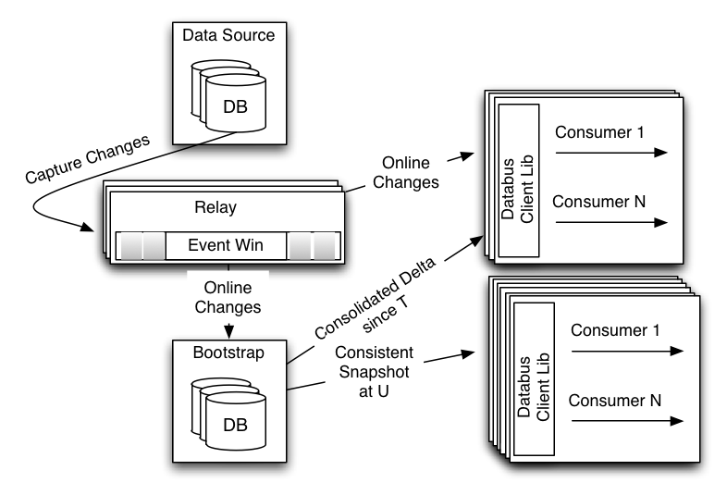

Figure III. Detailed Databus Architecture

Next, we will describe the three main components in greater detail.

1. Relay

As mentioned above, the first task of the relay is to capture changes from the source database. At LinkedIn, we employ two capture approaches, triggers or consuming from the database replication log.

Once captured, the changes are serialized to a data source-independent binary format. We chose Avro because it is an open format with multiple language bindings. Further, unlike other formats like Protocol Buffers, Avro allows serialization in the relay without generation of source-schema specific code.

The serialized events are stored in a circular in-memory buffer that is used to serve events to the Databus clients. We typically run multiple shared-nothing relays that are either connected directly to the database, or to other relays to provide replicated availability of the change stream.

The relay with the in-memory circular buffer provides:

* Default serving path with very low latency (<1 ms)
* Efficient buffering of tens of GB of data with hundreds of millions of Databus events
* Index structures to efficiently serve to Databus clients events from a given sequence number *S*
* Server-side filtering for support of multiple partitioning schemes to the clients
* Support of hundreds of consumers per relay with no additional impact on the source database

1. Bootstrap server

The main task of the Bootstrap server is to listen to the stream of Databus events and provide long-term storage for them. It serves all requests from clients that cannot be processed by the relay because of its limited memory. Thus, the Bootstrap server isolates the primary database from having to serve those clients.

There are two types of queries supported:

* Consolidated delta since sequence number (say *T*)
* Consistent snapshot at sequence number (say *U*)

The first query is used from clients that have some state but have fallen behind the time span of events stored in the relay. Instead of replaying all changes since *T*, the bootstrap server will return what we refer to as *consolidated delta*: only the last of multiple updates to the same row/key are returned. This has the effect of “fast playback” of time and allows the client to return faster to consumption from the relay.

The second type of query is used when the client does not have any state (e.g. a new client). In that case, the Bootstrap server will serve a recent consistent snapshot of the database and a sequence number *U* that is the sequence number of the last transaction applied in the snapshot. The client can then use the number *U* to continue consumption from the relay.

The main challenge is the ability to provide consistent results for the above query types without interruption of the events from the relay. We achieve this by using two separate storages: a log and snapshot storage.

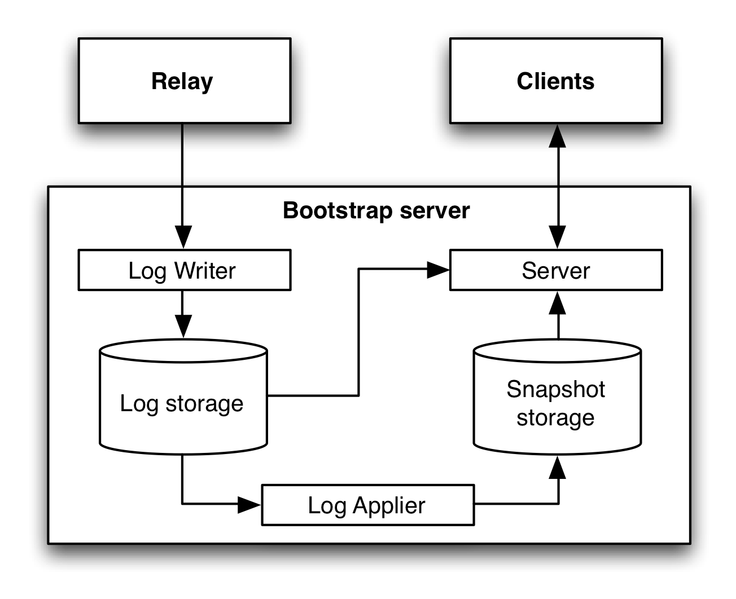Figure III. Bootstrap server design

The *Log writer* listens for Databus events from the relay and adds those to an append-only *Log storage*. The *Log applier* monitors for new rows in the Log storage and applies those to the *Snapshot storage* where only the last event for a given row/key is stored. On requests, the Server determines the optimal path. For clients whose request sequence number *T* is recent, it will serve directly from the Log storage. The append-only nature of the Log storage guarantees that the result is consistent. All other requests are first served from the Snapshot storage. This may return inconsistent results, as some of the rows may be modified during the snapshot serving (which can take a long time). To guarantee consistency, the Server replays all changes that have happened since the start of the snapshot phase.

Like the relay, the Bootstrap server also supports server-side filters that are pushed down to the storage if possible.

1. Databus client library

The Databus client library is the glue between the Relays and Bootstrap servers and the business logic of the Databus consumers. It provides:

* Tracking of progress in the Databus event stream with automatic switchover between the Relays and Bootstrap servers when necessary;
* Push (callbacks) or pull interface
* Local buffering and flow control to ensure continuous stream of Databus events to the consumers
* Support for multi-thread processing
* Retry logic if consumers fail to process some events
  1. Related Systems

The related systems can be classified in three categories:  generic pub/sub systems, database replication systems, and other CDC systems. Generic pub/sub systems like JMS implementations, Kafka and Hedwig generally provide message-level or, at best, topic-level semantics.  Topic-level lets clients serialize messages on a particular topic.  These semantics do not suffice for transaction log replication. Providing transaction-level semantics requires implementing a transaction envelope on top of the vanilla messaging API with transaction boundaries provided by the producers and bubbled up to the consumers.

Distributed messaging systems let producers write to them and are designed to provide persistence and ordering within a topic.  In order to provide fault-tolerance and high-availability, they must implement fairly complex protocols that write each message to multiple locations before acknowledging the producer.  As a benefit, the producer need not track or persist its outgoing messages; consumers need only request and re-request messages from the messaging system. This complexity however comes at a cost in terms of development, operations, sometimes reduced performance and corner cases around node failures that can result in message loss.

Two assumptions about the data source and consumer state greatly simplify the messaging system requirements. The first assumption is that the data source is the source of truth, and generates a commit sequence number with each transaction. The transaction log generated is then replayable from any commit sequence number. The second assumption is that consumers define their state relative to the source in terms of sequence number, and persist their current state; this means a consumer always knows which messages it has applied and which it has not.  These assumptions simplify the messaging tier from worrying about persistence and delivery guarantees, and focus just on scalable transport and replicated availability. The Databus relay cluster therefore is a much simpler system which pulls from a database, is stateless across restarts, and can be replicated very simply since it relies on the source database to provide the transaction log and drive ordering. Finally, generic pub/sub systems provide only log storage (typically limited by data size) and do not support snapshots and consolidated deltas.

Database replication systems are often database vendor specific (with some exceptions like Tungsten Replicator) and have limited capabilities for user-space processing. Many of the CDC systems are also database vendor specific and to the best of our knowledge do not have support for consistent snapshot or consolidated deltas.

* 1. Usage at LinkedIn

Databus has been a foundational piece of LinkedIn’s architecture since early 2005. It started off as the way to keep LinkedIn’s social graph and search index consistent and up-to-date with the changes happening in the databases. Over time, it started to get used as a pure replication system for populating read replicas, invalidating and keeping caches consistent as well as supporting near-line processing requirements. In 2010, we added the bootstrapping capability and reworked the in-memory data structures at the relay to provide high throughput and very low latency while scaling to very large memory sizes without any performance penalties. In terms of operational scale, Databus provides change capture for close to a hundred data sources with tens of relays at low millisecond latencies. Databus is the native replication tier for our next-gen distributed data store ESPRESSO, described next. Future work includes releasing the source code back to the open source community, supporting declarative data transformations and multi-tenancy.

1. Espresso

Espresso is a distributed, timeline consistent, scalable, document store that supports local secondary indexing and local transactions. ESPRSSO relies on Databus for internal replication and therefore provides a Change Data Capture pipeline to downstream consumers.

The development of Espresso was motivated by a desire to migrate LinkedIn’s online serving infrastructure off of monolithic, commercial, RDBMS systems running on high cost specialized hardware to elastic clusters of commodity servers running free software; and to improve agility by enabling rapid development by simplifying the programming model, separating scalability, routing, caching from business logic. Espresso bridges the semantic gap between a simple Key Value store like Voldemort and a full RDBMS.

* 1. Data Model and API

Documents in Espresso are identified by URIs in the following form:

http://<host>[:<port>]/<database>/<table>/<resource_id>[/<subresource_id>…]

The resource specified by a resource_id may be a *singleton resource* that references an individual document, or a *collection resource* that references a set of related documents. In the latter case, one or more subresource_ids identifies individual documents within the collection.

In Espresso, a *database* is a container of tables. A *table* is a container of *documents*.

Each database, table, and document has an associated schema. Schemas are represented in JSON in the format specified by the Avro specification [Avro].

A database schema defines how the database is partitioned. At present, the only supported partitioning strategies are hash-based partitioning or un-partitioned (all documents are stored on all nodes). We anticipate adding range based partitioning in the future.

A table schema defines how documents within the table are referenced. When defining the URI schema for a table, the resource_id may designate a single document or a collection of related documents that are identified by further elements of the URI path. For example, the Music database Artists table might contain profiles for recording artists by artist name:

/Music/Artist/Rolling_Stones

/Music/Artist/The_Beatles

whereas the Albums table might contain Albums by Artist

/Music/Album/Cher/Greatest_Hits

/Music/Album/Elton_John/Greatest_Hits

and the Song table might contain songs by artist by album

/Music/Song/Doris_Day/Move_Over_Darling/At_Last

/Music/Song/Etta_James/Gold/At_Last

/Music/Song/Etta_James/Her_Best/At_Last

each of these tables is defined by a table schema that describes the elements of the URI path.

The document schema defines the structure of the documents stored within a table. Document schemas are freely evolvable. To evolve a document schema, one simply posts a new version to the schema URI. New document schemas must be compatible according to the Avro schema resolution rules to insure that existing documents can be promoted to the new schema. For each document, the system stores a binary serialized version of the document along with the schema version needed to deserialize the stored document.

Fields within the document schema may be annotated with indexing constraints, indicating that documents should be indexed for retrieval via the field’s value. HTTP query parameters allow retrieval of documents via these secondary indexes. For example, if the Songs document schema contained a field lyrics with a free text index constraint, a GET for the URI:

/Music/Song/The_Beatles?query=lyrics:”Lucy in the sky”

would return

/Music/Song/The_Beatles/Sgt._Pepper/Lucy_in_the_Sky_with_Diamonds

/Music/Song/The_Beatles/Magical_Mystery_Tour/I_am_the_Walrus

At present, indexed access is limited to collection resources accessed via a common resource_id in the URI path. Future enhancements will implement global secondary indexes maintained via a listener to the update stream.

Within a database, tables that share a common resource_id schema may be updated transactionally. The system guarantees that all tables within a single database that are indexed by the same resource_id path element will partition identically; thus allowing their transactional update. In our exmple, the Artist, Album and Song tables all share the artist name as the resource_id. So one could post a new album for an artist to the Album table and each of the album’s songs to the Song table in a single transaction. Transactional updates are performed by a POST to a database with a wildcard table name in the URI; where the entity-body contains the individual document updates. The system guarantees that either all updates commit successfully or none commit.

* 1. System Architecture

The Espresso system is composed of four major components: routers, storage nodes, relays and cluster managers. Each is described below.

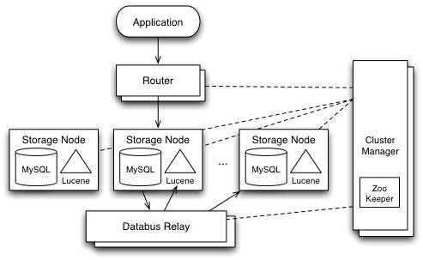

Figure IV.1 Espresso Architecture

**Router:** The router accepts HTTP requests, inspects the URI and forwards the request to the appropriate storage node. For a given request, the router examines the database component of the path and retrieves the routing function from the corresponding database schema. It then applies the routing function to the resource_id element of the request URI to compute a partition id. Next it consults the routing table maintained by the cluster manager to determine which storage node is the master for the partition. Finally, the router forwards the HTTP request to the selected storage node.

**Storage Node:** Requests for a document are routed to the storage node that is the master for the containing partition. The storage node maintains a consistent view of each document in a local data store and optionally indexes each document in a local secondary index based on the index constraints specified in the document schema. The initial implementation stores documents in MySQL as the local data store and Lucene for the local secondary index, though the design allows for alternate implementations via a plugin model. Each document is stored as a serialized byte stream indexed by the URL resource_id and any subresource_ids. In our Song table example, the underlying MySQL table would contain:

+-----------------+--------------+------+-----+

| Field | Type | Null | Key |

+-----------------+--------------+------+-----+

| artist | varchar | NO | PRI |

| album | varchar | NO | PRI |

| song | varchar | NO | PRI |

| timestamp | bigint(20) | NO | |

| etag | varchar(10) | NO | |

| val | blob | YES | |

| schema_version | smallint(6) | NO | |

+-----------------+--------------+------+-----+

Table IV.1 Database Schema

The timestamp and etag fields are used to implement conditional HTTP requests.

Requests for specific resources can be satisfied via direct lookup in the local data store. Queries first consult a local secondary index then return the matching documents from the local data store.

Each partition is replicated *n* ways within the cluster. The replication factor is specified in the schema for the database. Each storage node is master for a set of partitions and slave for a disjoint set of partitions.

Consider the application view of the Albums table described above as shown in Figure IV.2.

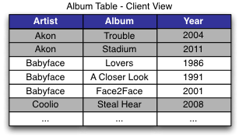

Figure IV.2 Album Table – Application View

The system will partition the table according to the resource_id component of the URL - the Artist in this example. Different values for Artist will hash to different partitions. Each storage node is master for some partitions and slave for others. The above table might partition as shown in Figure IV.3.

**Relay:** Espresso replication lays the foundation for Espresso’s fault-tolerant and elastic solution. It is designed to be timeline consistent, efficient, and robust.

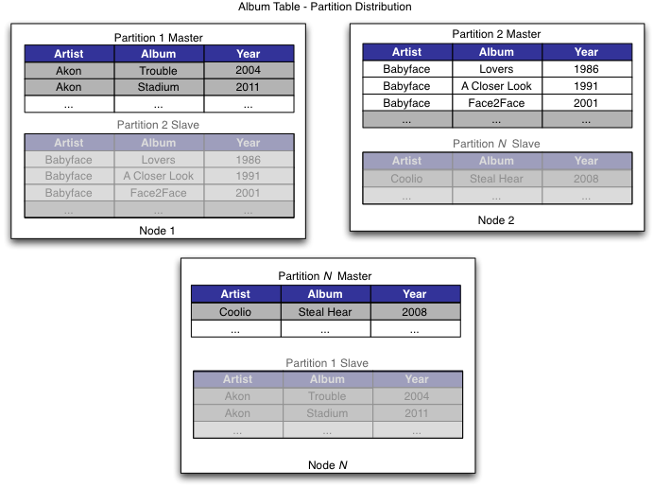

Figure IV.3 Album Table – Partition Layout

*Timeline consistency*. Changes are applied on a slave partition in the same order as on its master partition, i.e. in transaction commit order. This feature provides the basis for implementing failover and rebalancing in Espresso. Changes are captured, transferred and populated in the following manner. First, on a storage node, all changes are tagged with their transaction sequence number and captured in the MySQL binlog. Second, the MySQL binlog is shipped to a Databus relay node via MySQL Replication. Third, a storage node pulls changes from Databus relay and applies them to the slave partitions. All these steps follow the transaction commit order so that timeline consistency is guaranteed.

*Efficiency.* Replication uses minimal resources on the storage nodes so the impact on user query performance is minimized. We achieve such efficiency by 1) maintaining a single replication log on each storage node, and 2) pushing work to the Databus relay nodes. On a storage node, we run one MySQL instance and changes to all master partitions are logged in a single MySQL binlog to preserve sequential I/O pattern. However, each slave partition subscribes to changes only from its master partition, so binlog sharding is required. We use MySQL replication to publish the binlog of all master partitions on a storage node to the Databus relay, where the binlog is sharded into separate event buffers, one per partition. A slave partition consumes events from the corresponding Databus event buffer.

*Robustness.* Changes made by a transaction are durable under failures. Each change is written to two places before being committed -- the local MySQL binlog and the Databus relay. If a storage node fails, the committed changes can still be found in the Databus relay and propagated to other storage nodes. We use the synchronous feature of MySQL replication to achieve this goal. As described in section III(D)7, the Databus relay is fault-tolerant and can sustain a certain degree of failure. So the end-to-end replication is robust with these features provided.

Espresso provides faults-tolerance and elasticity based on its replication tier. When a master partition fails, a slave partition is selected to take over. The slave partition first consumes all outstanding changes to the partition from the Databus relay, and then becomes a master partition. It continues to replicate changes to the Databus relay. When adding new nodes to an existing Espresso cluster, certain master and slave partitions are selected to migrate to a new node. For each migrated partition, we first bootstrap the new partition from a snapshot taken from the original master partition, and then apply any changes since the snapshot from the Databus Relay. Once caught up, the new partition is a slave. We then hand off mastership to selected slaves.

**Cluster Manager:** The cluster manager, aka Helix, is designed to be a generic platform for managing a cluster of nodes; including Espresso storage nodes and Databus relay nodes. There are various scenarios, such as node failures and partition migration, where the system must react appropriately to satisfy the requirements of a fault tolerant system. Helix manages the various components in the cluster. It provides the following features:

*Robust hosted services.* It provides control flow for fault tolerance and optimized rebalancing during cluster expansion for partitioned and replication resources.

*Load balancing.* It performs smart allocation of resources to servers (nodes) based on server capacity and resource profile (size of partition, access pattern etc.).

*Service discovery.* It manages cluster configuration in a centralized fashion, and provides automatic service discovery to route requests.

*Server lifecycle management.* It manages entire operational lifecycle of server -- addition, deletion, start, stop, enable and disable without downtime.

*Health check.* It monitors cluster health and provides alerts on SLA violations.

To build such a system, we need a mechanism to co-ordinate between different nodes or components in the system. This mechanism can be achieved with software that reacts to any change in the cluster and comes up with a set of tasks needed to bring the cluster to a stable state. The set to tasks will be assigned to one or more nodes in the cluster. Helix is modelled as state machine. Helix implements a state machine that implements the following states:

* The IDEALSTATE for the cluster, representing the state when all configured nodes are up and running.
* The CURRENTSTATE representing the current state of the nodes in the cluster. The CURRENTSTATE will differ from the IDEALSTATE when one or more nodes are unavailable due to system failure, maintenance, etc.
* The BESTPOSSIBLESTATE is the state closest to the IDEALSTATE given the set of available nodes.

Helix generates tasks to transform the CURRENTSTATE of the cluster to the BESTPOSSIBLESTATE. When all nodes are available, the BESTPOSSIBLESTATE will converge to the IDEALSTATE. Tasks are assigned to nodes to perform state changes. Helix uses ZooKeeper as a distributed store to maintain the state of the cluster and a notification system to notify if there is any change in the cluster state.

* 1. Deployment of Espresso at LinkedIn

Espresso was first deployed at LinkedIn in September 2011 to serve read traffic for company profiles, products and reviews. Test deployments for users’ inbox content are underway. Future deployments for other data are under development.

1. Kafka

There is a large amount of event data generated at any sizable internet company. This data typically includes (1) user activity events corresponding to logins, page-views, clicks, “likes”, sharing, comments, and search queries; (2) operational metrics such as various service metrics and call stack. Event data has long been a component of offline analysis for tracking user engagement and system utilization. However, an increasing number of applications require online consumption of this data. These include (1) search relevance, (2) recommendations which may be driven by item popularity or co-occurrence in the activity stream, (3) security applications that protect against abusive behaviours such as spam or unauthorized data scraping, (4) newsfeed features that aggregate user status updates or actions for their “friends” or “connections” to read, and (5) real time dashboards of various service metrics.

**Sample producer code**:

producer = new Producer(…);

message = new Message(“test msg str”.getBytes());

set = new MessageSet(message);

producer.send(“topic1”, set);

We developed a system called Kafka [KNR11] for collecting and delivering event data. Kafka adopts a messaging API in order to support both real time and offline consumption of this data. Because event data is 2-3 orders magnitude larger than data handled in traditional messaging system, we made a few unconventional yet practical design choices in Kafka to make our system simple, efficient and scalable.

producer

BROKER 1

topic1/part1

/part2

topic2/part1

producer

consumer

consumer

**Figure V.1**. Kafka Architecture

BROKER 2

topic1/part1

/part2

topic2/part1

BROKER 3

topic1/part1

/part2

topic2/part1

1. Kafka API and Architecture

We first introduce the basic concepts in Kafka. A stream of messages of a particular type is defined by a topic. A producer can publish messages to a topic. The published messages are then stored at a set of servers called brokers. A consumer can subscribe to one or more topics from the brokers, and consume the subscribed messages by pulling data from the brokers.

Messaging is conceptually simple, and we have tried to make the Kafka API equally simple to reflect this. Instead of showing the exact API, we present some sample code to show how the API is used. The sample code of the producer is given below. A message is defined to contain just a payload of bytes. A user can choose her favorite serialization method to encode a message. For efficiency, the producer can send a set of messages in a single publish request.

To subscribe to a topic, a consumer first creates one or more message streams for the topic. The messages published to that topic will be evenly distributed into these sub-streams. The details about how Kafka distributes the messages are described later in Section V.C. Each message stream provides an iterator interface over the continual stream of messages being produced. The consumer then iterates over every message in the stream and processes the payload of the message. Unlike traditional iterators, the message stream iterator never terminates. If there are currently no more messages to consume, the iterator blocks until new messages are published to the topic. We support both the point-to-point delivery model in which multiple consumers jointly consume a single copy of all messages in a topic, as well as the publish/subscribe model in which multiple consumers each retrieve its own copy of a topic.

The overall architecture of Kafka is shown in Figure V.1. Since Kafka is distributed in nature, a Kafka cluster typically consists of multiple brokers. To balance load, a topic is divided into multiple partitions and each broker stores one or more of those partitions. Multiple producers and consumers can publish and retrieve messages at the same time.

1. Efficiency

In this section, we describe the layout of a single partition on a broker and a few design choices that we made to access a partition efficiently.

**Simple storage**: Kafka has a very simple storage layout. Each partition of a topic corresponds to a logical log. Physically, a log is implemented as a set of segment files of approximately the same size (e.g., 1GB). Every time a producer publishes a message to a partition, the broker simply appends the message to the last segment file. For better performance, we flush the segment files to disk only after a configurable number of messages have been published or a certain amount of time has elapsed. A message is only exposed to the consumers after it is flushed.

**Sample consumer code**:

streams[] = Consumer.createMessageStreams(“topic1”, 1)

for (message : streams[0]) {

bytes = message.payload();

// do something with the bytes

}

Unlike typical messaging systems, a message stored in Kafka doesn’t have an explicit message id. Instead, each message is addressed by its logical offset in the log. This avoids the overhead of maintaining auxiliary index structures that map the message ids to the actual message locations. Note that our message ids are increasing but not consecutive. To compute the id of the next message, we have to add the length of the current message to its id.

Many traditional messaging systems support out of order delivery of messages. This tends to increase the complexity of the system and is not necessary for our purpose. Instead, in Kafka, a consumer always consumes messages from a partition sequentially. If the consumer acknowledges a particular message offset, it implies that the consumer has received all messages prior to that offset in the partition. Under the covers, the consumer is issuing asynchronous pull requests to the broker to have a buffer of data ready for the application to consume. Each pull request contains the offset of the message from which the consumption begins and a maximum number of bytes to fetch. For every partition in a topic, a broker keeps in memory the initial offset of each segment file. The broker locates the segment file where the requested message resides by searching the offset list, and sends the data back to the consumer.

**Efficient transfer**: We are very careful about transferring data in and out of Kafka. Earlier, we have shown that the producer can submit a set of messages in a single send request. Although the ultimate consumer API iterates one message at a time, under the covers, each pull request from a consumer also retrieves multiple messages up to a certain size, typically hundreds of kilobytes.

Another unconventional choice that we made is to avoid explicitly caching messages in memory at the Kafka layer. Instead, we rely on the underlying file system page cache. This has the main benefit of avoiding double buffering---messages are only cached in the page cache. This has the additional benefit of retaining warm cache even when a broker process is restarted. Since Kafka doesn’t cache messages in process at all, it has very little overhead in garbage collecting its memory, making efficient implementation in a VM-based language feasible. Finally, since both the producer and the consumer access the segment files sequentially, with the consumer often lagging the producer by a small amount, normal operating system caching heuristics are very effective (e.g., write-through caching and read-ahead) for performance.

In addition, we optimize the network access for consumers. A typical approach to sending bytes from a local file to a remote socket involves the following steps: (1) read data from the storage media to the page cache in an OS, (2) copy data in the page cache to an application buffer, (3) copy application buffer to another kernel buffer, (4) send the kernel buffer to the socket. This includes 4 data copying and 2 system calls. On Linux and other Unix operating systems, there exists a sendfile API [ZC] that can directly transfer bytes from a file channel to a socket channel. This typically avoids 2 of the copies and 1 system call introduced in steps (2) and (3). Kafka exploits the sendfile API to efficiently deliver bytes in a log segment file from a broker to a consumer.

Finally, to enable efficient data transfer especially across data centers, we support compression in Kafka. Each producer can compress a set of messages and send it to the broker. The compressed data is stored in the broker and is eventually delivered to the consumer, where it is uncompressed. In practice, we save about 2/3 of the network bandwidth with compression enabled.

**Stateless broker**: Unlike most other messaging systems, in Kafka, the information about how much each consumer has consumed is not maintained by the broker, but by the consumer itself. Such a design reduces a lot of the complexity and the overhead on the broker. However, this makes it tricky to delete a message, since a broker doesn’t know whether all subscribers have consumed the message. Kafka solves this problem by using a simple time-based SLA for the retention policy. A message is automatically deleted if it has been retained in the broker longer than a certain period (e.g., 7 days). This solution works well in practice. Most consumers, including the offline ones, finish consuming either daily, hourly, or in real-time.

There is an important side benefit of this design. A consumer can deliberately rewind back to an old offset and re-consume data. This violates the common contract of a queue, but proves to be an essential feature for many consumers. For example, when there is an error in application logic, the application can re-play certain messages after the error is fixed. As another example, the consumed data may be flushed to a persistent store periodically (e.g, a text indexer). If the consumer crashes, the unflushed data is lost. In this case, the consumer can checkpoint the smallest offset of the unflushed messages and re-consume from that offset when it’s restarted.

1. Distributed Coordination

We now describe how the producers and the consumers behave in a distributed setting. Each producer can publish a message to either a randomly selected partition or a partition semantically determined by a partitioning key and a partitioning function. We will focus on how the consumers interact with the brokers.

Kafka has the concept of consumer groups. Each consumer group consists of one or more consumers that jointly consume a set of subscribed topics, i.e., each message is delivered to only one of the consumers within the group. Different consumer groups each independently consume the full set of subscribed messages and no coordination is needed across consumer groups. The consumers within the same group can be in different processes or on different machines.

Our goal is to divide the messages stored in the brokers evenly among the consumers, without introducing too much coordination overhead. In Kafka, the smallest unit of parallelism for consumption is a partition within a topic. This means that at any given time, all messages from one partition are consumed only by a single consumer within each consumer group. Had we allowed multiple consumers to simultaneously consume a single partition, they would have to coordinate who consumes what messages, which necessitates locking and state maintenance overhead. In contrast, in our design consuming processes only need coordination when the load has to be rebalanced among them, an infrequent event. For better load balancing, we require many more partitions in a topic than the consumers in each group. We can achieve this by over partitioning a topic.

To facilitate the coordination, we employ a highly available consensus service Zookeeper [Zoo]. Kafka uses Zookeeper for the following tasks: (1) detecting the addition and the removal of brokers and consumers, (2) triggering a rebalance process in each consumer when the above events happen, and (3) maintaining the consumption relationship and keeping track of the consumed offset of each partition. When a rebalance is triggered, each consumer reads the current information in Zookeeper and selects a subset of partitions to consume from.

1. Kafka Deployment at LinkedIn

We have been using Kafka in production for more than a year now. At LinkedIn, we have one Kafka cluster co-located with each datacenter where our user-facing services run. The frontend services generate various kinds of event data and publish it to the local Kafka brokers in batches. The online consumers of Kafka run in services within the same datacenter. They include: (1) processing news postings from each member and feed the processed data to a real-time search index; (2) aggregating discussions across groups/forums within the same industry; (3) a security application that limits the usage of accounts with irregularly high activity.

We also deploy a cluster of Kafka in a separate datacenter for offline analysis, located geographically close to our Hadoop cluster and other data warehouse infrastructure. This instance of Kafka runs a set of embedded consumers to pull data from the Kafka instances in the live datacenters. We then run data load jobs to pull data from this replica cluster of Kafka into Hadoop and our data warehouse, where we run various reporting jobs and analytical process on the data. We also use this Kafka cluster for prototyping and have the ability to run simple scripts against the raw event streams for ad hoc querying. Without too much tuning, the end-to-end latency for the complete pipeline is about 10 seconds on average, good enough for our requirements.

Currently, we collect about 400GB of compressed activity events per day, with a peak rate of 80k messages per second produced. We have also started collecting our service call events. We expect the peak rate to be more than 200k messages per second when this effort is fully ramped up.

Our tracking also includes an auditing system to verify that there is no data loss along the whole pipeline. To facilitate that, each message carries the timestamp and the server name when they are generated. We instrument each producer such that it periodically generates a monitoring event, which records the number of messages published by that producer for each topic within a fixed time window. The producer publishes the monitoring events to Kafka in a separate topic. The consumers can then count the number of messages that they have received from a given topic and validate those counts with the monitoring events to validate the correctness of data.

Kafka has been an Apache incubator project [KA] since July 2011. Since then, we have seen more and more companies outside of LinkedIn adopting Kafka. One of the most important features that we plan to add in the future is intra-cluster replication.

1. Conclusions

We have described a few of the key building blocks of the data infrastructure for a modern social web site. Each of these systems faces related problems around partitioning, routing, availability, expansion, management, and monitoring. However, the constraints imposed by the application requirements, as well as the fundamental difficulties of a distributed system result in the need to build specialized systems. Two of the problems we consider most important in this area are ways to reduce the complexity of these solutions. First, understanding the smallest most general set of infrastructure that can serve our current and future application needs. Second, the development of key lower-level distributed systems components that can be shared across these applications such as Zookeeper or Helix, which ease the development of these systems.

Acknowledgments

The following people from LinkedIn have worked on one or more of the four projects covered in this paper: Aditya Auradkar, Chavdar Botev, Shirshanka Das, Dave DeMaagd, Alex Feinberg, Phanindra Ganti, Lei Gao, Bhaskar Ghosh, Kishore Gopalakrishna, Brendan Harris, Joel Koshy, Kevin Krawez, Jay Kreps, Shi Lu, Sunil Nagaraj, Neha Narkhede, Sasha Pachev, Igor Perisic, Lin Qiao, Tom Quiggle, Jun Rao, Bob Schulman, Abraham Sebastian, Oliver Seeliger, Adam Silberstein, Boris Skolnick, Chinmay Soman, Roshan Sumbaly, Kapil Surlaker, Sajid Topiwala, Balaji Varadarajan, Jemiah Westerman, Zach White, David Zhang, and Jason Zhang.

References

|  |  |
| --- | --- |
| [Avro] | http://avro.apache.org/docs/current/spec.html |
| [KA] | <http://incubator.apache.org/kafka/> |
| [KNR11] | Jay Kreps, Neha Narkhede and Jun Rao Kafka: A Distributed Messaging System for Log Processing. NetDB 2011 |
| [ZC] | Efficient data transfer through zero copy: https://www.ibm.com/developerworks/linux/library/j-zerocopy/ |
| [Zoo] | <http://hadoop.apache.org/zookeeper/> |
| [FLP+10] | Daniel Ford, Francois Labelle, Florentina Popovici, Murray Stokely, Van-Anh Truong, Luiz Barroso, Carrie Grimes, Sean Quinlan. Availability in Globally Distributed Storage Systems. Proceedings of the 9th USENIX Symposium on Operating Systems Design and Implementation, 2010 |
| [DHJ+07] | Giuseppe DeCandia, Deniz Hastorun, Madan Jampani, Gunavardhan Kakulapati, Avinash Lakshman, Alex Pilchin, Swaminathan Sivasubramanian, Peter Vosshall, and Werner Vogels. Dynamo: Amazon's Highly Available Key-Value Store. In Proceedings of twenty-first ACM SIGOPS symposium on Operating systems principles, 2007 |
| [SMK+01] | Ion Stoica, Robert Morris, David Karger, M. Frans Kaashoek, and Hari Balakrishnan. Chord: A scalable peer-to-peer lookup service for internet applications. SIGCOMM 2001 |
| [LAM78] | Leslie Lamport. Time, clocks, and the ordering of events in a distributed system. ACM Communications, 21(7), pp. 558-  565, 1978 |
| [OBS99] | Michael A. Olson, Keith Bostic, and Margo Seltzer. Berkeley DB. USENIX1999 |
| [WHI09] | Tom White. Hadoop: The Definite Guide. O’Reilly Media. May 2009 |