Intelligent agents with Generative AI 2024/2025

Project: Museum Quiz System

Author: Boyan Ivanov
1. Introduction
- Project Name: Museum Quiz System
- Course: Intelligent Agents with Generative AI – 2024 / 2025
- Project Authors:
  - Boyan Ivanov, Faculty Number: 0MI0800011
- GitHub Repository: https://github.com/bobig6/genai-project-2025
- Short Project Description:
  - The system identifies museum exhibits through user-submitted images.
  - Uses Faster R-CNN for object detection.
  - Developed with Unity, Python FastAPI and PyTorch.

2. Business Needs
- Provide an interactive educational experience for museum visitors.
- Utilize machine learning to detect museum artifacts.

3. System Overview
- Client Application (Unity)
  - Users capture images using the camera of the device.
  - Sends images to the backend for validation.
- Server (FastAPI)
  - Handles API requests.
  - Manages object detection and model uploads.
- ML Model (Faster R-CNN)
  - Detects exhibits in images.
  - Supports training with synthetic and real data.

4. Key Features
- User Role
  - Capture and submit exhibit images.
  - Receive validation feedback.
- Admin Role
  - Upload and update ML models.
  - Manage exhibit datasets.
- ML Model & Data
  - Faster R-CNN with PyTorch.
  - Dataset Format: COCO JSON.
- Synthetic Data Generation:
  - Unity application, used for synthetic data generation with custom scripts.
  - The user provides a 3D model of the object. The application has a dataset of background images. The model is placed in the scene and then translated and rotated in random directions. In every cycle, the background images are changed. The images are captured and labeled in COCO JSON format.
- 3D Object Scanning:
  - PolyCam: Mobile application for 3D scanning objects.
  - The user takes multiple images of the object and from them a 3D model is generated.
  - Reference: https://poly.cam/
- Image Labeling:
  - VGG Image Annotator (VIA) 2.0.12: Open-source software based entirely on HTML for labeling images
  - The image labels are exported in COCO JSON format
  - Reference: https://www.robots.ox.ac.uk/~vgg/software/via/

5. Agent System Description (PEAS)
Agent | Performance Measure | Environment | Actuators | Sensors
User Interaction | High-quality user experience | Unity Mobile App | Sends images to server | Captures images
Prediction Server | Accurate and fast exhibit detection | FastAPI backend with GPU | Returns prediction results | Receives images via API
ML Model Trainer | High detection accuracy | Local machine (for training) | Saves/upload models | Receives datasets
Synthetic data generator | High quality data generation | Local machine (for generation) | Generates synthetic data | Receives models
3D scanning app | High quality scanning | Mobile application (PolyScan) | Generates 3D mesh | Receives pictures of objects
Image Labeling | Accurately labeled data | HTML page | Labels images | Receives images

6. System Architecture
- Unity Mobile App
  - Main Scene: Contains buttons for every object included in the recognition model.
  - Camera Scene: The user can take a picture of the object and send it to the API.
  - Results Scene: The application waits for a response from the server. The server returns “Object detected” or “Object not detected” and prediction data, which contains information about all the objects that the model has detected..
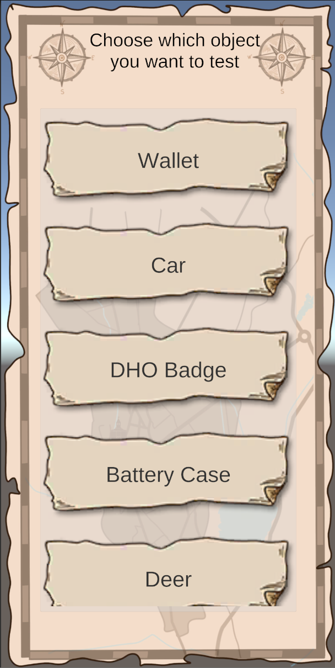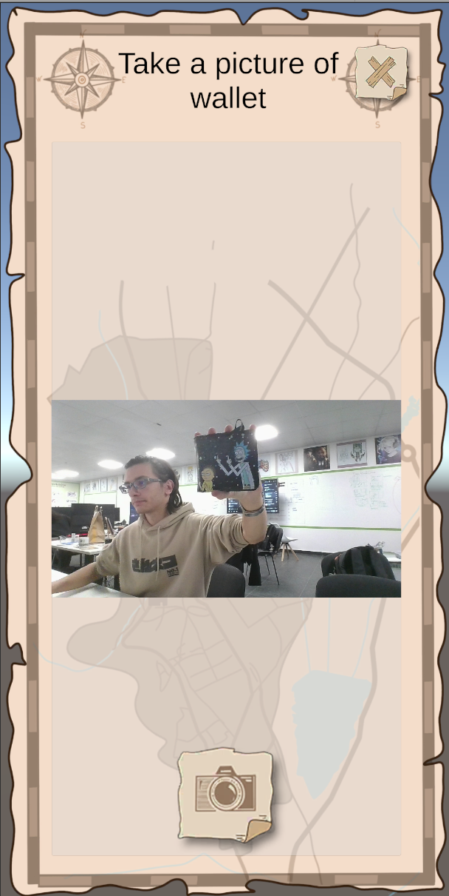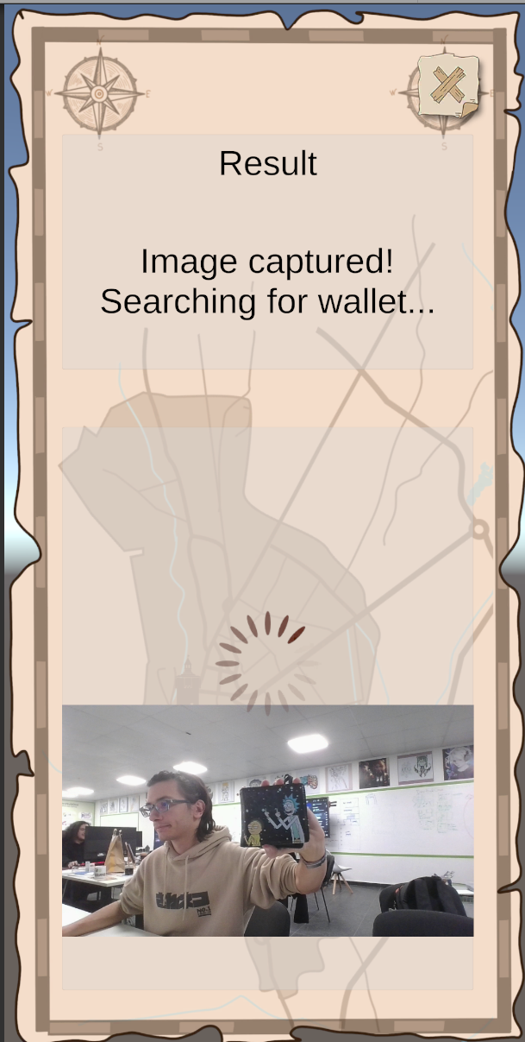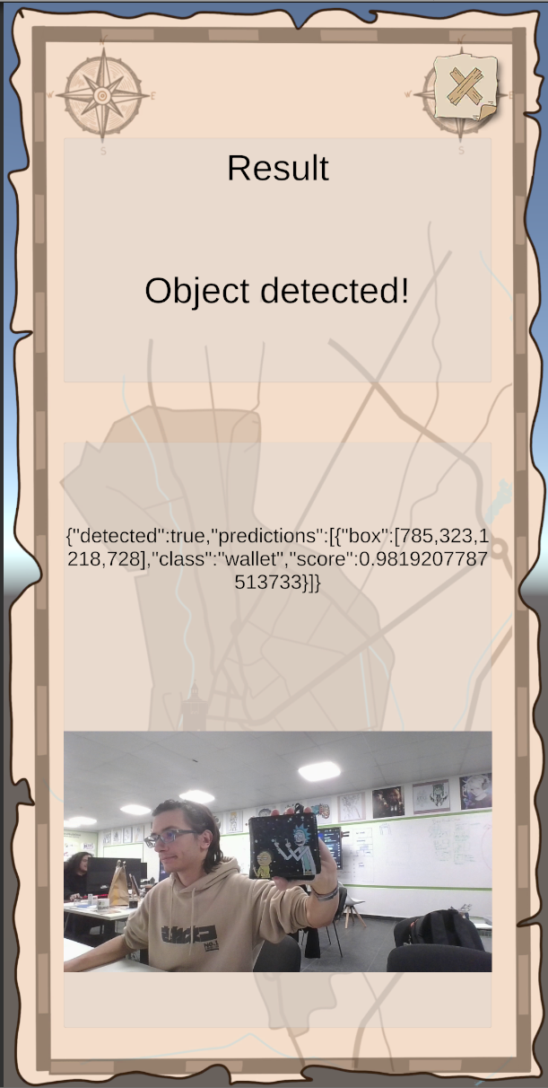
Image 1: Flow of the mobile application

- Server: The server handles model uploading and predictions..
  - /predict: The endpoint has the following parameters.
    - file: The image file which will be predicted.
    - target_class: The object class that has to be recognized.
    - threshold: The threshold of the prediction.
  - /admin: Endpoint to upload a model
    - file: The pre-trained model, which will be running on the server.
- Training: The training is done locally. To setup the training you need the following:
  - Install dependencies: All the dependencies are contained in the requirements.txt or you can run the following commands:
    - py -3.10 -m venv myvenv
    - myvenv\Scripts\activate
    - pip install torch torchvision torchaudio --index-url https://download.pytorch.org/whl/cu121
    - python.exe -m pip install --upgrade pip
    - pip install pycocotools
    - pip install jupyter notebook
  - Install and Setup CUDA: The version I am using is CUDA 12.1.
  - Run the Jupyter notebook:
    - Run the command:
      - jupyter notebook
  - Extract the photos
    - You can extract the photos from the ”photos.zip” archive. The photos there are already labeled. The file can be accessed at:
      - https://drive.google.com/file/d/1ZY_WbA-Fd4qw5YFBzw4P0LlLCNWVl5VE/view?usp=sharing
  - Open and run the Jupyter notebook
    - Open the “train_FasterRCNN.ipynb” notebook and run the cells inside.
    - The last three cells serve the following purposes:
      - Cell 9: Testing single images from trained model.
      - Cell 10: Testing model with camera input.
      - Cell 11: Evaluates the model on the test data_loader. For each image:
        - Ground-truth boxes are converted from COCO [x, y, width, height] to [x_min, y_min, x_max, y_max].
        - Predictions with scores lower than score_threshold are ignored.
        - A simple greedy matching is performed using the IoU threshold.
      - The function prints overall precision, recall, and F1 score.
- Image Labeling:
  - The images are labeled one by one using the VGG Image Annotator (VIA) 2.0.12: Open-source software based entirely on HTML for labeling images.
  - The labeling tool is provided in the “/labeling” folder under the name “via.html”.
  - The folder “via_projects” contains the project files for labeling each object.
  - The following attributes were used:
    - Attribute Name: obj_classes
    - Type: dropdown
    - Values: (id, description)
      - 1, wallet
      - 2, car
      - 3, dho_badge
      - 4, battery_case
      - 5, deer
      - 6, skull
      - 7, background
  - After that on each image a bounding box is drawn and a class is assigned.
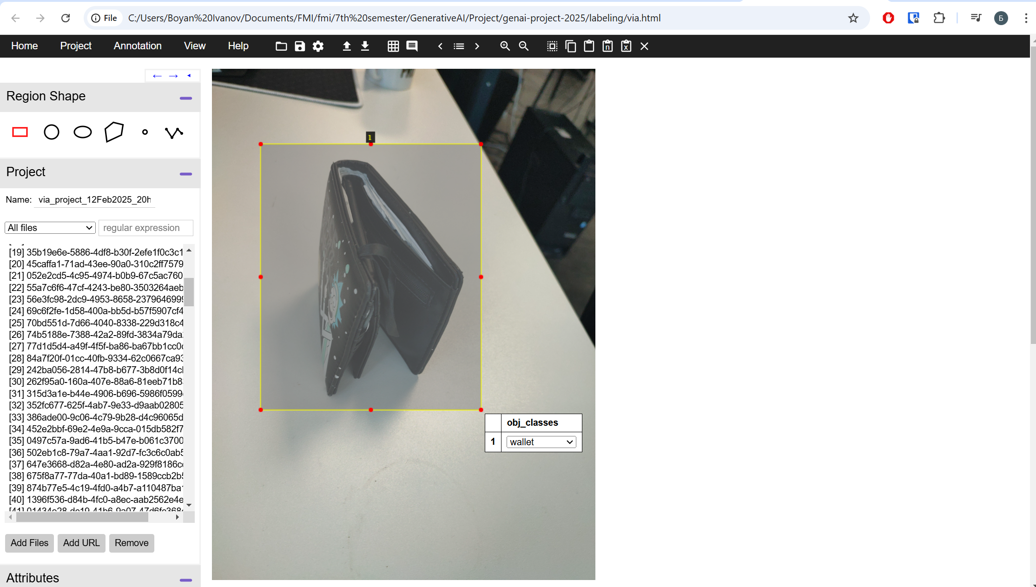
Image 2: Labeling software demonstration

- 3D Scanning
  - To be able to generate synthetic data, a realistic 3D model is required. The easiest and most effective way to scan an existing object is with a mobile application
  - The mobile application used for this project is PolyCam. This application can be downloaded from Google Play and App Store and has instructions for setup and use.
  - The models are then exported as GLB format to be used in the synthetic data generation.
  - Note: I have found that the pictures from the 3D scan can be exported and used in the training of the model
- Synthetic Data generation:
  - After many hours of research, I have found that the generation tools on the internet are either too complicated (Unity Perception) or depreciated (Nvidia Omniverse Replicator). Also they don’t support the COCO JSON format, which I have chosen to use.
  - Instead of them I decided to make a custom tool in unity to generate the synthetic data that I need.
  - The tool is provided in the “generation_and_mobile_project.unitypackage” at the following link:
    - https://drive.google.com/file/d/1NyGZJlZZl8DqWJKnAy7f_KxRXeZk8rzK/view?usp=sharing
  - The object is placed in the scene in front of the camera
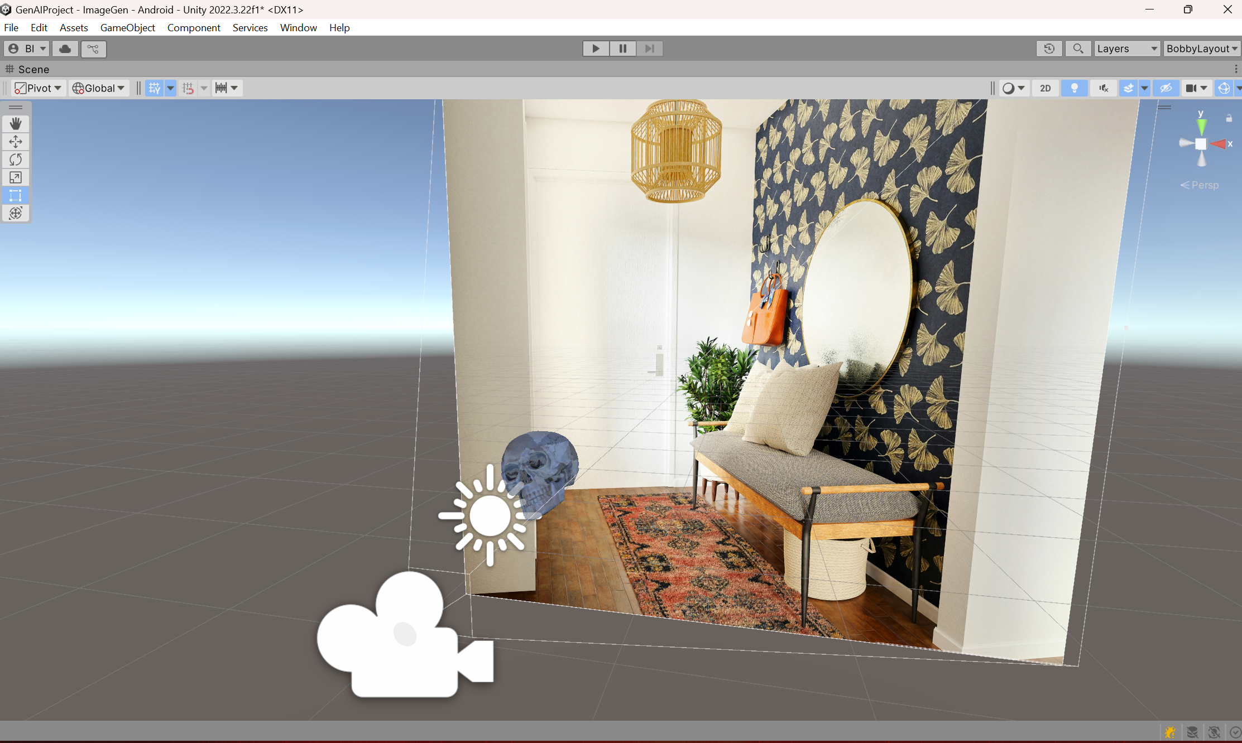
Image 3: Synthetic data generation tool demonstration

  - The object is assigned with the “Main Model Manager” component and it’s settings can be modified
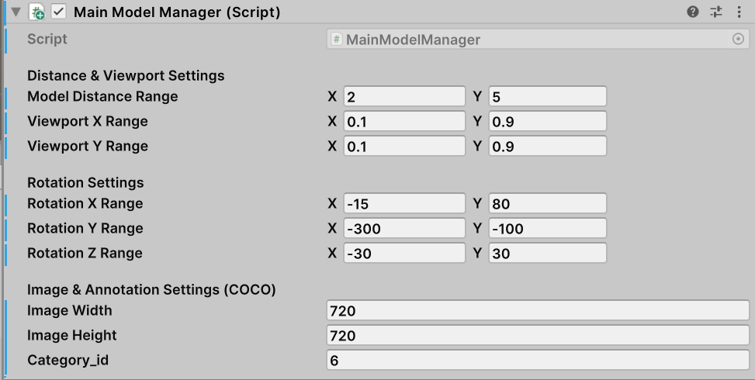
Image 4: “Main Model Manager” component

  - The backgrounds are controlled by the Background changer
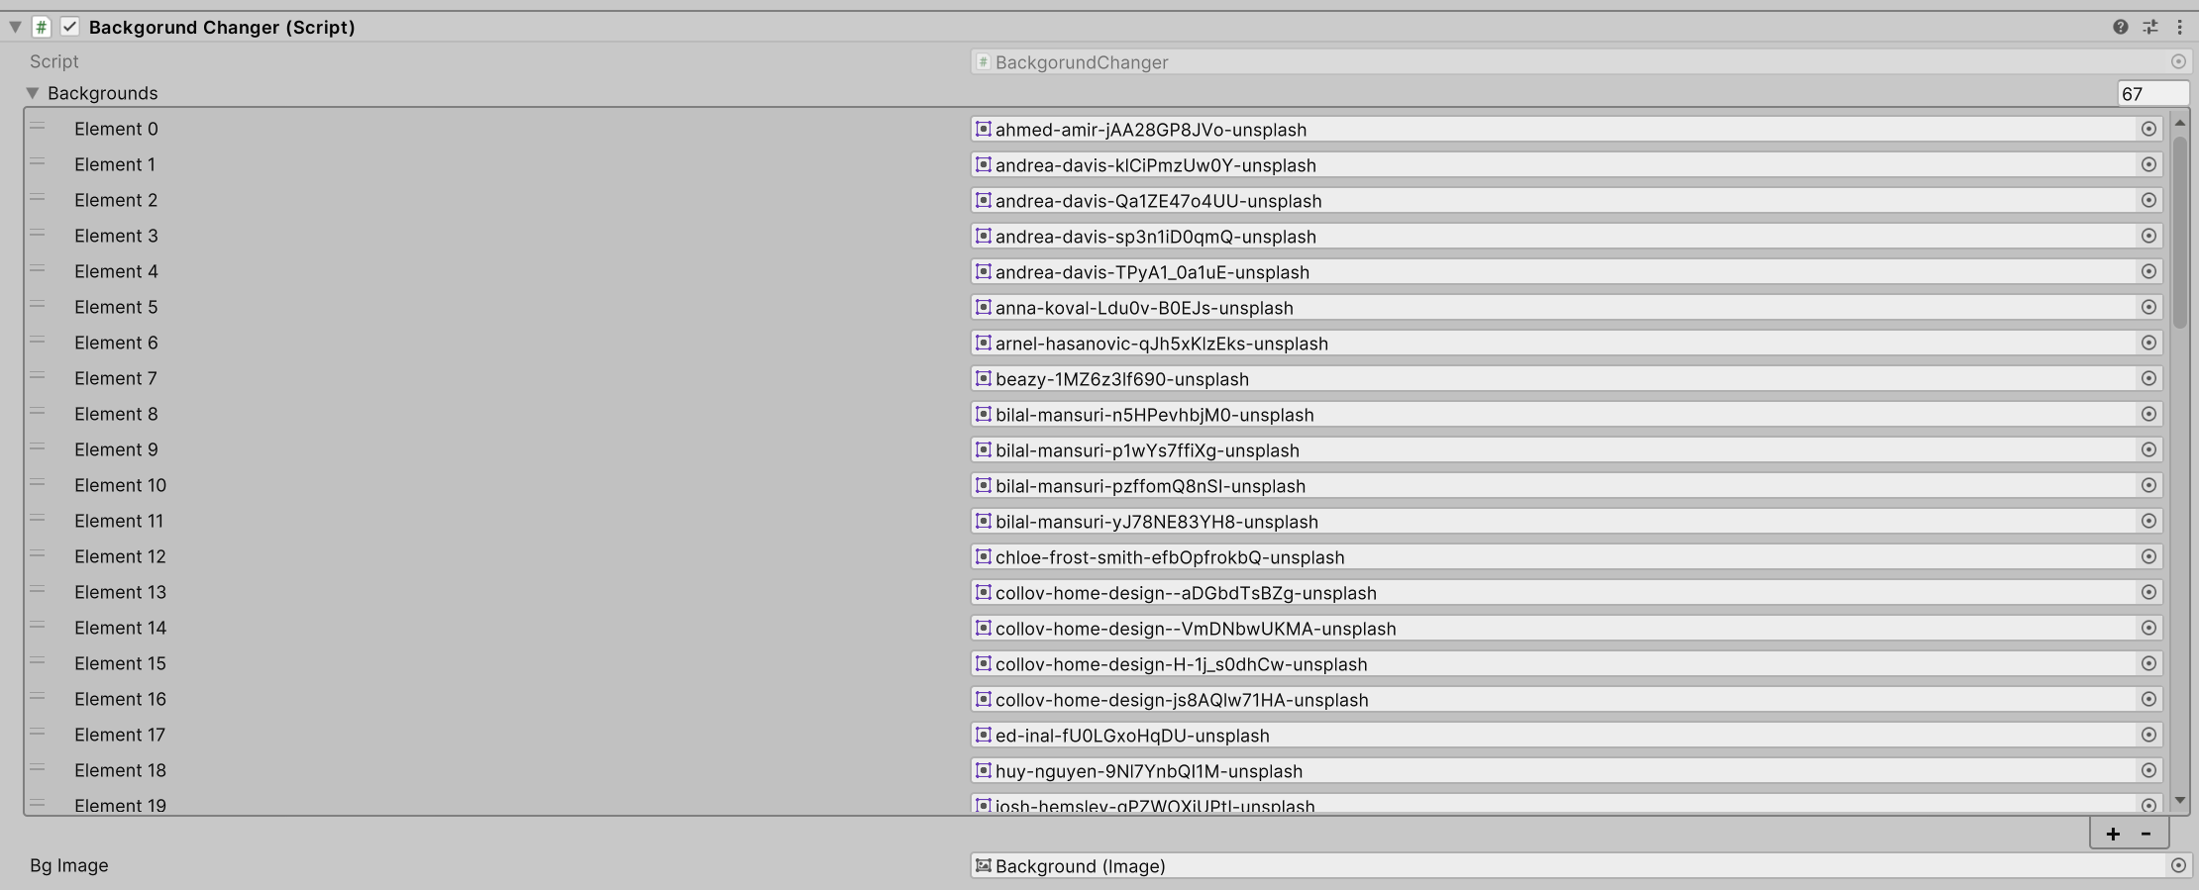
Image 4: “Background changer” component

  - The generation of images is controlled by the “Image Generator” component
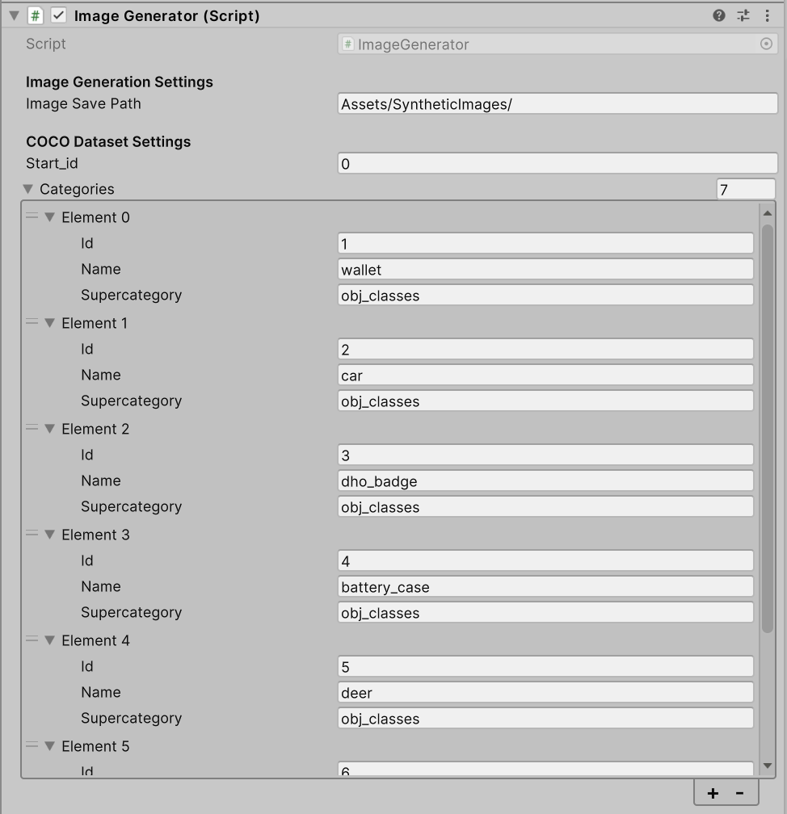
Image 5: “Image Generator” component

  - After the scenes is Played the following keys are used:
    - Enter: Accept an image and generate the next one
    - Space: Reject an image and generate the next one
    - E: Export the annotations file
  - The files are saved in the folder, that was assigned in the “Image Generator” component. (e.g “Assets/SyntheticImages”)

7. Model Training Process for Faster R-CNN with ResNet-50 Backbone
Model Selection
- Architecture:
  - Faster R-CNN with ResNet-50 as the backbone.
- Pre-trained Model:
  - Uses a pre-trained Faster R-CNN model with Feature Pyramid Networks (FPN) on COCO dataset.
- Modifications:
  - The final classification head is replaced with a custom FastRCNNPredictor to match the number of classes in the dataset.
  - Number of classes: 7 (1 background + 6 object classes).

Dataset Preparation
- Annotation Format: COCO JSON format.
- Data Loading:
  - Images are loaded from multiple folders inside photos/, each containing an annotations/ subfolder.
  - Annotations define bounding boxes in COCO format [x, y, width, height].
- Data Augmentation:
  - Minimal, only conversion to tensor.
- Splitting Strategy:
  - Train/Test Split: 80% training, 20% testing.
  - Handling Empty Datasets:
    - Any dataset folder without valid images or annotations is skipped.

Training Configuration
- Hardware:
  - Device: GPU (CUDA 12.1) if available, otherwise CPU.
  - Batch Size: 4
- Optimization:
  - Optimizer: Stochastic Gradient Descent (SGD).
  - Learning Rate: 0.005
  - Momentum: 0.9
  - Weight Decay: 0.0005
- Learning Rate Scheduler:
  - Scheduler: StepLR
  - Step Size: 3 epochs
  - Gamma: 0.1 (reduces learning rate by a factor of 10 every 3 epochs).
- Training Epochs:
  - Training continues indefinitely until manually stopped.
  - Model is saved every 5 epochs.
  - Model is saved with the filename fasterrcnn_resnet50_epoch_{epoch}.pth.

Training Procedure
- Data Preparation:
  - Load images and annotations.
  - Convert bounding boxes from [x, y, width, height] to [x_min, y_min, x_max, y_max].
  - Filter out invalid bounding boxes (width or height ≤ 0).
- Forward Pass:
  - Input images and annotations into the Faster R-CNN model.
  - Compute losses (classification loss, box regression loss, RPN objectness loss, RPN box loss).
- Backpropagation & Optimization:
  - Compute the total loss.
  - Perform backpropagation and update model parameters using SGD.
- Learning Rate Adjustment:
  - Reduce learning rate after every 3 epochs.
- Model Checkpointing:
  - Save model weights every 5 epochs.
  - If training is interrupted, save the last model checkpoint.

Evaluation Metrics
- Bounding Box Evaluation Strategy:
  - Ground truth boxes are compared to model predictions.
  - Bounding boxes are matched using Intersection over Union (IoU).
  - IoU Threshold: 0.5
  - Predictions below a score threshold of 0.5 are discarded.
- Performance Metrics:
  - Precision: Measures true positive predictions out of all predicted objects.
  - Recall: Measures how many ground-truth objects were correctly identified.
  - F1 Score: Harmonic mean of precision and recall.
Post-Training Usage
- Model Deployment:
  - The trained model is loaded for inference using torch.load.
  - The model is evaluated using test images or real-time video feed.
  - Bounding boxes and confidence scores are drawn on images for visualization.

Challenges & Considerations
- Overfitting: Limited dataset may cause model to memorize training samples.
- Imbalance Handling: Some classes may be underrepresented, requiring more data augmentation.
- Computation Cost: Faster R-CNN is computationally expensive; requires GPU for efficient training.

Key Hyperparameters & Their Impact
Parameter | Value | Impact
Backbone | ResNet-50 FPN | Feature extraction efficiency
Pretrained Weights | COCO | Faster convergence
Batch Size | 4 | Affects memory and training stability
Learning Rate | 0.005 | Affects convergence speed
Momentum | 0.9 | Helps smooth updates
Weight Decay | 0.0005 | Prevents overfitting
Step Size | 3 epochs | Adjusts learning rate every 3 epochs
Gamma | 0.1 | Reduces learning rate factor
IoU Threshold | 0.5 | Determines bounding box match quality
Score Threshold | 0.5 | Filters low-confidence predictions

8. Training and Testing Data
- For the training and testing data the following objects and methods were used:
  - Wallet
    - Images: 195 items
    - Results: Very accurate front and back recognition. Below average accuracy on the sides and bottom.
  - Car
    - Images: 70 items
    - Results: Accurate front and back, but very inaccurate sides and top. Collectively below average accuracy of recognition
  - Dho_badge
    - Images: 60 items
    - Synthetic images: 59 items
    - Original Model used. (Not scanned, but custom modeled). The object is 3D printed from this model.
    - Results: Very accurate front and side recognition
  - Battery_case
    - Images: 213 items
    - Synthetic images: 90 items
    - Original Model used. (Not scanned, but custom modeled). The object is 3D printed from this model.
    - Results: Medium accuracy, despite the absence of details and colors in the object. The object is black and is sometimes recognized even in black backgrounds.
  - Deer
    - Images: 144 items
    - Synthetic images: 53 items
    - 3D Scanned Model
    - Results: Medium accuracy, despite the 3D scan of the model being low quality.
  - Skull
    - Images: 33 items
    - Synthetic images: 138 items
    - 3D Scanned Model
    - Results: The highest accuracy of all, from all sides of the object.
9. Results and conclusions
The model was trained for 128 epochs with the losses provided in the “results_table.xlsx”. The evaluation results of the model are the following:
Evaluation results on test set:
Precision | 0.9795
Recall: | 0.9845
F1 Score: | 0.982

These results were achieved after the “Epoch 5” but further improvements were not made.
As a conclusion, I can say that I am very impressed with the results of the model. The model was able to achieve high accuracy of recognition with only 5 epochs of training which is not more than 30 minutes of training on my machine. The image taking, labeling and synthetic data generation are time consuming, but are reasonable for the results that are shown from the model. The data samples were chosen to test three training conditions:
- Images only
  - High amount of pictures
    - High accuracy
  - Low amount of pictures
    - Low accuracy
- Images + Original Models
  - Low amount of pictures, low amount of synthetic data
    - High accuracy
  - High amount of pictures, low amount of synthetic data
    - Medium accuracy (Note: Absence of details and colors in the object)
- Images + Synthetic Generated models
  - High amount of pictures, low amount of synthetic data
    - Medium accuracy
  - Low amount of pictures, high amount of synthetic data
    - High accuracy
For future improvements, more tests will be conducted to increase the accuracy of the model. Also the data generation process will be documented and streamlined for easier use. Lastly, currently the models have to be retrained every time a new object is added. A method for training on top of the previous model should be developed.
In conclusion, the project is usable in real-life business applications.

