# Introduction

# Data

We used composed daily zero coupon German Treasury bond prices with rolling 2, 5 and 10 year maturity from Bloomberg. Every day they picked most liquid bonds and on-the-run bonds and calculated the composite market price.

The time span is from January 1, 2006 to October 8, 2013. In total, we have 2027 daily data points.

The price evolution of the bonds can be found in the chart below.

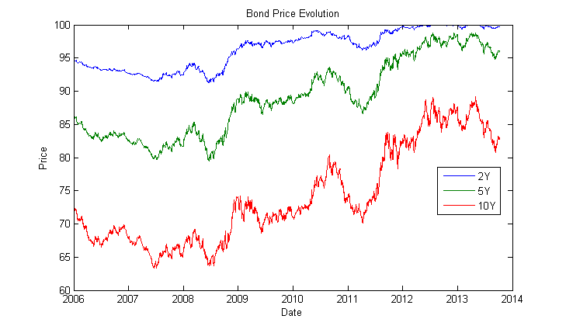

# Assumptions

In general, we assumed that the maturity of all the data in our sample is exactly 2, 5 and 10 years. For each of the models we assumed the individual SDE dynamics for the short rate and solutions for the bond prices. Even though all the models assumed constant parameters over time, we have performed the optimization every day in order to get a better understanding of how these parameters behave over time.

We assumed that the model parameters are *a*, *b*, *sigma* and *r(0)* for Vasicek and CIR and Beta0, Beta1, Beta2 and m for Nelson-Siegel model.

Even though the three bonds seem to be a small sample to perform the estimation, we found that optimal values of parameters remain quite stable over short period of time.

# Introduction to Models

The **Vasicek** model goes as follows:

$$dr=\left(b-ar\right)dt+σdW$$

In Vasicek Model, bond prices are given by:

$$p\left(t,T\right)=e^{A\left(t,T\right)-B\left(t,T\right)r\left(t\right)}$$

where:

$$\left\{\begin{aligned}B\left(t,T\right)=\frac{1}{a}\{1-e^{-a\left(T-t\right)}\} \\ A\left(t,T\right)=\frac{\left\{B\left(t,T\right)-T+t\right\}\left(ab-\frac{1}{2}σ^{2}\right)}{a^{2}}-\frac{σ^{2}B^{2}\left(t,T\right)}{4a}\end{aligned}\right.$$

The **CIR** model goes as follows:

$$dr=a\left(b-r\right)dt+σ\sqrt{r}dW$$

In CIR model, the term structure is given by:

$$F^{T}\left(t,r\right)=A_{0}\left(T-t\right)e^{-B\left(T-t\right)r}$$

where

$$\left\{\begin{aligned}B\left(x\right)=\frac{2(e^{γx}-1)}{\left(γ+a\right)\left(e^{γx}-1\right)+2γ} \\ A_{0}\left(x\right)={\left[\frac{2γe^{(a+γ)(\frac{x}{2})}}{\left(γ+a\right)\left(e^{γx}-1\right)+2γ}\right]}^{\frac{2ab}{σ^{2}}}\end{aligned}\right.$$

The **Nelson-Siegel** model proposes that the instantaneous forward curve can be modeled with the following:

$$f=β_{0}+β_{1}e^{\frac{-m}{τ}}+β_{2}e^{\frac{-m}{τ}}\frac{m}{τ}$$

This can be integrated to derive an equation for the zero curve:

$s= β_{0}+\left(β_{1}{+β_{2})\frac{m}{τ}(1-e}^{\frac{-m}{τ}}\right)-β_{2}e^{\frac{-m}{τ}}$

# Techniques

We used interior point algorithm to perform the optimization in order to minimize the sum of squared errors between theoretical and market bond prices. This is a build in Matlab function called *fmincon*. The boundaries for individual parameters (Vasicek and CIR) were set to [-0.1; -0.1; -0.1; -0.1], [0.4; 0.4; 0.4; 0.4]. We set the maximal number of iterations to 15,000; function and parameter tolerance to 1e-15 and maximal number of function evaluations to 1000. We believe that these values are reasonable enough to perform both fast and reliable parameter estimation.

# Results

In this section we provide the results of our project. We will look at the time evolution of different parameters for individual models.

First, we will look at the evolution of the short rate r(0). Note that as a benchmark we have used overnight interbank interest rate. As you can see from the chart below the models produced reasonable approximation to the benchmark rate. However, the short rate in Vasicek model becomes negative after some time.

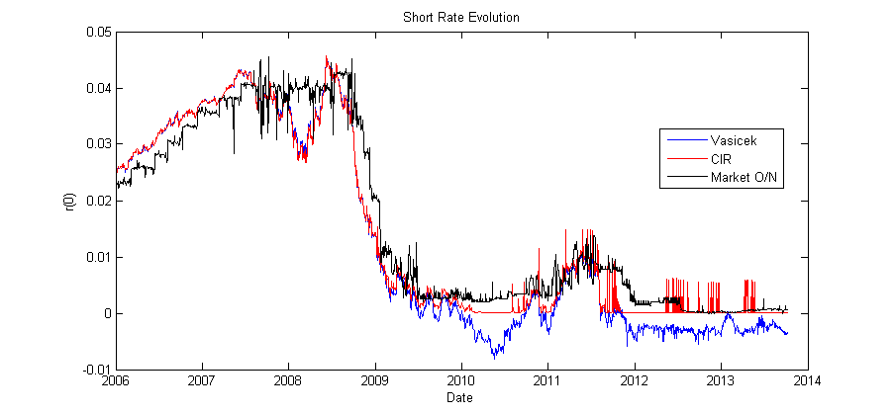

Next, we will look at the evolution of volatility in Vasicek and CIR model. Note, that in case of CIR model the volatility is expressed as Sigma*Sqrt(r(0)). Again, for the period 2006-2009 both models give us almost the same values. However, in period 2010-2013 they differ quite substantially.

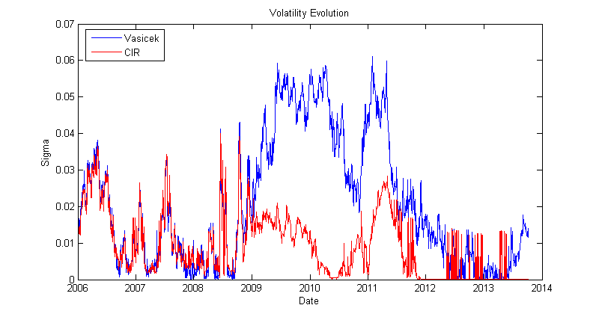

And lastly, we will look at the long term interest rate implied by the models. In case of Vasicek it is b/a and in case of CIR it is b. We noticed large fluctuations due to the extremely volatile markets over this time span and the models had obviously a hard time to approximate this value from the given bond data. Introduction of some smoothing function would help us to avoid huge spikes but it goes beyond the scope f this project.

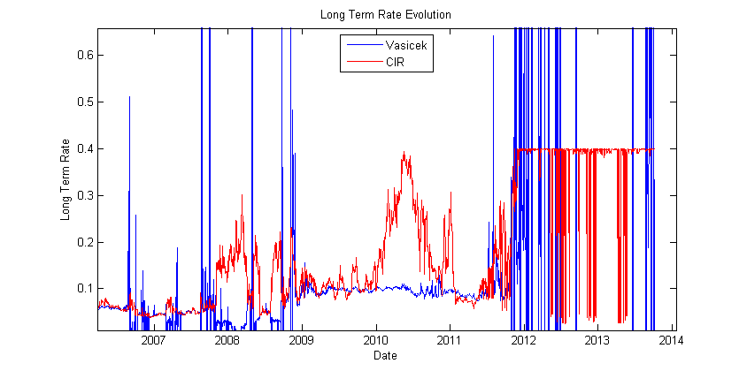

Now, we will look at the optimal coefficients of Nelson-Siegel model. We have encountered few issues during the optimization on certain days where the algorithm couldn’t find the optimal values.

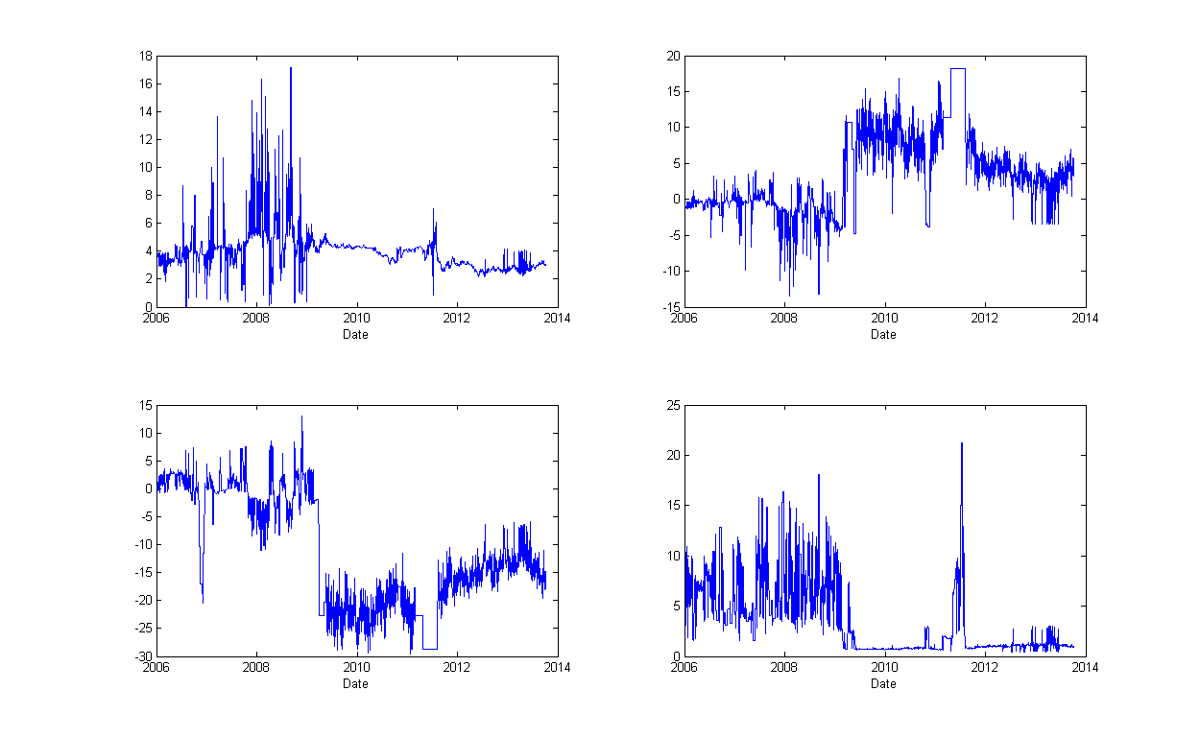

In the picture above we can see the evolution of Beta0, Beta1, Beta2 and m parameters over time.

Finally, we look at the mean squared error between theoretical bond prices and market bond prices. The average mean squared error was 1.4328e-07, 1.7660e-05 and 1.0980e-07 for Vasicek, CIR and Nelson-Siegel, respectively. The evolution of mean squared error over time:

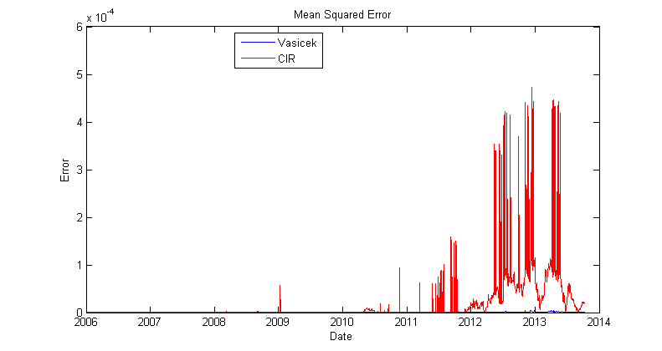

# Time Series Analysis

# Trading Strategy

Utilizing the data from our time series analysis, we tried to predict the next day prices and trade accordingly. We have found that there is not a profitable trading strategy in using the data. If we could find a profitable strategy, the market would discover our strategy and eliminate profits. The market makes it difficult to find any advantage and limits the time if an advantage is found.

# Conclusion