****

Vehicle Tracking and Fleet Monitoring Solutions

**User Manual - aQuila Track S101**

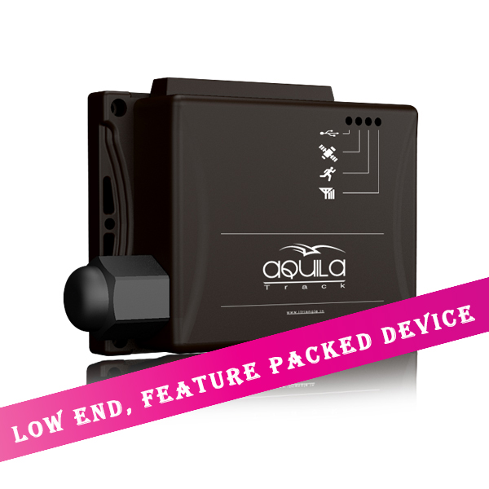



No. 3420, 1st Floor, Service Road, RPC Layout (West), Vijayanagar, Bangalore – 560040

Phone: +91-80-23180601 | Email: [customercare@itriangle.in](mailto:customercare@itriangle.in)

URL: [www.itriangle.in](http://www.itriangle.in) | Tracking: [www.aquilatrack.com](http://www.aquilatrack.com)

Foreword

Dear Customer,

Thank you for purchasing aQuiLaTM Track.

aQuiLaTM Track S101 is a compact, easy to install and highly reliable Vehicle Tracking and Fleet Management System that increases the efficiency, productivity and safety, through real-time & precise tracking of position and status of your vehicle.

aQuiLaTM Track S101 is developed using Global Positioning System (GPS), coupled with Google Maps and GSM Mobile technology to communicate real time information to the Web based highly user friendly online tracking application software

aQuiLaTM Track is made of high quality components and material to provide very high durability and efficiency to meet customer expectations and carries a warranty of 1 year as per the terms & conditions stated in the Warranty Policy provided in this book.

While iTriangle Infotech takes every care in making the product trouble free, in the unlikely event of failure of the product, iTriangle Infotech ensures the rectification of problem within a shortest possible time keeping the business interest of its customers.

Kindly refer to different sections of this manual for more details on our Service Policy.

Thanking you once again and assuring you of our best services at all times,

Vadiraj S Katti

Managing Director

Copyright Notice:

The information disclosed herein is the exclusive property of iTriangle Infotech Pvt. Ltd and no part of this document can be reproduced or transmitted in any form or by any means including electronic storage, reproduction, and/or execution without the prior written permission from iTriangle Infotech Pvt. Ltd. The information contained in this document is subject to change without notice and should not be construed as a commitment by iTriangle Infotech Pvt. Ltd unless such commitment is expressly given in a separate document

iTriangle InfoTech Pvt. Ltd © Copyright notice and statement that “No part of this document may be reproduced without the prior written consent of iTriangle InfoTech Pvt. Ltd”

Disclaimer and Limitation of Liability

**iTriangle Infotech Pvt. Ltd** takes no responsibility for any damage or loss resulting from the use of its products or services and will not be liable to compensate any kind of losses or claims by any parties, which may arise through the use of products or services offered by iTriangle Infotech Pvt. Ltd

While the information contained herein is assumed to be accurate, iTriangle InfoTech Pvt. Ltd assumes no responsibility for any errors or omissions.

**Contents**

* 1. [About this document 6](#_Toc381470513)
  2. [Symbols Used in this Manual 6](#_Toc381470514)
  3. [aQuila S101 device 7](#_Toc381470515)
  4. [Installation 7](#_Toc381470516)
  5. [Section 1: Introduction to aQuila Track S101 8](#_Toc381470517)
  6. [About aQuila Track S101 8](#_Toc381470518)
  7. [How aQuila Track Hardware works? 8](#_Toc381470519)
  8. [aQuila Track Working Diagram 10](#_Toc381470520)
  9. [Device parts 11](#_Toc381470521)
  10. [Section 2: aQuila Track S101 Device Installation 12](#_Toc381470522)
  11. [Tools required for installation 13](#_Toc381470523)
  12. [Consumable material required for installation 14](#_Toc381470524)
  13. [Installation Steps 15](#_Toc381470525)
  14. [POWER CONNECTION – COMMERCIAL VEHICLES 16](#_Toc381470526)
  15. [POWER CONNECTION – PERSONAL 4 WHEELERS 16](#_Toc381470527)
  16. [CONNECTION TO IGNITION OUTPUT IN THE VEHICLE 17](#_Toc381470528)
  17. [FUEL WIRE CONNECTION AND CALIBRATION 18](#_Toc381470529)
  18. [PICTURE – DEVICE PLACEMENT IN CAR 21](#_Toc381470530)
  19. [PICTURE – DEVICE PLACEMENT IN TRUCK 22](#_Toc381470531)
  20. [PICTURE – DEVICE PLACEMENT IN 2 WHEELER 23](#_Toc381470532)
  21. [How to insert SIM card in to the device 24](#_Toc381470533)
  22. [Troubleshooting 25](#_Toc381470534)
  23. [Problem: Device does not track 26](#_Toc381470535)
  24. [Warranty Policy 27](#_Toc381470536)
  25. [Contact Us: 30](#_Toc381470537)

# About this document

This manual is designed to guide you through installation of aQuiLaTM Track S101device and trouble shooting of problems step-by-step. The manual is divided in to ***two sections***. **Section-1** covers the various features of **S101** and **Section-2** covers installation and trouble shooting.

iTriangle Infotech recommends users to read the manual completely and carefully before using aQuiLaTM Track S101.

# Symbols Used in this Manual

In this manual, we apply easily understood language and many drawings in order to simplify the installation procedure.

|  |  |
| --- | --- |
|  | Warning indicates that ignoring the warning may cause permanent damage to the device or injury to the person. |
|  | Tip, indicates some information, which may be useful and effective while installing or trouble shooting the device. Experienced or qualified person can skip this information. |
| bs05632 | Note gives additional information relating to the topic that is being discussed. |

# aQuila S101 device

# Installation

# Section 1: Introduction to aQuilaTrack S101

## About aQuila TrackS101

aQuila TrackS101 is a complete Vehicle Tracking and Fleet Management Hardware. It is a robust, compact and high performance GPS / GSM based electronic device designed to be fitted in any vehicle. It records the vehicle location and events data at regular intervals, which is configurable to meet the user requirement and transmits the data to central server to make it user understandable data.

aQuila Track helps user to get data on different events of the vehicle, while on move as well as when stationary. It gives vital information like ***vehicle location, speed, date, time, distance*** and ***usage of selected in-vehicle gadgets*** and equipment like, Engine usage and Fuel. aQuilaTrack S101 comes with ***2 Digital I/Os*** that can be configured to provide alerts on any 2 of the events like Door Open/Close, Vehicle AC On/Off, Emergency Button Press, etc. aQuila Track S101 can be configured to send ***Alerts for Stoppage*** and ***Over Speed*** of the vehicle.

## How aQuila Track Hardware works?

aQuilaTrack S101 is a Vehicle Tracking, Fleet Management and Remote Data Acquisition hardware designed to suit every requirement. It comes in a compact, portable and rugged whether proof enclosure. It comprises of world class GPS and GSM modules. Where, GPS records the ***location, date, time, speed*** and ***distance*** at regular intervals and the Event Management Module records ***different events*** of the vehicle. GSM transmits the GPS and Event data to central server at pre-configured intervals. Every aQuila Track device requires a SIM card of a GSM mobile operator to send the data to the central server and for voice communication. The data from device to the central server is sent in the form of GPRS Packets at every 2 minutes

aQuila Track device can be configured to record the data at an interval as low as 30 seconds and transmit the data to the central server at a minimum interval of 1 minute. That means, the latest vehicle location gets updated once every 1 minute.

|  |
| --- |
| Reducing tracking interval increased the GPRS data usage and expenses. iTriangle will not be liable to pay any compensation and/or penalty for the increased expenses due to increase in GPRS usage |

aQuila TrackS101uses in-vehicle battery power source in the range of 9 – 32 V and works only on DC Power. It is built to take care of Spikes and Surges. In case of Spikes in the device power line, the safety fuse will blow off to protect the device. It has a built-in power management to reduce power consumption when the device is idle and/or vehicle is stationary.

|  |
| --- |
| bs05632  If the GSM / GPRS network is not available for transmission of data, the device will store the data in the memory and transmit to central server once it comes to GSM / GPRS coverage area |

## aQuila Track Working Diagram

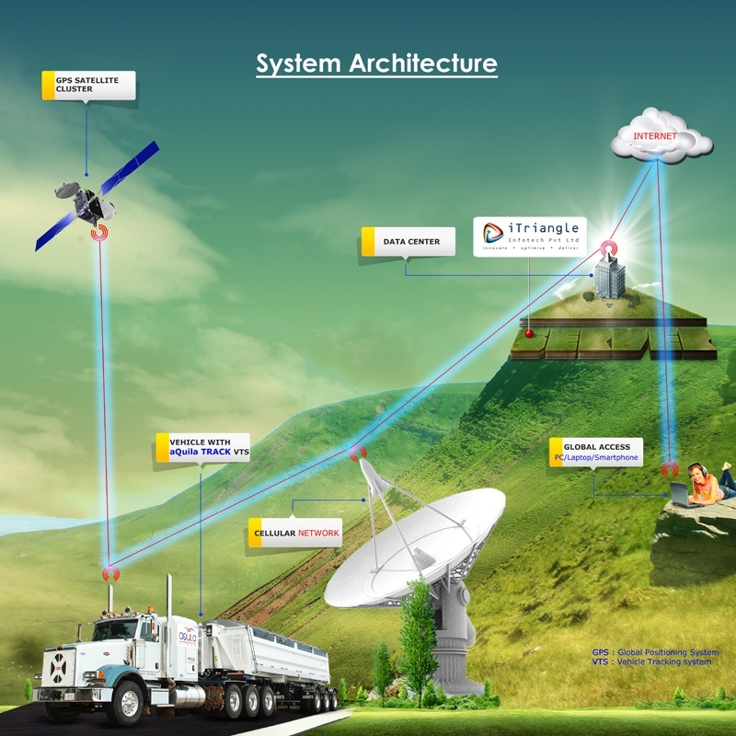

## Device parts

**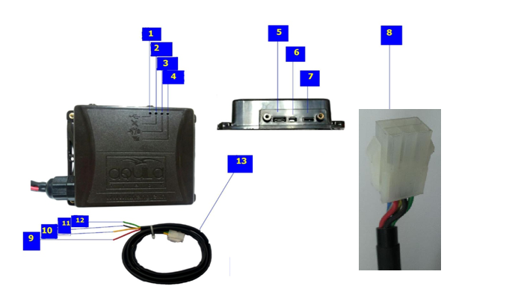**

1. USB Indicator
2. GPS indicator
3. Processor Indicator
4. GSM indicator
5. USB Port
6. RESET switch
7. On / Off Switch
8. Connectors
9. Red – Vehicle Battery +ve
10. Yellow – Fuel
11. Black – Ground
12. Green – Ignition
13. Wiring kit

# 

# Section 2: aQuila Track S101

# Device Installation

|  |
| --- |
| It is highly recommended that Installation of aQuila Track S101 and its accessories must be done by a trained technician only. All the material mentioned in this section are for indication purpose only and iTriangle Infotech Put Ltd will not be responsible for any problem and/or damage to person and/or material caused during / after installation |

|  |  |
| --- | --- |
| C:\Users\R K Sriranga\Desktop\handle_with_care.png  Handle the device with care and do not place any heavyweights on the device. There is a Li-ion Battery inside. Application of Power, Temperature and Humidity beyond the specified range can damage device and void Warranty | |
| C:\Users\R K Sriranga\Desktop\protect-from-water-md.png  It is recommended that the aQuila track device not be installed in the places prone to water and rain. Remove aQuila device during servicing to avoid accidental water splash and high voltages |

## Tools required for installation

|  |  |
| --- | --- |
|  | Portable drilling machine for making holes (in case necessary to mount the device) |
| **F:\Vighnesh\Installation Training Materials\Vehicle Tool Kit.jpg**F:\Vighnesh\Installation Training Materials\Screw driver set.jpg | A standard screwdriver set comprising cross/flat/Phillips screwdrivers of small/medium sizes and a poker. Choosing one with a magnetic head would be better. |
| F:\Vighnesh\Installation Training Materials\Nose plier.jpgF:\Vighnesh\Installation Training Materials\cutting Plyer.jpg | Pliers can be used as an auxiliary tool to pull out the power connectors, hold wires, etc |
|  | Forceps can be used to pick up tiny screws and/or SIM card |
|  | Rubber gloves can prevent you from being incised and suffering the static charge. |
| F:\Vighnesh\Installation Training Materials\wire-stripper-big.jpg | Wire stripper for stripping cables/wires while installing |
|  | Torch light for low light / night environments |
|  | Cutters for cutting cables/wires while installing |
|  | Extra screws of all sizes required in case of accidental misplacement of originally supplied screws |
|  | A hammer for better punch |
| F:\Vighnesh\Installation Training Materials\3-1-2-Digital-Multimeter-DT830A-.jpg | Multimeter for measuring voltage and current. |
|  | Micro USB Cable for uploading Configuration, Firmware, etc |
| F:\Vighnesh\Installation Training Materials\GlueGun.jpg | Glue Gun to seal any connectors |

## 

## Consumable material required for installation

|  |  |
| --- | --- |
| Cable ties | Cable ties for tying the wires together |
| cable tie mount | Self-adhesive cable tie mounts to hold the wire harness / wires in a line. |
| Insulation tape | Insulation tape to cover the electrical joints and protect open wires from short circuit |
| fefikwiknew | Fevi kwik – Instant adhesive for fixing anything instantly |
| F:\Vighnesh\Installation Training Materials\double-sided-tapes.jpg | Double Sided adhesive tape to fix the device firmly under the dash board |
| C:\Users\R K Sriranga\Desktop\battery lugs.jpg | Battery Lug Terminals to connect the power cables firmly. |
| C:\Users\R K Sriranga\AppData\Local\Microsoft\Windows\Temporary Internet Files\Content.Word\PVC_Corrugated_Pipe.jpg | Corrugated (Flexible) PVC Conduit Pipe for protection to Cables / wires |

## Installation Steps

1. Open the Box and check for contents as specified on the box
2. Take the SIM card that you have purchased from a Mobile Operator
3. Insert SIM card in any Mobile Phone to check, SIM card for Registration, Activation and GPRS connectivity
4. If all parameters are found working, insert the SIM card in the holder as shown in the picture below in this document
5. Switch ON internal Device Battery
6. Connect device to vehicle battery / continuous power source in the vehicle as explained below in this document
7. Keep the vehicle in an Open area
8. **Check for Processor Status**
   1. A healthy Processor is indicated by an LED (RED) on the front panel of the device that will blink at every 4 seconds
   2. If the Processor is not working or has a problem, this LED will be steadily ON
9. **Check for GPS Fix:**
   1. The GPS LED (Blue Color) does not blink till the device gets the good GPS Fix
   2. Wait for 2-3 minutes for the first time to get GPS Fix
   3. Once the Device gets good GPS Fix, the GPS LED starts to blink at every second
10. **Check for GSM / GPRS Connectivity:**
    1. Wait for 2-3 minutes after connecting the device to the vehicle battery to get the SIM registered to the Operator Network
    2. While the device is getting registered to the Mobile Operator network, the GSM LED (Green) will blink frequently
    3. Once the Device is connected to the GSM service provider network the GSM LED (Green) will start to blink at every 4 seconds.
11. 5-10 minutes after connecting the device to the vehicle battery, all the 3 LEDs start to blink indicating that the device is communicating with the configured server

|  |  |
| --- | --- |
| POWER CONNECTION – COMMERCIAL VEHICLES **MINI TRUCKS, TRUCKS, BUSES, MINI BUSES, TEMPO / FORCE TRAVELLER, GOODS AUTO, APE, ACE, AND ALL TYPES OF GOODS VEHICLES** | |
| 01 | Remove the ignition key |
| 02 | Run RED (+ve) and BLCK (-ve) wires from battery till the location of device placement. Ensure that the wiring is done FIRMLY and NEATLY without any hanging or sagging of wires. Use Self-adhesive Cable Tie Mounts and cable ties to do the wiring. |
| 03 | Connect RED wire of Aquila Device Power Cable (Long Cable) to the +ve (RED) cable drawn from the vehicle battery and ensure that the connection is firm. |
| 04 | Connect the BLACK wire of the Aquila Device Power Cable (Long Cable) to the –ve (BLACK) wire drawn from the vehicle battery and ensure that the connection is firm. |
| 05 | Check if the Dash Board is made of Metal or Plastic / Fiber. |
| 06 | If the Dash Board is made of Metal, INSTALL THE DEVICE OUTSIDE THE DASH BOARD ONLY and Use IP box to ensure that the connectors and device are secured from vulnerabilities. |
| 07 | If the Dash Board is made of Fiber OR Plastic, DEVICE CAN BE INSTALLED INSIDE THE DASH BOAD and IP Box is not required. |

|  |  |
| --- | --- |
| POWER CONNECTION – PERSONAL 4 WHEELERS | |
| 01 | Remove the ignition key |
| 02 | Identify the power line +ve cable coming from the battery to the ignition switch by measuring the voltage between each of the wire coming in to the ignition switch assembly. |
| 03 | See if the metal conductor in the connector or wire connection point at the ignition switch is accessible, else remove the skin from each of the wire |
| 04 | Firmly hold the +ve (RED) probe of the multimeter to the wire conductor and –ve (BLACK) probe of the multimeter to the GROUND point (- ve terminal of the vehicle battery OR any screw / bolt directly connected to metal body of the vehicle) |
| 05 | Voltage at the +ve wire of the (incoming supply line) ignition should be matching to the battery voltage of the vehicle |
| 06 | Check the Voltage at the Ignition input point at   * Vehicle OFF condition * Vehicle Ignition ON Condition * Vehicle Engine start condition * Maximum Acceleration at Neutral / stationary   In any condition, the voltage should not exceed 32V. Please do not install the device in the vehicle if the voltage is beyond 32V |
| 07 | Connect RED wire of Aquila Device Power Cable (Long Cable) to the +ve (RED) cable at the Vehicle Ignition input by removing a small portion of the PVC skin at least 2 inch away from the ignition switch (if already removed the skin for testing the voltage, use the same) |
| 08 | Connect the BLACK wire of the Aquila Device Power Cable (Long Cable) to the GROUND by connecting the wire to the –ve terminal of the vehicle battery OR to the point where GROUND wire of any of the other accessories of the vehicle is connected and ensure that the connection is VERY FIRM / TIGHT |
| 09 | For all vehicles other than Cars and SUVs, it is highly recommended to connect the +ve and –ve of the device directly to the vehicle battery |

|  |  |
| --- | --- |
| CONNECTION TO IGNITION OUTPUT IN THE VEHICLE | |
| 01 | Take each wire other than the +ve wire connecting the ignition switch assembly and look for a metal conductor / connector pin of the wire at the switch end, if not found, remove a small portion of the PVC skin at least 2 inch away from the Switch end |
| 02 | **KEEP THE IGNITION SWITCH IN OFF POSITION AND FOLLOW THE STEPS BELOW:** |
| 03 | Firmly hold the RED probe of the Multimeter at the skinned portion of each of the wire one-by-one and BLACK probe of the Multimeter to the GROUND (- ve terminal of the vehicle battery OR any screw / bolt directly connected to metal body of the vehicle) and measure the Voltage. The Voltage MUST BE ZERO when the Ignition is in OFF position |
| 04 | **KEEP THE IGNITION SWITCH IN ACCESSORIES POSITION AND FOLLOW THE STEPS BELOW:** |
| 05 | Firmly hold the RED probe of the Multimeter at the skinned portion of each of the wire one-by-one and BLACK probe of the Multimeter to the GROUND (- ve terminal of the vehicle battery OR any screw / bolt directly connected to metal body of the vehicle) and measure the Voltage. The Voltage MUST BE EQUAL TO THE BATTERY VOLTAGE when the Ignition is in Accessories position At least 1 wire shows ZERO voltage when the ignition is in Accessories position |
| 06 | **KEEP THE IGNITION SWITCH IN ON POSITION AND FOLLOW THE STEPS BELOW:** |
| 07 | Take the wire / wires that showed ZERO volts when the Ignition at Accessories position, firmly hold the RED probe of the Multimeter at the skinned portion of the wire and BLACK probe of the Multimeter to the GROUND (- ve terminal of the vehicle battery OR any screw / bolt directly connected to metal body of the vehicle) and measure the Voltage. The Voltage MUST BE EQUAL TO THE BATTERY VOLTAGE when the Ignition is in ON position. Connect the GREEN wire of Aquila Wire Cable (Long cable) to this wire that showed ZERO when the ignition switch is at Accessories and Showed BATTERY VOLTAGE when the ignition is at ON position |

|  |  |
| --- | --- |
| FUEL WIRE CONNECTION AND CALIBRATION | |
| 01 | Check for Vehicle Electrical System (Battery Voltage) in all the vehicles. i.e. 12V system or 24V system |
| 02 | Calibration must be done separately for each vehicle if the Vehicle Electrical System is different. |
| 03 | Check for type / shape of the fuel tank in the vehicle. Calibration must be done separately for each type of tank even if the Vehicle Electrical system is identical / same |
| 04 | In case of multiple vehicles with the same electrical system and type of fuel tank, only one vehicle in the lot may be calibrated  Identify the right fuel power wire: |
| 05 | Switch ON the ignition |
| 06 | Check the wires at the Fuel Tank side and measure the voltage for anything between 0.1 and 5V (if tank is accessible) |
| 07 | If fuel tank is not accessible (in some cars) check each wire in the connector coming in to the instrument cluster (gauges) for 0-5V analog voltage line. Once the wire is identified, measure the voltage for anything between 0.1 and 5V |
| 08 | After measuring the voltage, confirm the fuel wire by following any or all of the given below procedures: |
| 09 | Switch OFF ignition and test continuity in the wire coming in to the instrument cluster and the wire at the tank side |
| 10 | Switch ON the ignition and shake the vehicle heavily and see if the voltage in the multimeter changes by more than 500 mV or above |
| 11 | Connect Yellow wire of the aQuila device to the confirmed Fuel wire of the vehicle |
| 12 | Connect Green wire of the aQuila device to the ignition |
| 13 | Connect RED to +ve terminal of the battery or battery line coming in to the vehicle at Ignition section near steering and ensure that the full battery voltage (12V / 24V) is present even when the Ignition key is removed |
| 14 | Connect BLACK wire of the aQuila device to the Ground point in the vehicle (any screw / bolt directly fastened to the metal body of the vehicle) or to the –ve terminal of the vehicle battery |
| 15 | Confirm that the device is tracking and ignition status changes in the aQuila Track Web Application |
| 16 | Empty the tank to dry and measure the voltage and note the same |
| 17 | Start the Engine and note the Empty Tank Voltage when the engine is running |
| 18 | Calibrate Fuel Tank based on the capacity by filling Fuel at consistent regular steps as per below table:   |  |  | | --- | --- | | **TANK CAPACITY** | **RECOMMENDED FILLING STEPS** | | Up to 30 ltr | 1 ltr | | 30 - 80 ltr | 2 ltr | | 80 - 150 ltr | 5 ltr | | 150 and above | 10 ltr | |
| 19 | Wait for 1 – 2 minute OR till the 1nd digit after decimal point in the voltage value settles in the multimeter and record the value read in the multimeter |
| 20 | Read the FULL TANK voltage and record the same |
| 21 | After recording the full tank voltage, start the engine and read the voltage value of the fuel line and record the same separately |
| 22 | RECORD CALIBRATION VALUES IN **FUEL CALIBRATION REPORT** ONLY |
| 23 | Submit the Calibration Reading to office immediately after the calibration either over phone or in person |
| 24 | NOTE THAT THE IGNITION CONNECTION IS MUST |
| 25 | NOTE THAT THE IGNITION MUST BE KEPT “ON” THROUGHOUT THE CALIBRATION PROCESS |

## PICTURE – DEVICE PLACEMENT IN CAR

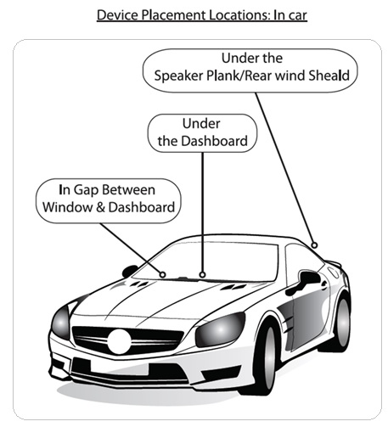

## PICTURE – DEVICE PLACEMENT IN TRUCK

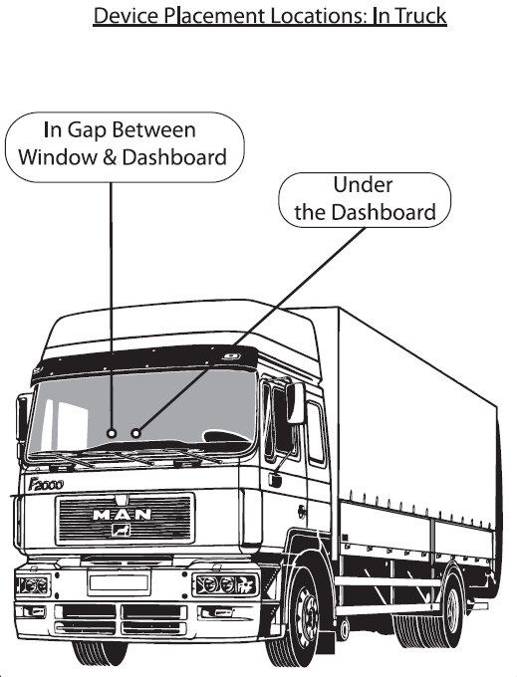

## PICTURE – DEVICE PLACEMENT IN 2 WHEELER

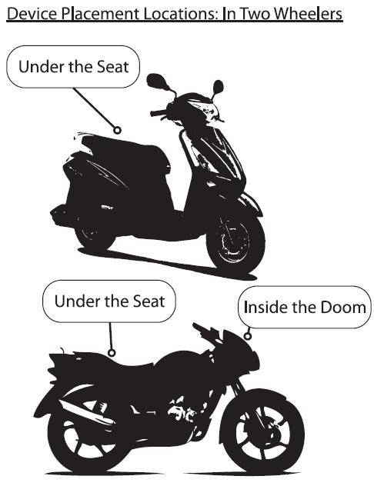

## How to insert SIM card in to the device

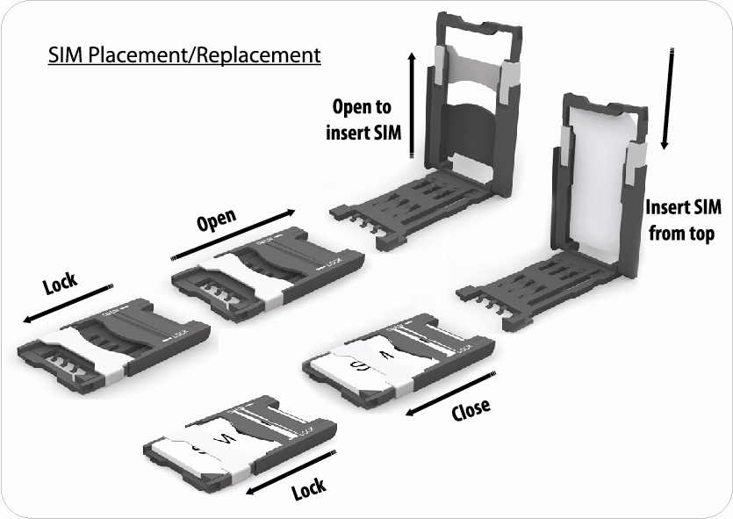

# Troubleshooting

## Problem: Device does not track

Trouble Shooting Steps

1. Check if all the 3 LED are steadily ON and Flashing

If all the LEDs are OFF

1. Check Vehicle Battery voltage, if less than 9 volts or over 32 volts, replace vehicle battery or get the vehicle electrical system rectified
2. Check for Power Connection (both +ve and -ve) and if loose or disconnected, reconnect
3. Check FUSE and if blown off, replace it with 5 A Glass Fuse
4. Check FUSE Holder and if it is loose and/or broken replace the cable

If GPS LED is OFF

1. Check if the vehicle is parked in a covered area and move the vehicle to an open area
2. Check the location of device installation in the vehicle and follow instructions in this manual to correct it
3. Check if there is any metal above the device and if yes, change the location of the vehicle where there is no metal surrounding the device
4. Check if any metal or item kept on the device and clear the same

If Processor LED is off

1. Contact aQuila Track Customer Care

If GSM LED is off

1. Remove SIM card from the device and check in a mobile for SIM registration
2. Check for GPRS connectivity

|  |  |
| --- | --- |
| bs05632 | If none of the above steps resolve any / all of the problems listed above, please contact aQuila Track Customer Care |

# Warranty Policy

**Limited Warranty**

iTriangle InfoTech Pvt. Ltd. warrants that this Vehicle tracking/fleet management device will be free from defects in materials and workmanship during the shelf life of the product, according to the following terms and conditions:

1. The limited warranty for the product extends for the first twelve (12) months beginning on the date of purchase of the device.
2. The limited warranty extends only to the original consumer (consumer) of the product and is not assignable or transferable to any other person.
3. During the limited warranty period, iTriangle InfoTech Pvt. Ltd. or its authorized service network may repair or replace, at iTriangle’s option, any defective product or parts thereof with new or factory rebuilt replacement items, and return the product to the consumer in working condition. No charge will be made to the consumer for either part or labor in repairing or replacing the product. All replaced part, boards or equipment shell become property of iTriangle. The external housing and cosmetic parts shall be free of defects at the time of purchase of the product and therefore, shall not be covered under these limited warrants terms.
4. Repaired product will be warranted for the balance of original warranty period or ninety (90) days from the date of repair whichever is longer.
5. The consumer shall have no coverage or benefits under this limited warranty if any of the following conditions are applicable and customer has to pay for such services at the rates prevailing at the time of service
   * 1. In case of incomplete warranty card and invoice, i.e. (no mention of dealers sign, date and seal or expiry date) then warranty will cease to be in force.
     2. The product has been subject to: abnormal use, abnormal condition, improper storage, exposure to moisture or dampness, exposure to excessive temperature or other such environmental conditions, unauthorized modifications, unauthorized repair including but not limited to unauthorized spare parts in repairs, misuse, neglect, abusive, accident, alteration, improper installation, Acts of God, spill of foods or liquids, maladjustments to customer controls or other acts which are beyond the responsibility of iTriangle, including deficiencies in consumable parts such as fuses and breakage or damage to antennas, unless caused directly by defects in materials or workmanship, and normal wear and tear of the product.
     3. The user is advised not to do installation of the device by their own. It is strongly recommended that the user has to get in touch with the customer care of iTriangle Infotech Pvt. Ltd. And take their assistance for installation and server registration of the device. The company holds no responsibility for the damage whatsoever that may happen if the installation is done without the company’s assistance and coordination.
     4. iTriangle was not notified by consumer of the alleged or defect or malfunction of the product during the applicable limited warranty period.
     5. The product IMEI /serial number of the necessary date code has been removed, defaced or altered.
     6. The product was used with or connected to accessory not supplied by iTriangle, not fit for use with the product or used in other than its intended use.
     7. Disconnection of Power supply to the device by any means like, snapping of wire intentionally or accidentally, removal of wiring, missing wiring kit, etc
     8. Displacement of installation from the vehicle by customer without prior training and written consent of iTriangle Infotech
6. Performance variations arising due to passage of time, sustained usage and climatic conditions. Any extraneous particle entering the product or damaging its physical product or damaging its physical property like water, dust, soil, burn or extreme temperature beyond the specified limit.
7. If a problem develops during the limited warranty period, the consumer should take the following step-by-step procedure:
   1. The consumer shall contact the nearest iTriangle office or [customercare@itriangle.in](mailto:customercare@itriangle.in) for the location of the nearest authorized service center.
   2. If ‘a’ above is not convenient, the consumer may also contact to the place of purchase for the location of the nearest authorized service center.
   3. The consumer shall arrange for the product to be delivered to the authorized service center.
   4. Upon request from ITriangle or its authorized service center, the consumer must provide invoice, original warranty card, duly stamped and signed, or other information to prove the date and place of purchase.
   5. The consumer will be billed for any parts or labour charges not covered by this limited warranty.
8. Transportation, delivery and handling charges incurred in the transport of the product to and from iTriangle or its authorized service center will be borne by the consumer.
9. Any implied warranty of merchantability or fitness for a particular purpose or use shall be limited to the duration of the foregoing written warranty. Otherwise, the forgoing warranty is the consumer’s sole and exclusive remedy and is in lieu of all other warranties, express or implied. iTriangle shall not be liable for any incidental or consequential damages or a loss of anticipated benefits or profits, loss of impairment of privacy of conversation, work stoppage or loss or impairment of data arising out of the use or inability to use the product.
10. While iTriangle would take adequate steps for availability of spare parts at all the time, however in stray cases (as decided by iTriangle or its authorized personnel) of non-availability of spare parts, iTriangle would offer commercial solution to consumer on its sole discretion.
11. The maximum value of claims, if entertained by iTriangle, will be limited to the maximum retail price of the product, prevailing at that point of time.
12. iTriangle neither assumes nor authorizes any authorized service center or any entity to assume for it, any other obligation or liability beyond that which it expressly provided for in this limited warranty.
13. All warranty information, product features and specifications are subject to change without notice.
14. All disputes are subject to the jurisdiction of the Courts of Bangalore only.

# Contact Us:

**iTriangle Infotech Pvt. Ltd**

**#3420, 1st Floor, Service Road**

**RPC Layout (West)**

**Vijayanagar**

**Bangalore – 560040**

**Customer Care:**

**Email:** [**customercare@itriangle.in**](mailto:customercare@itriangle.in)

**Phone: +919739008344**