Introduction
EventTools is a small online package to provide web-based access to tour and clinic information for NMRA regional and national conventions. It was originally created for the X2011West NMRA convention, and continues to evolve. EventTools stores a single copy of information for events, including:
- Clinics
- General/Prototype Tours
- Layouts and Layout Tours
- Miscellaneous Events
- Operating Sessions and requests
From this, EventTools can create order forms, on-line shopping cart, calendars, schedules, printed masters, etc, with completely consistent information. As events sell out, get cancelled or modified, attendees can always be given the most up-to-date and consistent information.

EventTools is installed onto a convention web site. It then provides a series of screens for entering and editing information, and utilities that the convention webmaster can use to present information on the convention's web site. Usually two copies are installed: a “test” one where the information is transient, and people can experiment with the tools without risk of damaging any real data, and a “production” copy contains the real data that will be used for the Convention itself. These are typically reached via different URLs.

When you first access an EventTools page, you may be asked to identify yourself. Enter your convention email address (if in doubt, ask the convention webmaster); you can leave the password field blank for now.

The main page presents options for entering, editing and viewing each type of information:

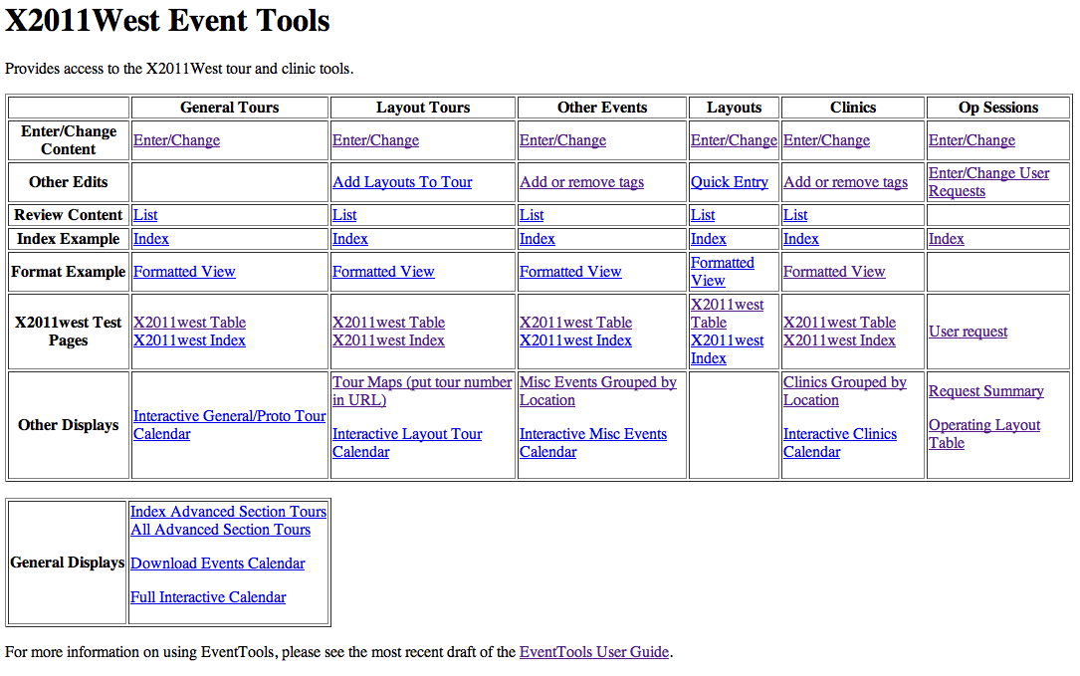

Intended Workflow
- Gather information
- Enter information
- Review and approve listings
- Display to user
- Update as needed
You enter and update (edit) entries on different web pages for each type. There's an entry/edit page for clinics, another for layouts, another for layout tours, another for general tours (including prototype and other non-layout tours) etc. Information can be entered and accumulated using those until it's ready for display, and then marked to be presented to the user.
Each entry can be marked with a status value chosen from:
Internal Name | Shown to User
Unknown | Proposed
Incomplete, Some Data Entered | Proposed
Waiting Approval | Under Construction
Approved: Under Construction | Under Construction
Approved: (on sale) | (shows link to on-line store entry
Sold Out | Sold Out
Cancelled | Cancelled

(These are typical values; you can provide your own through the index page.) As you enter information for a layout, tour or event, you also update the status as appropriate. EventTools is be configured to only who entries with a certain status and above (but see note about layouts below). Normally, “Under Construction” & better are shown by default.
Note: Both layouts and layout tours have a status field. If you set a layout or layout tour so that it's visible, it will be shown. In a perfect world, they would be set consistently: When the layout tour is approved for sale, the layouts would be visible. This level of coordination has been hard for some convention committees, however, so a layout will also be displayed if it's attached to a layout tour that is being displayed even if it's entry is tagged as some lesser code like Incomplete or even Unknown. This keeps the layout tour's list of layouts complete.

Entering Information into EventTools
Convention committees typically have various people responsible for different aspects of the planning. They generate information that needs to be entered into EventTools so that it can do its job. That can be done as a batch process, where spreadsheets or other documents in well-defined formats are inserted directly into the EventTools database. This makes sense for large, already-existing documents. There is no need to create those documents for import, however, because there are web pages that allow you to directly enter and change information. The rest of this section is a short tutorial on those.

Adding a Tour
To add a new layout tour, you start on the layout tour enter/edit page, reachable from the index page:

The page goes on for a while, but at the bottom there are control buttons:

Click the “Add” button, which switches to a page where a new layout can be entered:

Fill that out with as much information as you have. Leave blank any fields you don't have, or don't know.
Most of the fields are self-evident text, but there are a few that have special formating:
- Start and end time fields must use a specific date/time format: 2011-07-02 13:00:00 for example. If you don't know the time, leave the field blank and a default will be used. If you know the day, but not the time, enter the time as all zeroes, e.g.: “2011-07-04 00:00:00”.
- “Self-Guided” should be set to “Y” if this is a self-guided tour. In that case, enter the start and end times for when the layouts are open. Don't include any travel time in that interval.
- The price field must not contain a dollar sign. You can include the cents or just use dollars without a decimal point, so “12” and “12.00” are both fine. A “0” price can be entered. As a special case, if you want to have “TBA” shown, enter a “-1”.
- The “Description” field is HTML so that it can be formatted, include links, etc. Generally, you can just cut&paste text into it, but there are a couple of exceptions to that:
- If you're cutting and pasting from Microsoft Word, you might have “curly quotes” in your text. Anything that looks like a quote mark, including apostrophes, should be replaced with the apostrophe that's at the right side of the home row of keys on a US keyboard.
- If you want to have a line break, don't just leave an empty line, also insert <p/> at the desired spot.
- If you enter code for a hyperlink or other tag, use single quotes instead of double quotes to mark attributes. (If you don't know what this means, don't worry about it).
- Double-quote characters '' should be replaced with &quot; and ampersands should be replaced with &amp; when noticed. It's not a problem if any of these are missed, however, as they're checked during a later step.
In general, just enter your text into the Description field, and the fine details will be sorted out later.
- URLs should be entered with a “http://” at the front to ensure they access reliably.
“Save” saves your new entry and takes you back to the prior page. Click that if you're just entering one tour. “More” saves your new entry, clears the page, and leaves you here so you can enter another tour efficiently. “Cancel” deletes your new information and goes back to the prior page.
A very similar process, except on a different add/edit page (see the index page), is used to enter a general/prototype tour, clinic or miscellaneous event. These other types of events share some common fields like name, times, and status, but also record information specific to the type of event such as clinic presenter name.

Editing Tour Information
To edit an existing layout tour, you start on the layout tour enter/edit page:

To edit a layout tour, you first select it, and then go to an edit page. To select it, you check the radio box on the left side of the tour's row. If the tour isn't shown on the first page, you can use the buttons at the bottom of the page to move to the next page, first or last page or a specific page:

You can also search for a specific layout tour by clicking the “V” button in the upper left corner. This will open an entry box at the top of each column, in which you can enter a search string, then hit enter to show only rows that match:

After you check a row, click “Change” to get a new page:

This is similar to the “Add” page, except that the existing content is filled-in already. Edit it as needed, then click “Save” to save your changes, or “Cancel” to abandon them.

Adding a Layout
The process for adding a layout is very similar to that for adding a layout tour, except that there are a lot more information fields. You can record the layout address to automatically generate tour maps and bus mileage calculations. You can also record all of the information on the OPSIG questionnaire for operating-session layouts, which saves work when organizing those sessions.
The screens for adding, editing and displaying fill a separate column on the EventTools index page. The top link is to the main “Enter/Change” screen, which provides access to all the information fields. Just below that is the “Quick Entry” link, which consists of just the most common fields to make it easy to enter initial information quickly.
A few fields might require more explanation:
“Access”: By default, EventTools presents a layout's handicapped accessibility using a 6 point code:
- Handicapped Hostile
- Several steps and/or duck-under(s)
- Average house (1-2 steps)
- No hazards
- Special adaptations for the handicapped
- Unknown/not entered
For the access item, you just pick one of those.
“Short Description”: A one-line description that appears in various summaries, in the tour listings, etc.
“Long Description”: This can be much larger. Special formatting, including URLs, can be done using HTML tags, but in general you don't have to worry about this. Just enter the text, and IT will fix up the formatting as needed.
“Owner URL”: If the owner has provided a URL for a web page describing their layout, it should be entered here starting with the http:// prefix.
“Local URL”: This is a URL for a specific convention web page that describes the layout, if one exists. In general, you can leave this blank and let the webmaster fill it out.
For items like scale, gauge, scenery completion fraction, etc, EventTools can be configured to either allow you to enter free-form text, or to only permit you to select from specific values. Selecting between these two approaches is done on a variable-by-variable basis when EventTools is installed. Consult the Administration Manual for more information on this. If EventTools has been configured to only allow specific values, you can add/edit/delete the acceptable values in the “Constraints” section of the index page.

Editing Layout Information
This is very similar to the process for editing a layout tour described earlier. Note that you can search on any of the fields to find the layout you want to edit, including the description. The starting URL is on the index page as “Enter/Change” in the “Layouts” column.

Adding a Layout to a Tour
Start with the “Add Layouts to Tour” link in the “Layout Tours” column of the index page:

To put an additional layout on a layout tour, click “Add” at the bottom of the screen. It becomes:

From the top selection box, select the layout tour that should receive the new layout. From the lower box, select the layout you want to add.
When a tour is displayed, the “order” numbers are sorted lowest-to-highest to determine the order of the layouts on the tour. The order numbers don't have to be consecutive, and it'll be easier to renumber the tours later if you leave some extra space between them. We recommend putting 10 in for the first layout on the tour, 20 for the second, 30 for the third, etc. Or you can leave this blank and handle it later.
Finally, click “Save” to enter this value and leave this page, or “More” if you want to enter more layouts on tours.

Removing a Layout from a Tour
Start with the “Add Layouts to Tour” link in the “Layout Tours” column of the index page:

Click the “V” symbol at the upper left to open up a search box, type the tour number in the box over the “Tour” column, and hit enter:

This will restrict the display to just that layout tour. It will show even if it wasn't on the front page originally. You can also enter layout information in the “Layout” column and search for that.
Now select the layout you want to remove by checking the radio button on the left side, and clicking “Delete”. You'll be asked to confirm that before the deletion is done.

Reordering the Layouts on a Tour
Start on “Enter/Change Layout” page: http://www.x2011west.org/eventtools/edit_layout_tour_add_layout.php

Click the “V” symbol at the upper left to open up a search box, type the tour number in the box over the “Tour” column, and hit enter:

This will restrict the display to just that layout tour. It will show even if it wasn't on the front page originally. You can also enter layout information in the “Layout” column and search for that.
The order column, on the left, determines the order that the layouts are listed in the tour. It's sorted from lowest-to-highest numbers. To change the listing order, you change those values. They need not be consecutive, or spaced in any particular way. For example, to move the NWP layout from 3rd to 2nd in this sample tour, you could change it's order number to 15.
To do that, select the radio box at the left of the NWP row, and click change. You'll get a new page:

Type a new value in the “order box” and click Save.

Entering Clinic Information
Clinics are entered and added using similar techniques. You can provide additional information about the clinic and clinician. Clinician contact information (email, phone, etc) are not made visible to the convention attendees.
You can assign a clinic to a specific location (room in hotel, etc) by selecting it when entering/editing the entry. Specific locations can be added/edited/deleted via the “Edit Location Keys” link in the “General Edits” section of the index page. Note that changing the name of a location will change the name of all the clinics that have already been assigned to it. This lets you put a set of clinics in a location called “TBA 1”, and later assign it to a specific room like “Oak Room”.
In addition to the basic clinic listing, you can assign tags to clinics. You can assign as many tags to a clinic as you wish, and can add the same tag to as many clinics as you wish. These can then be e.g. used to display a “track” of clinics for people with certain interests such “WP”, “NASG” or “Scenery”. The process starts with the “Add or Remove Tags” in the “Clinics” column of the index page, and works very similarly to adding a layout to a layout tour as described above. You select an existing clinic entry that you want to tag, and then provide the tag.

Op Sessions
EventTools can keep track of operating sessions, and allow users to request specific ones.
Operation sessions are built on top of the layout information that's separately stored in EventTools. See the preceding sections for instructions on how to enter layout information. Note that modelers interesting in operating are often interested in the optional fields on realism, control systems, card forwarding methods, scheduling, etc, so operating layouts should probably have more complete information than ones that are just included in layout tours.
Once the operating layouts have been defined, you can add operating session information to them. To do that, use the edit/change operating session page, linked from the upper right of the index page:
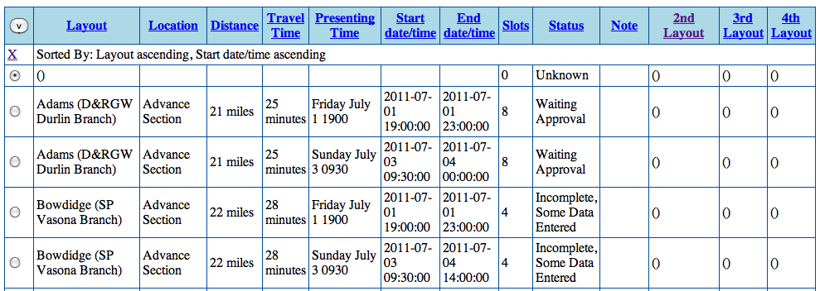
Each line represents an operating session. The fields are:
Location: Typically “Advance Section”, “North Bay”, “Sacramento” or similar, this label appears on some of the index pages.
Distance and Travel Time: Presented in the operating session listings so attendees can plan how much time to allow to get to the session.
Presenting Time: Unlike for layout tours, where the time listings are automatically generated from start and stop times, the operating session organizers originally wanted to generate their own descriptions of layout times so they could say things like “Sometime Thursday” instead of a precise time. This field is displayed where-ever the start time is displayed to the user.
Start Time and End Time: If provided, these will be used to mark operating sessions in the general and attendee-specific calendars.
Slots: Number of people who can attend. Not used initially during the request phase, but used as part of assigning people to requested layouts.
Status: The same status codes as for layouts and layout tours are available for operating sessions. See the first section above for more information on these.
Note: Free form, for use as desired. Not visible to the attendees.
2nd Layout, 3rd Layout, 4th Layout: An op session can be a two-fer, three-fer, four-fer with multiple layouts. These can either be sequential (people operate at one then another) or in parallel (the group of attendees splits across the layouts and operates them at the same time).
To change an operating session, select its radio box and click “Change”. You'll get a new screen where the entry can be changed. Layouts are selected from drop-down boxes. The contents of those are in alphabetical order by layout owner last name. Once the box has been selected by tabbing or with the mouse, type a few characters of the name to go directly to a layout. Once the entry has been updated as you'd like, click “Save” to save your changes and go back to the index.
Users can enter requests via a custom URL that's also connected in the index as “User Request” in the Op Session column. You can view, change, add or delete those via the “Enter/Change User Request” entry in the Op Session column of the index. That leads to a screen that looks like:
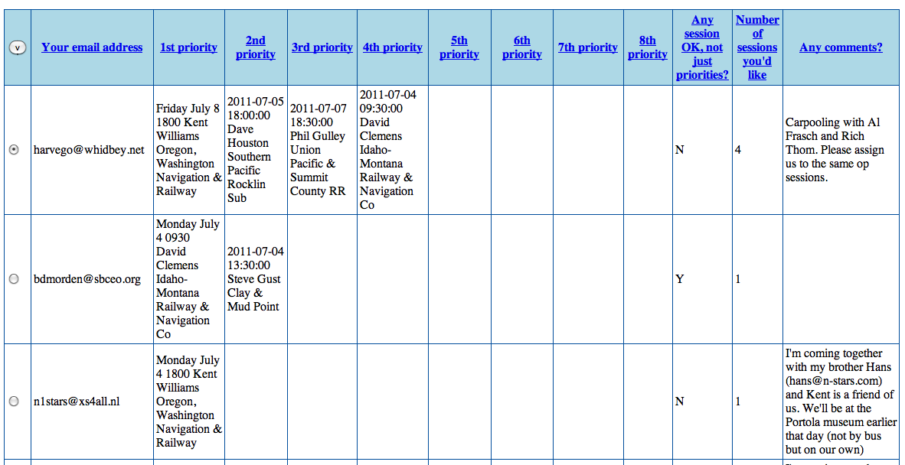
There are “Add”, “View”, “Change”, “Copy”, “Delete” and navigation buttons at the bottom of the screen. To change an entry, for example, select it with the radio button on its left side, and click “Change”. That will take you to a screen like:
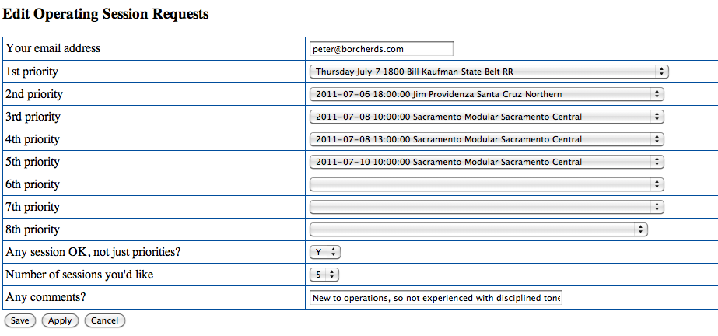

You change whatever information you'd like, and then click “Save”, or click “Cancel” to go back without making any changes.

Reviewing and Approving Listings
Once information has been entered, you review it using the “Review Content” or “Listing” pages on the main page. By default, these display all listings regardless of status, highlighting missing information. Typical entries for general tours look like:
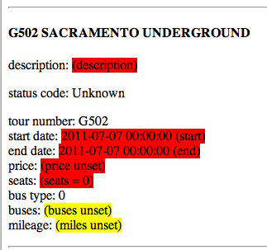
And a layout entry with missing information looks like:
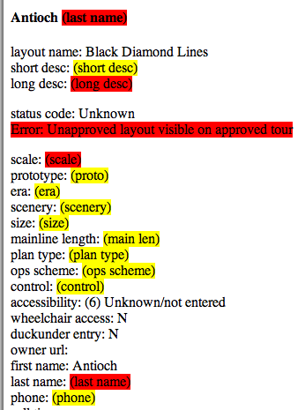
High-priority missing information or errors are highlighted in red. Optional, but desirable, missing information and possible future errors are highlighted in yellow. The status code is not colored, because any value is considered correct.
There are also “formatted” displays available from the main page. These display the information using a simplified version of the format provided for on the main convention web pages. These let you easily get a quick view of what the user will see.
Missing information can be added using the same edit pages described previously. Once the information is OK, use the add/edit page to set the entry's status high enough that it will display on the main convention pages.

Displaying Information to the User
Generally, EventTools users don't have to worry about this step. Display on the main web site is automatic once the status has been set to a suitable value.
The on-line store (if used) has to be updated manually, and the various printed documents such as the paper order packet are only updated periodically. It's important that people making changes that will effect those, for example changes to prices or schedules, stay in touch with the rest of the organizers.

Updating as Needed
If you update something via a production-database page, the change on the web site is immediate. For example, a change to a description will appear the next time the user displays the page containing it.
As discussed in the previous section, though, the on-line store and printed materials are updated less often. Please notify the appropriate convention committee members when you want those updated.

Additional Capabilities
Once EventTools has the data, it can help you do all sorts of things with it. By entering data early, even partial data, you can enlist the help of others to improve the data, check it, etc.

Mapping
For example, it can draw maps of the locations of layouts on a layout tour, show distances and directions between the layouts, and generally help plan the tour time and cost:
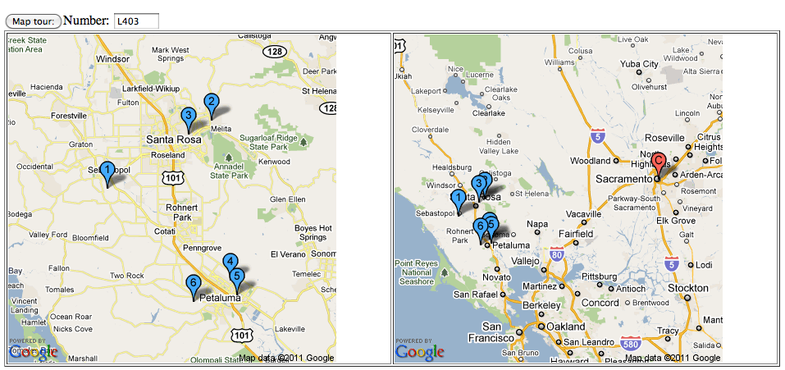

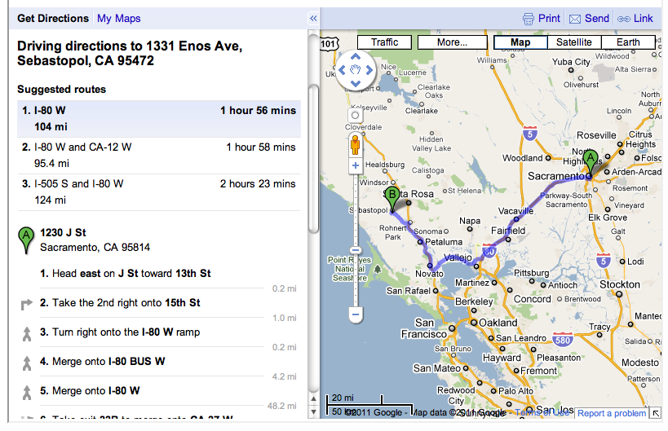
The Google maps can even tell you when you've mistyped the address, or have accidentally put it in the wrong town.
Tours can be displayed by day and time in a way that makes it easy to tell where buses can be shared, and mileage calculations can be done to ensure that limits are not exceeded.

Distributing the Editing Task
Because everybody is inherently working off the same set of data, you can share out the work as needed without worrying about inconsistent data. Access can also be restricted in whatever way, with some people only being able to enter/edit certain kinds of data or only certain entries.
- Once you have layout owner email addresses entered, you can give them access to update and improve their own layout entry. They can fill in the detailed fields so that you don't have to worry about all that data. They can be asked to improve the entry until they're happy with it and approve it, removing the need to spend time going back and forth.
- Clinicians can be given access to update their clinic descriptions and attached URLs, without giving them the ability to change the schedule.

Consistency Checks
Since the data is being accumulated in a common place, it can be looked at in multiple ways to make planning easier.
- Clinics can be displayed by room and time to detect double-booking.
- By restricting the clinic display to only clinics with specific tags, you can easily see where conflicts have been built into the schedule.
- Non-rail tours and clinics can be displayed together to easily check for overlaps and conflicts.

Program (Timetable) Printing
We provide some special pages which format information for the printed program (timetable). This formatted information can then be transferred to the page-layout software being used to create the program master. See the Program Printing section of the index page. Formatting here is by a “cascading style sheet” (CSS). Please consult your local webmaster, who can modify the CSS definitions to formatting as you'd like.

Printing Updates
At some date decided by the committee, data is extracted from EventTools to print a paper program. Changes after that date generally have to be provided to convention attendees on separately printed updates.
The dates of changes, minor or major, are marked in the database so that we can identify those made after the program was printed and select which of those to put on a printed update. Recording the change date is automatic, and you don't have to do anything about it.
But not all changes require an update to the user. Some are too minor or only involve intermal information, e.g. a clinician email address which is not given to attendees anyway. Whether a change does or doesn't need to be published really isn't something that EventTools can decide on by itself, so there's an additional yes/no field called “Changed?” associated with entries. You use to keep track of significant changes after the program is printed. The possible values are blank (the default) and "Y". When you change an entry, you consider how significant that change is, and set "Changed?" to "Y" if it's significant enough to be included in a printed update. If it's not, leave it at blank.

