Quick Start: Using EventTools to Set Up an Ops Meet
This note walks you through basic setup for an operating meet: a weekend-sized get-together of 10 to 100 operators who operating on a dozen or so layouts.
There's additional information linked at the end, but we recommend you not read it at this point. EventTools has lots of features, and people can get lost in the details. We recommend you start by loading the basic aspects of your operating meet (by following this note), and then start to explore how the various features would work for you.
(This version of the note has been customized for the http://adaumann.com web site; adjust the URLs as needed for yours)

Get Started
- Get EventTools installed and configured on your web server.
- You can take a look at the index page (http://adaumann.com/eventtools/), but don't click on the links yet; we'll walk you through that later on.

Enter Some Layouts
- You enter or edit the layouts on the “Enter/Change Layouts” page: http://adaumann.com/eventtools/edit_layouts_all.php
- Go there. It should look like (the test layout might not be there):
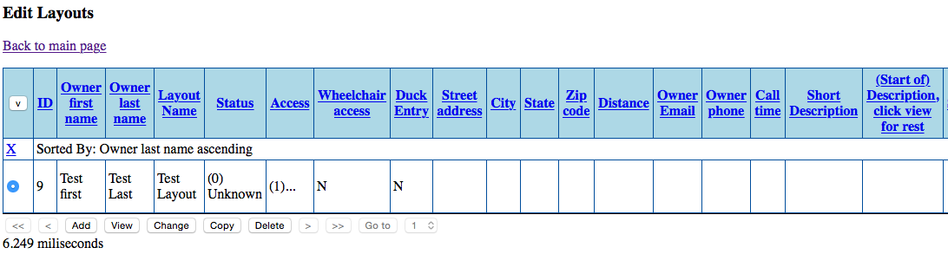
- Click the “Add” button to get a screen that looks like this:
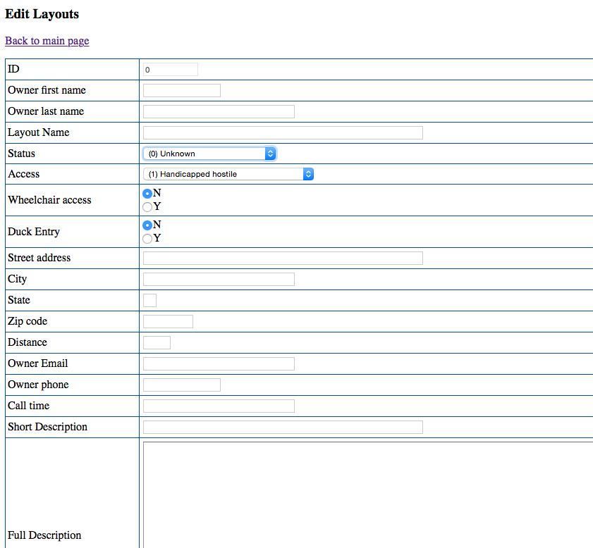
(There's a bit more further down) Fill it out:
- ID: You can't change this.
- Owner first name, Owner last name, Layout name: These will appear in listings
- Status: If you want this to appear to users, select the bottom entry “Offering Sessions”. If you don't want it to appear (maybe you're still negotiating with the owner), select “Waiting approval”. (There's more on this in the EventTools Admin manual)
Everything below this is optional. Fill it out if you want to and have the information. If you decide to use them, best if you fill it out consistently for all layouts.
- Access, wheelchair entry, duck entry: If you fill these out, people can sort on them when looking through the pages on layouts.
- Street Address, City, State, Zip code, Distance: For your purposes, generally not visible to attendees (but see the description of creating a map web page in the manual)
- Owner email, Owner phone, Call time: never displayed to the attendees
- Short Description: Displays in the dense tables
- Full Description: Displays on layout pages
The rest are various other items that can appear on the layout web pages. You don't have to use any particular piece of information, but it's good to be consistent about what you fill out or not. EventTools can be configured to help with that by giving you a set of consistent choices to choose from, see the EventTools Admin manual.
Once you've filled out the info, click “Save” to store it and return to the prior screen. Alternately, if you have another layout to enter, click “More” to save it and give you a clean entry page.
Repeat until you've entered a good sample of layouts.

Check Your Layout Table
You can get an idea of how your content will look on your web site by checking some sample pages, also available from the main page:
- Index example: http://adaumann.com/eventtools/index_layouts.php
- Format example: http://adaumann.com/eventtools/format_all_layouts.php
You can go back and make changes to specific values later.

Define Operating Sessions
To define a basic operating session, you just need to specify the layout, start time and end time, and number of attendees.
- To define them, go to the “Edit Operating Sessions” page (http://adaumann.com/eventtools/edit_ops_add_layout.php) which looks like:
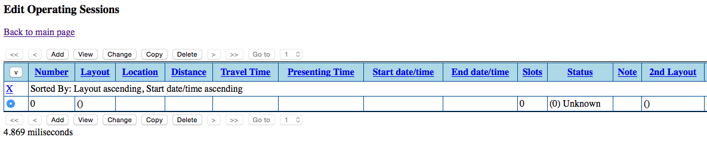
(Ignore the “2nd layout” etc fields for now; they're for combined sessions where you have to work on one layout first, then the other)
- Click “Add”. You'll get a new window:
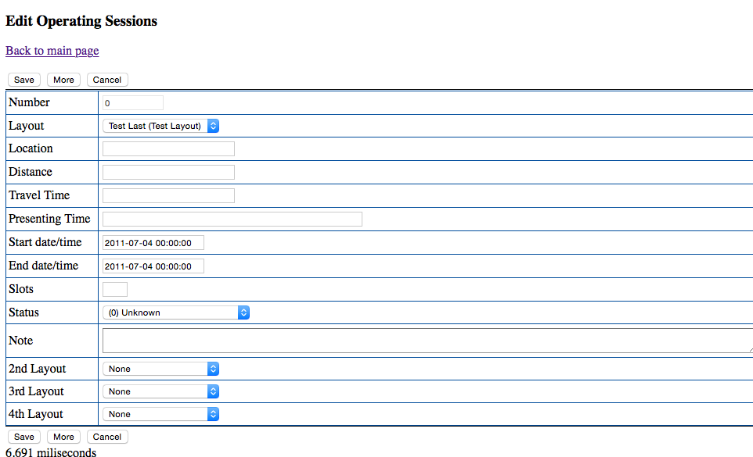
You can't change the “Number” field. For the rest, enter:
- Layout – select a layout from the ones you've already defined.
- Location, Distance, Travel Time: Hints for attendees to help them select sessions to request
- Presenting Time: If you want to display something other than the exact start time, e.g. “Sunday Morning” instead of “2017-01-02 10:30:00”, enter it here.
- Start date/time, End date/time: Enter in the format “2011-07-04 00:00:00” with a 24-hour clock
- Slots: Enter the max number of attendees you want to schedule; don't include the owner, helpers, or others who aren't being scheduled in.
- Status: “Waiting Approval” if it shouldn't show on the web yet, “Offering Sessions” if it should be. You can use “Waiting Approval” if you're still negotiating with the owner, but want to reserve the timeslot, for example.
- Note: Just for you, not displayed to the user.

Check your Sessions
To get a look at the sessions, go to:
- Operating Session Index (http://adaumann.com/eventtools/index_ops.php): This shows a compact listing
- Operating Session vs Day (http://adaumann.com/eventtools/view_ops_by_day.php): This shows a grid of available sessions by time. (It doesn't work well until you have a few sessions defined for each day, so please ignore any error messages until then)

Connect to Your Web Site
Finally, embed EventTools code in your web site so that the site shows the layout and session information, and contains the registration form.
To do that, proceed to the “EventTools Administration Guide” document.

That's usually done for you, but if you're installing EventTools yourself see the EventTools Admin manual.

