Introduction
EventTools is a small online package to provide web-based access to information for model railroading events. It was originally created for the X2011West NMRA convention, and continues to evolve. This document describes using EventTools for a small operating session event such as BayRails or ProRail. See also the “EventTools Ops Quick Start Guide” for a step-by-step guide to entering initial data; manuals are also available that describe the technical setup, use for larger conventions, and other topics.

EventTools stores a single copy of information, including:
- Layouts
- Operating Sessions
- Attendees and their operating session requests
From this, EventTools can create web pages, rosters, assign sessions, generate mailings, and in general help the committee do their jobs.

EventTools is installed onto the event's web site. It then provides a series of screens for entering and editing information, and utilities that the even's webmaster can use to present information on the events' web site.

The main page presents options for entering, editing and viewing each type of information:

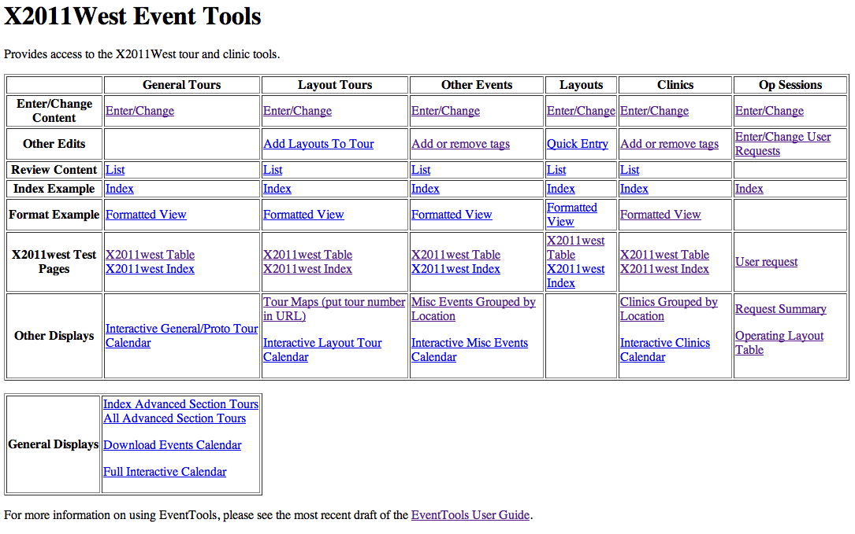
For small operating-session events, probably only the “Layouts” and “Op Session” sections will appear.

Intended Workflow
- Gather information
- Enter information
- Review and approve listings
- Display to user
- Update as needed
You enter and update (edit) entries on different web pages for each type. There's an entry/edit page for for layouts, another for operating sessions on those layouts, etc. Information can be entered and accumulated using those until it's ready for display, and then marked to be presented to the user.
Each entry can be marked with a status value chosen from:
Internal Name | Shown to User
(0) Unknown | Proposed
(1) Some Data Entered | Proposed
(2) Waiting Approval | Under Construction
(3) Approved: Under Construction (no links) | Under Construction
(5) Sold Out | Sold Out
(6) Cancelled | Cancelled
(40) Not Available | Not Available
(50) Offered as a Bonus Session | Bonus Session
(60) Offering Sessions | Offering Sessions

(These are typical values; you can provide your own through the index page.) As you enter information for a layout or operating session, you also update the status as appropriate. EventTools is be configured to only who entries with a certain status and above. Normally, only “Offering Sessions” entries are shown by default, so when the listing is completely ready to display you set the status to that.

Combined Sessions
A “combined session” is one that has involves more than one layout. It might have one layout in the morning and another in the afternoon, for example. Combined sessions are created by adding the 2nd, 3rd or even 4th layout to a regular session. Their names are presented slightly differently, but they otherwise function the same during the selection and assignment process: People request them, and then get assigned by priority. Combined sessions are displayed somewhat differently in the layout and sessions listings to help the attendee understand what they're signing up for.

Reservation by Session or By Layout
Large conventions with a lot of things going on, e.g. a national NMRA convention, might want to let attendees sign up for a specific session of those offered at a layout: “I want to operate on Bill's Tuesday evening, but I can't make Thursday evening”. EventTools calls this “reservation by session”
Smaller events, such as a ProRail, might want to allow people to sign up to operate on a specific layout. The organizers then assign them to sessions as needed to fit everybody in. This is called “reservation by layout”.
EventTools works slightly differently during the registration and assignment processes depending on whether it's been configured to use “by session” or “by layout” during EventTools setup for the event. The mode can be changed later, but you might have to revisit any assignments that have been made.

Bonus Sessions
“Bonus sessions” are typically one or two sessions on the day before and/or after the main event. They may be some distance from the other layouts but on the way for some attendees or have some other specialized character.
EventTools provides some special support for bonus sessions. Instead of requesting them in the same mix as all the other layouts during registration, attendees can request then specifically. They can then be assigned in bulk early in the process so the organizers can let attendees know early whether to include the session(s) in their travel plans.
Bonus sessions are indicated via a special status code for the session, and by specific coding in the registration form.
Generally, bonus sessions are a pain to administer properly, and it's best to avoid them. Just make them sessions like all the others and let people request them.

Customer Options
You can use Customer Options to get additional information, such as whether an attendee is willing to run a yard or dispatch. For more information on setting these up, see the configuration manual.
These can also be used for making first-come-first-served assignments. Just have an option question like “Would like to operate on Ralph's layout”, and accept the first people that say yes to that when registering. This doesn't involve the operating-session assignment process at all.

Entering Information into EventTools
Committees typically have various people responsible for different aspects of the planning. They generate information that needs to be entered into EventTools so that it can do its job. That can be done as a batch process, where spreadsheets or other documents in well-defined formats are inserted directly into the EventTools database. This makes sense for large, already-existing documents. There is no need to create those documents for import, however, because there are web pages that allow you to directly enter and change information.
The usual process is to:
- Enter the layouts
- Define the operating sessions for those layouts
- Create pages that show that information to the attendees and allow them to sign up
- Process the session requests and make assignments
- Providing information to attendees, layout owners and organizers.
What follows is a short tutorial on those.

Adding a Layout
The process for adding a layout is very similar to that for adding a layout tour (see main EventTools manual for now; this will be included here later), except that there are a lot more information fields. You can record the layout address to automatically generate tour maps and bus mileage calculations. You can also record all of the information on the OPSIG questionnaire for operating-session layouts, which saves work when organizing those sessions.
The screens for adding, editing and displaying fill a separate column on the EventTools index page. The top link is to the main “Enter/Change” screen, which provides access to all the information fields. Just below that is the “Quick Entry” link, which consists of just the most common fields to make it easy to enter initial information quickly.
A few fields might require more explanation:
“Access”: By default, EventTools presents a layout's handicapped accessibility using a 6 point code:
- Handicapped Hostile
- Several steps and/or duck-under(s)
- Average house (1-2 steps)
- No hazards
- Special adaptations for the handicapped
- Unknown/not entered
For the access item, you just pick one of those
“Short Description”: A one-line description that appears in various summaries, in the tour listings, etc.
“Long Description”: This can be much larger. Special formatting, including URLs, can be done using HTML tags, but in general you don't have to worry about this. Just enter the text, it will look OK.
“Owner URL”: If the owner has provided a URL for a web page describing their layout, it should be entered here starting with the http:// prefix.
“Local URL”: This is a URL for an event-specific web page that describes the layout, if one exists. The webmaster may have set up a convention for how to fill this out.
“Photo URL”: Similar to “Local URL”, this can point to a page with additional photos or more information about a layout. Some committees use this like a hybrid of Owner URL or Local URL, where they'll provide a basic page if the owner doesn't have one.
Distance: This is the one-way distance from event center (e.g. the hotel) to the layout. Note that there's also a distance field on the op-sessions. This is so that combined sessions or sessions that e.g. start right after another event (a picnic?) can have a custom distance value. You should fill out both.
Number of operators: This is the typical number of people needed to operate the layout. In the layout entry, this should be the total number of people. There's also a number of operators field on the individual operating session. That's the number of people the layout owner wants assigned for that particular session; it might not be the same.
For items like scale, gauge, scenery completion fraction, etc, EventTools can be configured to either allow you to enter free-form text, or to only permit you to select from specific values. Selecting between these two approaches is done on a variable-by-variable basis when EventTools is installed. Consult the Administration Manual for more information on this. If EventTools has been configured to only allow specific values, you can add/edit/delete the acceptable values in the “Constraints” section of the index page.

Editing Layout Information
You can also go back and edit the layout information later, using very similar screens. The starting URL is on the index page as “Enter/Change” in the “Layouts” column, the same one you used above. Click “Change” instead of “Add” at the bottom after selecting the layout (row) you want to modify.

Entering Op Sessions
Operation sessions are built on top of the layout information that's separately stored in EventTools. See the preceding sections for instructions on how to enter layout information. Note that modelers interesting in operating are often interested in the optional fields on realism, control systems, card forwarding methods, scheduling, etc, so operating layouts should probably have more complete information than ones that are just included in layout tours.
Once the operating layouts have been defined, you can add operating session information to them. To do that, use the edit/change operating session page, linked from the upper right of the index page:
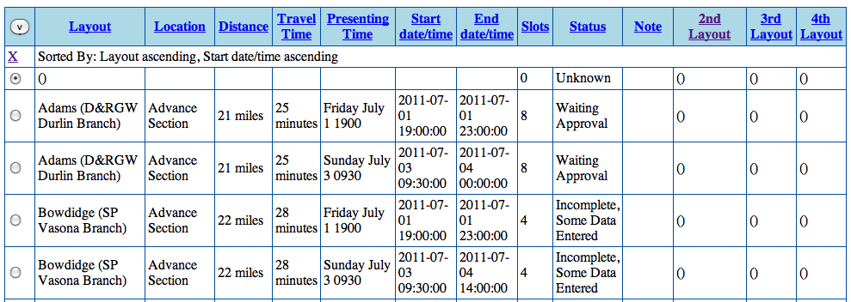
Each line represents an operating session. The fields are:
Layout: The session layout is selected from a drop-down box that lists the pre-defined layouts. The contents are in alphabetical order by layout owner last name. Once the box has been selected by tabbing or with the mouse, type a few characters of the name to go directly to a layout.
Location: Optional, this is used for grouping layouts. Typically “Advance Section”, “North Bay”, “Sacramento” or similar, this label appears on some of the index pages.
Distance and Travel Time: Presented in the operating session listings so attendees can plan how much time to allow to get to the session. Note that the distance might be different from the distance listed for the layout itself, if attendees will be coming from a different place or this is a combined operating session.
Presenting Time: (Optional) In addition to the precise start and stop times, the operating session organizers originally wanted to generate their own descriptions of layout times so they could say things like “Sometime Thursday” instead of a precise time. This field is displayed where-ever the start time is displayed to the user.
Start Time and End Time: These are required. They will be used to mark operating sessions in the general and attendee-specific calendars.
Slots: Number of people who should be assigned to the session. Not used initially during the request phase, but used as part of assigning people to requested layouts. This can be different from the number of operators field on the layout, which is the total number of people present.
Status: The same status codes as for layouts and layout tours are available for operating sessions. See the first section above for more information on these.
Note: Free form, for use as desired. Not visible to the attendees.
2nd Layout, 3rd Layout, 4th Layout: An op session can be a two-fer, three-fer, four-fer with multiple layouts. These can either be sequential (people operate at one then another) or in parallel (the group of attendees splits across the layouts and operates them at the same time).

Editing Session Information
To change an operating session, select its radio box and click “Change”. You'll get a new screen where the entry can be changed. Once the entry has been updated as you'd like, click “Save” to save your changes and go back to the index.

Session Displays
There are several custom pages providing different views of the session information. You can use these for your own work, or use them as models of pages to display to the attendees. They're all accessed from the Op Sessions column of the index page.
- Requests Summary – This is a two part page. At the top is a table by session of how many 1st, 2nd, etc priority requests have been made for it. At the bottom is a table of the attendees who have requested layouts.
- Operating Layout Table – This is a quick summary of the layout information, suitable for embedding in a public web page
- Operating Sessions vs Day – This provides a table of layout versus day, with the session start times indicated on each operating day. It's very useful for planning purposes.

Attendee Information
Before making a registration form, you should understand how EventTools tracks attendee information.
For large conventions, or ones that sell things through an online store, EventTools will integrate with the store's customer database. Zen Cart at X2011 was the original example of this, but EventTools can work with others too. In that case, the attendees will enter and maintain their contact and address information through the stores pages.
In smaller events, EventTools can provide very simple management of attendees information. It can track one email address, a home and cell telephone number, and a single postal address. Users enter this through the registration form (see below). Their primary ID is the email address, so every attendee must have one. EventTools provides a rough edit page that you can make available to attendees to edit their contact information, or you can have them re-enter it through the registration page. The organizers have “View/Edit contact info”, “View/Edit addresses” and “Table of contact info” pages available from the attendee info section of the index page to manage this information.

Attendee Groups
Sometimes several attendees will want to be assigned to the same layouts to that e.g. they can travel together. These are called “attendee groups”. EventTools provides limited support for attendee groups.
The members of the group must select the exact same operating sessions during their reservation, and must identify their group in the comment field. The organizer doing the session assignment then tells EventTools to group those people together. EventTools will take into account that they're a group when trying to fit them into sessions. It knows that a group of three can't fit into a session with only two slots remaining, so it can try moving somebody else at the same priority to another selection to make things fit better, etc.

Attendee Categories
Not all attendees are created equally. EventTools doesn't care why they're different, just that they are. The organizers might want to give session assignment priority to new attendees, or returning attendees, or ones who've come for a long way. Regardless of the policy, it's embodied in a “attendee category code” that each attendee has. Higher numbers result in earlier assignment when doing automated assignments.
This can be edited from various screens, but the “View/Edit attendee category code” page available from the attendee section of the index page is specifically intended for setting & reviewing this.

Timestamps and Registration Order
EventTools uses several kinds of timestamps to tell when users first registered for the event, and when they last updated their registration information. The “first registration” time is taken to be when the attendee's information was first recorded, even if they didn't select sessions or layouts at that point. The “most recent” or “last modified” time is the last time any of the information was changed. Typically this is the session requests, but it could be any of the other information.

Making a Registration Form
You probably don't want to enter the attendee's information and op session requests manually. You can create a web page on your web site that allows them to do this for themselves.
Note: An attendee can only register requests for operating sessions, not for layouts. You should have an operating session defined for each of the active layouts before starting registration. These don't have to have final times or other details defined, but they must exist.
The “sample_ops_reg_form.php” file is a starting point for a registration from. There are many ways to do it, but that page shows one that works reasonably well. It's divided into several parts to make it easier to customize. Note that it's appearance is incredibly basic, so you should embed it in a page presentation structure that makes it look like all your other pages.
- Create the form
  - Create the part that gathers the user name, etc
  - Create the part that asks optional questions
  - Create the part that asks for op session preferences
- Process the form on return
  - Parse the returned information
  - Enter it into EventTools
  - If desired, email it to somebody
  - If desired, add it to a sequential file
The registration form can also handle up to eight yes/no questions that can be used to sign up for optional dinners, let the attendee say whether he wants to be a yardmaster or dispatcher, etc. You activate these by defining the name and description of each option in the “Customer Options (Registration Extra Questions)” page accessible from the lower part of the index page.
Once you've created the registration form, you can test it by entering a few dummy registrations. The “Request Summary” link on the main index page takes you to summary of the op session requests so you can check that it's working. The top part shows the requests for each session by priority, including the total number of requests. The bottom part shows the names that have been entered. Once you're sure the registration form is working, you can delete your test requests.

Adding and Editing Op Session Requests
You can view, change, add or delete op session requests via the “Enter/Change User Request” entry in the Op Session column of the index. That leads to a screen that looks like:
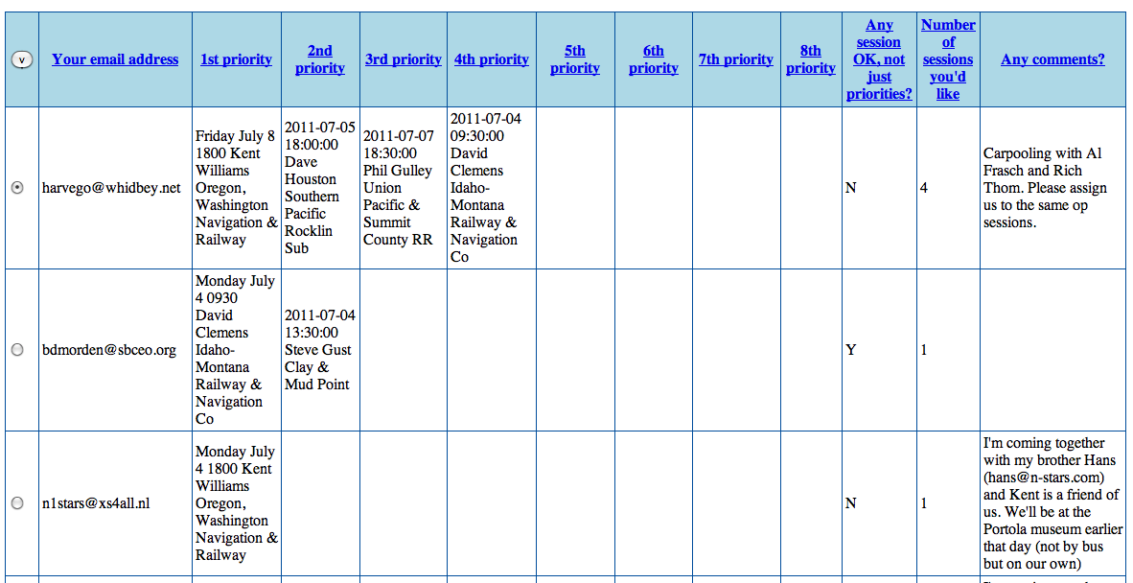
There are “View”, “Change”, “Copy”, “Delete” and navigation buttons at the bottom of the screen. To change an entry, for example, select it with the radio button on its left side, and click “Change”. That will take you to a screen like:
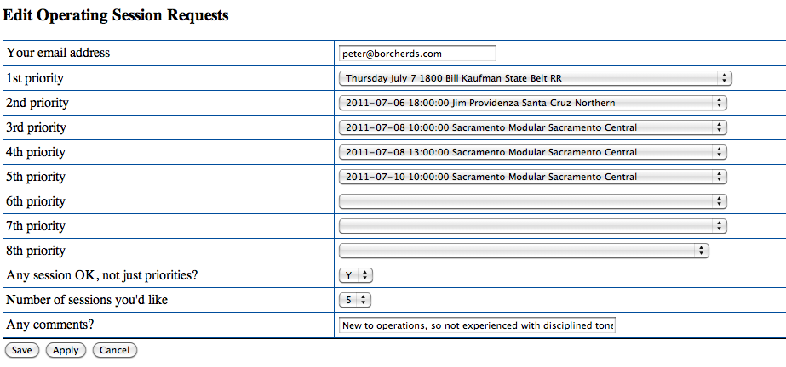
You change whatever information you'd like, and then click “Save”, or click “Cancel” to go back without making any changes.

Assigning Attendees to Op Sessions
Once you have the attendee's information, there's a two-part process for assigning them to sessions. This is all done by selecting the “Start Assignments with Grouping” link in the index page:

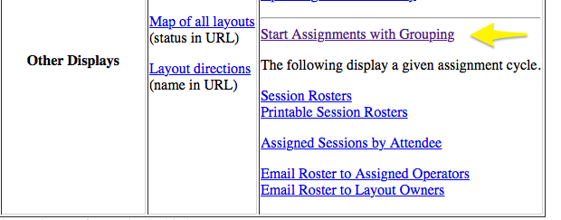
This takes you to a page where you're asked to select a “cycle”:
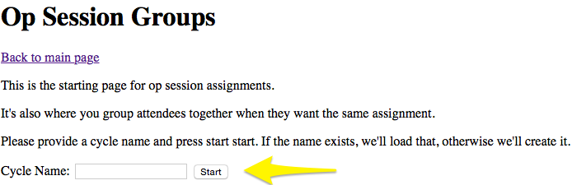
You can take several tries at doing the assignment, called “cycles”. This lets you try different ways of doing it, only using the one you like. Cycles have names, which can be whatever helps you keep them straight. For example, you can call them “1”, “2”, “3” as you make changes and refine your assignments; numbering them helps you keep track of that. Some people use dates: “March 3”, “March 5”, “March 5 afternoon”, “March 6 morning”. Later on, you'll see you can make a copy of a cycle to keep, for example calling it “For Committee Review”. For now, just put “Learning to use this” in the Cycle Name field and click Start.
Next, you go to a page where group s of attendees together into groups that will be assigned together. This allows you to handle “Traveling with Bill, please assign us to same layout” requests. Grouping should only be done with identical requests. There's a column on the page where the “^” symbol indicates a request that matches with the one right above it. (If the requests don't ask for the same layout, who do you send them to?)
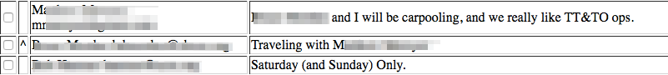
If you want to combine those into a group, for example if they asked you to, check the boxes by the ^ symbol for everybody in the group (more than two OK):
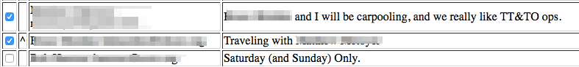
and then click the “Group” button at the bottom of the page. The group will then get a merged line in the listing:
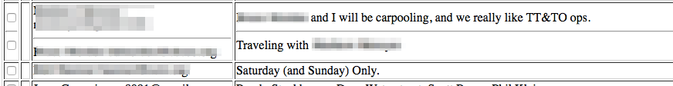

When you've assigned all the groups, you can move on to the actual assignment. Click the “Continue to Assignments” button at the top of the page. This will take you to a new window:
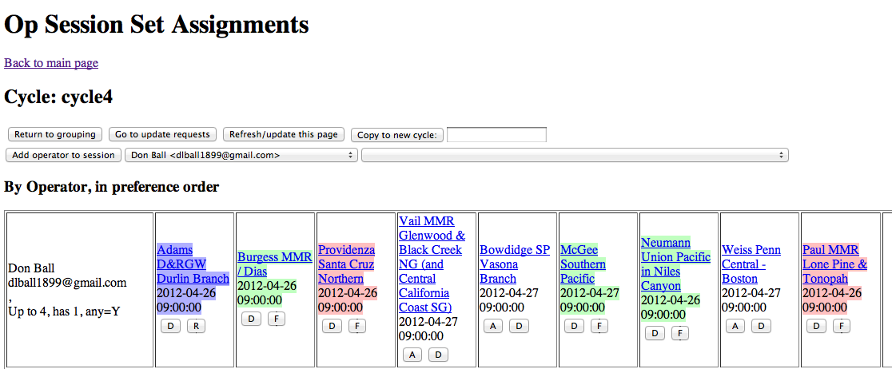
At the top of the page are navigation links and buttons. “Copy to new cycle” lets you make a duplicate of the current assignments into a new named cycle, and continue with that new one. You can use the new one for an experiment, or consider the older one as a backup or whatever you wish. Ignore the rest of the buttons for now.
Below that is a table of requests made by each operator. The requested layouts are listed in order. The color means:
- White background – requested, not assigned, but could be assigned.
- Blue background – assigned
- Light red background – can't be assigned due to a current conflict, e.g. another assignment at the same time.
- Dark red background – manually disabled, can't be automatically assigned
- Green background – Can't be assigned because the layout is full. This is green, instead of red, because it might become available if somebody else's assignment is changed.
The buttons do things. Note that only some possibilities apply.
- A – Assign this person to this session
- D – Disable the request: Not assigned, and won't be selected by any automatic assignment.
- R – Release – drop a current assignment
- F – Force assignment to the session, even if the session is full or in a conflict.
The label at the left shows how many operating sessions the user wants; how many they have assigned now; and whether they'll take anything or just the ones they requested.
Lower in the page is a second table that lists the requests and assignments for each operating session:

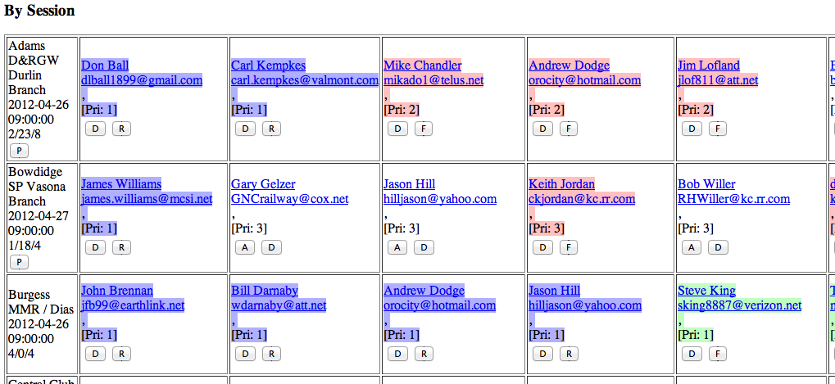
The color coding and buttons are the same, with the addition of the “P” button. The “P” button assigns requests with the next-highest priority to the session. For example, if first and second priorities have been assigned, and there are more spaces in a particular session, “P” will assign anybody who gave 3rd priority to this session.
The number at the left is the number of operators assigned, the number of people still to be assigned (not counting those with conflicts) and the total number of spaces in the session. There's a tooltip on this (and most other buttons and fields), so just hover your mouse over the numbers if you can't remember which number is which.
If you have multiple sessions defined for layouts, the bottom of the box contains buttons for moving unassigned requests to other sessions on the same layout. If you have Tuesday and Thursday sessions, for example, these buttons make it easy to move over requests from a full Thursday so they can be assigned to empty slots on Tuesday. They're moved over, but not assigned; you have to do that later.
The assignment buttons take groups into account. If you do something that affects one member of a group, e.g. assign them to a session, that same thing will be done to all the others. You won't be allowed to assign just part of the group to a session. If there's not enough room for all of them, the group will show as blocked on that session.
At the very bottom of the page is a “Fill best priority N” button which tries to do the best it can to assign people to their Nth priority spot. This starts out as “Fill best priority 1”, but goes to later request priorities (e.g. “Fill best priority 2”, “Fill best priority 3”) as assignments are made and the smaller values are no longer relevant. It works with one attendee category (see page 7) at a time, starting at the highest numbered. It assigns people within that group to their next request in registration-update time order (see page 7) at first, but tries a number of alternatives to maximize the number of people getting their first requests. All other things being equal, early registrants within attendee category are more likely to get their requests than later ones, but the program may change that to allow more people from the attendee category to get their top choices.

Recommended way to do assignments
Particularly when using lots of EventTools features, assignment can get complicated. One approach:
- Start by doing your grouping. Do this in a cycle called “initial groups”. When you get it the way you want it, proceed to assignment, but don't do any yet.
- Use the “Copy to new cycle” button to create a new cycle called “prep pass”. This leaves your original “initial groups” cycle with your groups but without any assignments, so you can go back to that at any time.
- For all the layouts that have multiple sessions, if those sessions are really interchangeable, go through the lower part of the assignment page and “Move to:” the same date, preferably the date with the fewest other sessions. For example, if it's a Friday-Sunday meet, with lot of other operations on Saturday and Sunday, move all these to Friday. This will help fill those Friday sessions, and make it less likely that a Saturday or Sunday assignment will block some other session.
- Use “Copy to new cycle” to create a new “Pass 1”. This leaves your adjusted dates as a backup if needed.
- Press the “Fill Best Priority 1” button at the bottom. See how it looks. (EventTools may move some people from one date to another if that lets them get a layout) If there are any assignments you don't like (Andre doesn't want Rolf at his layout...), manually drop them and use the D (for disable) button to make sure they don't get put back.
- Press the “Fill Best Priority 2” button at the bottom. At this point, people should have been assigned to their first and second choices if possible. But there might be schedule conflicts or full sessions, so some people might be assigned yet.
- If there are conflicts that have completely blanked people out, now would be a good time to fix them so those people don't fall further behind
  - Consider adding them to a session that filled up before their choice. An F button will force assignment, even if there are no seats left. In that case, you can either manually remove somebody else with an R button, or leave the count high (after talking to the layout owner, of course).
  - If there's still space in their 3rd or 4th choice, use an A button to assign them. That ensures they'll be assigned before anybody else, preventing it from running out before it's their turn, etc.
Typically, you use automatic assignment, trim it up manually a little, periodically copy to a new cycle in case you want to go back, and then repeating until everybody has assignments. If you run out of requests, you can manually assign people to sessions that have space using the “Add operator to session” button and fields at the top.

Changes to assignees and requests
Once you start making assignments, the list of registrants and requests are frozen. Later registrants won't appear until you manually “update requests”. This is done so that you can make assignments for people who met the deadline, then later update to include late registrants and assign them.
To update, click the “Go to update requests” button at the top of the assignments page. This will give you a new page with all the changes that people have requested, and buttons to make those changes.
First the page lists new & deleted users, with buttons to add and remove them. Then it will list all the specific requests that attendees have changed or added. We provide separate buttons for all these to give you control over your meet: You don't have to add a late registrant if that makes problems, for example; just don't click that button. Nor do you have to let people change their requested sessions after they've been assigned. The organizers get to decide how they want to handle all that.
Click the buttons to make the changes (in the current cycle), and then go back to the assignment page to make any needed assignments. New attendees will have to have assignments made on their requests, because they're not assigned to anything yet. Deleted attendees will have made their slots available again. You can go back and forth on this multiple times if you want.

Displaying Information to the User
Generally, EventTools users don't have to worry about this step. Display on the main web site is automatic once the status has been set to a suitable value.
There are several tools for printing useful information. These are all available from the index page:
Session Rosters – You first enter the assignment cycle name you want to see, and then it presents a summary table showing attendees on one line per session. Useful when talking to layout owners.
Printable Session Rosters – Like the above, but the result is formatting for printing signup sheets for each session. Existing assignments are shown, with blank lines to allow people to sign up for any empty slots. Some organizing committees like to use this for last-minute sign up in the convention room, for example.
Session by Attendee – Like Session Rosters above, but shows assigned sessions on one line per attendee. Useful when discussing assignments with the attendee.
There are also tools for emailing information to attendees and to layout owners. See the main index page for links. These take you to a page where you'll enter some additional information:

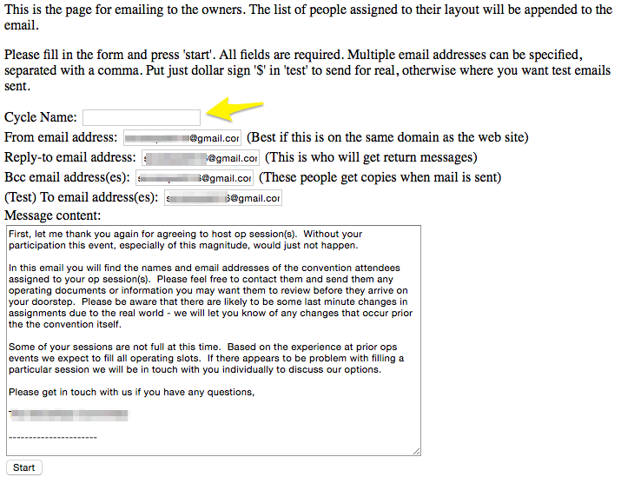
The steps are:
- Enter the name of your current assignment cycle. EventTools uses that to get information about which layout owners (ones with people assigned) or attendees (one with sessions assigned) to email.
- The “From”, “Reply-to” and “Bcc” email addresses are automatically filled in, but you can change them. The three addresses are:
  - “From” - this is where the email will appear to have come from. Can't be blank. Should be a single email address, not multiple addresses.
  - “Reply-to” - if the recipient sends an email in reply, this is where that email will go. Can't be blank. You can put in multiple addresses by separating them with commas: foo@gmail.com, bar@gmail.com
  - “Bcc” - who should get a copy of every email sent? You can leave this blank, but it's better to have one of the organizers get & keep a copy of the emails in case there's confusion later on. You can put in multiple addresses by separating them with commas: foo@gmail.com, bar@gmail.com
- The “To email address(s)” field can to two different things:
  - If there's a specific email address in the field, all the emails will be sent to that address only, not to the attendee or owner. This is a good way of testing how the mailing is going to go: You'll be able to see each email that would have been sent to the attendee or owner, with all the specific information about sessions and attendees filled in. We recommend that you do this as a test before sending for real (next bullet).
  - If you enter a dollar sign ($) there, the program will send the emails to each person's email address as known by EventTools. This is the way you can email the entire group of people all at one time. For an owner email, it's taken from the layout table. For an attendee email, it's taken from the attendee's registration.
- The body of the email is in the large text field. The program provides some default text, but you're welcome to modify it as you will. Note that EventTools doesn't remember your changes: You get the same default content every time. You might want to keep the text in a word-processor document on your computer so you can copy & paste it back and forth.
When the email is sent, each email gets specific information appended to it. When emailing the layout owners, this will be the names and contact info of the people assigned to their sessions. When emailing attendees, it's the names and times of the sessions to which they've been assigned. Run a test emailing to see the exact content and format.
Finally, pressing the “Start” button starts the process of formating and sending the emails. If you've used the “Bcc” field or are running a test, you should start to see emails arriving right away. The sending process is throttled down to make it less likely that your emails will look like spam, so it might take a couple minutes to complete the mailing for a large meet.

When you first access an EventTools page, you may be asked to identify yourself. Enter your email address (if in doubt, ask the webmaster); you can leave the password field blank for now.
Layouts and operating sessions have independent status fields. You should make sure that layouts used for operating sessions have their status set so that they're visible to the attendees; EventTools doesn't enforce this yet.
If need be it can be a dummy.
EventTools can't automatically split requests, e.g. “We want to be together on Tuesday, but not Thursday”. Those can be handled manually if the organizers want, of course.

