# Introduction

This document describes the telephone system on the SP Shasta Division, specifies operating procedures and provides check lists for trouble shooting.

## The Prototype and Control Station Set up

In prototype practice everyone at a fixed station (operators, dispatchers) were always on the line because they were wearing a headset or were in earshot of a speaker across the line. If you (an operator or dispatcher) wanted to talk to someone, you got on the line and announced your station name and whom you were calling. Crews would not normally call in from TT&TO territory to OS as there were operators to this. CTC dispatchers could set "MC" lights on relay sheds at OS points to indicate that crews should stop and call in. We use the MC lights at both OSs and in Dunsmuir yard. The calling station would wait until sure the line was clear and then announce his location.

There are three talk circuits (lines) on the Shasta Division:

* The Dunsmuir circuit for the Canyon (CTC) dispatcher: This line connects the Canyon dispatcher to the phones from Redding to Black Butte.

The dispatcher has a modern dynamic microphone, a footswitch which acts as a "stomp to talk" switch, a vintage Western Electric 100F self-powered loudspeaker (featuring vacuum tubes! -- so be sure to turn it on with the right hand knob, note pilot light is on and wait 30 seconds for it to warm up and be sure to turn it off after the session). The whole arrangement is run off a blue unit that says "Valcom" on it -- it's a heavily modified telephone grade intercom. The DS has an additional phone (a 1930s vintage model 302) for calling the BU (Shasta) DS.

* The Black Butte Operator circuit: This connects the TT&TO territory phones to the Black Butte operator, who has responsibility for talking to the stations on the dark (Shasta) portion of the railroad.

The Black Butte operator has a classic two-pronged jack box into which any compatible headset can plugged but we've got it set up with a wireless headset so the operator can walk around and investigate situations on the TT&TO section of the layout. There is no stomper as we don't want the operator to be tied to his position. Note that operator has a plunger switch on the jack box so he can get on the CTC line and talk to the CTC dispatcher, but if left there, none of the TT&TO (Shasta) stations can talk to him, so the plunger switch should be used sparingly.

* The Shasta circuit for the Shasta dispatcher: This connects the Shasta dispatcher to the Klamath Falls operator. Prototypically it would also connect to the Black Butte operator, but he’s so close that they just talk to each other directly. The Canyon dispatcher also has a phone on this line which he can pick up to talk to Shasta dispatch.

The Shasta dispatcher has classic a Scissors Mount Candlestick Phone, a footswitch which acts as a "Stomp to talk" switch, and a vintage Western Electric 100F self-powered loudspeaker (featuring vacuum tubes! -- so be sure to turn it on and wait 30 seconds for it to warm up and to turn it off after the session). There are no active electronics in the speech path, so the Shasta DS needs to get his mouth into the horn of the mic and speak firmly (this is your GRANDFATHER’s phone). The Shasta has a box with push buttons which may be used to signal (buzz) the dark stations although generally he will ask the Black Butte operator to set a train order board.

In addition the Shasta DS has a toggle switch under the desk to put himself on the Canyon (CTC) dispatcher's line if he needs to talk to him.

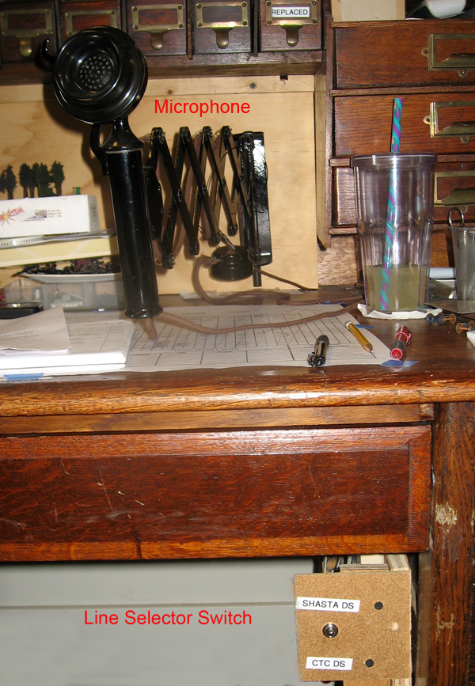

Figure 1 - Shasta DS Overview

There is also a position within the helix for the Reading/KFalls Operator. It is similar to the BBOP position except that it has a footswitch which acts as a "stomp to talk" switch. The R/KF operator normally uses a modern, light weight, headset but may elect to use the breast plate unit. Note that the Breast Plate mic is not very efficient and care must be taken to keep the horn in position and speak very firmly if the R/KF operator is to be heard. R/FK has a plunger style switch which may be used select between the CTC and Shasta circuits. Normally he stays on Shasta but may be signaled by the CTC board using an MC. Generally the plunger is left in the Shasta Position.

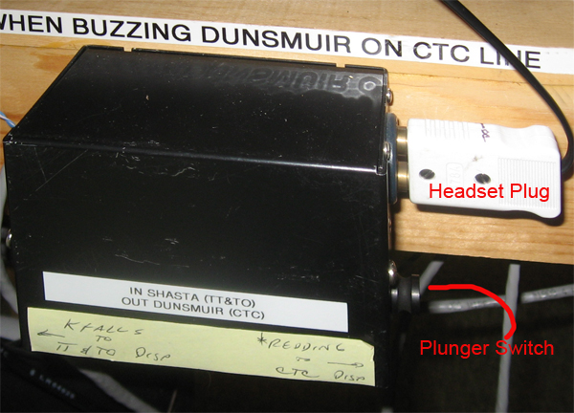

Figure 2 - Helix Headset Jack and Switch

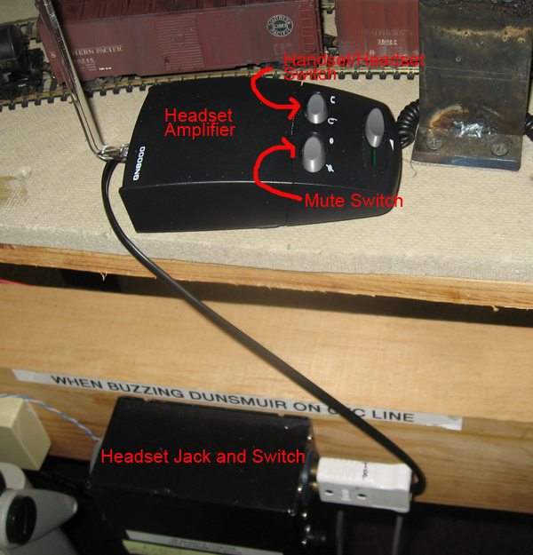

Figure 3 - Headset Amplifier



Figure 4 - Schematic Diagram

# Operating Instructions:

1. For a train crew to OS:

A. Stop at Station, check to see that switch is calling the correct DS (you DO know which one you're supposed to call?)  
B. LISTEN to ensure that no one else is talking on the line at the moment  
C. PUSH the push-to-talk button in the handset and announce your station "Grass Lake"

D. Wait for DS to acknowledge  
D. OS your train " X4261E by at 1:15 PM"

2.  If the Redding Operator wants to talk to the CTC dispatcher:

A. He sets his line switch to CTC, listens for traffic and announces himself: "Redding"   
B. The dispatcher answers and they converse  
C. Redding operator sets his line switch back to Shasta line when done

3. If the Redding Operator wants to talk to Shasta dispatch, he does the same as for CTC but with the line switch set to BU. Default is listening to BU.  
  
4. If the Shasta dispatcher wants to call KFalls, he sets his line switch to Shasta (default) and announces himself and asks for KFalls, and the KFalls op should answer.  If not (KF is on the CTC line), the dispatcher has a buzzer key on the control box

5. If the BU DS wants information from a train which is on the road, he asks the BU Agent to set a TO board and have the train call in at the next open TO office. The BBOP will act as his proxy.  
  
6. If the CTC DS wants to talk to a train which is on the road, he sets the MC switch for the station and codes it.  Crew should see blinking light, stop and call in. Once the Train has answered, the CTC DS turns his MC switch off and codes again to clear the blinking light.  
  
7. If the CTC DS wants to call a manned station (e.g. a yard) he sets the MC switch for the station and codes it which drives a buzzer with telegraph code for the station, and optionally can set a light.  The Yardie or OP picks up.

8. If the CTC DS wants to talk to the Shasta DS, he picks up the desk set and listens for traffic, then announces himself. No PTT on this set.

# Stations

| **Station** | **CTC Line** | **Shasta Line** | **BB Operator Line** |
| --- | --- | --- | --- |
| Black Butte | X |  | Default |
| Black Butte Operator | X |  | Default |
| CTC DS | Default | 302 Set |  |
| Upper Dunsmuir (Turntable) | Primary |  | Secondary |
| Lower Dunsmuir (Yard) | X |  |  |
| Grass Lake |  |  | X |
| Leaf |  |  | X |
| Redding Sta |  |  | X |
| Reading/K Falls | X | X |  |
| Shasta DS | X | Default |  |
| Shasta Springs | X |  |  |

Table 1- Stations

# Checklist and Troubleshooting

1. CTC Station
   1. Power on (for Valcom Blue Box)
   2. Amplifier on (Twist knob on right clockwise)
   3. Dispatcher using footswitch
   4. Mic on (slide switch below mic)
2. Shasta Dispatcher station
   1. Toggle switch on correct line
   2. Amplifier on (Twist knob on right clockwise)
   3. Dispatcher using footswitch
3. Black Butte operator station
   1. Plunger switch on correct line
   2. Headset properly charged
   3. Headset not muted (button on headset)
4. R/KF operator station
   1. Plunger switch on correct line
   2. Operator using footswitch
   3. Amplifier (the headset plugs into the amp) not muted (lips with bar across them) left hand rocker switch
   4. Amplifier set to headset not handset (see icons on right hand rocker switch)
   5. Batteries not dead. Leave them out of the amplifier box (flip lid up)
   6. Amplifier settings OK:
      1. Transmit volume is the small shaft inside. Full volume is all the way clockwise. Back it off one position to avoid distortion
      2. Mic type matching on the side – leave on A
      3. There’s a third one – can you check? It’s OK now [20150423]
5. All Upstairs lines
   1. Power on for phone system
   2. No fuses blown
   3. Before session, walk the layout and pick up each phone, (both positions of there is a toggle switch) push the PTT and be sure you can hear yourself in your ear. Best to test with someone at each DS position and be sure levels are OK.