Patrick Liu

CS&SS554

Homework 1

1/22/2017

1.)

a.)

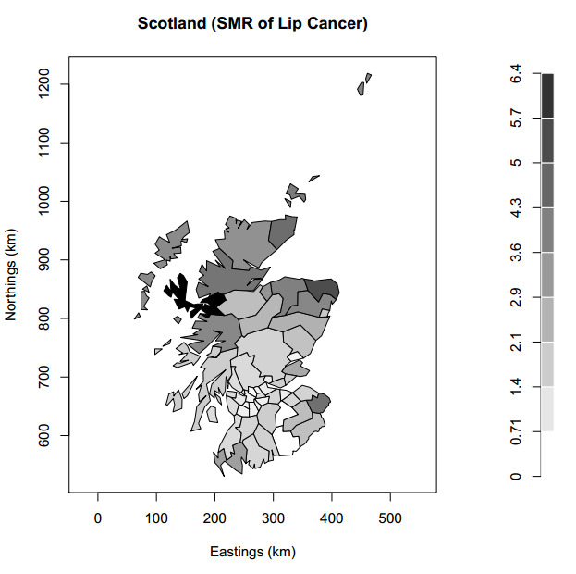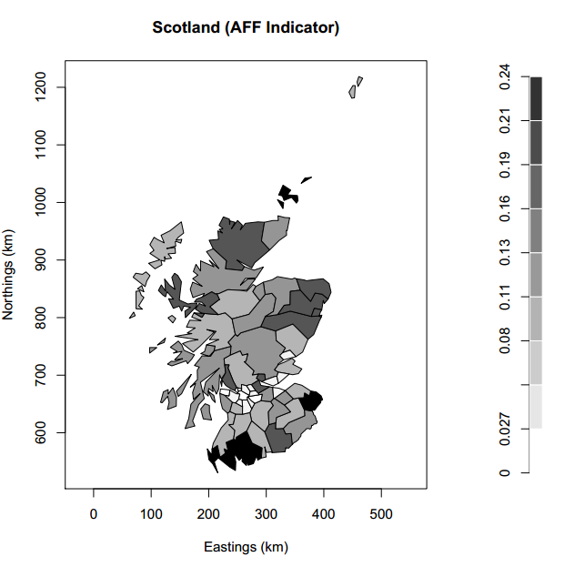

b.) $\exp\left(α\right)$ is equivalent to the estimate of baseline risk of lip cancer when there is no AFF. $\exp\left(β\right)$ is estimate of the relative risk describing the area-based association between incidence of lip cancer and AFF.

c.)

|  |  |  |  |  |
| --- | --- | --- | --- | --- |
|  | Estimate | Standard Error | exp(Estimate) | 95% CI (exp) |
| $$α$$ | -0.542 | 0.0695 | 1588 | 0.506-0.664 |
| $$β$$ | 7.373 | 0.596 | 2.09 | 492.99-5094.11 |

Estimate of $k$ = 4.92

d.)

|  |  |  |  |  |
| --- | --- | --- | --- | --- |
|  | Estimate | Standard Error | exp(estimate) | 95% CI (exp) |
| $$α$$ | -0.293 | 0.525 | 0.746 | 0.0195-0.153 |
| $$β$$ | 5.67 | 1.182 | 290.035 | 27.991-2885.14 |
| $$β_{lat}$$ | -0.00087 | 0.00132 | 0.999 | 0.997-1.001 |
| $$β_{long}$$ | 0.00385 | 0.00070 | 1.0038 | 1.002-1.005 |

e.) There is significant relationship between longitude and lip cancer risk, and including longitude as a covariate attenuates the magnitude of the relationship between lip cancer risk and AFF. Our first model didn’t account for any of the spatial autocorrelation in the data—this second model suggests that our initial model overestimated the effect of AFF on lip cancer incidence. Some of the estimated effect is now attributed to longitude, which was significant. This is likely accounting for some other underlying omitted variable that we’re not currently accounting for.