Patrick Liu

CS&SS554

Homework 4

2/15/2017

1.) Cluster detection with Besag and Newell (k=500) identifies the regions in the southwest of Pennsylvania as potential clusters.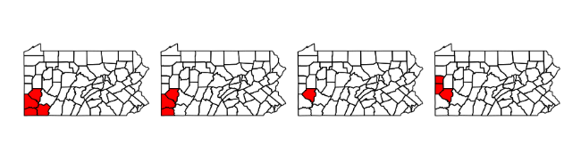

2.) Clutser detection using Satscan method of Kulldorff similarly finds the cluster in the southwest corner of Pennsylvania.

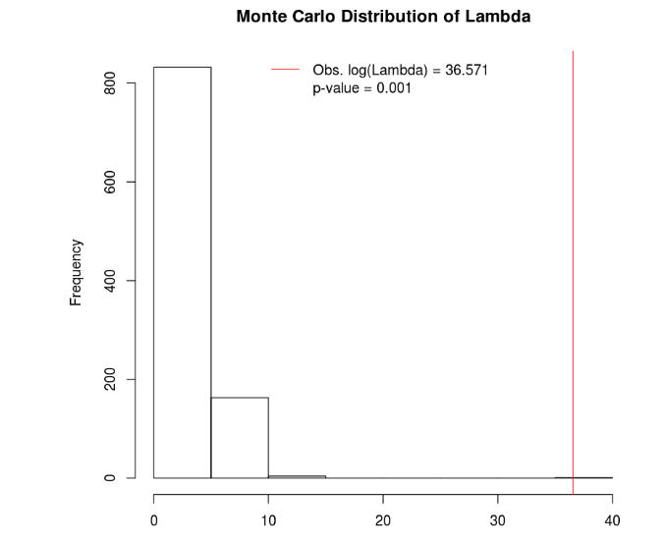

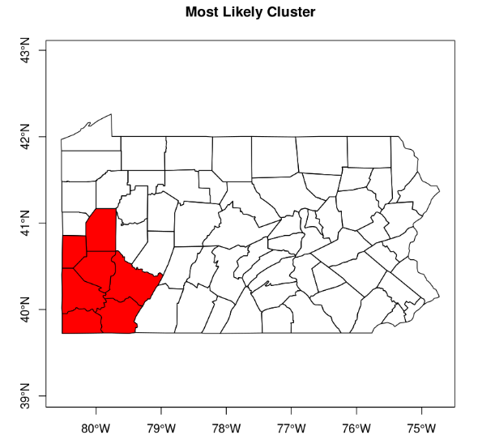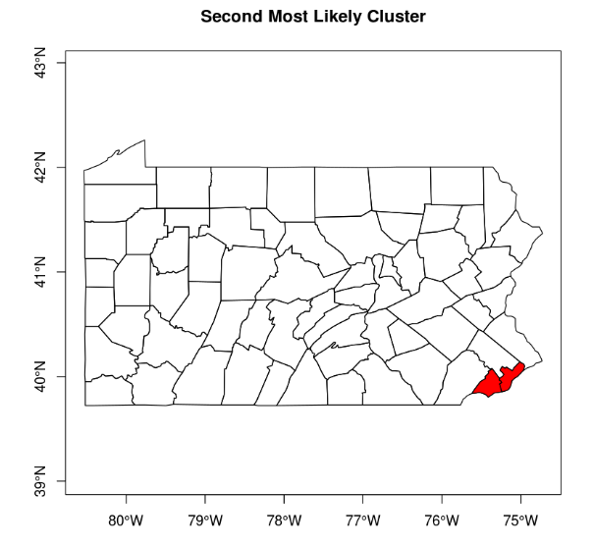

2.)

a.) Map of RR estimates using empirical Bayes

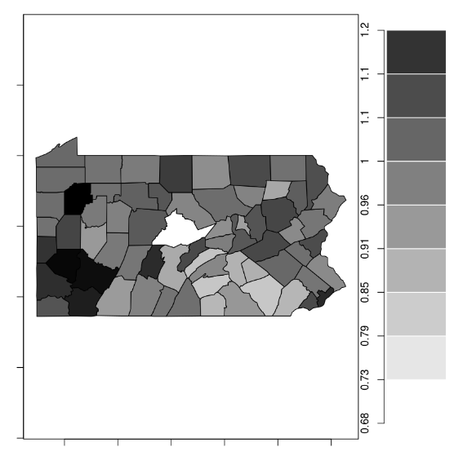

b.) Plot of empirical bayes against SMRs. The estimate looks reasonable but shows shrinkage/expansion at the lower and higher ends of the distribution.

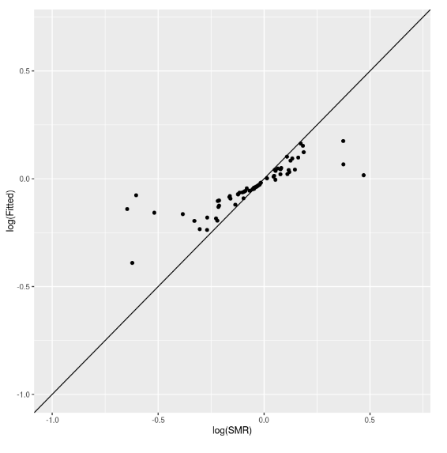 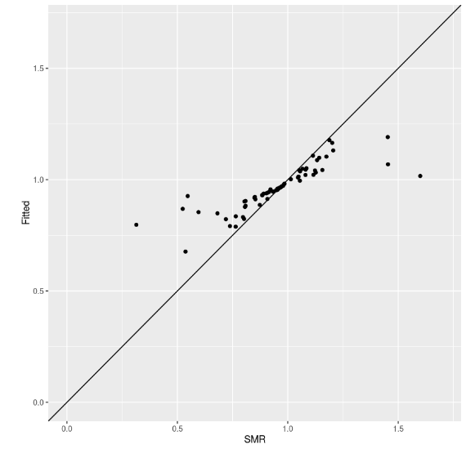

c.) Plots of draws from the gamma distribution for I = 1, 2, 3, 4

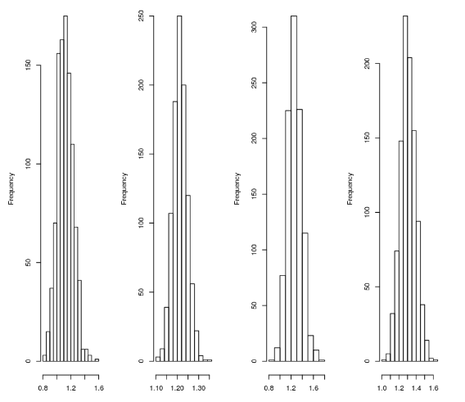

d.) Plots of gamma densities using EBpostdens

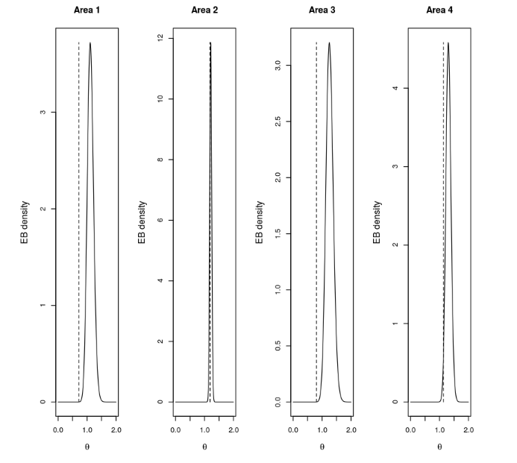

e.) Maps of posterior medians

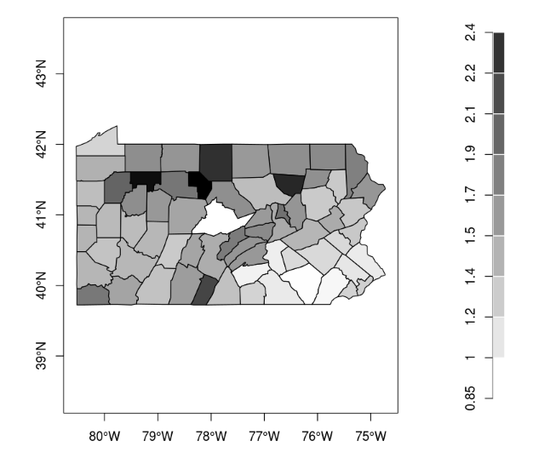

Plot of median versus means suggests left skew in the distribution.

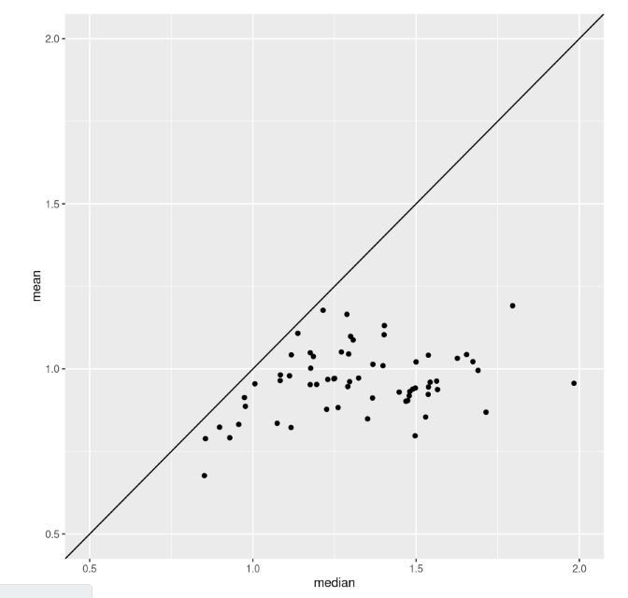

f.) Map of posterior standard deviations, which looks comparable with the standard error of the SMR map.

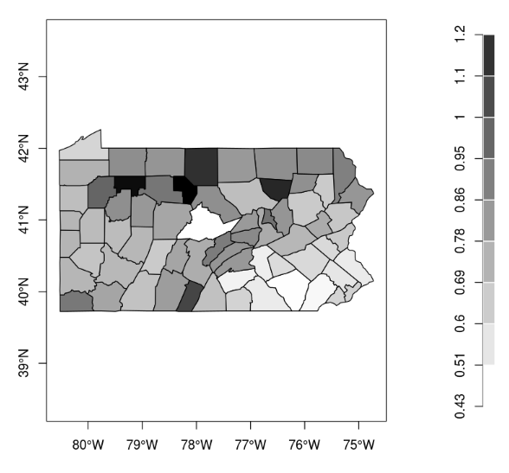

g.) Posterior probabilities that exceed threshold of 1.2. Regions include the cluster detected previously in the southwest, but also a several counties around the northern border. The second detected cluster in the southeastern corner looks like it is clustered in low values.

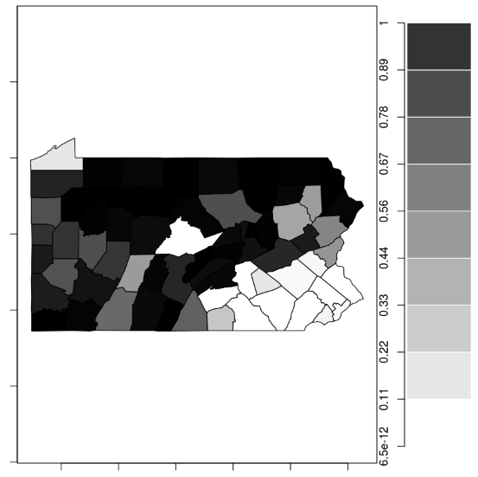

h.) Fit of Poisson-Lognormal using INLA

Beta_0: 0.955 (0.912-0.998)

Sigma_e: 0.14 (0.106-0.184)

i.) Map of RR estimates from INLA

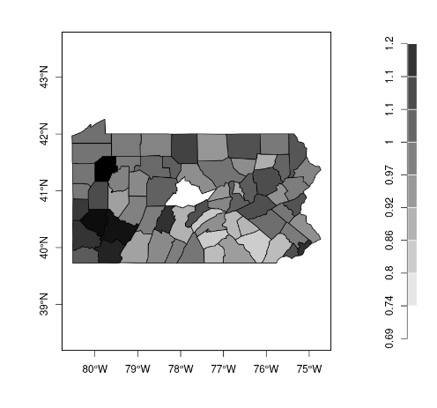

Comparison with Poisson-Gamma model shows that the estimates are very similar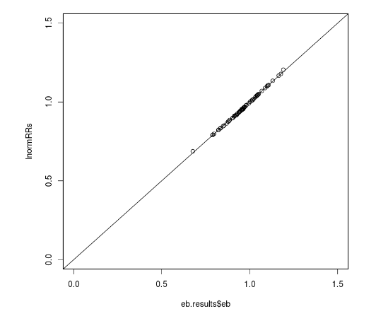

j.) Histogram of random effects seems to follow a normal distribution

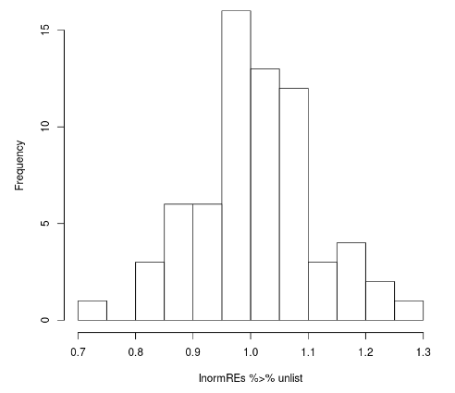

k.) Fit with spatial random effects using penn.graph neighborhood structure

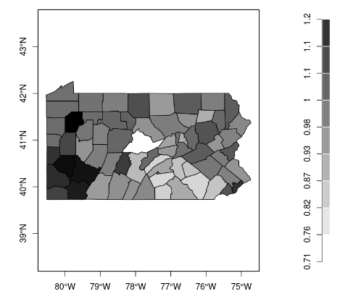

The precision of the random effects for Si (median 5e03) is much larger than that of ei (median 4.5e01), suggesting that there is a strong effect of clustering.