# District-level estimates of reproductive health indicators in Uganda

Patrick Liu

CS&SS 554A, Wakefield (Winter 2017)

# Background

Globally, it is estimated that 275,000 maternal deaths occurred worldwide in 20151. Progress towards the achievement of millennium development goal (MDG) 5 has been slow, with only 10 countries who have achieved a 75% decrease in maternal mortality rate (MMR) by 2015. As the MDG era has come to a close, the adoption of the Sustainable Development Goals (SDGs) was meant to build on the momentum of the past 35 years, but also reframe the goals within the context of environmental and societal challenges inherent in sustainable development.

Increasing access to reproductive health services—such as skilled birth attendance, delivery in a facility, and antenatal care—has played an important role in the reduction of MMR in the past several decades1. The creation of SDG target 3.7 has continued to highlight importance of reproductive health services, specifically calling for universal access to sexual and reproductive health services by 20302.

A recent report found that just 10 countries—which include Uganda—account for 60 percent of all maternal deaths globally. The Global Burden of Disease 2015 study estimated that, nationally, the maternal mortality rate in Uganda was around 300 per 100,000, remaining relatively constant since 20001. In an attempt to improve maternal health outcomes, Uganda’s government has prioritized expanding reproductive health services over the past two decades. To date, however, most studies benchmarking health systems performance in Uganda have been at the national or regional level—making it impossible for policymakers to understand disparities in access at the subnational level or be able to utilize these gaps for more targeted policies and interventions3.

Recently, the Ugandan government has been undergoing a process of dividing districts into smaller units, intending to prevent resources distributed to districts to remain in chief townships and not reach more rural areas4. As of 2005, Uganda was divided into 55 districts and the city of Kampala (56 districts in total). Contemporary estimates of reproductive health service at this geographic granularity will be crucial for serving as a benchmark for measuring progress and targeting policy in the forthcoming SDG era.

In the current study, we utilize data from the 2000, 2006, and 2011 Uganda Demographic and Health Survey to estimate utilization of key reproductive health service indicators for the 55 districts of Uganda and the city of Kampala.

# Methods

## Data and Indicator Definitions

The 2000, 2006, and 2011 Uganda Demographic and Health Survey (UDHS) is the third, fourth, and fifth follow-up in the series of DHS surveys completed in Uganda5. Each are household surveys that follow a multi-stage cluster sampling structure and are focused on measuring key maternal and child health outcomes and indicators of health care utilization. These three surveys were chosen because the data are geo-located whereas prior surveys in the series were not.

The UDHS follows a stratified multi-stage cluster sampling design. In the first stage, enumeration areas were selected, stratified by region and urbanicity. In the second stage of sampling, households were selected randomly from a complete listing of households.

We utilized questions from the Women’s Questionnaire module to analyze utilization to reproductive health services. Specifically, we report estimates for the antenatal care (ANC4), skilled birth attendance (SBA), and in-facility delivery (IFD). More detailed definitions can be found in Table 1.

**Table 1. Definitions for indicators of access to reproductive health services**

|  |  |
| --- | --- |
| Indicator | Definition |
| ANC4 | Proportion of births where mother went to at least four skilled (doctor, nurse, midwife) antenatal care visit |
| SBA | Proportion of births delivered with a skilled birth attendant (doctor, nurse, midwife) present |
| IFD | Proportion of births delivered in a health (public or private) facility |

## Data Processing

Survey questions pertaining to ANC, SBA, and IFD are asked about the respondent’s most recent birth. As this restriction disproportionately excludes older children from high parity mothers, we restricted the age range for to children born within the past year. Categories of skilled workers and health facilities are reported at more granular levels by the UDHS. Here, we have aggregated skilled health workers for antenatal care and birth attendance to include doctors, nurses, and midwives—to serve as a proxy for the availability of basic emergency obstetric care (EmOC). Health facilities included any facility that was not home or a traditional health facility—these included public and private hospitals, clinics, and birthing centers.

## Geographical/time units of analysis

The UDHS reports at the national level and a subnational level of ten sub-regions (Central 1, Central 2, Kampala, East Central, Eastern, North Karamoja, West Nile, Western, and Southwest). In this analysis, we estimate coverage at the district level— with 55 districts and the city of Kampala.

Clusters from each of the surveys are geo-located and reported with jittered latitude and longitude coordinates. We reassigned the clusters from the sub-regional level to district level by including all clusters within the boundaries of the new districts as part of that district. **Figure 1** displays clusters within the district boundaries for the 2011 UDHS.

We estimated coverage for four time periods from 2000 to 2015—specifically, 2000, 2005, 2010, and 2015.

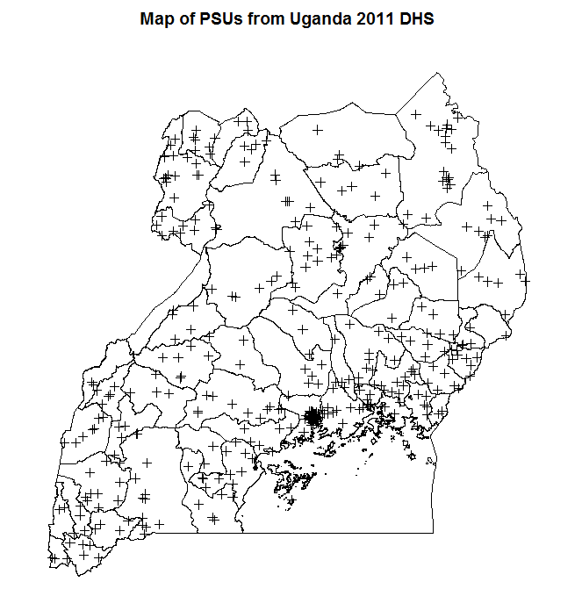

**Figure 1.** Distribution of clusters for the 2011 UDHS within the 56 districts of Uganda

## Modeling

We fit the following Bayesian hierarchical model for each of the care indicators:

$$y_{s,t}= log\left(\frac{\hat{p_{s,t}}}{1- \hat{p_{s,t}}}\right)\sim N(θ_{s,t}, {\hat{V}}_{s,t})$$

$$θ_{s,t}=β_{0}+ϵ_{t}+T_{t}+γ_{s}+S_{s}$$

$${\hat{V}}_{s,t}= \frac{var(\hat{p_{s,t})}}{{\hat{p_{s,t}}}^{2}(1- {\hat{p_{s,t}}}^{2}) }$$

$$ϵ_{t} \sim N\left(0, σ_{e}^{2}\right), γ_{s} \sim N(0, σ_{γ}^{2})$$

$$T_{t} | T_{t-1}, T_{t+1}\sim N(\frac{1}{2}\left(T_{t-1}+ T_{t+1}\right), \frac{σ_{t}^{2}}{2})$$

$$S_{i} | S_{j}, j ∈ne\left(i\right)\sim N(\overline{S_{j}},σ_{s}^{2})$$

where ps,t, the proportion covered for a given indicator in time t and district s is normally distributed in process in logit space with mean $θ_{s,t}$ and variance ${\hat{V}}_{s,t}$, the delta transformed variance estimate which incorporates the complex survey design of each survey. The specified model has an intercept $β_{0}$ and a series of random affects that account for space and time effects: $ϵ_{t}$ is unstructured random effect on time, $T_{t}$ is a temporal random effect that follows a random walk 1 process, $γ_{s}$ is an unstructured random effect on district, and $S_{s}$ is a spatial random effect that follows an intrinsic conditional autoregressive (ICAR) process. Weakly informative priors for $β_{0}$, $σ_{e}^{2}$, $σ_{γ}^{2}$, $σ_{t}^{2}$, and $σ_{s}^{2}$. The median, 2.5th, and 97.5th percentiles of the posterior distribution were inverse-logit transformed to generate point estimates and uncertainty intervals (UIs) in each district and time interval.

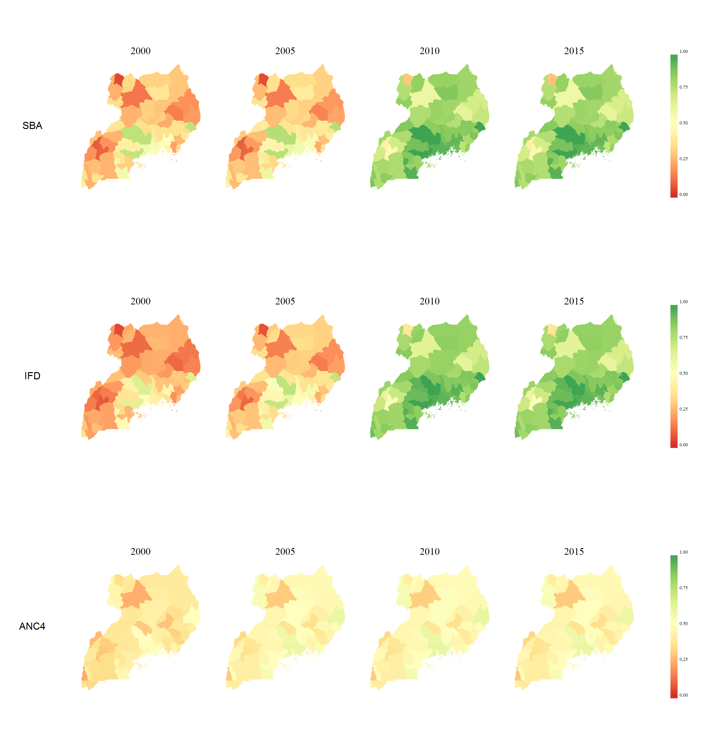

**Figure 2.** District-level maps of the median estimate of SBA, IFD, and ANC4 in 2000, 2005, 2010, and 2015.

# Results

Nationally, coverage of both SBA and IFD Has increased substantially since 2000 while coverage of ANC4 has remained relatively stagnant since 2000. The general trends of increasing SBA and IFD, and stagnation of ANC4 at the national level occur across most districts in Uganda.

There is a great deal of heterogeneity in coverage between districts across coverage of SBA, IFD, and ANC4 (Figure 2). The geographic distribution of coverage for SBA is very similar to that of IFD, while that of ANC4 is more equally distributed, but has collectively lower coverage (Figure 3). Regionally, the southern districts of Uganda near Kampala have the highest coverage across indicators while areas in the West, North East, and North West in particular have consistently low overage. Across time, most of the progress in coverage of SBA and IFD is seen between the periods of 2005 and 2010.

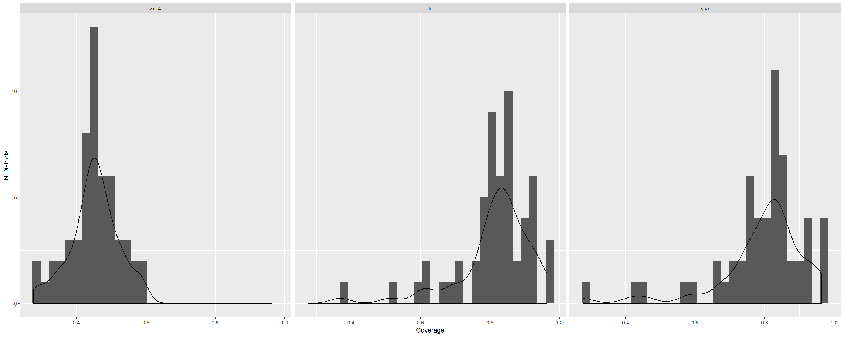

**Figure 3.** Histograms and densities of coverage estimates for SBA, IFD, and ANC4 by district

Despite overall increases in SBA and IFD, several districts including Yumbe, Kabarole, and Kamwenge still have relatively low coverage for SBA at 27.7%, 41%, and 45.8%, respectively. As of 2015, a total of 44 districts have yet to reach 50% coverage of ANC4. A full table of estimates can be found in **Appendix Table 1** (submitted online).

# Discussion

This study represents a small area estimation analysis in which we have modeled coverage of key reproductive health indicators in Uganda at the district level from 2000-2015. While both coverage SBA and IFD increased over the time period, with a majority of districts reaching overage of 75% by 2015, coverage of ANC4 generally flattened and has stayed low. Analyzing district level trends revealed marked heterogeneity and disparities in coverage levels. For example, in 2015, the largest gap between the highest and lowest districts for SBA was about 70% (between Yumbe and Kapchorwa). Because surveys like the UDHS are costly and completed relatively infrequently, this further emphasizes the importance of routinely monitoring health indicators at the district level at the administratively through further developing the HMIS system6. Nevertheless, these estimates provide an important insight into identifying areas of high need in which attention and resources should be focused.

The findings of ANC4 coverage being stagnant over time is consistent with a similar recent analysis done at the regional level3. This gap in ANC4 coverage is consistent with previous findings that women are late to start antenatal care in Uganda, leaving a large proportion of pregnant mothers unable to attend 4 ANC sessions before delivery7. The disparities in SBA and IFD coverage is not unique to Uganda, but seen across sub-Saharan Africa. Better understanding of the service and person-level barriers to care—including cost, distance to care, cultural practices, and adequate health center staffing and supplies—will be crucial steps in improving coverage across Uganda and closing the disparities in coverage.

# Conclusion

Decentralization of Uganda’s health system management in favor of more local governance requires subnational benchmarking as we progress into the SDG era. From 2000 to 2015, Uganda has experienced district-level increases in SBA and IFD while coverage levels of ANC4 has stalled. Continuation of estimates at this level going forward are crucial for measuring progress and setting relevant and targeted policy not only in Uganda but across countries in sub-Saharan Africa.

# References

1 Kassebaum NJ, Barber RM, Bhutta ZA, *et al.* Global, regional, and national levels of maternal mortality, 1990–2015: a systematic analysis for the Global Burden of Disease Study 2015. *Lancet* 2016; **388**: 1775–812.

2 Goal 3 .:. Sustainable Development Knowledge Platform. https://sustainabledevelopment.un.org/sdg3 (accessed March 13, 2017).

3 Roberts DA, Ng M, Ikilezi G, *et al.* Benchmarking health system performance across regions in Uganda: a systematic analysis of levels and trends in key maternal and child health interventions, 1990–2011. *BMC Med* 2015; **13**: 285.

4 Local Governments Act 1997 | ULII. http://www.ulii.org/ug/legislation/consolidated-act/243 (accessed March 13, 2017).

5 The DHS Program - Quality information to plan, monitor and improve population, health, and nutrition programs. http://dhsprogram.com/ (accessed March 13, 2017).

6 Kiberu VM, Matovu JK, Makumbi F, Kyozira C, Mukooyo E, Wanyenze RK. Strengthening district-based health reporting through the district health management information software system: the Ugandan experience. *BMC Med Inform Decis Mak* 2014; **14**: 40.

7 Kisuule I, Kaye DK, Najjuka F, *et al.* Timing and reasons for coming late for the first antenatal care visit by pregnant women at Mulago hospital, Kampala Uganda. *BMC Pregnancy Childbirth* 2013; **13**: 121.