Extra Chapter Version Control for Software Code Using git and GitHub

Objectives:
* To introduce forms of source code version control for the Raspberry Pi OS, particularly the git command, and Github
* To detail the basic concepts and structure of a Git repository
* To illustrate the Git staging model
* To define a Directed Acyclic Graph (DAG)
* To provide numerous practical examples of using the git command
* To show strategies of managing a Git repository with branches via example
* To give a tutorial on GitHub use
* To allow you to use GitHub to obtain the supplementary materials for this book

Commands and primitives covered:
git

Anything that you are required to type on the command line is show in bold type.

2.1 Introduction to Version Control

Studies have shown that about two-thirds of the cost of a software product is spent on maintenance. The maintenance of a software product comprises corrective maintenance and enhancement. In corrective maintenance, the errors and bugs found after the deployment of a software product are fixed. In enhancement, the product is enhanced to include more features, such as an improved user interface. Regardless of its type, maintenance means changing and/or revising the source code for the product and generating new executables. This means using a version control system (VCS). As you revise source code, you may need to undo changes made to it and go back to an earlier version of the software. If an individual or team of programmers is working on a piece of software, they should be able to locally and autonomously maintain editable (modifiable) versions that can be joined together at a convenient time.

Git and GitHub are atomic-level, distributed, content-oriented VCSs. Atomic-level means that when you take a snapshot of the software package, everything in it is captured in the snapshot at a single instance in time. Distributed means that the entire software package you are working with is available to all collaborators locally at all times. Content-oriented means that when you join different branches of work on the software, only the content of lines in the files along the branches you are merging are considered. Here, content means “with form,” and context means “with meaning.” Git only considers content when it operates on your software files and directories; the individual(s), collaborator(s), or integrator(s) of the software project are responsible for the merged context of the files in the software package. The combining of different lines of development of a project that causes content conflicts are indicated by Git with several useful strategies and mechanisms, and their resolution is aided by many tools that are available as add-ons to Git. But only the people writing and testing how the software works, the content creators, and those people managing that process, are responsible for resolving merged-context conflicts.

In-Chapter Exercise
1. Give a detailed example of what you think is content tracking in a revision control system. Then contrast that example with what you think is context tracking.

Git, as a source code maintenance tool, is a software database for tracking changes made to a set of source code files over time. Although programmers most often use it to coordinate changes to software source code, you can use Git to track any kind of content.
Git can-

1. Examine the state of your source code project at earlier points in time.
2. Show the differences among various states of the project, and the files present at those states.
3. Split the project development into multiple independent lines, called branches, which can evolve separately.
4. Regularly recombine branches by merging, or reconciling, the changes made in two or more branches.
5. Allow many people to work on a project simultaneously, sharing and combining their work as needed.

Git is a member of the newer generation of distributed VCSs. Older systems such as SCCS, RCS, CVS, and Subversion are centralized, meaning that there is a single, central copy of the project content and history to which all users must refer. If the central copy is unavailable, all users must wait until the central copy is online again. Distributed systems such as Git have no central copy. Each user has a complete, independent copy of the entire project history, called a repository, and full access to all version control facilities. Network access is only needed to share changes among members of the same development team or group.

Git’s distributed nature accommodates many different styles of interaction, or workflows. Individuals can share work directly between their personal repositories. Git is the technology behind the social coding website GitHub, which includes many well-known open-source projects, most notably for the Linux kernel.
We discuss Git and GitHub in an examples-based tutorial presentation.

For Git and GitHub, the following subsections will include:

1. How Git is used, and how it works on a Raspberry Pi system.
2. A high-level overview of the Git terminology, data structures, objects, and actions.
3. Illustrations, both graphical and verbal, of the Git staging model, what a directed acyclic graph (DAG) is, and a finer-grained view of the object store contents.
4. A short and a long example of how to create, edit, branch, and merge branches of a Git repository.
5. An exploration of GitHub as a remote repository.
6. Three basic examples of how to use the git clone, git push, and git pull commands and options to transfer repository contents between a local repository and GitHub online.
To get the most useful information out of this Chapter, you are encouraged to first read through the high-level background materials in first three subsections. Then do the examples in the subsequent three sections, as many times as necessary to become comfortable using Git and GitHub. Finally, be sure to do all In-Chapter Exercises and the problem set on Git and GitHub at the end of this Chapter.

2.2 What Is Git Used for and How Does It Work?

Git is used to manage one or more source code project repositories, each packaged into its own directory that you create for the source code files in that project.

The concept of a project contained in its entirety in a Raspberry Pi Os single directory on the file system, is very critical and important.

A repository is a database containing all the information needed to archive and manage the revisions and history of a project. In Git, as with most VCSs, a repository archives a complete copy of the entire project, with all of the revisions to it.

Git maintains a set of configuration settings and files within each repository. Unlike file data and other repository metadata, configuration settings are not transferred from one repository to another during a cloning, or duplicating, operation. Instead, Git manages and inspects the configuration and setup information on a per-site, per-user, and per-repository basis. Within a repository, Git maintains two primary data structures, the object store and the index. The object store is designed to be efficiently copied during a clone operation as part of the mechanism that supports a fully distributed VCS. The index is transitory information, is private to a repository, and can be created or modified on demand as needed. All of this repository data is stored at the root of the working directory of the repository, in a hidden subdirectory named .git.

Simply put, with Git and GitHub, you can manage your source code repositories and work in an independent, collaborative, or integrated and efficiently managed way. A majority of the introductory material we present here is aimed at the independent developer. From a learning point of view, you need to first know how to use Git in an independent way. Then we also show some collaborative workflows, particularly with GitHub.

***Note***
We do not touch on the integrative management techniques and commands of Git or GitHub.

In-Chapter Exercise
2. What do you think the role of an integrator of a project would be, in terms of what a revision control system accomplishes for a software development and maintenance program, and the project that envelops it?

2.3 Basic Git Terminology
Following are the definitions of essential, and very basic Git terms used throughout our examples. These terms are further partitioned into categories that reflect the basic structure of the Git repository itself.

2.3.1 Top-Level Terminology

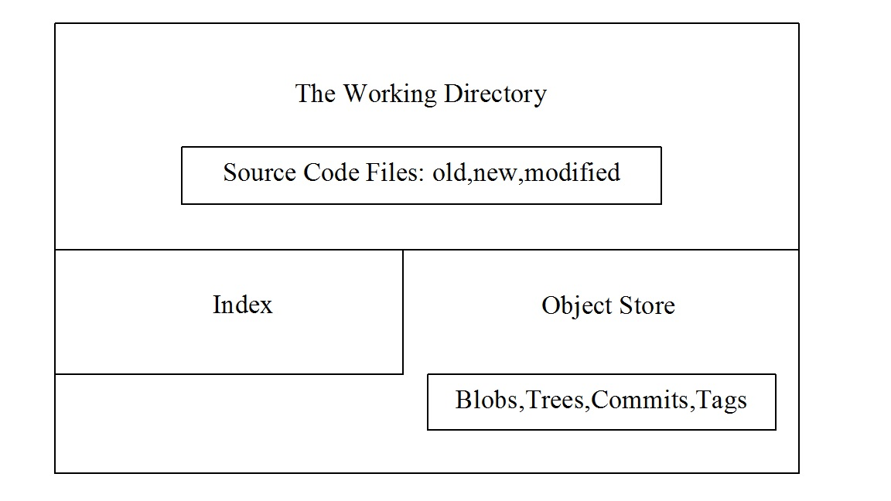

Figure 2.1 The Structure of the Repository

Repository: The repository is the working directory, and contains inside of itself the source code files you want to maintain and control, the object store, and the index, as shown in Figure 2.1. The advantage of having the repository self-sufficient inside of its own container is that the container can then be shared locally and globally.

A repository can also be thought of as a collection of commits, each of which is an archive of what the project’s working tree looked like at a past date, whether on your Raspberry Pi, or another one. It also defines HEAD, which identifies the branch or commit the current working tree stemmed from. It contains a set of branches and tags, to identify certain commits by name.

Working directory: The working directory is any directory on your file system that has a repository associated with it, typically indicated by the presence of a subdirectory within it named .git. It includes all the files and subdirectories in that directory.

Object store: Holds the changes in your source code over time, as you perform more commit operations. It is found in the .git subdirectory of your working directory. Its primary components or data structures are blobs, trees, commits, and tags.

The index (staging area): This is a cache, or intermediate area, between your working tree and your repository. You can add changes to the index and build your next commit step by step. When your index content is complete, you then commit from the index. It is also used to keep information during failed merges (your side, their side, and current state). Unlike other, similar tools you may have used, Git does not commit changes directly from the working tree into the repository. Instead, changes are first made in the index. Think of it as a way of double-checking your additions or modifications, one by one, before doing a commit. You can also call it the staging area.

Blobs: Each version of a file is represented as a blob. Blob, a contraction of “binary large object,” is a term that’s commonly used in computing to refer to some variable or file that can contain any data and whose internal structure is ignored by the program. A blob is treated as being opaque. A blob holds a file’s data but does not contain any metadata about the file or even its name.

Trees: A tree object represents one level of directory information. It records blob identifiers, path names, and a bit of metadata for all the files in one directory. It can also reference other subtree objects recursively and thus build a complete hierarchy of files and subdirectories.

Commits: A commit object holds metadata for each change introduced into the repository, including the author, committer, commit date, and log message. Each commit points to a tree object that captures, in one complete snapshot, the state of the repository at the time the commit was performed. The initial commit, or root commit, has no parent. Most commits have one commit parent. However, as we explain later, a commit, called a merge commit, can reference more than one parent. A commit is the state of your project, or of your working tree at some point in time. The state of HEAD at the time your commit is made becomes that commit’s parent. This is what creates the revision history.

Tags: A tag is also a name for a commit, similar to a branch, except that it always names the same commit, and can have its own shorthand descriptive text name. A tag object assigns an arbitrary, human-readable name to a specific object, usually a commit. Although the 40-digit-long hexadecimal number is an exact reference to a commit, a more tractable, understandable, and familiar tag name like Ver-1.0-Beta is more useful for humans.

Working tree: A working tree is a data structure component that represents the state of your source code files and directories at any given point in the history of the repository. Sometimes referenced as the contents of the index, it can be best thought of for beginners in Git as the data structure tree that loads or fills the working directory with its files and directories when you either create or checkout a commit.

Adding: Putting files from the working directory into the index for staging.

Branch: A branch is just a name for a line of commits, also called a reference. It is the parentage of a commit that defines its history—hence, the typical notion of a “branch of project development.” It can be simply thought of as a different line of development in the project. A branch in Git is just a “label” that points to a commit. You can get the full history through the parent pointers. A branch by default is only local to your repository.

Checking out: Bringing a branch of the repository into the working directory is called checking out.

Directed acyclic graph (DAG): A DAG is a graph of the state of a repository, showing all commits and the parent–child relationships of the commits. It is also a good graphic representation of the branches, tags, and location of HEAD, if those are included in the graph. See Section 2.3.3 for more complete and descriptive information.

Master: The main line of development in most repositories is done on a branch called the master. It is the default name for the main branch of development.

HEAD: Your repository uses HEAD to define what is currently checked out. If you checkout a branch, HEAD symbolically refers to that branch, indicating that the branch name should be updated after the next commit operation. If you checkout a specific commit, HEAD refers to that commit only. This is referred to as a detached HEAD, and occurs, for example, if you check out a tag name.

Clone: A clone is a replicated copy of the entire repository, with all of its data structures, files, configurations, and so on.

Merge: The opposite of branch—that is, the fusion of branches and their commits.

In-Chapter Exercise
3. What do you think would be the quickest and easiest way to delete an entire a local repository on your Raspberry Pi system? What command would you use to accomplish this?

2.3.2 The Git Staging Model

Git has three main states that your files can be in: modified, staged, and committed. Modified means that you have changed the file but have not committed it to your database yet. Staged means that you have designated a modified file in its current version to go into your next commit snapshot. Committed means that the data is safely stored in your Git repository database. It is held as a data structure consisting of the four types of objects in your object store.

The three main sections of a Git project are seen in Figure 2.2. They are the working directory (where you initially add, create, or modify files), the index or staging area (where you prepare files to be put into the repository), and the repository (that is, in a database held in the .git subdirectory of your working directory).

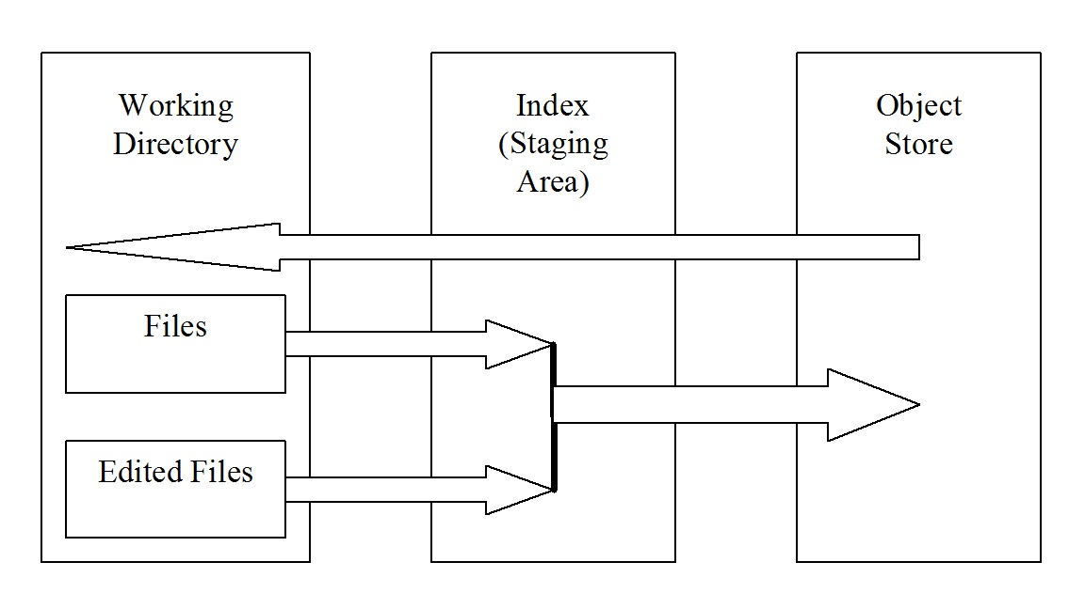

Figure 2.2 Working directory, index (staging area), and repository

The object store, in your .git subdirectory of your working directory, is where Git stores the metadata and object database for your project. This is the most important part of Git, and it is what is copied when you clone a repository to collaborate with other members of a software development team or group. The working directory contains a single checked-out copy of one version of the project. These files are pulled out of the compressed database in the repository directory and placed on disk for you to use or modify, using the git checkout command. The index is a file contained in the .git subdirectory of your working directory that stores information about what will go into your next commit.

The basic Git workflow is as follows:
1. You place new files into, delete files from, or modify files in your working directory.
2. You stage the files, adding snapshots of them to your index.
3. You do a commit, which takes the files as they are in the staging area and stores that snapshot permanently to your object store.

If a particular version of a file is in the object store, it is considered committed. If it is modified, but has been added to the index, it is staged. And if it was changed since it was checked out but has not been staged, it is modified.

2.3.3 Directed Acyclic Graphs

In order to plan, or visualize the history of a repository structure, a Directed Acyclic Graph (DAG), or commit graph, can be used. The name of the graph is derived from the fact that the flow of commits happens along the arrows of the graph (directed), and there is no way you can form a closed circle of commits by following the arrows (it is acyclic). We show an example in Figure 2.3, and will employ this graphic aid to help you visualize the state and the history of the kinds of commits we show.

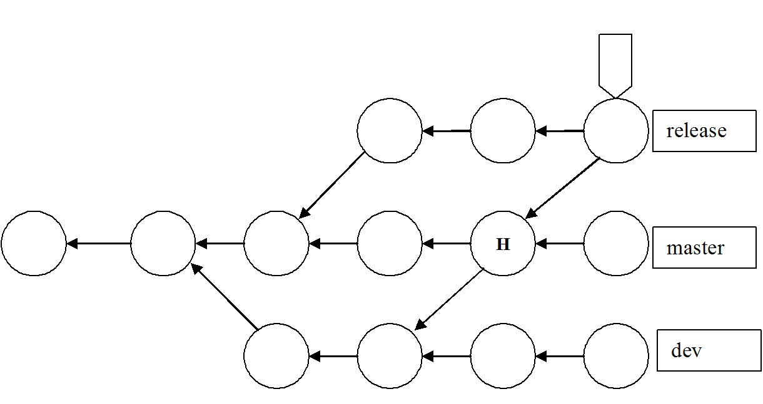

Figure 2.3 Example DAG

In Figure 2.3, the circles represent commits, and arrows point from a commit to its parent(s). Time does flow from left to right in a DAG, although there is no precise correlation in terms of a time or date stamp on any of the commits. There is just the implication that commits to the left happened earlier than commits to the right in the graph. But the arrows point from right to left! For most people, this is counterintuitive; usually we see the arrow pointing from something that happened first to its successor. In the DAG, arrows point backward toward a parent from a child. The first commit has no parents and is called a root commit; it was the initial commit in this repository’s history. Most commits have a single parent, indicating that they evolved in a linear way from a single previous state of the project, usually incorporating a set of related changes or edits. A commit that has multiple parents is called a merge commit. This indicates that the commit incorporates the changes made on one branch of the commit graph into a commit on another branch of the graph.

There are two other important features of a DAG shown in Figure 2.3. The last commit on the “release” branch has a tag at the top of it, which could contain a descriptive abbreviation of the name of that commit—perhaps “Version 1.0,” or something like that, denoting that this is the first release of the software project. Also, the letter “H” represents the position of HEAD, or the currently checked-out commit on the master branch.

***Note***
We will omit the arrowheads in such diagrams from now on.

The labels on the right side of this picture—release, master, and dev—are the named branches. The branch name refers to the latest commit on that branch. Such a commit is called the tip of the branch. The branch itself is defined as the collection of all commits in the graph that are reachable from the tip by following the parent arrows backward along the history to the initial commit.

2.3.4 Contents of the Object Store

Now that we’ve illustrated how the working directory is structured, how commits are staged, and the general layout of a repository as shown in a DAG, we can take a finer-grained look at the objects contained in the object store. Figure 2.4 shows the four object types that are found in the object store, and the relationships between those objects.

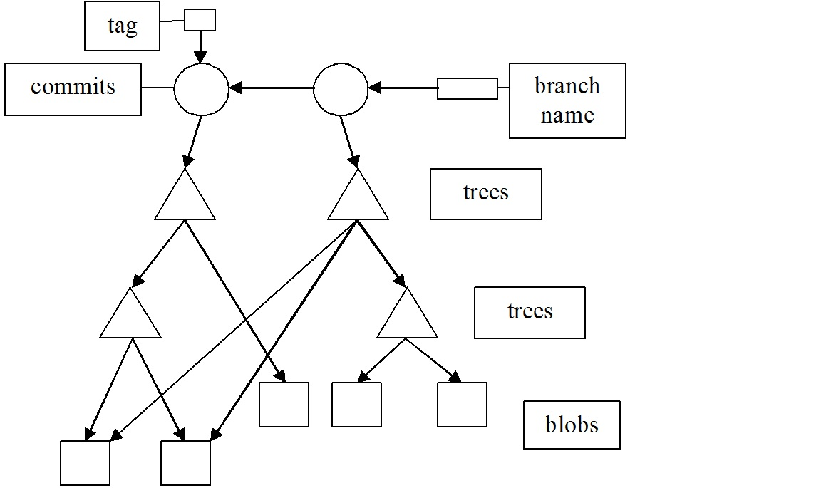

Figure 2.4 Contents of the Object Store

Remember from the DAG shown in Figure 2.3 that time flows from left to right, and an arrow points backwards, from a child to a parent. Starting at the top, we see a rectangle to the right representing the branch name, and another smaller square representing a tag object. The name by default is “master”, but can be assigned text that is more meaningful to you. The tag is a shorthand label that might represent the initial release number, or version of the software code. The circles represent commits. So this diagram shows two commits. The triangles represent tree objects, which can be thought of as directory, or linking information, between commits and blobs. Finally, at the bottom are a number of blobs, shown linked to the trees that point to them.

In the next section, we discuss a few Examples involving Git and GitHub. Before discussing these examples, we give a brief description of the git command, taken from the man page on our Raspberry Pi system.

NAME
git - the stupid content tracker

SYNOPSIS
git [--version] [--help] [-C <path>] [-c <name>=<value>]
[--exec-path[=<path>]] [--html-path] [--man-path] [--info-path]
[-p|--paginate|-P|--no-pager] [--no-replace-objects] [--bare]
[--git-dir=<path>] [--work-tree=<path>] [--namespace=<name>]
[--super-prefix=<path>]
<command> [<args>]

DESCRIPTION
Git is a fast, scalable, distributed revision control system with an unusually rich command set that provides both high-level operations and full access to internals.

See man gittutorial to get started, then see man giteveryday , for a useful minimum set of commands.

You can learn more about individual Git commands with "git help command". The gitcli man page gives you an overview of the command-line command syntax.

HIGH-LEVEL COMMANDS (PORCELAIN)
We separate the porcelain commands into the main commands and some ancillary user utilities. You can get man pages for each of these as well.

Main porcelain commands
git-add(1)
Add file contents to the index.
git-am(1)
Apply a series of patches from a mailbox.
git-archive(1)
Create an archive of files from a named tree.
git-bisect(1)
Use binary search to find the commit that introduced a bug.
git-branch(1)
List, create, or delete branches.
git-bundle(1)
Move objects and refs by archive.
git-checkout(1)
Switch branches or restore working tree files.
git-cherry-pick(1)
Apply the changes introduced by some existing commits.
git-citool(1)
Graphical alternative to git-commit.
git-clean(1)
Remove untracked files from the working tree.
git-clone(1)
Clone a repository into a new directory.
git-commit(1)
Record changes to the repository.
git-describe(1)
Give an object a human readable name based on an available ref.
git-diff(1)
Show changes between commits, commit and working tree, etc.
git-fetch(1)
Download objects and refs from another repository.
git-format-patch(1)
Prepare patches for e-mail submission.
git-gc(1)
Cleanup unnecessary files and optimize the local repository.
git-grep(1)
Print lines matching a pattern.
git-gui(1)
A portable graphical interface to Git.
git-init(1)
Create an empty Git repository or reinitialize an existing one.
git-log(1)
Show commit logs.
git-maintenance(1)
Run tasks to optimize Git repository data.
git-merge(1)
Join two or more development histories together.
git-rerere(1)
Reuse recorded resolution of conflicted merges.
git-show-branch(1)
Show branches and their commits.
git-verify-commit(1)
Check the GPG signature of commits.
git-verify-tag(1)
Check the GPG signature of tags.
git-whatchanged(1)
Show logs with difference each commit introduces.
gitweb(1)
Git web interface (web frontend to Git repositories).

2.4 Examples of Using Git and GitHub

We show a few Examples in this Section describing how to make use of Git and GitHub.
Each Example consists of the following:

1. Topic covered.
2. Objectives.
3. Introductory material for understanding the contents.
4. Git commands referenced and used.
5. Prerequisites.
6. Detailed procedures.
7. Conclusions.

Example 2.1: A Short Introduction to Git

Objectives: To briefly illustrate the Git staging model, and how to see differences between the various states of the parts of the repository.

Introduction: As shown previously, the workflow in Git basically follows a pattern of-

Add--> Edit--> Modify--> Stage--> Commit

This is the staging model. In this example, we show the essential Git commands that allow you to do that, repetitively if necessary. As you do more commits, you add, in a linear fashion, more nodes on the branch named master downstream, after you create the first node in this example. Earlier commits are called upstream commits. The history of the repository flows downstream from the initial commit to the latest commit. Similar to the diff command, the four basic forms of the git diff command allow you to examine and compare the files and directories present during different states the repository has gone through.

Command | Description
git config --global user.name "<name>" | Sets the author of commits in this repository
git config --global user. Email <email_address> | Sets the email address of the author of commits in this repository
git init | Creates the .git directory in the working directory, initializing the data structures and objects necessary for a repository to exist
git status | Reports the on the differences between files in the working directory and the index, and what files are untracked.
git add <file> | Stages a file to the index
git commit | Takes a snapshot of the index, both files and directories
git diff | Shows the difference between two project states, in this form meaning your working directory and the index
git diff <commit_identifier> | Shows the differences between your working tree and a specifically identified commit
git diff –cached <commit_identfier> | Shows the differences between staged files in the index and a specifically identified commit
git diff <commit_id_1> <commit_id_2> | Shows the difference between two project states, in this form between commits commit_id_1 and commit_id_2
git log –oneline | Shows history of commits in an abbreviated format

Table 2.1 Git Commands Referenced in Example 2.1

Git Commands Referenced:

Table 2.1 shows the Git commands, and a brief description of each, that are used in this Example. It is arranged in the order presented. Any argument enclosed in < > is a string of text. In order to get a more complete description of all the commands in the table, you can look at the man page for a particular command. For example, man git-status gives you a complete man page for the git status command.

Prerequisites:

The following are the prerequisites for carrying out this Example:

1. Having Git installed on your Raspberry Pi system.
2. Reading through and doing the In-Chapter Exercises shown in the previous subsections.
3. Anything you type on the command line is shown in bold type, and is always followed by pressing the <Enter> key.

Procedure:

Do the following steps, in order, to meet the objectives of this Example.

1. Create a working directory within which your Git repository will exist, and make that the current working directory.

% mkdir short-git
% cd short-git
%

2. Do an initial configuration of Git, in our case for the user “bob”.

% git config --global user.name bob
% git config --global bob.email “bob’s_email_address”
%

The last two lines above assume that you want to have a user name of “bob” (as shown in the first line), and will use the actual email address of bob in the second line.
If you give the git config –global --edit command to check this, you will see the following as output-

% git config --global --edit
[user]
name = bob
[bob]
email = bob’s_email_address

Make sure you quit the default editor without changing anything!

3. Initialize a repository in the current working directory.

% git init
hint: Using 'master' as the name for the initial branch. This default branch name
hint: is subject to change. To configure the initial branch name to use in all
hint: of your new repositories, which will suppress this warning, call:
hint:
hint: git config --global init.defaultBranch <name>
hint:
hint: Names commonly chosen instead of 'master' are 'main', 'trunk' and
hint: 'development'. The just-created branch can be renamed via this command:
hint:
hint: git branch -m <name>
Initialized empty Git repository in /home/bob/short-git/.git/
%

The above command initializes an empty Git repository in /usr/home/bob/short-git/.git/.

4. Create and save a short C program, named hello.c, in the current working directory, as shown:

% cat > hello.c
#include <stdio.h>
int main() {
// printf() displays the string inside quotation
printf("Hello, World!");
return 0;
}
<Ctrl> c
%

5. Use Geany from the Raspberry Pi menu > Programming, to compile hello.c, and build it, then list the files in the current working directory. You should have hello.c, hello.o, and hello in the directory.

6. Use the git status command to examine the status of the repository at this point. It will show you that you are on the branch named master, you can do your initial commit, the untracked files are hello.o and hello.c, and you can stage those files by using git add.

% git status
On branch master

Initial commit

Untracked files:
(use "git add <file>..." to include in what will be committed)

hello
hello.c
hello.o

nothing added to commit but untracked files present (use "git add" to track)
%

7. Stage only the source code file hello.c with the git add command.

% git add hello.c
%

8. Now do your initial commit, and in the editor (nano for us) that opens, add a message to go along with this commit..

% git commit
[master (root-commit) 0a93b9e] Hello, World!
1 file changed, 6 insertions(+)
create mode 100644 hello.c

9. Look at the status of the repository.

% git status
On branch master
Untracked files:
(use "git add <file>..." to include in what will be committed)
hello
hello.o

nothing added to commit but untracked files present (use "git add" to track)
%

10. Now lets make a change in the file hello.c, and track the changes with some of the forms of the git diff command. First, edit the file with your favorite text editor, and on the fourth line, change the text as shown in the following command output:

% nano hello.c
#include <stdio.h>
int main() {
// printf() displays the string inside quotation
printf("Hello, Raspberry Pi Administrator!");
return 0;
}
%

11. Examine the status of the repository. The output shows that the file has been changed since the last commit, but has not been staged for a new commit yet!

% git status
On branch master
Changes not staged for commit:
(use "git add <file>..." to update what will be committed)
(use "git restore <file>..." to discard changes in working directory)
modified: hello.c

Untracked files:
(use "git add <file>..." to include in what will be committed)
hello
hello.o

no changes added to commit (use "git add" and/or "git commit -a")
%

12. Now we use the git diff command to see the difference between what is in the working directory and the index.

% git diff
diff --git a/hello.c b/hello.c
index 34d86c4..cf6bae2 100644
--- a/hello.c
+++ b/hello.c
@@ -1,6 +1,6 @@
#include <stdio.h>
int main() {
// printf() displays the string inside quotation
- printf("Hello, World!");
+ printf("Hello, Raspberry Pi Administrator!");
return 0;
}
%

13. Now stage the file hello.c in preparation for a new commit.

% git add hello.c
%

14. If you execute git diff, since there are no differences between what is in the working directory and the index, you get no output!

% git diff
%

15. Now use another form of the command: git diff –cached commit, to see the differences between the files staged in the index and any given commit. If you omit the commit argument, HEAD is used as the default commit. Remember from the glossary that HEAD is a reference to the current commit. The output should be exactly the same as from step 12. That’s because what is in the working directory is the current commit as seen in the object store: HEAD, the current last commit.

% git diff --cached
diff --git a/hello.c b/hello.c
index 34d86c4..cf6bae2 100644
--- a/hello.c
+++ b/hello.c
@@ -1,6 +1,6 @@
#include <stdio.h>
int main() {
// printf() displays the string inside quotation
- printf("Hello, World!");
+ printf("Hello, Raspberry Pi Administrator!");
return 0;
}
%

16. Now commit the changes, in the editor, add a message line to describe the new commit.

% git commit
[master 6112bd0] Added Raspberry Pi Administrator to the message.
1 file changed, 1 insertion(+), 1 deletion(-)
%

17. Examine the history of commits with the git log command in an abbreviated format with the --oneline option.

% git log --oneline
6112bd0 (HEAD -> master) Added Raspberry Pi Administrator to the message.
0a93b9e Hello, World!
%

18. See the differences between the two commits we have done so far by using git diff commit1 commit2, where commit1 can be referred to as 0a93b9e, and commit2 can be referred to as 6112bd0. These references are seen in the git log –oneline command output in step 17..

% git diff 0a93b9e 6112bd0
diff --git a/hello.c b/hello.c
index 34d86c4..cf6bae2 100644
--- a/hello.c
+++ b/hello.c
@@ -1,6 +1,6 @@
#include <stdio.h>
int main() {
// printf() displays the string inside quotation
- printf("Hello, World!");
+ printf("Hello, Raspberry Pi Administrator!");
return 0;
}
%

Notice the changes are compared one after the other, and in different colors as well.

19. Examine with git diff the differences in only commit 0a93b9e.

% git diff 0a93b9e
diff --git a/hello.c b/hello.c
index 34d86c4..cf6bae2 100644
--- a/hello.c
+++ b/hello.c
@@ -1,6 +1,6 @@
#include <stdio.h>
int main() {
// printf() displays the string inside quotation
- printf("Hello, World!");
+ printf("Hello, Raspberry Pi Administrator!");
return 0;
}
%

20. Repeat steps 4–19 as many times as you want to, each time creating or modifying new or existing files in the working directory. Also, it would be helpful to repeat this entire example several times, in several new directories with newly created repositories to gain practice. Each time, you stage the files with git add and then commit the additions or modifications with git commit. Then examine the differences as shown with git diff and the variations we’ve shown above. As you do more commits, you are adding, in a linear fashion, more and more nodes downstream on the branch named master.

Conclusions: This short Example illustrated the staging model in Git. It introduced a small set of Git commands that allowed you to implement the model, once or repetitively, and see the differences between commits.

In-Chapter Exercise
4. The git diff command is similar to what other Linux command?

Example 2.2: Creating, Editing, and Branching a Git Repository

Objectives: To introduce the Git commands that create, edit, and allow you to develop a C source code project along different branches in a Git repository. To show how different branches may be merged.

Introduction: In order to appreciate, and effectively utilize the Git concepts shown in the previous Example, we present another complete Git Example showing repository creation, editing, branching, and merging. Maintaining source code files and their history was, and primarily still is, the objective of deploying Git. In the following steps, we create C source code files as needed, with a text editor in the directory that has a Git repository in it. This method of introducing the files into the working directory does not preclude placing those files in that directory by any other viable means, for example by copying them from another directory, or even another file system. We then edit those files to change their content and commit those changes. Finally, we show how to create branches along which different lines of development of the source code can proceed, and how to merge different branches. We try to emphasize the staging model, or the edit-stage-commit workflow model, as detailed in the previous Example, throughout the current Example.

***Note***
We have purposefully not done commits and merges of branches that would produce merge conflicts. The mechanisms and strategies for resolving content conflicts are more usefully covered in other Git reference sources beyond the scope of this Example, just as the mechanisms and strategies for resolving context conflicts are.

Command | Description
git init | Create a Git repository in the current directory
git status | View the status of each file in a repository
git add <file> | Stage a file for the next commit
git commit | Commit the staged files with a descriptive message
git log | View a repository’s commit history
git config --global user.name "<name>" | Define the author name to be used in all repositories
git config --global user. Email <email> | Define the author email to be used in all repositories
git checkout <commit-id> | Move a previous commit into the working directory
git tag -a <tag-name> -m "<description>" | Create an annotated tag pointing to the most recent commit
git revert <commit-id> | Undo the specified commit by applying a new commit
git reset –hard | Reset tracked files to match the most recent commit
git clean –f | Remove untracked files
git reset --hard / git clean –f | Permanently undo uncommitted changes
git branch | List all branches
git branch <branch-name> | Create a new branch using the working directory as its base
git checkout <branch-name> | Make the working directory and HEAD match the specified branch
git merge <branch-name> | Merge a branch into the checked-out branch
git branch -d <branch-name> | Delete a branch
git rm <file> | Remove a file from the working directory (if applicable) and stop tracking that file

Table 2.2 Git Commands Referenced in Example 2.2

Git Commands Referenced: Table 2.2 shows the Git commands, and a brief description of each, that are used in this example. It is arranged in the order presented. Any argument enclosed in < > is a string of text. In order to get a more complete description of all the commands in the table, you can look at the man page for a particular command. For example, man git-status gives you a complete man page for the git-status command.

Prerequisites: The following are the prerequisites for carrying out this example:
1. A recent version of Git available on your system, executable by an ordinary user from the command line. On our Raspberry Pi 4B and 400, Git was preinstalled.
2. Being able to use a text editor, such as nano, vi, vim, or emacs, to create C program source code files.
3. Having reviewed and done the In-Chapter Exercises above on Git concepts. This not only gives you a conceptual, top-down view of Git, but also shows you how to obtain Git help and use the man pages on the system for Git commands.
4. Completion of Example 2.1.

Procedure: Do the steps shown, in the order presented, to meet the objectives of this example. This is a long and detailed example. If you make mistakes, which for a beginner not familiar with the commands is understandable (they are irrevocable,) simply start over again in a new directory that has another name than the one shown in step 1!

1. The first step in creating a repository to retain a history of your source code project files is to create a directory within which the repository can exist. We name this directory first-git. Then you can do a very elementary configuration of Git to identify yourself to the system. In our case, we do this for the user “bob”.

If you have indeed done Example 2.1 , you don’t have to type in the third and fourth commands!

% mkdir first-git
% cd first-git
% git config --global user.name bob
% git config --global bob.email “bob’s_email_address”
%

The last two lines above assume that you want to have a user named “bob” (as shown in the first line), and will use bob’s email address in the second line. Of course, you can substitute your name and email address in place of those shown.

If you give the git config –global --edit command to check this, you will see the following as output-

% git config --global --edit
[user]
name = bob
[bob]
email = bob’s_email_address

Make sure you quit the default editor without changing anything!

2. Create a C source code file named first.c with the text editor of your choice. Save it in the current working directory, which should be first-git.

3. The next command initializes the repository, which enables the Git program in the current working directory. There is now a .git subdirectory in first-git that stores all the tracking data for our repository. The .git folder is the only difference between a Git repository and an ordinary folder, so deleting it will turn your project back into a collection of files that are not version-controlled.

% git init
hint: Using 'master' as the name for the initial branch. This default branch name
hint: is subject to change. To configure the initial branch name to use in all
hint: of your new repositories, which will suppress this warning, call:
hint:
hint: git config --global init.defaultBranch <name>
hint:
hint: Names commonly chosen instead of 'master' are 'main', 'trunk' and
hint: 'development'. The just-created branch can be renamed via this command:
hint:
hint: git branch -m <name>
Initialized empty Git repository in /home/bob/first-git/.git/
%

4. Before we try to start creating revisions, view the status of our new repository. Execute the following command:

% git status
On branch master

No commits yet

Untracked files:
(use "git add <file>..." to include in what will be committed)
first.c

nothing added to commit but untracked files present (use "git add" to track)
%

This status message tells you that we are about to make our initial commit, and that we have nothing to commit but untracked files. An untracked file is one that is not under version control. Git doesn’t automatically track files, because there are often project files that we don’t want to keep under version, revision control. These might be binaries created by a C program, compiled Python modules (.pyc files), or any other unnecessary files. To keep a project small and efficient, you should only track source files, and omit anything that can be generated from those files. This latter content is part of the build process(compilation), not revision control.

5. The next step stages the file first.c in preparation for doing the first commit.

% git add first.c
%

We added first.c to the snapshot of the index for the next commit. Git’s term for creating a snapshot is called staging because we can add or remove multiple files before actually committing it to the project history. The index holds a snapshot of the content of the working tree, and it is this snapshot that is taken as the contents of the next commit. Thus, after making any changes to the working directory and before running the commit command, you must use the add command to add any new or modified files to the index.

6. Now we examine the repository status with the git status command.

% git status
On branch master

No commits yet

Changes to be committed:
(use "git rm --cached <file>..." to unstage)
new file: first.c
%

Now, instead of first.c being an untracked file, it is shown as being staged to be committed.

7. We are ready to commit.

% git commit
%

The first part of committing is to use the default text editor you are put into by Git to add the text on the first line as “The initial commit”. Then save and quit the editor.

[master (root-commit) ddd2dff] The initial commit
1 file changed, 0 insertions(+), 0 deletions(-)
create mode 100644 first.c
%

8. We need a new command, git log, to view the project revision history. When you execute this command, Git will output information about our first commit:

% git log
commit ddd2dff8ae8aeb6ebb3715d57ad2fea96d0334c8 (HEAD -> master)
Author: bob <bobk48@gmail.com>
Date: Sun Jul 9 19:10:46 2023 -0700

The initial commit
%

9. We continue to add new C source code files to our working directory. Create two C source code files named second.c and third.c with the text editor of your choice. Save them in the current working directory, which should be first-git.

10. We now need to stage those two new files, in preparation for committing them to our repository.

% git add second.c third.c
%

11. Take a look at the status of the repository.

% git status
On branch master
Changes to be committed:
(use "git restore --staged <file>..." to unstage)
new file: second.c
new file: third.c
%

12. Take a look at the history of the repository.

% git log
commit 74088f645993f3df16f27565628ea38c271357e0
Author: bob <your_email_address>
Date: Mon Nov 10 18:59:44 2014 -0800

The initial commit
%

13. Commit the two new files.

% git commit

Use the text editor that automatically launches to add second.c and third.c added as the first line in the file. Then save the file and quit the text editor.

[master 138b11c] second.c and third.c added
2 files changed, 0 insertions(+), 0 deletions(-)
create mode 100644 second.c
create mode 100644 third.c
%

14. The git add command is used to stage new files. It can also be used to stage modified files. So, use a text editor to modify the previously created C source code files first.c, second.c, and third.c.

15. Then take a look at the status of the repository. Git lists the tracked files as being modified.

% git status
On branch master
Changes not staged for commit:
(use "git add <file>..." to update what will be committed)
(use "git restore <file>..." to discard changes in working directory)
modified: first.c
modified: second.c
modified: third.c

no changes added to commit (use "git add" and/or "git commit -a")
%

16. Stage those modified files.

% git add first.c second.c third.c
%

17. Now commit the modified, staged files. In the text editor, add a description that you feel is appropriate for this commit.

% git commit
[master dd57a94] Modified all three C files.
3 files changed, 3 insertions(+)
%

18. Our history can now be shown as follows:

% git log --oneline
dd57a94 (HEAD -> master) Modified all three C files.
138b11c second.c and third.c added
ddd2dff The initial commit
%

The git log command comes with formatting options. We use the --oneline flag, git log --oneline.

19. Condensing output to a single line is one way to get an overview of a repository. Another way is to pass a filename to git log:

% git log --oneline second.c
dd57a94 (HEAD -> master) Modified all three C files.
138b11c second.c and third.c added
%

20. Let’s take a little break here to see what we’ve accomplished in this Example so far. We’ve recorded different versions of a project into a Git repository. Maintaining these copies has provided us with backups. Critically, we can have independent versions of the state of the project that can be used for the purposes of creating multiple lines, tracks, or “branches” of code development. Our next objective will be to view the previous states of a project, revert back to them, and reset uncommitted changes if necessary. First, let’s return to the state of the repository at the commit “138b11c second.c and third.c added”(step 18.). The HEAD is now at dd57a94.

The git checkout command will position HEAD at any commit we desire, going all the way back to the initial commit!

% git checkout dd57a94
Note: switching to 'dd57a94'.

You are in 'detached HEAD' state. You can look around, make experimental
changes and commit them, and you can discard any commits you make in this
state without impacting any branches by switching back to a branch.

If you want to create a new branch to retain commits you create, you may
do so (now or later) by using -c with the switch command. Example:

git switch -c <new-branch-name>

Or undo this operation with:

git switch -

Turn off this advice by setting config variable advice.detachedHead to false

HEAD is now at dd57a94 Modified all three C files.
%

As the Git messaging has told you, you are in the detached HEAD state. You can look around, make experimental changes and commit them, and you can discard any commits you make in this state without impacting any branches by performing another checkout.

Optional- If you want to create a new branch to retain new commits you want to create, you can (now or later) by using -b with the checkout command again. For example:

% git checkout -b new_branch_name

21. Let’s go back to the initial commit.

% git checkout ddd2dff
Previous HEAD position was dd57a94 Modified all three C files.
HEAD is now at ddd2dff The initial commit
%

22. We can check the status of the repository at this point.

% git status
HEAD detached at ddd2dff
nothing to commit, working tree clean
%

23. In all previous steps, we worked on the master branch, where our second and third commits reside. To retrieve our complete history, we just have to check out this entire branch. This is a very brief introduction to branches, but it’s all we need to know to navigate between commits. The following command makes Git update our working directory to reflect the state of the master branch’s snapshot. It recreates the second.c and third.c files for us, and the content of first.c is updated as well. We’re now back to the current state of the entire commits history of the project.

% git checkout master
Previous HEAD position was ddd2dff The initial commit
Switched to branch 'master'
%

24. Tags are references to milestones, or releases in a software project. They let developers easily browse and check out important revisions. For example, we can now use a tag named “v1.0” as a label referring to the third commit instead of its random number ID. To view a list of existing tags, execute the git tag command without any arguments. We can label this a stable version of the C program modules, if indeed it is one!. The -a option tells Git to create an annotated tag, which lets us record our name, the date, and a descriptive message, specified via the -m option. We can finalize it by tagging the most recent commit with a version number as follows:

% git tag -a v1.0 -m "Stable version of the software"
%

25. Now we can add C modules to the working directory that allow us to experiment, without committing those modules. Use the text editor of your choice to create an experimental C source code file named experiment.c, and save it in the current working directory.

26. Then stage that file.

% git add experiment.c
%

27. Now, let’s check on the status of the repository.

% git status
On branch master
Changes to be committed:
(use "git restore --staged <file>..." to unstage)
new file: experiment.c
%

28. Commit that file, and in the editor, add the label “Add an experimental C program”.

% git commit
[master 0301d6a] Add an experimental C program
1 file changed, 0 insertions(+), 0 deletions(-)
create mode 100644 experiment.c
%

29. Now let’s look at a history of commits to this repository.

% git log
commit 0301d6a443bb08a44621093fd443bb8e027ef1d9 (HEAD -> master)
Author: bob <bobk48@gmail.com>
Date: Mon Jul 10 09:32:30 2023 -0700

Add an experimental C program

commit dd57a94ebf3514bb4cbcb8fcb307f1fe92ba8ce9 (tag: v1.0)
Author: bob <bobk48@gmail.com>
Date: Mon Jul 10 06:37:40 2023 -0700

Modified all three C files.

commit 138b11c389046249ef16e7176ee68c1dc7d70995
Author: bob <bobk48@gmail.com>
Date: Mon Jul 10 06:27:44 2023 -0700

second.c and third.c added

commit ddd2dff8ae8aeb6ebb3715d57ad2fea96d0334c8
Author: bob <bobk48@gmail.com>
Date: Sun Jul 9 19:10:46 2023 -0700

The initial commit

%

30. Let’s go back to our stable revision. Remember that the v1.0 tag is now a shortcut to the third commit’s ID.

% git checkout v1.0
Note: switching to 'v1.0'.

You are in 'detached HEAD' state. You can look around, make experimental
changes and commit them, and you can discard any commits you make in this
state without impacting any branches by switching back to a branch.

If you want to create a new branch to retain commits you create, you may
do so (now or later) by using -c with the switch command. Example:

git switch -c <new-branch-name>

Or undo this operation with:

git switch -

Turn off this advice by setting config variable advice.detachedHead to false

HEAD is now at dd57a94 Modified all three C files.
%

As the Git message states -”You are in detached HEAD state. You can look around, make experimental changes and commit them, and you can discard any commits you make in this state without impacting any branches by performing another checkout,”
and,
Optional - If you want to create a new branch to retain commits you create, you may do so (now or later) by using -b with the checkout command again. For example:

% git checkout -b new_branch_name

31. After seeing the stable version of the repository, you decide to scrap the C code experiment you started in step 25. But, before you undo the changes to the repository, you need to return to the master branch. If you didn’t, all of your updates would be on some nonexistent branch. You should never make changes directly to a previous revision!

% git checkout master
Previous HEAD position was dd57a94 Modified all three C files.
Switched to branch 'master'
%

32. Now you can again examine the history of your repository with the git log command. This yields the shorthand name of the last commit we executed entitled, “Add an experimental C program”.

% git log --oneline
0301d6a (HEAD -> master) Add an experimental C program
dd57a94 (tag: v1.0) Modified all three C files.
138b11c second.c and third.c added
ddd2dff The initial commit
%

33. Now you want to restore your stable release, by removing the most recent commit. ***Note***
Make sure to change 0301d6a to the ID supplied by your system’s Git for the experimental C code commit before running the next command. Also, the command we use, git revert, undoes the commit we specify as its argument.

% git revert 0301d6a

You are put into the default text editor, which allows you to change the title of the reverted commit. Leave the commit title the same, save the file and quit the editor.

Removing experiment.c
[master 290ec3e] Revert "Add an experimental C program"
1 file changed, 0 insertions(+), 0 deletions(-)
delete mode 100644 experiment.c
%

34. Look at what files are in the working directory, and also see a history of your commits.

% ls
first.c second.c third.c

% git log --oneline
290ec3e (HEAD -> master) Revert "Add an experimental C program"
0301d6a Add an experimental C program
dd57a94 (tag: v1.0) Modified all three C files.
138b11c second.c and third.c added
ddd2dff The initial commit
%

Instead of deleting the “Add an experimental C program commit”, Git undoes the changes it contains, then adds an additional commit showing the reversion. So, your fifth and fourth commits represent the exact same snapshot! Git is designed to never lose history: the fourth snapshot is still accessible, just in case you want to continue developing it.

35. Now you can try to add a file that we definitely will want to get rid of completely. Use your text editor to create a file named dumbc.c, and then edit first.c to make a small change in it. Now look at the status of the repository.

% git status
On branch master
Changes not staged for commit:
(use "git add <file>..." to update what will be committed)
(use "git restore <file>..." to discard changes in working directory)
modified: first.c

Untracked files:
(use "git add <file>..." to include in what will be committed)
dumb.c

no changes added to commit (use "git add" and/or "git commit -a")
%

36. You now have a tracked file, and an untracked file, that need to be changed. First, you’ll take care of the tracked first.c.

% git reset --hard
HEAD is now at 290ec3e Revert "Add an experimental C program"
%

This changed all tracked files to match the most recent commit. You can also pass a filename to this command to reset only that file. For example, git reset --hard first.c. The --hard flag is what actually updates the file. Running git reset first.c without any flags will simply destage the file, leaving its contents as is. In either case, git reset only operates on the working directory and the staging area, so our git log history remains unchanged.

37. Now remove the dumb.c file. Of course, we could manually delete it, but using Git to reset changes eliminates human errors when working with several files in large teams. Run the following command:

% git clean -f
Removing dumbc.c
%

This will remove all untracked files. With dumb.c gone, git status should now tell you that you have a “clean” working directory, meaning our project repository matches the most recent commit.

***Note***
Be careful with git reset and git clean. Both operate on the working directory, not on the committed snapshots. Unlike git revert, they permanently undo changes, so make sure you really want to delete what you’re working on before you use them!

38. To begin creating and using branches, list what branches exist at this point.

% git branch
* master
%

This command displays the only current branch, named * master. The master branch is Git’s default branch, and the asterisk next to it means that it is currently checked out. This means that the most recent snapshot in the master branch resides in the working directory. There is only one working directory for each project, and additionally, only one branch can be checked out at a time.

39. Look at some previous commits before you begin creating a new branch. First get a shorthand list of the repository commit history.

% git log --oneline
290ec3e (HEAD -> master) Revert "Add an experimental C program"
0301d6a Add an experimental C program
dd57a94 (tag: v1.0) Modified all three C files.
138b11c second.c and third.c added
ddd2dff The initial commit
%

40. Then checkout the “Add an experimental C program” commit.

% git checkout 0301d6a
Note: switching to '0301d6a'.

You are in 'detached HEAD' state. You can look around, make experimental
changes and commit them, and you can discard any commits you make in this
state without impacting any branches by switching back to a branch.

If you want to create a new branch to retain commits you create, you may
do so (now or later) by using -c with the switch command. Example:

git switch -c <new-branch-name>

Or undo this operation with:

git switch -

Turn off this advice by setting config variable advice.detachedHead to false

HEAD is now at 0301d6a Add an experimental C program
%

The HEAD normally is on the tip of a development branch, meaning you are on that branch. But when we checked out the previous commit, the HEAD moved to the middle of the branch. We are no longer on the master branch, since it contains more recent snapshots than the HEAD. This is reflected in the Git branch output from the previous command, which tells us that we’re currently not on a branch.

41. You can now create a branch from this commit. Name it “test”.

% git branch test
%

42. To be able to add commits to the new branch, move onto that branch by checking it out.

% git checkout test
Switched to branch 'test'
%

43. Use your favorite text editor to make minor changes to the file experiment.c, so that we can begin development along this branch. Be sure to save the modified experiment.c!

44. Now stage the modified experiment.c.

% git add experiment.c
% git status
On branch test
Changes to be committed:
(use "git restore --staged <file>..." to unstage)
modified: experiment.c
%

45. The following commit will create a fork in our project repository, as shown in Figure 2.5. Label the commit in the editor “Modified experiment.c”.

% git commit
[test ef75671] Modified experiment.c
1 file changed, 1 insertion(+)
%

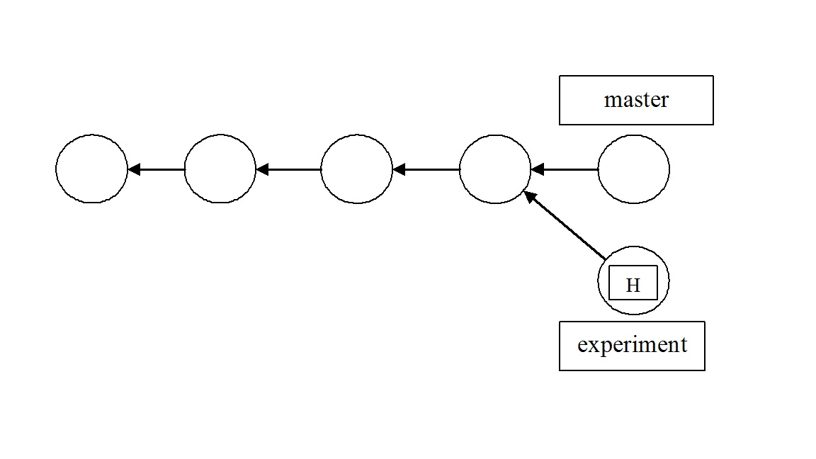

Figure 2.5 Forked Project Repository

46. Now take a look at the history of your commits, in abbreviated form, with the following command.

% git log --oneline
ef75671 (HEAD -> test) Modified experiment.c
0301d6a Add an experimental C program
dd57a94 (tag: v1.0) Modified all three C files.
138b11c second.c and third.c added
ddd2dff The initial commit
%

The history before the fork is shown as part of the new branch. Since we are on the branch test, the test history spans all the way back to the first commit. The project repository has a complex history, but each individual branch still has a linear history. Snapshots and commits occur one after another in a linearly evolving fashion. This means that we can work within branches in the same way we did in steps 1–37.

47. Add one more snapshot to the test branch. Use the mv command to rename experiment.c to experiment2.c, then use the following Git commands to update the repository.

% mv experiment.c experiment2.c
% git status
On branch test
Changes not staged for commit:
(use "git add/rm <file>..." to update what will be committed)
(use "git restore <file>..." to discard changes in working directory)
deleted: experiment.c

Untracked files:
(use "git add <file>..." to include in what will be committed)
experiment2.c

no changes added to commit (use "git add" and/or "git commit -a")

% git rm experiment.c
rm 'experiment.c'
% git status
On branch test
Changes to be committed:
(use "git restore --staged <file>..." to unstage)
deleted: experiment.c

Untracked files:
(use "git add <file>..." to include in what will be committed)
experiment2.c
% git add experiment2.c
% git status
On branch test
Changes to be committed:
(use "git restore --staged <file>..." to unstage)
renamed: experiment.c -> experiment2.c
%

The git rm command tells Git to stop tracking experiment.c (and delete it if necessary), and git add starts tracking experiment2.c. The “renamed: experiment.c -> experiment2.c” message in the final status output shows us that Git knows when we are just renaming a file. You could have made editing changes to experiment.c to justify moving the branch forward with another commit. Your snapshot is staged and ready to be committed.

48. We now do a new commit along the new branch. In the editor, provide the label “Renamed experiment.c to experiment2.c”.

% git commit
[test 326fed6] Renamed experiment.c to experiment2.c
1 file changed, 0 insertions(+), 0 deletions(-)
rename experiment.c => experiment2.c (100%)
%

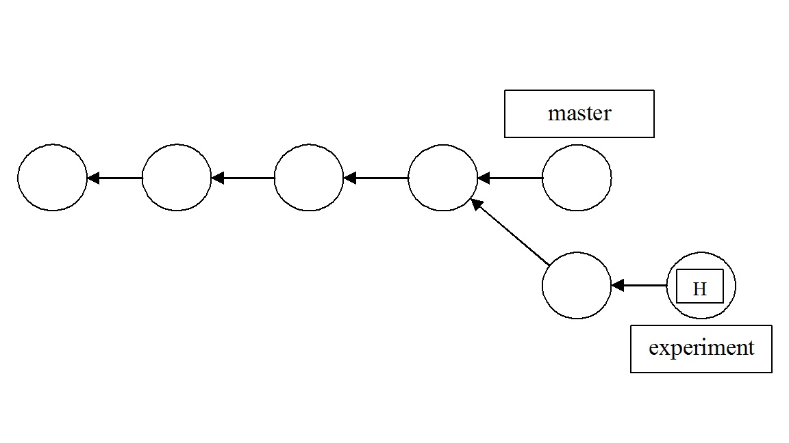

Figure 2.6 DAG of Project Repository

49. Look at the history of commits along this branch. Your project repository should now now look as shown in Figure 2.6.

% git log --oneline
326fed6 (HEAD -> test) Renamed experiment.c to experiment2.c
ef75671 Modified experiment.c
0301d6a Add an experimental C program
dd57a94 (tag: v1.0) Modified all three C files.
138b11c second.c and third.c added
ddd2dff The initial commit
%

50. Now fork another branch off the master branch. In preparation for doing this, return the HEAD to the master branch by using the git checkout command.

% git checkout master
Switched to branch 'master'
%

51. Now that you are back on the master branch, list the branches in this repository.

% git branch
* master
test

% git log --oneline
290ec3e (HEAD -> master) Revert "Add an experimental C program"
0301d6a Add an experimental C program
dd57a94 (tag: v1.0) Modified all three C files.
138b11c second.c and third.c added
ddd2dff The initial commit
%

52. You will now create a new branch, forked off the master branch, and named “modules”.

% git branch modules
%

53. Make the modules branch the current branch.

% git checkout modules
Switched to branch 'modules'
%

54. In your favorite text editor, create a C program file named “module1.c”. Then stage module1.c.

% git add module1.c
%

55. Check the status of the repository.

% git status
On branch modules
Changes to be committed:
(use "git restore --staged <file>..." to unstage)
new file: module1.c
%

56. Now commit module1.c, and in the editor, label the commit “Added module1.c”.

% git commit
[modules 0aec443] Added module1.c
1 file changed, 0 insertions(+), 0 deletions(-)
create mode 100644 module1.c
%

57. In your favorite text editor, add a reference to the C code in module1.c into the files first.c, second.c, and third.c.

58. Stage the changes you made in first.c, second.c, and third.c.

% git add first.c second.c third.c
%

59. Check the status of the project repository.

% git status
On branch modules
Changes to be committed:
(use "git restore --staged <file>..." to unstage)
modified: first.c
modified: second.c
modified: third.c
%

60. Commit the changes to the files first.c, second.c, and third.c, and in the editor, label this commit “Add references to module1.c”.

% git commit
[modules 4321414] Added references to module1.c
3 files changed, 3 insertions(+)
%

61. Now examine the history of commits along this branch.

% git log --oneline
4321414 (HEAD -> modules) Added references to module1.c
0aec443 Added module1.c
290ec3e (master) Revert "Add an experimental C program"
0301d6a Add an experimental C program
dd57a94 (tag: v1.0) Modified all three C files.
138b11c second.c and third.c added
ddd2dff The initial commit
%

A DAG of your project repository at this point is shown in Figure 2.7.

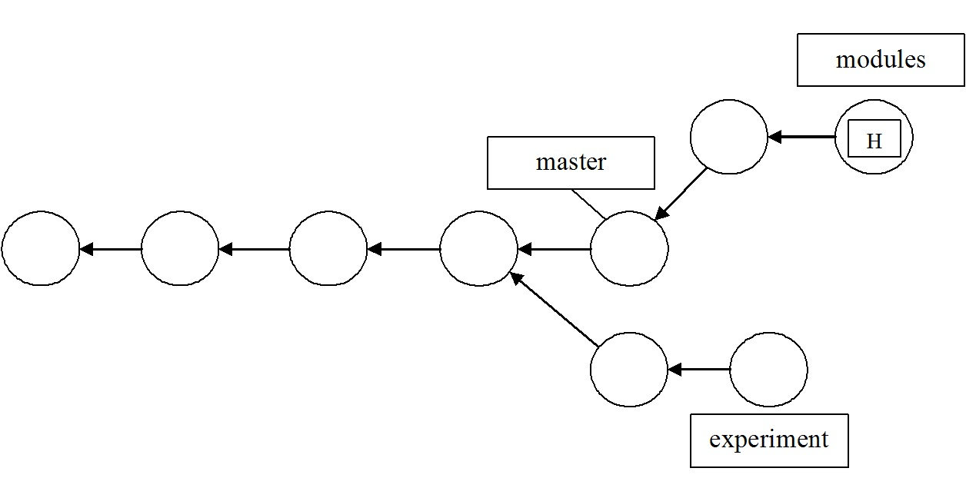

Figure 2.7 DAG of Repository with Three Branches

62. In preparation for merging the modules branch with the master branch, do the following. First, switch to the master branch, then check the files in the working directory. Finally look at the commit history of the repository as seen along the master branch.

% git checkout master
Switched to branch 'master'

% ls
first.c second.c third.c

% git log --oneline
290ec3e (HEAD -> master) Revert "Add an experimental C program"
0301d6a Add an experimental C program
dd57a94 (tag: v1.0) Modified all three C files.
138b11c second.c and third.c added
ddd2dff The initial commit
%

63. You will now merge the modules branch with the master branch. This command always merges into the current branch. The modules branch is unchanged. Check the history of commits with git log --oneline to make sure that modules’s history of commits has been added to master’s history of commits. The DAG representing the final state of the repository is shown in Figure 2.8.

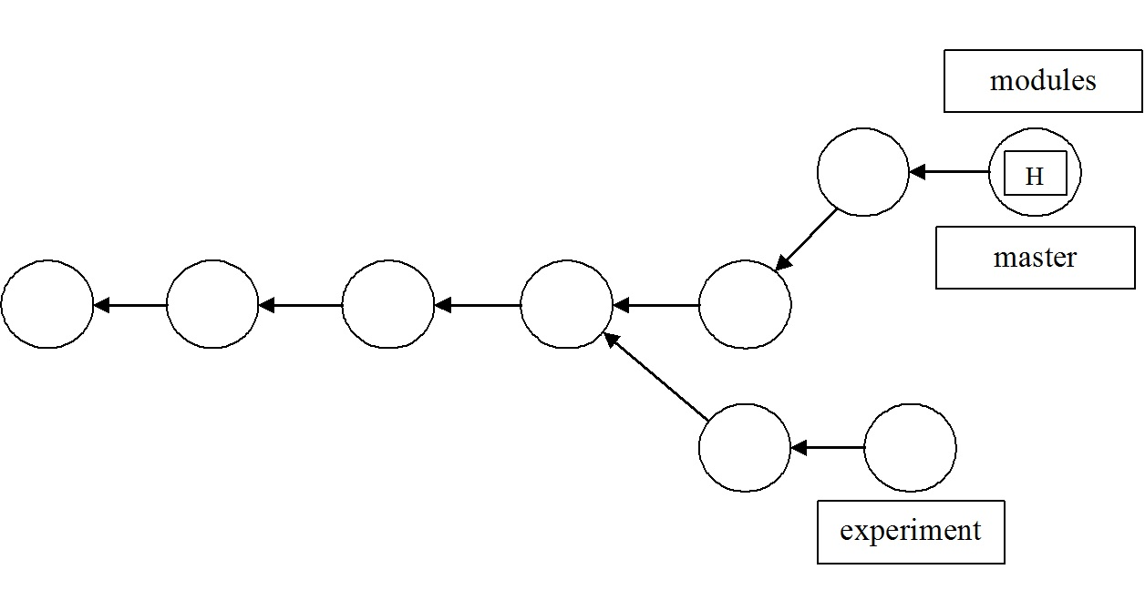

Figure 2.8 DAG of Final State of Project Repository

% git merge modules
Updating 290ec3e..4321414
Fast-forward
first.c | 1 +
module1.c | 0
second.c | 1 +
third.c | 1 +
4 files changed, 3 insertions(+)
create mode 100644 module1.c

% git log --oneline
4321414 (HEAD -> master, modules) Added references to module1.c
0aec443 Added module1.c
290ec3e Revert "Add an experimental C program"
0301d6a Add an experimental C program
dd57a94 (tag: v1.0) Modified all three C files.
138b11c second.c and third.c added
ddd2dff The initial commit
%

Conclusions: In this example, we created C source code files as needed with a text editor in the directory that has the Git repository in it. We then edited those files to change their content and committed those changes. Finally, we showed how to create branches along which different lines of development of the source code can proceed, and how to merge different branches. We emphasized the staging model, or edit-stage-commit workflow model, as detailed in the previous Example, throughout this example.

In-Chapter Exercises

5. Under what circumstances would you want to track, or stage, other kinds of files in a Git repository related to the C program development and build process?

6. If, after step 63, you were to create a new text file in the working directory, but not stage and commit, would that file still be in the working directory after you do a checkout of the initial commit? Why/why not?

2.5 GitHub as a Remote Repository

GitHub is a popular remote repository where you can easily and securely work together with a team to do the development and maintenance of a software project. We first provide some background information on Git URLs and refspecs. then, in this section’s examples, we show the basics of how to take files from a local repository and put them on a GitHub repository using the command-line in a terminal window. We also show how to take files from GitHub and retrieve them back onto a local repository. The basis and groundwork for these operations are expedited on the command-line with the Git commands we have illustrated thus far.

Therefore, having completed the previous subsections on Git is necessary to your understanding of the GitHub interactions shown here. We also introduce new Git commands to allow you to work with a GitHub remote repository.

We do not show how to get an account on GitHub, or how to create a new repository using the web-based GUI interface of GitHub. It is assumed in all of the examples that you can do those two basic steps via a Web browser at www.github.com, and can navigate to the URL we show. The repository on your system is called the local, or current repository, and a repository created and stored at GitHub is called the remote repository.

You can easily, and expediently use the git remote command and its options and arguments to create, remove, manipulate, and view a remote repository at Github. For example, to add a remote reference specification, or refspec, to the current local repository, you can use the git remote add command with the proper options and arguments. You can also look at what has been defined as a remote repository in the .git/config file. All the remote repositories you added are recorded in the .git/config file, and can be manipulated using the git config command, and its options and arguments.

The basic Git commands that refer to remote repositories are:

git clone Transfers a remote repository into the local repository
git fetch Retrieves objects and their related data structures from a remote repository
git pull Merges changes from a remote repository into a corresponding local branch
git push Copies objects and their related data structures to a remote repository
git ls-remote Lists references in a given remote repository

2.5.1 Git URLs

With the git remote command, Git names the argument forms of reference to the remote repository as Uniform Resource Locators (URLs). A Git URL that refers to a repository on a local file system can be:

/pathname/repo.git
file:///pathname/repo.git

The first reference form uses hard links within the Raspberry Pi file system to directly share exactly the same objects between the current and remote repository. The second, and preferred form, copies the data instead of sharing it via links.

A Git URL that refers to a repository on a remote system can take several forms. These forms include http, https, ssh, scp, rsync, and ftp. The primary and preferred ways of designating a remote repository using http or https, and which we use in the examples, are as follows:

http://github.com/pathname/repository_name
https://github.com/pathname/repository_name

where pathname is a username on GitHub, and repository_name is a specific named repository for that user. The named repository does not have to end in with a .git suffix. These two URL forms are most favored by GitHub.

Server firewalls usually allow the http port 80 and https port 443 to remain open, and by default on the Raspberry Pi, port 22 is for ssh.

For a remote repository whose data must be retrieved across a wide area network, such as the Internet, you can also use the Git native protocol, which refers to the custom protocol used internally by Git to transfer data. Examples of a native protocol URL include:

git://example.com/pathname/repo.git
git://example.com/~user/pathname/repo.git

These forms are used by Git to publish repositories for anonymous read. You can both clone and fetch using these URL forms.
The Git native protocol can be tunneled over an ssh connection using the following URL specification:

ssh://[user@]github.com[:port]/pathname/repo.git

where user@ is the client-side ssh username on the local system, port is the optional designation of a port on the client other than the default port 22, pathname is the username on GitHub, and repo.git is the name of the specific repository on GitHub.
Git also supports a URL form with scp-like syntax. It is identical to the ssh forms, but there is no way to specify a port parameter:

[user@]example.com:/pathname/repo.git

For a more complete list and explanation of the remote URL specifications, use the command man git-clone. Then, you should page down to the URL specifications section of that man page.

2.5.2 Understanding Remote Pull and Push Operations

Git and GitHub workflow techniques, branching tactics and strategies, and particularly the resolution of merge conflicts when working with those techniques and strategies, can be very complicated. Those things are also as varied as the different kinds of software development and maintenance people work on, the size of the development teams, and their experience and goals. For the basic Git commands that allow you to work with remote repositories, it is helpful for a beginner to know some background material for those commands discussed in the previous Sections. Since most of your workflow as a beginner involves using the git push and git pull commands, it is very helpful to know what the underlying assumptions and bases for those commands are.

After you have cloned a remote repository to a local one, the commands git pull and git push keep the two repositories synchronized as far as their local content is concerned. The most important thing to remember about keeping repositories synchronized is that, with regard to content, a repository consists of two things: an object store and a set of references, or refs—in other words, a commit graph and a set of branch names and tags that designate commits. When you clone a repository, such as with the command git clone URL/repository, Git does the following things in the order shown:
•
1. Creates a new local repository that is essentially a replica of the remote repository

2. Adds a remote named origin to refer to the repository being cloned in .git/config:

[remote "origin"]
fetch = +refs/heads/*:refs/remotes/origin/*
url = URL/repository

The line in the config file with fetch in it is the refspec, an assignment statement that specifies a correspondence between sets of refs in the two repositories: the pattern on the left side of the colon names refs in the remote, associated with the pattern on the right side of the colon, which are the corresponding refs in the local repository.
•

3. Runs the command git fetch origin, which updates our local refs for the remote’s branches (creating them in this case), and asks the remote to send any objects we need to complete the history for those refs (in the case of this new repository, all of them).
•
4. Checks out the remote repository’s current branch (its HEAD ref), giving you a working directory, and .git directory in it—that is, a replicated local repository cloned from the remote repository.

So now you can execute the git show-ref command as follows and view the local repository refs:

% git show-ref --abbrev master
b5216a81 refs/heads/master
%

When you use the git pull command, Git first executes a fetch on the remote for the current branch, updating the remote’s local tracking refs and obtaining any new objects needed to complete the history of those refs—that is, all commits, tags, trees, and blobs reachable from the new branch tips. Then it tries to update the current local branch to match the corresponding branch in the remote. If only one side has added content to the branch, then this will succeed, and is called a fast-forward update since one ref is simply moved forward along the branch to catch up with the other.

If both sides have committed to the branch, however, then Git has to do something to incorporate both versions of the branch history into one shared version. By default, this is a merge: Git merges the remote branch into the local one, producing a new commit that refers to both sides of the history via its parent pointers. And this would most likely lead to merge conflicts.

When you use the git push command, Git updates the corresponding branch in the remote with your local repository branch contents, sending any objects the remote needs to complete the new state of the remote repository. This will fail if the update is non-fast-forward, and Git will suggest that you first git pull in order to resolve the differences between repositories.

Nothing in remote-tracking branches ties the things you do to your repository to the remote; the relationship is one way. Each remote-tracking branch is just a branch in your repository like any other branch, a ref pointing to a particular commit. They are only “remote” in the sense that they point to a remote repository. They track the state of corresponding branches in the remote, and you can update them using the command git pull.

A repository can have many remotes, set up at any time; see the git remote add command in Example 2.3. If the original repository you cloned from is no longer available, you can fix its URL by editing the .git/config file for a particular local repository. You can remove a remote reference entirely with git remote rm. This command will remove the remote-tracking branches for that remote repository too.

2.6 GitHub Examples

The following section illustrates your basic interaction with GitHub as a remote repository, using Git commands typed at the Raspberry Pi command-line.

Example 2.3 Setting Up a Personal Access Token at Github

Objectives: To obtain a personal access code for your Github account, and use it to authenticate yourself to Github, log in, and do some basic operations there.

Prerequites:

1. Having an account at Gihub.
2. Having gone through the above section to familiarize yourself with Github operations.
3. Having a local repository that you’ve constructed with Git commnds.

Procedures: Do the following steps, in the order presented, to complete the objectives of this Example-

Starting from August 13th, 2021, GitHub no longer supports the use of passwords when authenticating Git operations over HTTPS, which is basically what you do when you use the command line to access Github. Instead, you need to use personal access tokens (PATs), or SSH keys for authentication. Here's how you can use the git push command on the command-line to push code to GitHub, using a personal access token:

1. Generate a personal access token (PAT) on GitHub:

a. Go to your GitHub account settings.
b. Navigate to the "Developer settings" section.
c. Select "Personal access tokens."
d. Click on "Generate new token."
e. Provide a meaningful name for the token and select the desired scopes (permissions) for the token.
f. Click "Generate token."

GitHub will display the generated personal access token. Make sure to copy it down somewhere, electronically on your Raspberry Pi, on paper, etc., because you won't be able to see it again.

2. Configure Git to use the personal access token:

a. Open your terminal, and navigate to the local repository directory which you want to push, or pull, files to or from Github.
b. Run the following command, replacing <personal-access-token> with the token you generated in the previous step:

git config --global credential.helper store
git config --global user.name "Your GitHub username"
git config --global user.email "Your GitHub email"
git config --global user.password "<personal-access-token>"

3. Push code to GitHub:

Commit your changes using the git commit command. Then use the git push command to push your code to GitHub, as follows:

git push origin <branch-name>

Replace <branch-name> with the name of the branch you want to push.

4. Enter your personal access token when prompted:

Git will prompt you to enter your username and password. Instead of your GitHub password, enter the personal access token you generated in step 1.

That's it! Your code should now be pushed to GitHub using the git push command with a personal access token for authentication. Remember to keep your personal access token secure and avoid sharing it with others, as it provides access to your GitHub account.

5. Following is actual code on the Raspberry Pi command-line that accomplishes the above steps. In our code, the name of the local repository is RpiVols, which has not yet been initialized with the git init command:

~ $ mkdir RPiVols
~ $ cd RPiVols
~/RPiVols $ git config --global credential.helper store
~/RPiVols $ git config --global user.name "bobk48"
~/RPiVols $ git config --global user.email "bobk48@gmail.com"
~/RPiVols $ git config --global user.password "Your Personal Access Token"
~/RPiVols $ git init
hint: Using 'master' as the name for the initial branch. This default branch name
hint: is subject to change. To configure the initial branch name to use in all
hint: of your new repositories, which will suppress this warning, call:
hint:
hint: git config --global init.defaultBranch <name>
hint:
hint: Names commonly chosen instead of 'master' are 'main', 'trunk' and
hint: 'development'. The just-created branch can be renamed via this command:
hint:
hint: git branch -m <name>
Initialized empty Git repository in /home/bob/RPiVols/.git/
~/RPiVols $ nano README.md
~/RPiVols $ chmod u+x README.md
~/RPiVols $ git add README.md
~/RPiVols $ git commit -m "First commit."
[master (root-commit) 512c895] First commit.
1 file changed, 1 insertion(+)
create mode 100755 README.md
~/RPiVols $ git remote add origin https://github.com/bobk48/RaspberryPiOS
~/RPiVols $ git push -u origin master
Username for 'https://github.com': bobk48
Password for 'https://bobk48@github.com': "Your Personal Access Token"
Enumerating objects: 3, done.
Counting objects: 100% (3/3), done.
Writing objects: 100% (3/3), 226 bytes | 226.00 KiB/s, done.
Total 3 (delta 0), reused 0 (delta 0), pack-reused 0
To https://github.com/bobk48/RaspberryPiOS
* [new branch] master -> master
Branch 'master' set up to track remote branch 'master' from 'origin'.
~/RpiVols $

Example 2.4 Basic GitHub Operations

Objectives: To create a new repository in your existing account at GitHub, and transmit, or push, files to the new GitHub repository from a local repository.

Prerequisites: The following are the prerequisites for carrying out this Example:

1. Having an account at www.github.com, and knowing how to add a new repository to that account.

***Note***
Our login procedure at Github involved having an access code sent to our cell phone via SMS messaging, and we’ve found that to be the quickest, and easiest means of credentialing and verifying ourselves to Github.

2. Having completed the previous sub-sections that familiarize you with Git commands executed on the command-line.
3. Having an Internet connection and a suitable Web browser installed and operating on your Raspberry Pi system
4. Local and remote GitHub repositories with only one branch each on them.
5. Having completed Example 2.3.

Introduction: In this example, we first create a working directory with a new Git repository in it. Then we add a file to this new local repository, and use the git push command to move that file up to a repository at GitHub.

Command | Description
git init | Add a Git repository in the current directory
git add <file> | Stage <file> for the next commit
git commit -m "Message" | Execute a commit with Message automatically added using the –m option.
git remote add origin <path> | Identify the valid <path> as a Git remote repository reference
git push -u origin master | Transmit the branch named master to the current remote repository and add upstream tracking information
git remote –v | List the remotes defined for this repository

Table 2.3 Git Commands Referenced

Git Commands Referenced: Table 2.3 shows the Git commands, and a brief description of each, that are used in this example. It is arranged in the order that the commands are presented. Any argument enclosed in < > is a string of text. In order to get a more complete description of all the commands in the table, you can look at the man page for a particular command. For example, man git-push gives you a complete man page for the git push command.

Procedure: Do the following steps, in the order presented, to meet the objectives of this example.

1. Create the working directory and make it the current directory.

% mkdir githubtest
% cd githubtest
%

2. Add a new file to the directory.

% touch README.md
%

3. Initialize Git in this new directory.

% git init
hint: Using 'master' as the name for the initial branch. This default branch name
hint: is subject to change. To configure the initial branch name to use in all
hint: of your new repositories, which will suppress this warning, call:
hint:
hint: git config --global init.defaultBranch <name>
hint:
hint: Names commonly chosen instead of 'master' are 'main', 'trunk' and
hint: 'development'. The just-created branch can be renamed via this command:
hint:
hint: git branch -m <name>
Initialized empty Git repository in /home/bob/githubtest/.git/
%

4. Stage the file README.md, and do an initial commit to the repository.

% git add README.md
% git commit -m "First Commit"
[master (root-commit) 60fa518] First Commit
1 file changed, 0 insertions(+), 0 deletions(-)
create mode 100644 README.md
%

5. In your Web browser, navigate to GitHub at www.github.com, log into your account there, and create a new repository in your GitHub account. Name that repository githubtest.

6. Use the git remote command to designate your GitHub repository githubtest as a remote repository for the local repository we created in steps 1-4. To find the URL to designate as the GitHub repository, look in the URL bar of your browser when you are in the GitHub repository named githubtest that you created in step 5.

On our system, in our browser, the URL to this new repository on GitHub is https://github.com/bobk48/githubtest

This will be different for you on your system, into your account at Github!

% git remote add origin https://github.com/bobk48/githubtest.git
%

7. Use the git push command to take the local repository and move it up to GitHub. Supply the username and password for the GitHub repository as needed.

***Note***
You may need to supply your username and Personal Access Token in the next command.

% git push -u origin master
Enumerating objects: 3, done.
Counting objects: 100% (3/3), done.
Writing objects: 100% (3/3), 207 bytes | 207.00 KiB/s, done.
Total 3 (delta 0), reused 0 (delta 0), pack-reused 0
To https://github.com/bobk48/githubtest.git
* [new branch] master -> master
Branch 'master' set up to track remote branch 'master' from 'origin'.

%

8. Check the names of the files in the local repository.

% ls
README.md
%

In your browser, check the content of the repository test. The only file in your Github repository should be README.md and it should be labeled as a First Commit.

9. Use the git remote command to list the remote repositories for this local repository.

% git remote -v
origin https://github.com/bobk48/githubtest.git (fetch)
origin https://github.com/bobk48/githubtest.git (push)
%

What this output shows you is that you can transfer (using the git push command) new content to the remote repository, and get content from it (using the git fetch command).

10. To add a new file to the GitHub repository from the local repository, first create the file with your favorite text editor, and put some text in it.

% nano newfile.txt
... Create and save a new textfile named newfile.txt ...
newfile.txt: new file: 1 lines, 47 characters.
%

11. List the files in your working directory.

% ls
README.md newfile.txt
%

12. Stage newfile.txt , and commit it.

% git add newfile.txt
% git commit -m "second new file added"
[master 51b1949] second new file added
1 file changed, 1 insertion(+)
create mode 100644 newfile.txt
%

13. Now use git push again to push the contents of the repository to your GitHub repository.

***Note***
You may need to supply your username and Personal Access Token in the next command.

% git push origin master
Enumerating objects: 4, done.
Counting objects: 100% (4/4), done.
Delta compression using up to 4 threads
Compressing objects: 100% (2/2), done.
Writing objects: 100% (3/3), 293 bytes | 293.00 KiB/s, done.
Total 3 (delta 0), reused 0 (delta 0), pack-reused 0
To https://github.com/bobk48/githubtest.git
60fa518..51b1949 master -> master
%

In your browser, after refreshing your view of the repository githubtest, check its content. You should see the same files there that are in your local repository along the branch master. And if you examine the file newfile.txt, the text you created in it locally should now be in that file at Github as well.

Conclusions: By designating a GitHub repository as a remote repository reference using an HTTP URL, we accomplished moving files up from a local repository to a GitHub repository.

In-Chapter Exercises

7. What refspec URL and fetch assignments are listed for the repository test? What branch refspecs are listed? How did you find this out?
8. What Git command do you use locally to put an earlier, or upstream, commit into the working directory?

$$$$

Example 2.5 Cloning a GitHub Repository

Objectives: To clone an existing remote GitHub repository into a new local repository.

Introduction: In order to share the contents of an existing GitHub repository between members of a software development and maintenance team, it is a usual practice to clone, or copy, a complete repository from GitHub into a new local repository. In the previous Example 2.4, we first created a working directory and a new Git repository in it. Then we added a file to this new local repository and used the git push command to move that file up to an existing repository at GitHub. In this example, we will use the git clone command to create an entirely new local Git repository from an existing remote GitHub repository. Then we will add a new file to the local repository and use git push to transfer that file to the GitHub repository. To simplify things for the beginner, there is only one branch on the remote GitHub repository.

Command | Description
git clone <remote_designation> | Transfers a complete repository from the remote designated into a local repository, maintaining the branch and file structure
git status | Shows the current state of the repository
git add <object(s)> | Stages the named object(s) to the index
git commit –m "Message" | Commits the contents of the staged files in the index
git push <remote_designation> master | Transfers the working directory to the remote designated on the branch master

Table 2.4 Git Commands Referenced

Table 2.4 shows the Git commands, and a brief description of each, that are used in this example. It is arranged in the order presented. Any argument enclosed in < > is a string of text. In order to get a more complete description of all the commands in the table, you can look at the man page for a particular command. For example, man git-clone gives you a complete descriptive man page for the git clone command.

Prerequisites: The following are the prerequisites for carrying out this example:
1. Having completed the previous subsections that familiarize you with Git commands executed on the Raspberry Pi command line
2. Having an Internet connection, and a suitable Web browser installed and operating on your Raspberry system
3. Having completed Example 2.4, and having your Web browser pointed at the githubtest repository created in that example so you can check on its contents
4. Having access to an account on GitHub that has in it the existing repository githubtest created in Example 2.4.

Procedure: Perform the following steps, in the order presented, to meet the objectives of this example:

1. Create a new empty directory beneath your home directory on your Raspberry Pi system named github_clone , and make that directory the current working directory.

% mkdir github_clone
% cd github_clone
%

This new directory will serve as the file system landing zone, within which the git clone command shown in the next step will replicate the entire remote GitHub repository.

2. Use the git clone command to transfer the contents of the remote GitHub repository into the current working directory. Remember that the URL we show in the command is different from the one that you will be seeing on your system, so make the appropriate changes. Remember that the URL for this repository is valid for our system and account at Github. Your URL and account will be different from the one shown here!

% git clone https://github.com/bobk48/githubtest
Cloning into 'githubtest'...
remote: Enumerating objects: 6, done.
remote: Counting objects: 100% (6/6), done.
remote: Compressing objects: 100% (3/3), done.
remote: Total 6 (delta 0), reused 6 (delta 0), pack-reused 0
Receiving objects: 100% (6/6), done.
%

3. List the contents of the working directory. It should contain, in a subdirectory of github_clone named githubtest, the complete repository from your GitHub repository in Example 2.4. The directory listed is the working directory for the cloned repository. If you descend into that subdirectory, everything that is in your GitHub repository is in the directory githubtest.

% cd githubtest
% ls
newfile.txt README.md
%

The githubtest directory is now your working directory, in Git terminology.

4. With your favorite text editor, create a new file, with any contents you want in it, in the directory githubtest. Save the file, and exit the text editor.

% nano newfile2.txt

newfile2.txt: new file: 1 lines, 58 characters.
%

5. List the contents of directory githubtest.

% ls
README.md newfile.txt newfile2.txt
%

6. Check the status of the local repository with the git status command.

% git status
On branch master
Your branch is up to date with 'origin/master'.

Untracked files:
(use "git add <file>..." to include in what will be committed)
newfile2.txt

nothing added to commit but untracked files present (use "git add" to track)
%

7. Stage and commit the new file to the local repository, in preparation for transferring it up to GitHub.

% git add newfile2.txt
% git commit –m “Added newfile2.txt to test”
[master e14e502] Added newfile2.txt to test
1 file changed, 1 insertion(+)
create mode 100644 newfile2.txt
%

8. Use git push to transfer the new file up to the GitHub repository named githubtest on the branch master. Remember that the URL for this repository is valid for our system and account at Github. Your URL and account will be different from the one shown here!

% git push https://github.com/bobk48/githubtest master

***Note***
You may have to supple your login name and PAT at this point!

Enumerating objects: 4, done.
Counting objects: 100% (4/4), done.
Delta compression using up to 4 threads
Compressing objects: 100% (2/2), done.
Writing objects: 100% (3/3), 329 bytes | 329.00 KiB/s, done.
Total 3 (delta 0), reused 0 (delta 0), pack-reused 0
To https://github.com/bobk48/githubtest
51b1949..e14e502 master -> master

%

9. From your Web browser, examine the GitHub repository named githubtest. It should now contain the file you pushed to it in step 8.

Conclusions: The easiest way to create a local repository that is an exact copy of a GitHub repository is to use the git clone command.
You can also fork a repository.

From the Github docs-

“A fork is a new repository that shares code and visibility settings with the original “upstream” repository. Forks are often used to iterate on ideas or changes before they are proposed back to the upstream repository, such as in open source projects or when a user does not have write access to the upstream repository.”

In fact, some users of this book will prefer to fork the book’s repository, so that changes made to that Github repository are always updated on the user’s local repository.

We pose a project at the end of this chapter that asks you to fork the book’s repository.

In-Chapter Exercises

9. What refspec URL and fetch assignments are listed for the repository test? What branch refspecs are listed? How did you find this out?
10. After having completed both Examples 2.4 and 2.5, what command(s) would enable you to update the repository githubtest from Example 2.4 with what is in your online GitHub repository named githubtest?
11. What Git command can you use to see the abbreviated list of commits in the current branch of a repository, and their commit comments?

Example 2.6 Pulling from a GitHub Repository

Objectives: To show the mechanics of taking content from a GitHub repository branch, and adding it to a local repository by merging it with a local repository branch.

Introduction: The easiest way to share content from a GitHub repository is to use the git pull command. This command combines git fetch and git merge , so that the content of a GitHub repository branch can be duplicated on a branch of one of your local repositories. We create a new local working directory, and repository in it, to receive the content from a remote source on GitHub. We then use the GitHub repository-

https://github.com/bobk48/RaspberryPiOS,

which contains all of the source code examples for the book you are now reading, and other pertinent materials, as the remote source. This is the URL specified in the Preface.

Command | Description
git init | Creates the .git directory in the working directory, initializing the data structures and objects necessary for a repository to exist
git status | Reports on the differences between files in the working directory and the index, and what files are untracked
git add <file> | Stages a file to the index
git commit -m "<Message>" | Takes a snapshot of the index, both files and directories, with <Message> automatically added
git pull <ref> master | Retrieves the branch named master from the remote <ref> designated into the current branch

Table 2.5 Git Commands Referenced

Table 2.5 shows the Git commands, and a brief description of each, that are used in this example. It is arranged in the order presented. Any argument enclosed in < > is a string of text. In order to get a more complete description of all the commands in the table, you can look at the man page for a particular command. For example, man git-pull gives you a complete man page for the git pull command.

Prerequisites: The following are the prerequisites for carrying out this example:
1. Knowing how to navigate to www.github.com using a Web browser GUI interface
2. Having completed the previous sub-sections that familiarize you with Git commands executed on the Raspberry Pi command line
3. Having an Internet connection and a suitable Web browser installed and operating on your Raspberry Pi system
4. Having completed Examples 2.4 and 2.5.

Procedure: Carry out the following steps, in the order presented, to meet the objectives of this example:

1. Begin by setting up a new local repository working directory and initializing it as a Git repository.

% mkdir RPibook
% cd RPibook
% git init
Initialized empty Git repository in /usr/home/bob/RPibook/.git/
%

2. Put a file in the new repository.

% touch Readme.txt
%

3. Examine the status of the new repository.

% git status
On branch master

Initial commit

Untracked files:
(use "git add <file>..." to include in what will be committed)

Readme.txt

nothing added to commit but untracked files present (use "git add" to track)
%

4. Stage the Readme.txt file, and make your initial commit into the new repository.

% git add Readme.txt
% git commit -m "first commit"
[master (root-commit) 57e0400] first commit
1 file changed, 0 insertions(+), 0 deletions(-)
create mode 100644 Readme.txt
%

5. Use the git pull command to fetch and merge the entire RaspberryPiOS repository from the branch named master.

% git pull https://github.com/bobk48/RaspberryPiOS master
From https://github.com/bobk48/RaspberryPiOS
%

You are placed in the default editor. Leave the first line, numbered 1, as is, and save and quit the file.

* branch master -> FETCH_HEAD
1 Merge branch 'master' of https://github.com/bobk48/RaspberrPiOS
2
3 # Please enter a commit message to explain why this merge is necessary,
4 # especially if it merges an updated upstream into a topic branch.
5 #
6 # Lines starting with '#' will be ignored, and an empty message aborts
7 # the commit.
/usr/home/bob/RPibook/.git/MERGE_MSG: 7 lines, 295 characters.
Merge made by the 'recursive' strategy.
.gitattributes | 22 ++++++
.gitignore | 43 ++++++++++++
README.md | 4 ++

…
Output Truncated

6. Examine the contents of the working directory.

% ls
The current contents of the RaspberryPIOS repository will appear here.
%

Conclusion: Using the git pull command, you can take content from a GitHub repository branch and put it on a local repository branch.

In-Chapter Exercise

12. What refspec URL and fetch assignments are listed for the repository RaspberryPiOS? How did you find this out?

