Editing Text Files

Objectives
* To explain the general utility of editing text files on a Raspberry Pi system
* To show the basic capabilities of Nano
* To show the basic capabilities of Vi, and Vim, and Gvim
* To present examples of C++ programs created, built, and run with Geany
* To provide a Geany an abbreviated reference source
* To illustrate some of the important ways of customizing these editors
* To cover the commands and primitives
cp, geany, gvim, ls, nano, pwd, sh, vi, vim, who

1.0 Introduction and Quickstart

Questions: What is the salient difference, for a novice Raspberry Pi user, between a “text editor” , an Integrated Development Environment(IDE), and a “word processor”? And why would that user want to deploy a text editor, when text files can be created using the Raspberry Pi Integrated Development Environment tools and facilities of Geany and Thonny?

Answers: Simply put, text editing is Character User Interface (CUI)-oriented, and IDEs, and word processing are Graphical User Interface (GUI)- oriented. And there might be a circumstance where a purely-text based file is needed, that’s not going to be executed as part of a C++ program or project, or a Python3 script file. For example, a simple Bash script, or an amendment to some system setup, or application resource file that’s stored as text somewhere in the filesystem structure of your Raspberry Pi OS.

Even though Vi, Vim, and Gvim are highly customizable text editors, they don’t have built-in project management features like Geany, or Visual Studio Code, for example. But you can use various plugins, and techniques in those older editors to organize C++ source code files into projects. Here are some approaches you can consider when using those editors:

1. File System Organization: You can organize your C++ files in a directory structure that mimics your project's organization. Use subdirectories for different parts of your project (e.g., src, include, tests) and name files logically. Then, you can use Vim's file navigation commands to open files and navigate the project.

2. Use a Project Drawer Plugin: There are Vim plugins like NERDTree and Vim-vinegar that provide a file explorer or project drawer within Vim, making it easier to navigate and manage your project files.

3. Fuzzy File Finders: Plugins like fzf or CtrlP can help you quickly find and open files within your project by fuzzy searching filenames or paths.

4. Project-Specific Settings: You can create project-specific settings in your .vimrc or use a plugin like vim-projectionist to define project-specific configurations, file patterns, and settings.

5. Build Tools Integration: If you use a build system like CMake or Makefiles, you can integrate them into Vim to build and manage your project from within the editor.

6. Tag-Based Navigation: Vim has built-in support for ctags, which generates an index of symbols in your code. You can use plugins like CtrlP or fzf with ctags to navigate your codebase efficiently.

7. Session Management: Vim's built-in session management allows you to save and load workspace sessions. You can create a session for each project to save window layouts, opened files, and other settings.

8. Plugin Suites: Consider using plugin suites like SpaceVim or Janus, which come with various plugins and configurations tailored for specific programming languages, including C++.

9. Version Control Integration: If you use version control systems like Git, you can integrate Git with Vim to help you manage project files, branches, and commits.

10. Custom Scripts: You can create custom scripts or functions in Vimscript or other scripting languages (e.g., Python) to automate project-specific tasks.

While Vim itself doesn't provide a project management framework like Geany or Visual Studio Code, it offers a powerful and flexible environment where you can combine various plugins and custom configurations to suit your project organization needs. You can tailor your Vim setup to match your workflow and project structure effectively.

In this chapter we expose the ordinary novice Raspberry Pi user to basically three families of text editor: Nano, Vi/Vim/Gvim, and Geany. They are historically grounded in UNIX, when that operating system was purely text-based (similar to its extremely developed command line interface.) And with the advent of more sophisticated word processors in GUI environments, UNIX (and then Linux) text editors took on equivalent trappings in the mid-1980’s. But Linux text editors never dispensed with a purely text-based mode of operation, as can be seen in the sections of this chapter. We use the following editors that are commonly available on our Raspberry Pi system: Nano, Vi, Vim, Gvim, and Geany.

1.1 Quick Start: The Simplest Path through These Editors

To stress how the keyboard keys are used in these editors, we provide the following reference to the keys used to execute commands or change modes:

1. Pressing the Escape key is signified as <Esc>
2. Pressing the Enter key is signified as <Enter>
3. Pressing the <Ctrl> key in combination with another single key is signified as <Ctrl+X>, where you hold down the <Ctrl> key and press the X key (or any valid key for that combination) at the same time.
4. Pressing the Alt key in combination with another single key is signified as <Alt+X>,
where you hold down the <Alt> key and press the X key (or any valid key for that combination) at the same time.
5. A variant of 3. and 4. is shown as <Ctrl>+X a [b], where you first press and release <Ctrl> and X simultaneously, then press the a key, and optionally press the b key (or any valid combination of single keys or strings of characters).

What you type, or hold down on the keyboard, is shown in bold text. As a preliminary first example, the following sequence of key presses and typing makes use of the above references-

For Vi, Vim, and Gvim
- At the shell prompt, run the program by typing vi file1 then press <Enter>.
- Type A
- Type some text.
- Press <Esc>
- Type : (colon)
- Type wq then press <Enter>.

You now have a file in your default directory named file1 with the text you typed in it.

1.2 First Comments on Raspberry Pi Text Editors

The Raspberry Pi OS uses both a GUI, with powerful window management systems, and a CUI. Therefore, to do useful things such as execute multiple commands from within a script file, write e-mail messages, or create C, or C++ language programs, you must be familiar with one, or perhaps multiple ways of entering text into a file. In addition, you must also be familiar with how to edit existing files efficiently—that is, to change their contents or otherwise modify them in some way. Text editors allow you to view a file’s contents, similar to the more command, so that you can identify the key features of the file, and then read and utilize the information contained in it. For example, a file without any extension, such as foo (rather than foo.txt) might be a text file that you can view with a text editor.

The editors that we consider here are all considered full-screen display editors. That is, on the display screen or monitor that you are using to view or edit a file, you are able to see a portion of the file, which fills most or all of the window allocated to the text editor screen display. You are also able to move the cursor, or point, to any of the text you see in this full-screen display, with either the arrow keys on the keyboard or with a mouse. That text material is usually held in a temporary storage area in computer memory called the editor buffer. If your file is larger than one screen, the buffer contents change as you move the cursor through the file. The difference between a file, which you edit, and a buffer is crucial. For text-editing purposes, a file is stored on disk as a sequence of data. When you edit that file, you edit a copy that the editor creates, which is in the editor buffer. You make changes to the contents of the buffer—and can even manipulate several buffers at once—but when you save the buffer, you write a new sequence of data to the disk, thereby saving the file.

Another important operational feature of all Raspberry Pi editors is that, traditionally, their actions are based on keystroke commands, whether they are a single keystroke or combinations of keys pressed simultaneously or sequentially. Because one of the primary input devices in UNIX and Linux has been the keyboard, using the correct syntax of keystroke commands is absolutely mandatory. But the keyboard method of input, once you have become accustomed to it, is as efficient or, for some users, even more efficient than mouse/GUI input. Keystrokes also are more flexible, giving you more complete and customizable control over editing actions. Generally, you should choose the editor you are most comfortable with, in terms of the way you prefer to work with the computer. Of course, for most beginners, that will be Nano. However, your choice of editor also depends on the complexity and quantity of text creation and manipulation that you want to do. Practically speaking, editors such as Vi, Vim, Gvim, are capable of handling complex editing tasks in multiple windows on multiple files, and provide you with a visual software development environment, as well as document production and management capability. But to take advantage of that power, you have to learn the mechanics of the commands that are needed to perform those tasks and how they are implemented either graphically or by typing them—and retain that knowledge. The basic functions common to the text editors are listed in Table 1.1, along with a short description of each function.

Function | Description
Cursor movement | Moving the location of the insertion point or current position in the buffer
Cut or copy, paste | “Ripping out” text blocks or duplicating text blocks, reinserting ripped or duplicated blocks
Deleting text | Deleting text at a specified location or in a specified range
Inserting text | Placing text at a specified location
Opening, starting | Opening an existing file for modification, beginning a new file
Quitting | Leaving the text editor, with or without saving the work done
Saving | Retaining the buffer as a disk file
Search, replace | Finding instances of text strings, replacing them with new strings

Table 1.1

For the text editors Vi, Vim, and Gvim, you can’t immediately begin to enter text into the file you are editing. You have to be in Insert mode to do that. Vi, Vim, and Gvim have modes.

In Nano you can start typing text into the file immediately.

Nano is a modeless editor, and that’s why it easy to use. That basically means that you can immediately begin entering and editing text using the keyboard and some particular pointing device, such as a mouse or keyboard arrow keys.

We present the tutorial information on Nano in this chapter using typed commands.

It is very important to realize that Vi, Vim, and Gvim all generally use the same commands and have basically the same functionality. But Vim and Gvim are not only more graphical - allowing you to work more efficiently in GUI environments such as those on your Raspberry Pi system - but they also have an improved and expanded command structure.

***Note***
Gvim was not pre-installed on our Raspberry Pi systems. But we used the APT package manager on the Raspberry Pi command line to install Gvim, as shown in the section on Gvim below.

The easiest and best way to install these editors on your system is by using the Add/Remove Software menu choice from the Raspberry Pi Preferences menu. The most expedient way of doing an installation of these editors, if they are not already installed on your Raspberry Pi system, is to use a graphical form of package management. This assumes you are interacting with your Raspberry Pi using a desktop management system GUI. The most recent versions of the text editors we illustrate in this chapter at the time this book was written are as follows-

For Vim: Vim Version 8.2.2434
For Gvim: Vim-gtk 2:8.2.2434

In addition, be aware that if you are logging into a Raspberry Pi system via a terminal window, such as with ssh or PuTTY from another machine, many of the graphical modes and techniques of using these text editors will not be available to you. But that doesn’t prevent you from using the traditional typed commands and keyboard edits that we show for Nano, for example!

1.3 Using Text Editors

Modern Linux uses both a Graphical User Interface (GUI), with powerful window management systems, and a Character User Interface (CUI). Therefore, to do useful things such as execute multiple commands from within a script file, write e-mail messages, or create C language programs, you must be familiar with one or perhaps multiple ways of entering text into a file. In addition, you must also be familiar with how to edit existing text files efficiently—that is, to change their contents or otherwise modify them in some way. Text editors allow you to view a file’s contents, similar to the more command, so that you can identify the key features of the file, and then read and utilize the information contained in it. For example, a file without any extension, such as foo (rather than foo.txt) might be a text file that you can view with a text editor.

The editors that we consider here are all considered full-screen display editors. That is, on the display screen or monitor that you are using to view or edit a file, you are able to see a portion of the file, which fills most or all of the window allocated to the text editor screen display. You are also able to move the cursor, or point, to any of the text you see in this full-screen display, with either the arrow keys on the keyboard or with a mouse. That text material is usually held in a temporary storage area in computer memory called the editor buffer. If your file is larger than one screen, the buffer contents change as you move the cursor through the file. The difference between a file, which you edit, and a buffer is crucial. For text-editing purposes, a file is stored on disk as a sequence of data. When you edit that file, you edit a copy that the editor creates, which is in the editor buffer. You make changes to the contents of the buffer—and can even manipulate several buffers at once—but when you save the buffer, you write a new sequence of data to the disk, thereby saving the file.

Another important operational feature of all the editors discussed in this chapter is that, traditionally, their actions are based on keystroke commands, whether they are a single keystroke or combinations of keys pressed simultaneously or sequentially. Because one of the primary input devices in the Raspberry Pi OS is the keyboard, using the correct syntax of keystroke commands is mandatory. But the keyboard method of input, once you have become accustomed to it, is as efficient or, for some users, even more efficient than mouse/GUI input. Keystrokes also are more flexible, giving you more complete and customizable control over editing actions. Generally, you should choose the editor you are most comfortable with, in terms of the way you prefer to work with the computer. However, your choice of editor also depends on the complexity and quantity of text creation and manipulation that you want to do. Practically speaking, editors such as Vi, Vim, Gvim are capable of handling complex editing tasks in multiple windows on multiple files, and provide you with a visual software development environment, as well as document production and management capability. But to take advantage of that power, you have to learn the mechanics of the commands that are needed to perform those tasks and how they are implemented either graphically or by typing them—and retain that knowledge. The basic functions common to the text editors that we cover here are listed in Table 1.1, along with a short description of each function.

1.4 Nano

Our objectives in this section are to give a basic introduction to the Nano text editor, which is the simplest, and best for beginners What You See Is What You Get(WYSIWYG) editor in this chapter.

1.4.1 Introduction to Nano and Typographic Conventions

In this section, we introduce the simple text editor Nano, which comes pre-installed on our Raspberry Pi OS. To stress how the keyboard keys are used in the Nano editor, we repeat the following typographic convention reference for the keys used to execute commands in Nano:

1. Pressing the Escape key is signified as <Esc>
2. Pressing the Enter key is signified as <Enter>
3. Pressing the <Ctrl> key in combination with another single key is signified as <Ctrl+X>, where you hold down the <Ctrl> key and press the X key (or any valid key for that combination) at the same time.
4. Pressing the Alt key in combination with another single key is signified as <Alt+X>,
where you hold down the <Alt> key and press the X key (or any valid key for that combination) at the same time.
5. A variant of 3. and 4. is shown as <Ctrl>+X a [b], where you first press and release <Ctrl> and X simultaneously, then press the a key, and optionally press the b key (or any valid combination of single keys or strings of characters).

1.4.2 A Nano Quickstart

For many users, Nano would be the most efficient and adequate editor to deploy whenever a text editor is needed. Many of the tasks shown in the other standard text editors can be done quickly and easily by a novice user of a Raspberry Pi system using Nano.

To get started in Nano, either when you only have a CUI available, or when you are interacting with a Raspberry Pi via some desktop GUI , on the command line in a terminal window, type the following:

$ nano

You are immediately able to enter text into the editor, and move the cursor around with the arrow keys available on either a physical, or “virtual” keyboard (for example, such as is available on an iPad running the Termius terminal application). The first screen display presented by Nano is shown in Figure 1.1. You can also use the Delete key to delete text on the current line, at the first character before the current position of the cursor in the on-screen display of the text.

If you typed nano file2, where file2 is the name of an already-existing text file, that text file is displayed on-screen, allowing you to make changes or additions to it.

There are four main sections of the editor. The top line shows the program version, the current filename being edited, and whether or not the file has been modified. Next is the main editor window showing the file being edited. The status line is the third line from the bottom and shows important messages. The bottom two lines show the most commonly used commands executed via keyboard “shortcuts” in the editor.

Referring to Figure 1.1, at the bottom of the Nano screen display, there are several keyboard shortcut choices that you can make by holding down the Control (<Ctrl>, displayed as ^ on the Nano menu) key on your keyboard, in combination with a letter key.

***Note***
The two most important Nano shortcut choices presented are:

1. The command <Ctrl+O>, which allows you to write (in other words, save) the contents of what is shown on-screen to a file in the current working directory, without leaving the Nano editor.

2. The command <Ctrl+X> which allows you to exit from the editor, and return to the Raspberry Pi command prompt. If you’ve made changes to the current buffer, Nano will prompt you to save those changes (Yes/No), and then specify a file name to save the buffer to, with the default name presented for you to accept.

To get a more in-depth explanation of the other menu choices at the bottom of the Nano screen display, and of the capabilities of Nano itself, see the following sections. We also refer you to the various on-line help pages. A good place to start is “The Beginner’s Guide to Nano, the Linux Command-Line Text Editor”, cuurently found at the following website-

https://www.howtogeek.com/42980/the-beginners-guide-to-nano-the-linux-command-line-text-editor/

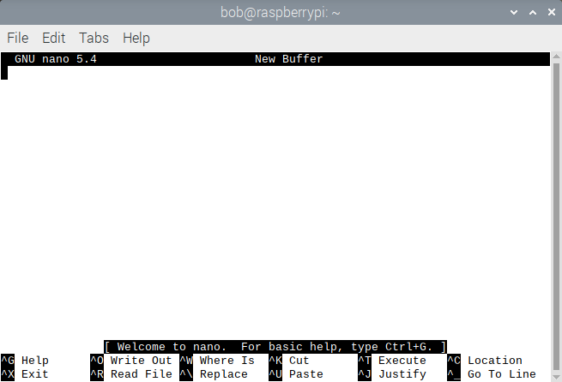
Figure 1.1 General Appearance of the Nano Screen

1.4.3 A Brief Nano Tutorial
The following sub-sections illustrate and explain some of the basic operations, as well as some of the features, of Nano.

1.4.3.1 Creating and opening a new file

If you want to create a new file and open it using Nano, use the following command(s) from a terminal window:

$ nano
or
$ nano [filename]
The second command is also used to open an existing file, where filename is the name of the existing file. If you want to open a file which is not located in your current directory, then you have to use the absolute or relative path to that file. For example /home/bob/filename.

Figure 1.2 shows a file that has been opened with the second command shown above.

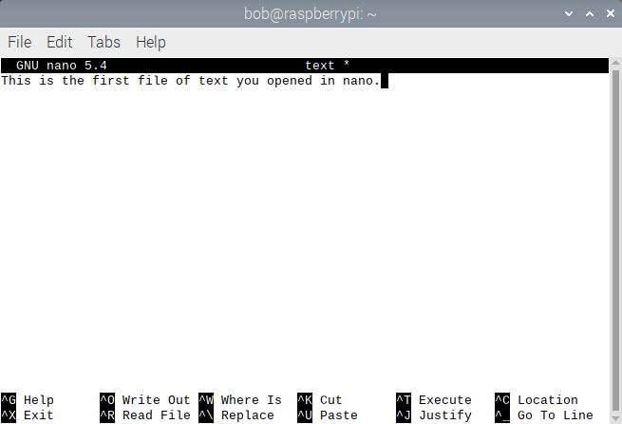
Figure 1.2 First Opened File in Nano

At the bottom of the editor window, keyboard shortcuts are displayed (they are not GUI menu choices!) that let you perform some basic operations. Examples of these are Cut, Paste, Write Out, Exit, etc. .

1.4.3.2. How to Save a File

To save a file, use the keyboard shortcut <Ctrl+O>. When you use this key combination, the editor will prompt you for a filename (or confirm the name if it was already provided when the editor was started). Enter your filename, and press <Enter> to save the file with that name.

This is illustrated in Figure 1.3.

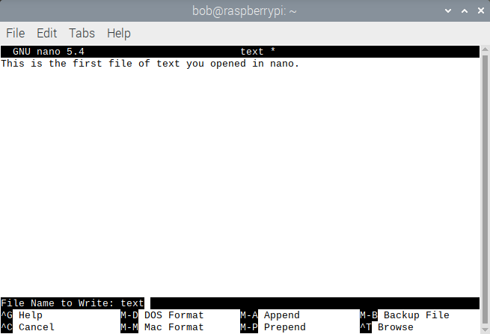
Figure 1.3 Writing Out a File With a Specific File Name

1.4.3.3 How to Cut and Paste Text

To cut and paste a particular line of existing text that has already been entered into the buffer, first bring the cursor to any character on that line by using the arrow keys on the keyboard. Press <Ctrl+K> to cut that whole line out of the buffer, then position the cursor with the arrow keys to the place where you want to paste the “cut” line back into the buffer. Since in our example, there’s only one line, now blank, in the buffer, the cursor is on line 1. Finally use <Ctrl+U> to paste the cut line back in.

For example, in Figure 1.4, if you want to cut the first line and paste it multiply to two lines below the first. go to the beginning of line 1 using the arrow keys on the keyboard, and then press <Ctrl+U>. Then, the position the cursor below the first line and press <Ctrl+U>. Repeat to do this multiply. In Figure 1.4, this paste was done nine times.

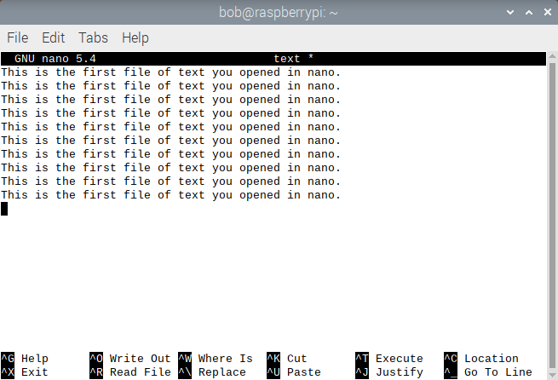
Figure 1.4 Cut and Pasted Text From One Line to Other Lines

1.4.3.4 How to Search and Replace a Word

This feature allows you to search for a particular word in the buffer, as well as replace it with another word.

To search for a word in Nano, press <Ctrl+W>. Then, you will be asked to enter the word which you want to search for. After typing-in the word (we typed-in “opened”,) press <Enter> , and Nano will take you to the first matched entry below or on the same line the cursor is positioned on, that matches that entry. In Figure 1.5, the cursor was on line 2, so Nano found the first instance of the word “opened”, which was on the 2nd line.

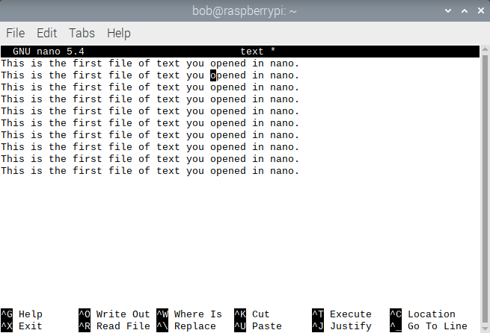
Figure 1.5 Searching for Text

You can also replace a word (or phrase) with another by pressing <Ctrl+\>. When you press this key combination, Nano prompts you for the word (or phrase) which you want to replace. After typing-in the word (or phrase), press <Enter>. You will be will prompted for the replacement word (or phrase). After this, you will be prompted for various ways of doing the replacement, and then are asked to confirm the changes. Once confirmed, the replacement is done.

1.4.3.5 How to Insert Another File into Current One in the Buffer

To insert text from another, already-saved file, into the buffer you are currently editing , do the following. Press <Ctrl+R> , and then give the complete pathname to the file which you want to insert into the current buffer, at the current position of the cursor in that buffer.

The following Figure illustrates this procedure.

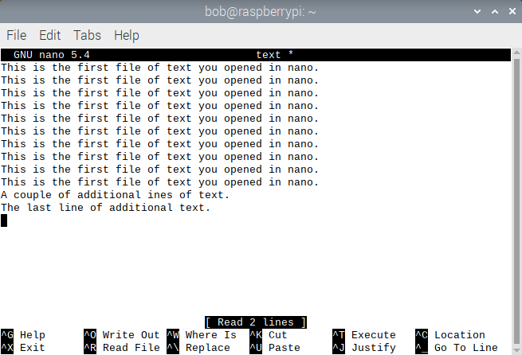
Figure 1.6 Inserting Text from a File

As you can see in Figure 1.7, the text of a file “/home/bob/second_nano” was inserted at the cursor position(which in the file”text” from Figure 1.5, was placed on a blank line created after the last line of text already in that file.)

1.4.3.6 How to Show the Cursor Position

It is possible to get information about the position of your cursor in the current buffer. This can be done by pressing the <Ctrl+C> keyboard shortcut.

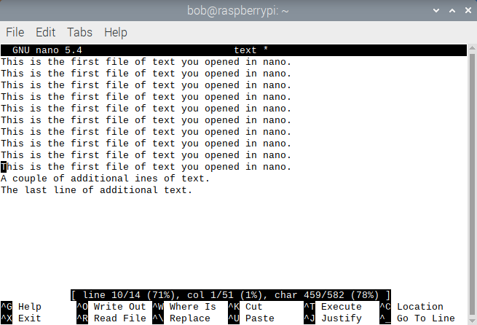
Figure 1.7 Cursor Position Report

Figure 1.7 shows that after <Ctrl+C> was pressed in the file “text”, the cursor position got highlighted in the editor area, and detailed information about it showed up in the status line (the one that's highlighted, or darkened in the figure - third line from the bottom of the window). It reports the cursor is at line 10 of 14, which is 78% through the file, at column 1 of 51 columns, and character 459 of 582 characters total in the buffer.

1.4.3.7 Displaying Line Numbers in the Current Buffer, or Permanently

You can show line numbers in the current buffer by pressing <Alt+#>. On most keyboards, the pound sign(#) is obtained using Shift and 3. After you’ve done this, the display looks as follows in the file “text” that we’ve created previously, with the line numbers in the buffer displayed along the left side of the window:

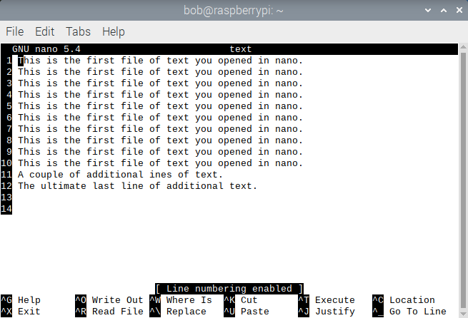
Figure 1.8 Display of Line Numbers in a Buffer

You can permanently display line numbers by creating or editing the Nano configuration file, found in your home directory. Here's how you can do it:

1. Open a terminal window.

2. Type the following command to edit or create the Nano configuration file:

$ nano ~/.nanorc

3. In the Nano configuration file, add the following line to enable line numbers:

set linenumbers

4. Save the file by pressing <Ctrl+O>, then press Enter. To exit Nano, press <Ctrl+X>.

5. Use the chmod command to make sure the access privileges to the ~/.nanorc file are set to u+x.

6. The line numbers should now be permanently displayed whenever you open Nano to edit a file.

Note that if the ~/.nanorc file doesn't exist, you can create it by following the steps above. If it already exists, simply add the set linenumbers line to it.

In-Chapter Exercises

1.1 Launch Nano without specifying a file name on the command line, and then enter some text into the New Buffer. Save that text into a file in your current working directory.
1.2 Cut some text out of a displayed file in Nano, using Nano keyboard commands, and then paste it in at another point in the display. What commands did you use to do this?
1.3 Replace a string of text in a displayed file in Nano with another string of text. What command(s) did you use to do this? Can this be done at multiple sites repetitively in the file, and simultaneously all at once?
1.4 Describe, in your own words, the concept of a buffer in Nano.
1.5 How did you select multiple characters in nano for the commands executed in the exercises above? If you use a single-console, text-only method of logging into and interacting with the Raspberry Pi, how can you select multiple characters for the operations you are asked to do in the exercises above?
1.6 a. In only a single terminal display, how can you open multiple buffers in previously-created text files in Nano, and switch between editing in them? b. What would be the major advantage of doing this?

1.5 Vi, Vim, and Gvim

The Vi, Vim, and Gvim text editors for the Raspberry Pi OS have almost all the features of a word processor, and have tremendous flexibility in creating text files. Initially, they are as easy to use as Nano, and can create simple text files for a novice user. Once you begin to exploit their more complex capabilities, their advantages allow you to create, manipulate, and use the kinds of text files that the full range of Raspberry Pi users, from absolute novice to seasoned veteran, commonly work with. We will proceed in the following sections and sub-sections to demonstrate Vi as a text-only interface editor, then move to a more graphical interface approach with Vim and Gvim.

As we mentioned in Section 1.1, the notion of a buffer as a temporary storage facility for the text that you are editing is very useful and important in Vi, Vim, and Gvim.

Some examples of buffers in these three editors are as follows-
a. The main buffer, sometimes referred to as the editing buffer, or the work buffer, is the main repository for the body of text that you are trying to create, or to modify from some previous permanently archived file on disk.
b. The general purpose buffer is where your most recent “ripped-out” (cut/copied) text is retained.
c. Indexed buffers allow you to store more than one temporary string of text.

1.5.1 Basic Shell Script File Creation, Editing, Execution

Shell Script File: Practice Session 1.1 shows how to create a script file, or collection of Linux commands that are executed in sequence, and then execute the script. For this example, we assume that you are running the Bourne Again (bash) shell.

On your Raspberry Pi system, do Practice Session 1.1 for the bash shell, which is the default shell in that system, and don’t change shells.

And don’t worry too much if you make an error in Steps 2, 3, and 4; you can go through the rest of the script file discussion, and then come back to this example after you have learned some of the Vi text editing commands, and become more familiar with them.

Practice Session 1.1

Step 1: At the shell prompt, start vi by typing vi firscrip and then pressing <Enter>. The vi screen appears on your display.
Step 2: Type A. Then type ls -la and then press <Enter>.
Step 3: Type who and then press <Enter>.
Step 4: Type pwd and then press the <Esc> key. At this point, your screen should look like that shown in Figure 1.9.
Step 5: Type :wq and then press <Enter>. You exit from Vi.
Step 6: At the shell prompt, type chmod u+x firscrip and then press <Enter>. Then type ./firscrip and press <Enter>.
Step 7: Note the results. How many files do you have in your present working directory? What are their names and sizes? Who else is using your computer system? What is your present working directory?

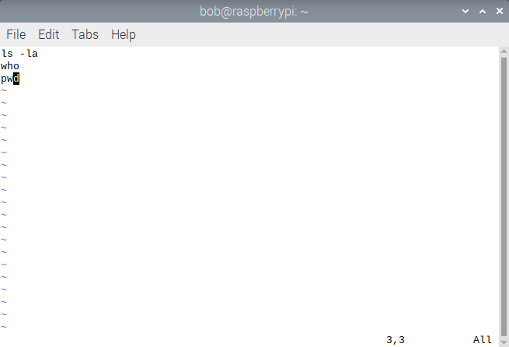
Figure 1.9 File firscrip After Step 4.

In Practice Session 1.1, you accomplished these things:

* At Step 2, typing A took Vi out of Command mode (which is what Vi starts in by default) and placed it in one of the forms of Insert mode. In other words, anything that you typed at the keyboard was appended as text on the first line in the text area of the editor.
* When you pressed the <Esc> key in Step 4, Vi was taken out of Insert mode and put back into Command mode.
* When you typed : in Step 5, that was a valid Command mode prefix character for the two commands that followed, and put Vi in Last Line mode.
* When you typed wq after the :, Vi interpreted those commands in Last Line mode as write out or save the file, and quit the editor.
* The two commands in Step 6 allow you to execute the contents of the Bash shell script file.

In-Chapter Exercises

1.7 Launch Vi in a terminal, or console, window on your Raspberry Pi system, by just typing vi on the command line. Then create a simple text file, and save it as firstext.txt in your current working directory. Finally, gracefully exit the Vi editor. What commands did you use to accomplish everything you did for this exercise?
1.8 Launch Vi in a terminal, or console, window on your Raspberry Pi system, by just typing vi on the command line. Then create another bash script file, similar to the one shown in Practice Session 1.1, but placing other common single Linux commands in it. Save it as 2ndscrip in your current working directory. Finally, gracefully exit the Vi editor, and test this script file on the bash command line. What commands did you use to accomplish everything you did for this exercise?

1.5.2 How to Start, Save a File, and Exit

When you need to do Raspberry Pi text editing that gives you as much functionality as a typical word processor, you can use the Vi text editor. To start Vi from the command line, use the following general syntax (anything enclosed in square brackets [ ] is optional):

vi [options] [file(s)]
Purpose: Allows you to edit a new or existing text file(s)
Output: With no options or file(s) specified, you are placed in the Vi program and can begin to edit a new buffer
Commonly used options/features:
+n Begin to edit file(s) starting at line number n
+/exp Begin to edit at the first line in the file matching string exp

The operations that you perform in Vi fall into two general categories: Command mode operations, which consist of key sequences that are commands to the editor to take certain actions, and Insert mode operations, which allow you to input text.

The general organization of the Vi text editor, and how to start, exit, and switch modes, are illustrated in Figure 1.10. The general organization of Vim and Gvim, and how to start, exit, and switch modes in those editors, is the same as shown for Vi in Figure 1.10.

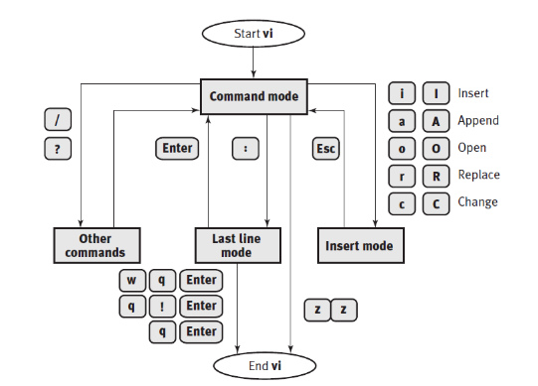
Figure 1.10 General Organization of Vi, Vim, and Gvim

For example, to change from Command mode, which you are in when you first enter the editor, to Insert mode, type a valid command, such as A to append text at the end of the current line. Certain commands that are prefixed with the :, /, ?, or :! characters are echoed or shown to you on the last line on the screen and must be terminated by pressing <Enter>. Last Line mode, sometimes called ex mode because it is derived from an older, UNIX editor, the ex editor, allows you to execute certain commands and leave the editor. To change from Insert mode to Command mode, press the <Esc> key.

The keystroke commands that you execute in Vi are case sensitive; for example, uppercase A appends new text after the last character at the end of the current line, whereas lowercase a appends new text after the character the cursor is on.

To start Vi, at the shell prompt, type vi (and optionally designate some option[s] and file name[s]) and then press <Enter>. You are now in Command mode. To enter Insert mode, type A and you are now able to insert text on the first line of the file.

After entering text, you can press the <Esc> key to enter Command mode.

At any point in your creation or manipulation of text, when you’re in Command mode, you can press the u key on the keyboard to undo the last operation.

From Command mode, you can save the text that you just inserted into the buffer to a file on disk by typing :w filename and pressing <Enter>, where filename is the name of the file you want to save the text to. To quit the editor, type :q. To quit without saving, type :q!

1.5.3 The Format of a Vi Command and the Modes of Operation

In Command mode, the generic syntax of keystrokes is:

[#1] operation [#2] target
where:
anything enclosed in [ ] is optional;
#1 is an optional number, such as 5, specifying how many operations are to be done;
operation is what you want to accomplish, such as deleting lines of text;
#2 is an optional number, such as 5, specifying how many targets are affected by the operation; and
target is the text that you want to do the operation on, such as an entire line of text.

***Note***
If the current line is the target of the operation, the syntax for specifying the target is the same as the syntax of the operation; for example, dd deletes the current line. Also, a variation on this generic syntax is the cursor movement command, whereby you can omit the numbers and operation and simply move the cursor by word, sentence, paragraph, or section.

Table 1.2 lists some specific examples of this generic syntax and variations used in Command mode.

Command | Action
cw | Change word.
cc | Change line.
c$ | Change text from current position to end of line.
C | Same as c$.
dd | Delete current line.
7 dd | Delete 7 lines.
d$ | Delete text from current position to end of line.
D | Same as d$.
5dw | Delete 5 words.
d7,14 | Delete lines 7 through 14 in the buffer.
d} | Delete up to next paragraph.
d^ | Delete back to beginning of line.
d/ pat | Delete up to first occurrence of pattern.
dn | Delete up to next occurrence of pattern.
df x | Delete up to and including x on current line.
dt x | Delete up to (but not including) x on current line.
dL | Delete up to last line on screen.
dG | Delete to end of file.
gqap | Reformat current paragraph to text width (Vim and Gvim).
g~w | Switch case of word (Vim and Gvim).
guw | Change word to lowercase (Vim and Gvim).
gUw | Change word to uppercase (Vim and Gvim).
p | Insert last deleted or yanked text after cursor.
gp | Same as p, but leave cursor at end of inserted text (Vim and Gvim).
gP | Same as P, but leave cursor at end of inserted text (Vim and Gvim).
]p | Same as p, but match current indention (Vim and Gvim).
[p | Same as P, but match current indention (Vim and Gvim).
P | Insert last deleted or yanked text before cursor.
r x | Replace character with x. Does not require the use of <Esc>!
R text | Replace with new text (overwrite), beginning at cursor. <Esc> ends replace mode.
s | Substitute character. <Esc> ends substitute mode.
4s | Substitute four characters. <Esc> ends substitute mode.
S | Substitute entire line. <Esc> ends substitute mode.
u | Undo last change.
<Ctrl+R> | Redo last change (Vim and Gvim).
U | Restore the current line, if you have not moved off of it.
x | Delete current cursor position.
X | Delete back one character.
5X | Delete previous 5 characters
. | Repeat last change.
~ | Change case and move cursor right.
<Ctrl+A> | Increment number at the cursor (Vim and Gvim).
<Ctrl+X> | Decrement number at the cursor (Vim and Gvim).

Table 1.2 Examples of Vi Command Syntax

As previously stated, when you start Vi, it is in Command mode. When you want to be in Insert mode instead of Command mode, press a valid key to accomplish the change. Some of these keys are shown in Table 1.3.

Key | Action
a | Appends text after the character the cursor is on
A | Appends text after the last character of the current line
c | Begins a change operation, allowing you to modify text
C | Changes from the cursor position to the end of the current line
i | Inserts text before the character the cursor is on
I | Inserts text at the beginning of the current line
o | Opens a blank line below the current line and puts the cursor on that line
O | Opens a blank line above the current line and puts the cursor on that line
R | Begins overwriting text
s | Substitutes single characters
S | Substitutes whole lines

Table 1.3 Important Keys Used to Switch From Command to Insert Mode

After inserting text, you can edit the text, move the cursor to a new position in the buffer, and save the buffer and exit the editor—all from within Command mode. When you want to change from Insert mode to Command mode, press the <Esc> key.

To save the buffer and exit the editor, press the : key (colon) to enter Last Line mode. The general commands that are useful in Last Line mode are shown in Table 1.4.

Command | Action
: n, m w file | Write lines n to m to new file.
: n, m w >> file | Append lines n to m to existing file.
:r filename | Reads and inserts the contents of the file filename at the current cursor position
:wq | Saves the buffer and quits
:w | Saves the current buffer and remains in the editor.
:w filename | Saves the current buffer to filename
:w! filename | Overwrites filename with the current text
:w! | Write file (overriding protection).
:w! file | Overwrite file with current text.
:w %.new | Write current buffer named file as file.new.
:q | Quit Vi (fails if changes were made).
:q! | Quit Vi without saving the buffer.
:Q | Quit Vi and invoke ex.
:vi | Return to Vi after Q command.
ZZ | Quits Vi, saving the file only if changes were made since the last save
% | Replaced with current filename in editing commands.
# | Replaced with alternate filename in editing commands.

Table 1.4 Important Commands in Command Mode

For now, we recommend that you use the arrow keys on the keyboard to move the cursor around in the buffer. It is possible to also use the h, j, k, and l keys on the keyboard to move the cursor. In Gvim, you can use the mouse and its buttons!

The following Practice Session introduces you to some of the commands presented in Tables 1.2 through 1.4. Feel free to use either Vi or Vim to do the steps of the following on your Raspberry Pi system:

Practice Session 1.2

Step 1: At the shell prompt, type vi firstvi and then press <Enter>.
Step 2: Type A, then type This is the first line of a vi file. and then press <Enter>.
Step 3: Type This is the line of a vi file. and then press <Enter>.
Step 4: Type is the 3r line of a vi
Step 5: Press the <Esc> key.
Step 6: Type :w and then press <Enter>.
Step 7: Use the arrow keys on the keyboard to position the cursor on the character l in the word line on the second line of the file.
Step 8: Type i and then 2nd_ , where the _ is a space character
Step 9: Press the <Esc> key.
Step 10: Use the arrow keys to position the cursor anywhere on the third line of the file.
Step 11: Type I and then This_ , where the _ is a space character.
Step 12: Press the <Esc> key.
Step 13: Use the arrow keys on the keyboard to position the cursor on the character r in 3r on this line.
Step 14: Type a and then d.
Step 15: Press the <Esc> key.
Step 16: Type A and then _file., where the _ is a space character.
Step 17: Press the <Esc> key on the keyboard. Your screen display should look similar to Figure 1.11.
Step 18: Type :wq. You will be back at the shell prompt.

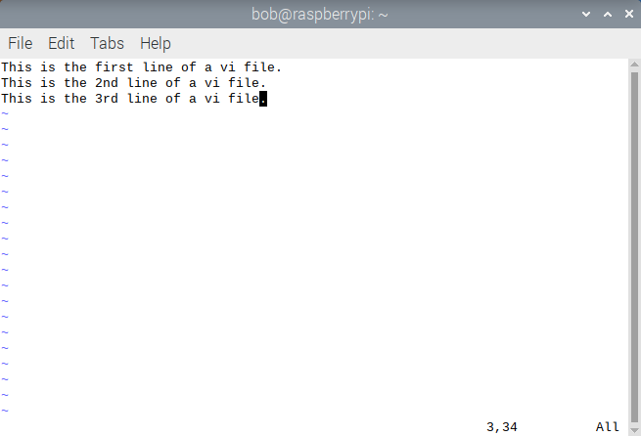
Figure 1.11 File firstvi

The following In-Chapter Exercises ask you to apply some of the operations you learned about in the previous practice session.

In-Chapter Exercises

1.9 With Vi you begin editing a file that you created yesterday. You want to save a copy of it with a different filename while still in Vi, but you don’t want to quit this editing session. How do you accomplish this result in Vi?
1.10 What happens if you accomplish five operations in Vi and then type 5u when in Command mode?
1.11 In your own words, give a brief description of what the following Vi commands accomplish (Use Tables 1.2 through 1.4 to guide you in your answers.):

dd, d1,12, x, a, 5b, 3w, :q!, G, 1G

1.5.4 Cursor Movement and Editing Commands

In Command mode, several commands accomplish cursor movement and text editing tasks. Table 1.5 lists important cursor movement and keyboard editing commands. As we have already noted, character-at-a-time or line-at-a-time moves of the cursor can be accomplished easily with the arrow keys, or alternatively with the h, j, k, and l keys on the keyboard.

The following practice session lets you continue editing the file you created in Practice Session 1.2 by using commands presented in Table 1.5.

Command | Action
1G | Moves the cursor to the first line of the file
G | Moves the cursor to the last line of the file
0 (zero) | Moves the cursor to the first character of the current line
<Ctrl+G> | Reports the position of the cursor in terms of line # and column #
$ | Moves the cursor to the last character of the current line
w | Moves the cursor forward one word at a time
b | Moves the cursor backward one word at a time
x | Deletes the character at the cursor position
dd | Deletes the line at the current cursor position
u | Undoes the most recent change
r | Replaces the character at the current cursor location with what is typed next

Table 1.5 Cursor Movement and Keyboard Editing

Practice Session 1.3

Step 1: At the shell prompt, type vi firstvi and then press <Enter>.
Step 2: Type G. The cursor moves to the first character on last line of the file.
Step 3: Hold down the <Ctrl> and g keys at the same time. On the last line of the screen display, Vi reports the following:
"firstvi" 3 lines --100%-- 3,1 All
This is a report of the buffer that you are editing, the total number of lines in the buffer, the percentage of the buffer that this line represents, the current column position of the cursor, and other editor settings that are the default.
Step 4: Type o. A new line opens below the third line of the file, and you’re in Insert mode.
Step 5: Type This is the 5th line of a vi file. Type <Esc>.
Step 6: Type 0 (zero). The cursor moves to the first character of the line you just typed in.
Step 7: Type $. The cursor moves to the last character of the current line.
Step 8: Type O. A new line opens above the current fourth line.
Step 9: Type This is the 44th line of a va file. Type <Esc>.
Step 10: Use the arrow keys to position the cursor over the first 4 in 44 on this line.
Step 11: Type x.
Step 12: Use the arrow keys to position the cursor over the a in va on this line.
Step 13: Type r and then type i.
Step 14: Type dd.
Step 15: Type :wq to go back to the shell prompt.
Step 16: At the shell prompt, type more firstvi and then press <Enter>. How many lines with text on them does more show in this file?

1.5.5 Yank and Put (Copy and Paste) and Substitute (Search and Replace)

Every word processor is capable of copying and pasting text, and also of searching for old text and replacing it with new text. Copying and pasting are accomplished with the Vi commands yank and put. In general, you use yank and put in sequence, and move the cursor (with any of the cursor movement commands or methods) only between yanking and putting. Some examples of the syntax for yank and put are given in Table 1.6.

Command Syntax | What It Accomplishes
y2W | Yanks two words, starting at the current cursor position, going to the right
4yb | Yanks four words, starting at the current cursor position, going to the left
yy or Y | Yanks the current line
p | Puts the yanked text after the current cursor position
P | Puts the yanked text before the current cursor position
5p | Puts the yanked text in the buffer five times after the current cursor position
Y | Copy current line
yy | Copy current line
" x yy | Copy current line to register x
ye | Copy text to end of word
yw | Like ye, but include the whitespace after the word
y$ | Copy rest of line
" x dd | Delete current line into register x
" x d | Delete into register x
" x p | Put contents of register x
y]] | Copy up to next section heading
J | Join current line to next line
gJ | Same as J, but without inserting a space (Vim and Gvim)
:j | Same as J
:j! | Same as gJ

Table 1.6 Example Yank and Put Command Syntax

The simple Vi forms of search and replace are accomplished using the substitute command. This command is executed when Vi is in Last Line mode, where you preface the command with the : character, and terminate the command by pressing <Enter>. The format of the substitute command as it is typed on the status line is:

:[range]s/pattern/string[/option(s)][count]
where:
anything enclosed in [ ] is not mandatory;
: is the colon prefix for the Last Line mode command;
range is a valid specification of lines in the buffer (or the current line is the range);
s or substitute is the syntax of the substitute command;
/ is a delimiter for searching;
pattern is the text or objects you want to replace;
/ is a delimiter for replacement;
string is the new text or objects;
/option(s) is a modifier, usually g for global, to the command; and
count is the number of lines to execute the command on from the current position.

The grammatic constructions of pattern and string can be extremely explicit and complex, and may take the form of a regular expression. A regular expression in UNIX and Linux is a string that is used to describe sequences of characters. Some examples of the syntax for the substitute command, including Vim/Gvim-only constructions, are given in Table 1.7.

Command Syntax | What It Accomplishes
:s/john/jane/ | Substitutes the word jane for the word john on the current line, only once.
:s/john/jane/g | Substitutes the word jane for every word john on the current line.
:1,10s/big/small/g | Substitutes the word small for every word big on lines 1–10.
:1,$s/men/women/g | Substitutes the word women for every word men in the entire file.
:'<,'>s/this/that/g | Select the range in Command mode first by typing <Ctrl+V> and using the arrow keys. Then type :. The word that will be substituted for the word this (Vim, Gvim only).
:s/ \<tim\>/tom/ | Substitutes only the whole word tim with the word tom, not the partial match of tim in any string.
:%s/terrible/wonderful/gc | Interactive substitution using c option of the word terrible with the word wonderful (Vim, Gvim only).
:%s/^/ \=line(".") . ". "/g | Makes the line numbers of all lines in the buffer permanently part of each line (Vim, Gvim only).

Table 1.7 Example Syntax for the Substitute Command

Practice Session 1.4 shows you how to use the Vi commands yank and put to copy and paste. It also allows you to do individual, and multiple searches, and replace text with the Vi substitute command.

Practice Session 1.4

Step 1: At the shell prompt, type vi multiline and then press <Enter>.
Step 2: Type A and then type Windows is the operating system of choice for everyone.
Step 3: Press the <Esc> key. You have left Insert mode and are now in Command mode.
Step 4: Press the 0 (zero) key. The cursor moves to the first character of the first line.
Step 5: Type yy. This action yanks, or copies, the first line to a special buffer.
Step 6: Type 7p. This action puts, or pastes, the first line seven times, creating seven new lines of text containing the same text as the first line. The cursor should now be on the first character of the eighth line. If it’s not, use the arrow keys to put the cursor there.
Step 7: Type 1G. This action puts the cursor on the first character of the first line in the buffer.
Step 8: Hold down the <Shift> and ; keys at the same time. Doing so places a : in the status line at the bottom of the Vi screen display, allowing you to type a command.
Step 9: Type s/everyone/students/ and then press <Enter>. The word everyone at the end of the first line is replaced with the word students.
Step 10: Use the arrow keys to position the cursor on the first character of the second line.
Step 11: Type :s/everyone/computer scientists/ and then press <Enter>.
Step 12: Repeat Steps 8–10 on the third through eighth lines of the buffer, substituting the words engineers, system administrators, web servers, scientists, networking nerds, and mathematicians for the word everyone on each of those seven lines. Type 1G
Step 13: Type :1,$s/Windows/Linux/g and then press <Enter>. You have globally replaced the word Windows on all eight lines of the file with the word Linux . Correct?
Step 14: Your Vi screen display should now look like Figure 1.12. Type :wq. You have now saved the changes and exited from Vi.

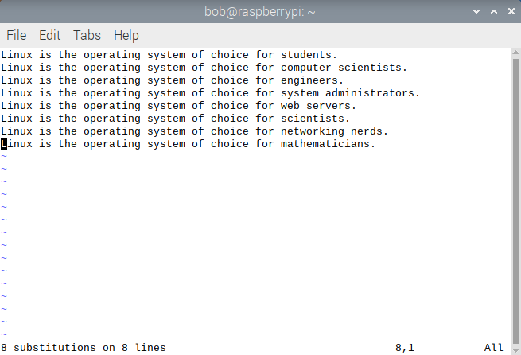
Figure 1.12 Multiline Vi fFile

1.5.6 Vim and Gvim

Vim and Gvim are two examples among many of enhanced, “improved” versions of Vi. The following subsections illustrate some of the advantages of using Vim and Gvim over the traditional Vi editor.

1.5.6.1 Vim Enhancements

The following capabilities of Vim, that enhance Vi functionality, particularly the first one shown, are suggestions that you can use to expedite your editing tasks with Vim and Gvim over and above the capabilities of Vi:

* vimrc
If you want to enable any of the improved facilities of Vim and Gvim, you should create a ~/.vimrc file. Even if this file is empty, it will enable the facilities that we illustrate in this section!

* Help
In Vim Last Line mode, type help or press the <F1> function key.
Vim opens a help buffer that gives you extensive help on its facilities. In Last Line mode, when in the help buffer, type q to exit help.

* Multiple Windows
The Last Line mode command split splits the current window in two. You can then move the cursor up to a window with <Ctrl+W> j and down a window with <Ctrl+W> k. For example, the Last Line mode command split new.c splits the window and begins editing the file named new.c. To close a window, use the normal Vim exit commands ZZ or :q!.

* Multiple Levels of Undo
Unlike Vi, you can use the undo command to undo several steps back in the command history. For example, typing u in Command mode undoes the last action in Vim, and typing 3u in Command mode undoes the last three actions you did in Vim. The undo level is set by default to 1000. You can redo multiply as well, using <Ctrl+R>. For example, 3 <Ctrl+R> redoes the last 3 actions that were undone with u.

* Visual Mode
Typing v causes Vim to enter Visual mode. You can then highlight a block of text and execute a Vim Command mode operation on it. The v command selects text by character. The <Ctrl+V> command selects text as a block. The V command selects the current line. See Section 1.5.6.2 for more details on this facility in Vim.

* The incsearch and hlsearch Environmental Options (Incremental Search and Highlight Search)
For the incremental search, by default, searching starts after you enter the string. With the option-
:set incsearch
incremental searches will be done. The Vim editor will start searching when you type the first character of the search string. As you type in more characters, the search is refined.
For the highlight search option, setting the option turns on search highlighting. This option is enabled by the command-
:set hlsearch
After the option is enabled, any search highlights the string matched by the search.

* The cindent Environmental Option and the = Command Option
Like Vi autoindent, the Vim editor does a more specific form of indentation. The cindent option is set with the command:
:set cindent
This turns on C programming language-style indentation. Each new line will be automatically indented the correct amount according to the C indentation standard.

* The :make Command
To compile a C program with an accompanying make file, and correct the errors, you can type this command in Last Line mode:
make
This runs the make command and captures the output. When the command finishes the editor starts editing the first file. The next step is to fix the error. After that you need to go to the line causing the next error. This is done using the command cn . This command will go to the location of the next error even if it is in another file. You can continue fixing problems and using cn until all your problems are resolved, or you want to do a recompile. If you want to see the current error message again, use the command cc

* Last Line Mode Command History
When you are in Last Line mode, you can use the <Up> arrow key to recall an older command line entry, and then can use the <Down> arrow key to go forward to newer commands. Then, when you press <Enter> after you have indexed to that previous command in the history, that previous command is executed again.
There are four histories you can utilize in Vim, but the two most important ones are for:
- Last Line mode command history
- / and ? search command history
Your search history is most useful to you, particularly because if you type complex search criteria, you do not want to have to retype them every time you want to repeat that search!

The two other histories are for expressions and input lines for the input() function.
As an example, you have done a Last Line mode command, typed five more Last Line mode commands, and then want to repeat the first command again. To do this, in Last Line mode press the <Up> arrow key five times. Another way of doing this is to type the first few letters of the Last Line mode command you want to return to.
The <Up> arrow key will use the text typed so far and compare it with the lines in the history. Only matching lines will be used.
If you do not find the line you were looking for, use the <Down> arrow key to go back to what you typed and correct that. You can also type <Ctrl+U> to start all over again.

To see all the lines in your Last Line mode command history, while in Last Line mode, type: history
You will then see a complete history of the Last Line mode commands for this session at the bottom of the screen display.
Your entire search history for this session is displayed by typing history/ in Last Line mode.
<Ctrl+P> will work like the <Up> arrow key, except that it doesn’t matter what you already typed. <Ctrl+N> works like the <Down> arrow key.

* The Last Line Mode Command Line Window
Typing any text in the Last Line mode command history to modify a previous command and then execute it is possible, but difficult for beginners.
A better way to use a modified form of a Last Line mode command from the history is to open the command line window while in Command mode by typing-
q:
Vim now opens a small utility window at the bottom of the screen. It contains the command line history and an empty line at the end.

In the buffer in this small utility window, you are in Insert mode, and can use Insert mode commands to modify text and also move commands. You can use the arrow keys to move around.
For example, move up the history tree with the <Up> arrow key to the :1,$s/Windows/Linux/g line, a command in the history of the creation of the file multiline.

Change the word Linux to Raspberry Pi OS in the Command Line Window. Now press <Enter> when on that line, and this command will be executed. The command line window will then close. The <Enter> command will execute the line under the cursor. This works if Vim is in Insert mode or in Command mode.
Unfortunately, changes you make in the command line window are lost! They do not result in any changes in the command history itself, but the command you execute when you are in the command line window will be added at the end of the history, similar to all other executed commands. Also, only one command line window can be open at a time.
The command line window is very useful when you want to see your old command history, index to a particular command, edit it, and execute it.
A search command in your history can be used to find something new if you index to it and modify it. For example, if in the command line window one of the lines contained :s/everyone/computer scientists/, you could index to it in the command line window and modify and execute it.
To exit from the command line window, type :q!

* Word Completion
When you are typing and you enter a partial word, you can cause Vim to search for a completion by using <Ctrl+P> (search for previous matching word) and <Ctrl+N> (search for next match).

* Record and Playback
The . (period) command repeats the previous change in Command mode. To accomplish multiple, complex changes in Vim Command mode, you can use the record and playback facility. There are three steps in record and playback:
- The q(register) command starts recording keystrokes into the key named register. The register name must be a letter of the alphabet.
- Type the commands you want to record in the register.
- To end recording, press q.
You can now execute the macro by typing the command @register. For example, you have a list of filenames in a buffer that looks like this:

stdio.h
fcntl.h
unistd.h
stdlib.h

And what you want is the following:

#include "stdio.h"
#include "fcntl.h"
#include "unistd.h"
#include "stdlib.h"

You start by moving to the first character of the first line. Next, in Command mode, you execute the following commands:

qa
^
i#include "<Esc>
$
a"<Esc>
j
q

These commands do the following:
- Start recording a macro in register a.
- Move to the beginning of the line.
- Insert the string #include " at the beginning of the line.
- Move to the end of the line.
- Append the double quotation mark (") character to the end of the line.
- Go to the next line.
- Stop recording the macro.
Now that you have done the work once, you can repeat the change by typing the command "@a" three times.
The "@a" command can be preceded by a count, which will cause the macro to be executed that number of times. In this case you would type: "3@a".

In-Chapter Exercises

1.12 How would you open a unique history window for the / and ? commands?
1.13 Where does the cursor have to be positioned in the buffer if you want to execute a modified version of the substitute command :s/everyone/computer scientists/ correctly?
1.14 Can you include Last Line mode commands, such as substitute, or write to a file, in a record and playback session?

1.5.6.2 Vim Visual Mode

Because Vi does not have a graphical, or “visual,” method of selecting and operating on blocks of text, we use Vim Visual mode. In Vim, Visual mode is the graphical and easy way to select a block of text in order to use a prescribed operator on it. The following will briefly describe Visual mode’s features and give a simple example. Vim Visual mode allows you to apply commands to blocks of text that can be selected graphically, even though you may not be in a GUI environment. In general, all of the Vi commands and operating modes shown previously work in both Vim and Gvim.

Using Visual mode is done in three steps:

Step 1: Move the cursor to the start of the text block, mark the start of the block with "v" (character mode), "V" (line mode), or <Ctrl+V> (blockwise mode). The character under the cursor will be used as the start of the block.
Step 2: Depending on what kind of functionality is provided in the terminal or console window you are working in, move to the end of the text block, either with the arrow keys on the keyboard, with the h, j, k, or l keys on the keyboard, or with the mouse and mouse button(s). The text from the character where you start Visual mode, up to and including the character under the cursor, is highlighted. Generaly v and V modes allow definition of non-rectangular blocks, whereas <Ctrl+V> allows definition of only rectangular blocks.
Step 3: Type a prescribed operator command. The highlighted characters from Step 2 will be operated upon depending on the nature of the prescribed operator listed.

You can use <Esc> to stop the definition of a block any time before you use a prescribed operator.

A simple example that illustrates how you can copy and paste using Visual mode follows in Practice Session 1.5.

Practice Session 1.5

Step 1: At the shell prompt type vim visualtest1, then press <Enter> on the keyboard.
Step 2: Type three or four arbitrary lines of text of uneven length (five to ten words each) into the buffer that opens on screen. Put some spaces at the beginning of some of the lines.
Step 3: Position the cursor on the first character of the first line of the buffer.
Step 4: Type v. On the last line display you will be notified that you have entered Visual mode! Now you can define the block that will be all or possibly only a portion of Step 2 text.
Step 5: Expand the highlighted area by using the input device of your choice until all the text you typed in Step 2 is highlighted. On our display, we used the arrow keys, and the highlighted area shows greyed-out (in fact, that’s how we knew we were defining the area to be yanked.)
If you make a mistake in defining the block, use <Esc> to stop the block definition and begin highlighting again at the first character in the buffer until you get the block definition you desire.
Step 6: Type y.
Step 7: On the last line display you will see a report of how many lines you just yanked.
Step 8: Position the cursor anywhere on the last line of the buffer.
Step 9. Type o. A new line opens below the last line in the buffer. Press <Esc>.
Step 10: Type p. The yanked block from Step 6 is put back in the buffer, starting on the new line you opened in Step 9 and proceeding downward. Repeat if you so desire, to get a better feel for opening a blank line and pasting the yanked text. Save the file if you want to.

1.5.6.3 Using Gvim to Cut and Paste between Multiple Open Buffers

To illustrate the speed and efficiency of using Gvim as a modern graphical Raspberry Pi text editor, and to describe some of Gvim’s functions, the following practice session allows you use Gvim to create text in two different files, open buffers into those files in two different windows, and copy and paste between those buffers.

To install Gvim on our Raspberry Pi systems, we used the following command:

bob@raspberrypi:~ $ sudo apt-get install vim-gtk
Output truncated...

***Note***
All of the typed-in Vim commands and operating modes shown previously work in both Vim and Gvim.

Practice Session 1.6

Step 1: At the shell prompt in a terminal window, type gvim gvim1 and then press the <Enter> key.
Step 2: A new Gvim window opens on screen. In that window, type A and then type This is the first line of text. Then press the <Enter> key twice.
Step 3: Type This is the third line of text. Then press the <Enter> key.
Step 4: From the Gvim pull-down menu, make the choice Window>Split. You now are looking into two windows on the same buffer.
Step 5: From the Gvim pull-down menu, make the choice File>Save. Click the OK button in the Save window, if one appears. The buffer is saved to the file gvim1.
Step 6: Use the mouse and click anywhere in the lower window with the left mouse button. You are now working in the lower buffer.
Step 7: From the Gvim pull-down menu, make the choice File>Save As. In the Name: box at the top of the window that opens, change the name of the file to gvim2, and then make the Save button choice. The buffer is saved as gvim2, and you are looking into the buffer through two windows.
Step 8: The active buffer is still seen in the lower window. Use the mouse and <Delete> key on the keyboard to change the word first to the word second, and the word third to the word fourth in the lower window.
Step 9: Click anywhere in the top window.
Step 10: Make the Gvim pull-down menu choice File>Open. Scroll down and open gvim1 in the current directory by selecting it and making the OK button choice. You should now be seeing gvim1 in the upper window, and gvim2 in the lower window.
Step 11: Click anywhere in the bottom window.
Step 12: Use the mouse and left mouse button to highlight the text This is the second line of text. Make sure the cursor is on the period as you finish selecting that line.
Step 13: Make the Gvim pull-down menu choice Edit>Copy. You have “yanked” a line of text in the lower buffer graphically.
Step 14: Click on the second blank line in the upper window buffer.
Step 15: Make the Gvim pull-down menu choice Edit>Paste. The line This is the second line of text. is now on the second line of the upper window buffer. You can use the Gvim pull-down menu choice Edit>Undo to correct mistakes in copying and in pasting.
Step 16: Repeat Steps 11 through 15 to copy and paste the line This is the fourth line of text. from the lower window buffer to the upper window buffer, where it should be the fourth line of text. When you are done, your screen display should look similar to Figure 1.13.
Step 17: While the active window buffer is the upper window, make the Gvim pull-down menu choice File>Save-Exit.
Step 18: At the shell prompt in a terminal window, type more gvim1. What appears on screen? Do the same for the file gvim2. What appears on screen?

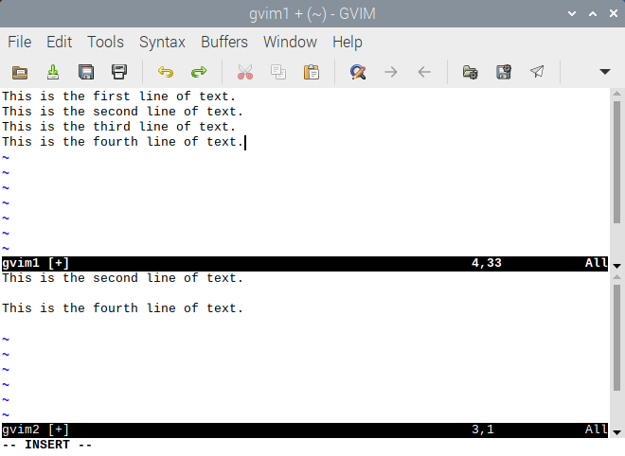
Figure 1.13 File gvim1 After Step 16.

A complete summary of Vi, Vim, and Gvim commands is given in Table 1.9, which we conveniently append to the end of this chapter so that you may print it for use as a handy paper reference when doing text editing with these editors.

In-Chapter Exercises

1.15 Repeat Practice Session 1.6 for Gvim using another text file with content of your own choosing, and then cut and paste from it into 3 other files that you open simultaneously in the same Gvim terminal window. Save all 4 files when finished.
1.16 Similar to Practice Session 1.6, use non-graphical Vi in a terminal window on a non-GUI-based Raspberry Pi system, such as a server install, to achieve the same results. What commands did you use to do this? Which editor was easier to use to achieve the same results?
1.17 On a GUI-based Raspberry Pi, how could you achieve the same results as using Gvim in Practice Session 1.6 by using two, or more, sessions in separate terminal windows running Nano, or Vi in them?

1.5.7 Changing Vi, Vim, and Gvim Behavior

In general, all of the environment options commands shown in this section work in Vi, Vim, and Gvim. Note that, because Vim stands for VI Mproved, Vim and Gvim have many more environmental options. As previously suggested, you can create an empty version of the ~/.vimrc file to enable many of the behavioral changes we show here. We also suggest you modify both your ~/.exrc and ~/vimrc files to accomplish the behavioral changes illustrated, depending on which editor you want the changes to be implemented in. If you put a Vim-specific behavior-changing option in the .exrc file, when you run Vi, you will probably get a warning message in Vi, but not a fatal error message.

You can modify any of several environment options to customize the behavior of the Vi, Vim, and Gvim editors, either when you are in the editor at a given time, or for every editor session. These options include, for example, specifying maximum line length and automatically wrapping the cursor to the next line, displaying line numbers as you edit a file, and displaying the mode that the editor is in. You can use full or abbreviated names for most of the options. Some of the most important and useful options and their abbreviations are summarized in Table 1.8a. Also see Table 1.8b for a summary of the use of the set command.

Option | Abbreviation | Purpose
autoindent | ai | Aligns the new line with the beginning of the previous line.
ignorecase | ic | Ignores the case of a letter during the search process (with a / or the ? command).
list | list | Displays invisible characters, such as ^I for <Tab> and a $ for end-of-line characters.
nolist | nolist | Turns off the display of invisible characters.
noignorecase | noic | Instructs cases to be case sensitive.
number | nu | Displays line numbers when a file is being edited; line numbers are not saved as part of the file.
nonumber | nonu | Hides line numbers.
scroll |  | Sets the number of lines to scroll when the <Ctrl+D> command is used to scroll the Vi screen up.
set |  | Displays all the Vi variables that are set.
all |  | Displays all set Vi variables and their current values.
showmode | smd | Displays the current Vi mode in the bottom right corner of the screen.
noshowmode | nosmd | Turns off the mode of operation display.
wrapmargin | wm | Sets the wrap margin in terms of the number of characters from the end of the line, assuming a line length of 80 characters.
Table 1.8a Important Environmental Options for Vi,Vim, and Gvim

Last line mode syntax | What it does
abbr command
:ab in out | Use in as abbreviation for out in Insert mode.
:unab in | Remove abbreviation for in.
:ab | List abbreviations.
map!, map commands
:map string sequence | Map characters string as sequence of commands. Use #1, #2, etc., for the function keys.
:unmap string | Remove map for characters string.
:map | List character strings that are mapped.
:map! string sequence | Map characters string to input mode sequence.
:unmap! string | Remove input mode map (you may need to quote the characters with <Ctrl+V>).
:map! | List character strings that are mapped for input mode.
qx | Record typed characters into register specified by letter x (Vim and Gvim).
q | Stop recording (Vim and Gvim).
@x | Execute the register specified by letter x. Use @@ to repeat the last @ command.
set command
:set x | Enable boolean option x, show value of other options.
:set nox | Disable option x.
:set x=value | Give value to option x.
:set | Show changed options.
:set all | Show all options.
:set x? | Show value of option x.

Table 1.8b Last Line Mode Syntax

The set command in Last Line mode changes environmental options. There are two types of environmental options that can be modified with the set command: toggle options, which are either “on” or “off,” and options that require the use of an argument.

For example, after typing :set showmode, you have toggled the mode display “on,” and the editor displays the current mode at the bottom of the screen. If you then type :set noshowmode, you have toggled the mode display “off.” Similarly, after typing :set nu, Vi displays the line numbers for all the lines in the file. To turn “off” the line number display, type :set nonu. When the :set ai command has been executed, the next line is aligned with the beginning of the previous line. This useful feature allows you to easily indent source codes that you compose with Vi. Pressing <Ctrl+D> on a new line moves the cursor to the previous indentation level.

To see a listing of what all environment options in the editor are (the ones you have modified and the defaults) at any time, type :set all

There are a lot of them!

To see a listing of what environment options you have modified, either for this session only, or for all sessions, type :set When you use set to modify the environment options within an editor session, the options are set for that session only!

If you want to customize your environmental options for all Vi, Vim, and Gvim sessions, you need to put your options in the .exrc file in your home directory. You can use the set command to modify one or more options in the .exrc file as follows (typing the two keyboard keys <Ctrl+C> terminates the creation of the cat command):

$ cat > .exrc
set wm=5 showmode nu ic
<Ctrl+C>
$

The wm=5 option sets the wrap margin to 5, and is an example of a set command that requires an argument. That is, each line will be up to 75 characters long. The ic option allows you to search for strings without regard to the case of a character. Thus, after this option has been set, the /Hello/ command searches for strings hello and Hello.

In-Chapter Exercises

1.18 After examining Tables 1.8 a & b, select a few of the environment options that most appeal to you and then place them in your ~/.exrc file , whether it exists or not. Test them by running Vi.
1.19 If you haven’t already done so, place the set showmode environment setting in your ~/.exrc and in your ~/.vimrc file, whether they exist or not. Run Vim and then Gvim. Do various operations in both those editors. Does the mode you are in appear in the mode line in both editors?

1.5.7.1 Executing Shell Commands from Within Vi, Vim, and Gvim

At times you will want to execute a shell command without quitting Vi, and then restarting it. You can do so in Command mode by preceding the command with :!. Thus, for example, typing :! pwd would display the pathname of your current directory, and typing :! ls would display the names of all the files in your current directory. After executing a shell command, the editor asks you to Press ENTER or type command to continue , and then you are returned to Command mode.

1.5.8 Vi, Vim, and Gvim Keyboard Macros

Vi, Vim, and Gvim offer a variety of macro facilities; a macro is a keystroke construction that uses one or more compact set keystrokes to represent another larger number of keystrokes that are substituted for the single or compact set. Macros are used in Vi, Vim, and Gvim for the following reasons:

1. During Insert mode, to construct an abbreviation. For example, in a text file where you use often-repeated blocks of the same text.
2. In Command mode, Vi, Vim, and Gvim commands can be associated or mapped to other keys, such as the function keys at the top of the keyboard.
3. Complex commands and their arguments can be triggered by a single keystroke or a shorter sequence of keystrokes.

Here is a brief summary description of the various Vi, Vim, and Gvim macro operations, which are covered in the indicated subsections below:

Text abbreviation (Section 1.5.8.1), which operates in Insert mode. An abbreviation works only in Vi, Vim, and Gvim Insert mode.

Keystroke mapping (Sections 1.5.8.2 and 1.5.8.3), which operates in Insert mode, and uses the map! and map Last Line mode commands. Once defined, a map! sequence is triggered only in Insert mode, and a map sequence is triggered only in Vi, Vim, and Gvim Command mode.

Macro Record (Section 1.5.8.4), which shows the definition and use of a recorded macro.

In those sections, we will describe and give examples of some of the Vi, Vim, and Gvim macro facilities, and also give an additional example of a specialized Vim macro feature that can be used in Gvim as well.

1.5.8.1 Text Abbreviation Macros Used in Insert Mode

To save keystrokes while entering text, in Last Line mode, use the abbr(eviate), or just ab command.

It has the following general syntactic form:

:ab[br] [abbreviation abbreviated]
where:
: gets you into Last Line mode;
[ ] designates optional components;
ab or abbr is the command for creating an abbreviation;
abbreviation is a valid string of contiguous (no spaces allowed) characters; and
abbreviated is the substitute text you want to be placed in the buffer.

Text abbreviations can be canceled with the Last Line mode unabbr command, followed by typing the abbreviation you want to cancel. Also, if you just type abbr in Last Line mode, you get a listing of all the abbreviations that are active.

To use the abbreviation, when you are in Insert mode, whenever you type the string that represents abbreviation, and follow it by a non-alphanumeric character, the substitution will take place. The editor will examine the next character after you type the abbreviation to see if it’s non-alphanumeric or underscore, and if so, abbreviation will be erased, and the string that represents abbreviated will be substituted for it. Also, you are no longer in Insert mode.

For example, in Last Line mode, if you type ab kts Know this stuff! and then press <Enter>, kts is the abbreviation. Then anywhere in Insert mode, when you type kts and follow it by pressing the space key, the left or right arrow keys (all of which yield non-alphanumeric characters and are not the underscore keys on the keyboard for our Raspberry Pi system), the string Know this stuff! will be substituted on that line, and you will no longer be in Insert mode.

***Note***
As shown in the next section, this is different from keystroke mapping using the map! or map commands.

The following are some useful abbreviations for Python3 program file creation:

:ab 1 #!/usr/local/bin/python
:ab 2 from Tkinter import *
:ab 3 import os
:ab 4 import sys

1.5.8.2 Keystroke-Mapping Macros Used in Insert Mode

map! works on characters that are typed in Insert mode. As shown in the previous section, abbr won’t substitute text until you type a non-alphanumeric after the abbreviation string. Notice the editor echoes each character of the abbreviation as you type it, just in case you really want the string of characters that represents abbreviation to be an actual string of characters that you want in your text. Keystroke mapping works in a more keystroke, time-dependent way. Keystroke mapping used in Insert mode is handled by the Last Line mode map! command, which takes the following general form:

:map! [substitution substituted]
where:
: gets you into Last Line mode;
[ ] designates optional components;
map is the command for creating a keyboard mapping;
substitution is a valid string of contiguous (no spaces allowed) characters; and
substituted is the substitute text you want to be placed in the buffer.

For example, in Last Line mode, if you type map! ts This will save you time! and then press <Enter>, ts is the substitution. Then, anywhere in Insert mode, when you type ts in a short amount of time (under approximately half a second), the string This will save you time! will be substituted on that line, and you will still be in Insert mode. If you type more slowly, the literal string ts will be inserted.

The keystroke sequence <Ctrl+V> will let you escape the mapping, as long as you precede the macro with it. So no matter how fast you type in <Ctrl+V> ts, you get the literal string ts inserted.

Remapping abbreviations can be canceled with the Last Line mode unmap command, followed by typing the substitution you want to cancel. Also, if you just type map! in Last Line mode, you get a listing of all the mappings that are active.

1.5.8.3 Keystroke-Remapping Macros Used in Command Mode

Command-mode remapping is accomplished with the map Last Line mode command.
The general form of the map command is as follows:

:map [substitution substituted]
where:
: gets you into Last Line mode;
[ ] designates optional components;
map is the command for creating a keyboard mapping;
substitution is a valid string of contiguous(no spaces allowed) characters; and
substituted is the substitute text you want to be placed in the buffer.

Some editor command keys cannot be remapped in Command mode. Two examples of these keys are : (colon) and u.
Remapping substitutions can be canceled with the Last Line mode unmap command, followed by typing the remapping you want to cancel. Also, if you just type map in Last Line mode, you get a listing of all the mappings that are active. You will see that the editor already has several mappings defined by default.

As an example, in Last Line mode, if you type :map <F8> :wq<CR> and then press <Enter>, the function key <F8> at the top of your keyboard is the substitution. The substituted is the command to write the buffer to a file and quit the editor. <CR> represents the <Enter> key. After this mapping is done, anytime you are in Command mode, when you press the function key <F8>, the buffer will be written to the default file and you will exit the editor.

Another interesting and useful example is the following Last line mode map command, which can be used so that when you press the function key <F3> during editor sessions, a skeleton C program construct is entered into a blank buffer, as shown in Figure 1.14:

:map <F3> <Esc>i#include <stdio.h><CR>main(argc, argv)<CR> int argc;<CR> char *argv[];<CR>{<CR>}<Esc>

where:

<Esc> is used to represent the Escape key.
<CR> is used to represent the <Enter> key.

When you press the function key <F3>, Vim will insert the desired skeleton C program construct into the buffer.

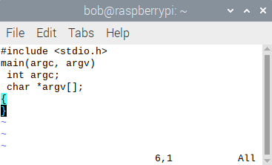

Figure 1.14 C Program Skeleton Done with the map Command

1.5.8.4 Vim/Gvim Macro Example

Here is a repeat of Practice Session 1.5, slightly enlarged, that uses a Vim-specific macro command sequence to accomplish kind of the same thing that Practice Session 1.5 did, but in another way.

Practice Session 1.7
Step 1: From the shell prompt, type vim PiOS2 and then press <Enter> on the keyboard.
Step 2: In Vim, type A and then type the following 10 lines of text, each on its own line:

computer scientists
students
hackers
systems analysts
newbies
Raspberry Pi gurus
computer programmers
systems administrators
network administrators
Raspberry Pi users

Step 3: Press <Esc>, then place the cursor anywhere on the first line of text.
Step 4: Type q a. This puts you in record mode and associates the macro you are about to record with the a key.
Step 5: Type I. The cursor is now at the start of the first line in Insert mode.
Step 6: Type Raspberry Pi OS is the operating system of choice for with a single space after the r in the word for. Press <Esc>.
Step 7: Place the cursor anywhere on the second line of text.
Step 8: Type q. This ends record mode.
Step 9: Type 9@a This “plays back” the macro defined with the a key nine times, once on each of the lines below the first line, inserting the text string “Raspberry Pi OS is the operating system of choice for”. Your screen display should now look like Figure 1.15.
Step 10: Save the file, print it out, and memorize its contents.

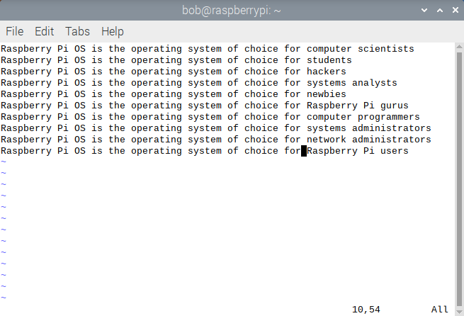
Figure 1.15
1.6 Geany Introduction

To provide you with a useful comparison to the Raspberry Pi text editors, this section covers Geany, the freely available Integrated Development Environment(IDE) that comes pre-loaded with the Raspberry Pi OS. We illustrate essential Geany operations in the context of the creation, and building, of C++ and Python programs and script files.

***Note***
This section is not a tutorial on C++, or Python! In fact, you don’t even have to know about the syntax of those languages to be able to appreciate how Geany facilitates the development process of C++ and Python code. The fact that those languages are structured, with distinct syntactic forms whose production and creation are made easier and simpler to input by Geany, is the real lesson here.

To begin our discussion of Geany, it’s worth noting the key differences between a Raspberry Pi OS text editor, like Nano or Vim, and a Raspberry Pi OS IDE like Geany.

It’s also worth noting at this point that none of these apps are strictly speaking word processors, like LibreOffice Writer.

The five key differences between text editors and IDEs are-

1. Scope and Complexity: Text editors like Vim, Emacs, or Nano are simpler and focused on text editing with minimal additional features. IDEs like Geany, Visual Studio Code, IntelliJ IDEA, or Eclipse, are comprehensive development environments offering extensive features for coding, debugging, testing, and project management.
2. Functionality: Text editors mainly provide basic text editing capabilities, syntax highlighting, and search/replace functions. IDEs, like Geany, offer advanced features like compilation and linking, integrated debugging, version control, intelligent code completion, and project navigation.
3. Integration and Workflow: IDEs, like Geany, integrate various tools and services seamlessly within the development environment, streamlining the development workflow. Text editors usually rely on external tools for tasks like compilation and linking, debugging, or version control.
4. Learning Curve: Text editors generally have a steeper learning curve, especially for powerful but complex ones like Vim or Emacs. IDEs typically have a more intuitive and user-friendly GUI interface, making it easier for beginners to start coding.
5. Resource Usage: Text editors are usually lightweight and consume fewer system resources compared to full-fledged IDEs. IDEs tend to be more resource-intensive, due to their comprehensive features and capabilities.

In general, IDEs on Linux provide a comprehensive set of tools and features to facilitate software development. Here are some key aspects:

1. Feature-Rich Environment: IDEs offer a wide array of features like code completion, syntax highlighting, integrated debugging, refactoring tools, version control integration, and project management capabilities.
2. Code Assistance and Productivity Tools: IDEs provide intelligent code completion, suggesting code snippets, variable names, and method signatures as you type. This enhances productivity and reduces errors.
3. Debugging and Testing: Debugging is seamlessly integrated within the IDE, allowing developers to set breakpoints, inspect variables, and step through code. Testing frameworks can be integrated for automated testing.
4. Project Management: IDEs often have built-in project management tools, making it easier to organize and navigate through complex codebases. This includes features like project-wide search, file hierarchy views, and class/module navigation. Some even offer integration of local projects with GitHub.
5. Integration with Build Systems: IDEs integrate with various build systems and tools, enabling developers to compile, link, build, and package their applications from within the IDE. This streamlines the development workflow.
6. Plug-in Ecosystem: Most IDEs support an extensive ecosystem of plugins or extensions. Developers can customize their IDE by adding plugins for specific languages, frameworks, or tools, tailoring it to their needs.
7. Cross-Language Support: Many IDEs support multiple programming languages, allowing developers to work on projects with diverse technology stacks seamlessly.

Popular Linux IDEs include:

1. Geany: As stated in the Geany Manual, “Geany is a small and lightweight Integrated Development Environment. It was developed to provide a small and fast IDE, which has only a few dependencies on other packages. Another goal was to be as independent as possible from a particular Desktop Environment like KDE or GNOME. Geany only requires the GTK+ runtime libraries.”

2. Visual Studio Code (VSCode): A versatile and highly customizable IDE developed by Microsoft.

3. IntelliJ IDEA: Known for its powerful features and support for Java and related technologies.

4. Eclipse: An open-source IDE with a broad ecosystem and support for multiple languages.

5. PyCharm: A specialized IDE for Python development.

To prepare you for working with Geany, we provide you with a listing of some typical IDE features as presented in the seven points above, such as

1. User Interface: Geany has a clean and straightforward user interface, resembling a text
editor but with additional IDE features. It’s designed to be intuitive and easy to navigate.
2. Code Editing Features:
Syntax highlighting for a wide range of programming languages.
Code folding to collapse and expand sections of code for better readability.
Autocomplete functionality to suggest and complete code snippets.
3. Build and Compile:
Geany allows you to build and compile your projects directly within the IDE.
It supports various build systems and compilers.
4. Integrated Development Tools:
Basic integrated tools include a terminal emulator and a file browser for easier
navigation within the project.
5. Plugin Support:
Geany supports a range of plugins to enhance its functionality.
These plugins can provide additional features like version control integration,
project management, and more.
6. Project Management:
Geany offers project management features, enabling you to organize your files
and resources effectively.
7. Cross-Platform Support:
Geany is available for Linux, Windows, and macOS, making it versatile and
adaptable to different operating systems.
8. Extensible and Customizable:
Users can customize Geany to their preferences, adjusting settings, color schemes,
and installing plugins to tailor the IDE to their needs.
9. Documentation and Community:
Geany has good documentation and an active community, providing support and
assistance to users.

Geany is favored by developers looking for a lightweight and fast IDE without compromising essential features necessary for efficient coding. It’s suitable for a variety of programming languages and project types.

1.6.1 Geany Usage

You can start Geany in the following ways:
* From the Desktop Environment menu:
On your Desktop, using the Raspberry Menu, make the Programming > Geany choice.
* From the Raspberry Pi command line, type geany and press <Enter>.

1.6.2 The Geany Workspace

A picture is worth a million words. The Geany window, or workspace, is shown in the following figure:

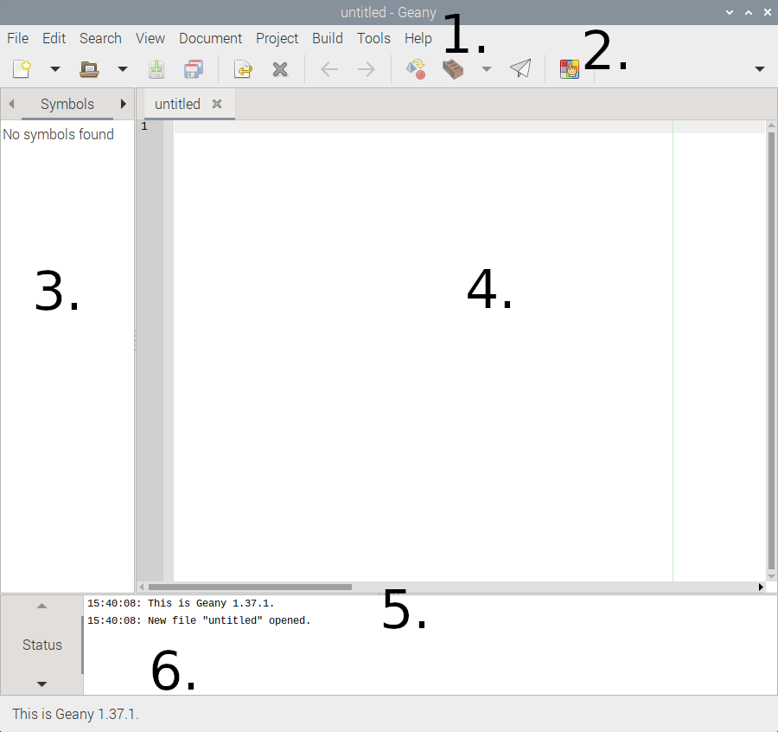
Figure 1.16

The workspace has the following parts, labeled as such in Figure 1.16:

1. The menu of pull-down text choices, File, Edit, Search, View, Document, Project, Build, Tools, Help.
2. A toolbar with several icons on it.
3. A sidebar that can show the following tabs:
* Documents - A document list, and
* Symbols - A list of symbols in your code. This is what is shown in Figure.1.16.
* Files – If you make the Geany menu choice Tools > Plugin Manager, you can put a check
mark next to the File Browser plugin, and then Geany will include a file browser in this sidebar.
See Section1.6.4.10 for more information about obtaining and loading useful plugins.
4. The main editor window.
5. A message window, which can show the following tabs:
* Status - A list of status messages. This is what is shown in Figure.1.16.
* Compiler - The output of compiling or building programs.
* Messages - Results of 'Find Usage', 'Find in Files' and other actions
* Scribble - A text scratchpad for any use.
* Terminal - A terminal window.
6. A status bar

***Note***
By default, when you launch Geany, it loads all files from the last time Geany was launched. And, you can start several “instances” of Geany, but only the first instance will load files from the last session.

To run a second instance of Geany from the command-line, don’t include any filenames as arguments, or disable opening files in a running instance using the appropriate command line option.

1.6.3 Five Easy Geanys, and Some Geany Py

To begin this section, we present five Practice Sessions that allow you to get your feet wet with Geany as an IDE on the Raspberry Pi OS, in the context of C++ program development and execution. C++ as the illustrative language in this section was chosen because it’s a modern OOP language. Of course, everything shown in this Section can be applied, with the modification of different arguments and targets, to working with other compiled High Level Languages(HLLs,) such as C, C#, or intermediate languages like Python3 (which is both interpreted and compiled), Java, etc..

We then present a block of Python3 programs that you can use Geany to create, edit and execute. These programs are taken directly from Volume 2, Chapter 2, where they were executed in various fashions, partly via the use of the Raspberry Pi IDE named Thonny.

1.6.3.1 Compiling and Executing C++ Programs

We provide some background material in this section on the development process of a C++ program, particularly the compilation and execution processes. Several C compilers are available on the Raspberry Pi OS, including gcc and g++. The most commonly used C++ compiler for the Raspberry Pi OS is the GNU C++ compiler, g++. All C++ compilers, such as the GNU compiler for C++ can also be used to compile C programs. The g++ compiler invokes gcc with options necessary to make it recognize C++ source code. We solely utilize the g++ compiler in Geany in this chapter. It’s instructive at this point to see a synopsis of the man page for g++, as follows:

***********************************************************************************

g++(1)

NAME
gcc - GNU project C and C++ compiler
SYNOPSIS top
gcc [-c|-S|-E] [-std=standard]
[-g] [-pg] [-Olevel]
[-Wwarn...] [-Wpedantic]
[-Idir...] [-Ldir...]
[-Dmacro[=defn]...] [-Umacro]
[-foption...] [-mmachine-option...]
[-o outfile] [@file] infile...

Only the most useful options are listed here.

DESCRIPTION

When you invoke GCC, it normally does pre-processing, compilation, assembly and linking. The "overall options" allow you to stop this process at an intermediate stage. For example, the -c option says not to run the linker. Then the output consists of object files output by the assembler.

Other options are passed on to one or more stages of processing. Some options control the preprocessor and others the compiler itself. Yet other options control the assembler and linker; most of these are not documented here, since you rarely need to use any of them.

Most of the command-line options that you can use with GCC are useful for C programs; when an option is only useful with another language (usually C++), the explanation says so explicitly. If the description for a particular option does not mention a source language, you can use that option with all supported languages.

***********************************************************************************

The Build command in Geany does all that, and can be combined with the make command, a Linux utility that allows a combining of source files together to form a single executable image. A synopsis of the man page for the make command is as follows:

***********************************************************************************

make

SYNOPSIS
make [-einpqrst] [-f makefile]... [-k|-S] [macro=value...]
[target_name...]

DESCRIPTION

The make utility shall update files that are derived from other files. A typical case is one where object files are derived from the corresponding source files. The make utility examines time relationships and shall update those derived files (called targets) that have modified times earlier than the modified times
of the files (called prerequisites) from which they are derived. A description file (makefile) contains a description of the relationships between files, and the commands that need to be executed to update the targets to reflect changes in their prerequisites. Each specification, or rule, shall consist of a target, optional prerequisites, and optional commands to be executed when a prerequisite is newer than the target. There are two types of rule:
1. Inference rules, which have one target name with at least one
<period> ('.') and no <slash> ('/')
2. Target rules, which can have more than one target name

OPTIONS

The following options, and option argumaents, are supported:

-e Cause environment variables, including those with null
values, to override macro assignments within makefiles.

-f makefile
Specify a different makefile. The argument makefile is
a pathname of a description file, which is also
referred to as the makefile.

-i Ignore error codes returned by invoked commands. This
mode is the same as if the special target .IGNORE were
specified without prerequisites.

-k Continue to update other targets that do not depend on
the current target if a non-ignored error occurs while
executing the commands to bring a target up-to-date.

-n Write commands that would be executed on standard
output, but do not execute them. However, lines with a
<plus-sign> ('+') prefix shall be executed. In this
mode, lines with an at-sign ('@') character prefix
shall be written to standard output.

-p Write to standard output the complete set of macro
definitions and target descriptions. The output format
is unspecified.

-q Return a zero exit value if the target file is up-to-
date; otherwise, return an exit value of 1. Targets
shall not be updated if this option is specified.
However, a makefile command line (associated with the
targets) with a <plus-sign> ('+') prefix shall be
executed.

-r Clear the suffix list and do not use the built-in
rules.

-S Terminate make if an error occurs while executing the
commands to bring a target up-to-date. This shall be
the default and the opposite of -k.

-s Do not write makefile command lines or touch messages
(see -t) to standard output before executing. This mode
shall be the same as if the special target .SILENT were
specified without prerequisites.

-t Update the modification time of each target as though a
touch target had been executed.

COMMAND ARGUMENTS

The following arguments are supported:

target_name
Target names, as defined in the EXTENDED DESCRIPTION
section. If no target is specified, while make is
processing the makefiles, the first target that make
encounters that is not a special target or an inference
rule shall be used.

macro=value
Macro definitions, as defined in Macros.

If the target_name and macro=value operands are intermixed on the
make utility command line, the results are unspecified.

*******************************************************************************

1.6.3.2 C++ and Geany Practice Sessions

Practice Session 1.8 Creating a C++ Program from Scratch

Objectives: To launch Geany on your Raspberry Pi system, and use it basically as a text editor to produce a simple C++ program. To then compile and execute that program using the graphical menu facilities of the Geany IDE.

Prerequisites: Having Geany on your Raspberry Pi system, which it is by default in the Raspberry Pi OS.

Background:
As indicated in Section 1.6.1, the most useful aspects of Geany as purely a replacement, or substitute for a text editor, are its capabilities to expedite code creation, particularly for the HLLs like C++. Capabilities like the coding assistance and productivity enhancement tools- intelligent code completion, suggesting code snippets, variable names, and method signatures as you type. This enhances productivity and reduces errors. And of course, autoindentation, triggered by key block programming tokens such as curly braces ({}) in C++. In this Practice Session, you’ll get exposure to this productivity enhancement, as well as Geany’s capability to compile, link, and execute structured programming code.

Procedure:
The following steps allow you to easily create, build, and execute a simple C++ program in Geany.

1. From the Raspberry Pi Menu, make the choice Programming > Geany to launch one instance of the Geany IDE. A file named “untitled” opens in the main editor window. Make the Geany menu choice File > Save as…, and save the file in a convenient location on your Raspberry Pi, with the name count1.cpp. This convenient location now becomes Geany’s current working directory. You can see that in the sidebar if the Documents heading is selected.

2. Make the Geany menu choice Edit > Preferences > Editor > Completions. Make sure a check mark is in the box next to Curly brackets { } under Auto-close quotes and brackets, and then click on the OK button in the lower right of the Preferences window.

This check mark signifies that auto-indentation is enabled, which will be triggered by the key C++ structured block programming token curly brace ({). Now, every time you type a left curly brace while entering text in the editor window, a matching right one will appear. And the subsequent new line of code will be indented by the specified default indentation.

3. In the main editor window of Geany, as seen in Figure 1.16, type in the following C++ program.

#include <iostream>
#include <string>

int main() {
std::string inputString;
char targetLetter;

// Prompt the user for input string
std::cout << "Enter a string: ";
std::cin >> inputString;

// Prompt the user for the target letter
std::cout << "Enter the letter you want to count: ";
std::cin >> targetLetter;

int count = 0;

// Loop through the characters in the input string
for (char ch : inputString) {
// Check if the current character matches the target letter
if (ch == targetLetter) {
count++;
}
}

// Display the count
std::cout << "The letter '" << targetLetter << "' appears " << count << " times in the string." << std::endl;

return 0;
}

Notice a few important things here-

a. Once you type the first { (curly brace), Geany automatically indents the second line of the C++ code. The same thing is true after you type in the second and third curly braces, automatically indenting those following lines of code after the curly braces.
b. By default, Geany applies a color coding scheme to the first line in the file as you type it in. Why is this true?
c. Fold regions appear at the left margin of the code. If you click on the – minus signs inside the fold boxes, the blocks of code incorporated automatically in those fold regions disappear temporarily. This is very useful for large, multi-line programs , where you can hide parts of the code, and only work on blocks of it.

4. After you’re sure you’ve typed in everything shown above in step 3. correctly, make the Geany menu choice File > Save.

5. Make the Geany menu choice Build > Build, or press the Function key <F9>.
If you typed in everything from step 3. correctly, the following message appears in the Geany message window-

g++ -Wall -o "count1" "count1.cpp" (in directory: /home/bob/Desktop/cpp)
Compilation completed successfully

6. Click on the paper airplane icon in the menu bar. This runs the program in a separate terminal window outside of the Geany window. For our example run here, we reproduce the output in that terminal window in the way we entered it as follows:

Enter a string: laksdjlkjffffkajlskdjlka
Enter the letter you want to count: f
The letter 'f' appears 4 times in the string.

------------------
(program exited with code: 0)
Press return to continue

7. Press <Enter> in the terminal window to continue. Run the program we several input string values to further test it.

***Note***
If you enter a space character in the anywhere in the input string, you won’t get the proper output! Why is that?

8. Make the Geany menu choice File > Close All.

9. Quit Geany by making the Geany menu choice File > Quit.

Conclusion:
You launched Geany on your Raspberry Pi system, and used Geany as a text editor to produce a simple C++ program. Then you used the Build Menu choice to compile the code, and the Run icon to execute that program, using the graphical menu facilities of Geany.

Practice Session 1.9 Opening, Building, and Running a Previously Saved C++ Programming

Objectives: To open an existing file with C++ code in it, build an image from that source, and execute the built image using Geany graphical menu choices.

Prerequisites:
1. Having Geany available on your Raspberry Pi system,
2. having completed Practice Session 1.8,
3. downloading the appropriate source code files for this chapter from www.github.com/bobk48/RaspberryPiOS/coderepository

Background:
It’s often necessary to load a file into Geany that you’ve previously worked on, or that someone in your DevOps team has given you. In this exercise, you will download and open a C++ file that calculates the Greatest Common Factor (GCF) of four interactively entered integers, using the Euclidean algorithm. Once you build and run the file, you’re prompted for the four integers, and it displays the GCF in a terminal window external to the Geany window.

***Note***
Once you exit Geany, without closing anything, upon the next launch of a single instance of Geany, that file is automatically loaded again, facilitating further work you might want to do on or with it. That’s a convenient feature of the IDE. Since at the end of Practice Session 1.8, you closed everything before exiting Geany, on a subsequent launch of a single instance of the app, the file named “untitled” is opened again.

Procedures:

1. In your web browser, navigate to the www.github.com/bobk48/RaspberryPiOS/coderepository, and download the file GCF4.cpp to a convenient directory on your Raspberry Pi system..

2. Launch Geany, either from the Raspberry Pi Programming > Geany menu, or from the command line.

3. From the Toolbar at the top of the Geany window, make the File > Open an existing file menu choice, and use the Raspberry Pi navigator screen to choose the file GCF4.cpp from Step 1.. It loads into the main editor window.

4. From the Toolbar at the top of the Geany window, make the Build the current file menu choice (It looks like a brown brick.) In the message window at the bottom of the screen two messages appears, similar to the following-

g++ -Wall -o "2nd" "GCF4.cpp" (in directory: /home/bob/Desktop/cpp)
Compilation finished successfully.

The directory shown will be the directory you downloaded the source code files to, not the pathname of that we illustrate here!

5. From the Toolbar at the top of the Geany window, click on the Run or view the current file icon. (It looks like a paper airplane.)

6. A terminal window appears on screen, showing the output results of our test running the GCF4 code, as follows.

Enter the first number: 3
Enter the second number: 27
Enter the third number: 9
Enter the fourth number: 81
The Greatest Common Factor of 3, 27, 9, and 81 is 3

------------------
(program exited with code: 0)
Press return to continue

Press <Enter> to close the terminal window.

7. Run the program again to test other sets of integers.

8. Make the Geany menu choice File > Close and then the choice File > Quit .

Conclusion:
You downloaded and opened a file with C++ code in it, built an image from that C++ source, and executed the built image using Geany graphical menu choices, to find the Greatest Common Factor of four integers.

Practice Session 1.10 Geany Project Basics in C++

Objectives: To create a C++ program that finds the Least Common Denominator(LCD) of three entered fractions, and to place that program in a new project, and its attendant folder(s) in Geany.

Prerequisites
Completion of Practice sessions 1.8 and 1.9.

Background:

As mentioned in the section on vi,vim, and gvim,, even though those editors are highly customizable text editors, they don’t have built-in project management features like Geany.

Files are managed individually in Geany, even though you can view files and folders in the Documents sidebar display, there is no usable folder context, so you can't add folders through Geany unless you do it via the command line. Geany has a built in terminal that can be accessed from the Messages area at the bottom of the Geany window (Item 5. in Figure 1.16). Because Geany does not allow you to add folders from the File browser if you’ve enabled that plugin, you can use this terminal for folder management. Scroll the menu on the left of the messages window, using the arrows, to the Terminal item to open a view into that terminal. Then use Linux file maintenance commands to do folder management, or other operations you might want to accomplish.

***Note***
See Section 1.6.4.10 to enable the File browser sidebar, which allows you to navigate to files and directories where you can view the contents of Geany’s current working directory, or the directory of the current project.

A project is a Geany convenience feature that allows you to save your file state, and IDE settings that may be specific to your project.

Procedures:

1. Launch Geany. As described in the Background to this Practice Session, Geany has a built in terminal that can be accessed from the Messages area at the bottom. Because Geany does not allow you to add folders from the file browser if you’ve loaded that plugin, you can use this terminal for folder management. Scroll the menu on the left of the messages window, using the arrows, to the Terminal item to open a view into that terminal.

2. From the terminal in the Messages area of Geany, create a project directory.

bob@raspberrypi:~ $ mkdir project2

Change to the folder second.

bob@raspberrypi:~ $ cd project2

3. So we can see the files we're working with if we switch to the Files sidebar display, and navigate to the new projects2 folder.

Create a new file called third.cpp. There are 2 steps to accomplish this:

a. Make the Geany menu choice File > New This creates a new tab with the name 'untitled'
b. Make the Geany menu choice File > Save As... In the Raspberry Pi file window that opens on screen, in the Name area, type third.cpp. Navigate to the project2 directory. It’s empty! Then click on the Save button in the Save File window. This will allow you to save your file third.cpp into the new project2 folder.

4. Add the following C++ code into the editor area, save your new file as third.cpp into your project2 folder:

#include <iostream>

// Function to find the greatest common divisor (GCD) of two numbers
int findGCD(int a, int b) {
if (b == 0) {
return a;
}
return findGCD(b, a % b);
}

// Function to find the least common multiple (LCM) of two numbers
int findLCM(int a, int b) {
return (a * b) / findGCD(a, b);
}

int main() {
int num1, den1, num2, den2, num3, den3;

// Input three fractions
std::cout << "Enter the first fraction (numerator denominator): ";
std::cin >> num1 >> den1;
std::cout << "Enter the second fraction (numerator denominator): ";
std::cin >> num2 >> den2;
std::cout << "Enter the third fraction (numerator denominator): ";
std::cin >> num3 >> den3;

// Find the LCD of the denominators
int lcm12 = findLCM(den1, den2);
int lcd = findLCM(lcm12, den3);

// Output the LCD
std::cout << "The LCD of the three fractions is: " << lcd << std::endl;

return 0;
}

5. Projects

a. For this example, with the third.cpp file still open, from the Geany menu, choose Project >New...
In the New Project window that opens, type third into the Name: bar. Change the Filename: entry to /home/bob/project2/third.geany, and the Base path: entry to /home/bob/project2/third/

b. Then click on the Create button in the New Project window.

c. A Question box will open, asking you if you want to “Move the current documents into the new project’s session?”. Select 'Yes' to add third.cpp to the new project.

d. Another Question box opens, saying that The path “home/bob/project2/third/” does not exist. Create the project’s base path directory? Click the OK button.

***Note***
Of course, your pathnames will be slightly different, depending on the names of your home directory.

An explanation of the contents of the New Project window is as follows-

Name - this is the project name
FileName - The name and location of the project file.
BasePath - This is the folder where your project files belong. The third.cpp file is in the home/bob/project2 folder.
Now you have a project file that will load your source files and set your project directory when you load it.

So at this point, in the /home/bob/project2 directory, as viewed int the Geany terminal window, you have the following files-

third third.cpp third.geany

You must delete the directory named third with the following command in a terminal window:

$ rmdir third

***Note ***
This ordinarily would be the project directory that would hold all of your code, but for the sake of this Practice Session, and the next, where we clone project directories, we take the liberty of deleting that created directory because we created a project directory by hand, and didn’t use the default projects folder to contain our new project, and its attendant files and sub-folders.

6. Build

The Geany menu choice Build > Build will create an executable image. You can make the Geany menu choice Build > Build, or press the function key on the keyboard <F9>, to accomplish this. First click on the arrow buttons again to scroll up in the sidebar until “Messages” is displayed. Then, make the Geany menu choice Build > Build.

The following message appears in the Messages area at the bottom of the Geany window, IF you have faithfully and correctly typed in the code from Step 4.:

g++ -Wall -o "third" "third.cpp" (in directory: /home/bob/project2)
Compilation finished successfully.

7. Executing

So now that you have an executable image of this C++ program, you can execute it simply by clicking on the paper airplane icon (Run or view the current file) in the Geany Toolbar area. When we did that on our Raspberry Pi system, we got the following output in a separate terminal that opened off the Geany window-

Enter the first fraction (numerator denominator): 2 3
Enter the second fraction (numerator denominator): 3 4
Enter the third fraction (numerator denominator): 15 16
The LCD of the three fractions is: 48

------------------
(program exited with code: 0)
Press return to continue

8. Press the <Enter> key to close the terminal window.

9. Make the Geany menu choice File > Close All , then quit Geany.

It’s interesting to notice at this point that even though you ostensibly closed everything before quitting, on the next launch of Geany, you are placed back in the Project named third.

Conclusion: You created a C++ program that finds the Least Common Denominator(LCD) of three entered fractions, and placed that program in a newly created project, with its attendant directory in Geany. This technique is admittedly a hybrid version of the way it is ordinarily done.

Practice Session 1.11 Cloning Geany Projects

Objectives: To clone, or copy, an already-created Geany project that contains C++ program files, into another folder so that you can modify the copied C++ programs in this new project folder for an alternative use case.

Prerequisites:
1. Completion of Practice Sessions 1.8 through 1.10.

Background: To clone an entire project directory in this Practice Session, we use the cp -r Linux command, so that all the files created in the previous Practice Exercise in the project directory from there are duplicated into a new cloned project directory. The purpose of doing this is so that you can reuse the same code in a new project, and modify it, while retaining the original code in the original project directory. In this Practice Session, we also switch to the terminal display in the Message area at the bottom of the Geany window to execute Raspberry Pi OS commands. If you want to, you can open a separate terminal outside of Geany to accomplish this. We also utilize the Files sidebar of the Geany window to navigate to directories, and display their contents.

***Note***
See Section 1.6.4.10 to enable the File browser sidebar, which allows you to navigate to files and directories where you can view the contents of Geany’s current working directory, or the directory of the current project.

Procedures:

1. At the Raspberry Pi command line in a terminal display in the Message area, change the current working directory to the projects folder you created in Practice Session 1.10. This Practice Session assumes that your projects folder, when you change to the one created in Practice Session 1.10, is at /home/bob/project2/, but on your Raspberry Pi system, it will be slightly different, depending on where you created it in Practice session 1.10.

2. Create a new subdirectory of your home directory, named project3, with the following command-

$ cp -r project2 project3

project3 will be where your cloned project files will exist, after you execute this command.

3. Change the current working directory to project3 in the sidebar Files sidebar display. The following files should now be shown in that new directory-

third third.cpp third.geany

The file third is the executable image of the compiled program third.cpp, and the file third.geany is a Geany project file that holds information about the project.

4. Launch Geany, and in the Files sidebar display, navigate to /home/bob/project3, and double click on the project3 icon. You should now see the listing of files there as third, third.cpp, and third.geany in the Files sidebar display .

5. Select the file third.cpp, and double click on it to open it. The C++ code should appear in the Geany main editor pane.

6. Make the Geany menu choice Build > Build, or press the Function key <F9>.

You should get the following messages in the terminal area-

g++ -Wall -o "third" "third.cpp" (in directory: /home/bob/project3)
Compilation finished successfully.

6. Execute the program named third by clicking on the paper airplane icon.

7. The output we got, displayed in a separate terminal window, is exactly the same as we got in Practice Session 1.3 when we input the three fractions values, and should be as follows:

Enter the first fraction (numerator denominator): 2 3
Enter the second fraction (numerator denominator): 3 4
Enter the third fraction (numerator denominator): 15 16
The LCD of the three fractions is: 48

------------------
(program exited with code: 0)
Press return to continue

8. Press the <Enter> key to close the terminal window.

9. You are now free to modify the code of this file, save it with a different name, recompile and relink the newly-modified file, and execute it with the Geany’s Build facility. You have two versions of the C++ program in this cloned project directory, the original copied over from the project2 directory, and perhaps a modified one, or few.

10. Make the Geany menu choice File > Close All , then Project > Close. Finally, quit Geany.

Conclusion: In a hybridized way, you cloned, or copied, an already-created Geany project directory that contained a C++ program file, into another directory so that you can then modify the original C++ program in that new directory.

Practice Session 1.12 Building Multiple C++ Modules into One Executable Image in a Project

Objectives: To use Geany and a makefile to write and execute a C++ program with two separate modules, that can be compiled with make into one executable program, where integers are input into the first module, and printed out by the second module.

Prerequisites: Completion of Practice Sessions 1.8 through 1.11.

Background:

There is an automated Geany menu choice that accomplishes the process of building multiple modules into a single executable image. That is done in Geany via the use of a makefile. A makefile is traditionally a UNIX or Linux script used in software development to automate the build process of a program or project. It contains a set of rules and dependencies that define how to compile and link the source code files to produce the final executable image, or library.

In the context of C++ compilation and linking, a makefile typically includes the following components:

Targets: These are the desired end products of the build process, such as executable images or libraries.

Dependencies: These are the files that the target depends on, including source code files, header files, and other dependencies.

Rules: These define how to build the target based on its dependencies. Each rule typically specifies the compiler flags, source files, and other build instructions necessary to generate the target.

The makefile's primary purpose is to streamline and automate the compilation and linking process. When a developer invokes the Linux make command in a terminal, for example, make reads the makefile, determines which targets need to be rebuilt based on their dependencies and modification times, and executes the necessary build commands accordingly.

This ensures that only the modified or affected files are compiled and linked, saving time and resources during the development process.

For example, a simple makefile for a C++ program might look like this:

CC = g++ # C++ compiler
CFLAGS = -Wall -O2 # Compiler flags

TARGET = my_program # Name of the target executable
SOURCES = main.cpp helper.cpp # Source files

all: $(TARGET)

$(TARGET): $(SOURCES)
$(CC) $(CFLAGS) -o $(TARGET) $(SOURCES)

clean:
rm -f $(TARGET)

In this example:

CC is the compiler being used (here, g++).
CFLAGS are the compiler flags for optimization and warnings.
all is a target that depends on $(TARGET) (the executable).
$(TARGET) depends on $(SOURCES) (the source files). The rule specifies how to compile and link the sources into the target executable.
clean is a target that can be used to remove the target executable.

By using this makefile, invoking make in the terminal would compile and link the C++ source files (main.cpp and helper.cpp) into the my_program executable using the specified compiler and flags. Invoking make clean would remove the executable.

See Section 1.6.3.1 for more information on the make command.

Procedures:

1. Launch Geany, type in the following three C++ source code files, and using the Geany menu File > Save , save them separately as input_module.cpp, output_module.cpp, and main.cpp respectively:

input_module.cpp:

// input_module.cpp
#include <iostream>

int getInput() {
int num;
std::cout << "Enter an integer: ";
std::cin >> num;
return num;
}

______________________________________________________________________________

output_module.cpp:

// output_module.cpp
#include <iostream>

void printOutput(int num) {
std::cout << "The entered integer is: " << num << std::endl;
}

______________________________________________________________________________

main.cpp:

// main.cpp
#include <iostream>

// Declare the functions from the modules
extern int getInput();
extern void printOutput(int num);

int main() {
int num = getInput(); // Get input from the first module
printOutput(num); // Print the input using the second module

return 0;
}

4. Create a file in Geany, named makefile, that contains the following:

my_program: main.cpp input_module.cpp output_module.cpp
g++ -o my_program main.cpp input_module.cpp output_module.cpp

This makefile will compile main.cpp, input_module.cpp, and output_module.cpp into one executable called my_program. There should now be four(4) tabs above the main Geany editor window.

5. Make the Geany menu choice Build > Set Build Commands. The Project Properties window opens on screen. Edit the Execute commands line 1. to read “./my_program”
Then, make the OK button choice in the Project Properties window.

6. Make the Geany menu choice Build > Make

7. Click on the Run or view the current file icon in the toolbar to run the program. A separate terminal opens on screen, and a prompt appears as shown below, asking you to enter an integer. We entered the integer 42. The program will print the entered integer as follows:

Enter an integer: 42
The entered integer is: 42

8. Press <Enter> on the keyboard to close the open terminal the program has generated.

9. Make the Geany menu choice File > Close All , then quit Geany.

Conclusion: This Practice Session demonstrates how to use Geany and a makefile to create a C++ program with two separate modules, one for input and one for output, and how to pass an integer from one module to another for processing and display.
1.6.3.3 A Geany Py

In this section, we use the Geany IDE to create and execute a number of Python programs and script files. Python is an interpreted language that’s basically an Object Oriented Programming (OOP) language, that can also very easily incorporate the procedural(imperative) model. The latter is much easier to understand for beginners.

Disclaimer:

Again, the objective here in this section, as it was for C++, is not to teach the basics of the Python language. Our goal is to illustrate how Geany can be used as a graphical code editor to expedite the creation and execution of Python programs, and script file code.

1.6.3.3.1 Geany Py Preliminary Considerations

In order to prepare Geany for use with Python, you need to setup some preliminary things first. These preliminaries allow you to use Geany for the creation and execution of Python code in a manner very similar to the use of Thonny, the other IDE already available by default in the Raspberry Pi OS.

There are basically five ways to execute Python code from within an IDE such as Geany. They are as follows, as delineated in detail in Chapter 2, Section 2.2.6 of Volume 2 of this series:

Way 1 (Interactive Mode)

In the Geany terminal, you launch either Python2 or Python3, and type a single line of Python code on the Python command line (>>>) in the Geany terminal. Or maybe multiple lines of Python code, to see the results immediately. A good reason to use this mode is that you can test small fragments of Python code, one line, or a couple of lines, at a time, directly in the current Python interpreter which is either the default Python interpreter, or another one that you’ve installed and selected. This is equivalent to executing Python in a Raspberry Pi terminal.

Remember, to submit a line of Python code to its interpreter, at the end of the line, press <Enter> on the keyboard.

Way 2 (Script Mode)

This mode uses the Run or view file... icon on the Geany toolbar to execute the multiple line Python code found in this section.

***Note***
Before you begin to type any code into the Geany editor window, you should make the Geany menu choice File > Save As … first , and make sure you save the at-this-point blank untitled file with the .py extension, and a meaningful name in a predetermined, and easily accesible directory. That way, Geany knows to deploy the appropriate build and execute parameters for the lines of Python code you’re going to type into the Geany editor window.

Then, you can perform a check. Make the Geany menu choice Build > Set Build Commands, and in the Set Build Commands window, the following should appear-

On lines 1. Compile and 3. Lint of the Python commands area for Python3, for example-

python3 -m py_compile "%f"
pep8 --max-line-length=80 "%f"

In the Error regular expression area-

(.+):([0-9]+):([0-9]+)

On the 1. of the Execute commands area for Python3, for example-

python3 "%f"

You can also modify those commands to have either Python3 (and perhaps its latest version), or Python2 build and execute your code.

So, in the above entries, change the python3 entries to python if you want Python2 to build and execute your code. After making changes in the Set Build Command window, click on the OK button at the bottom of the window to close it.

You type multiple, properly formatted and syntactically correct Python commands into the Geany editor window. This is traditionally called a script file (and is saved with a file name ending in .py). Then you click on the Geany Run Toolbar icon, and the results of the execution of the Python commands are seen in a separate window that opens on screen.

A good reason to use this mode is if you have programs or scripts with more than a few lines of code in them, and you do not want to type that code in every time you want to run it.

Of course, when you use the Geany Toolbar Save icon, you can resave the multiple line Python code into a meaningfully-named file in Geany’s current working directory, and then at some later time, use Geany’s Open an existing file Toolbar icon to bring that file back into the editor window, if you want to modify it.

Way 3 (Import Script Mode)

Similarly to Way2 (Script Mode), you use Geany as a code, or text editor, to create and save multiple Python commands in a script file, in the Geany current working directory.

Then in the Geany terminal, you execute Python2 or Python3, and at the Python3 command prompt there, you bring the script file into Python with the Python3 import command. A good reason to use this mode is if your script files contain function definitions. A simple example of this is as follows:

# A function with two arguments
def mult_numbers(num1, num2):
product = num1 * num2
print('Product: ',product)

A good reason to use this mode is to bring those structures and functions into the current interactive Geany Python session environment, or namespace.

How do you know what the Geany current working directory is?

It’s set to a default, and can be changed to any directory you want in the filesystem of your Raspberry Pi OS, to retrieve, or save, Python3 script files from or to. To find out, and be able to reset the current working directory in Geany, in the Geany terminal at the Prompt, type the following commands-

>>> import os
>>> os.getcwd()
'/home/bob/Public'
>>>

We see from the above output that the current working directory, where Geany retrieves and saves script files to from the Script Area is /home/bob/Public

To change that current working directory to /home/bob/Documents, for example, type the following command on the command line in the Geany terminal, after you’ve typed in the previous two commands-

>>>os.chdir("/home/bob/Documents")

Way 4 (Bash Mode)

We use this Mode a few times in this section. This is an alternative way of executing Python scripts, that depends upon the working environment within which you are executing Python. That alternative, very similar to the way of executing a Bash , or other script file, is to include this line as the first line in the Python script file(if you want to use Python3 to execute your code) -

#! /usr/bin/env python3

You must also be sure that you have execute privilege on the file with the .py extension, such as first.py, using the chmod u+x first.py command. Then, to execute that script file, on the Bash command line in the Geany terminal, type the following:

$./first.py

This method uses Bash to execute the script file.

The main advantage of this method is that, depending on which version of Python you want to run, you can place the command name for that version in the first line of the script file. For example, if you want to use Python Version 3.11.3 (if you’ve installed that version!) to run the script file, you could modify the first line in the script file to read-
#! /usr/bin/env python3.11

There are portability issues with this method, for example when the working environment is in conflict with what version of Python you want to execute the script file code with. But for beginners, you can ignore those issues for now.
This method of executing the Python code is sometimes called running it as a user-written library module.

Way 5 (Compiling a Script File into Bytecode for Bash Execution)

It is possible to run a Python script file in Geany that you have used the interpreter to compile into a portable form of executable code, to execute from the Bash command line. It’s called the bytecode form. We don’t use it here in this section. But we offer help on how to use this mode in Chapter 2, Section 2.2.6 of Volume 2 of this series.

1.6.3.3.2 Other Prelimminary Considerations

To autoindent lines of Python code in the Geany editor window, do the following:

1. Launch Geany and open a new file you want to enter Python code into.

2. To ensure that Geany will recognize the code in the files you create and execute in this section as Python language code, make the Geany menu Document > Set Filetype > Scripting Languages > Python source file choice. Also, make sure there’s a check mark on the Document menu next to Auto-indentation.

3. To check the auto-indentation, when you type Python code and press <Enter>, Geany should automatically indent the next line based on the structured programming context.

1.6.3.3.3 Python Code Examples

In this section, we offer a range of Python script file, and program code, most of which uses the procedural(imperative) model, and some of which uses the OOP paradigm, that can be created and executed in Geany with the modes we specified in Section 1.6.3.3.1.

The following code for the first example is a more involved use of OOP- creating a class, and then using some methods to manipulate the objects in that class. After setting up the preliminaries as shown in Section 1.6.3.3.1, type in the following code, using the Geany editor window, into a file that you use Geany to name firstclass.py .

Practice Session 1.13
____

#!/usr/bin/python3
class Structure:
'Common base class for all Python Structures'
StrucCount = 0

def __init__(s, name, number):
s.name = name
s.number= number
Structure.StrucCount += 1

def displayCount(s):
print ("Total Structures %d" % Structure.StrucCount)

def displayStructure(s):
print ("Name : ", s.name, ", Number : ", s.number)

Then, in the Geany terminal, execute Python3, and run the code with the following instructions-
(You can leave out the comments):

>>> import firstclass
>>> Stru1 = firstclass.Structure("Arithmetic Operators", 17) #creates the first object
>>> Stru2 = firstclass.Structure("Logical Operators", 10) #creates the second object
>>> Stru1.displayStructure()
Name : Arithmetic Operators , Number : 17 #displays the first object
>>> Stru2.displayStructure() #displays the second object
Name : Logical Operators,, Number : 10
>>> print ("Total Structures %d" % firstclass.Structure.StrucCount) #prints total structures
Total Structures 2
>>> Stru1.inst = 7 #creates a new attribute of Stru1
>>> hasattr(Stru1, 'inst') #checks object for attribute
True
>>> getattr(Stru1, 'inst') #gets the value of the attribute
7
>>> getattr(Stru1, 'name') #gets the value of the attribute
'Arithmetic Operators'
>>>

The following is an example of function definitions in Python2.

Practice Session 1.14
____
In the Geany editor window, type in the following code-

def add(a, b):
c = a + b
return(c)
def subtract(a, b):
c = b - a
return(c)
def multiply(a, b):
c = a * b
return(c)
def divide(a, b):
c = a / b
return(c)

Name this file math1.py. Then, run Python2 in the Geany terminal with the command python, and type the following three lines of Python code:

>>> import math1
>>> z = math1.add(3, 4)
>>> z
7
>>>

The following is an example of conditional execution in Python.

Practice Session 1.15
____

Type in the following code in the Geany editor window.

x = 1
if x == 0: # the == is a logical, or Boolean operator
print ("x equal 0")
elif x == 1: #one or more of these optional blocks are allowed
print ("x equal 1")
else: #the optional block
print ("x is something else")

When you’re finished correctly typing the above in, click on the Run or view the current file icon in the Geany Toolbar.

x equal 1

It is also possible to nest Python conditional execution blocks inside of one another.

For example, for the code execution below, enter the following correctly into a file named two7.py in Geany. Geany indents according to the Rule of Four!

Then, in Geany click on the Run Toolbar icon:

Practice Session 1.16
____

w = 36
y = 13
z = 20
if w < 37:
print ("w is less than 37")
if y > 13:
print ("y is greater than 13")
elif y == 13:
print ("y is equal to 13")
else:
print ("y is less than 13")
if z > 21:
print ("z is greater than 21")
elif z == 21:
print ("z is equal to 21")
else:
print ("z is less than 21")
else:
print ("w is greater than or equal to 37")

The following is what should appear on your display in the Geany terminal:

w is less than 37
y is equal to 13
z is less than 21
>>>

Here’s a Python3 program that uses the sys module to allow you to enter some text, and have it echoed on the command line:

Practice Session 1.17
_____
#!/usr/bin/python3
import sys
s = input("Enter input:")
print ("You entered:", s)
r = input("Enter another line:")
words = r.split(' ')
print ("The first word is:", words[0])
print ("The second word is:", words[1])
rest = (' '.join(words[2: ]))
print ("The rest of the line is:", rest)
sys.exit() #normal exit status

On our Raspberry Pi system, using Python 3.9.2, we ran the Python3 code in Geany. We named the file ex27.py. We obtained the following output, with the supplied text shown in bold:

$ ./ex27.py
Enter input: Linux rules!
You entered: Linux rules!
Enter another line: Raspberry Pi rules!
The first word is: Raspberry
The second word is: Pi
The rest of the line is: rules!
Process ended with exit code 0.
$

Here’s another Python3 program that uses the sys module, and some of its methods to allow you to enter some text, and have it echoed on the command line:

Practice Session 1.18
_____
#!/usr/bin/python3
import sys
x = (sys.argv)
print ("The command name is: ", sys.argv[0])
print ("The value of the command line arguments are: ", x[1:10])
print ("Another way to display values of all the arguments: ", sys.argv[1:])
print ("Yet another way is: ", sys.argv[slice(1,15)])
sys.exit ()

On our Raspberry Pi system and Geany, using Python 3.9.2, we ran the Python3 code in the Geany terminal, after we named it ex28.py. Remember to give yourself access privileges on the file ex28.py with the command chmod u+x ex28.py if necessary! We obtained the following output, with the argument list to the ./ex28.py command as shown :

$ ./ex28.py a b c d e f g h i j k l m n
The command name is: ./ex28.py
The value of the command line arguments are: ['a', 'b', 'c', 'd', 'e', 'f', 'g', 'h', 'i']
Another way to display values of all the arguments: ['a', 'b', 'c', 'd', 'e', 'f', 'g', 'h', 'i', 'j', 'k', 'l', 'm', 'n']
Yet another way is: ['a', 'b', 'c', 'd', 'e', 'f', 'g', 'h', 'i', 'j', 'k', 'l', 'm', 'n']
$

The following is a neat-looking graphics plot done by Python. You first need to install the following necessary libraries, using pip, on the Raspberry Pi command line-

$ pip install matplotlib numpy
Output truncated …
$

Practice Session 1.19
_____

import numpy as np
import matplotlib.pyplot as plt
from mpl_toolkits.mplot3d import Axes3D

# Generate x values
x = np.linspace(-2*np.pi, 2*np.pi, 100)
# Compute sine and tangent for each x
sin_x = np.sin(x)
tan_x = np.tan(x)

# Create a 3D plot
fig = plt.figure()
ax = fig.add_subplot(111, projection='3d')

# Plot the sine and tangent functions
ax.plot(x, sin_x, tan_x)

# Set labels for axes
ax.set_xlabel('X')
ax.set_ylabel('Sine(X)')
ax.set_zlabel('Tangent(X)')

# Show the plot
plt.show()

After you enter the above code into the Geany editor window, click on the Run Toolbar icon. The output we got is shown in Figure 1.17-

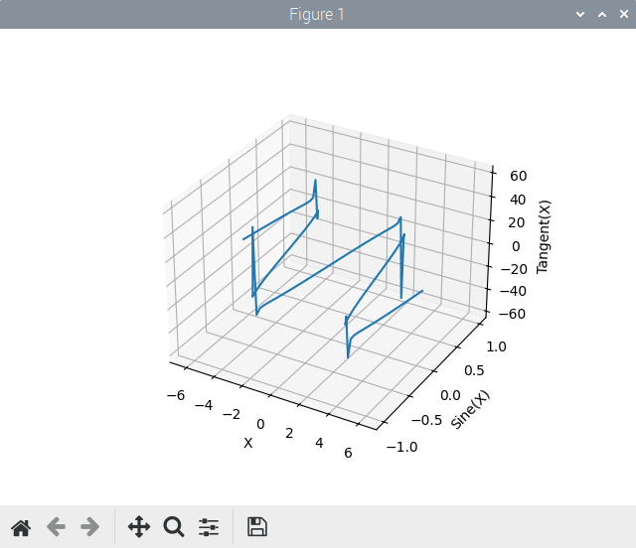

Figure 1.17 3-D matplotlib.pyplot of Sine and Tangent Functions

Here is an example( the code of which we named ex35.py) of carrying out simple system administration, in this case using Python 2.7.12. It customizes a shell command to show permissions set on files in the current working directory that match a certain pattern:

Practice Session 1.20
_____
#!/usr/bin/python
import stat, sys, os, glob
try:
#Getting search pattern from user and assigning it to a list
pattern = input("Enter the file pattern to search for:\n")
matching_Files = glob.glob(pattern)
print ("Files:")
print (matching_Files)
print ("*******************************")
for file in matching_Files:
mode=stat.S_IMODE(os.lstat(file)[stat.ST_MODE])
print ("\nPermissions for file ", file, ":")
for level in "USR", "GRP", "OTH":
for perm in "R", "W", "X":
if mode & getattr(stat,"S_I"+perm+level):
print (level, " has ", perm, " permission")
else:
print (level, " does NOT have ", perm, "permission")
except:
print ("Error - check your input of file matching pattern")

Once we saved and ran the code with the Geany Run or view the current file … toolbar icon ( the paper airplane button) using Python 2.7.12, and the input shown, we got the following results in a separate terminal window that opened on screen:

Enter the file pattern to search for:
*.py
Files:
2_1.py
2_16.py
2_17.py

*******************************

Permissions for file 2_1.py :
USR has R permission
USR has W permission
USR does NOT have X permission
GRP has R permission
GRP does NOT have W permission
GRP does NOT have X permission
OTH has R permission
OTH does NOT have W permission
OTH does NOT have X permission

Output truncated...

For the Python3 code in Practice Sessions 1.21 through 1.23, you have to install the Python3 Tkinter libraries, as shown on the following Raspberry Pi command lines:

bob@raspberrypi:~ $ sudo apt-get install python3-tk
Reading package lists... Done
Building dependency tree... Done
Reading state information... Done
Suggested packages:
tix python-tk-dbg
The following NEW packages will be installed:
python-tk
0 upgraded, 1 newly installed, 0 to remove and 0 not upgraded.
Need to get 24.4 kB of archives.
After this operation, 104 kB of additional disk space will be used.
Get:1 http://deb.debian.org/debian bullseye/main arm64 python-tk arm64 2.7.18-1 [24.4 kB]
Fetched 24.4 kB in 0s (282 kB/s)
Selecting previously unselected package python-tk.
(Reading database ... 317512 files and directories currently installed.)
Preparing to unpack .../python-tk_2.7.18-1_arm64.deb ...
Unpacking python-tk (2.7.18-1) ...
Setting up python-tk (2.7.18-1) ...
bob@raspberrypi:~ $ sudo apt-get install tk-dev
Output truncated…
bob@raspberrypi:~ $

The following simple example shows a complete tkinter Python script, and the widget it creates. You should create, and then execute these six lines of code in the Geany editor window (after saving the untitled file with a .py extension), and run it with the Toolbar Run or view the current file ... icon.

Practice Session 1.21
_____
import tkinter
from tkinter import ttk
w = tkinter.Tk()
w.title("Python GUI")
ttk.Label(w,text="My first tkinter gui window").grid(column=0, row=0)
w.mainloop()

When this widget was generated on our Raspberry Pi 400, it appeared in the upper-left corner of the display screen, just below the raspberry in the Raspberry Pi menu, but we could manually move it wherever we wanted on the screen display.

To close the widget, just click on the “destroy window” button in your style of GUI window in which the widget was created. You may have to expand the window to see all of the window manipulation buttons, but we didn’t need to do that on our Raspberry Pi 400.

The next simple Example allows a user to add two real numbers as text, that has been entered interactively, on lines inside the tkinter widget. And, as in Example 1.21, you can enter the code in Geany’s editor window, and use the Run or view the current file ... icon to launch it.

Practice Session 1.22
_____
import tkinter as tk
from tkinter import ttk
from functools import partial

# This is the data generating module, which computes the sum.
def add_it(label_result, n1, n2):
num1 = (n1.get())
num2 = (n2.get())
result = float(num1)+float(num2)
label_result.config(text="Sum = %f" % result)
return

# This grids the widget object where indicated, then returns it.
def mkgrid(r, c, w):
w.grid(row=r, column=c, sticky='news')
return w

root = tk.Tk()
root.title('Real Number Adder')
# The rest hooks the adder into the grid manager widgets.
add1_lab = mkgrid(0, 0, ttk.Label(root, text="addend 1",
anchor='e'))
add2_lab = mkgrid(1, 0, ttk.Label(root, text="addend 2",
anchor='e'))
add1= mkgrid(0, 1, ttk.Entry(root))
add2= mkgrid(1, 1, ttk.Entry(root))
spacer = mkgrid(0, 2, ttk.Label(root, text=''))
labelResult = ttk.Label(root)
labelResult.grid(row=7, column=2)
add_it = partial(add_it, labelResult, add1, add2)
add_but = mkgrid(1, 2, ttk.Button(root, text="Add them",
command=add_it))
# Starts the root main event loop
root.mainloop()

The results of running this tkinker script file is seen in Figure 1.18:

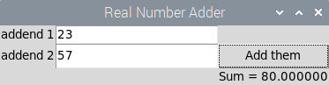

Figure 1.18 tkinter Adder Script Output Results

Even though Practice Session 1.22 ostensibly uses the procedural(imperative) programming model, syntax, and data abstraction, you should begin to see that tkinter GUI scripts are basically composed of OOP class instance objects. All of the methods that are applied to those instances come from the methods applied to the core widgets in tkinter.

The following example will construct a Fahrenheit-to-Celsius temperature conversion GUI with tkinter. And, as in Practice Sessions 1.21 and 1.22, you can enter the code in Geany’s editor window, and use the Run or view the current file ... Toolbar icon to launch it.

Practice Session 1.23
_____
import tkinter as tk
from tkinter import ttk
# This computes the Celsius temperature from the Fahrenheit.
def findcel():
famt = ftmp.get()
if famt == '': #not double quote, 2 single quotes
cent.configure(text='')
else:
famt = float(famt)
camt = (famt - 32) / 1.8
# A method(configure) applied to an object (cent) that is converted to a string (str(camt)).
cent.configure(text=str(camt))
# This grids the widget object where indicated, then returns it.
def mkgrid(r, c, w):
w.grid(row=r, column=c, sticky='news')
return w
root = tk.Tk()
root.title('Temp Conversion')
# The rest hooks the temps into the grid graphics manager widgets.
flab = mkgrid(0, 0, ttk.Label(root, text="Fahrenheit Temperature",anchor='e'))
clab = mkgrid(1, 0, ttk.Label(root, text="Celsius Temperature",anchor='e'))
ftmp = mkgrid(0, 1, ttk.Entry(root))
cent = mkgrid(1, 1, ttk.Label(root, text="", relief='sunken',anchor='w'))
elab = mkgrid(0, 2, ttk.Label(root, text=''))
fbut = mkgrid(1, 2, ttk.Button(root, text="Compute Celsius",command=findcel))
# Starts the root main event loop
root.mainloop()

The results of running this tkinker script file is seen in Figure 1.19:

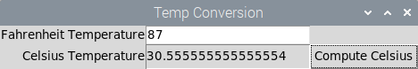

Figure 1.19 tkinter Temperature Conversion Output Results

Again, even though the previous example is ostensibly a procedural(imperative) model program design, you should be able to recognize from this line-by-line description and explanation that the underlying core widgets from tkinter are OOP classes that we have instanced as objects.

The example used methods applied to those classes, but the structure of our script file was still functional and declarative in nature.

The following Python3 code brings together much of the syntax and structure from this section. It illustrates a Python3 solution to the producer-consumer problem, using an FIFO queue with the queue.Queue class, in a multi-threaded program. It uses OOP, and the threading module and its methods, to start two threads- Producer and Consumer.

An overview of how Python3 use the Queue class to obtain a solution to the producer-consumer problem, taken from the reference material, is as follows:

“The Producer places a piece of data on the queue using the .put method. The utility and advantage the queue module is most visible here- .put locks the queue, checks to see if the queue is full, and calls an internal .wait() to pause the producer if the queue is full. The Consumer then uses the .get method to acquire the lock before removing data from the queue, and .get checks for an empty queue. If the queue is empty, the consumer is put in a wait state.
.get() and .put() also implement the notification logic to allow “talking” between Producer and Consumer threads.”

In this final Geany-run Python3 example, create the code in a file named ex45.py in the Geany editor, and run it (and also terminate it, and the Python3 process it spawns using <Ctrl>+C) using the Run or view the current file ... icon :

Practice Session 1.24
_____
from threading import Thread
import time
import random
import queue

q_buffer = queue.Queue()

class Producer(Thread):
def run(self):
numbers = range(5)
global q_buffer
while True:
actual_number = random.choice(numbers)
q_buffer.put(actual_number)
print ("Produced thread", actual_number)
time.sleep(random.random())

class Consumer(Thread):
def run(self):
global q_buffer
while True:
actual_number_gotten = q_buffer.get()
q_buffer.task_done()
print ("Consumed thread", actual_number_gotten)
time.sleep(random.random())

Producer().start()
Consumer().start()

Output from the above example is as follows:

Produced thread 1
Consumed thread 1
Produced thread 0
Produced thread 4
Consumed thread 0
Consumed thread 4
Produced thread 3
Consumed thread 3
Produced thread 0
Consumed thread 0
Produced thread 4
Consumed thread 4
Produced thread 4
Consumed thread 4
Produced thread 2
Produced thread 1
Consumed thread 2
Produced thread 1
<Ctrl>+C

1.6.4 Geany Abbreviated Reference Encyclopedia

The following sections are abstracts and condensed versions of portions of the Geany documentation, found at this website-

https://www.geany.org/manual/current/index.html

We’ve selected those portions rather subjectively, and not necessarily alphabetically, based upon the what we’ve presented previously in Geany.

1.6.4.1 Indentation

Geany allows each document to indent either with a tab character, multiple spaces or a combination of both. This is critical when you’re coding in a structured language, such as C++ or Python.

1. The Tabs setting indents with one tab character per indent level, and displays tabs as the indent width.

2. The Spaces setting indents with the number of spaces set in the indent width for each level.

3. The Tabs and Spaces setting indents with spaces as above, then converts as many spaces as it can to tab characters at the rate of one tab for each multiple of the `Various preference` setting
*indent_hard_tab_width* (default 8) and displays tabs as the *indent_hard_tab_width* value.

The default settings can be overridden per-document using the Geany Document menu. They can also be overridden by on a per project basis.

The indent mode for the current document is shown on the status bar, when a file is being edited in the editor window, as follows:

TAB
Indent with Tab characters.
SP
Indent with spaces.
T/S
Indent with tabs and spaces, depending on how much indentation is on a line.

Applying new indentation settings

After changing the default settings you may wish to apply the new settings to every document in the current session. To do this use the Geany Project > Apply Default Indentation menu item.

Detecting indent type

The Detect from file indentation preference can be used to scan each file as it's opened and set the indent type based on how many lines start with a tab vs. 2 or more spaces.

Auto-indentation

When enabled, auto-indentation happens when pressing <Enter> on the keyboard when in the editor window. It adds a predetermined amount of indentation to the next line, so the user doesn't always have to indent each line manually. Of course, if you initially save the file with a .cpp or py extension, then Geany recognizes the file to by C++ or Python code, and indents according to the structured programing rules of those languages.

Geany has four types of auto-indentation:

None
Disables auto-indentation completely.
Basic
Adds the same amount of whitespace on a new line as on the previous line. For the Tabs and the Spaces indent types the indentation will use the same combination of characters as the previous line. The Tabs and Spaces indentation type converts as explained above.
Current chars
Does the same as *Basic* but also indents a new line after an opening brace '{', and de-indents when typing a closing brace '}'. For Python, a new line will be indented after typing ':' at the end of the previous line.
Match braces
Similar to *Current chars* but the closing brace will be aligned to match the indentation of the line with the opening brace. This requires the filetype to be one where Geany knows that the Scintilla
lexer understands matching braces (C, C++, D, HTML, Pascal, Bash,Perl, TCL).

1.6.4.2 Search, Replace , and Go to

This section describes search-related commands from the Search menu and the main editor window's popup menus:

Find, Find selection, Find usage, Find in files, Replace, Go to symbol definition, Go to symbol declaration, and Go to line

There are also two toolbar entries:

Search bar, and Go to line entry

Using the Search bar is the quickest way to find some text. You can performs a case-insensitive search in the current document during text entry. Pressing <Enter> will search again, and pressing
<Shift>-<Enter> will perform searching backwards.

The Find dialog window is used for finding text in one or more open document, and is seen in Figure 1.20.

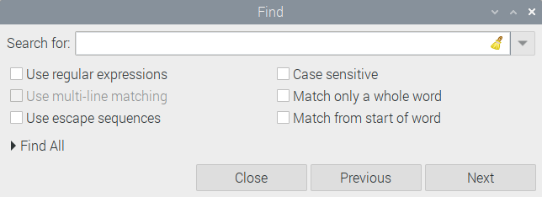
Figure 1.20 Find Dialog Window

1.6.4.3 Preferences

You adjust Geany's settings using the Geany pull-down menu choice Edit > Preferences. Any changes you make there can be applied by clicking on either the Apply or the OK button. These settings will be persistent between Geany editing sessions. Most settings here have a help “popup” message. Just hover with your mouse over the item in the window to get help on it. The General startup preferences are seen in Figure 1.21.

You may also adjust some View settings (under the View menu) that persist between Geany sessions. The settings under the Document menu are only for the current document, and revert to defaults when you restart Geany.

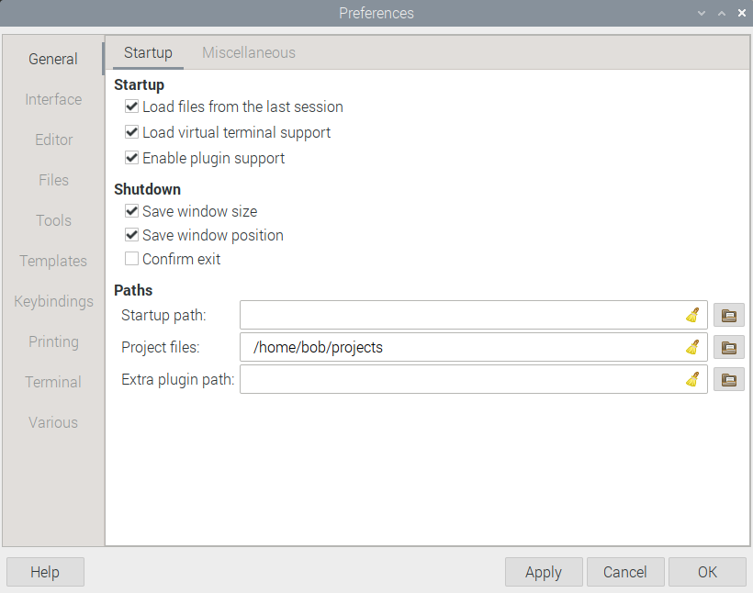

Figure 1.21 General Startup Preferences

Here are some brief descriptions of some of the Preferences Startup choices as seen in Figure 1.21-

Load files from the last session
On startup, load the same files you had open the last time you used Geany.

Load virtual terminal support
Load the library for running a terminal in the message window area.

Enable plugin support
Allow plugins to be used in Geany.

Shutdown
Save window position and geometry
Save the current position and size of the main window so next time you open
Geany it's in the same location.

Confirm Exit
Have a dialog pop up to confirm that you really want to quit Geany.

Paths
Startup path
Path to start in when opening or saving files. It must be an absolute path.

Project files
Path to start in when opening project files.

1.6.4.4 Interface preferences

The following Edit > Preferences menu is for the Interface tab, as seen In Figure 1.22.

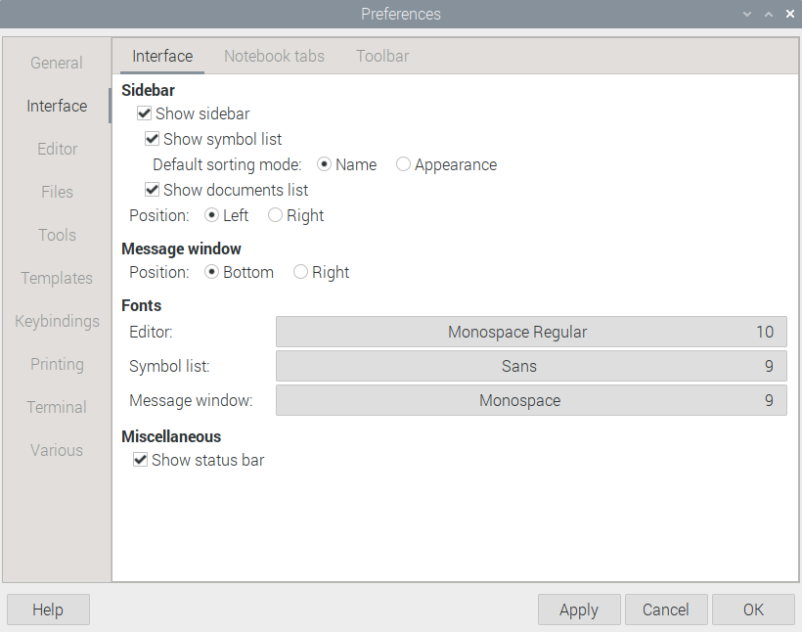

Figure 1.22 Interface Preferences

Abbreviated descriptions of the settings follows:

Sidebar
Show sidebar
Whether to show the sidebar at all.

Show symbol list
Show the list of functions, variables, and other information in the current document you are editing.

Show documents list
Show all the documents you have open currently. This can be used to
change between documents, and to perform some common operations such as
saving, closing and reloading.

Position
Whether to place the sidebar on the left or right of the editor window.

Message window
Position
Whether to place the message window on the bottom or right of the editor window.

Fonts
Editor
Change the font used to display documents.

Symbol list
Change the font used for the Symbols sidebar tab.

Message window
Change the font used for the message window area.

Miscellaneous
Show status bar
Show the status bar at the bottom of the main window. It gives information about
the file you are editing like the line and column you are on, whether any
modifications were done, the file encoding, the filetype and other information.

1.6.4.5 Editor Indentation preferences

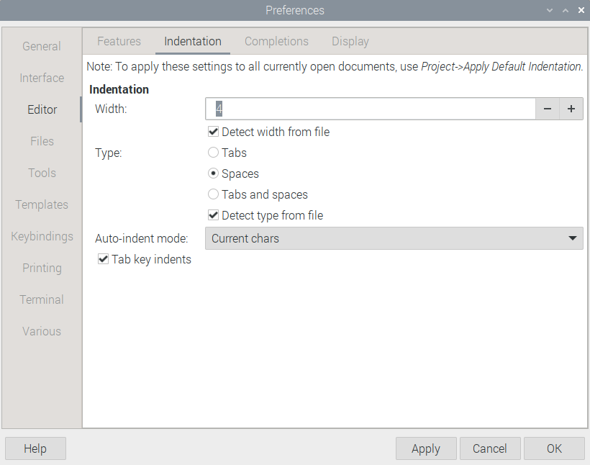
Figure 1.23 Indentation Preferences

Abbreviated descriptions of the Indentation preferences settings, as seen in Figure 1.23, are as follows:

Indentation group

Width
The width of a single indent size in spaces. By default the indent size is equivalent to 4 spaces.

Detect width from file
Try to detect and set the indent width based on file content, when a file is opened.

Type
When Geany inserts indentation, whether to use:

* Just Tabs
* Just Spaces
* Tabs and Spaces, depending on how much indentation is on a line

The *Tabs and Spaces* indent type is also known as *Soft tab support* in some other editors.

Detect type from file
Try to detect and set the indent type based on file content, when
a file is opened.

Auto-indent mode
The type of auto-indentation you wish to use after pressing <Enter>, if any.

Basic
Just add the indentation of the previous line.
Current chars
Add indentation based on the current filetype and any characters at
the end of the line such as ``{``, ``}`` for C, ``:`` for Python.
Match braces
Like *Current chars* but for C-like languages, make a closing
``}`` brace line up with the matching opening brace.

Tab key indents
If set, pressing tab will indent the current line or selection, and
unindent when pressing Shift-tab. Otherwise, the tab key will
insert a tab character into the document (which can be different
from indentation, depending on the indent type).

1.6.4.6 Editor Completions preferences

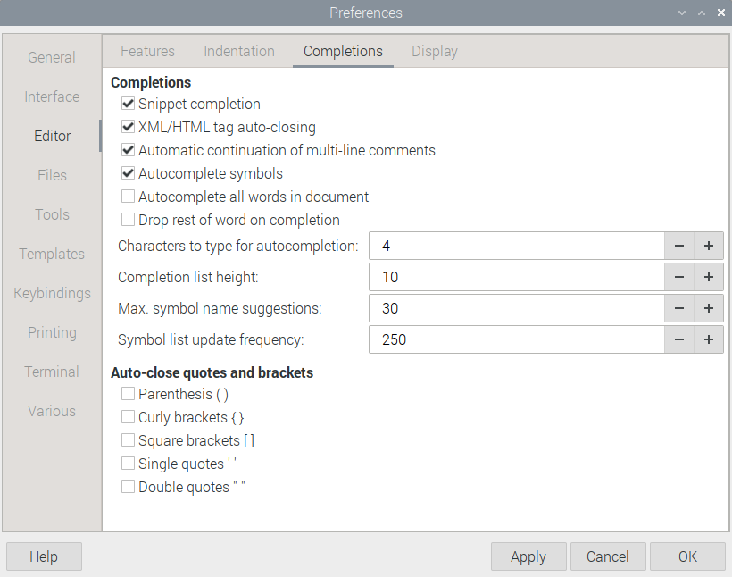
Figure 1.24

Abbreviated description of the Editor Completions settings, as seen in Figure 1.24, are as follows:

Auto-close quotes and brackets

Geany can automatically insert a closing bracket and quote characters when you open them. For instance, you type a curly brace { ,Geany will automatically insert a closing curly brace }. This allows you to conform to the syntax of a C++ program. With the following options, you can define for which characters this should work, depending on the coding requirements of the document or program you’re working on.

Parenthesis ( )
Auto-close parenthesis when typing an opening one
Curly brackets { }
Auto-close curly brackets (braces) when typing an opening one
Square brackets [ ]
Auto-close square brackets when typing an opening one
Single quotes ' '
Auto-close single quotes when typing an opening one
Double quotes " "
Auto-close double quotes when typing an opening one

1.6.4.7 Project Management

Project management in Geany involves the following:

1. Storing and opening session files on a project basis.
2. Overriding default settings with individual project settings.
3. Configuring the Geany Build menu, so that software suites can be configured and individually applied on a per-project basis.

As long as a project is “open”, the Build menu will use the items defined in that project's settings, instead of the defaults. See Section 1.6.4.9, Set Build menu, for information on configuring the Set Build menu.

***Note***
The current project's settings are saved when it is closed, or when Geany is shutdown. When restarting Geany, the previously opened project file that was in use at the end of the last session will be reopened.

The Project menu choices are as follows.

New project

To create a new project, fill in the *Name* field. By default this sets up a new project file, in ~/projects/name.geany, where name is the project name you assign to it.

The Base path text field is setup to use ``~/projects/name``. This can be set to any existing path. It will not change the file structure contained in it.

Project properties

You can set an optional description for the project.

The *Base path* field is used as the directory to run the Build menu commands. That pathname can be an absolute pathname, or it is considered to be relative to the project's file name.

The *File patterns* field allows to specify a list of file patterns for the project.

The *Indentation* tab allows you to override the default Indentation settings.

Open project

The Open command displays a standard file chooser, starting in ``~/projects``. Choose a project file named with the .geany extension.

When project session support is enabled, Geany will close the currently open files and open the session files associated with the project.

Close project

Project file settings are saved when the project is closed. When project session support is enabled, Geany will close the project session files and open any previously closed default session files.

1.6.4.8 Build menu

After creating and editing code with Geany, the next step is to compile, link, build, interpret, and run it.

This is the most important aspect of using an IDE like Geany, above and beyond the traditional UNIX and Linux text editors. Even more critical and useful than the same capabilities in an extremely developed text editor like Gnu emacs.

As Geany supports many languages each with a different approach to such operations, and as there are also many language independent software building systems, Geany does not have a built-in build system, nor does it limit which system you can use. Instead the build menu provides a configurable and flexible means of running any external commands to execute your preferred build system.

This section provides a description of the default configuration of the
Build Menu and then covers how to configure it, and where the defaults fit in.

Running the commands from within Geany has two benefits:

* The current file is automatically saved before the command is run.
* The output is captured in the Compiler notebook tab and parsed for
warnings or errors.

Indicators

Indicators are red squiggly underlines which are used to highlight errors which occurred while compiling the current file. So you can easily see where your code failed to compile. You can remove them by selecting *Remove Error Indicators* in the Document menu.

1.6.4.8.1 Default Build Menu Items

Depending on the current file's filetype, the default Build menu will contain
the following items:

* Compile
* Build
* Lint
* Make All
* Make Custom Target
* Make Object
* Next Error
* Previous Error
* Execute
* Set Build Menu Commands

Compile

The Compile command has different uses for different kinds of files. For compilable languages such as C and C++, the Compile command isset up to compile the current source file into a binary object file.
Java source files will be compiled to class file bytecode.

Interpreted, or intermediate languages such as Perl, Python, and Ruby will compile to bytecode if the language supports it, or will run a syntax check, or if that is not available will run the file in its language interpreter.

Build

For compilable languages such as C and C++, the Build command will link the current source file's equivalent object file into an executable image. If the object file doesn’t exist, the source will be compiled and linkedin one step, producing just the executable binary.

***Note***
Purely interpreted languages do not use the Build command. If you need complex settings for your build system, or several different Build settings applicable to multiple source code files, then creating a makefile and use the make command; this technique will also be useful for users to build your software.

Lint

Source code lint programs are basically used to find code that doesn't correspond to certain style guidelines: non-portable code, common or hard to find errors, variables used before being set, unused functions, division by zero, constant conditions, etc. Lint programs inspect the code and issue warnings much like the compilers do. This is formally referred to as static code analysis.

Some common lint programs are pre-configured in the Build menu (``pep8`` for Python, ``cppcheck`` for C/C++, JSHint for JavaScript, ``xmllint`` for XML, ``hlint`` for Haskell, ``shellcheck`` for shell code, ...), but all these are standalone tools you need to obtain before using.

Make

This runs the make command in the same directory as the current file.

Make Custom Target ...

This is similar to running 'Make' but you will be prompted for the make target name to be passed to the Make tool. For example, typing 'clean' in the dialog prompt will run "make clean".

Make Object

Make Object will run "make current_file.o" in the same directory as the current file, using the filename for 'current_file'. It is useful for building just the current file without building the whole project.

Next Error

The next error item will move to the next detected error in the file.

Previous Error

The previous error item will move to the previous detected error in the file.

Execute

Execute will run the corresponding executable file, shell script or interpreted script in a terminal window.

After your program or script has finished executing, the run script will prompt you to press the return key. This allows you to review any text output from the program before the terminal window is closed.

***Note***
The execute command output is not parsed for errors.

1.6.4.9 Set Build Commands

Most of the configuration of the Build menu is done through the Set Build Commands menu choice. When no project is open, you can edit the configuration via that menu. You can edit the configuration of an open project in the Build tab of the Project Properties dialog box. That menu item also shows the project dialog when a project is open. Both use the same dialog box shown in Figure 1.25.

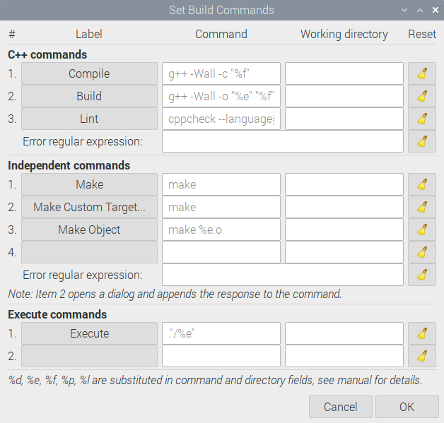

Figure 1.25 Set Build Commands Dialog Box

The dialog box is divided into three sections:

Filetype build commands (selected based on the current document's filetype).

In Figure 1.25-
g++ -Wall -c "%f"
g++ -Wall -o "%e" "%f"
cppcheck --language=c++

Independent build commands (available regardless of filetype).

In Figure 1.25-
make

Filetype execute commands.

In Figure 1.25-
."/%e"

The filetype and independent build sections also each contain a field for the regular expression used for parsing command output for error and warning messages.

The columns in the first three sections allow setting of the label, command, and working directory to run the command in. An item with an empty label will not be shown in the menu. An empty working directory will default to the directory of the current document.

If there is no current document then the command will not run.

The dialog box will always show the command selected by priority, not just the commands configured in this configuration source. This ensures that you always see what the menu item is going to do if activated.

If the current source of the menu item is higher priority than the configuration source you are editing then the command will be shown in the dialog but will be insensitive (greyed out). This can't happen
with the project source but can with the preferences source dialog.

The clear buttons remove the definition from the configuration source you are editing. When you do this the command from the next lower priority source will be shown. To hide lower priority menu items without having anything show in the menu, configure with nothing in the label but at least one character in the command.

Substitutions in commands and working directories

Before the command is run, the first occurrence of each of the following two character sequences in each of the command and working directory fields is substituted by the items specified below:

* %d - the absolute path to the directory of the current file.
* %e - the name of the current file without the extension or path.
* %f - the name of the current file without the path.
* %p - if a project is open, the base path from the project.
* %l - the line number at the current cursor position.

***Note***
If the base path that is set not an absolute path, then it is taken as relative to the directory of the project file. This allows a project file stored in the source tree to specify all commands and working directories relative to the tree itself, so that the whole tree including the project file, can be moved and even checked into and out of version control without having to re-configure the build menu.

1.6.4.10 Plugins

To install all plugins, or a specific one, on your Raspberry Pi system, first you have to know which one you want. You can type in the following command in a terminal window to get a listing:

$ apt-cache search geany

or you can go to the following web page to get a listing:

https://plugins.geany.org/install.html

To install a wide variety of the all the plugins available, use the following command:

$ sudo apt-get install geany-plugins

To install a specific plugin, after you’ve chosen one of them, such as the autoclose plugin, use the following command:

$ sudo apt install geany-plugin-autoclose

Plugins are loaded at startup. Some plugins add menu items to the Geany Tools menu when they are loaded.

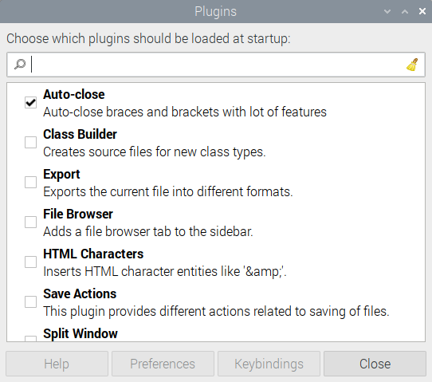

Figure 1.26 Plugin Manager Window

The Plugin Manager, launched by making the Geany Tools > Plugin Manager choice, lets you choose which plugins should be loaded at startup. You can also load and unload plugins on a per use basis using this manager window. Once you click the checkbox for a specific plugin in the manager window, it’s loaded or unloaded according to its previous state. An interesting and useful feature of the Plugin Manager window is that if you hover your mouse near one of the plugins listed, a brief description of it, along with pertinent information about the plugin, appears on screen.

1.6.4.11 Customizing the Toolbar

You can add, remove and reorder the elements in the toolbar using the following graphical way-

Make the Geany menu choice Edit > Preferences, and click on the Interface sidebar menu in the Preferences window that opens. When you choose the Toolbar heading, a window opens, and Customize Toolbar button on it to the right. Click on that button, and the Customize Toolbar sub-window opens, as seen in Figure 1.27.

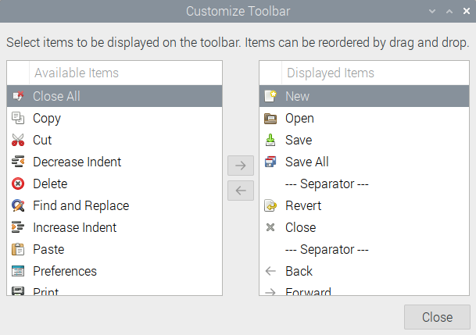

Figure 1.27 Customize Toolbar Sub-Window

In Figure 1.27, in the column to the left, all Available Items for inclusion on the Toolbar are shown, and in the right column, all Displayed Items are shown. Between the two columns, left and right-facing arrows allow you to interchange items between Available and Displayed Items. Once you use the arrows to interchange Toolbar items, the new Toolbar item appears on the extreme left of the Toolbar items that are already displayed at the top of the Geany window. Make the Close button choice to confirm your addition(s) or subtraction(s).

Here’s a listing of Available Toolbar Elements, as of version 1.37.1 of Geany:

Element name Description

New Create a new file
Open Open an existing file
Save Save the current file
SaveAll Save all open files
Reload Reload the current file from disk
Close Close the current file
CloseAll Close all open files
Print Print the current file
Cut Cut the current selection
Copy Copy the current selection
Paste Paste the contents of the clipboard
Delete Delete the current selection
Undo Undo the last modification
Redo Redo the last modification
NavBack Navigate back a location
NavFor Navigate forward a location
Compile Compile the current file
Build Build the current file, includes a submenu for Make commands. Geany
remembers the last chosen action from the submenu and uses this as default
action when the button itself is clicked.
Run Run or view the current file
Color Open a color chooser dialog, to interactively pick colors from a palette
ZoomIn Zoom in the text
ZoomOut Zoom out the text
UnIndent Decrease indentation
Indent Increase indentation
Replace Replace text in the current document
SearchEntry The search field belonging to the 'Search' element (can be used alone)
Search Find the entered text in the current file (only useful if you also
use 'SearchEntry')
GotoEntry The goto field belonging to the 'Goto' element (can be used alone)
Goto Jump to the entered line number (only useful if you also use 'GotoEntry')
Preferences Show the preferences dialog
Quit Quit Geany

1.7 Summary

In this chapter, we covered Nano, Vi/Vim/Gvim, and Geany, the most useful group of text editors, and an Integreated Develoment Environment(IDE) that the Raspberry Pi OS offers. We achieved this in both a command line, text-based way, and in a graphical way, for these editors and the IDE. They are useful because Raspberry Pi systems use both a text-driven and GUI-based operating system. Common operations done by an ordinary user, such as editing script files, writing e-mail messages, or creating and compiling C++ or Python language programs, are done with text editors and an IDE.

In text editors, a full-screen display editor shows a portion of a file that fills most or all of the screen display. The cursor, or point, can be moved to any of the text shown in the screen display. Editing a file involves editing a copy that the editor creates, called a buffer. Keystroke commands are one of the primary ways of interacting with these editors. Using a GUI to interact with these editor is time efficient and easy to learn. The editor(s) used should fit the user’s personal criteria, particularly if the user is new to the Raspberry Pi OS.

The most important functions that are common to the Raspberry Pi text editors are:
Cursor movement, cut/copy and paste, deleting text, inserting text, opening an existing file, starting a new file, quitting, saving, and search and replace.

The most important functions common to Raspberry Pi IDE’s are:
1. Feature-Rich Environment: IDEs offer a wide array of features like code completion, syntax highlighting, integrated debugging, refactoring tools, version control integration, and project management capabilities.
2. Code Assistance and Productivity Tools: IDEs provide intelligent code completion, suggesting code snippets, variable names, and method signatures as you type. This enhances productivity and reduces errors.
3. Debugging and Testing: Debugging is seamlessly integrated within the IDE, allowing developers to set breakpoints, inspect variables, and step through code. Testing frameworks can be integrated for automated testing.
4. Project Management: IDEs often have built-in project management tools, making it easier to organize and navigate through complex codebases. This includes features like project-wide search, file hierarchy views, and class/module navigation.
5. Integration with Build Systems: IDEs integrate with various build systems and tools, enabling developers to compile, build, and package their applications from within the IDE. This streamlines the development workflow.
6. Plug-in Ecosystem: Most IDEs support an extensive ecosystem of plugins or extensions. Developers can customize their IDE by adding plugins for specific languages, frameworks, or tools, tailoring it to their needs.
7. Cross-Language Support: Many IDEs support multiple programming languages, allowing developers to work on projects with diverse technology stacks seamlessly.

We provide summary tables of commands and operations for Vi/Vim/Gvim as Table 1.9.

Vi Syntax
Command | Action
cw | Change word.
cc | Change line.
c$ | Change text from current position to end of line.
C | Same as c$.
dd | Delete current line.
7 dd | Delete seven lines.
d$ | Delete text from current position to end of line.
D | Same as d$.
5dw | Deletes five words.
d7,14 | Deletes lines seven through fourteen in the buffer.
s | Substitute character. <Esc> ends substitute mode.
4s | Substitute four characters. <Esc> ends substitute mode.
S | Substitute entire line. <Esc> ends substitute mode.
u | Undo last change.
<Ctrl+R> | Redo last change (Vim and Gvim).
U | Restores the current line, if you have not moved off of it.
x | Delete current cursor position.
X | Delete back one character.
5X | Delete previous five characters
. | Repeat last change.
~ | Change case and move cursor right.
<Ctrl+A> | Increment number at the cursor (Vim and Gvim).
<Ctrl+X> | Decrement number at the cursor (Vim and Gvim).
Vi Mode Keys
Key | Action
a | Appends text after the character the cursor is on.
A | Appends text after the last character of the current line.
c | Begins a change operation, allowing you to modify text.
C | Changes from the cursor position to the end of the current line.
i | Inserts text before the character the cursor is on.
I | Inserts text at the beginning of the current line.
o | Opens a blank line below the current line and puts the cursor on that line.
O | Opens a blank line above the current line and puts the cursor on that line.
Vi Command Mode
Command | Action
:wq | Saves the buffer and quits.
:w | Saves the current buffer and remains in the editor.
:w filename | Saves the current buffer to filename
:q | Quit Vi (fails if changes were made).
:q! | Quit Vi without saving the buffer.
:Q | Quit Vi and invoke ex.
:vi | Return to Vi after Q command.
ZZ | Quits Vi, saving the file only if changes were made since the last save.
Vi Cursor Movement
Command | Action
1G | Moves the cursor to the first line of the file.
G | Moves the cursor to the last line of the file.
0 (zero) | Moves the cursor to the first character of the current line.
<Ctrl+G> | Reports the position of the cursor in terms of line # and column #.
$ | Moves the cursor to the last character of the current line.
w | Moves the cursor forward one word at a time.
b | Moves the cursor backward one word at a time.
x | Deletes the character at the cursor position.
dd | Deletes the line at the current cursor position.
u | Undoes the most recent change.
r | Replaces the character at the current cursor location with what is typed next.
Vi Yank and Put
Command Syntax | What It Accomplishes
y2W | Yanks two words, starting at the current cursor position, going to the right.
4yb | Yanks four words, starting at the current cursor position, going to the left.
yy or Y | Yanks the current line.
p | Puts the yanked text after the current cursor position.
P | Puts the yanked text before the current cursor position.
Vi Substitute
Command Syntax | What It Accomplishes
:s/john/jane/ | Substitutes the word jane for the word john on the current line, only once.
:s/john/jane/g | Substitutes the word jane for every word john on the current line.
Vi Environment Options
Last line mode syntax | What it does
abbr command
:ab in out | Use in as abbreviation for out in Insert mode.
:unab in | Remove abbreviation for in.
:ab | List abbreviations.
map!, map commands
:map | List character strings that are mapped.
:map! string sequence | Map characters string to input mode sequence.
:unmap! string | Remove input mode map (you may need to quote the characters with <Ctrl+V>).
:map! | List character strings that are mapped for input mode.
set command
:set x | Enable boolean option x, show value of other options.
:set | Show changed options.
:set all | Show all options.
:set x? | Show value of option x.

TABLE 1.9 Vi, Vim, Gvim Command Summary

