Data Summary
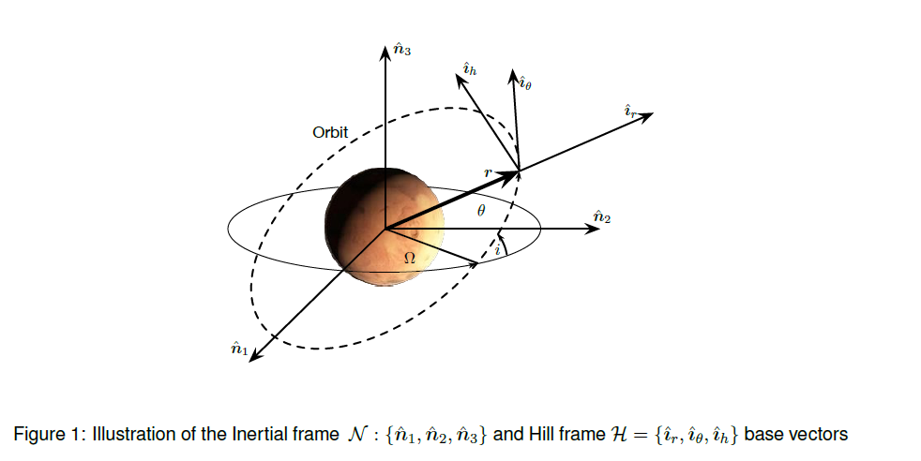
 | LMO | GMO
r | 3796.19 km | 20424.2 km
Ω | 20° | 0°
i | 30° | 0°
$θ$ (t0) | 60° | 250°
$$\dot{θ}$$ | 0.000884797 rad/s | 0.0000709003 rad/s

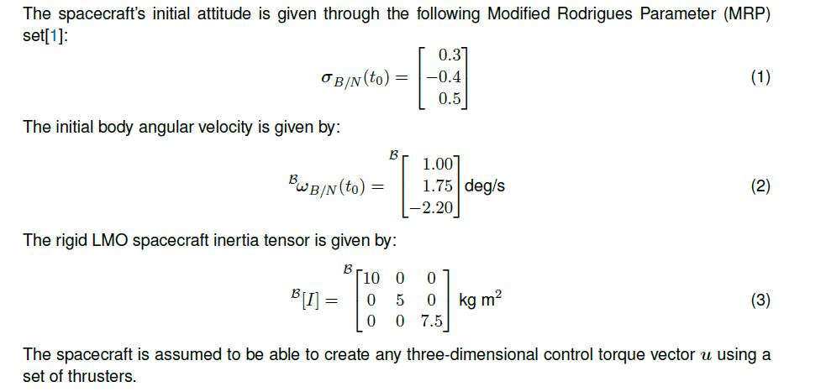

Task 1
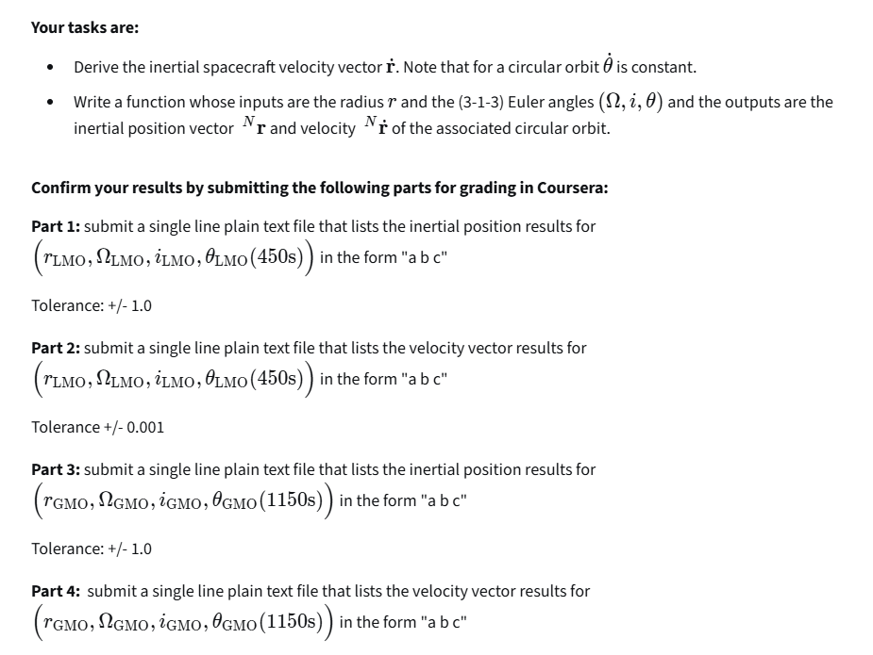
Solution
P
O
Reference Frames:
$$N:\left\{O,{\hat{n}}_{1},{\hat{n}}_{2},{\hat{n}}_{3}\right\}$$
$$H:\left\{P,{\hat{i}}_{r},{\hat{i}}_{θ},{\hat{i}}_{h}\right\}$$
Position vector:
$$r=r{\hat{i}}_{r}$$
Angular velocity:
$$ω=\dot{θ}{\hat{i}}_{h}$$
Position velocity on reference frame N:
$${}_{}^{N}{\dot{r}}={}_{}^{H}{\dot{r}+}ω×r$$

Position velocity with the assumption that the orbit is circular:
$${}_{}^{H}{\dot{r}=0}$$
$${}_{}^{N}{\dot{r}}=ω×r$$
$${}_{}^{N}{\dot{r}}=\dot{θ}{\hat{i}}_{h}×r{\hat{i}}_{r}=\dot{θ}r {\hat{i}}_{h}×{\hat{i}}_{r}=\dot{θ}r {\hat{i}}_{θ}$$

Direction Cosine Matrix for 3-1-3 Euler Angles:
$${\left[HN\right]}_{313}=\left[\begin{matrix}c_{θ3}c_{θ1}-s_{θ3}c_{θ2}s_{θ1} & c_{θ3}s_{θ1}+s_{θ3}c_{θ2}c_{θ1} & s_{θ3}s_{θ2} \\ -s_{θ3}c_{θ1}-c_{θ3}c_{θ2}s_{θ1} & -s_{θ3}s_{θ1}+c_{θ3}c_{θ2}c_{θ1} & c_{θ3}s_{θ2} \\ s_{θ2}s_{θ1} & -s_{θ2}c_{θ1} & c_{θ2}\end{matrix}\right] \left[\begin{matrix}θ_{1} \\ θ_{2} \\ θ_{3}\end{matrix}\right]=\left[\begin{matrix}Ω \\ i \\ θ\end{matrix}\right]$$

$$Ω=const$$
$$i=const$$
$$θ=θ_{0}+ωt$$

Position components of point P on frame N:
$${}_{}^{N}r={\left[NH\right]}_{313}{}_{}^{H}{r={\left[HN\right]}_{313}^{T}}\left[\begin{matrix}r \\ 0 \\ 0\end{matrix}\right]$$

Velocity components of point P on frame N:
$${}_{}^{N}{\dot{r}}={\left[NH\right]}_{313}{}_{}^{H}{\dot{r}={\left[HN\right]}_{313}^{T}}\left[\begin{matrix}0 \\ \dot{θ}r \\ 0\end{matrix}\right]$$

Task 2
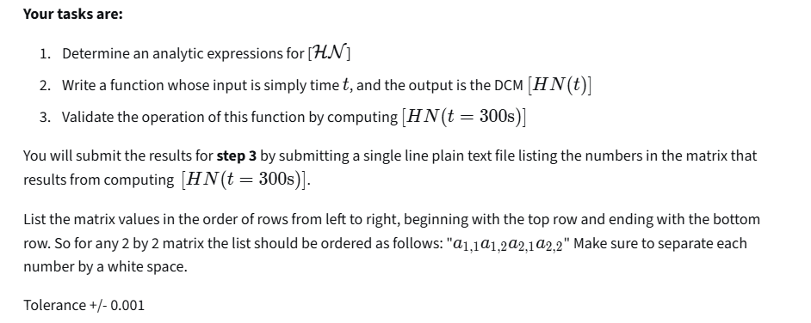

Solution

Direction Cosine Matrix for 3-1-3 Euler Angles:
$${\left[HN\right]}_{313}=\left[\begin{matrix}c_{θ3}c_{θ1}-s_{θ3}c_{θ2}s_{θ1} & c_{θ3}s_{θ1}+s_{θ3}c_{θ2}c_{θ1} & s_{θ3}s_{θ2} \\ -s_{θ3}c_{θ1}-c_{θ3}c_{θ2}s_{θ1} & -s_{θ3}s_{θ1}+c_{θ3}c_{θ2}c_{θ1} & c_{θ3}s_{θ2} \\ s_{θ2}s_{θ1} & -s_{θ2}c_{θ1} & c_{θ2}\end{matrix}\right] \left[\begin{matrix}θ_{1} \\ θ_{2} \\ θ_{3}\end{matrix}\right]=\left[\begin{matrix}Ω \\ i \\ θ\end{matrix}\right]$$

$$Ω=const$$
$$i=const$$
$$θ=θ_{0}+ωt$$

Task 3
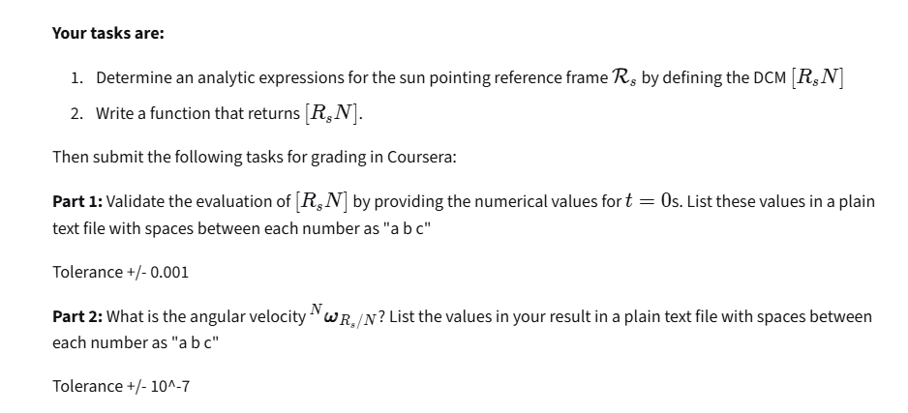
Solution
r_{s2}
P
r_{s1}
r_{s3}
Reference Frames:
$$N:\left\{O,{\hat{n}}_{1},{\hat{n}}_{2},{\hat{n}}_{3}\right\}$$
$$R_{s}:\left\{P,{\hat{r}}_{s1},{\hat{r}}_{s2},{\hat{r}}_{s3}\right\}$$
$${\hat{r}}_{s3}={\hat{n}}_{2} {\hat{r}}_{s1}=-{\hat{n}}_{1} {\hat{r}}_{s2}={\hat{n}}_{3}$$
$${\left[R_{s}N\right]}_{}=\left[\begin{matrix}-1 & 0 & 0 \\ 0 & 0 & 1 \\ 0 & 1 & 0\end{matrix}\right]$$
The frame does not rotate:
$${{}_{}^{N}ω}_{Rs/N}=0$$

Task 4
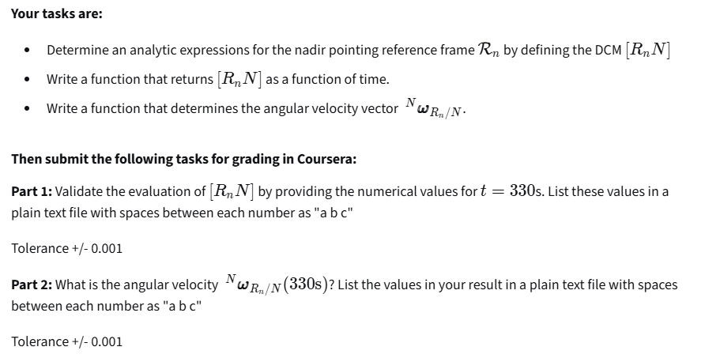
Solution

r_{n3}
r_{n2}
r_{n1}
P
r_{s3}
$$H:\left\{P,{\hat{i}}_{r},{\hat{i}}_{θ},{\hat{i}}_{h}\right\}$$
$$R_{n}:\left\{P,{\hat{r}}_{n1},{\hat{r}}_{n2},{\hat{r}}_{n3}\right\}$$
$${\hat{r}}_{n1}={-\hat{i}}_{r} {\hat{r}}_{n2}={\hat{i}}_{θ} {\hat{r}}_{n3}={-\hat{i}}_{h}$$
$${\left[R_{N}H\right]}_{}=\left[\begin{matrix}-1 & 0 & 0 \\ 0 & 1 & 0 \\ 0 & 0 & -1\end{matrix}\right]$$
$$\left[R_{N}N\right]=\left[R_{N}H\right]\left[HN\right]$$

$${\left[HN\right]}_{313}=\left[\begin{matrix}c_{θ3}c_{θ1}-s_{θ3}c_{θ2}s_{θ1} & c_{θ3}s_{θ1}+s_{θ3}c_{θ2}c_{θ1} & s_{θ3}s_{θ2} \\ -s_{θ3}c_{θ1}-c_{θ3}c_{θ2}s_{θ1} & -s_{θ3}s_{θ1}+c_{θ3}c_{θ2}c_{θ1} & c_{θ3}s_{θ2} \\ s_{θ2}s_{θ1} & -s_{θ2}c_{θ1} & c_{θ2}\end{matrix}\right] \left[\begin{matrix}θ_{1} \\ θ_{2} \\ θ_{3}\end{matrix}\right]=\left[\begin{matrix}Ω \\ i \\ θ\end{matrix}\right]$$

Angular vector on H reference frame:

$${}_{}^{H}{ω_{H/N}}=\left[\begin{matrix}-s_{3}s_{2} & c_{3} & 0 \\ c_{3}s_{2} & -s_{3} & 0 \\ c_{2} & 0 & 1\end{matrix}\right]\left[\begin{matrix}{\dot{θ}}_{1} \\ {\dot{θ}}_{2} \\ {\dot{θ}}_{3}\end{matrix}\right] \left[\begin{matrix}{\dot{θ}}_{1} \\ {\dot{θ}}_{2} \\ {\dot{θ}}_{3}\end{matrix}\right]=\left[\begin{matrix}\dot{Ω} \\ \dot{i} \\ \dot{θ}\end{matrix}\right]=\left[\begin{matrix}0 \\ 0 \\ \dot{θ}\end{matrix}\right]$$

$${}_{}^{H}{ω_{H/N}}=\left[\begin{matrix}-s_{3}s_{2} & c_{3} & 0 \\ c_{3}s_{2} & -s_{3} & 0 \\ c_{2} & 0 & 1\end{matrix}\right]\left[\begin{matrix}0 \\ 0 \\ \dot{θ}\end{matrix}\right]=\left[\begin{matrix}0 \\ 0 \\ \dot{θ}\end{matrix}\right]$$

$$\left[R_{N}N\right]=\left[R_{N}H\right]\left[HN\right]$$

$${{}_{}^{Rn}ω}_{Rn/N}=\left[R_{N}H\right]{{}_{}^{H}ω}_{H/N}=\left[\begin{matrix}-1 & 0 & 0 \\ 0 & 1 & 0 \\ 0 & 0 & -1\end{matrix}\right] \left[\begin{matrix}0 \\ 0 \\ \dot{θ}\end{matrix}\right]=\left[\begin{matrix}0 \\ 0 \\ -\dot{θ}\end{matrix}\right]=-{{}_{}^{H}ω}_{H/N}$$

$${}_{}^{N}{ω_{Rn/N}=}-{\left[R_{N}N\right]}^{T}{{}_{}^{H}ω}_{\frac{H}{N}}=-{\left[HN\right]}^{T}{\left[R_{N}H\right]}^{T}{{}_{}^{H}ω}_{\frac{H}{N}}={\left[HN\right]}^{T}\left[\begin{matrix}-1 & 0 & 0 \\ 0 & 1 & 0 \\ 0 & 0 & -1\end{matrix}\right]\left[\begin{matrix}0 \\ 0 \\ -\dot{θ}\end{matrix}\right]={\left[HN\right]}^{T}\left[\begin{matrix}0 \\ 0 \\ \dot{θ}\end{matrix}\right]$$

$${}_{}^{N}{ω_{Rn/N}=}{{}_{}^{N}ω}_{H/N}$$

Task 5
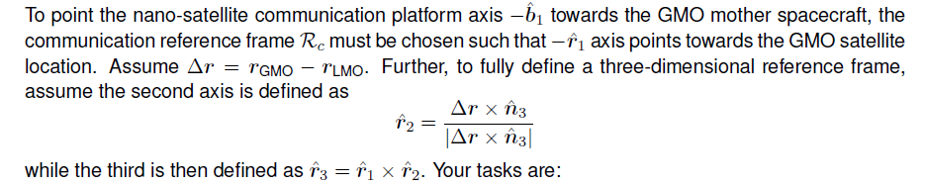

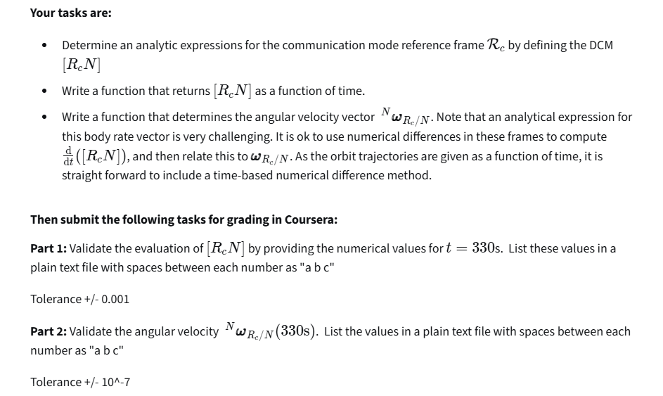
Solution

r_{c3}
r_{c1}
r_{c2}
r_{LMO}
Δ_{r}
r_{GMO}
-r_{c1}

$$R_{n}:\left\{P,{\hat{r}}_{n1},{\hat{r}}_{n2},{\hat{r}}_{n3}\right\}$$

Difference vector
$$Δr=r_{GMO}-r_{LMO}$$
First reference frame versor
$${\hat{r}}_{c1}=\frac{-Δr}{\left|Δr\right|}$$
Second versor
$${\hat{r}}_{c2}=\frac{Δr×{\hat{n}}_{3}}{\left|Δr×{\hat{n}}_{3}\right|}$$
third versor

$${\hat{r}}_{c3}={\hat{r}}_{c1}×{\hat{r}}_{c2}$$

Rotation matrix creation from reference frame triad
$$\left[R_{c}N\right]={\left[\begin{matrix}{\hat{r}}_{c1} & {\hat{r}}_{c2} & {\hat{r}}_{c3}\end{matrix}\right]}^{T}$$

Rotation matrix at instant t and t+Δt
$${\left[R_{c}N\right]}_{t} {\left[R_{c}N\right]}_{t+∆t}$$

Small relative rotation over small time interval Δt:
$${\left[R_{c}N\right]}_{t+∆t} {\left[R_{c}N\right]}_{t}^{T}$$

MRP kinematic equation for small rotations and small time intervals:
$$\dot{σ}=\frac{1}{4}\left[B(σ)\right]ω$$
$$B(σ_{t+Δt/t})≈1$$
$$\dot{σ}≈\frac{σ_{t+Δt/t}}{∆t}$$

$${{}_{}^{R_{n}}ω}_{Rc/N}≈\frac{4}{∆t}σ_{t+Δt/t}$$
$${{}_{}^{N}ω}_{Rc/N}={\left[R_{c}N\right]}^{T}{{}_{}^{R_{n}}ω}_{Rc/N}$$

Task 6

