Melting in the FeO-MgO-SiO2 system: A very brief overview (including problems and some potential solutions)

Introduction

In order to accurately model processes involving silicate melts, we must be fairly confident in our ability to extrapolate away from the P-T conditions and melt compositions where melts coexist with solids (where we have the best constraints on melt properties). For this reason, we must have accurate models of:
- solid mineral species; at least to the melting point, but also with reasonable properties (S, Cp) at the melting point,
- EoSs of endmember melts, enabling extrapolation to extreme P-T conditions,
- solution models, which must fit key points on phase diagrams (which are constraints on deltaG at single P and T) and also excess enthalpies, entropies and volumes of mixing. Preferably, the solution model should span the entire binary/ternary system, and be of an appropriate form to model short range order. Simple Margules models won't cut it, especially close to the melting point where short range order is probably significant.

MgO-SiO2

Solids

There are some problems with the existing thermodynamic models for solids in the MgO-SiO2 system. Firstly, the Holland and Powell (2011) EoS (PTV, Modified Tait) tends to blow up at high temperature. This EoS is based on integrating Gibbs up temperature and then up pressure, so it fails at high temperature even at high pressures where V < V_0.

Meanwhile, the Stixrude and Lithgow-Bertelloni dataset uses an EoS based on the Debye model for solids. It still blows up at high volumes when the q_0 parameter is large, but because it is a VTP EoS, it behaves well at high temperatures if V/V_0 is not too large.

Because the SLB model is based fairly rigidly on the Debye model, it doesn't have the freedom of the Holland and Powell model to independently fit thermal and volumetric properties. This is perfect for a Debye-like solid, where such a model allows extrapolation to extreme conditions. However, most Earth materials exhibit behaviour which are difficult to model using the Stixrude scheme, and for this reason, there are some parameter choices which may lead to poor extrapolation at high temperature. For example, periclase heat capacities are fit extremely well with a negligible q_0 (which determines the volume dependence of the Grueneisen parameter; ~0.15), as are volumes. However, the best fits for Cp and V require different values of the Grueneisen parameter. In order to fit both with the same grueneisen parameter, a large q_0 (1.72) is used, which leads the model to blow up when T > 3056 K at 1 bar (which is just below the melting point). In other models, (e.g. forsterite), choices of gamma_0 and q_0 result in small fluctuations in Cp curves not reflected in experimental data.

Finally, the ab initio results reported by de Koker et al. (2013) yield volumes which are in remarkably good agreement with Stixrude and Lithgow-Bertelloni (2011). However, the Gibbs free energy of the reaction bridgmanite → periclase + stishovite is much more positive, as is the entropy. This is relevant to discussions of mixing properties, as shall be seen later.

 |  |  | Model ∆G (kJ/mol) |  |  | Model ∆S (J/K/mol) |  |  | Model ∆V (kJ/GPa/mol)
P (GPa) | T (K) | DKS | SLB | HP | DKS | SLB | HP | DKS | SLB | HP
20 | 2524 | 59 | 8 | 17 | 22 | 9 | 20 | 0.45 | 0.42 | 0.89
140 | 4273 | 119 | 25 | 139 | 17 | 1 | 41 | 0.22 | -0.13 | 0.44

Table 1: Energetics of the reaction bridgmanite → periclase + stishovite according to three published datasets. Spurious values are highlighted (see text for discussion).

It is worth pointing out that the excess heat capacities of reaction in the HP dataset are much larger at mantle temperatures (ca. 5% total) than in SLB (ca. 2% total), and blow up beyond about 3000 K (for the reason discussed above). Excess heat capacities of reactions between oxides at high temperature are typically no more than a couple of percent of total heat capacity (Furukawa and Saba, 1965). Thus, despite the generally better agreement between the ab initio thermal properties and those in the HP dataset, it is probably more appropriate to use the SLB dataset for investigations of mantle processes.

Liquids

We are particularly interested in making sure our models fit the experimental melting curves, and any other data (entropies, heat capacities of fusion, volumes) which have been provided in the literature. A compilation of experimental and modelled data is given in Table 2.

Phase | Conditions | dT/dP [K/GPa] | Sfusion [J/K/mol] | Sliq | Vfusion (cm^3/mol) | Ab initio consistent with experiment?
MgO (per) | 1 bar, 3098 K | 200 [1],  35 [1a] | ~25 [2]  ~32.1 [7] | 169.5 [2]  176.5 [7] | 3.8 [7mod];  5 [1,2];  0.9 [1a,2] | y for 1,2  N for 1a, 2
Mg2SiO4 (fo) | 1 bar, 2174 K | 52 [3] | ~32.6 [2], 65.3 +/- 6.4 [4], 97.1 [7] | ~ 487 [4]  516.3 [7] | 8.4 [7];  3.4 [3,4] | N
MgSiO3 (en) | 1 bar, 1838 K | 110 [5] | 45.2 [2*], 57.5 [7] | 333.4 [7] | 5.8 [7];  5.0 | N
MgSiO3 (pen) | 1 bar, 1830 K [incongruent]  1 bar, 1850 K | 128 [8]  90 [8, tp] | 40.7 [2], 55 [7] | 310.8 [2]  334.4 [7] |  | N
SiO2 (qtz) | 1 bar, 1696 K | 470 [17] | 4.53 [2,16],  -5.9 [7] | 158.7 [2]  148 [7] | 2.1 [16,17]  3.6 [7]
SiO2 (crst) | 1 bar, 1999 K | ~ 0 | 4.45 [6],  -5.4 [7] | 173.2 [6]  163 [7] | ~ 0 ,  ~ -0.2 [7] | (y, but insensitive to Sfusion)
Fe2SiO4 (fa) | 1 bar, 1490 K [9] | 70 [10] | 59.9 [9]  164.0 [7] | 486.85 [9,HP]  481.9 [9,SLB]  590.9 [18] | 4.92 [11]  6.8 [7] | N
FeO (wus) | 1 bar, 1650 K | 70 [12, 1, 13] | 19 [14]  14.5 [2] | 167.8 [14,SLB]  170.5 [14, HP]  171.990 [2] | ~2.2 [15] | N/A  (exptl constraints don't agree)

Table 2: Properties of liquids at the melting point of various solids in the FMS system.
[1] Zhang and Fei, 2008
[1a] Zerr and Boehler (1994)
[2] JANAF
[2*] JANAF with HP tweak for pren → en (S += 4.5 J/K/mol)
[3] Davis and England, 1964; Presnall and Walter, 1993
[4] Richet et al., 1993
[5] Presnall and Gasparik, 1990
[6] Richet et al., 1992
[7] de Koker et al. (liq) with HP or SLB (solid) to calculate Sfusion
[7mod]: slight tweaks to SLB_per to fit HP Cp and volumes (separate models), doesn't make a huge difference relative to DKS_2013 periclase.
[8] Boyd, 1964
[9] Stebbins et al., 1984
[10] Lindsley et al., 1967
[11] Mo et al., 1982 (liquid volume 53.18 cm^3/mol at 1490 K, HP fa V is 48.26)
[12] Lindsley et al., 1966
[13] Knittle and Jeanloz, 1991
[14] Coughlin et al., 1951
[15] Hara et al., 1988
[16] Richet et al., 1982
[17] Zhang et al., 1993 (figure therein, refs Jackson, 1976; and Kanzaki, 1990)
[18] Ramo and Stixrude (2014)
Liquid solution models

There have been several attempts to produce MgO-SiO2 mixing models. At 1 bar, models based on experimental data include that by Wu et al. (1993). Constraints on high pressure models are provided by experiments on the SiO2-rich liquidus at 1, 1.5 and 5 GPa (Hudon et al, 2004; Dalton and Presnall, 1997), which indicate a region at high SiO2 where d2Vmix/dX^2 is negative. Melting curves at more MgO-rich compositions indicate a negative volume of mixing which reaches a minimum around forsteritic compositions (Figure 1).

The MgO-SiO2 model of Hudon et al. (2004; Equation 1; Figure 1) incorporates pressure dependence in the form of a composition-dependent (but P-T invariant) volume for the Gibbs energy of Mg-Si pair formation:

DeltaGMgSi = -86090 – 10180P – (48974 – 37.656T + 10615.37P)*Y + (328109 – 125.52T + 8911.75P)*Y^7 (equation 1)

where P and T are in GPa and K.

The experimental immiscibility gap used to construct this model essentially constrains d2Vmix/dX^2 at high SiO2 content, rather than the magnitude of the excess volume. The large volume of reaction (~15 cm^3/mol) at the Mg2SiO4 composition produces excess volumes at the forsterite melting point (~6.5 cm^3/mol cations) that are a little larger than those estimated using Table 2, and rapidly lead to unrealistic liquid stabilities. There is therefore clearly a need to better quantify excess (negative) volumes at 1 bar and their probable decay at high pressure.

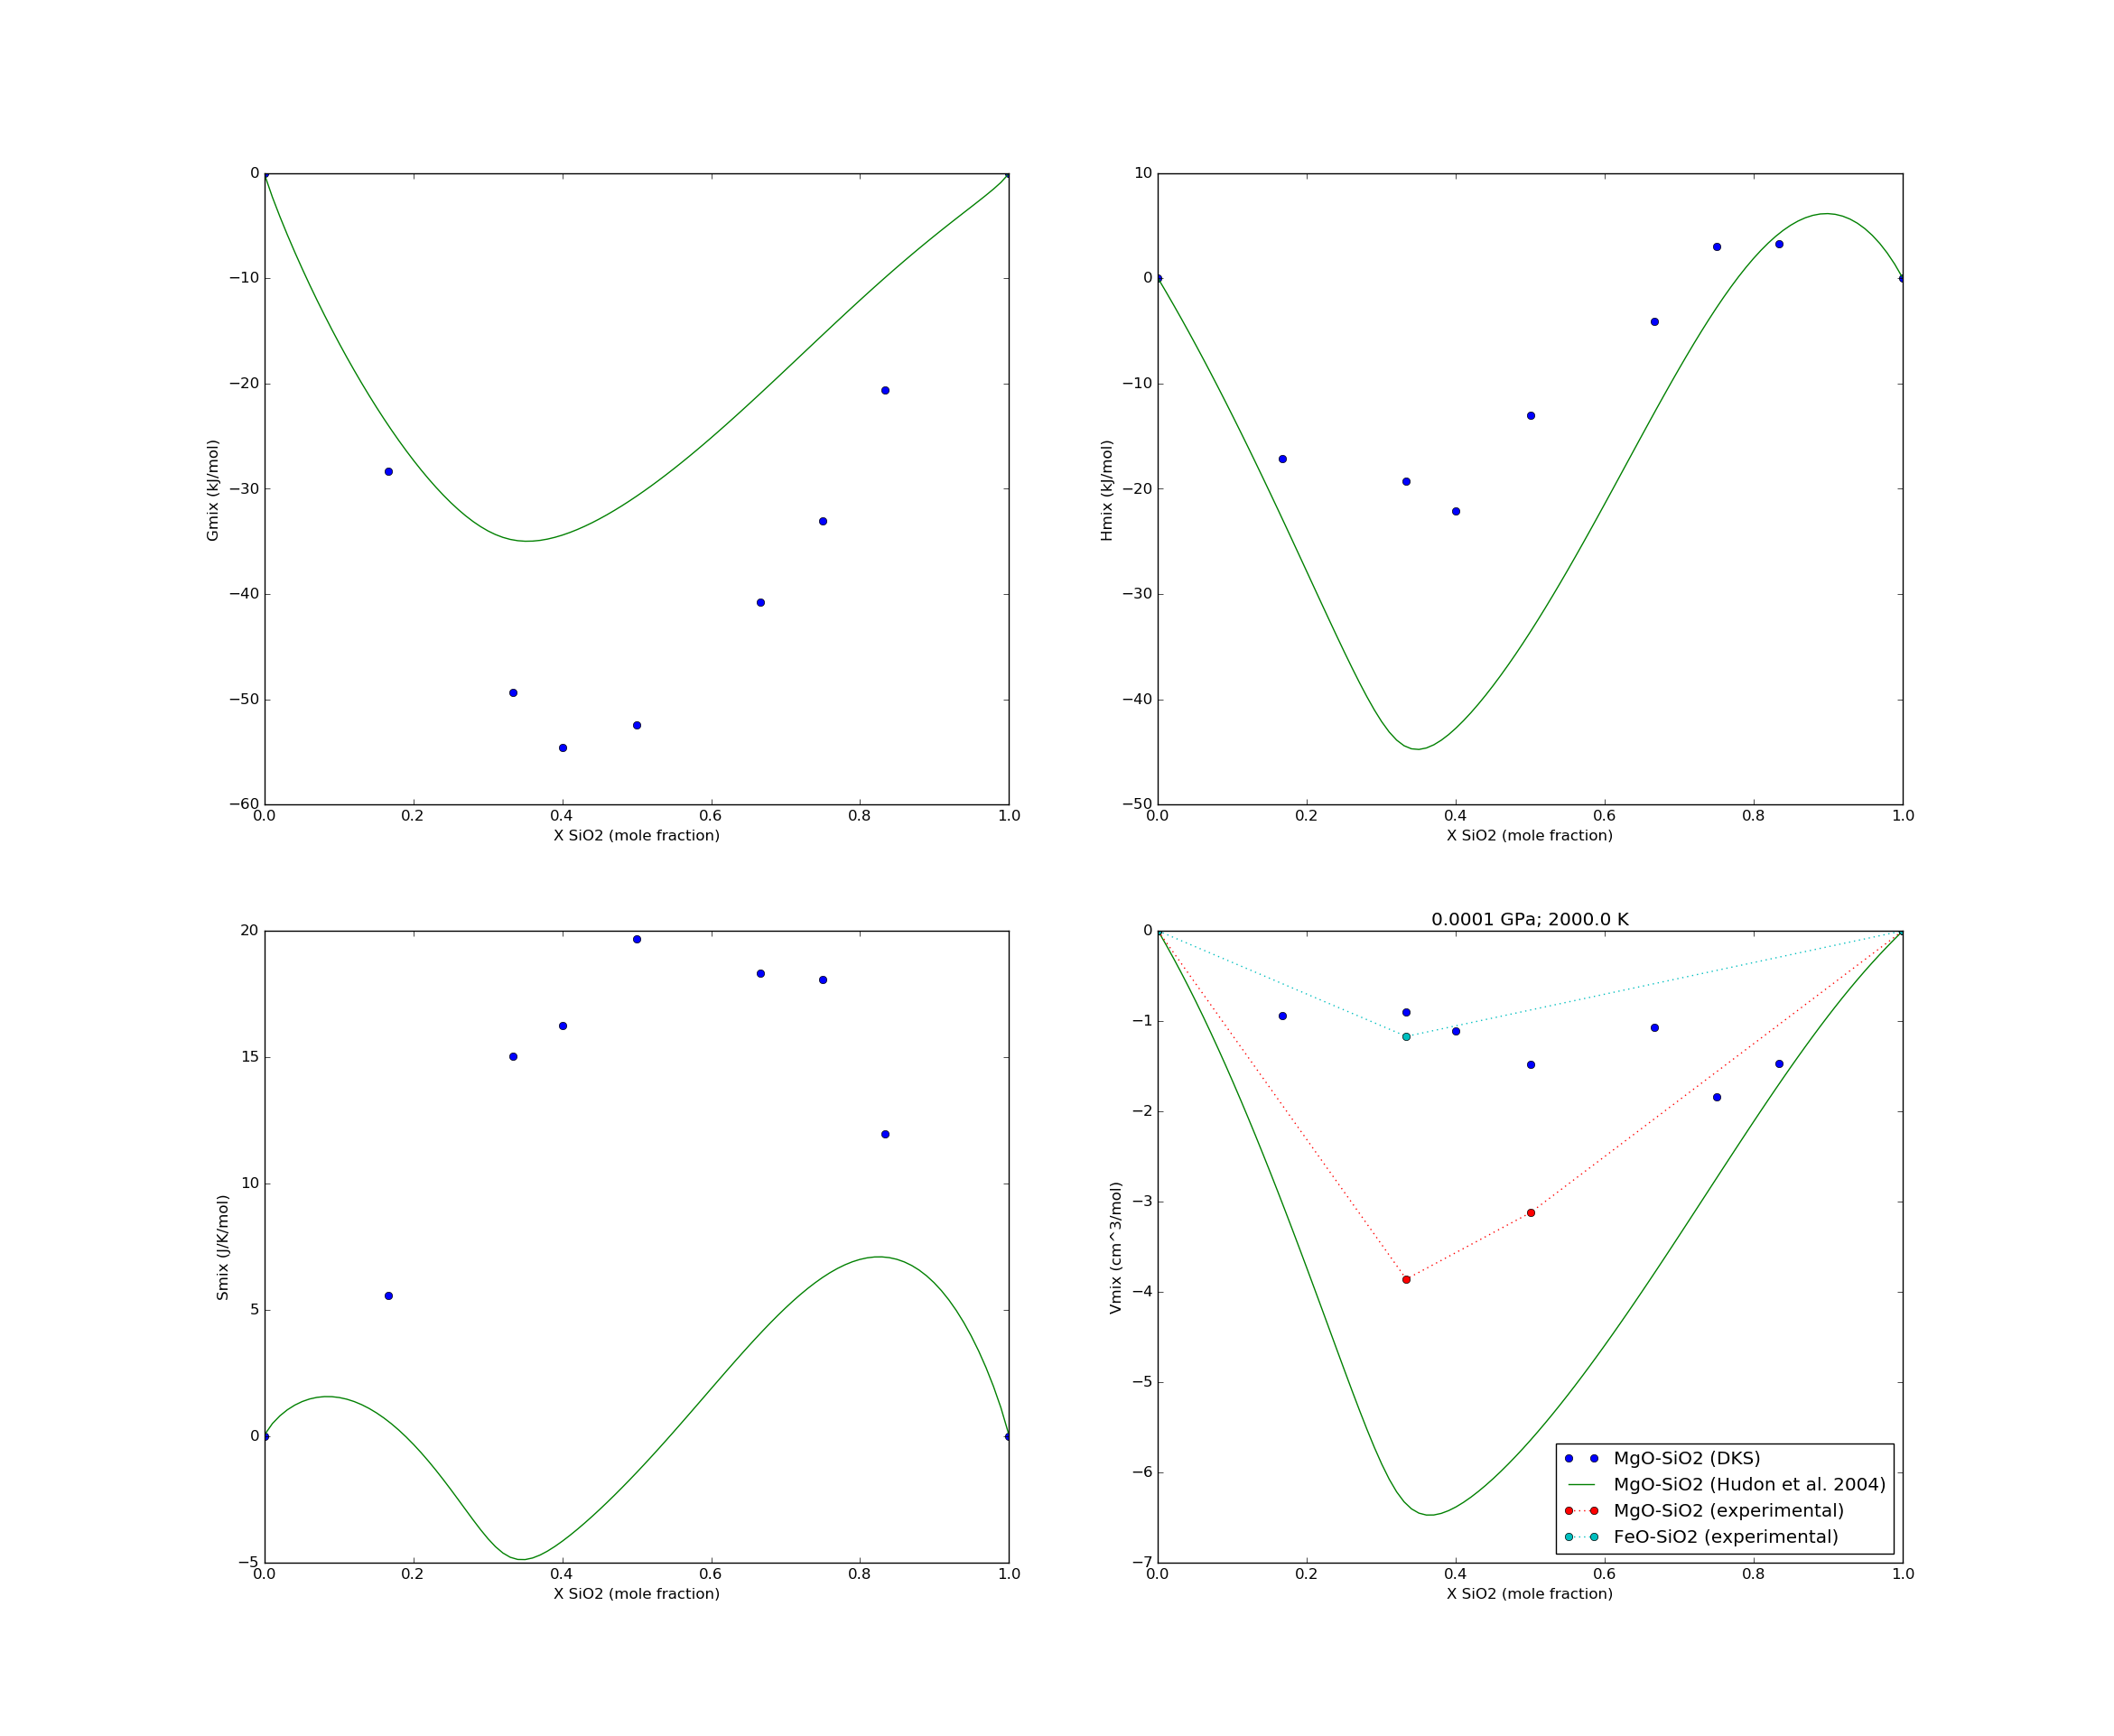
Figure 1. A comparison of different models for the MgO-SiO2 systems at 1 bar and 2000 K. Blue points are from de Koker et al. (2013), Green lines from Hudon et al. (2004), which is based on Wu et al. (1993). Experimental excess volumes are based on the solid equations of state of Holland and Powell and the excess volumes in Table 2.

There has also been an effort to investigate high pressure properties of MgO-SiO2 liquids based on molecular dynamics (de Koker et al., 2013). There are several important things to note about this liquid solution model. Firstly, the entropies of mixing across the binary do not come from the simulations. They are derived from experimental entropy estimates and the 1 bar per-fo eutectic, fo-cen peritectic and consolate point. The resulting excess entropies are very high, which is not concerning in itself, but the excess entropies show no evidence for short range order, for which there is experimental evidence around the melting point of forsterite (Blander and Pelton, 1987; Wu et al., 1993; Richet et al., 1993).
The solid entropies are then fit to the melting points. There appears to be an inconsistency here: for example, the entropy of forsterite liquid is derived from the forsterite entropy and entropy of fusion, and then the entropy of forsterite is tweaked to match the melting curve. Because the excess entropy of forsterite is very high, the entropy of forsterite at the melting point is also very high (and almost certainly incompatible with the available experimental data.

There are also some issues with the volume of mixing derived from the ab-initio data. The magnitude of the negative volume of mixing at high MgO contents is smaller than that derived from experimental data. The relatively large excess negative volumes at high SiO2 contents also mean that d2Vmix/dX^2 is positive, contradicting the experimental results of Hudon et al. (2004) and Dalton and Presnall (1997).

Finally, Harvey et al. (2015) used the ab initio mixing enthalpies of de Koker et al. (2013) at 3000 K and volumes to create a thermodynamic liquid solution model based on the quasichemical model. They fitted excess entropies at 1 bar with experimental data and developed polynomial and exponential expressions to allow excess volumes to decay to zero at infinite temperature and pressure.

As the excess volumes of de Koker et al. (2013) are inconsistent with experimental data, the model of Harvey et al. will not be able to fit high pressure experimental data. In terms of model formalism, the decay of excess volumes with temperature, if confirmed, may very well be related to the disappearance of short range order, and therefore is better incorporated into the gibbs energy of pair formation of the quasichemical model as done by Hudon et al. (2004), rather than an ad-hoc additive term. The decay with pressure can be worked directly into the pressure dependence of the gibbs energy by replacing the constant pressure dependence with \int V_xs dP.

Solid-liquid equilibria at high pressure

Figure 2 illustrates the problems with using the raw results from de Koker et al. with experimental solids. The diagram corresponds to the Gibbs free energy of mixing at 24 GPa and the temperature of the pv-stv eutectic from Baron et al. (2017). Clearly the de Koker ab initio models are quite close in terms of energy; melt is only metastable by about 6 kJ/mol. However, when we instead use experimental estimates of the Gibbs energy of reaction of pv → per + stv (SLB or HP) not only is melt already stable, but perovskite now melts incongruently (the pv-stv tieline no longer makes a tangent with the melt curve at any temperature). Clearly, this is a problem. To fit the eutectics of Baron et al. with such a small Gibbs energy of reaction, it seems that we must be a) much closer to the stv melting point at 2605 K, and b) the Gibbs energy of mixing must be rather more asymmetric than suggested by de Koker et al. (2013).

I don't understand how Boukare et al. (2016) manage to fit the MgO-SiO2 eutectics with de Koker et al. (2013) liquids, Stixrude and Lithgow-Bertelloni (2005) solids and a symmetric mixing model, but this is what they report. The melting curves for MgO and SiO2 look suspiciously like the ones derived from the ab initio solids from de Koker et al.. (2013).
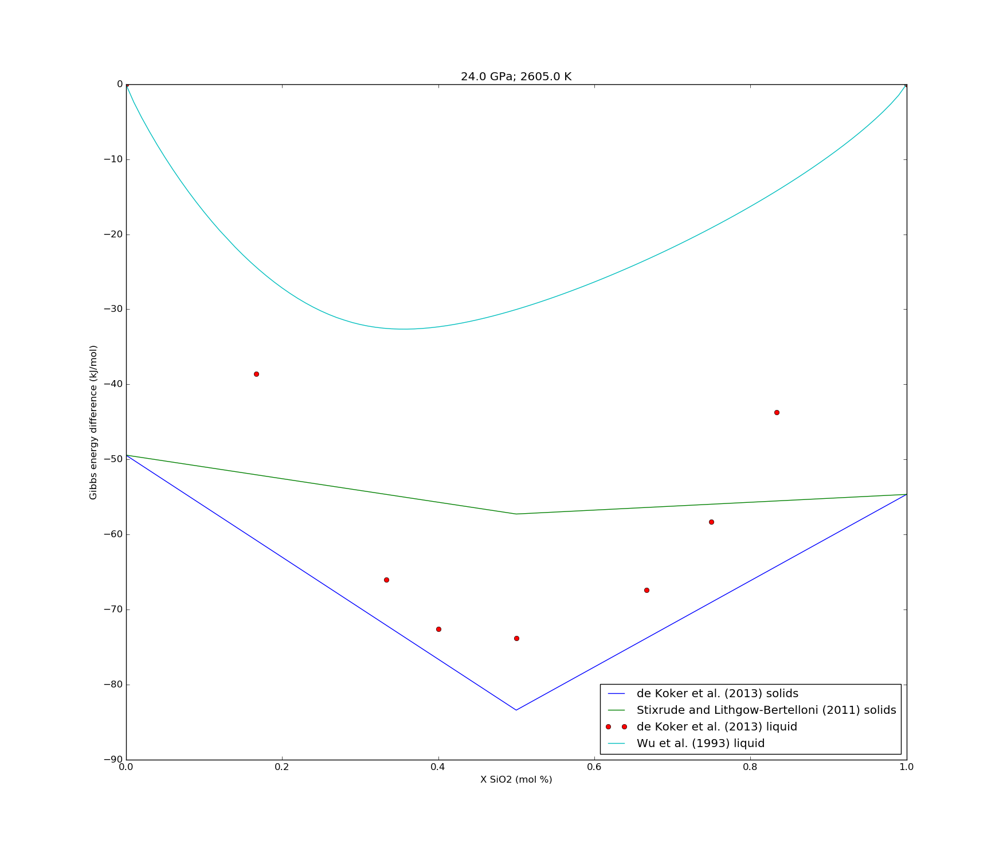
Figure 2. Excess Gibbs free energies at 24 GPa, 2605 K relative to mechanical mixing between MgO and SiO2 liquids. In blue is the lines between periclase, perovskite and stishovite from de Koker et al. (2011). In green, is the same line, but with the Gibbs energy of reaction from Stixrude and Lithgow-Bertelloni (2011). Red dots are values for liquids from de Koker et al (2013). For comparison, the cyan line is the 1 bar model from Wu et al. (1993).

Some notes on approximate liquid EoSes:

In the JANAF tables and several other references, the heat capacity of liquids at constant pressure is approximated to be constant. If we were to make the further assumption that 1 bar is not a special pressure (and that therefore heat capacity is only a function of pressure), then the implication via Maxwell's relations is:

{dCp / dP}T = d2H / dPdT = -T {d2V/dT2}P = -b (a function of pressure)

Integrating with respect to temperature, we obtain an expression for V:

d2V/dT2 = b/T

dV/dT = aV = b ln T + c

V = bT ( lnT – 1) + cT + d

where b, c and d are functions of pressure.

We note that dV/dT tends to increase with increasing temperature, and as such, Cp should decrease with increasing pressure.

If we make the additional approximation that aV = constant, Cp is constant everywhere (b=0) and V is therefore linear with temperature.

Remember that Cp – Cv = -{dP/dV}_{T}*(aV)^2*T = c^2*{dP/dV}_{T}*T

If Cp - Cv = constant, {dV/dP}_{T} is inversely proportional to T, leading to the simplest equation of state requiring the following parameters:
T_0 (melting point at 1 bar)
G_0 (to fit melting curve at 1 bar)
Cp (to fit experimental data)
S_0 (to fit experimental data)
aV (to fit experimental data)
(plus a P-V relationship at T_0; V_0, K, K', K'' etc)

FeO
The properties of solid Fe_{x}O are not particularly well-known at high temperature. The only study to investigate the heat capacity at high temperature (and beyond the melting point at 1377 C / 1650 K) is Coughlin et al. 1951:

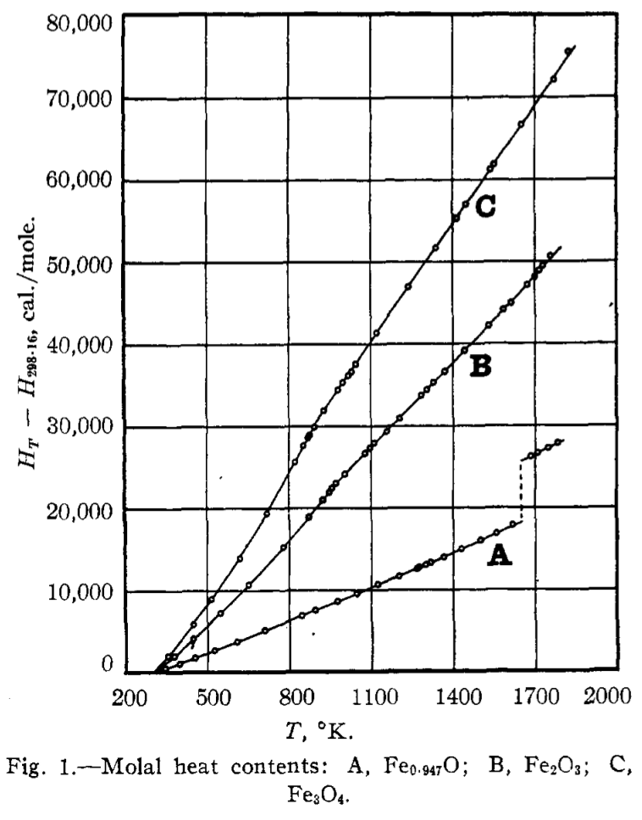
The volumetric properties are also poorly studied. The most detailed and useful study is probably Hayakawa et al., 1972, which stops some 300 K from the melting point. The linear variation in volume with temperature and O content suggests that extrapolation is reasonable, however.

The paucity of data also applies to liquid Fe_{x}O. The calculated entropy jump of 19 J/K/mol (4.54 cal/K/mol) at the melting point calculated by Coughlin has not been independently verified. As for the volume, there is a significant amount of disagreement in the literature over the compositional dependence on the volume:

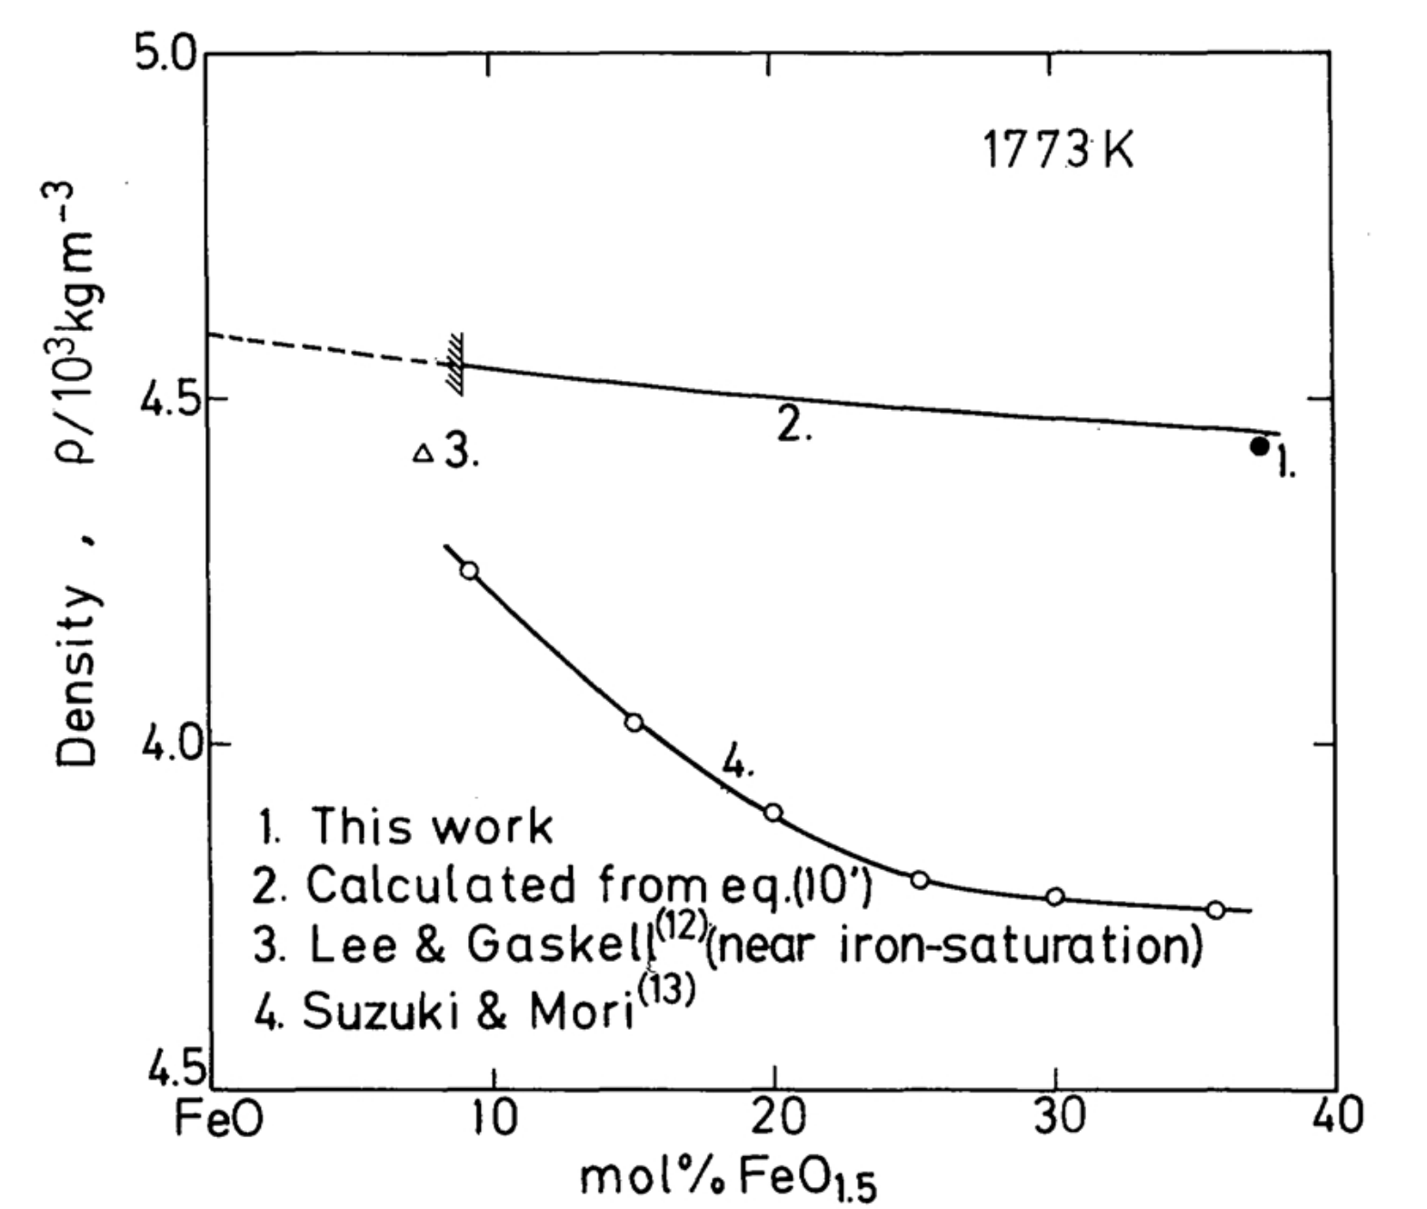
Hara et al. (1988) published a simple linear model for CaO-FeO-FeO1.5 melts. Bhattacharyya and Gaskell (1996) also updated estimates for density.

Quick conversion
Fe0.947O = 0.947*FeO1.056 = 48.64 mol % Fe = 11.2 mol % FeO1.5 = 5.9 mol % Fe2O3
= 12.3 mass % Fe2O3

We now illustrate the main problem with the FeO melting curve using the composition Fe0.947O used in the Coughlin et al. study.
At the melting point (1650 K), HP2011 fper (which appears to be calibrated for Fe0.947O) has a volume of 1.27163e-5 m^3/mol. Meanwhile, a linear extrapolation of the lattice parameter of Hayakawa et al., 1972 from 950-1050 C gives a volume of 1.28102e-5 m^3/mol.

The liquid has a volume of 1.5010e-5 m^3/mol (from Hara et al., 1988), so:

deltaV = 1.5010e-5 – 1.28102e-5
deltaS = 19 J/K/mol
dTdP = deltaV/deltaS ~ 115 K / GPa

Meanwhile, the available melting curves all suggest a significantly shallower slope (no greater than about 70 K / GPa; Lindsley et al., 1966)
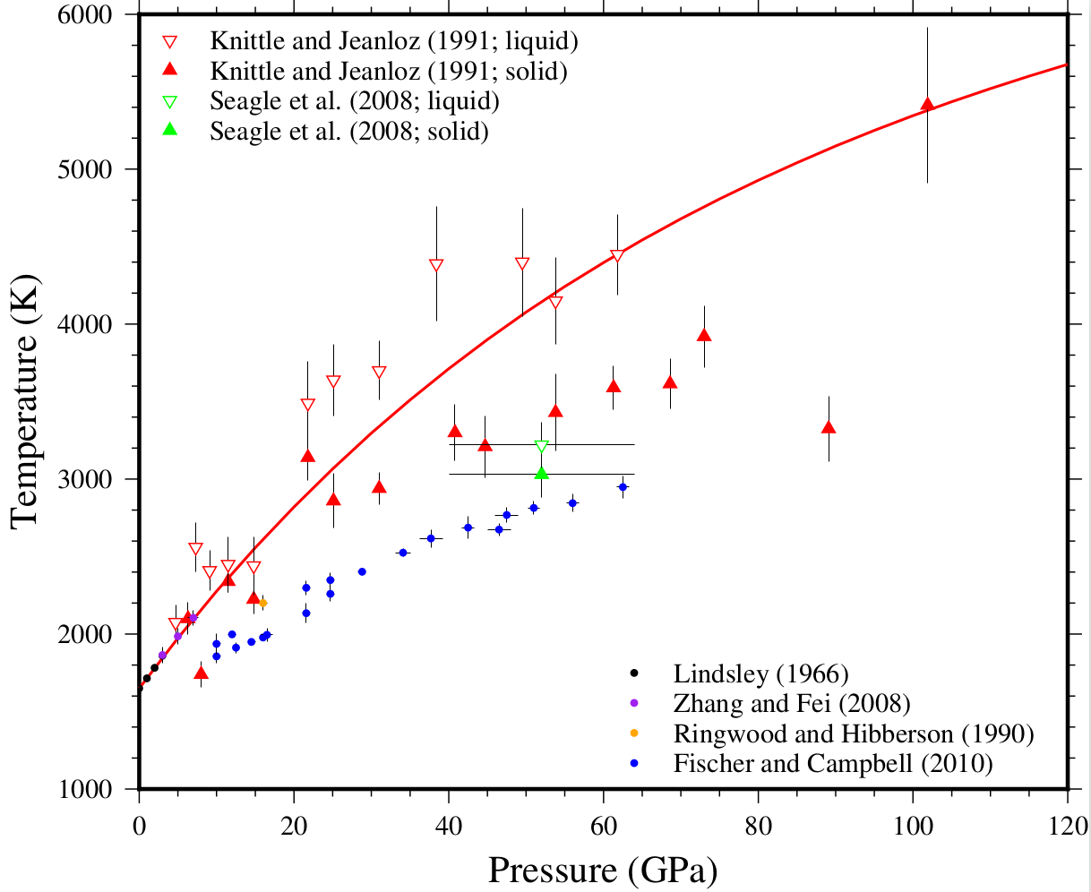

In fact, Shen et al. (1993) suggest that their melting curve is in agreement with the Lindsley data, but that the slope changes rapidly at low pressure. Their definition of melting is the start of a continuous change in texture, with a “fluid-like motion” in the “molten” sample. They note that quenching after the first change in texture does not produce a circular quench blob, and argue that in-situ observation is thus required to catch the onset of melting. It isn't clear to me whether their change in texture actually represents melting in this case. Their results are ~150 K higher than Boehler et al. (1990), who measured melting via power-temperature function, intensity of Ar-laser light and recording resistance-temperature. Their results are ~450 K lower than Seagle et al. (2008) at 50 GPa, who monitored melting via disappearance of synchrotron XRD peaks.

FeO-SiO2
Kato et al., 1984:
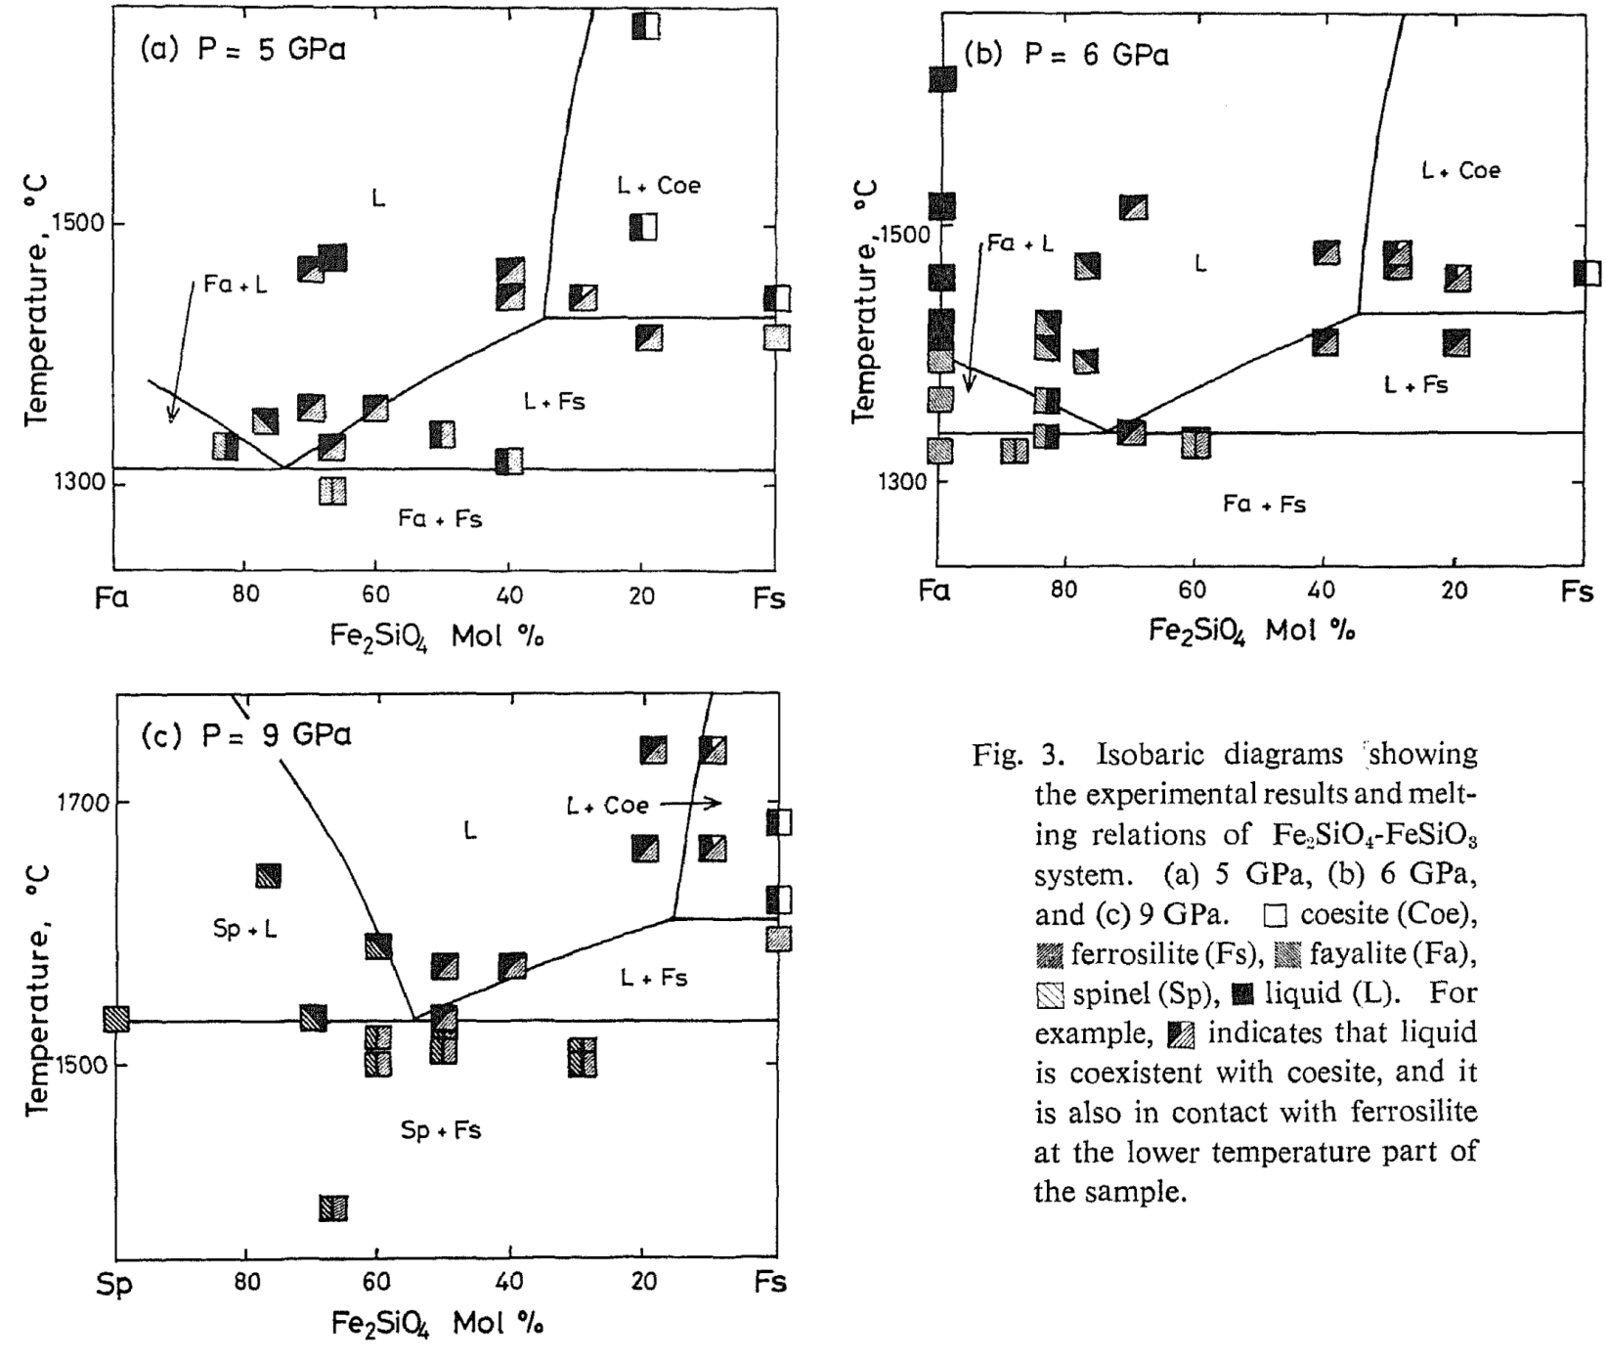

Ohtani, 1979
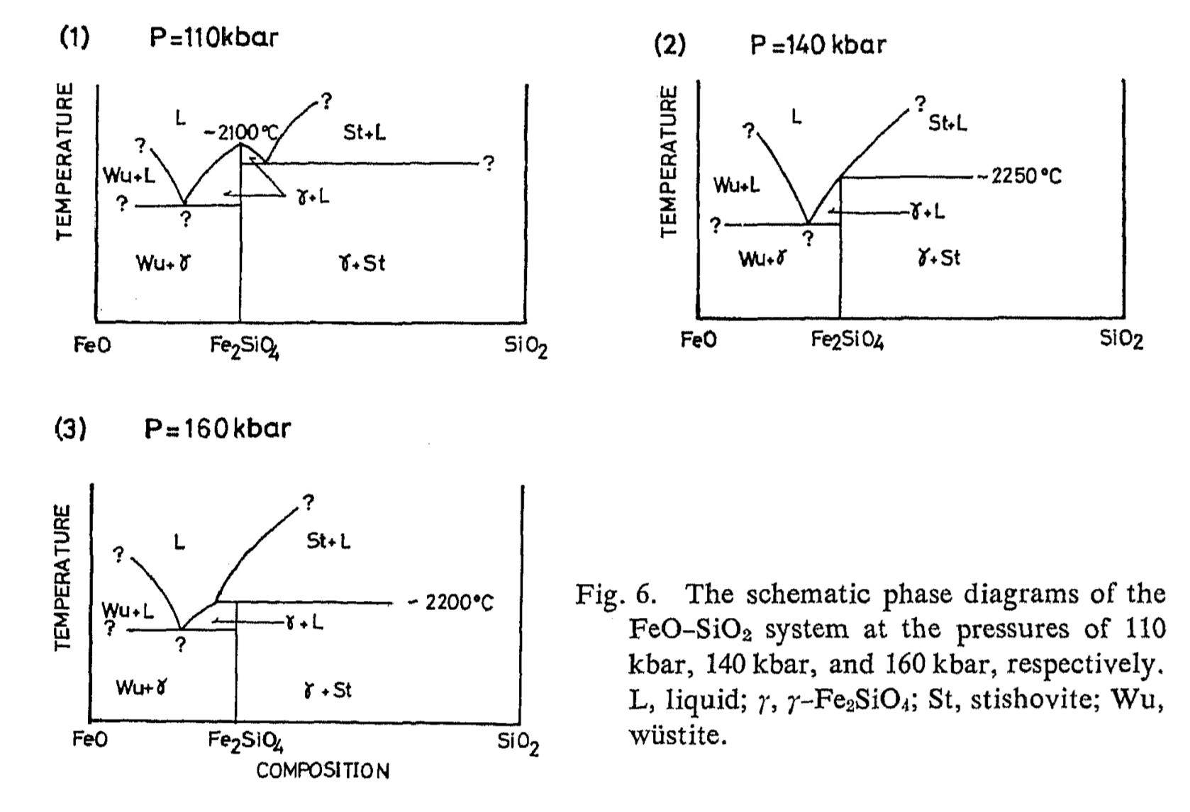
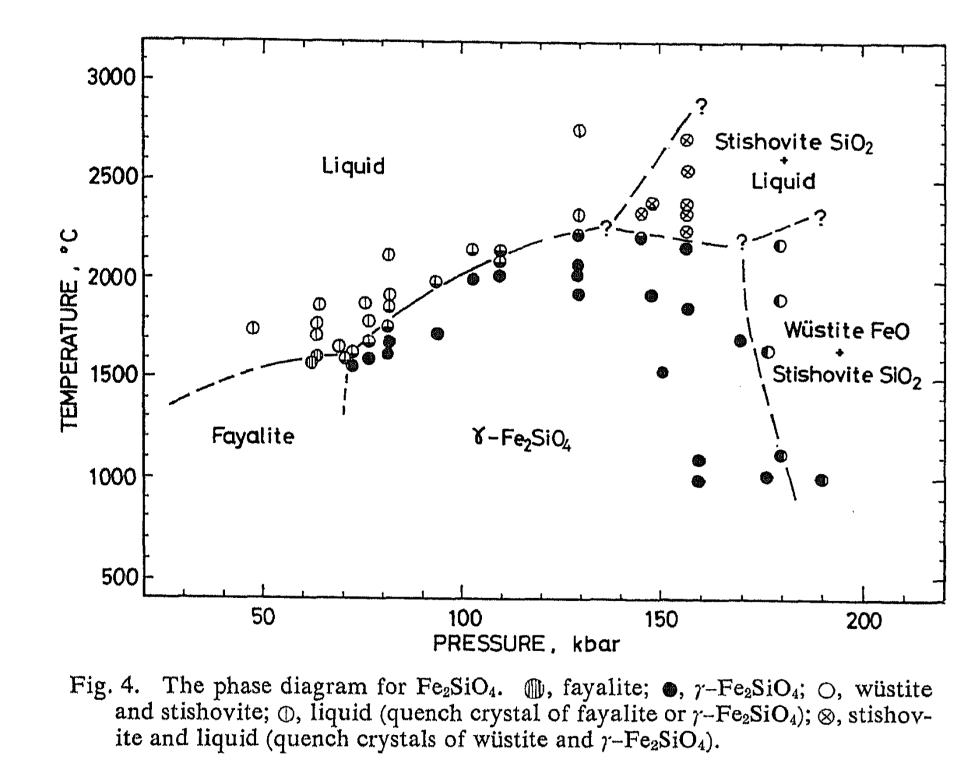
Ohtani et al., 1998
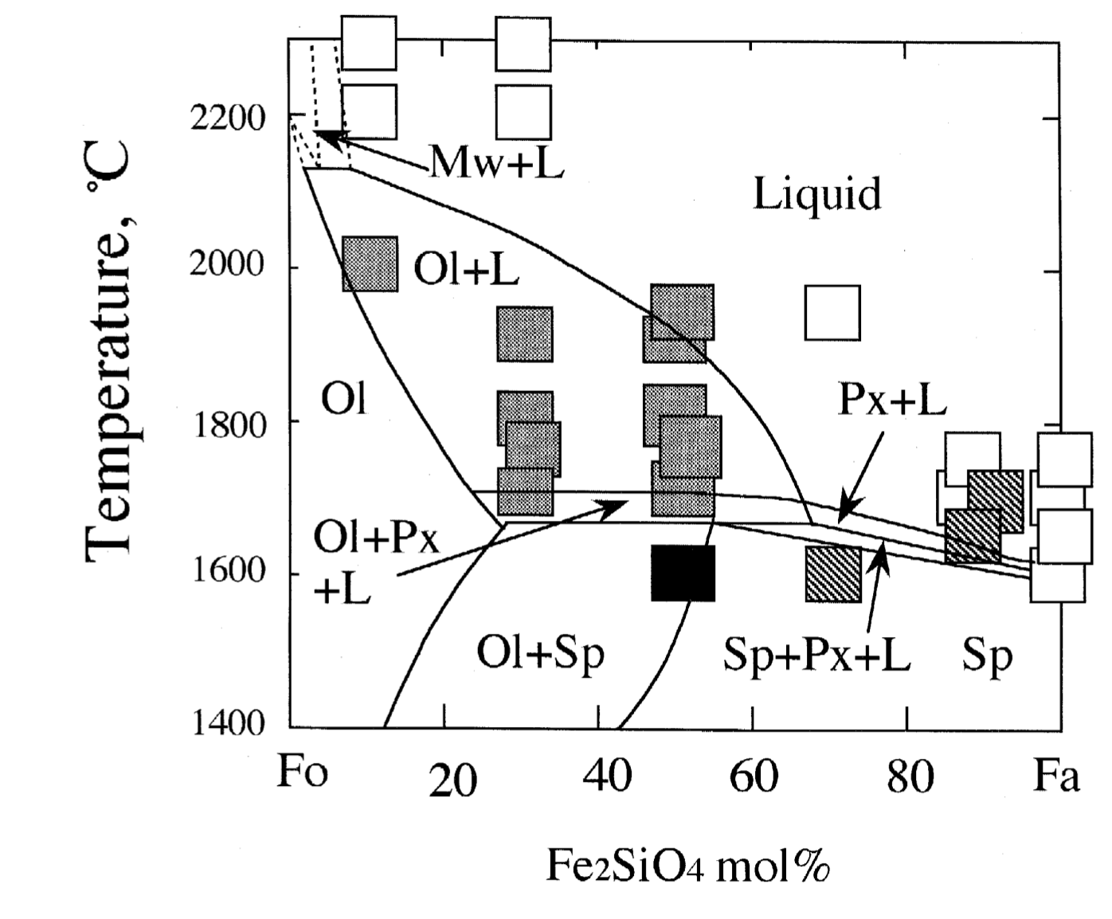
Kato et al., 2016

Eutectic compositions in the FeO-SiO2 become very FeO rich… for reference, 1 and 5 wt% SiO2 is equivalent to 1.2 and 5.9 mol% SiO2. Note that their eutectic at 17 GPa is at about 2000 K, some 400 K lower than suggested by Ohtani (where he put his triple point).

