Plan

# Abstract

% Water in the lower mantle

%

%

%

% Scatterers

# Introduction

% Motivation

The lower mantle is primarily composed of magnesium-rich bridgmanite and periclase. High pressure syntheses suggest that these phases contain no more than ~10 ppm water. These concentrations are exceptionally low, implying that the lower mantle is essentially dry. This result is at odds with geochemical analyses of magmas derived from plumes apparently rooted in the lower mantle, which appear to indicate high levels of water in their source rocks. Hydrous minerals are thought to be marginally unstable in the lower mantle, which further restricts the number of possible hosts of water in the lower mantle.

One interesting observation is that high water concentrations appear to be related to recycled components in plumes. If this is true, it suggests that mafic lithologies may have a higher water capacity than ultramafic lithologies in the lower mantle. In addition to magnesium-rich bridgmanite, recycled mafic components of plumes also contain Ca-rich perovskite, the so-called “new”-Aluminous (NAL) phase, a calcium-ferrite structured phase, and stishovite. In this study, we investigate the water storage capacity of aluminous stishovite in the lower mantle.

Pure stishovite contains almost no water. Water contents increase with increasing Al content, but not as rapidly as expected from the simple coupled substitution Si → Al + H. It appears that perhaps 6 out of every 7 Al atoms are incorporated via the creation of oxygen vacancies. These water contents are estimated from FTIR, via two calibrations proposed by XXXX. The calibration of Pawley yields water contents about 60% that of Paterson. If these water contents are applicable to the lower mantle, water-saturated stishovite and post-stishovite in mafic assemblages (~4 wt% Al2O3) contains 0.12 wt% H2O.

At a pressure of ~60 GPa, pure stishovite undergoes a displacive phase transition from a tetragonal structure to the orthorhombic CaCl2 structure (space group no. 136 → 58). This transition is particularly interesting in terms of water capacity, as the post-stishovite phase is isostructural with Phase H ((Mg,Fe)Si(OH)2) and delta-AlOOH. Indeed, electron probe measurements of synthetic Phase H-delta-AlOOH solid solutions exhibit silica excesses, which may be thought of as a post-stishovite component. Although these hydrous phases may not be stable, a nominally anhydrous post-stishovite phase may contain a component of such phases, and therefore become a significant host of water in the lower mantle.

No water contents have ever been measured in post-stishovite, as it is not possible to quench and recover the orthorhombic phase. The addition of Al2O3 to the crystal structure under hydrous conditions significantly lowers the transition pressure. Although it has been argued that this is also true of anhydrous crystals, ab-initio studies suggest that the incorporation of interstitial hydrogen plays an important role in reducing the transition pressure by relieving the mismatch between Al–O and Si–O bond lengths, and therefore allowing rotation of the Al-octahedra. The incorporation of 6 wt% Al2O3 lowers the transition pressure to 23 GPa. Making the assumption that the transition pressure is a linear function of Al content, post-stishovite with >10 wt % Al2O3 should be quenchable. In order to accommodate so much aluminium into (post-)stishovite, high temperatures are required. Figure 1 illustrates a pseudobinary phase diagram across the join SiO2-AlOOH at 26 GPa. Stishovite is the stable phase at <1750C, and when the bulk composition has more than 10 wt % SiO2, coexists with either Phase Egg (nominally AlSiO3(OH)) or Phase D (nominally Al2SiO4(OH)2). At 2100 C, AlOOH-saturated SiO2 forms an incommensurate phase. We therefore focus on the synthesis and analysis of large crystals of Al-saturated SiO2 between 1800 and 2000 C.

# Methods

# Figures

Fig. 1: Phase diagram at 26 GPa

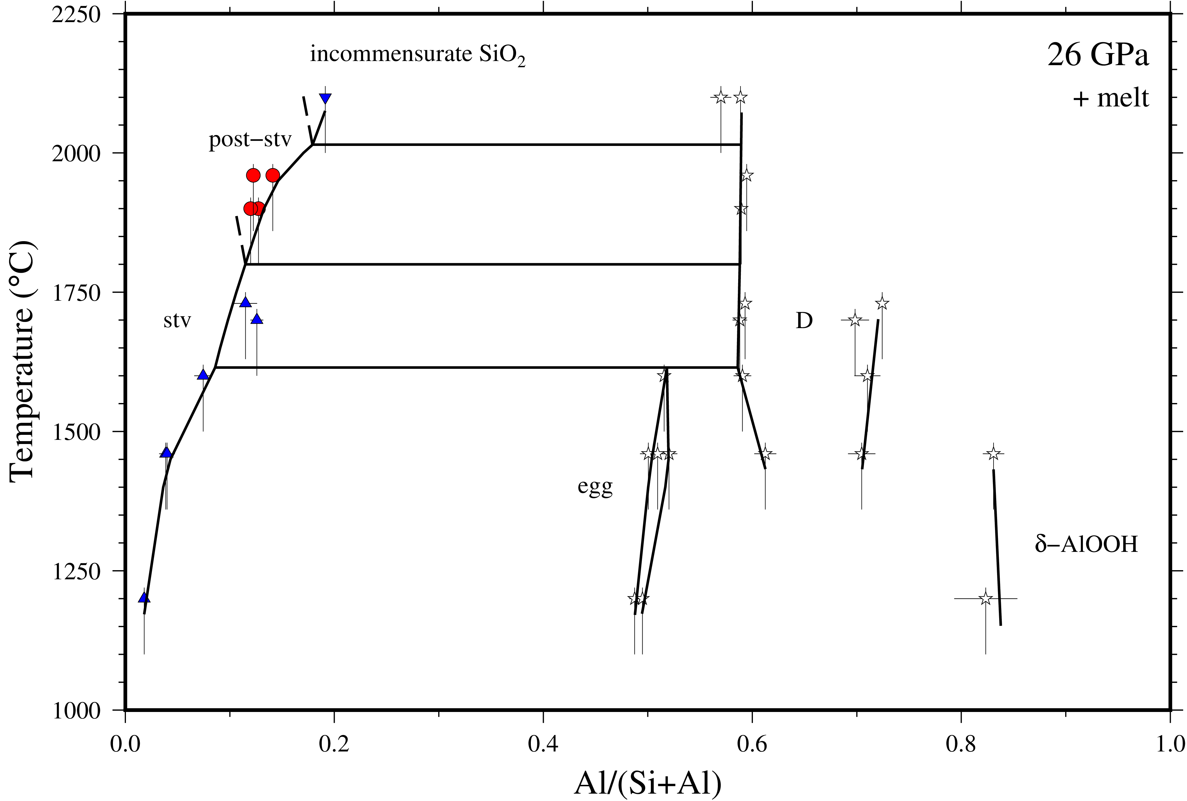

Fig. 2: SEM image

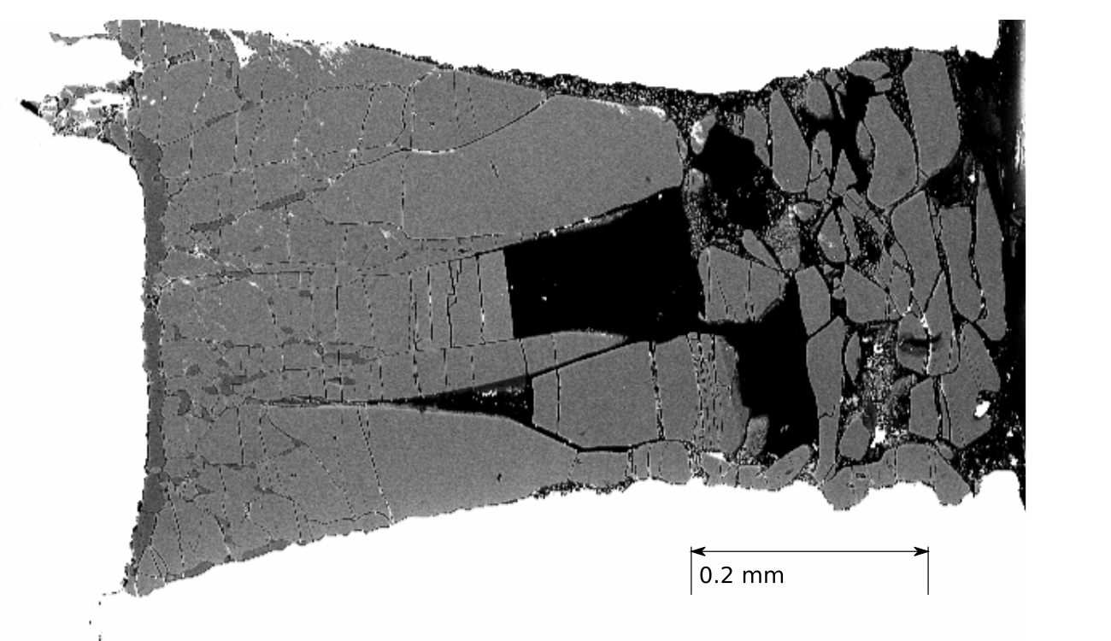

Fig. 3: XRD on H4095b (powder)

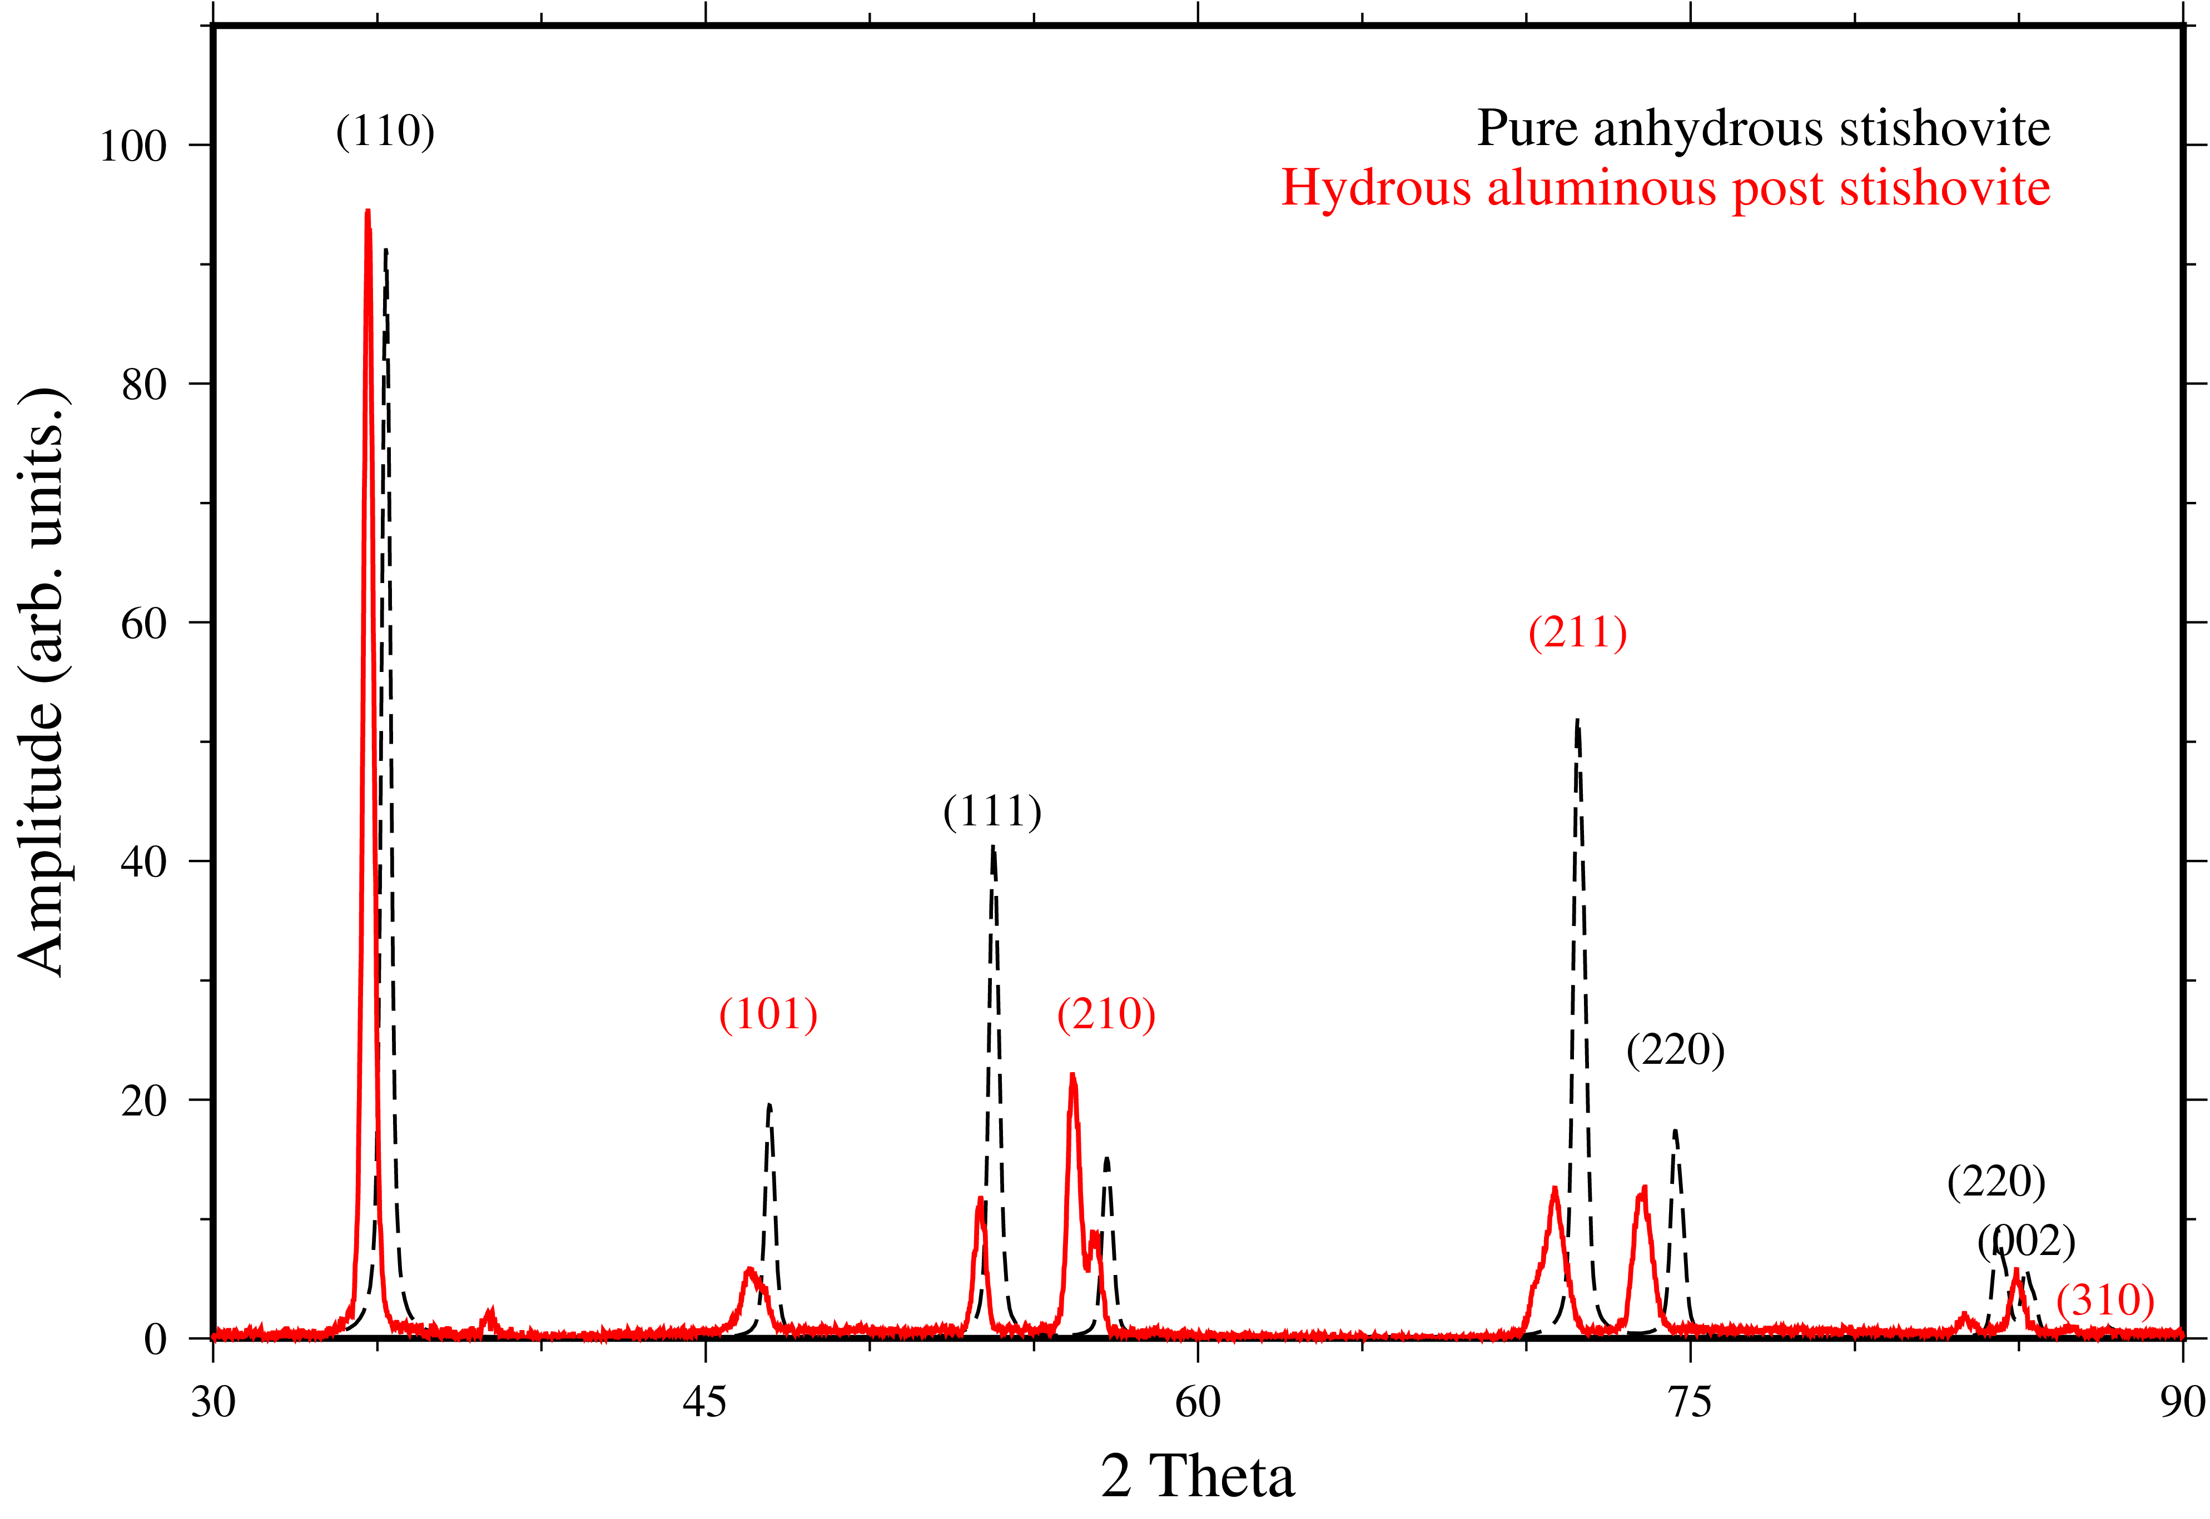

Fig. 4: Water contents

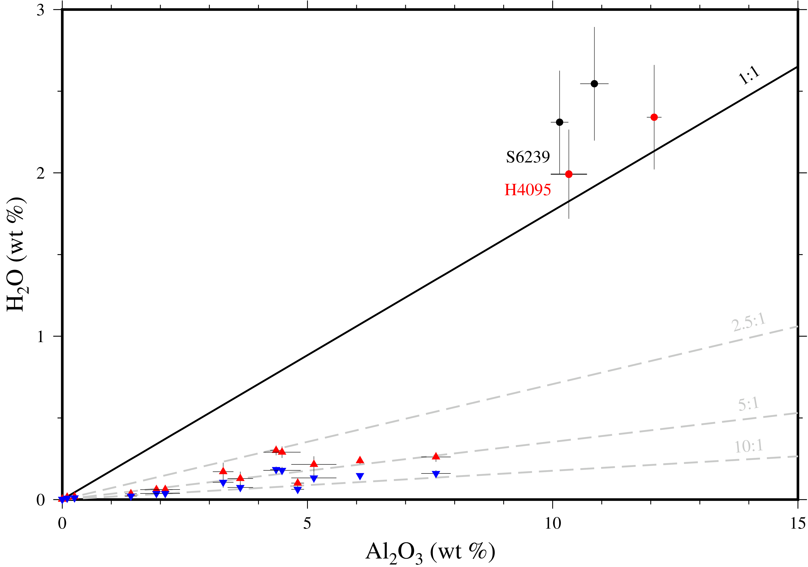

Volumes

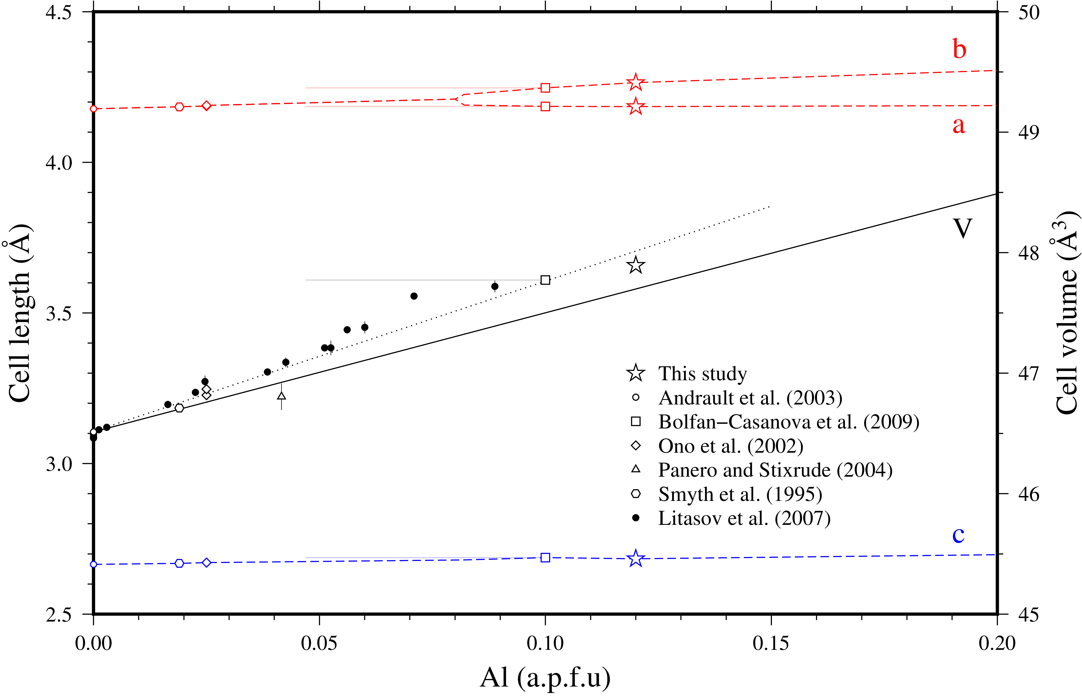

Single crystal refinement (S6239)



TEM on H4095b (11.1 wt % H2O via TEM, H4095b contains D)

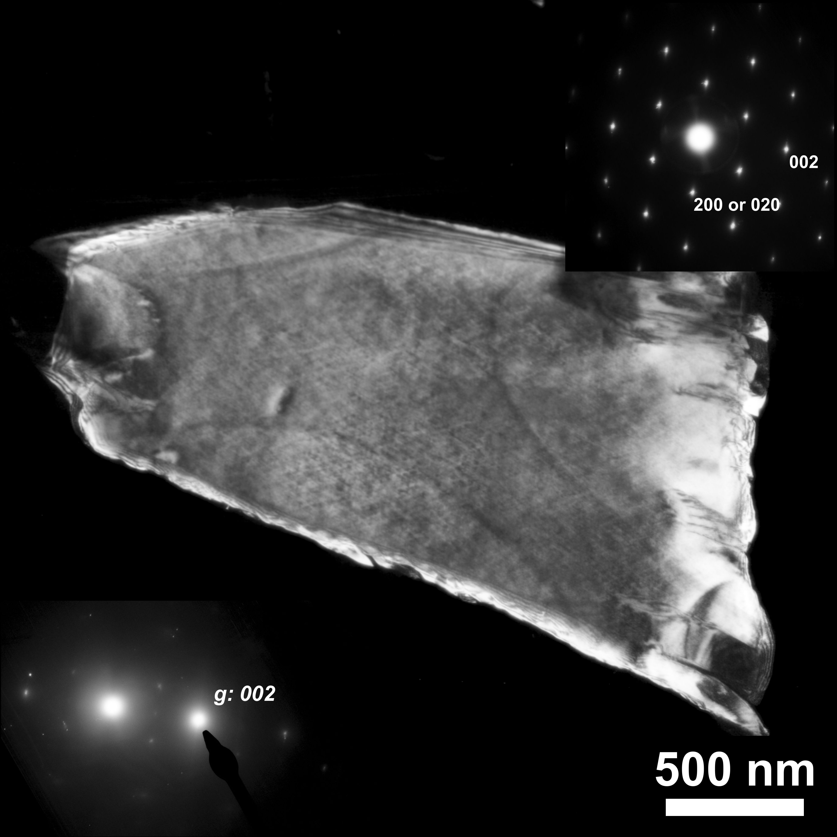

RAMAN

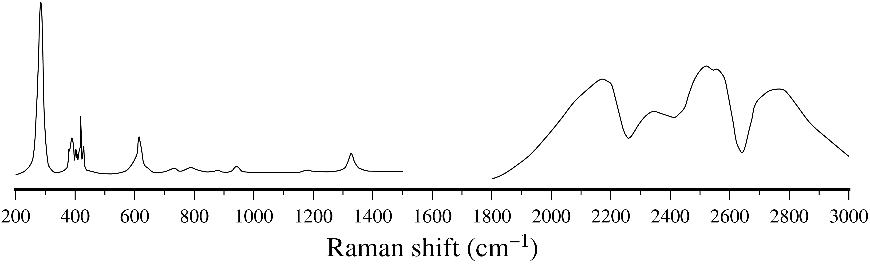

# Tables

|  |  |  |  |  |  |  |
| --- | --- | --- | --- | --- | --- | --- |
| Expt. # | P (GPa) | T (C) | Al2O3 (wt %) | H2O (wt %) | H/Al | Coexisting phases |
| S6239a | 25 | 1900 | 10.1 +/- 0.2 | 2.0 +/- 0.3 | 1.3 +/- 0.2 |  |
| S6239b | 25 | 1900 | 10.9 +/- 0.3 | 2.5 +/- 0.3 | 1.3 +/- 0.2 | Phase D |
| H4095a | 25 | 1960 | 10.3 +/- 0.4 | 2.0 +/- 0.3 | 1.1 +/- 0.2 |  |
| H4095b | 25 | 1960 | 12.1 +/- 0.1 | 2.3 +/- 0.3 | 1.1 +/- 0.2 | Phase D |