班级：NZ244 | 姓名：鲍未搏 | 学号：247099

实验一 The Harpe Gaming Store Website
实验目的
Samantha Goro is the owner of Harpe Gaming, a small board game store in Palmerston North, Manawatu. You have been asked to work on the store's new website, Samantha wants you to write the HTML5 code for the store's home page. Samantha also publishes reviews of new games as a service to her loyal customers. She would also like you to write the HTML5 code for two new reviews that she has written for the Towers and Temple game and the Alliance game. Samantha has already written all the content for the three pages and only requires your help to turn them into HTML5 documents.
实验内容
The Final Web Pages：
index.html
hg_towers.html
hg_alliance.html
三、实验结果
核心代码
（1）index.html：Harpe Gaming 商店主页
<!DOCTYPE html>
<html lang="en">
<head>
<meta charset="utf-8" />
<meta name="keywords" content="Harpe Gaming, board games, Palmerston North, Manawatu" />
<meta name="description" content="Harpe Gaming is a small board game store in Palmerston North, Manawatu" />
<title>Harpe Gaming</title>
</head>

<body>
<!-- 页面头部：店名和宣传语 -->
<header>
<h1>Harpe Gaming</h1>
<h2>Home of the Best Board Games in Palmerston North</h2>
</header>

<!-- 导航栏：三个页面之间的链接 -->
<nav>
<ul>
<li><a href="index.html">Home</a></li>
<li><a href="hg_towers.html">Towers and Temples</a></li>
<li><a href="hg_alliance.html">Alliance</a></li>
</ul>
</nav>

<!-- 主页内容：商店介绍 -->
<section id="intro">
<h2>Welcome to Harpe Gaming</h2>
<p>Harpe Gaming is a small board game store in the heart of
Palmerston North, Manawatu. We carry a huge selection of
strategy, card and family games, and we know every single
one of them.</p>
<p>Samantha Goro, the owner of the store, has been playing
board games since she was a child, and she is always happy
to help customers find a game that suits their tastes.</p>
</section>

<!-- 主页内容：新游戏评测入口 -->
<section id="reviews">
<h2>Game Reviews</h2>
<p>As a service to her loyal customers, Samantha publishes a
review whenever she comes across a new game worth talking
about. Here are the two most recent reviews:</p>
<ul>
<li><a href="hg_towers.html">Towers and Temples</a></li>
<li><a href="hg_alliance.html">Alliance</a></li>
</ul>
</section>

<!-- 页面底部：地址和联系方式 -->
<footer>
<address>
Harpe Gaming &bull; 1055 Main Street &bull; Palmerston North, Manawatu
</address>
<p>Telephone: (06) 555-1234 &nbsp; E-mail:
<a href="mailto:samantha@harpegaming.co.nz">samantha@harpegaming.co.nz</a>
</p>
</footer>
</body>
</html>
（2）hg_towers.html：Towers and Temples 游戏评测页
<!DOCTYPE html>
<html lang="en">
<head>
<meta charset="utf-8" />
<meta name="keywords" content="Towers and Temples, board game, review, Harpe Gaming" />
<meta name="description" content="Samantha Goro's review of the board game Towers and Temples" />
<title>Harpe Gaming: Towers and Temples</title>
</head>

<body>
<!-- 页面头部 -->
<header>
<h1>Harpe Gaming</h1>
<h2>Game Review: Towers and Temples</h2>
</header>

<!-- 导航栏 -->
<nav>
<ul>
<li><a href="index.html">Home</a></li>
<li><a href="hg_towers.html">Towers and Temples</a></li>
<li><a href="hg_alliance.html">Alliance</a></li>
</ul>
</nav>

<!-- 评测正文 -->
<article>
<h2>Towers and Temples</h2>
<p>Rating: <strong>4 / 5</strong></p>
<p>Rule your own kingdom in <em>Towers and Temples</em>, a
strategy game for two to four players from Beta Games.</p>
<p>In this game, each player takes on the role of a ruler who
must build towers and temples across their land. You collect
resources, lay down foundations and defend your territory,
trying to finish your buildings before your rivals do.</p>

<h3>What I like</h3>
<ul>
<li>The game is easy to learn but still offers deep
strategic choices.</li>
<li>Each game takes about an hour, a good length for a
week night.</li>
<li>The pieces are solid and the artwork is beautiful.</li>
</ul>

<h3>Things to watch out for</h3>
<ul>
<li>Some of the rule cards are a little hard to read at
first, so have a quick look through them before you
start.</li>
<li>It works best with four players.</li>
</ul>

<h3>Final verdict</h3>
<p>If you enjoy building games with a bit of friendly
competition, <em>Towers and Temples</em> is well worth a
place on your shelf. I recommend it to anyone who likes
games such as Carcassonne or Settlers of Catan.</p>
</article>

<!-- 页面底部 -->
<footer>
<address>
Harpe Gaming &bull; 1055 Main Street &bull; Palmerston North, Manawatu
</address>
<p>Telephone: (06) 555-1234 &nbsp; E-mail:
<a href="mailto:samantha@harpegaming.co.nz">samantha@harpegaming.co.nz</a>
</p>
</footer>
</body>
</html>
（3）hg_alliance.html：Alliance 游戏评测页
<!DOCTYPE html>
<html lang="en">
<head>
<meta charset="utf-8" />
<meta name="keywords" content="Alliance, board game, review, Harpe Gaming" />
<meta name="description" content="Samantha Goro's review of the board game Alliance" />
<title>Harpe Gaming: Alliance</title>
</head>

<body>
<!-- 页面头部 -->
<header>
<h1>Harpe Gaming</h1>
<h2>Game Review: Alliance</h2>
</header>

<!-- 导航栏 -->
<nav>
<ul>
<li><a href="index.html">Home</a></li>
<li><a href="hg_towers.html">Towers and Temples</a></li>
<li><a href="hg_alliance.html">Alliance</a></li>
</ul>
</nav>

<!-- 评测正文 -->
<article>
<h2>Alliance</h2>
<p>Rating: <strong>5 / 5</strong></p>
<p>Build a powerful empire in <em>Alliance</em>, a game of
diplomacy and trade for three to six players, designed by
the team at Corner House Games.</p>
<p>Every player controls one of six great houses. You make
alliances, trade resources and send your armies out to win
influence across the land. The twist is that your friends
today can become your enemies tomorrow, so every promise
has a price.</p>

<h3>What I like</h3>
<ul>
<li>The negotiation between players keeps everyone
involved from start to finish.</li>
<li>No two games ever play out the same way.</li>
<li>It fits well into an evening with friends &mdash;
about two hours for a full game.</li>
</ul>

<h3>Things to watch out for</h3>
<ul>
<li>There is a lot of reading on the first play-through,
so be prepared to learn the rules together.</li>
<li>You really need at least four players to see the game
at its best.</li>
</ul>

<h3>Final verdict</h3>
<p><em>Alliance</em> is one of my favourite games this year.
It is clever, tense and great fun, and it has earned a
permanent place in the store. If you like games about
negotiation and strategy, do not miss this one.</p>
</article>

<!-- 页面底部 -->
<footer>
<address>
Harpe Gaming &bull; 1055 Main Street &bull; Palmerston North, Manawatu
</address>
<p>Telephone: (06) 555-1234 &nbsp; E-mail:
<a href="mailto:samantha@harpegaming.co.nz">samantha@harpegaming.co.nz</a>
</p>
</footer>
</body>
</html>
运行效果：
（1）index.html 主页运行效果
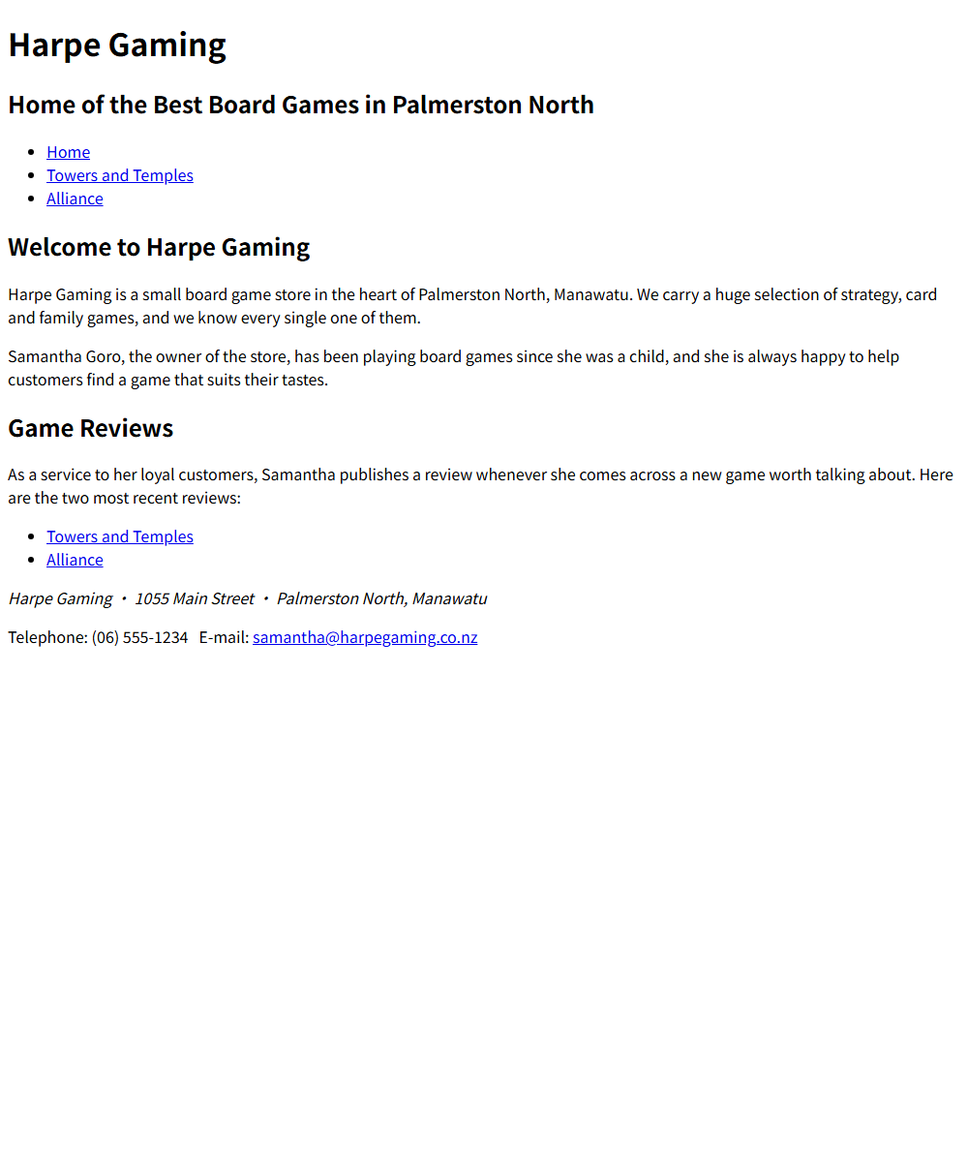
（2）hg_towers.html 游戏评测页运行效果
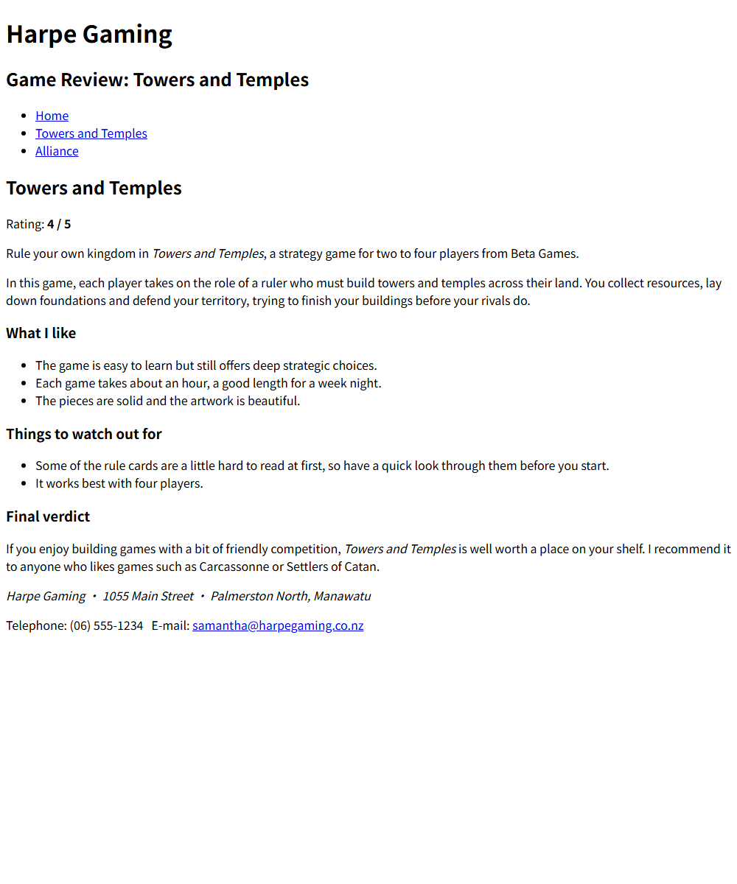
（3）hg_alliance.html 游戏评测页运行效果
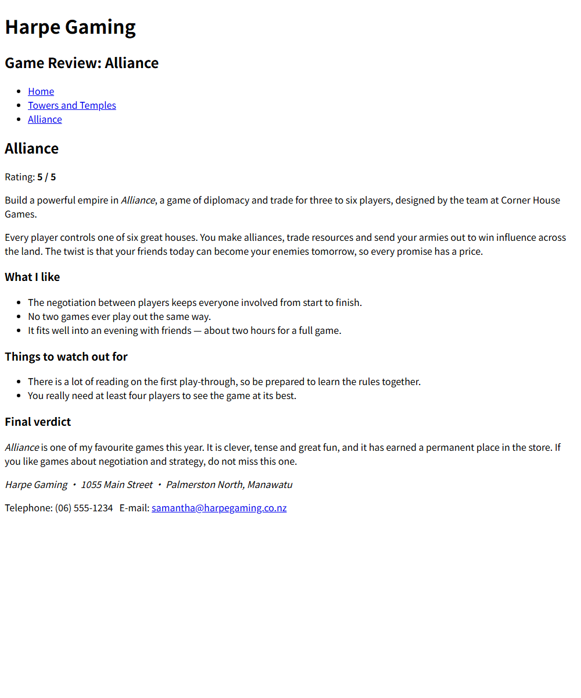
备注：上传文件命名要求：班级-学号-姓名-n（n为实验的编号）

