CSC521 Operating system
Project: myDispatcher - project 2
Programmer: Rob Miles
Professor: Dr. Lee
File Created: November 12, 2018

======================
Project Description
======================

This project is to implement the CPU scheduling policies, First-Come-First-Served (FCFS), Round-Robin (RR), Shortest Process Next (SPN) and Shortest Remaining Time (SRT). The dispatcher (aka short term scheduler) is a critical part of an operating system that takes care of the scheduling of processes by determining the order of execution for processes that are ready to be executed (in a ready state). As such, there are different algorithms that can be considered when analyzing a dispatcher. Each of the aforementioned algorithms will have its own unique advantages and disadvantages that can impact system performance.
FCFS merely executes the process in the queue that has been there longest. This yields simple, fair results that aren’t optimized but overhead cost is low. This experiment shows it is the optimal choice over the others. RR is also fair as it cycles through all queued processes each for particular time (quantum) duration. Shorter processes benefit from this and quantum size has an impact on overall efficiency. RR overhead is somewhat minimal. SPN will decide, once the latest process is complete, which is the next shortest process in the queue and execute it. Shorter processes benefit while longer ones are penalized so overall performance can be good if there is not a wide variation in process size. Overhead is increased due to the determination of the shortest process. SRT is similar to SPN but, won’t wait for the current process to complete before re-assessing the next shortest process. So, preemption can take place via interrupt. Again, shorter processes benefit while longer processes are penalized resulting in a risk of starvation if process size variation is great. The queue could be more optimized, however, overhead is increased further since more processing is needed to continuously determine shortest process. [1]

======================
Algorithm
======================

Start
- Iinitialize a current time variable for all files/functions to observe globalTimeTicker = 0
- Define Process struct as with variables for the following:
pid; //process identity
arrivalTime; //when the process is ready to be queued
exeTime; //aka service/burst time
remExeTime; //tracking of execution
exeStartTime; //when execution started
exeDoneTime; //when execution completed
turnaroundTime; //storage for convenience [completion - arrival time]
waitTime; //storage for convenience [turnaround - service time]
complete; //flag for assessing convenience, if process is done
Process *next; //linked list for all processes
Process *Qnext; //linked list used for when in process queue
- Create linked list head called Process inputProcesses
- Define function append(Process head_ref, int arrivalTime_in, int exeTime_in, int pid_in) to do the following:
  - Create a new Process called new_node
  - assign:
    - pid = pid_in;
    - arrivalTime = arrivalTime_in;
    - exeTime = exeTime_in;
    - remExeTime = exeTime_in;
    - the remaining Process instance variables set to NULL or 0
  - Point the front of the queue to this node *head_ref = new_node if *head_ref = NULL aka, if this is the first process in the list
  - Go to end of linked list while(last->next != NULL) { last = last->next }
  - Add reference to new_node at the end of linked list end of list last-next = new_node to appended it to list
- Set a pid counter to pid = 1
- Open input.dat file for reading and assign it to variable fp = fopen(argv[1], “rb”) - argv[1] is the input data file from command prompt
- Loop through fp, grab column 1 and 2 values as arrivalTime and exeTime for each row
  - For each row ! EOF, append(&inputProcesses, arrivalTime_in, exeTime_in, pid) to the linked list
  - Increment pid++
- Check if (number of arguments == 3) and provide user feedback if need be:
if (argc != 3) {“Input parameters should be input.dat and <ALGORITHM> to run.\n”}
- Check the input arguments and select appropriate algorithm based on input arguments from user.
Note: algorithms for the following are broken out later in this document since there are different branches at this point
  - if (userInput == "FCFS")
firstComeFirstServe(inputProcesses)
  - if (userInput == "RR”)
roundRobin(inputProcesses)
  - if (userInput == "STN")
shortestTimeNext(inputProcesses)
  - if (userInput == "SRT")
shortestRemainingTime(inputProcesses)
else warn "Make sure you're <ALGORITHM> parameter is one of the following [in all caps]: FCFS, RR, STN, SRT"
- create output.dat with processStatistics(inputProcesses)
  - Open a file "output.dat" as fp to write the output data
  - Iniitialize avgturnaround = 0, avgnormalizedTurnaround = 0, avgwaiting = 0;
  - Loop through Process list
    - calculate turnaround time, wait time, for each individual process
turnaroundTime = exeDoneTime - arrivalTime
waitTime = turnaroundTime - exeTime;
    - Add each process to the total tally for each process
avgturnaround += turnaroundTime;
avgwaiting += waitTime;
avgnormalizedTurnaround += turnaroundTime / exeTime
    - Print individual process information to output.dat file pid, arrivalTime, exeDoneTime, arrivalTime,
exeTime, waitTime, exeDoneTime, turnaroundTime
  - Complete average calculations by dividing by total number of rows
avgturnaround = avgturnaround / TOTAL_ROWS;
avgwaiting = avgwaiting / TOTAL_ROWS;
avgnormalizedTurnaround = avgnormalizedTurnaround / TOTAL_ROWS;
  - Print averages to screen for user
“Average turnaround time = avgturnaround
Average normalized turnaround time = avgnormalizedTurnaround
Average waiting time = avgwaiting”

End of main function

- Run FCFS algorithm firstComeFirstServe(inputProcessList)
- Initialize:
  - counter for completed processes expiredCounter = 0
  - Head queueList (our scheduler queue) as Process set to NULL
  - A variable for currently running processes activeProcess as Process
- Loop until all processes complete executing while (1)
  - Loop through input process list while inputProcessList != NULL
    - If inputProcess not complete
      - if inputProcess arrivalTime == globalTimeTicker (ie. if it's new to the queue)
        - append (current loop) process to scheduler queueList
  - If no activeProcess set, set activeProcess = queueList (used for first loop iteration)
  - if activeProcess has no exeStartTime set exeStartTime = current time
  - if activeProcess->reminingExecutionTime == 0 (ie process is finished executing)
    - if transitioning from complete to incomplete then {expiredCounter++}
    - set activeProcess complete to TRUE
    - to record the time completed (ie. doneTime = globalTimeTicker)
    - if all processes execution complete (ie expiredCounter == TOTAL_ROWS) return 0
    - otherwise, set activeProcess to next in queue
  - if activeProcess not complete
activeProcess remainingExecutionTime --
  - globalTimeTicker ++ (ie. increment current time)

- Run RR algorithm roundRobin(inputProcessList)
- Initialize:
  - Current turn position as slicePosition = 0
  - Default quantum as sliceSize = 1
  - Counter for completed processes expiredCounter = 0
  - Head queueList (our scheduler queue) as Process set to NULL
  - A variable for currently running processes activeProcess as Process
- Loop until all processes complete executing while (1)
  - Loop through input process list while inputProcessList != NULL
    - If inputProcess not complete
      - if inputProcess arrivalTime == globalTimeTicker (ie. if it's new to the queue)
        - append (current loop) process to scheduler queueList
  - If no activeProcess set, set activeProcess = queueList (used for first loop iteration)
  - f activeProcess has no exeStartTime set exeStartTime = current time
  - if activeProcess->reminingExecutionTime == 0 (ie process is finished executing)
    - if transitioning from complete to incomplete then {expiredCounter++}
    - set activeProcess complete to TRUE
    - to record the time completed (ie. doneTime = globalTimeTicker)
    - reset quantum counter (ie slicePosition = 1)
    - if all processes execution complete (ie expiredCounter == TOTAL_ROWS) return 0
    - If at end of queue (ie Qnext == NULL)
      - If at start of queue (ie Qprev == NULL means its the only process)
        - Empty the queue and active process(queueList = NULL, activeProcess = NULL)
      - Otherwise, drop last process from queue
      - And set activeProcess to start of queueList
    - Else store next process in queue
      - If not first process in queueList (ie Qprev != NULL)
        - Remove activeProcess from queue
      - else drop 1st in queue by pointing queueList to 2nd (ie queueList = activeProcess->Qnext)
    - move to the next in queue
  - else if end of time slice
    - if activeProcess is currently last in the queue
set activeProcess start of queueList
    - else move activeProcess to end of queueList
Point queueList head to 2nd process
Point activeProcess to queueList head
  - else increment quantum position with slicePosition ++
  - if activeProcess not complete
activeProcess remainingExecutionTime --
  - globalTimeTicker ++ (ie. increment current time)

- Run SPN algorithm shortestProcessNext(struct Process *inProc)
- Initialize things:
  - Counter for completed processes expiredCounter = 0
  - Head queueList (our scheduler queue) as Process set to NULL
  - A variable for currently running processes activeProcess as Process
  - A variable iterating to find shortest process processIterator as Process
  - A variable to keep track of size of current shortest process sizeComp
- Loop until all processes complete executing while (1)
  - Loop through input process list while inputProcessList != NULL
    - If inputProcess not complete
      - if inputProcess arrivalTime == globalTimeTicker (ie. if it's new to the queue)
        - append (current loop) process to scheduler queueList
  - If no activeProcess set, set activeProcess = queueList (used for first loop iteration)
  - f activeProcess has no exeStartTime set exeStartTime = current time
  - if activeProcess->reminingExecutionTime == 0 (ie process is finished executing)
    - if transitioning from complete to incomplete then {expiredCounter++}
    - set activeProcess complete to TRUE
    - to record the time completed (ie. doneTime = globalTimeTicker)
    - if all processes execution complete (ie expiredCounter == TOTAL_ROWS) return 0
    - If at end of queue (ie Qnext == NULL)
      - If at start of queue (ie Qprev == NULL means its the only process)
        - Empty the queue and active process(queueList = NULL, activeProcess = NULL)
      - Otherwise, drop last process from queue
    - Else store next process in queue
      - If not first process in queueList (ie Qprev != NULL)
        - Remove activeProcess from queue
      - else drop 1st in queue by pointing queueList to 2nd (ie queueList = activeProcess->Qnext)
    - move to the next in queue
  - set sizeComp to big value (65535) so any value will be smaller
  - reset iterator to head of queue
    - loop through queue
      - If one is found that has exeTime < sizeComp
      - set it as activeProcess, reset sizeComp, and remember previous process
  - if activeProcess not complete
activeProcess remainingExecutionTime --
  - globalTimeTicker ++ (ie. increment current time)

- Run SRT algorithm shortestRemainigTime(struct Process *inProc)
- Initialize things:
  - Counter for completed processes expiredCounter = 0
  - Head queueList (our scheduler queue) as Process set to NULL
  - A variable for currently running processes activeProcess as Process
  - A variable iterating to find shortest process processIterator as Process
  - A variable to manage process handoff called nextProcess as Process
  - A variable to keep track of size of current shortest process sizeComp
  - A flag bit flag = 0, to indicate if newly arrived process is shorter than activeProcess
- Loop until all processes complete executing while (1)
  - Loop through input process list while inputProcessList != NULL
    - If inputProcess not complete
      - if inputProcess arrivalTime == globalTimeTicker (ie. if it's new to the queue)
        - append (current loop) process to scheduler queueList
        - if newProcess exeTime < sizeComp
sizeComp = newProcess exeTime
store newProcess as nextProcess for later
set flag to 1
  - If no activeProcess set, set activeProcess = queueList (used for first loop iteration)
  - f activeProcess has no exeStartTime set exeStartTime = current time
  - if activeProcess->reminingExecutionTime == 0 (ie process is finished executing)
    - if transitioning from complete to incomplete then {expiredCounter++}
    - set activeProcess complete to TRUE
    - to record the time completed (ie. doneTime = globalTimeTicker)
    - if all processes execution complete (ie expiredCounter == TOTAL_ROWS) return 0
    - If at end of queue (ie Qnext == NULL)
      - If at start of queue (ie Qprev == NULL means its the only process)
        - Empty the queue and active process(queueList = NULL, activeProcess = NULL)
      - Otherwise, drop last process from queue
    - Else store next process in queue
      - If not first process in queueList (ie Qprev != NULL)
        - Remove activeProcess from queue
      - else drop 1st in queue by pointing queueList to 2nd (ie queueList = activeProcess->Qnext)
    - move to the next in queue
  - set sizeComp to big value (65535) so any value will be smaller
  - reset iterator to head of queue
    - loop through queue
      - If one is found that has exeTime < sizeComp
      - set it as activeProcess, reset sizeComp, and remember previous process
  - if flag was set to 1 (finish processing new, shorter process)
set activeProcess to nextProcess
reset flag = 0
  - if activeProcess not complete
activeProcess remainingExecutionTime --
  - globalTimeTicker ++ (ie. increment current time)

======================
Analysis
======================
Algorithm – main() | Analysis
- Iinitialize a current time variable for all files/functions to observe globalTimeTicker = 0  - Define Process struct as with variables for the following:  pid; //process identity  arrivalTime; //when the process is ready to be queued  exeTime; //aka service/burst time  remExeTime; //tracking of execution  exeStartTime; //when execution started  exeDoneTime; //when execution completed  turnaroundTime; //storage for convenience [completion - arrival time]  waitTime; //storage for convenience [turnaround - service time]  complete; //flag for assessing convenience, if process is done  Process *next; //linked list for all processes  Process *Qnext; //linked list used for when in process queue  - Create linked list head called Process inputProcesses  - Define function append(Process head_ref, int arrivalTime_in, int exeTime_in, int pid_in) to do the following:  - Create a new Process called new_node  - assign:  - pid = pid_in;  - arrivalTime = arrivalTime_in;  - exeTime = exeTime_in;  - remExeTime = exeTime_in;  - the remaining Process instance variables set to NULL or 0  - Point the front of the queue to this node *head_ref = new_node if *head_ref = NULL aka, if this is the first process in the list  - Go to end of linked list while(last->next != NULL) { last = last->next }  - Add reference to new_node at the end of linked list end of list last-next = new_node to appended it to list  - Set a pid counter to pid = 1  - Open input.dat file for reading and assign it to variable fp = fopen(argv[1], “rb”) - argv[1] is the input data file from command prompt  - Loop through fp, grab column 1 and 2 values as arrivalTime and exeTime for each row  - For each row ! EOF, append(&inputProcesses, arrivalTime_in, exeTime_in, pid) to the linked list  - Increment pid++ | 1. globalTimeTicker = 0  3. inputProcess = NULL  4. append() defined  5. pid = 1  6. fp = FILE “input.dat”  example of loop 1:  7. input.dat row 1 = “0 4”  arrivalTime_in = 0, exeTime_in = 4  7.i. append(inputProcess, 0, 4, 1)  4.i. new_node->pid = 1  4.ii. new_node->arrivalTime = 0  4.iii. new_node->exeTime = 4  4.vi. inputProcess = new_node  4.v. last->next = NULL  last->next = new_node  7.i. pid = 2  example of loop 2:  7. input.dat row 2 = “3 1”  arrivalTime_in = 0, exeTime_in = 4  7.i. append(inputProcess, 3 1, 2)  4.i. new_node->pid = 2  4.ii. new_node->arrivalTime = 3  4.iii. new_node->exeTime = 1  4.v. last->next != NULL  last = last->next  last->next == NULL  last->next = new_node  7.i. pid = 3  loops continue to repeat until end of file in input.dat

Algorithm – main() | Analysis
- Check if (number of arguments == 3) and provide user feedback if need be:  if (argc != 3) {“Input parameters should be input.dat and <ALGORITHM> to run.\n”}  - Check the input arguments and select appropriate algorithm based on input arguments from user.  Note: algorithms for the following are broken out later in this document since there are different branches at this point  - if (userInput == "FCFS")  firstComeFirstServe(inputProcesses)  - if (userInput == "RR”)  roundRobin(inputProcesses)  - if (userInput == "STN")  shortestTimeNext(inputProcesses)  - if (userInput == "SRT")  shortestRemainingTime(inputProcesses)  else warn "Make sure you're <ALGORITHM> parameter is one of the following [in all caps]: FCFS, RR, STN, SRT"  - create output.dat with processStatistics(inputProcesses)  - Open a file "output.dat" as fp to write the output data  - Iniitialize avgturnaround = 0, avgnormalizedTurnaround = 0, avgwaiting = 0  - Loop through Process list  - calculate turnaround time, wait time, for each individual process  turnaroundTime = exeDoneTime - arrivalTime  waitTime = turnaroundTime - exeTime;  - Add each process to the total tally for each process  avgturnaround += turnaroundTime;  avgwaiting += waitTime;  avgnormalizedTurnaround += turnaroundTime / exeTime  - Print individual process information to output.dat file pid, arrivalTime, exeDoneTime, arrivalTime,  exeTime, waitTime, exeDoneTime, turnaroundTime  - Complete average calculations by dividing by total number of rows  avgturnaround = avgturnaround / TOTAL_ROWS;  avgwaiting = avgwaiting / TOTAL_ROWS;  avgnormalizedTurnaround = avgnormalizedTurnaround / TOTAL_ROWS;  - Print averages to screen for user  “Average turnaround time = avgturnaround  Average normalized turnaround time = avgnormalizedTurnaround  Average waiting time = avgwaiting”  End of main function | 8. eg correct input:  “./mydispatcher input.dat FCFS”  eg incorrect input:  “./mydispatcher”  yields output:  “Input parameters should be input.dat and <ALGORITHM> to run”  9. input: “./mydispatcher input.dat FCFS”  calls: firstComeFirstServe(inputProcesses)  NOTE: algorithm branch steps A, B, C, D analysis after main section. Continuing with steps in main()…  10. incorrect input:  “./mydispatcher input.dat FirstCFS” [incorrect parameter]  yields output:  “Make sure you're <ALGORITHM> parameter is one of the following [in all caps]: FCFS, RR, STN, SRT”  returns 1  10.i fp = FILE ‘output.dat’  10.ii avgturnaround, avgnormalizedTurnaround, avgwaiting =0  10.iii. example for loop 1:  node != NULL  10.iii.i node->turnaroundTime = 4 - 0 = 4  node->waitTime = 4 - 4 = 0  10.iii.ii avgturnaround = 0 + 4 = 4  avgwaiting = 0 + 0 = 0  avgnormalizedTurnaround = 0 + (4/4) = 1  10.iii.iii. prints row 1 to ‘output.dat’  “1 runs 0-4: A=0, S=4, W=0, F=4, T=4” to output.dat  10.iii. example for loop 1:  node != NULL  10.iii.i node->turnaroundTime = 3 - 5 = 2  node->waitTime = 2 - 1 = 1  10.iii.ii avgturnaround = 4 + 1 = 6  avgwaiting = 0 + 2 = 2  avgnormalizedTurnaround = 0 + (2/1) = 2  10.iii.iii. prints row 2 to ‘output.dat’  “1 runs 3-5: A=3, S=1, W=1, F=5, T=2” to output.dat  TOTAL_ROWS = 10000; average sums just examples  10.iv avgturnaround = 20000/10000 = 2  avgwaiting = 30000/10000 = 3  avgnormalizedTurnaround = 10000/10000 = 1  10.v output:  Average turnaround time = 2.0000  Average normalized turnaround time = 3.0000  Average waiting time = 1.0000

Algorithm - FCFS | Analysis
- Run FCFS algorithm firstComeFirstServe(inputProcessList)  Initialize:  - counter for completed processes expiredCounter = 0  - Head queueList (our scheduler queue) as Process set to NULL  - A variable for currently running processes activeProcess as Process  Loop until all processes complete executing while  - Loop through input process list while inputProcessList != NULL  - If inputProcess not complete  - if inputProcess arrivalTime == globalTimeTicker (ie. if it's new to the queue)  - append (current loop) process to scheduler queueList  - If no activeProcess set, set activeProcess = queueList (used for first loop iteration)  - if activeProcess has no exeStartTime set exeStartTime = current time  - if activeProcess->reminingExecutionTime == 0 (ie process is finished executing)  - if transitioning from complete to incomplete then {expiredCounter++}  - set activeProcess complete to TRUE  - to record the time completed (ie. doneTime = globalTimeTicker)  - if all processes execution complete (ie expiredCounter == TOTAL_ROWS) return 0  - otherwise, set activeProcess to next in queue  - if activeProcess not complete  activeProcess remainingExecutionTime --  - globalTimeTicker ++ (ie. increment current time) | - firstComeFirstServe(inputProcesses)  expiredCounter = 0  queueList = NULL  activeProcess = queueList  loop example 1  - ipIndex = inputProcesses  1 ipIndex != NULL (so do loop)  1.i ipindex-> complete = 0  1.i.i (ipIndex->arrivalTime = 0) == (globalTimeTicker = 0)  1.i.i.a appendQ(queueList, ipIndex); where ipIndex = pid 1  …a.ii last = queueList  ...a.iii ipIndex->Qnext = NULL (incoming process is new last)  …a.iv @time 0 queueList = NULL so, queueList = ipIndex  @time 3 queueList != NULL so pass  ...a.v @time 0 Qnext == NULL, pass  @time 3 Qnext != NULL, set last = Process 2 (pid 2)  ...a.vi @time 3 last->Qnext = ipIndex (pid 2)  1.ii ipIndex = ipIndex->next; which is pid 2  2. activeProcess == NULL is TRUE; (only for first iteration)  so, activeProcess = queueList  3. activeProcess->exeStartTime =0; set to globalTimeTicker =0  4. @ time 0 remExeTime != 0, pass  @ time 4 remExeTime == 0  4.i expiredCounter = 0 + 1 = 1  4.ii pid1~activeProcess->complete = 1  4.iii ->exeDoneTime = 4  4.iV @time 4 expiredCounter != TOTAL_ROWS  @time n will evaluate to true when all processes complete  then algorithm will complete and return 0 into main()  4.v. @time 4 activeProcess->Qnext == TRUE(pid 2 arrives @3)  activeProcess = ->Qnext (pid 2 next in queueList)  4.v.ii activeProcess->Qnext = NULL  5. pid 2~ activeProcess->complete = 0  activeProcess->remExeTime = 1 -1 = 0  6. globalTimeTicker = 4 + 1 = 5

Algorithm - RR | Analysis
- Run RR algorithm roundRobin(inputProcessList)  - Initialize:  - Current turn position as slicePosition = 0  - Default quantum as sliceSize = 10  - Counter for completed expiredCounter = 0  - Head queueList (our scheduler queue) as Process set to NULL  - A variable for currently running processes activeProcess as Process  - Loop until all processes complete executing while (1)  - Loop through input process list while inputProcessList != NULL  - If inputProcess not complete  - if inputProcess arrivalTime == globalTimeTicker (ie. if it's new to the queue)  - append (current loop) process to scheduler queueList  - If no activeProcess set, set activeProcess = queueList (used for first loop iteration)  - if activeProcess has no exeStartTime set exeStartTime = current time  - if activeProcess->reminingExecutionTime == 0 (ie process is finished executing)  - if transitioning from complete to incomplete then {expiredCounter++}  - set activeProcess complete to TRUE  - record the time completed (ie. doneTime = globalTimeTicker)  - reset quantum counter  - if all processes execution complete (ie expiredCounter == TOTAL_ROWS) return 0  - If at end of queue (ie Qnext == NULL)  - If at start of queue (ie Qprev == NULL means its the only process)  - Empty the queue and active process(queueList = NULL, activeProcess = NULL)  - Otherwise, drop last process from queue  - And set activeProcess to start of queueList  - Else store next process in queue  - If not first process in queueList  - Remove activeProcess from queue  - else drop 1st in queue by pointing queueList to 2nd (ie queueList = activeProcess->Qnext)  - move to the next in queue  - else if end of time slice  - if activeProcess is currently last in the queue  set activeProcess start of queueList  - else move activeProcess to end of queueList  Point queueList head to 2nd process  Point activeProcess to queueList head  - else increment quantum position slicePosition ++  - if activeProcess not complete  activeProcess remainingExecutionTime --  - globalTimeTicker ++ (ie. increment current time) | slicePosition = 0  sliceSize = 10  expiredCounter = 0  queueList = NULL  activeProcess = queueList  loop example 1  ipIndex = inputProcesses  1 ipIndex != NULL (so do loop)  1.i ipindex-> complete = 0  1.i.i (ipIndex->arrivalTime = 0) == (globalTimeTicker = 0)  1.i.i.a appendQ(queueList, ipIndex); where ipIndex = pid 1  ...a.ii last = queueList  ...a.iii ipIndex->Qnext = NULL (incoming process is new last)  ...a.iv @time 0 queueList = NULL so, queueList = ipIndex  @time 3 queueList != NULL so pass  ...a.v @time 0 Qnext == NULL, pass  @time 3 Qnext != NULL, set last = Process 2 (pid 2)  ...a.vi @time 3 last->Qnext = ipIndex (pid 2)  1.ii ipIndex = ipIndex->next; which is pid 2  2. activeProcess == NULL is TRUE; (only for first iteration)  so, activeProcess = queueList  3. activeProcess->exeStartTime =0; set to globalTimeTicker =0  4. @ time 0 remExeTime != 0, pass  @ time 4 remExeTime == 0  4.i expiredCounter = 0 + 1 = 1  4.ii pid1~activeProcess->complete = 1  4.iii ->exeDoneTime = 4  4.iV slicePosition = 1  4.v @time 4 expiredCounter != 10,000  @time n will evaluate to true when all processes complete  then algorithm will complete and return 0 into main()  4.vi. @time 4 activeProcess->Qnext == TRUE(pid 2 arrives @3)  activeProcess = ->Qnext (pid 2 next in queueList)  4.v.ii activeProcess->Qnext = NULL  4.vii @time 4 not followed since went for 5.vi path  4.viii activeProcess = Process->pid 2  5. sliceSize =10 != slice position = 4; pass  6. slicePosition = 5  7. pid 2~ activeProcess->complete = 0  activeProcess->remExeTime = 1 -1 = 0  8. globalTimeTicker = 4 + 1 = 5

Algorithm - SPN | Analysis
- Run SPN algorithm shortestProcessNext(struct Process *inProc)  - Counter for completed processes expiredCounter = 0  - Head queueList (our scheduler queue) as Process set to NULL  - A variable for currently running processes activeProcess as Process  - A variable iterating to find shortest process processIterator as Process  - A variable to keep track of size of current shortest process sizeComp  Loop until all processes complete executing while (1)  - Loop through input process list while inputProcessList != NULL  - If inputProcess not complete  - if inputProcess arrivalTime == globalTimeTicker  - append (current loop) process to scheduler queueList  - If no activeProcess set, set activeProcess = queueList (used for first loop iteration)  - f activeProcess has no exeStartTime set exeStartTime = current time  - if activeProcess->reminingExecutionTime == 0  - if transitioning from complete to incomplete then {expiredCounter++}  - set activeProcess complete to TRUE  - to record the time completed (ie. doneTime = globalTimeTicker)  - if all processes execution complete (ie expiredCounter == TOTAL_ROWS) return 0  - If at end of queue (ie Qnext == NULL)  - If at start of queue (ie Qprev == NULL means its the only process)  - Empty the queue and active process(queueList = NULL, activeProcess = NULL)  - Otherwise, drop last process from queue  - Else store next process in queue  - If not first process in queueList (ie Qprev != NULL)  - Remove activeProcess from queue  - else drop 1st in queue by pointing queueList to 2nd (ie queueList = activeProcess->Qnext)  - move to the next in queue  - set sizeComp to big value (65535) so any value will be smaller  - reset iterator to head of queue  - loop through queue  - If one is found that has exeTime < sizeComp  - set it as activeProcess, reset sizeComp, and remember previous process  - if activeProcess not complete  activeProcess remainingExecutionTime --  - globalTimeTicker ++ (ie. increment current time) | - firstComeFirstServe(inputProcesses)  expiredCounter = 0  queueList = NULL  activeProcess = queueList  previousProcess = queueList  processIterator = NULL  tmpProcess = NULL  loop example 1  ipIndex = inputProcesses  1 ipIndex != NULL (so do loop)  1.i ipindex-> complete = 0  1.i.i (ipIndex->arrivalTime = 0) == (globalTimeTicker = 0)  1.i.i.a appendQ(queueList, ipIndex); where ipIndex = pid 1  .a.ii last = queueList  .a.iii ipIndex->Qnext = NULL (incoming process is new last)  .a.iv @time 0 queueList = NULL so, queueList = ipIndex  @time 3 queueList != NULL so pass  .a.v @time 0 Qnext == NULL, pass  @time 3 Qnext != NULL, set last = Process 2 (pid 2)  .a.vi @time 3 last->Qnext = ipIndex (pid 2)  1.ii ipIndex = ipIndex->next; which is pid 2  2. activeProcess == NULL is TRUE; (only for first iteration)  so, activeProcess = queueList  3. activeProcess->exeStartTime =0; set to globalTimeTicker =0  4. @ time 0 remExeTime != 0, pass  @ time 4 remExeTime == 0  4.i expiredCounter = 0 + 1 = 1  4.ii pid1~activeProcess->complete = 1  4.iii ->exeDoneTime = 4  4.iV @time 4 expiredCounter != TOTAL_ROWS  @time n will evaluate to true when all processes complete  then algorithm will complete and return 0 into main()  4.v. @time 4 activeProcess->Qnext == TRUE(pid 2 arrives @3)  activeProcess = ->Qnext (pid 2 next in queueList)  4.v.ii activeProcess->Qnext = NULL  4.vi @time 4 not followed since went for 5.vi path  4.vii activeProcess = Process->pid 2  5. sizeComp = 65535  6. processIterator = queueList  6.i @time4, loop1 processIterator!=NULL; continue loop  6.ii @time4 ->remExeTime < sizeComp == TRUE  6.i.i @time4 activeProcess = Process pid 2  6.i.ii sizeComp = 8  6.i.iii previousProcess = NULL  6.iii tempProcess = Process pid 1  6.iv processIterator == NULL  6.i @loop2, processIterator == NULL; continue  7. pid 2~ activeProcess->complete = 0  activeProcess->remExeTime = 1 -1 = 0  8. globalTimeTicker = 4 + 1 = 5

Algorithm - SRT | Analysis
- Run SRT algorithm shortestRemainigTime(struct Process *inProc)  - Counter for completed processes expiredCounter = 0  - Head queueList (our scheduler queue) as Process set to NULL  - For active process activeProcess as Process  - to find shortest process processIterator as Process  - to manage process handoff nextProcess as Process  - to keep track of size shortest process sizeComp  - flag = 0, if newly arrived process is shorter  Loop until all processes complete executing while (1)  - Loop through input process list while inputProcessList  - If inputProcess not complete  - if inputProcess arrivalTime == globalTimeTicker (ie. if it's new to the queue)  - append process to queueList  - if newProcess exeTime < sizeComp  sizeComp = newProcess exeTime  newProcess = nextProcess  set flag to 1  - If no activeProcess set, set activeProcess = queueList (used for first loop iteration)  - f activeProcess has no exeStartTime set exeStartTime = current time  - if activeProcess->reminingExecutionTime == 0  - if transitioning from complete to incomplete then {expiredCounter++}  - set activeProcess complete to TRUE  - to record the time completed (ie. doneTime = globalTimeTicker)  - if all processes execution complete (ie expiredCounter == TOTAL_ROWS) return 0  - If at end of queue (ie Qnext == NULL)  - If at start of queue (ie Qprev == NULL means its the only process)  - Empty the queue and active process(queueList = NULL, activeProcess = NULL)  - Otherwise, drop last process from queue  - Else store next process in queue  - If not first process in queueList  - Remove activeProcess from queue  - else drop 1st in queue by pointing queueList to 2nd (ie queueList = activeProcess->Qnext)  - move to the next in queue  - set sizeComp to big value (65535)  - reset iterator to head of queue  - loop through queue  - If exeTime < sizeComp  - set it as activeProcess, reset sizeComp, and remember previous process  - if flag was set to 1  - set activeProcess to nextProcess  reset flag = 0  - if activeProcess not complete  activeProcess remainingExecutionTime --  - globalTimeTicker ++ (ie. increment current time) | - firstComeFirstServe(inputProcesses)  expiredCounter = 0  queueList = NULL  activeProcess = queueList  nextProcess = NULL  processIterator = NULL  sizeComp = 0  flag = 0  loop example 1  ipIndex = inputProcesses  1 ipIndex != NULL (so do loop)  1.i ipindex-> complete = 0  1.i.i (ipIndex->arrivalTime = 0) == (globalTimeTicker = 0)  1.i.i.a appendQ(queueList, ipIndex); where ipIndex = pid 1  append same as described in FCFS  1.i.i.ii @time3 pid2->exeTime = 5  activeProcess->remExeTime = 1; pass  @time60 pid13->exeTime = 1  sizeComp > 1 (pid13); set sizeComp = 1  newProcess = pid13  flag = 1  1.iii ipIndex = ipIndex->next; which is pid 2  2. activeProcess == NULL is TRUE; (only for first iteration)  so, activeProcess = queueList  3. activeProcess->exeStartTime =0; set to globalTimeTicker (0)  4. @ time 0 remExeTime != 0, pass  @ time 4 remExeTime == 0  4.i expiredCounter = 0 + 1 = 1  4.ii pid1~activeProcess->complete = 1  4.iii ->exeDoneTime = 4  4.iv @time 4 expiredCounter != 10,000  @time n will evaluate to true when all processes complete  then algorithm will complete and return 0 into main()  4.v. @time 4 activeProcess->Qnext == TRUE(pid 2 arrives @3)  activeProcess = ->Qnext (pid 2 next in queueList)  4.vi @time 4 not followed since went for 5.vi path  4.vii activeProcess = Process->pid 2  5. sizeComp = 65535  5. processIterator = queueList  5.i @loop 1 processIterator!=NULL; continue  5.ii @time4 ->remExeTime < sizeComp == TRUE  5.i.i @time4 activeProcess = Process pid 2  5.i.ii sizeComp = 8  5.i.iii previousProcess = NULL  5.iii tempProcess = Process pid 1  5.iv processIterator == NULL  5.i @loop2, processIterator == NULL; continue  6 @time3 flag = 0 skip 7; @time60 flag = 1  7 N/A per 6. @time60 set flag = 0  8. pid 2~ activeProcess->complete = 0  activeProcess->remExeTime = 1 -1 = 0  9. globalTimeTicker = 4 + 1 = 5

======================
Experiments
======================

The following experiments show the execution and results for each of the Algorithms:

$ ./mydispatcher input.dat FCFS
Average turnaround time = 4807.7627
Average normalized turnaround time = 1939.4366
Average waiting time = 4802.8184
mydispatcher./mydispatcher input.dat RR (@1)
Average turnaround time = 4796.3286
Average normalized turnaround time = 992.3883
Average waiting time = 4791.3843

./mydispatcher input.dat RR (@4)
Average turnaround time = 4793.4741
Average normalized turnaround time = 1370.7897
Average waiting time = 4788.5337
./mydispatcher input.dat SPN
Average turnaround time = 3320.5576
Average normalized turnaround time = 1015.1395
Average waiting time = 3315.5815
./mydispatcher input.dat SRT
Average turnaround time = 1289.3232
Average normalized turnaround time = 74.9929
Average waiting time = 1284.3752
======================
Analysis of Experiments
======================
As a reference, the input.dat reference file consists of 10,000 process lines. The following graph illustrates the cumulative count of the number of processes with a given service time. This provides some idea about what the population of input processes is made of.

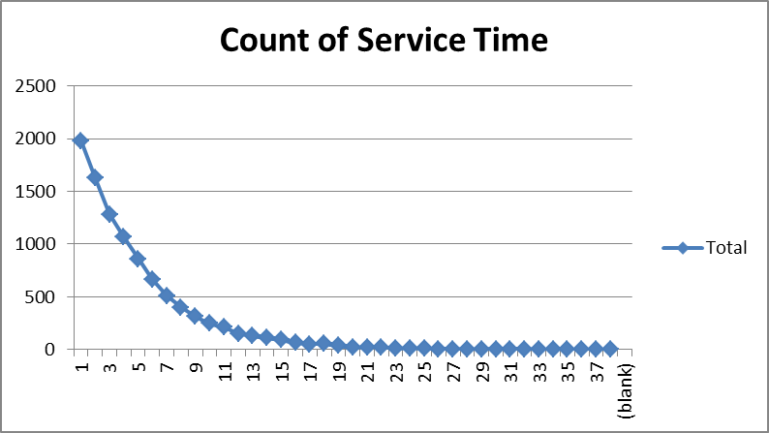

Each of the algorithms was tested against the examples in text book Operating Sytems internals and Design Principles by William Stallings [1]. The results for each of the 4 algorithms match exactly the examples found in the book. This is relevant when considering the variations in execution patterns observed.

Next is a series of graphics illustrating some of the basic data for each process as time passes. They provide a unique view of how the waiting time of processes change over the duration of simulated execution cycles. At this point, it is worth noting the difference in execution ticks versus real time ticks. We can see from our results that each algorithm takes an equal number of process execution ticks to complete the processing of all 10,000 processes. This is despite the fact that each algorithm may finish the execution of the process in a different order. This is shown in the chart data below. However, the total program execution time (calculated by a real time counter) varies for each. This tends to makes sense as the complexity of each algorithm differs depending on the number of steps each algorithm must take to determine what the target process is for the next execution. Here we observe the FCFS algorithm completes in the shortest amount of real time, followed by SRT and RR@1. This tends to make sense as FCFS has the least overhead.

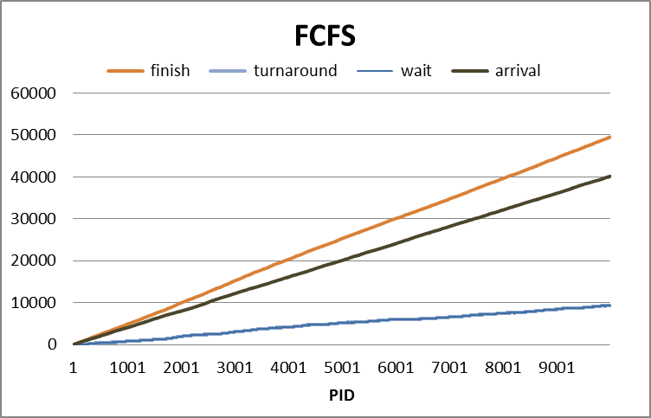 | Finished:  PID 10,000 @ 49522  programExecutionTime: 2.136896  - Very clean execution order and steady increase in waiting time.  - Wait and turnaround are almost indistinguishable
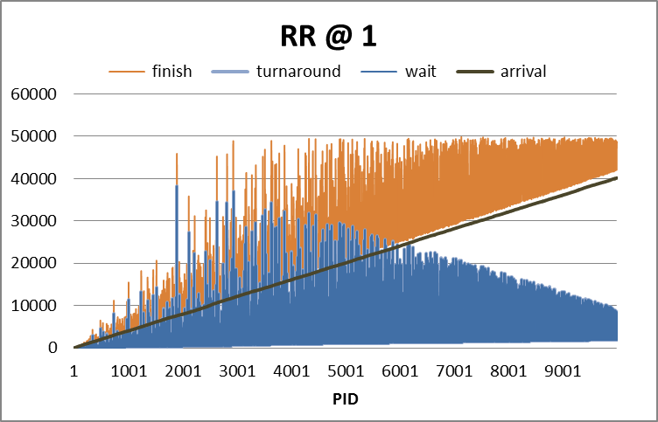 | Finished:  PID 9,521 @ 49522  PID 10,000 @ 48702  programExecutionTime: 2.232724  - Large variation in finish time  - Wait time increases greatly early on and tapers off  - Wait and turnaround are almost indistinguishable
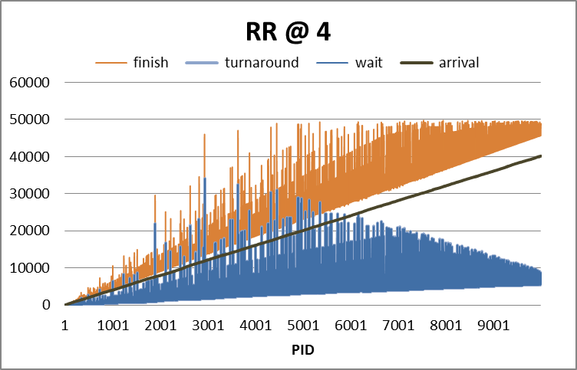 | Finished:  PID 8,756 @ 49522  PID 10,000 @ 48898  programExecutionTime: 2.460389  - Large variation in finish time, but less than @1 quantum size  - Wait time increases greatly early on and tapers off  - Wait and turnaround are almost indistinguishable
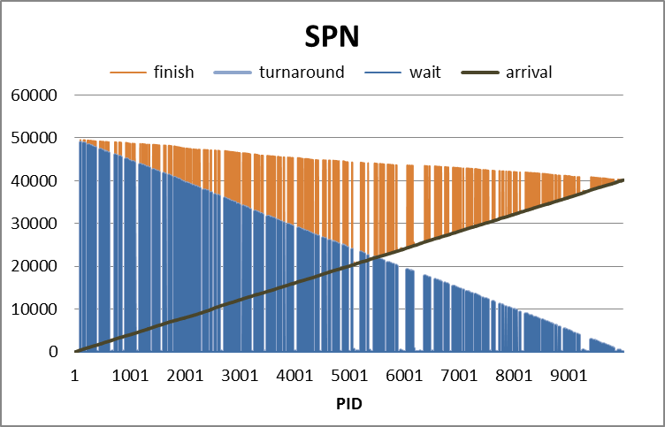 | Finished:  PID 102 @ 49522  PID 10,000 @ 40173  programExecutionTime: 2.246988  - Unusual pattern of variation in finish time and wait time.  - Pattern is very clean  - Possibly indicating starvation
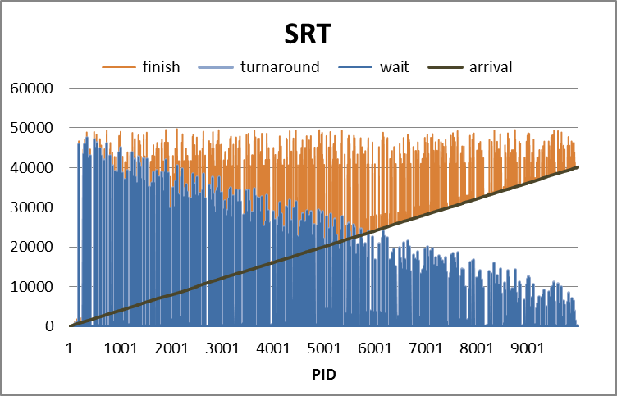 | Finished:  PID 1895 @ 49522  PID 10,000 @ 40205  programExecutionTime: 2.219293  - Unusual pattern of variation in finish time and wait time  - Similar to SPN but with more variability  - Possibly indicating starvation

After observing these results, it appears that FCFS is quite predictable. RR algorithms appear to suffer from a backlog early on but then catch up as indicated by the shape of waiting time as time progresses. SPN and SRT show a much different case. Waiting time is extremely variable early on and eventually settles down more towards the end of execution. It is difficult to say for sure, but this seems to indicate either a problem with the queue handling or, the propensity for starvation since some processes might always be down-prioritized due to shorter incoming processes.

Average turnaround time for all algorithms are:

 | Average Turnaround
 | FCFS | RR1 | RR4 | SPN | SRT
MEAN | 4807.8 | 4796.3 | 4793.5 | 3320.6 | 1289.3

The following graph illustrates the cumulative percent of number of processes with an turnaround time less than the value specified on the x-axis. The graph is shown in with a binary x-axis basis as well as a linear basis for visualization purposes.

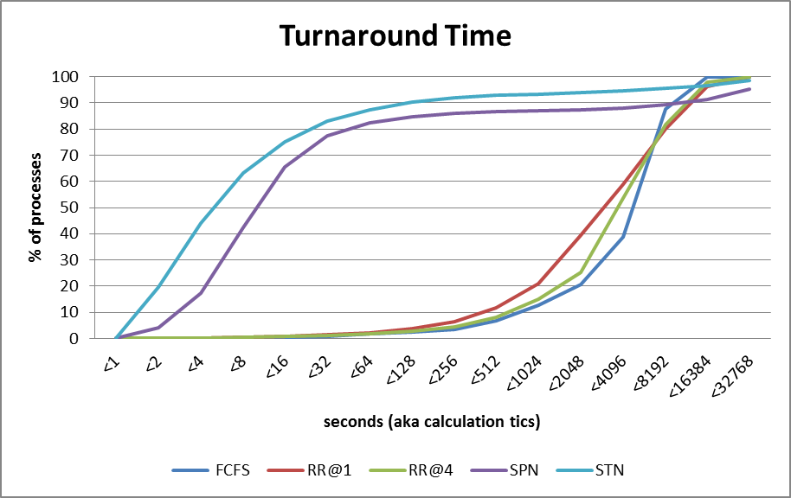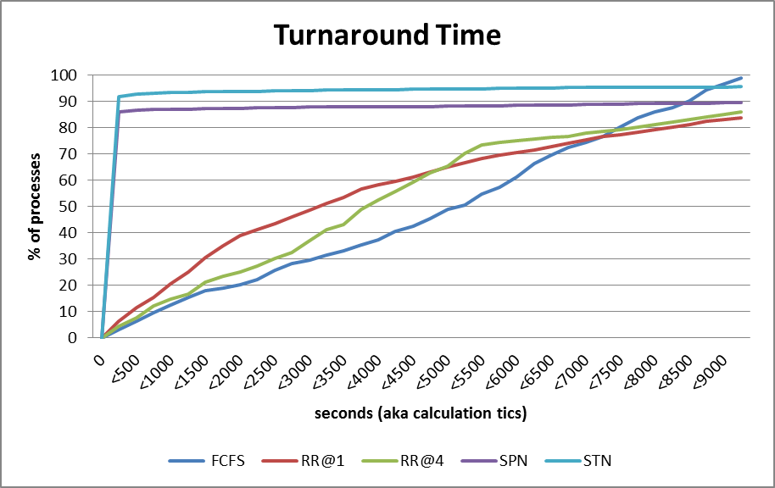

Average waiting time for all algorithms are:
 | Wait
 | FCFS | RR1 | RR4 | SPN | SRT
MEAN | 4802.8 | 4791.4 | 4788.5 | 3315.6 | 1284.4

The following graph illustrates the cumulative percent of number of processes with a waiting time less than the value specified on the x-axis. The graph is shown in with a binary x-axis basis as well as a linear basis for visualization purposes

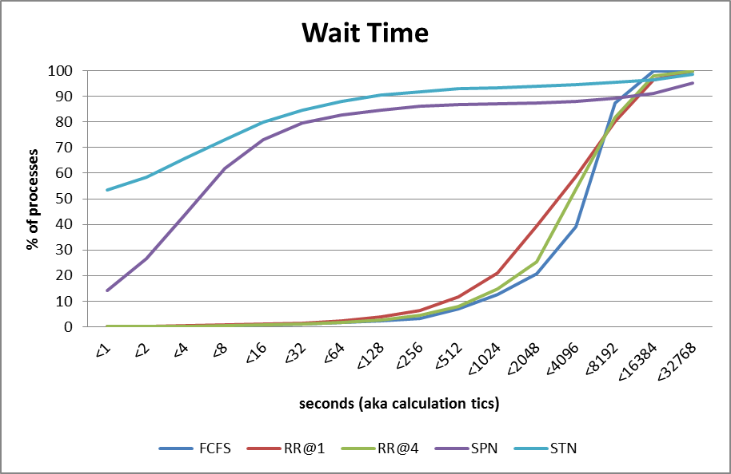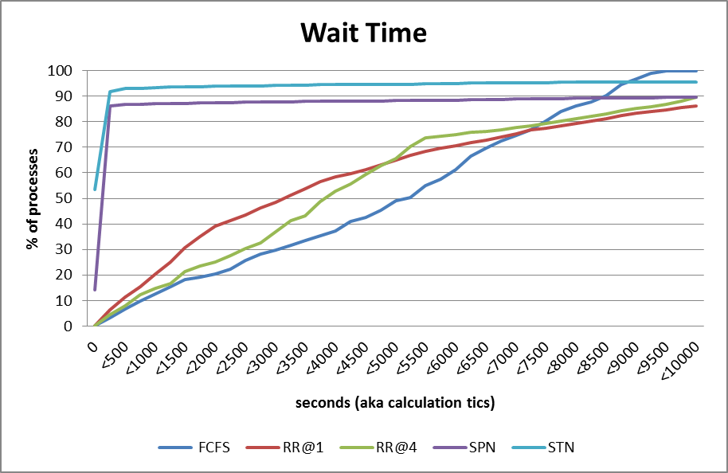

Average waiting time for all algorithms are:
 | Normalized Turnaround
 | FCFS | RR1 | RR4 | SPN | SRT
MEAN | 1939.4 | 992.4 | 1370.8 | 1015.1 | 992.4

The following graph illustrates the cumulative percent of number of processes with a normalized turnaround time less than the value specified on the x-axis. The graph is shown in with a binary x-axis basis as well as a linear basis for visualization purposes

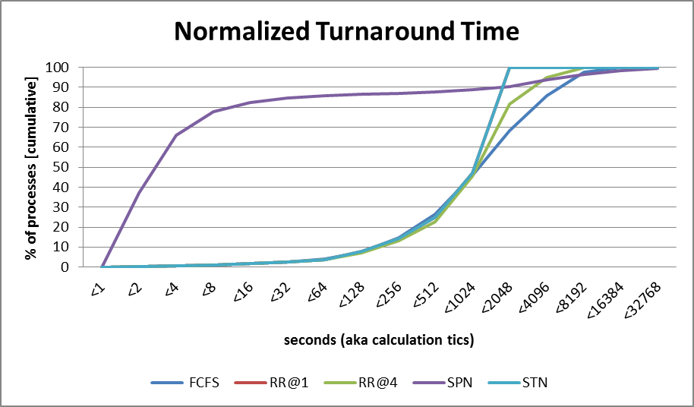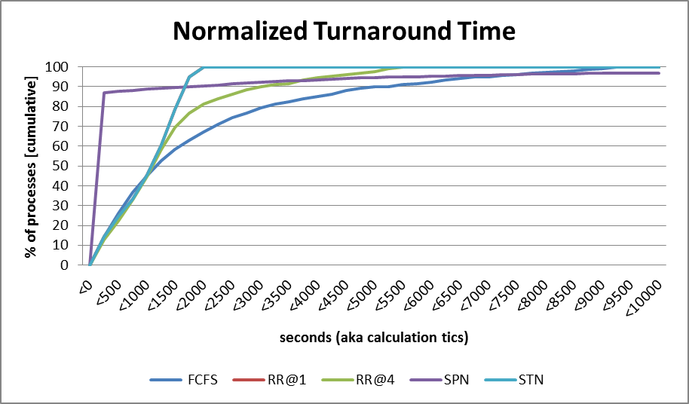

It can be observed from these graphs that there is a large number of processes with short execution times that are executed immediately. This has a drastic impact on the distribution of how long processes need to wait in queue. This is a strong indicator of the possibility of starvation since many processes are done quickly without significantly impacting the average. Some processes are lingering in a starvation like state.

======================
Conclusion
======================

The program developed here is for implementing a dispatcher program. Its purpose is to demonstrate an implementation of a simulated short term scheduler that illustrates the workings of some classic scheduler algorithms. First Come First Serve algorithm performs quickly and has little overhead as can be seen by the fact that there are about 50% of the lines of code as compared to Shortest Remaining Time. SRT and RR have the highest overhead and complexity however, RR executes in a predictable way and can be optimized by adjusting quantum size. Conversely, SRT automatically optimizes the execution of short processes while penalizing longer processes to the point of starvation. Greater process service time variation would be a scenario that would benefit from not using SRT. Shortest Process Next and Round Robin have similar complexity in terms of code size. In both cases, longer processes are penalized as well. This could cause starvation in SPN if the variation in service time was long enough but only yield poor response time in RR.

Based on the execution of the experiments described above and the analysis of experiments, this implementation illustrates the act of performing as a simple dispatcher. Excluding the processing overhead related to managing the queue selection, SRT has the lowest turnaround, wait and normalized turnaround time. However, starvation is an issue and the overall real execution time was longer than FCFS. Therefore, considering process fairness, and processing speed the results in analysis of experiments show that FCFS is the best choice since it performs well and manages fairness well.

======================
References
======================

[1] Stallings, William. Operating Sytems Internals and Design Principles, Ninth Edition. Chapter 9.

======================
Bugs
======================

None known

