How to fix “Microsoft has blocked macros”
What will you see?
Clicking Learn More takes you to a web page detailing the reasons for this message and provides instructions on how to enable the file for use: https://support.microsoft.com/en-gb/topic/a-potentially-dangerous-macro-has-been-blocked-0952faa0-37e7-4316-b61d-5b5ed6024216
The steps to unblock a file are as follows:
- Close the workbook
- Navigate to the location where the workbook is saved
- Right-click on the file and select Properties from the menu
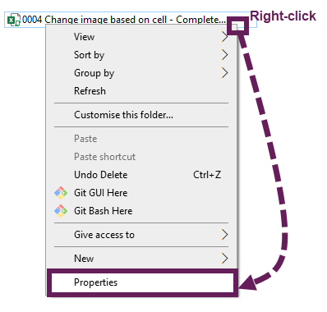
- Check the Unblock box, then click OK
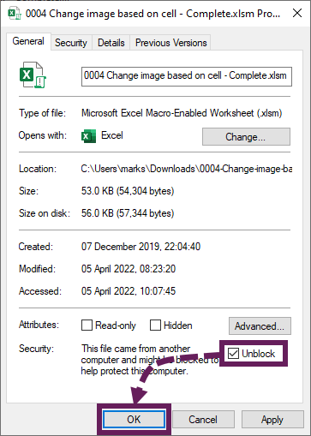
Now the workbook is unblocked, and the macros can run. It is essential to only unblock files from sources that you trust.

