牙叔教程 简单易懂

**文字居中**

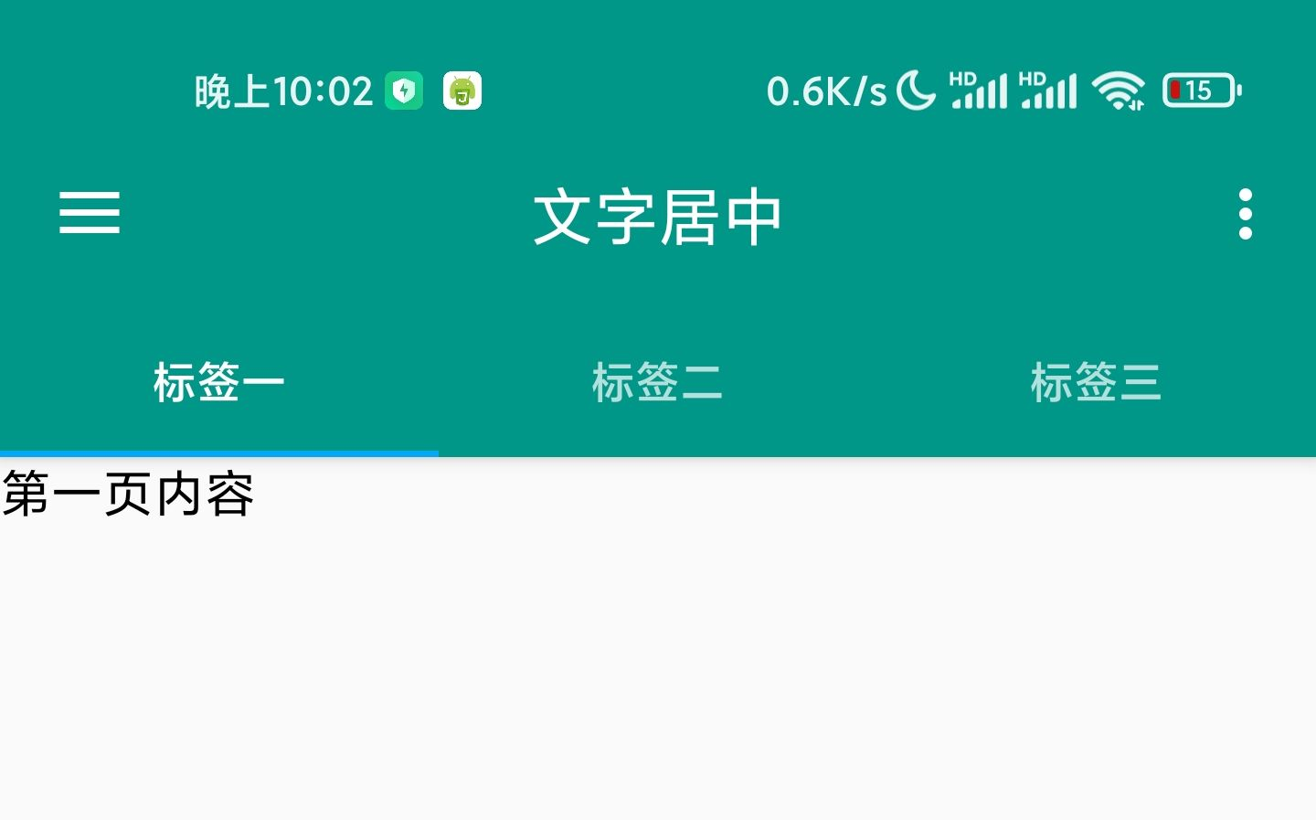

**改变颜色和字体大小**

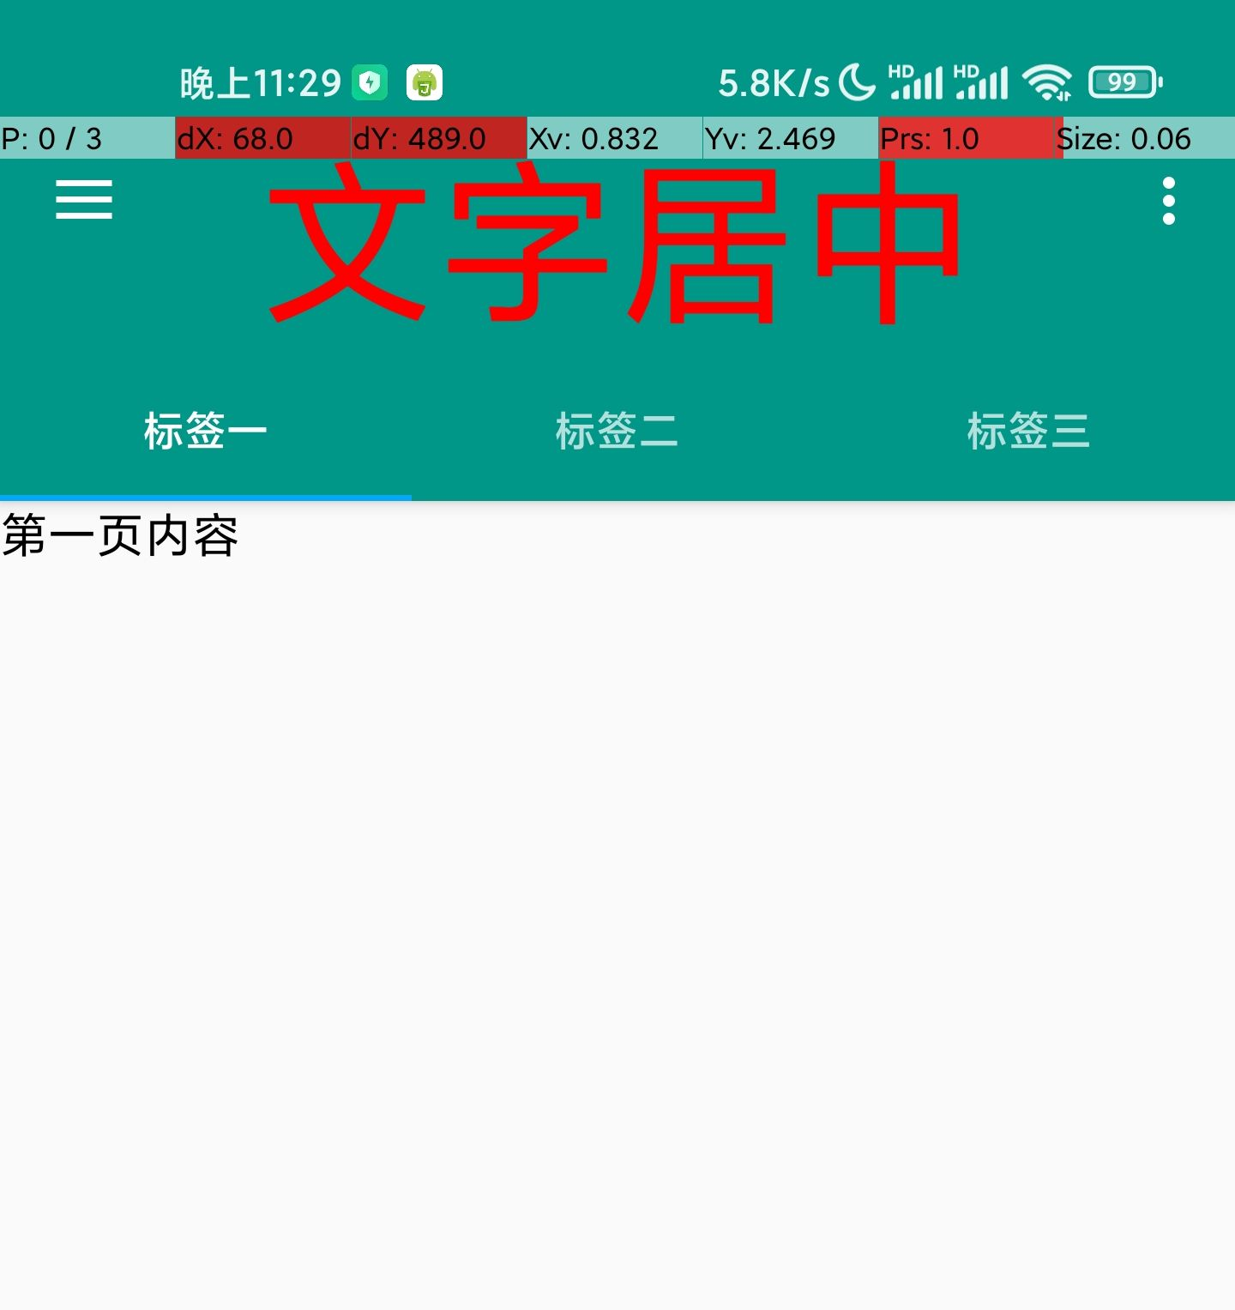

**环境**

手机: Mi 11 Pro

Android版本: 11

Autojs版本: 9.0.13

"ui";

engines.all().map((ScriptEngine) => {

if (engines.myEngine().toString() !== ScriptEngine.toString()) {

ScriptEngine.forceStop();

}

});

var color = "#009688";

ui.layout(

<drawer id="drawer">

<vertical>

<appbar>

<toolbar id="toolbar" gravity="center" title="">

<TextView

id="toolbarText"

textColor="#ff0000"

textSize="60sp"

android:layout_width="wrap_content"

android:layout_height="wrap_content"

android:layout_centerInParent="true"

android:layout_gravity="center"

android:text="文字居中"

/>

</toolbar>

<tabs id="tabs" />

</appbar>

<viewpager id="viewpager">

<frame>

<text text="第一页内容" textColor="black" textSize="16sp" />

</frame>

<frame>

<text text="第二页内容" textColor="red" textSize="16sp" />

</frame>

<frame>

<text text="第三页内容" textColor="green" textSize="16sp" />

</frame>

</viewpager>

</vertical>

<vertical layout_gravity="left" bg="#ffffff" w="280">

<img

w="280"

h="200"

scaleType="fitXY"

src="http://images.shejidaren.com/wp-content/uploads/2014/10/023746fki.jpg"

/>

<list id="menu">

<horizontal bg="?selectableItemBackground" w="*">

<img w="50" h="50" padding="16" src="{{this.icon}}" tint="{{color}}" />

<text textColor="black" textSize="15sp" text="{{this.title}}" layout_gravity="center" />

</horizontal>

</list>

</vertical>

</drawer>

);

//创建选项菜单(右上角)

ui.emitter.on("create_options_menu", (menu) => {

menu.add("设置");

menu.add("关于");

});

//监听选项菜单点击

ui.emitter.on("options_item_selected", (e, item) => {

switch (item.getTitle()) {

case "设置":

toast("还没有设置");

break;

case "关于":

alert("关于", "Auto.js界面模板 v1.0.0");

break;

}

e.consumed = true;

});

activity.setSupportActionBar(ui.toolbar);

//设置滑动页面的标题

ui.viewpager.setTitles(["标签一", "标签二", "标签三"]);

//让滑动页面和标签栏联动

ui.tabs.setupWithViewPager(ui.viewpager);

//让工具栏左上角可以打开侧拉菜单

ui.toolbar.setupWithDrawer(ui.drawer);

ui.menu.setDataSource([

{

title: "选项一",

icon: "@drawable/ic_android_black_48dp",

},

{

title: "选项二",

icon: "@drawable/ic_settings_black_48dp",

},

{

title: "选项三",

icon: "@drawable/ic_favorite_black_48dp",

},

{

title: "退出",

icon: "@drawable/ic_exit_to_app_black_48dp",

},

]);

ui.menu.on("item_click", (item) => {

switch (item.title) {

case "退出":

ui.finish();

break;

}

});

**名人名言**

思路是最重要的, 其他的百度, bing, stackoverflow, github, 安卓文档, autojs文档, 最后才是群里问问  
--- 牙叔教程

**声明**

部分内容来自网络  
本教程仅用于学习, 禁止用于其他用途

**bilibili**

[牙叔教程](https://space.bilibili.com/26079586)

**微信公众号 牙叔教程**



**QQ群**

747748653  
