EXT: OpenStreetMap
Extension Key: ods_osm
Copyright 2010-2016, Robert Heel, <typo3@bobosch.de>

This document is published under the Open Content License
available from http://www.opencontent.org/opl.shtml

The content of this document is related to TYPO3
- a GNU/GPL CMS/Framework available from www.typo3.org

Table of Contents
EXT: OpenStreetMap 1
Introduction 3
What does it do? 3
Screenshots 3
Donation 3
Users manual 4
Frontend Plugin 4
New elements 5
Extended elements 7
Administration 8
Configuration 9
Reference 9
Tutorial 12
To-Do list 13

Introduction

What does it do?
- Show an interactive OpenStreetMap map.
- Store coordinates in fe_users and tt_address tables and show as markers in the map.
- Show record information in popup window.
- Display gps tracks.

Screenshots

Frontend plugin
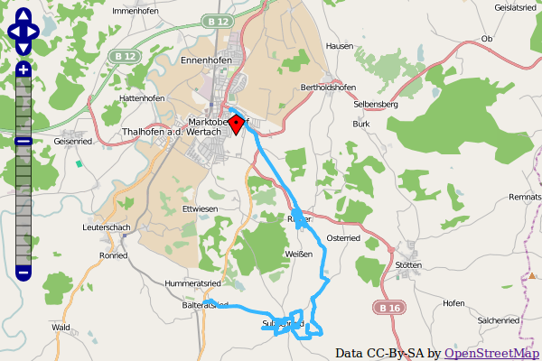

Donation
This extension was only possible with the help of many other free projects. You're likely using one of the main map “Mapnik”, “Osmarender” or “Cyclemap” - feel free to donate to the OpenStreetMap project http://donate.openstreetmap.org/
If you are using the address search (autocomplete longitude and latitude in address records), please donate the service you use:
Geonames: http://www.geonames.org/donations.html or buy some credits there.
Nominatim: http://donate.openstreetmap.org/
And don't forget the main components: http://typo3.org/ and http://openlayers.org/

Users manual

Frontend Plugin
Insert the Openstreetmap as frontend plugin and define at least one marker to show.
The map will center to the average coordinates of the markers.
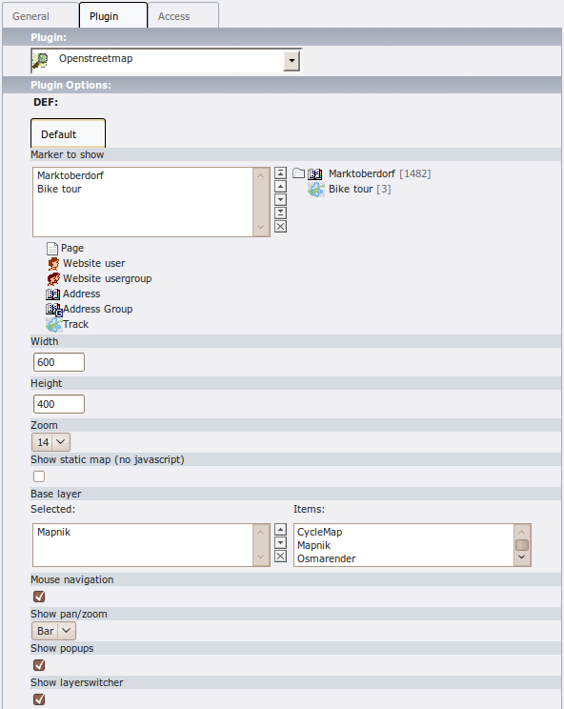
Plugin Option | Description | TS Option
Marker to show | Show these records on the map. | marker
Width | Width of the map in pixels. | width
Height | Height of the map in pixels. | height
Zoom | Zoom level. | zoom
Show static map | Use only an image, no javascript. | static
Base layer | Show this map. The user can switch between these base layers if the layerswitcher is enabled. | layer
Mouse navigation | Allow navigation with the mouse. | mouse_navigation
Show pan/zoom | Show pan/zoom element. | show_pan_zoom
Show popup | Show popup window with record information. | show_popup
Show layerswitcher | Show layerswitcher which allows the user to hide markers from the same group. | show_layerswitcher

New elements

Layer
You can define your own layers on root level.
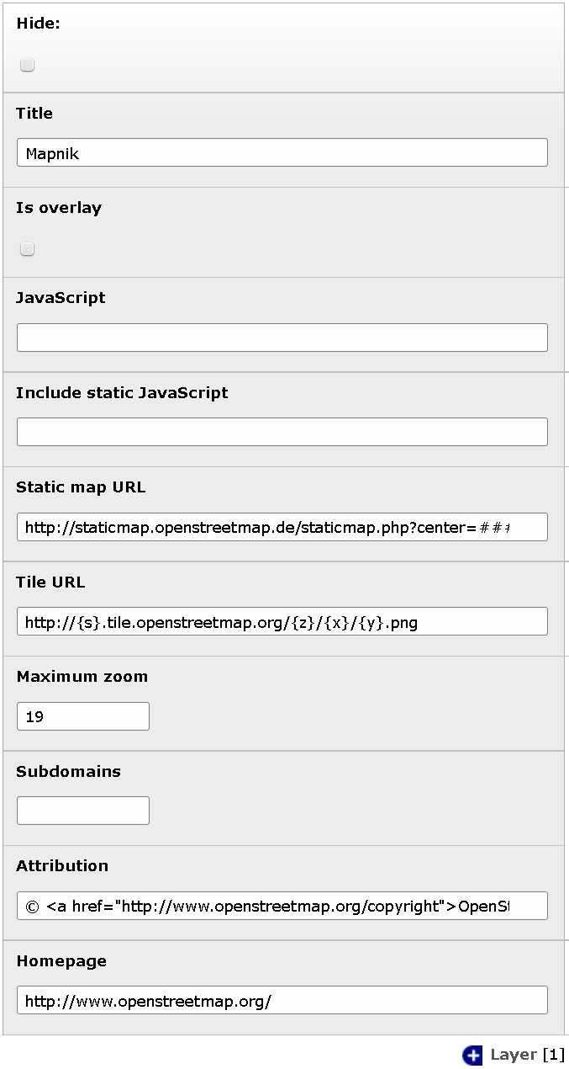
Element option | Description
Title | Title of this layer. Shown in layerswitcher.
Is overlay | Base layer or overlay layer?
JavaScript | JavaScript part to create this layer.  ###TITLE###: Title of layer.  ###VISIBLE###: Contains “'visible':true” if is overlay and no layerswitcher activated.
Include static JavaScript | Optionally include this javascript file.  ###STATIC_SCRIPT###: Value set by TS
Static map URL | Download static map from this URL.  ###lat###: Latitude of map center.  ###lon###: Longitude of map center.  ###zoom###: Zoom level.  ###width###: Image width.  ###height###: Image height.
Tile URL | URL to fetch tiles.  Used by OpenLayers if no JavaScript defined.  Used by leaflet.
Maximum zoom | Maximum zoom level of this layer.
Subdomains | Tile URL subdomains (Variable {s})
Attribution | Attribution text of this layer.
Homepage | Homepage URL of this layer.

Marker
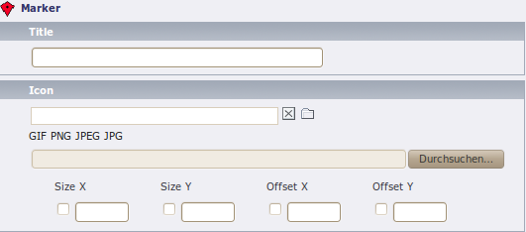
Element option | Description
Title | Title for this track. Only shown in backend.
Icon | Icon file.
Size | The size of the icon. Would determined automatically on save.
Offset | The offset of the icon. It describes the arrowhead. Would automatically choose the middle bottom of the image.

Track
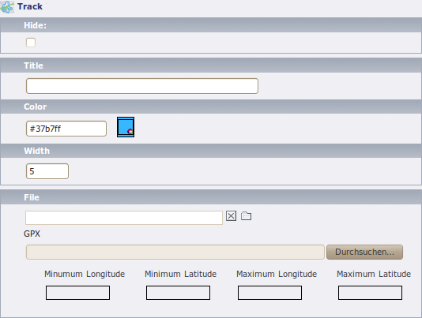
Element option | Description
Title | Title for this track. Shown in layerswitcher.
Color | Color of the track line in the map.
Width | Width of the track line.
File | Select only one gpx file here.

Extended elements

Address, Website user
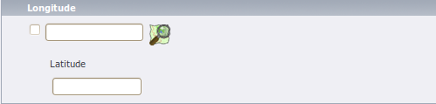
Element option | Description
Longitude and Latitude | Enter the coordinates of an address here. It would determined automatically if zip or city is set and autocompletion is enabled in the extension manager.  Use the OpenStreetMap image to search the coordinates on the map.

Address Group, Website usergroup
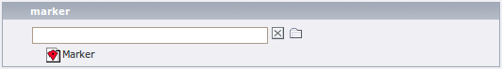
Element option | Description
Marker | Optionally specify a marker here.

Administration
In the extension configuration
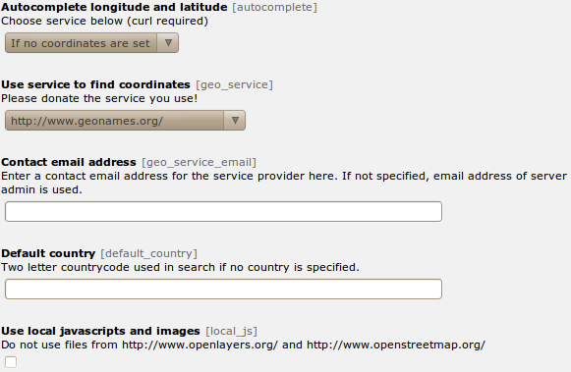
Option | Description
Autocomplete longitude and latitude | You can enable to search the coordinates on geonames.org when saving an fe_users or tt_address element.
Use service to find coordinates | Use this service to get the coordinates of an address. If you select “Only cache” you have to fill the cache table manually. If you select a provider here, be aware that the fields “zip”, “city” and “country” of every address record you save is sent to the provider.
Contact email address | Enter a contact email address for the service provider here. If not specified, email address of server admin is used.
Default country | Two letter countrycode used in search if no country is specified.
Use local javascripts and images | Activate this if you don't like to use the javascript files from http://www.openlayers.org/ and http://www.openstreetmap.org/ to use the local versions in ods_osm/res/.

Configuration

Reference
Property | Data type | Further information | Default
marker | array with table name and integer list | Tablenames and a comma separated list of record ids. | pages =  fe_users =  fe_groups =  tt_address =  tt_address_groups =  tx_odsosm_track =
width | integer |  | 640
height | integer |  | 400
zoom | integer | Zoom level is between 1 and 18, depends on the render. | 15
library | string | Use library:  leaflet  openlayers  static | openlayers
layer | Integer list | Comma separated list of tx_odsosm_layer uid's.  1: Mapnik  3: CycleMap  4: Seamarks  5: OpenPisteMap  13: ÖPNV Deutschland  14: Hike & Bike Map  15: Hillshading (NASA SRTM3 v2)  16: By Night  17: Hiking routes  18: Mapnik BW  19: MapSurfer.Net Road  20: MapSurfer.Net Topographic  21: MapSurfer.Net Hybrid  25: TransportMap  26: MapQuest  27: MapQuest Open Aerial  28: Cycling routes  29: Stamen Toner  30: Stamen Watercolor  31: Public Transport Lines | 1
mouse_navigation | boolean |  | 0
show_pan_zoom | integer | 0:No  1:Bar  2:+/- | 0
show_popups | boolean | 0:No  1:Click  2:Hover | 0
show_layerswitcher | boolean |  | 0
no_marker | boolean | If no marker is set:  0: Hide map  1: Show map | 1
popup | TS Object | There are two additional fields: “group_title” and “group_description” filled with group information. | fe_users = COA  fe_users {  10 = TEXT  10.field = name  10.wrap = <h2>|</h2>  20 = TEXT  20.field = description  }  tt_address = COA  tt_address {  10 = TEXT  10.field = name  10.wrap = <h2>|</h2>  20 = TEXT  20.field = description  }
external_control | boolean | Allow control with GET or POST  lon: Map center longitude  lat: Map center latitude  zoom: Map zoom level  layers: Comma separated list of tx_odsosm_layer uid's  records: Comma separated list of markers  Don't forget to set no_cache=1 | 0
layerswitcher.div | boolean | Use extra div for the layerswitcher. | 0
layerswitcher.options | string | Additional options when creating layerswitcher.
path_openlayers | string | Overwrites the path to OpenLayers.js
static_script | string | Marker ###STATIC_SCRIPT### in layer “Include static JavaScript”. Use it for google maps or bing maps api key.

Example

plugin.tx_odsosm_pi1 {
width = 800
height = 600
mouse_navigation = 1
}

Tutorial
- Open or create an fe_users or tt_address record.
- Enter zipcode or city and save the record (without closing it).
- Scroll to the “Longitude” section and use the OSM logo to open a map.
- Click on the correct position.
- Save the record again.
- Insert a content element plugin “Openstreetmap” on your page.
- Add your address record in “Marker to show”.
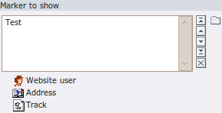

To-Do list
- Preserve sort order of layers
- 404 image

