A Comparative Study of Linear and Neural Network Models for Liver–Brain MicroRNA Co-Expression in Spaceflight-Exposed Mice
Pratheek Mukkavilli^{1*}, Michelle Medeiros¹, Rosa Prahl¹, Xavier-Lewis Palmer¹
¹ NASA Artificial Intelligence and Machine Learning Analysis Working Group, Open Science Data Repository Member, USA
*Corresponding author: Pratheek Mukkavilli, NASA Artificial Intelligence and Machine Learning Analysis Working Group, Open Science Data Repository Member, 2315 Creighton Ln, Sugar Land, TX 77479, USA. E-mail: pratheek.mukkavilli@gmail.com. Telephone: +1 (346) 409-5245.
Database: MicroRNA expression data were obtained from the RRRM-1/RR-8 NASA OSDR study records, including the OSD-914/GLDS-736 record referenced in this analysis, and the corresponding NCBI GEO series GSE294046, "MicroRNAs shape mouse age-independent tissue adaptation to spaceflight via ECM and developmental pathways."
Abstract
The liver and brain undergo divergent transcriptomic adaptations during spaceflight, yet inter-organ microRNA (miRNA) co-expression dynamics remain poorly characterized. We compared linear and non-linear models mapping 6 hepatic miRNA inputs to 5 brain miRNA targets, selected independently within each Leave-One-Out Cross-Validation (LOOCV) fold, in nine BALB/cAnNTac mice (Rodent Research Reference Mission-1/RR-8; 3 spaceflight, 3 habitat, 3 vivarium controls). A training-fold mean baseline, an unregularized linear regression, a nested ridge regression, and a regularized PyTorch Multi-Layer Perceptron (MLP) were evaluated under an identical, leakage-free LOOCV protocol. Linear regression achieved the lowest validation mean squared error (VMSE = 1.1600; 39.4% improvement over baseline) versus ridge regression (1.8809) and the MLP (5-seed mean 1.6489), but a fold-paired Wilcoxon signed-rank test found this linear-versus-MLP gap was not statistically significant (p = 0.73), driven largely by one outlier fold. KernelSHAP attribution on the fitted MLP identified mmu-miR-17-5p as the top-ranked liver input, consistent with a linear reading of the data. The modeled brain profile was heterogeneous: mmu-miR-124-3p was numerically higher in spaceflight samples, while let-7 family members and other variance-selected targets showed mixed patterns. These findings support a parsimony-first modeling strategy for sparse spaceflight miRNA datasets. All associations are correlational and exploratory.
Keywords: spaceflight biology; microRNA; linear regression; neural networks; model comparison; parsimony.
Abbreviations: CNS, central nervous system; GEO, Gene Expression Omnibus; HC, habitat control; LOOCV, leave-one-out cross-validation; miRNA, microRNA; MLP, multi-layer perceptron; MSE, mean squared error; OLS, ordinary least squares; OSDR, Open Science Data Repository; RRRM-1, Rodent Research Reference Mission-1; SHAP, Shapley Additive exPlanations; VC, vivarium control; VMSE, validation mean squared error.
1. Introduction
1.1 The Challenge of Systemic Spaceflight Biology
Spaceflight exposes biological organisms to a severe, interconnected matrix of physical and physiological stressors, including sustained microgravity, cosmic ionizing radiation, chronic circadian disruption, hyperconfinement, altered nutritional paradigms, and psychological stress associated with mission execution [1]. As humanity transitions toward long-duration deep space exploration—including extended lunar habitability and crewed Martian transits—the molecular adaptations that underlie these systemic stressors have become an urgent priority for aerospace medicine [2]. Large-scale integrative initiatives such as NASA's GeneLab and Open Science Data Repository (OSDR) have assembled extensive multi-mission rodent and human transcriptomic datasets, enabling community-wide access to spaceflight omics profiles [3, 4]. These repositories have substantially advanced our understanding of individual organ responses under microgravity, yet contemporary aerospace research still predominantly relies on single-tissue paradigms that analyze physiological systems as independent analytical silos, potentially obscuring coordinated multi-organ responses.
1.2 Hepatic Responses to Microgravity
The liver represents a critical systemic sensor and primary metabolic hub during environmental adaptation. Terrestrial research establishes the liver as the central gatekeeper for metabolic regulation, foreign compound detoxification, systemic redox balance, innate immune signaling, and macro-nutrient energy homeostasis [5]. Under spaceflight conditions, transcriptomic assays frequently reveal substantial perturbations within hepatic tissue. Rodent spaceflight datasets have identified hepatic transcriptional and miRNA alterations involving metabolic and stress-response pathways [5, 6]. Notably, Beheshti et al. identified a convergent miRNA and TGF-β1 regulatory signature as candidate master regulators of the systemic spaceflight response through integrative analysis of multiple rodent GeneLab datasets, and Malkani et al. identified and validated a circulating miRNA spaceflight signature shared across rodent and human cohorts in response to simulated microgravity, radiation, and short- and long-duration spaceflight [5, 6]. These expression patterns collectively suggest that the liver may act as a peripheral sensor, translating environmental spaceflight stressors into systemic molecular signals potentially propagated to distal organ systems via circulating mediators including non-coding RNAs.
1.3 Central Nervous System Adaptation During Spaceflight
Simultaneously, the central nervous system (CNS) experiences significant cellular and structural changes during spaceflight. Key responses recorded in rodent and human crew cohorts include neuroinflammatory signatures, altered neurotransmitter clearance, microstructural white matter shifts, and disruptions to circadian behavioral regularities [1, 7]. Longitudinal MRI studies of astronauts have reported measurable shifts in brain white-matter microstructure and intracranial fluid redistribution following long-duration spaceflight [8], while the NASA Twins Study documented complementary physiological fluid-shift, immune, and cognitive effects over a year-long mission [2]. In rodent models, transcriptomic profiling of brain cortical tissue in spaceflight cohorts has revealed differential expression across neuroinflammatory, cellular-stress, apoptotic, and metabolic gene networks [9]; whether miRNA-level regulation coordinates these post-transcriptional responses remains an open question that the present comparative framework begins to address. Yet, despite parallel observations of hepatic metabolic stress and central neuroinflammation, the aerospace community traditionally analyzes liver and brain datasets independently, risking systematic blindness to bidirectional inter-organ co-expression dynamics.
1.4 MicroRNA as Cross-Tissue Regulatory Mediators
MicroRNAs represent a compelling modality for cross-tissue co-expression analysis. As small non-coding RNAs of approximately 22 nucleotides, miRNAs post-transcriptionally regulate a substantial fraction of mammalian protein-coding genes by binding target messenger RNAs and promoting their degradation or translational repression [10]. Critically, miRNAs are detectable in biofluids as stable circulating molecules, providing a mechanistic basis for inter-organ communication [11]. Liver-enriched miRNAs, including mmu-miR-122-5p, were among the first circulating miRNAs shown to track drug- and toxin-induced liver injury [12], while CNS-enriched families such as miR-124 and the let-7 cluster were among the earliest tissue-specific miRNAs identified in brain and have since been extensively studied in the neuroscience literature [10, 13]. The co-expression dynamics between peripheral hepatic miRNA profiles and central nervous system miRNA regulatory environments under spaceflight conditions remain almost entirely uncharacterized, representing a gap in aerospace systems biology.
1.5 Computational Approaches for Small-n Spaceflight Data
A fundamental challenge in spaceflight biology is the mismatch between feature dimensionality and sample size. Spaceflight animal cohorts are often small because of operational and payload constraints, while high-throughput sequencing assays produce feature spaces of hundreds to thousands of miRNA measurements per tissue. Under these conditions, both simple statistical approaches and more flexible non-linear approaches carry distinct risks: linear models may fail to capture genuine non-linear co-expression structure, whereas non-linear models such as regularized neural networks may instead fit idiosyncratic noise in a handful of subjects and appear informative only because of favorable variance in a small validation set. Machine-learning approaches to integrating high-dimensional omics data have been reviewed broadly elsewhere [14], but principled guidance on whether added model complexity is actually justified in extremely small biological cohorts is lacking, and the relative merits of linear and non-linear cross-tissue spaceflight miRNA co-expression models have not, to our knowledge, been directly and rigorously compared.
1.6 Study Objectives
To address this gap, we present a comparative evaluation of linear and non-linear modeling strategies for mapping candidate cross-tissue miRNA co-expression associations between the liver and brain during spaceflight. Moving away from single-tissue analyses, and away from an unexamined assumption that greater model flexibility is inherently advantageous, we benchmarked a training-fold mean baseline, an unregularized multivariate linear regression, a nested ridge regression, and a customized PyTorch Multi-Layer Perceptron (MLP) against a preselected signature of 6 peripheral liver miRNA inputs and 5 central brain miRNA targets selected independently within each outer LOOCV fold (drawn from a 6-miRNA fold-selection union, Section 2.2), derived from synchronized miRNA expression matrices from female BALB/cAnNTac mice from the Rodent Research Reference Mission-1 (RRRM-1/RR-8; NASA OSDR records and GEO series GSE294046; n = 9; LAR cohort: 3 FL, 3 HC, 3 VC) [15], under an identical fold-wise-normalized LOOCV protocol applied uniformly to every model. Contrary to the expectation that a non-linear architecture would better capture cross-tissue structure, unregularized linear regression achieved the lowest aggregate out-of-fold error of all four models under this fully leakage-free protocol, though a fold-paired significance test found no statistically significant advantage over the MLP specifically (Section 3.1). Within the modeled cohort, mmu-miR-17-5p had the highest aggregated SHAP attribution among the liver inputs computed on the fitted MLP, and this pattern co-occurred with a heterogeneous modeled brain profile: central mmu-miR-124-3p was numerically higher in FL samples relative to HC and VC ground controls, while let-7 family members, mmu-miR-26a-5p, and the fold-dependent fifth target mmu-miR-181a-5p displayed a mixed response rather than a uniform trend. This study illustrates the importance of rigorous, leakage-free baseline comparison and model parsimony when exploring complex multi-organ miRNA co-expression patterns within small-n spaceflight data, and provides a computational framework intended to generate, rather than confirm, targeted biomedical hypotheses for long-duration space missions.
2. Materials and Methods
The canonical reproducibility run was verified with Python 3.9.6, PyTorch 2.8.0 [16], NumPy 2.0.2, pandas 2.3.3, scikit-learn 1.6.1 [22], SHAP 0.49.1, and Matplotlib 3.9.4. The canonical pipeline uses five fixed random seeds (101, 202, 303, 404, and 505) across all LOOCV runs. Metrics are reported as mean ± SD across these five seeds to quantify seed-dependent variation and facilitate computational reproducibility.
2.1 Ethics Statement
This study reanalyzed publicly archived miRNA expression data from NASA OSDR RRRM-1/RR-8 records and the corresponding GEO series GSE294046; no new animal experiments were performed by the authors, and no live vertebrate or higher invertebrate animals were handled, housed, or euthanised as part of this work. The original RRRM-1/RR-8 animal procedures that generated the reanalyzed data were approved and licensed by the NASA Flight Animal Care and Use Committee under Protocol #FLT-18-116, with additional receipt/handling approvals from the Scripps Research Institute Institutional Animal Care and Use Committee (protocol #09-0004) and the Stanford University Institutional Animal Care and Use Committee (protocol WYS1591). All procedures were performed in accordance with relevant institutional and federal animal-welfare guidelines and regulations, including the U.S. Public Health Service Policy on Humane Care and Use of Laboratory Animals and the Guide for the Care and Use of Laboratory Animals, as described in the source dataset and companion publication records [15, 17]. The authors confirm compliance with the ARRIVE guidelines for the design, conduct, and reporting of the animal experiments underlying the reanalyzed data [15, 17]; as a purely computational secondary analysis of de-identified, already-published expression data, the present manuscript does not itself constitute a new animal experiment requiring separate animal-welfare approval, but ARRIVE compliance is confirmed for the original data-generating procedures on which this reanalysis is based.
2.2 Dataset, Repository Access, and Data Preprocessing
Dataset Source and Access.
The primary data utilized in this study were obtained from the NASA Open Science Data Repository (OSDR) [3, 15] RRRM-1/RR-8 study records and the corresponding NCBI GEO series GSE294046, titled "MicroRNAs shape mouse age-independent tissue adaptation to spaceflight via ECM and developmental pathways," targeting the miRNA expression cohorts of the RRRM-1/RR-8 spaceflight payload. The experimental population consisted of n = 9 female BALB/cAnNTac mice allocated across three conditions within a Laboratory Animal Research (LAR) cohort: 3 spaceflight animals (FL) flown on board the International Space Station, 3 habitat control animals (HC) maintained in flight hardware on the ground, and 3 vivarium control animals (VC) housed under standard laboratory conditions. Raw count matrices for miRNA expression were retrieved from the OSDR/GEO accession infrastructure.
Raw Matrix Construction and Count Filtering.
The raw GSE294046 miRNA matrix contains 1,964 miRNA feature rows and 686 sample columns. The reproducible pipeline selected 58 liver and 25 brain miRNA sample columns, applied a count filter retaining miRNAs with raw count ≥ 5 in at least 5 samples, aligned paired LAR subjects, and produced clean matrices of 9 paired samples × 717 liver miRNAs and 9 paired samples × 637 brain miRNAs. The brain target matrix used GSE294046 brain miRNA columns.
Log1p Transformation and Z-Score Standardization.
Within each LOOCV fold, log1p transformation and z-score standardization were fitted only on the eight training samples. The held-out sample was transformed using the training-fold scaler. This fold-wise procedure was applied to both liver inputs and brain targets, and identically to every model compared in this study (Section 2.4), preventing held-out validation data from influencing normalization statistics for any model class. The normalization is defined as:
$x_{norm} = \frac{log(1 + x) − μ_{train}}{σ_{train}}$ (1)
where the numerator is log(1 + x) minus μtrain, and the whole quantity is divided by σtrain; μtrain and σtrain are fitted on the 8 training samples only.
Preselection of High-Confidence Feature Subsets.
After count filtering and paired-subject alignment, a targeted feature selection step was applied to both tissue matrices. The two tissue compartments used different selection strategies, which are accurately distinguished here. The 6 peripheral liver miRNA inputs were selected based on established roles in stress response, lipid metabolism regulation, and circulating miRNA biomarker literature [10, 13], and are held fixed across all folds and all four models compared in this study. The primary anchor feature, mmu-miR-17-5p, belongs to the miR-17-92 cluster, which has been linked to proliferative and stress-response signaling [18]. mmu-miR-122-5p, the sixth- and lowest-ranked feature in the aggregated SHAP analysis (Section 3.2), is a liver-enriched miRNA established as a circulating marker of drug- and toxin-induced hepatocellular injury [12].
The 5 central nervous system miRNA targets used in each LOOCV fold were selected computationally by ranking the 637 post-filter brain features by expression variance and retaining the top 5, but — unlike an earlier version of this pipeline, in which this ranking was addressed only as a limitation — that ranking is now performed independently inside each outer training fold, using only that fold's 8 training samples, rather than once on the full n = 9 cohort. This nesting removes the feature-selection leakage pathway previously flagged in this section; the reproducibility package's fold_target_selection.csv and baseline_fold_target_selection.csv audit tables record the fold-by-fold selection underlying every result in this manuscript. Across the nine outer folds, the top four targets by training-fold variance were identical in every fold: mmu-miR-124-3p, mmu-let-7c-5p, mmu-miR-26a-5p, and mmu-let-7a-5p. The fifth-ranked target, however, alternated depending on which sample was held out: mmu-let-7b-5p was selected in 5 of 9 folds (held-out samples FL-LAR-13, HC-LAR-1, HC-LAR-13, VC-LAR-13, VC-LAR-5) and mmu-miR-181a-5p in the remaining 4 folds (FL-LAR-1, FL-LAR-5, HC-LAR-5, VC-LAR-1; Table 2). Consequently, the fold-wise selected target set matched a naive full-cohort reference ranking — computed once on all nine samples for audit purposes only, and not used for modeling — in just 2 of 9 folds (HC-LAR-13 and VC-LAR-5). The union of brain targets used across all folds is therefore a 6-miRNA set: mmu-let-7a-5p, mmu-let-7b-5p, mmu-let-7c-5p, mmu-miR-124-3p, mmu-miR-181a-5p, and mmu-miR-26a-5p, of which any given fold uses 5. This remains a data-driven criterion and does not constitute a biologically curated set. mmu-miR-124-3p is a brain-enriched miRNA first identified through early tissue-specific miRNA profiling and subsequently characterized as involved in neuronal differentiation and multiple CNS processes [19]; mmu-let-7a-5p, mmu-let-7b-5p, and mmu-let-7c-5p are let-7 family members studied in relation to neurodevelopmental programs [10]; mmu-miR-26a-5p and mmu-miR-181a-5p are each a distinct miRNA family, neither a let-7 member, included solely because they ranked among the top-5 highest-variance brain features within one or more folds, and should not be grouped with the let-7 miRNAs. This feature selection step reduced the liver input space from 717 post-filter features to a fixed 6 and the brain target space from 637 post-filter features to a fold-specific 5 (drawn from the 6-miRNA union above), producing the tightly constrained input-output matrices used for all downstream modeling and model comparison; the MLP and all three baseline models (Section 2.4) use the identical fold-specific target set within each outer fold.
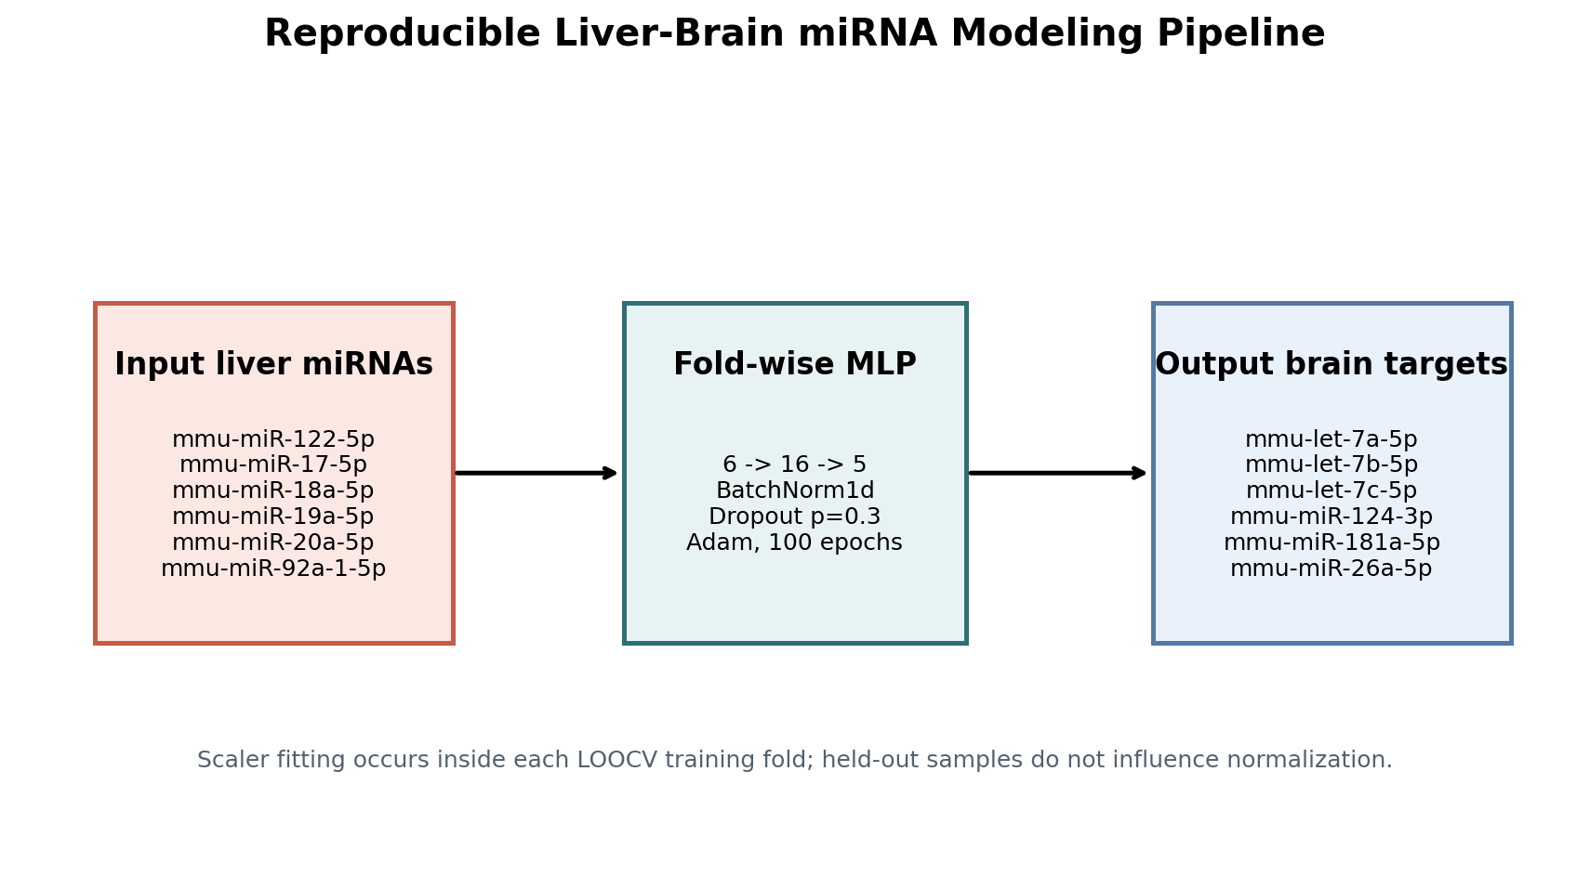
2.3 Neural Network Architecture
To model candidate non-linear miRNA co-expression associations bridging the peripheral liver state to central nervous system expression profiles, we engineered a tightly constrained Multi-Layer Perceptron (MLP) within the PyTorch framework [16]. Given the small sample size (n = 9) and the focused preselected feature scope, a compact regularized architecture was used to reduce, though not eliminate, the risk of overfitting; Section 2.4 describes the simpler baseline models against which this architecture is benchmarked.
The model architecture consists of a fully connected input layer mapping the 6 liver miRNA inputs to a hidden layer of dimension 16, followed by Batch Normalization (BatchNorm1d) applied to the hidden activations, a Dropout regularization layer, and a continuous regression output head designed to predict the 5 target central nervous system miRNA expression metrics. The feedforward processing of layer l is mathematically defined as:
$h^{(l)} = σ(W^{(l)} h^{(l−1)} + b^{(l)})$ (2)
where W(l) and b(l) represent the weight tensor and bias vector of layer l, and σ denotes the rectified linear unit (ReLU) activation function.
To structurally mitigate co-adaptation of features, a Dropout layer was applied with a dropout probability p = 0.3. The network weights were optimized by minimizing the Mean Squared Error (MSE) loss function using the Adam optimizer [20], regularized via an L2 weight decay penalty (λ = 10⁻²) to smooth the optimization landscape and constrain weight coefficients:
$L_{total} = \frac{1}{N}Σ_{i}{\left(y_{i} − ŷ_{i}\right)}^{2} + λΣ_{l}{‖W^{(l)}‖}_{2}^{2}$ (3)
where yi is the ground-truth central miRNA expression metric, ŷi is the model prediction, and N is the batch sample size. Optimization was carried out over 100 epochs with an initial learning rate η = 0.01. Five fixed seeds (101, 202, 303, 404, 505) are used; metrics reflect the mean across all five runs.
2.4 Baseline Models and Statistical Comparison
To determine whether the added flexibility of a non-linear architecture is actually justified in this small-sample regime, we benchmarked the MLP described above against three additional models, all evaluated under the identical outer LOOCV protocol and fold-wise log1p/z-score normalization described in Section 2.2.
Training-fold mean baseline. For each held-out LOOCV fold, this naive model predicts, for every brain target, the mean of that target's fold-wise-normalized value across the eight training samples. It uses no liver miRNA information and serves as the reference point for the relative-improvement percentages reported in Section 3.1.
Unregularized multivariate linear regression. An ordinary least squares model (scikit-learn LinearRegression [22]) was fit within each training fold, mapping the 6 fold-wise-normalized liver miRNA inputs to the 5 fold-wise-normalized brain miRNA targets. No regularization or hyperparameter tuning was applied.
Nested ridge regression. An L2-regularized linear model (scikit-learn Ridge [22]) was fit within each training fold. The regularization strength α was selected from {0.001, 0.01, 0.1, 1.0, 10.0, 100.0} using a nested leave-one-out cross-validation loop restricted to the eight training samples of each outer fold, so that the outer held-out sample never contributed to α selection. Selected α values ranged from 0.001 to 100.0 across the nine outer folds (Supplementary Table S1).
Subject-pairing permutation test. To test whether the MLP's out-of-fold performance exceeds chance association, the pairing between liver input profiles and brain target profiles was randomly shuffled and the same five-seed MLP training, fold-wise target-selection, and LOOCV evaluation procedure described in Sections 2.2-2.3 was rerun in full under each shuffled pairing. Because lower VMSE is better, the permutation p-value was calculated as (the count of permuted VMSE values less than or equal to the observed VMSE + 1) / (number of permutations + 1). Under the current fold-wise target-selection pipeline, 1,000 subject-pairing shuffles were generated with permutation seed 914. The observed five-seed mean MLP VMSE was 1.6489; 74 of 1,000 permuted VMSE values were less than or equal to the observed value, yielding p = 0.074925. The permuted VMSE distribution had median 2.8626 and 2.5-97.5 percentile range 1.3862-5.1584. This permutation test evaluates whether the MLP beats chance subject pairing; it is distinct from the fold-paired linear-versus-MLP comparison below and was not repeated for linear or ridge regression.
Fold-paired significance test. The aggregate VMSE values above pool nine outer LOOCV folds of potentially unequal difficulty into a single mean, which can make a model comparison appear more consistent than it is if one or two folds dominate the average. To test whether linear regression's lower aggregate VMSE reflects a consistent per-fold advantage over the MLP, rather than a small number of large-magnitude folds, we additionally compared the two models at the level of the individual outer fold. For each of the nine folds, the MLP's fold-level MSE was averaged across the five fixed seeds and paired with linear regression's fold-level MSE for that same held-out sample, yielding nine paired observations. A two-sided Wilcoxon signed-rank test was applied to these nine paired differences, and a sign test comparing the number of folds each model "won" (lower fold-level MSE) was computed as a distribution-free complement; neither test involves retraining beyond the deterministic linear-regression and five-seed MLP runs already reported above.
All four models (training-fold mean, linear regression, ridge regression, MLP) were evaluated on the same nine paired subjects, the same six liver inputs, the same five brain targets, and the same outer LOOCV folds, differing only in model class and, for ridge regression, the nested inner-fold hyperparameter search. This design ensures that the comparative VMSE values reported in Section 3.1 are directly attributable to model class rather than to differences in data handling.
2.5 Cross-Validation Framework
Evaluating any model — linear or non-linear — on sparse spaceflight datasets requires robust validation protocols to avoid optimistically biased performance metrics. A conventional holdout split would produce extremely small training and validation subsets and highly unstable performance estimates when n = 9. Thus, we implemented a Leave-One-Out Cross-Validation (LOOCV) framework, a standard approach for extremely small biological cohorts, and applied it identically across all four models described in Section 2.4.
Under this routine, each model undergoes n distinct training loops. In each iteration k, sample k is entirely withheld from the training phase to serve as an out-of-sample validation anchor, while the model parameters are optimized entirely on the remaining n−1 samples. Each subject contributes 5 target values (one per brain miRNA); the global predictive fidelity of a given model is calculated as the cumulative Validation Mean Squared Error (VMSE), averaged across both the n held-out subjects and the 5 target dimensions:
$VMSE = \frac{1}{n×5}Σ_{k}Σ_{j}{\left(y_{k,j} − ŷ_{k,j}^{(−k)}\right)}^{2}$ (4)
where ŷk,j(−k) is the prediction for target j of the k-th sample, generated by the model instance trained without that sample. Scaler fitting and the brain-target variance ranking described in Section 2.2 are both nested within each training fold for every model, so that no information from the held-out sample — including which brain miRNAs are treated as targets — influences that fold's training. This closes a feature-selection leakage pathway that an earlier version of this pipeline addressed only as a limitation; remaining caveats are discussed in Section 4.5.
2.6 Feature Tracking and Attribution
Although Section 3.1 shows that an unregularized linear model achieved the lowest aggregate out-of-fold error of all four models compared — albeit without a statistically significant fold-level advantage over the MLP — we additionally applied a feature-tracking layer to the fitted MLP to identify which peripheral hepatic miRNA inputs the network relied on most, and to assess whether this ranking is directionally consistent with a linear reading of the same data. KernelSHAP values were computed for each held-out LOOCV fold using the corresponding fold-trained MLP and training-fold background data. Absolute SHAP values were aggregated across folds, targets, and the five fixed seeds to summarize seed-level consistency in feature-attribution rankings. SHAP values describe the trained MLP's dependence on each input; they do not by themselves establish biological importance or causality, and rankings among correlated predictors can be unstable.
2.7 Use of AI Tools in Manuscript Preparation
Claude (Anthropic) was used for language polishing and formatting during preparation of this manuscript. All scientific content, data analysis, data interpretation, and conclusions were authored, directed, and verified by the research team; the AI tool was not used to generate scientific conclusions, analyze data, or select references.
3. Results
3.1 Comparative Model Performance: Linear Regression Achieves Lower Aggregate Error, Without a Significant Fold-Level Advantage over the MLP
To test whether a non-linear architecture provides an advantage over simpler linear approaches for modeling cross-tissue miRNA co-expression in this sparse cohort, we benchmarked four models — a naive training-fold mean baseline, an unregularized multivariate linear regression, a nested ridge regression, and the regularized PyTorch MLP — under an identical fold-wise-normalized LOOCV protocol, with brain-target selection also nested inside each outer fold (Section 2.2). Table 1 summarizes the canonical LOOCV results.
Contrary to the initial hypothesis that a non-linear architecture would better capture cross-tissue miRNA co-expression structure, unregularized linear regression again achieved the lowest aggregate LOOCV VMSE (1.1600), a 39.4% improvement over the naive mean baseline (1.9148). This margin is smaller than under an earlier, non-nested target-selection version of this pipeline, and, as detailed below, does not reach statistical significance when the two models are compared fold by fold rather than by aggregate mean alone. The MLP's 5-seed mean VMSE (1.6489; SD = 0.1396; range = 1.4527–1.8567) corresponds to a 13.9% improvement over the same baseline, now modestly ahead of the nested ridge regression (1.8809; 1.8% improvement) — a result only marginally better than simply predicting the training-fold mean, underscoring that added model complexity was not automatically rewarded in this cohort even when properly regularized and nested.
Because the aggregate VMSE above pools nine folds of unequal magnitude into a single mean, we additionally compared linear regression and the MLP fold by fold (Section 2.4). Linear regression achieved the lower fold-level MSE in 5 of the 9 outer folds, and the MLP in the remaining 4 (Supplementary Table S3) — a near-even split. A two-sided Wilcoxon signed-rank test on these nine paired differences found no statistically significant difference between the two models (W = 19, n = 9, p = 0.73), and a sign test on the 5-of-9 split was similarly non-significant (p = 1.00). The aggregate VMSE gap was driven substantially by a single fold, HC-LAR-1, in which the MLP's fold-level MSE (6.16) was more than ninefold higher than linear regression's (0.67); excluding this one fold, the mean fold-level error across the remaining eight folds was numerically lower for the MLP (1.09) than for linear regression (1.22). We therefore treat the aggregate VMSE figures above as descriptive rather than as evidence of a statistically robust performance difference between linear regression and the MLP, and report the fold-paired test as the primary basis for comparing the two models directly.
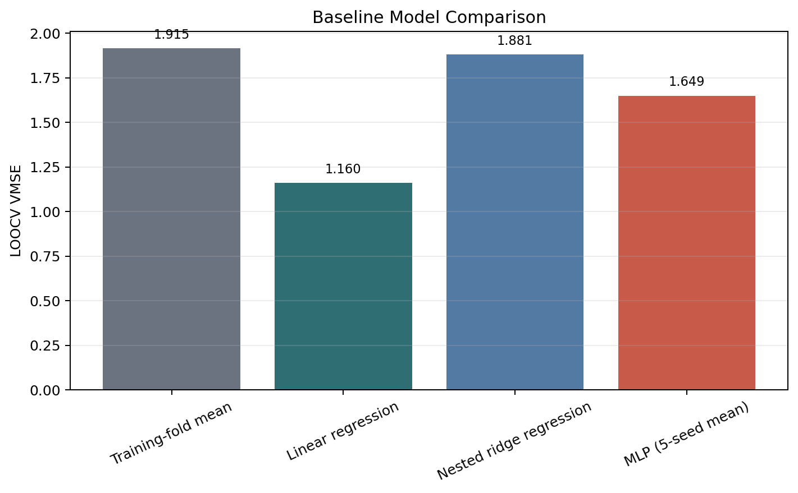
Because brain-target selection is now nested inside each outer fold (Section 2.2), the specific set of 5 brain targets differs somewhat from fold to fold. Table 2 summarizes this fold-wise selection: the top four targets by training-fold variance (mmu-miR-124-3p, mmu-let-7c-5p, mmu-miR-26a-5p, mmu-let-7a-5p) were identical in every fold, while the fifth-ranked target alternated between mmu-let-7b-5p (5 of 9 folds) and mmu-miR-181a-5p (4 of 9 folds) depending on which sample was held out. The fold-wise selected set matched a full-cohort reference ranking — computed once on all nine samples for audit purposes only — in just 2 of 9 folds.
Per-fold error for the linear and ridge models is reported in Supplementary Table S1. Fold-to-fold variability for linear regression increased relative to the earlier, non-nested target-selection pipeline, most notably in fold 1 (FL-LAR-1), where linear regression's fold MSE (3.4600) was far larger than the naive baseline's fold MSE (0.2063) — the single largest fold-level error observed for any model in this study — yet linear regression still achieved the lowest aggregate VMSE across all nine folds. Ridge regression's fold-level error also varied substantially depending on the fold-specific selected regularization strength, which ranged from α = 0.001 to α = 100.0; the fold with the largest ridge error (HC-LAR-1, 7.4239) again coincides with the largest selected ridge alpha (100.0), the same strongly-regularized-yet-still-poor fit pattern observed for this sample previously (Supplementary Table S1).
The MLP's out-of-fold error was similar in magnitude across all five fixed seeds (Supplementary Table S2): mean VMSE = 1.6489, SD = 0.1396, ranging from 1.4527 (seed 404) to 1.8567 (seed 101). This seed-to-seed stability indicates that the MLP's higher aggregate VMSE relative to linear regression is not attributable to an unlucky initialization; it instead reflects a consistent aggregate gap driven substantially by a single fold (HC-LAR-1), as the fold-paired test above shows this gap is not statistically significant once evaluated fold by fold.
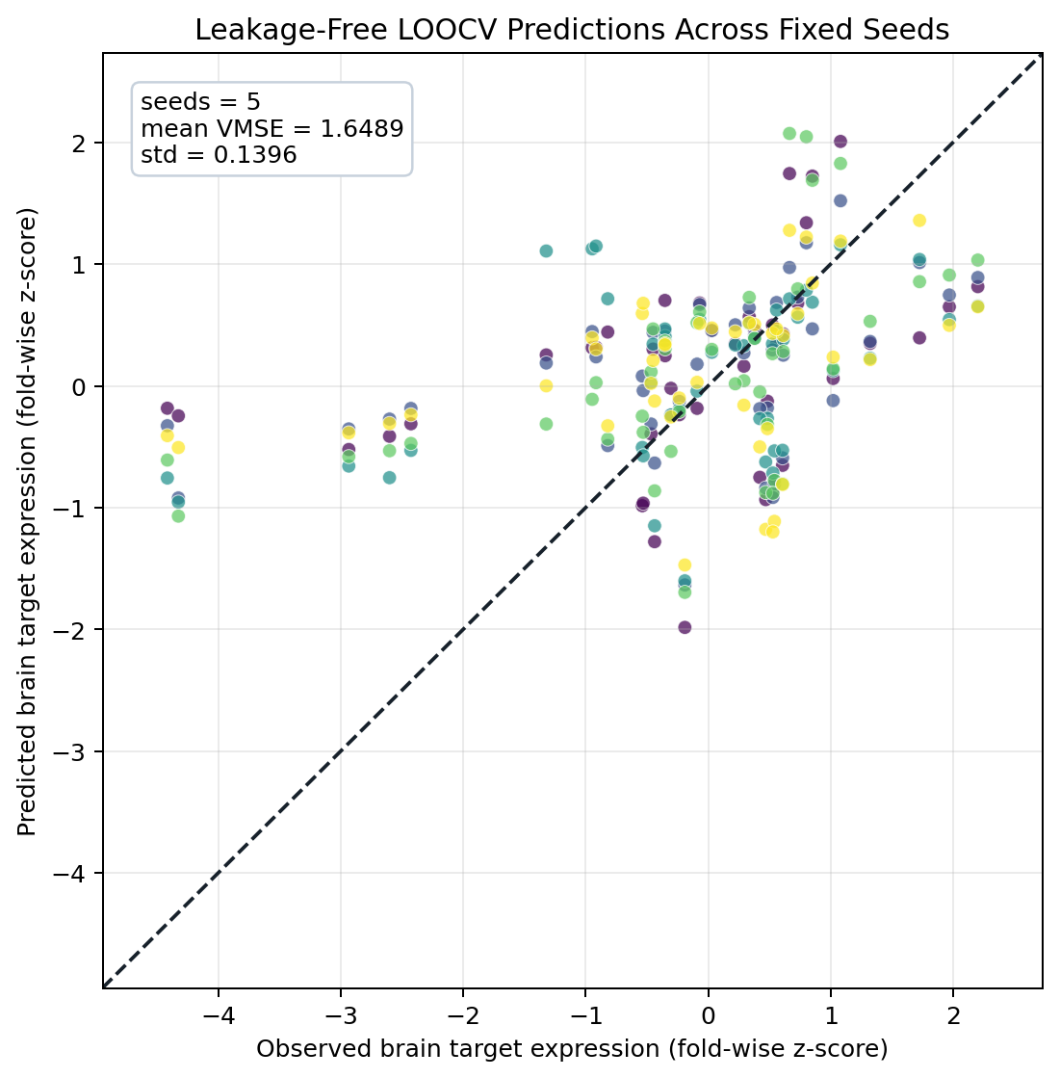
A subject-pairing permutation test for the MLP, intended to test whether its out-of-fold performance exceeds chance association, was regenerated under the fold-wise brain-target-selection pipeline described in Section 2.2. Across 1,000 subject-pairing shuffles (permutation seed = 914), the observed five-seed mean MLP VMSE was 1.6489, while the permuted VMSE distribution had median 2.8626 and 2.5-97.5 percentile range 1.3862-5.1584. In 74 of 1,000 shuffles, the permuted VMSE was less than or equal to the observed VMSE, giving a lower-tail permutation p-value of 0.074925 using the +1 finite-sample correction described in Section 2.4. This result is suggestive but does not meet a conventional p < 0.05 threshold. The permutation test asks a different question, whether the MLP beats chance pairing, than the fold-paired Wilcoxon comparison above, which asks whether linear regression beats the MLP; both remain informative for this small-n model-comparison setting.
Taken together, these results support a parsimony-first interpretation on practical rather than purely statistical grounds: in an n = 9 cohort with 6 liver inputs and a fold-specific set of 5 brain targets, an unregularized linear model achieved lower aggregate out-of-fold error than both the nested ridge regression and the MLP under a now fully leakage-free LOOCV protocol, in which both the normalization statistics and the brain-target selection itself are nested within each training fold, even though the linear-versus-MLP gap did not reach statistical significance in the fold-paired test above. Ridge regression's cross-validated regularization left it only marginally better than the naive mean baseline (1.8% improvement), underscoring that added model complexity was not automatically rewarded in this cohort even once properly regularized. We continue to treat linear regression as the preferred model of record for this dataset on parsimony grounds — fewer effective parameters, lower computational cost, and more directly interpretable coefficients — while being explicit that this preference rests on a numerical rather than a statistically significant advantage at this sample size; we retain the MLP and its SHAP attribution, described next, as a secondary analysis, and treat the regenerated, suggestive-but-non-significant permutation result and the small-n limits on statistical power as key constraints on interpretation (Section 4.5).
3.2 Feature Attribution: mmu-miR-17-5p as the Primary Driving Feature
Although linear regression achieved the lowest aggregate out-of-fold error of the models compared, without a statistically significant fold-level advantage over the MLP (Section 3.1), we retained the fitted MLP's feature-tracking analysis because it provides a fold-aggregated, non-parametric ranking of input importance that is complementary to, and can be checked against, a linear reading of the same data. Attribution scores were computed across all 6 preselected peripheral hepatic miRNA inputs, against each fold's fold-specific brain-target set (Section 2.2).
Feature tracking analysis identified mmu-miR-17-5p as the input with the highest mean absolute SHAP attribution within the prespecified six-feature input set, ranking first in the overall attribution aggregated across folds, targets, and seeds (mean absolute SHAP = 0.6058 ± 0.0649). The aggregated rankings place mmu-miR-20a-5p second (0.3405 ± 0.0569), mmu-miR-18a-5p third (0.2502 ± 0.0478), and mmu-miR-92a-1-5p fourth (0.2264 ± 0.0518); mmu-miR-19a-5p ranks fifth (0.2213 ± 0.0463), and mmu-miR-122-5p — despite its established role as a circulating liver-injury biomarker (Section 2.2) — ranks sixth and last in this cohort's attribution ranking (0.1906 ± 0.0121). These aggregated values reflect a consistent ranking across all five fixed seeds, though SHAP attribution reflects the MLP's learned dependence on each input rather than a direct measure of biological importance, and this ranking is computed on the weaker of the two primary models compared in Section 3.1. mmu-miR-17-5p is a member of the polycistronic miR-17-92 cluster, which has established roles in proliferation and stress-related signaling [18]; whether those roles explain its predictive ranking in this liver dataset remains unknown.
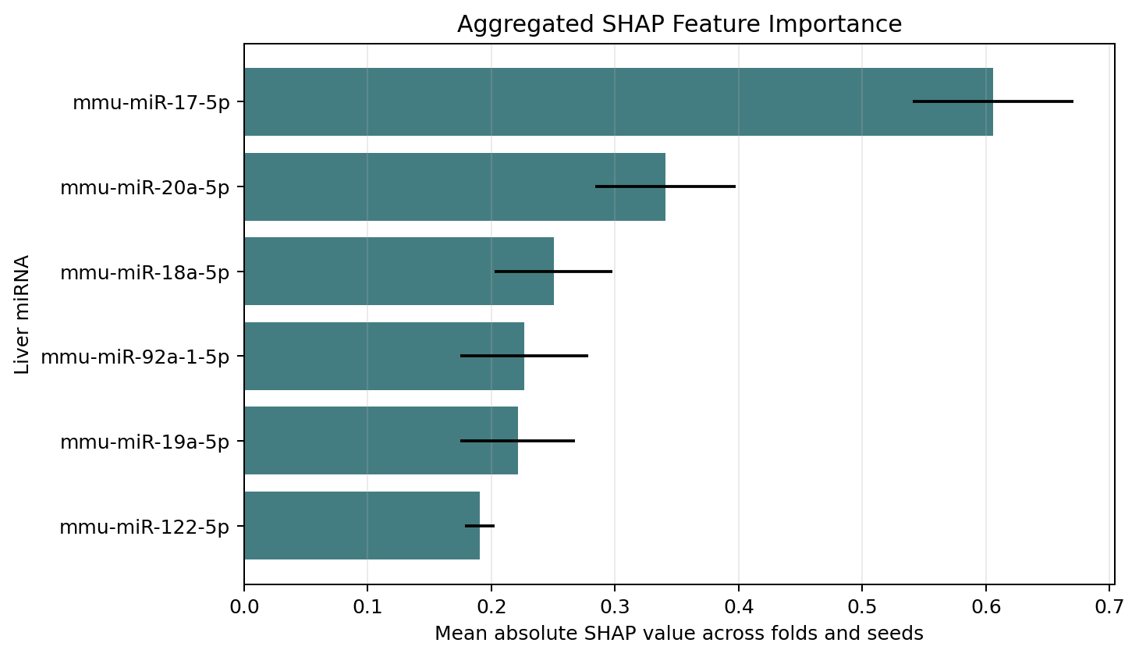
3.3 Downstream Systems Biology Analysis
Systems biology analysis was conducted to contextualize the candidate miRNA co-expression associations identified by the fitted models. Rather than a uniform, idealized suppression pattern, the cleaned expression matrix shows a heterogeneous expression pattern across tissue compartments. Within the hepatic matrix, the peripheral liver profile centered on mmu-miR-17-5p was associated with a baseline shift pattern broadly consistent with hepatic miRNA disruption documented in independent Rodent Research payloads within the NASA OSDR [5, 6]. In the brain, central mmu-miR-124-3p was numerically higher in the FL spaceflight group relative to HC and VC ground control groups — a pattern opposite to a simple suppression hypothesis — though with only three animals per group, this comparison should be treated as descriptive rather than statistically confirmed. mmu-miR-124-3p is a brain-enriched miRNA that has been characterized as involved in neuronal differentiation and multiple CNS processes [19]; its numerically higher levels in flight tissue may reflect a CNS microenvironment shift, broadly consistent with reports of neuroinflammatory and stress-related gene-network changes in spaceflight rodent cortical tissue [9]. The let-7 family targets, in contrast, showed a mixed expression profile across the FL/HC/VC cohort without a single, synchronized directional trend, consistent with the broadly pleiotropic role reported for let-7 family members and related miRNA clusters in developmental and metabolic regulation [10, 18]. The two non-let-7 variance-selected targets, mmu-miR-26a-5p and the fold-dependent mmu-miR-181a-5p, likewise showed a non-monotonic, VC-leaning pattern (highest mean raw count in the vivarium control group for both) rather than an FL-driven trend, reinforcing that the modeled brain profile as a whole is heterogeneous rather than uniformly suppressed or induced by spaceflight.
The full distribution of multi-tissue miRNA co-expression associations across the sample cohort is summarized in Table 3.
Group-level brain target expression patterns across the three LAR cohorts (FL, HC, VC) are shown in Figure 5, now including all 6 miRNAs in the fold-selection union (Section 2.2).
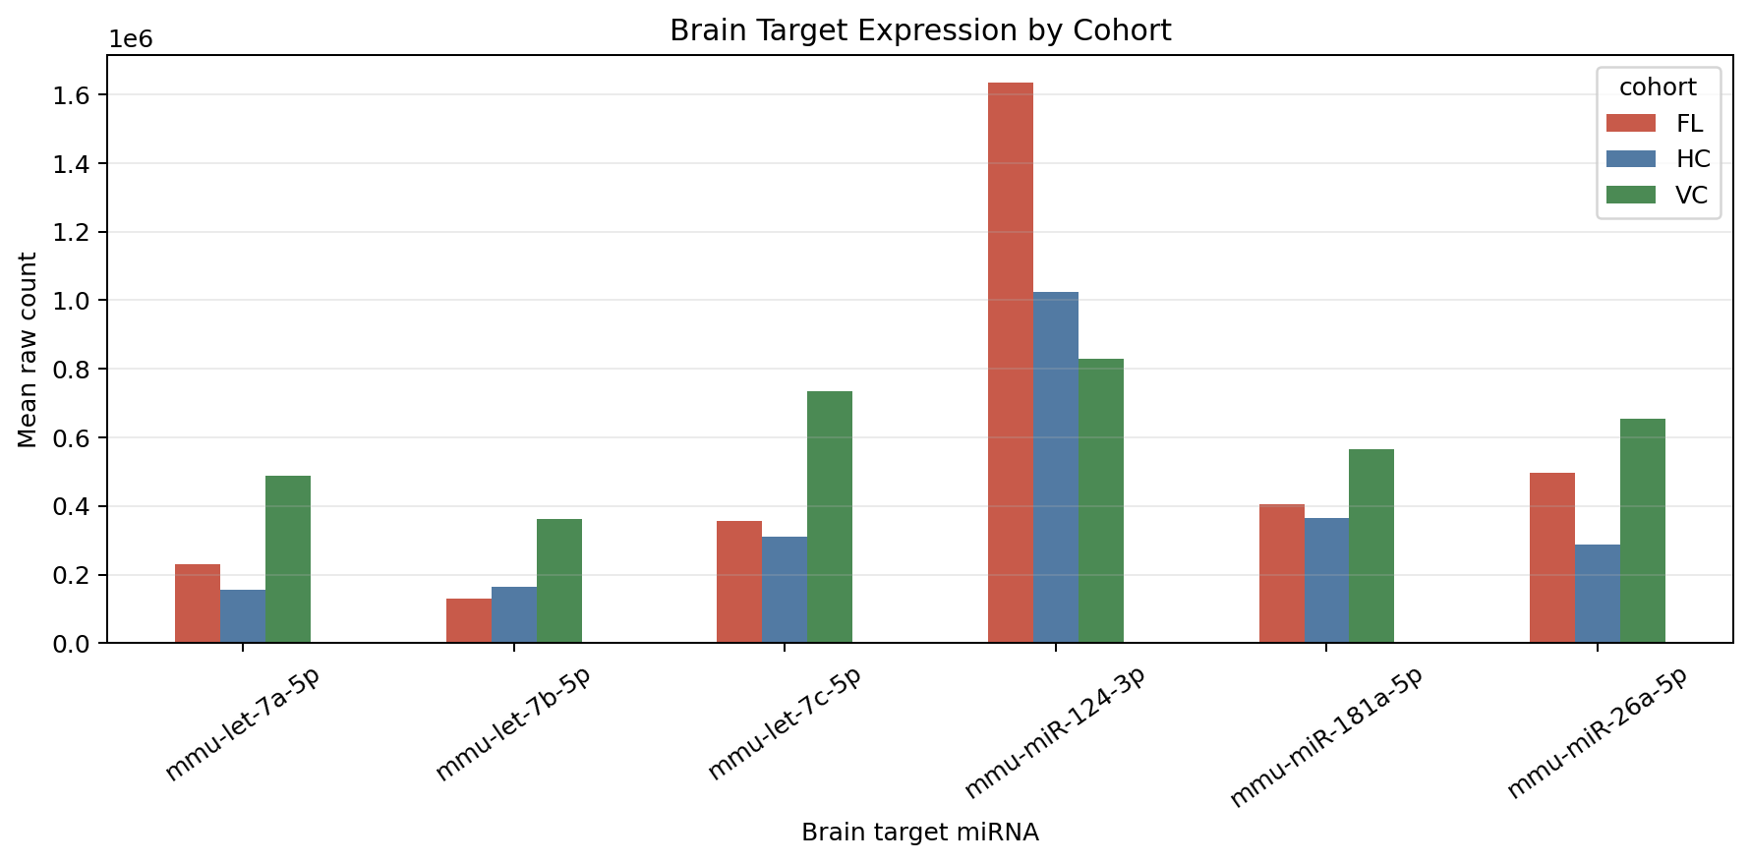
These results suggest an exploratory, model-supported association indicating that spaceflight-associated peripheral hepatic miRNA shifts may co-vary with a heterogeneous landscape of miRNA expression patterns within the central nervous system, rather than a single, uniform direction of effect.
4. Discussion
Our computational experiments present a comparative analysis in spaceflight biology, benchmarking linear and non-linear models for mapping candidate multi-organ miRNA co-expression associations during spaceflight, under a fold-wise LOOCV protocol in which both the normalization statistics and the brain-target variance ranking are nested within each training fold. An unregularized linear regression model achieved the lowest aggregate LOOCV validation mean squared error (1.1600) of all models evaluated — a numerically lower value than a nested ridge regression (1.8809, only marginally better than the naive mean baseline of 1.9148) and a regularized PyTorch Multi-Layer Perceptron (mean VMSE = 1.6489 across five fixed seeds) — though a fold-paired Wilcoxon signed-rank test found the linear-versus-MLP gap was not statistically significant (n = 9 folds, p = 0.73; Section 3.1). A regenerated 1,000-shuffle subject-pairing permutation test for the MLP yielded a suggestive but non-significant chance-pairing result (p = 0.074925; Section 2.4), so we do not claim definitive evidence that the MLP exceeds chance association in this revision. Together, the model-comparison results argue that, for this n = 9 cohort, model parsimony is at least as well supported as a more flexible non-linear alternative on practical grounds, though the available sample size limits how confidently either model can be said to outperform the other in a statistical sense.
Unlike standard correlation or differential-expression approaches applied to single tissues, this framework combines fold-wise scaling normalization, fold-wise brain-target selection, repeated-seed LOOCV, and rigorous baseline comparison and fold-aggregated KernelSHAP attribution — a validation-first design intended for the extreme n ≪ p regime (far more features than samples) of spaceflight cohorts — to surface candidate cross-tissue miRNA co-expression structure that would not be evaluated by a strictly single-tissue analysis, while also testing whether a more complex model class was actually needed to do so.
4.1 Parsimony as the Preferred Modeling Strategy in a Small-Sample Regime
The central methodological finding of this comparative analysis is that, in this n = 9 cohort, an unregularized linear regression model achieved a numerically lower aggregate error than a regularized non-linear neural network on identical held-out folds, though this gap did not reach statistical significance when the two models were compared fold by fold (fold-paired Wilcoxon signed-rank test, n = 9, p = 0.73; Section 3.1). This qualified result is nonetheless consistent with a broader statistical principle: when sample size is small relative to model capacity, added flexibility tends to increase estimation variance more than it reduces bias, and simpler models often generalize at least as well even when the true underlying relationship may include some non-linear structure. Traditionally, the aerospace community has used neural network architectures to explore complex, high-dimensional omics associations without a matched linear baseline; the results reported here illustrate why that comparison matters, independent of whether the gap reaches significance at this sample size. Regularization, dropout, and strict LOOCV do not, by themselves, guarantee that a non-linear model trained on eight subjects will outperform a much simpler alternative; a fold-paired test found no significant difference between the two models here, and a regenerated subject-pairing permutation test found that the MLP's out-of-fold performance was suggestive but not conventionally significant against chance pairing (p = 0.074925; Section 2.4). This argument therefore rests on a numerically lower aggregate error for linear regression, and on its far greater parsimony, rather than on a well-powered statistical significance claim. Because linear regression achieved the lowest aggregate VMSE and requires far fewer effective parameters relative to sample size, we treat it as the preferred model of record for this dataset on parsimony and interpretability grounds, and view the present analysis as a parsimony-first case study relevant to other small-n spaceflight omics problems — while being explicit that a larger cohort would be needed to determine whether either model has a genuine predictive edge. This architecture-comparison exercise, rather than the neural network in isolation, is best viewed as the primary contribution of this work: a pilot framework for generating candidate biological hypotheses about astronaut physiological adaptation, built on the model class that is actually supported by the available data.
4.2 A Heterogeneous Liver-Brain Regulatory Landscape
It is important to distinguish the localized tissue expression changes commonly reported in spaceflight literature from the exploratory cross-tissue associations identified by our pipeline. Our feature tracking analysis, computed on the fitted MLP, identified mmu-miR-17-5p, rather than mmu-miR-122-5p, as the input with the highest SHAP attribution — mmu-miR-122-5p in fact ranked lowest, sixth of six, in this cohort's attribution ranking (Section 3.2) — a finding that reframes which hepatic input received the highest attribution within this model, though not necessarily which is most biologically important. Because linear regression achieved the lowest aggregate error overall, without a statistically significant fold-level advantage over the MLP (Section 3.1), this SHAP-based ranking should be read as a corroborating, descriptive signal about which liver input the fitted models lean on most, rather than as an endorsement of the neural network's predictive superiority. mmu-miR-17-5p is a member of the polycistronic miR-17-92 cluster, which has established roles in cell-cycle progression, metabolic adaptation, and stress-related signaling [18]; whether these roles explain its predictive ranking in this liver dataset remains unknown and warrants independent follow-up.
The modeled brain expression analysis likewise resists a simplified, uniform narrative. Central mmu-miR-124-3p was numerically higher in FL spaceflight samples relative to HC and VC ground control groups — the inverse of an idealized suppression hypothesis — consistent with a possible CNS microenvironment shift rather than straightforward down-regulation. This observation is broadly consistent with reports of neuroinflammatory and stress-related gene-network changes in spaceflight rodent cortical tissue [9], and with the broader observation that long-duration spaceflight is accompanied by dynamic molecular and physiological changes in humans [2]. The let-7 family, meanwhile, displayed a mixed response across the LAR cohort rather than a single synchronized trend, consistent with the broadly pleiotropic role reported for let-7 family members as regulators of developmental and metabolic programs [10, 18].
4.3 Cross-OSDR Contextualization of Hepatic and CNS Findings
A key strength of this analysis is its grounding within the broader NASA Open Science Data Repository ecosystem. A companion 2026 Nature Communications study drawing on the same OSDR/GSE294046 resource characterized multi-organ miRNA adaptation patterns via extracellular matrix and developmental pathways [17]; the present work extends that analysis by applying a rigorously benchmarked cross-tissue modeling framework to explore hepatic-to-CNS miRNA co-expression dependencies not directly assessed by single-tissue approaches. The hepatic expression patterns identified in the RRRM-1/RR-8 cohort are broadly consistent with prior integrative analyses: Beheshti et al. analyzed seven independent rodent spaceflight transcriptomic datasets available through NASA GeneLab and identified a candidate miRNA and TGF-β1 regulatory signature associated with the systemic spaceflight response [5]; Malkani et al. identified and validated a circulating miRNA spaceflight signature shared across rodent and human cohorts exposed to simulated microgravity, radiation, and short- and long-duration spaceflight [6]. The identification of mmu-miR-17-5p as the highest-attribution hepatic feature in our models is broadly consistent with these documented hepatic disruption patterns, as the miR-17-92 cluster is a known transcriptional target of stress-responsive transcription-factor networks more generally [18], though this remains an inference rather than a directly established link.
On the CNS side, the numerically higher raw mmu-miR-124-3p counts observed in the FL group in our brain cortical profiles are broadly consistent with the wider literature documenting CNS adaptation under spaceflight conditions. Roy-O'Reilly et al. reviewed evidence for structural and functional alterations to the brain during spaceflight and highlighted their potential relevance to crew health in long-duration space exploration [7]. Separately, Holley et al. characterized gene expression profiles in the spaceflight mouse brain following a 35-day ISS mission and identified 54 differentially expressed genes with pathway-level shifts in neuroinflammation, cellular stress, apoptosis, and metabolism in flight versus ground control tissue [9]. Taken together, these cross-OSDR observations suggest that the hepatic and CNS expression shifts identified in our exploratory co-expression analysis are biologically plausible and broadly consistent with independent spaceflight transcriptomic evidence; this contextualizes, but does not independently confirm, the associations reported here, which remain subject to the small-n constraint discussed throughout this study.
4.4 Implications for Multi-Organ Hypothesis Generation
If a spaceflight biological system exhibits candidate cross-tissue miRNA co-expression dependencies, designing countermeasures targeting isolated organs may be insufficient. Monitoring central nervous system markers without also tracking the underlying hepatic expression environment may represent an incomplete observational approach, as the peripheral liver miRNA profile may co-vary with corresponding CNS expression states in directions that are not always intuitive.
Future biomedical hypotheses should enforce a multi-organ observational approach, and should default to the simplest model class adequate to the data rather than assuming a neural network is required. By utilizing this exploratory computational framework, aerospace medical researchers can identify candidate liver-associated miRNA patterns (such as mmu-miR-17-5p) that could motivate future evaluation in circulating biospecimens as indicators of corresponding central nervous system miRNA expression trends; note that the present analysis uses liver-tissue expression, not circulating blood miRNAs, so any clinical accessibility claim would apply only to a future, separately validated biospecimen. Importantly, the static co-expression associations identified here represent candidate correlations and should not be interpreted as established physiological mechanisms without wet-lab validation.
4.5 Limitations and Future Work
While our comparative framework offers a more rigorous lens on systemic spaceflight miRNA co-expression biology than a single-model analysis would, several distinct limitations must be explicitly acknowledged.
First, the RRRM-1 cohort is small (n = 9), reflecting the strict physical and logistical constraints of ISS payloads [3]. Replicating these candidate cross-tissue associations, and the linear-versus-non-linear comparison reported here, across larger, multi-modal human and animal datasets within the NASA OSDR will be essential to determine whether the mmu-miR-17-5p liver-brain candidate pattern and the parsimony finding generalize across diverse biological cohorts and longer spaceflight durations. Companion OSDR datasets from RR-1, RR-3, RR-6, and RR-9 [5, 6] represent natural extensions for future validation, as do the human astronaut multi-omic profiles assembled through the NASA GeneLab platform [3, 4].
Second, the experimental cohort comprises 3 spaceflight, 3 habitat control, and 3 vivarium control animals. Accordingly, "flight" vs. "ground" comparisons reflect a three-group design with extremely limited per-condition replication, and all flight-associated expression trends should be interpreted with appropriate caution.
Third, the current pipeline is strictly correlational and captures co-expression trends between peripheral liver miRNA inputs and central brain miRNA targets within a static cross-sectional dataset.
Fourth, although the canonical repository pipeline uses fold-wise scaler fitting and fixed repeated seeds (101, 202, 303, 404, 505) for the MLP, the n = 9 cohort and three-animal-per-condition design remain severe constraints for any model class; deep neural networks in particular are known to be prone to instability and overfitting in sample sizes of this magnitude regardless of regularization strategy, which is broadly consistent with the MLP's higher aggregate error relative to the unregularized linear model reported in Section 3.1, though that difference was not statistically significant at the fold level.
Fifth, the brain target set was selected by variance within this cohort rather than independent biological curation, so external validation in additional OSDR cohorts is required. Future wet-lab validation — specifically utilizing targeted miRNA knockdown models or localized hepatic antioxidant interventions in simulated microgravity systems — is required to determine whether any causal or mechanistic relationship underlies the identified co-expression patterns. Future work will also explore the integration of multi-tissue variational autoencoders (β-VAEs) to explicitly separate task-specific environmental expression shifts from baseline inter-subject physiological variance, alongside repeated-seed robustness analyses to quantify remaining seed-level model variance.
Sixth, an earlier version of this pipeline selected the target-miRNA set by ranking expression variance across the full nine-animal cohort prior to cross-validation, identically for every model compared, which introduced a form of feature-selection leakage that fold-wise scaling alone did not eliminate. This has since been corrected: brain-target selection is now nested inside each outer LOOCV training fold, using only that fold's 8 training samples, for every model (Section 2.2; audited in fold_target_selection.csv and baseline_fold_target_selection.csv). This fix changed the reported VMSE values (Table 1) and reduced, but by construction cannot fully eliminate, the residual similarity between overlapping training folds inherent to LOOCV on n = 9 subjects; it also means the specific 5-target set now varies by fold (Table 2), which should be kept in mind when comparing SHAP attributions or fold-level errors across folds that use different target sets.
Seventh, we benchmark the MLP against a naive mean baseline, an unregularized linear regression, and a nested ridge regression under an identical, now fold-wise target-selected LOOCV protocol, and find that linear regression achieves the lowest aggregate VMSE, though by a smaller margin than under the earlier, non-nested pipeline, and a fold-paired Wilcoxon signed-rank test (Section 3.1) found this linear-versus-MLP difference was not statistically significant (n = 9 folds, p = 0.73). A regenerated subject-pairing permutation test under this corrected pipeline yielded p = 0.074925 for the MLP (74/1000 permuted VMSE values less than or equal to observed; observed VMSE = 1.6489; median permuted VMSE = 2.8626), so the MLP's chance-pairing test remained suggestive but not conventionally significant. We did not run an equivalent permutation test for the linear or ridge models. Extending this permutation framework to the linear and ridge models, together with validation in larger cohorts, is a high-priority next step.
Eighth, aside from the fold-paired Wilcoxon signed-rank comparison reported in Section 3.1, most other reported metrics (aggregate VMSE, SHAP attribution) remain descriptive machine-learning outputs computed for hypothesis-generating purposes rather than confirmatory inferential statistics, consistent with the small-n, exploratory focus of this work; with only nine paired folds, the fold-paired test itself has limited statistical power, and a non-significant result should not be read as positive evidence that the two models perform identically, only that this dataset cannot distinguish between them with confidence.
Ninth, Figure 5 reports unnormalized raw sequencing counts rather than library-size-normalized expression values; because sequencing depth can vary by sample, the group differences shown there should be treated as a raw-data visualization rather than confirmed evidence of a flight-associated expression change. A normalized, individual-animal-level version of this figure is planned for future work.
Tenth, the ridge regression's inner-fold-selected regularization strength varied by five orders of magnitude across the nine outer folds (α = 0.001 to 100.0; Supplementary Table S1), indicating that the nested hyperparameter search is itself highly unstable when only 8 training samples are available per outer fold. The ridge comparison point reported in Table 1 should therefore be interpreted with this instability in mind, and may not represent a fully reliable estimate of ridge regression's achievable performance in this cohort; it does not affect the primary linear-versus-MLP comparison, which involves no inner-loop hyperparameter selection for either model.
5. Conclusion
We present a comparative analysis of linear and non-linear models for mapping candidate cross-tissue miRNA co-expression patterns associated with the spaceflight environment, applied to a focused signature of 6 peripheral liver and 5 central brain miRNA features (selected independently within each LOOCV fold from a 6-miRNA fold-selection union) from female BALB/cAnNTac mice (RRRM-1 / RR-8; NASA OSDR records and GEO series GSE294046) [15]. Contrary to our initial expectation that a regularized PyTorch Multi-Layer Perceptron would better capture non-linear cross-tissue structure, an unregularized linear regression model achieved the lowest aggregate LOOCV validation mean squared error (1.1600; 39.4% improvement over a naive mean baseline of 1.9148) under a fully leakage-free protocol in which both normalization and brain-target selection are nested within each training fold, achieving a numerically lower aggregate VMSE than both a nested ridge regression (1.8809; 1.8% improvement) and the MLP (5-seed mean 1.6489; 13.9% improvement). However, a fold-paired Wilcoxon signed-rank test on the nine outer LOOCV folds found the linear-versus-MLP difference was not statistically significant (n = 9, p = 0.73): linear regression won only 5 of 9 folds outright, and the aggregate gap was driven substantially by a single outlier fold in which the MLP's error was more than ninefold higher than linear regression's. We therefore report this as a case study favoring parsimony on practical rather than purely statistical grounds — fewer effective parameters, lower computational cost, and more directly interpretable coefficients — while being explicit that a rigorously baselined linear model was not shown to significantly outperform the more flexible non-linear alternative at this sample size, and that the margin narrowed further once brain-target selection was corrected to remove a feature-selection leakage pathway present in an earlier version of this pipeline. A regenerated 1,000-shuffle subject-pairing permutation test for the MLP produced a suggestive but non-significant chance-pairing result (p = 0.074925), and a larger validation cohort capable of resolving the linear-versus-MLP question with adequate statistical power remains the most important next step.
KernelSHAP attribution computed on the fitted MLP identified mmu-miR-17-5p as the highest-attribution peripheral liver feature, a pattern broadly consistent with a linear reading of the same data and one we treat as the primary driving feature of the modeled cross-tissue association; the classic circulating liver-injury marker mmu-miR-122-5p ranked lowest of the six liver inputs in this cohort. This feature co-occurs with numerically higher raw counts of central mmu-miR-124-3p and a mixed, non-uniform response across the let-7 family, mmu-miR-26a-5p, and the fold-dependent target mmu-miR-181a-5p. Cross-referencing with companion spaceflight datasets available through NASA OSDR [3, 5, 6] suggests that these hepatic and CNS expression patterns are broadly consistent with spaceflight phenotypes documented across independent Rodent Research payloads, though this contextualization does not constitute independent confirmation.
The most important methodological lesson from this work is that model comparison against simple, well-specified baselines, target selection that is properly nested within cross-validation folds, and a fold-level significance test rather than aggregate metrics alone are all essential before attributing predictive value to a more complex architecture, particularly in the small-sample regime that characterizes most spaceflight omics cohorts; here, that combination revealed that an apparent 39% aggregate improvement did not correspond to a statistically consistent per-fold advantage. Future aerospace biomedical research should pair leakage-free target selection, baseline model comparisons of the kind reported here, and larger cohorts with integrated, multi-tissue miRNA profiling to more rigorously test whether non-linear cross-tissue structure exists and, if so, at what sample size it becomes detectable. Monitoring peripheral hepatic miRNA shifts, and mmu-miR-17-5p in particular, as candidate indicators of central nervous system expression states represents a hypothesis that warrants further investigation — ideally using the simplest model that is adequate to the data — in future multi-organ studies of astronaut health during long-duration missions.
Data Availability
All analysis code, processed input files, cleaned matrices, reproducibility outputs, summary tables, fold-wise target-selection audit tables, baseline tables, SHAP attribution tables, permutation-test outputs, and figure-generation scripts are archived on Zenodo at https://doi.org/10.5281/zenodo.21283918 [21]. The corresponding live GitHub repository is available at https://github.com/bobsbuiscuit123/osd914-analysis. The raw miRNA expression data underlying this study are available through the RRRM-1/RR-8 NASA OSDR study records and the corresponding NCBI GEO series GSE294046. Figures 2-5 were generated from the cleaned matrices available at the Zenodo archive; Figure 1 is a schematic of the computational workflow rather than a data-derived plot. The canonical reproducibility entry point is reproduce.py, which selects brain targets independently inside each outer LOOCV training fold; running make reproduce rebuilds the clean liver and brain matrices, LOOCV metrics, prediction tables, fold-wise target-selection audit tables, SHAP attribution summaries, figures, and dashboard under the reproducibility/ directory, and make baselines regenerates the model-comparison tables and figures reported in Section 3.1. The current subject-pairing permutation null for the MLP under this fold-wise pipeline was generated with .venv/bin/python baselines.py --permutations 1000; the summary p-value is stored in reproducibility/baseline_metrics.json, and the full null distribution and pairings are stored in reproducibility/tables/permutation_mlp_vmse.csv, reproducibility/tables/permutation_mlp_seed_vmse.csv, and reproducibility/tables/permutation_pairings.csv.
Supplementary Information accompanies this manuscript and comprises Supplementary Table S1 (per-fold linear and nested ridge regression error, with selected ridge α, for all nine outer LOOCV folds), Supplementary Table S2 (per-seed MLP validation error for all five fixed seeds), and Supplementary Table S3 (per-fold linear-regression MSE paired against five-seed-mean MLP MSE, with signed rank and win/loss outcome, underlying the fold-paired Wilcoxon signed-rank test reported in Section 3.1), all derived from tables already produced by the canonical reproducibility pipeline (baseline_fold_metrics.csv and fold_metrics.csv) without additional model retraining.
References
1. Afshinnekoo, E. et al. Fundamental biological features of spaceflight: advancing the field to enable deep-space exploration. Cell 183, 1162–1184 (2020).
2. Garrett-Bakelman, F. E. et al. The NASA Twins Study: a multidimensional analysis of a year-long human spaceflight. Science 364, eaau8650 (2019).
3. Ray, S., Gebre, S., Fogle, H., Berrios, D. C., Tran, P. B., Galazka, J. M. & Costes, S. V. GeneLab: omics database for spaceflight experiments. Bioinformatics 35, 1753–1759 (2019).
4. Berrios, D. C., Galazka, J., Grigorev, K., Gebre, S. & Costes, S. V. NASA GeneLab: interfaces for the exploration of space omics data. Nucleic Acids Res. 49, D1515–D1522 (2021).
5. Beheshti, A., Ray, S., Fogle, H., Berrios, D. & Costes, S. V. A microRNA signature and TGF-β1 response were identified as the key master regulators for spaceflight response. PLoS ONE 13, e0199621 (2018).
6. Malkani, S. et al. Circulating miRNA spaceflight signature reveals targets for countermeasure development. Cell Rep. 33, 108448 (2020).
7. Roy-O'Reilly, M., Mulavara, A. & Williams, T. A review of alterations to the brain during spaceflight and the potential relevance to crew in long-duration space exploration. npj Microgravity 7, 5 (2021).
8. Lee, J. K. et al. Spaceflight-associated brain white matter microstructural changes and intracranial fluid redistribution. JAMA Neurol. 76, 412–419 (2019).
9. Holley, J. M., Stanbouly, S., Pecaut, M. J., Willey, J. S., Delp, M. & Mao, X. W. Characterization of gene expression profiles in the mouse brain after 35 days of spaceflight mission. npj Microgravity 8, 35 (2022).
10. Bartel, D. P. Metazoan microRNAs. Cell 173, 20–51 (2018).
11. Turchinovich, A., Weiz, L. & Burwinkel, B. Extracellular miRNAs: the mystery of their origin and function. Trends Biochem. Sci. 37, 460–465 (2012).
12. Wang, K. et al. Circulating microRNAs, potential biomarkers for drug-induced liver injury. Proc. Natl Acad. Sci. USA 106, 4402–4407 (2009).
13. Lagos-Quintana, M., Rauhut, R., Yalcin, A., Meyer, J., Lendeckel, W. & Tuschl, T. Identification of tissue-specific microRNAs from mouse. Curr. Biol. 12, 735–739 (2002).
14. Huang, S., Chaudhary, K. & Garmire, L. X. More is better: recent progress in multi-omics data integration methods. Front. Genet. 8, 84 (2017).
15. NASA Open Science Data Repository. OSD-914/GLDS-736 and Rodent Research Reference Mission-1 (RRRM-1/RR-8) payload records; corresponding NCBI GEO series GSE294046. https://osdr.nasa.gov/bio/repo/data/payloads/RRRM-1%20%28RR-8%29 (accessed 13 July 2026).
16. Paszke, A. et al. PyTorch: an imperative style, high-performance deep learning library. Adv. Neural Inf. Process. Syst. 32 (2019).
17. Grandke, F. et al. MiRNAs shape mouse age-independent tissue adaptation to spaceflight via ECM and developmental pathways. Nat. Commun. 17, 1387 (2026).
18. Mendell, J. T. & Olson, E. N. MicroRNAs in stress signaling and human disease. Cell 148, 1172–1187 (2012).
19. Sun, Y., Luo, Z.-M., Guo, X.-M., Su, D.-F. & Liu, X. An updated role of microRNA-124 in central nervous system disorders: a review. Front. Cell. Neurosci. 9, 193 (2015).
20. Kingma, D. P. & Ba, J. Adam: a method for stochastic optimization. In Proc. 3rd Int. Conf. Learning Representations (ICLR) (2015).
21. Mukkavilli, P., Medeiros, M., Prahl, R. & Palmer, X. L. Reproducibility package for predictive modeling of spaceflight-induced microRNA co-expression patterns. Zenodo https://doi.org/10.5281/zenodo.21283918 (2026).
22. Pedregosa, F. et al. Scikit-learn: machine learning in Python. J. Mach. Learn. Res. 12, 2825–2830 (2011).
Acknowledgements
The authors are grateful for the data infrastructure provided by the NASA Open Science Data Repository, and to collaborating NASA-affiliated scientists, working group members, and institutional mentors for technical support, guidance, and collaboration throughout this work. This research received no specific grant from any funding agency in the public, commercial, or not-for-profit sectors.
Author Contributions
P.M. conceived the study, designed the computational pipeline, performed all data preprocessing, model training, baseline and permutation-test analysis, feature tracking analysis, and drafted the manuscript. M.M. contributed to biological interpretation and manuscript review. R.P. contributed to systems biology downstream analysis and manuscript review. X.L.P. contributed to cross-OSDR contextualization, critical revision of the manuscript for intellectual content, and co-author feedback integration. All authors approved the final version for submission.
Additional Information
Competing interests
The authors declare no competing interests.
Figure Legends
Figure 1. Reproducible Liver-Brain miRNA Modeling Pipeline. Schematic of the computational workflow (not a data-derived plot). Six liver miRNA inputs (left) are mapped through a PyTorch MLP (hidden dim 16, BatchNorm1d, Dropout (p = 0.3), Adam, 100 epochs) to a fold-specific set of five brain miRNA targets (right, showing the 6-miRNA union across all folds — mmu-let-7a-5p, mmu-let-7b-5p, mmu-let-7c-5p, mmu-miR-124-3p, mmu-miR-181a-5p, mmu-miR-26a-5p); the same six liver inputs and fold-specific brain targets are also used by the mean-baseline, linear regression, and ridge regression models described in Section 2.4. Brain-target ranking and scaler fitting both occur inside each LOOCV training fold, using only that fold's 8 training samples; held-out samples do not influence target selection or normalization. Five fixed seeds (101, 202, 303, 404, 505) are used for the MLP for reproducibility.
Figure 2. Baseline Model Comparison. LOOCV VMSE for the training-fold mean baseline, unregularized linear regression, nested ridge regression, and the MLP (5-seed mean), evaluated under an identical fold-wise-normalized, fold-wise-target-selected LOOCV protocol. Linear regression achieved the lowest aggregate VMSE among all four models, though a fold-paired Wilcoxon signed-rank test found the linear-versus-MLP difference not statistically significant (Section 3.1).
Figure 3. Leave-One-Out Cross-Validation Predictions (MLP). Scatter plot of ground-truth brain expression targets versus out-of-sample continuous predictions from the MLP across independent validation loops (n = 9), shown against an x = y reference line. Mean VMSE = 1.6489 (SD = 0.1396; range = 1.4527–1.8567) across five fixed seeds. Table 1 compares this aggregate performance against the mean baseline, linear regression, and ridge regression; linear regression achieved a numerically lower aggregate VMSE than the MLP shown here, though this difference was not statistically significant in a fold-paired test (Section 3.1).
Figure 4. Model Interpretability & Feature Importance. SHAP attribution rankings, computed on the fitted MLP, across Leave-One-Out Cross-Validation (LOOCV) folds for the preselected peripheral hepatic microRNA input subset. mmu-miR-17-5p had the highest mean SHAP attribution aggregated across all LOOCV folds and fixed seeds (0.6058 ± 0.0649), followed by mmu-miR-20a-5p (0.3405 ± 0.0569), mmu-miR-18a-5p (0.2502 ± 0.0478), mmu-miR-92a-1-5p (0.2264 ± 0.0518), mmu-miR-19a-5p (0.2213 ± 0.0463), and mmu-miR-122-5p (0.1906 ± 0.0121). Error bars = SD across five fixed seeds (n = 5 seeds × 9 LOOCV folds). Attribution rank reflects MLP dependence, not confirmed biological importance, and is presented as a secondary analysis to the primary model-comparison result in Section 3.1.
Figure 5. Brain Target Expression by Cohort (FL / HC / VC) — Raw-Count Visualization. Mean raw miRNA counts, not normalized for library size, for each of the 6 miRNAs in the fold-selection union (any given fold uses 5 of these 6; Section 2.2), stratified by cohort (spaceflight [FL], habitat control [HC], vivarium control [VC]). Raw count data from GSE294046. This panel is presented as a raw-data visualization rather than as evidence of a confirmed expression difference: mmu-miR-124-3p shows numerically higher raw counts in FL relative to both control groups, while mmu-miR-26a-5p and mmu-miR-181a-5p instead show their highest mean raw counts in the VC group; with n = 3 per group, unnormalized counts, and no statistical test applied, between-group comparisons should not be interpreted as confirmed flight-associated effects. Normalized, individual-animal-level quantification is planned for a follow-up analysis.
Tables
Table 1.
Model | LOOCV VMSE | Improvement vs. mean baseline
Training-fold mean | 1.9148 | 0.0%
Linear regression | 1.1600 | 39.4%
Nested ridge regression | 1.8809 | 1.8%
MLP, 5-seed mean | 1.6489 | 13.9%
Canonical LOOCV results across all evaluated fitted models under the fold-wise, leakage-free brain-target selection pipeline (Section 2.2). VMSE = validation mean squared error, averaged over the n = 9 outer LOOCV folds and each fold's 5 fold-specific brain targets; lower is better. Improvement is relative to the training-fold mean baseline. A fold-paired Wilcoxon signed-rank test found the linear-versus-MLP VMSE difference not statistically significant (n = 9, p = 0.73; Section 3.1; per-fold values in Supplementary Table S3). The regenerated subject-pairing permutation null for the MLP is reported separately in Section 3.1 and archived in baseline_metrics.json and the permutation CSV outputs.
Table 2.
Fold | Held-out sample | Cohort | 5th-ranked target (alternates) | Matches full-cohort ref.?
1 | FL-LAR-1 | FL | mmu-miR-181a-5p | No
2 | FL-LAR-13 | FL | mmu-let-7b-5p | No
3 | FL-LAR-5 | FL | mmu-miR-181a-5p | No
4 | HC-LAR-1 | HC | mmu-let-7b-5p | No
5 | HC-LAR-13 | HC | mmu-let-7b-5p | Yes
6 | HC-LAR-5 | HC | mmu-miR-181a-5p | No
7 | VC-LAR-1 | VC | mmu-miR-181a-5p | No
8 | VC-LAR-13 | VC | mmu-let-7b-5p | No
9 | VC-LAR-5 | VC | mmu-let-7b-5p | Yes
Fold-wise brain-target selection audit. In every outer LOOCV fold, the top four targets by training-fold variance were identical (mmu-miR-124-3p, mmu-let-7c-5p, mmu-miR-26a-5p, mmu-let-7a-5p); this table shows the fifth-ranked target, which alternated between mmu-let-7b-5p and mmu-miR-181a-5p depending on which sample was held out. "Matches full-cohort reference" indicates whether the fold's fifth-ranked target matches the target selected when ranking is instead performed once on the full nine-sample cohort (an audit comparison only; the full-cohort ranking is not used for modeling). Source: fold_target_selection.csv / baseline_fold_target_selection.csv.
Table 3.
Biomarker | Location | FL vs. control | Interpretive description
Hepatic matrix | Peripheral liver | Baseline shift pattern | Overall liver input profile
mmu-miR-17-5p | Liver (top SHAP feature) | Highest attribution | Highest MLP attribution
mmu-miR-124-3p | Central brain | Numerically higher in FL | Numerically higher raw count in FL
let-7 family | Central brain | Heterogeneous / mixed | Mixed raw-count pattern
mmu-miR-26a-5p | Central brain | Heterogeneous / mixed | Variance-selected non-let-7 target
mmu-miR-181a-5p | Central brain (fold-dependent) | Heterogeneous / VC-leaning | Alternates with let-7b-5p across folds
Summary of exploratory cross-tissue miRNA expression and attribution patterns across the LAR cohort (n = 3 per group; descriptive summary, not a statistical test).

