Supplementary results for first hospitalisation counts before and during the COVID pandemic
The tables distinguish disjoint descriptive periods from overlapping model fits. Confidence intervals are nominal pointwise 95% normal-reference Wald intervals for exploratory associations; no later-era effect is inferred by subtracting nested coefficients.

Annual recorded counts
Supplementary Table S1. Annual recorded first hospitalisations after coronary heart disease (CHD) or heart failure (HF) diagnosis, 2013–2023. Each total is the sum of twelve supplied monthly counts. Admission cause and eligible person-time were unavailable; no incidence rate or unique combined patient count is implied.
Year | CHD first hospitalisations | HF first hospitalisations
2013 | 23,830 | 4,336
2014 | 17,760 | 3,675
2015 | 15,411 | 2,934
2016 | 14,510 | 2,734
2017 | 13,962 | 2,620
2018 | 12,616 | 2,527
2019 | 12,396 | 2,344
2020 | 10,237 | 1,964
2021 | 12,035 | 2,275
2022 | 11,076 | 1,976
2023 | 12,323 | 2,296

Descriptive periods
Supplementary Table S2. Monthly mean recorded counts in non overlapping calendar periods. Coronary heart disease (CHD) and heart failure (HF) arithmetic means from aggregate period summaries.
Period | Months | CHD monthly mean | HF monthly mean
2013–2019 | 84 | 1315.3 | 252.0
2020–2022 | 36 | 926.3 | 172.6
2023 | 12 | 1026.9 | 191.3

Complete baseline panel
Supplementary Table S3. All twelve baseline weather models, January 2013–December 2023. CHD denotes coronary heart disease; HF denotes heart failure. Days-in-month offset, calendar-month indicators, four-degree-of-freedom natural time spline; Newey–West lag-six intervals. BH q-values cover these twelve two-sided Wald tests of zero exposure coefficient only; interval endpoints are not multiplicity-adjusted. The window spans 132 calendar months, not 132 independent replicates.
Outcome | Exposure | Count ratio and 95% CI | p | BH q
CHD | Mean temperature / 1°C | 0.993 (0.976–1.010) | 0.424 | 0.726
CHD | Mean maximum / 1°C | 0.993 (0.979–1.007) | 0.321 | 0.642
CHD | Mean minimum / 1°C | 0.994 (0.977–1.012) | 0.509 | 0.764
CHD | Hot nights / 5 days | 1.022 (1.002–1.042) | 0.032 | 0.192
CHD | Very hot days / 5 days | 0.999 (0.974–1.025) | 0.962 | 0.962
CHD | Cold days / 5 days | 0.995 (0.949–1.043) | 0.823 | 0.900
HF | Mean temperature / 1°C | 0.974 (0.947–1.002) | 0.069 | 0.207
HF | Mean maximum / 1°C | 0.981 (0.958–1.005) | 0.113 | 0.272
HF | Mean minimum / 1°C | 0.973 (0.947–1.000) | 0.050 | 0.202
HF | Hot nights / 5 days | 1.003 (0.976–1.031) | 0.825 | 0.900
HF | Very hot days / 5 days | 0.995 (0.963–1.028) | 0.764 | 0.900
HF | Cold days / 5 days | 1.073 (1.006–1.144) | 0.031 | 0.192

The HF mean-minimum-temperature lag-six interval includes one on the unrounded scale; its upper bound is 1.0000496637 (Wald p = 0.0504). Rounding to 1.000 in Table S3 or 1.0000 in Table S6 does not change that interpretation.
The nested pre-2020 continuous-temperature fits were CHD mean temperature 0.980 (0.970–0.990), mean maximum 0.982 (0.974–0.991), and mean minimum 0.982 (0.972–0.992); HF corresponding fits were 0.945 (0.927–0.963), 0.958 (0.939–0.977), 0.944 (0.927–0.961). These estimates are not multiplicity-adjusted or a later-era contrast.

Overlapping analysis windows
Supplementary Table S4. Official-day associations in nested (2013–2019) and full (2013–2023) windows. CHD denotes coronary heart disease; HF denotes heart failure. Ratios per five additional days with Newey–West lag-six 95% intervals. The pre-2020 window is contained within the full series, with a separately reconstructed spline basis. These are dependent sensitivity fits, not independent pre/post estimates.
Outcome | Exposure | Pre 2020 84 months | Full 132 months
CHD | Hot nights / 5 days | 1.011 (0.991–1.032) | 1.022 (1.002–1.042)
CHD | Very hot days / 5 days | 0.997 (0.982–1.012) | 0.999 (0.974–1.025)
CHD | Cold days / 5 days | 1.036 (1.007–1.067) | 0.995 (0.949–1.043)
HF | Hot nights / 5 days | 0.965 (0.937–0.994) | 1.003 (0.976–1.031)
HF | Very hot days / 5 days | 0.990 (0.960–1.021) | 0.995 (0.963–1.028)
HF | Cold days / 5 days | 1.113 (1.053–1.176) | 1.073 (1.006–1.144)

Calendar specification sensitivity
Supplementary Table S5. Complete official day panel under alternative calendar specifications. Coronary heart disease (CHD) and heart failure (HF) ratios per five days with Newey–West lag-six intervals. The full series is January 2013–December 2023. Baseline and nested values are in Supplementary Table S4. Year indicators replace the spline. COVID-phase intercepts supplement the baseline in the full series; they are not a third window. Omission checks shorten the 132-calendar-month window to 120 or 108 months. These window lengths are not independently verified fitted-observation counts. These sensitivity estimates have no multiplicity adjustment.

CHD
Specification | Hot nights | Very hot days | Cold days
Time spline 3 df | 1.011 (0.990–1.032) | 0.993 (0.967–1.020) | 0.989 (0.934–1.046)
Time spline 6 df | 1.024 (1.005–1.044) | 0.999 (0.975–1.023) | 0.999 (0.952–1.047)
Time spline 8 df | 1.023 (1.005–1.042) | 0.997 (0.974–1.021) | 0.997 (0.950–1.047)
Year indicators | 1.025 (1.000–1.050) | 1.006 (0.983–1.029) | 0.994 (0.939–1.052)
Omit first 12 months | 1.020 (1.000–1.040) | 0.995 (0.969–1.022) | 1.008 (0.954–1.065)
Omit first 24 months | 1.017 (0.999–1.036) | 0.993 (0.966–1.020) | 0.989 (0.930–1.053)
COVID phase intercepts | 1.013 (0.994–1.033) | 0.993 (0.973–1.013) | 0.991 (0.943–1.041)

HF
Specification | Hot nights | Very hot days | Cold days
Time spline 3 df | 0.993 (0.963–1.025) | 0.989 (0.956–1.024) | 1.066 (1.005–1.131)
Time spline 6 df | 1.004 (0.977–1.032) | 0.995 (0.963–1.028) | 1.072 (1.005–1.143)
Time spline 8 df | 1.002 (0.978–1.028) | 0.993 (0.963–1.024) | 1.062 (0.994–1.135)
Year indicators | 1.004 (0.982–1.026) | 0.997 (0.971–1.024) | 1.061 (0.997–1.129)
Omit first 12 months | 1.007 (0.977–1.038) | 0.995 (0.963–1.029) | 1.067 (0.995–1.143)
Omit first 24 months | 1.003 (0.974–1.034) | 0.988 (0.957–1.021) | 1.043 (0.965–1.127)
COVID phase intercepts | 0.994 (0.972–1.016) | 0.990 (0.963–1.017) | 1.074 (1.006–1.145)

Uncertainty constructions
Supplementary Table S6. Uncertainty intervals for all twelve baseline models, January 2013–December 2023. CHD denotes coronary heart disease; HF denotes heart failure. All four constructions use the same fitted coefficient. Lag-six q-values appear in Table S3 and do not apply to the other interval constructions. Four decimal places are retained for the near-null CHD hot-night lag-three bounds.

CHD
Exposure | Model CI | HC1 CI | NW3 CI | NW6 CI
Mean temperature / 1°C | 0.9772–1.0092 | 0.9745–1.0120 | 0.9759–1.0105 | 0.9762–1.0102
Mean maximum / 1°C | 0.9788–1.0073 | 0.9764–1.0098 | 0.9784–1.0077 | 0.9791–1.0069
Mean minimum / 1°C | 0.9788–1.0098 | 0.9763–1.0124 | 0.9768–1.0119 | 0.9771–1.0116
Hot nights / 5 days | 0.9950–1.0494 | 0.9973–1.0469 | 1.0003–1.0439 | 1.0019–1.0422
Very hot days / 5 days | 0.9741–1.0254 | 0.9747–1.0247 | 0.9735–1.0260 | 0.9744–1.0251
Cold days / 5 days | 0.9539–1.0371 | 0.9555–1.0353 | 0.9495–1.0419 | 0.9488–1.0427

HF
Exposure | Model CI | HC1 CI | NW3 CI | NW6 CI
Mean temperature / 1°C | 0.9561–0.9929 | 0.9494–0.9999 | 0.9487–1.0006 | 0.9474–1.0020
Mean maximum / 1°C | 0.9645–0.9981 | 0.9584–1.0044 | 0.9593–1.0035 | 0.9583–1.0046
Mean minimum / 1°C | 0.9556–0.9909 | 0.9500–0.9967 | 0.9483–0.9986 | 0.9469–1.0000
Hot nights / 5 days | 0.9702–1.0372 | 0.9706–1.0367 | 0.9739–1.0332 | 0.9759–1.0311
Very hot days / 5 days | 0.9637–1.0274 | 0.9629–1.0282 | 0.9637–1.0273 | 0.9630–1.0281
Cold days / 5 days | 1.0227–1.1253 | 1.0113–1.1381 | 1.0066–1.1434 | 1.0065–1.1435

Released baseline diagnostics
Supplementary Table S7. Diagnostics from all twelve baseline models, January 2013–December 2023. CHD denotes coronary heart disease; HF denotes heart failure. Theta is the negative-binomial dispersion parameter. Pearson dispersion, lag-one Pearson residual autocorrelation and lag-six Ljung–Box p-values describe the released fits; no new diagnostic test was performed. Small Ljung–Box p-values indicate residual dependence; they do not establish interval calibration. Sandwich covariance depends on regression-score autocovariances, so positive residual autocorrelation alone does not require HAC intervals to widen. All released baseline convergence flags were true.
Outcome | Exposure | Theta | Pearson dispersion | Residual ACF1 | Ljung–Box p lag6
CHD | Mean temperature | 160.456 | 1.114 | 0.534 | 1.24e-09
CHD | Mean maximum | 160.760 | 1.114 | 0.533 | 1.36e-09
CHD | Mean minimum | 160.190 | 1.114 | 0.532 | 1.48e-09
CHD | Hot nights | 163.009 | 1.116 | 0.508 | 1.17e-08
CHD | Cold days | 159.450 | 1.114 | 0.528 | 2.24e-09
CHD | Very hot days | 159.359 | 1.114 | 0.529 | 2.05e-09
HF | Mean temperature | 186.459 | 1.149 | 0.139 | 0.469
HF | Mean maximum | 178.627 | 1.147 | 0.150 | 0.397
HF | Mean minimum | 190.800 | 1.151 | 0.131 | 0.514
HF | Hot nights | 164.480 | 1.139 | 0.174 | 0.364
HF | Cold days | 188.039 | 1.149 | 0.146 | 0.356
HF | Very hot days | 164.636 | 1.140 | 0.179 | 0.319

Interpretation and source binding
The pre-2020 window contains 84 of the 132 full-window calendar months, with a recalculated spline basis. Released metadata record window length rather than the number of observations used by each fitted model. Complete-case handling was not independently documented; this does not establish that any observations were missing. No independent 2020–2023 coefficient, interaction test or weather standardisation is reported. General-population rates in older aggregate files are omitted because the population is not the eligible first-event risk set.
Tables draw from the repository files outputs/tables/cvd_descriptive_annual_totals.csv, cvd_descriptive_covid_era_means.csv, cvd_core_robust_estimates.csv and cvd_trend_depletion_sensitivity.csv. Baseline diagnostics are in cvd_core_model_fit.csv. All health values have HA_APPROVED_AGGREGATE provenance; no monthly governed files were read to produce this revision.

Conceptual observation process
Supplementary Figure S1. Observation processes underlying a recorded first stay. CHD denotes coronary heart disease; HF denotes heart failure. Conceptual diagram of how underlying clinical state, diagnosis recording, care contact, eligibility and competing death can affect the supplied count. Arrows specify plausible relationships with unknown signs; they are not identified effects or a complete causal adjustment graph. Admission cause, eligible person-time and linked clinical measurements were unavailable. No numerical cohort flow is inferred.
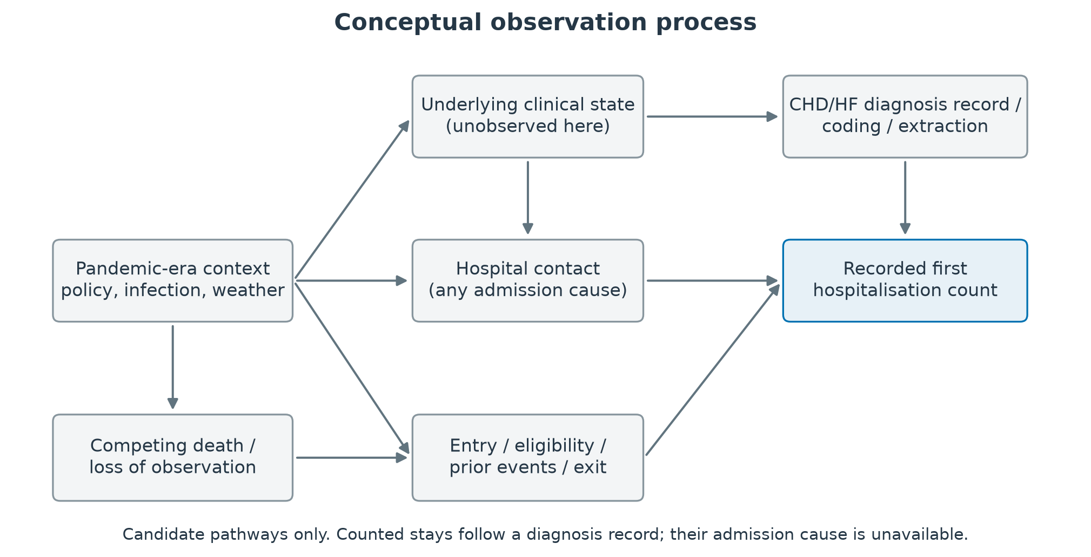

Visual comparison of nested and full windows
Supplementary Figure S2. Official day associations in overlapping analysis windows. CHD denotes coronary heart disease; HF denotes heart failure. Points and Newey–West lag-six 95% confidence intervals for 2013–2019 and 2013–2023 reproduce Supplementary Table S4. The pre-2020 84 months are contained within the full 132 months, and the spline basis is recalculated in each fit. The paired display is a sensitivity comparison, not independent pre/post estimates or a test of a change. Ratios are per five additional official days, without a consecutive-day requirement.
