一、主题相关要点
1、Theme Setup 主题配置
Metronic 具有6中色彩主题，default, darkblue, blue, grey, light, light2.
要部署一种主题，你需要包含../assets/layouts/layout/css/themes/[theme_name].css 在页面的 head 部分。
例如，你喜欢蓝色主题，包含../assets/layouts/layout/css/themes/darkblue.css css 文件。CSS 文件调用命令如下：
<link href="../assets/layouts/layout/css/themes/default.css" rel="stylesheet" type="text/css"id="style_color"/>

2、Theme Style 主题样式
Metronic 默认采用直角样式，若要改为圆角，只需要改变 "components.css" 为 "components-rounded.css"即可。如下所示：
<link href="../assets/global/css/components-rounded.css" rel="stylesheet" type="text/css" id="style_components"/>

3、Layout Settings 布局配置
了解如何使用 Metronic 可用布局选项的最好的方式，就是打开 Metronic 页面，使用位于页面右上角的 "Theme Settings" 面板。选择你的首选布局选项，当你的布局组合变化时，采用 Chrome 开发工具或者 Firefox 的 Firebug 工具去看 HTML 源码改变。当你改变某个布局选项，通常一些 css 样式会增加到你的页面主体元素中。当你改变布局设置，仅仅这最高父 HTML 元素被改变，页面内容则保持原样。
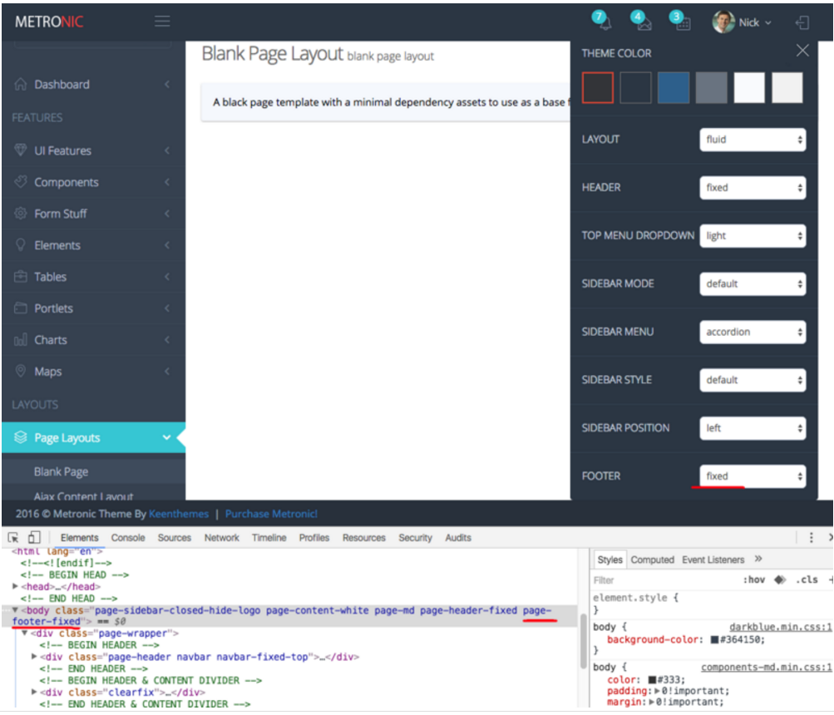
4、Fixed Header & Footer On Mobile Devices 在移动设备上固定头部或底部
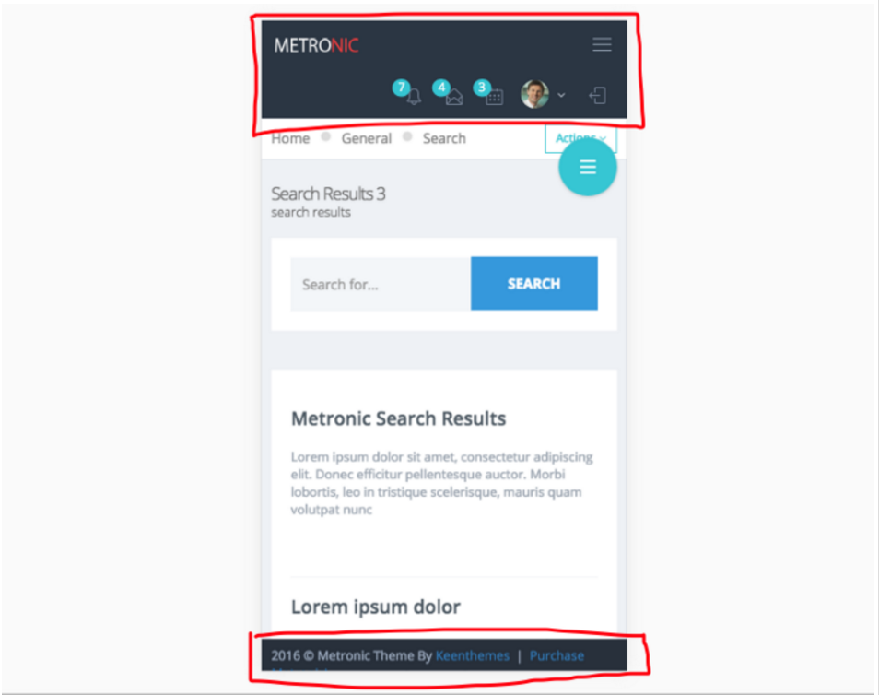
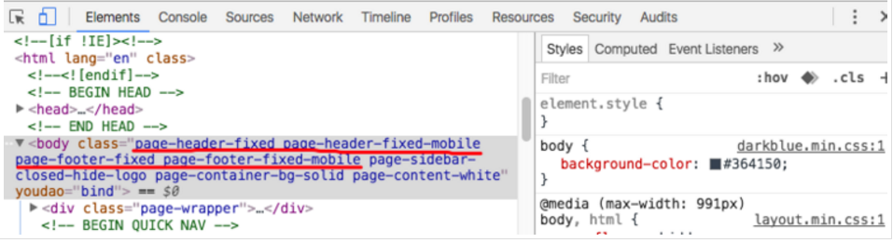

5、Sidebar Menu Settings 侧边栏菜单配置
默认的侧边栏菜单带有data-auto-scroll="true"和data-slide-speed="200"配置。若要禁用侧边栏的自动滚动效果，应用data-auto-scroll="false"到page-sidebar-menu标签。要改变子菜单滑动速度，则设置一个新的值data-slide-speed="300".
<ul
class="page-sidebar-menu page-header-fixed" data-keep-expanded="false" data-auto-scroll="true" data-slide-speed="300" style="padding-top: 20px">

6、Sidebar Menu Light Style 侧边栏 Light 样式
用着浅色侧边栏样式，你需要应用 page-sidebar-menu-light class
属性在 page-sidebar-menu class 属性后面。
<ul
class="page-sidebar-menu page-sidebar-menu-light
page-header-fixed"
data-keep-expanded="false" data-auto-scroll="true"
data-slide-speed="200" style="padding-top: 20px">

7、Sidebar Menu With Hover Submenus 侧边栏菜单弹出子菜单模式
要启用这个效果你需要应用page-sidebar-menu-hover-submenu 在 page-sidebar-menu 样式后。
<ul class="page-sidebar-menu page-sidebar-menu-hover-submenu
page-header-fixed"
data-keep-expanded="false" data-auto-scroll="true" data-slide-speed="200"
style="padding-top: 20px">

- 模板架构
1、所有的模板文件都有着固定结构，包括：header, mega menu, top menu, user bar, sidebar menu, quick sidebar, content 和 显示在底部的 footer。
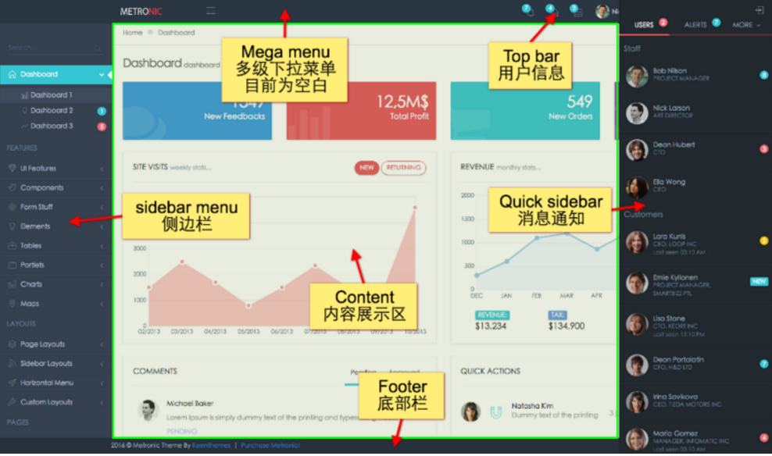

2、Metronic 所用到的插件和资源
Metronic 用了几十个插件和扩展资源，这才使得这个模板显得尤为强大。具体这些插件的描述我就不一一列述了，大家可以逐一点下下面表格的链接了解了解。
Name | Description | URL
jQuery | Core Javascript library | http://www.jquery.com
Twitter Bootstrap | Sleek, intuitive, and powerful front-end framework for faster and easier web development | http://getbootstrap.com
Select2 | Select2 is a jQuery based replacement for select boxes. It supports searching, remote data sets, and infinite scrolling of results | http://ivaynberg.github.io/se...
Bootstrap Confirmation | Socicon Social Icons. | http://mistic100.github.io/Bo...
Socicon | Bootstrap plugin for on-place confirm boxes using Popover. | http://www.socicon.com/
Bootstrap Tagsinput | Bootstrap Tags Input is a jQuery plugin providing a Twitter Bootstrap user interface for managing tags. | https://github.com/timschlech...
Flow Chart | Bootstrap plugin for on-place confirm boxes using Popover. | http://adrai.github.io/flowch...
Autosize | A small, stand-alone script to automatically adjust textarea height. | http://www.jacklmoore.com/aut...
Bootstrap Summernote | Super Simple WYSIWYG Editor for Bootstrap 3. Summernote is a javascript program that helps you to create WYSIWYG Editor on web. | http://hackerwins.github.io/s...
Bootstrap Hover Dropdown Plugin | A simple plugin to enable twitter bootstrap dropdowns to activate on hover and provide a nice user experience. | https://github.com/CWSpear/bo...
Twitter Typeahead | A fast and fully-featured autocomplete library. | http://twitter.github.io/type...
amCharts | Charting library & maps. Where all data goes visual. | http://www.amcharts.com/
iCheck | SUPER CUSTOMIZED CHECKBOXES AND RADIO BUTTONS FOR JQUERY & ZEPTO. | http://fronteed.com/iCheck/
Bootstrap Select | A custom select for @twitter Bootstrap using button dropdown. | http://silviomoreto.github.io...
jQuery Notific8 | jQuery Notific8 is a notification plug-in that was inspired by the notification style introduced in Windows 8. | http://willsteinmetz.net/jque...
jQuery jsTree | A tree view plugin for jQuery. | http://www.jstree.com/
Bootstrap Maxlength | This plugin integrates by default with Twitter bootstrap using badges to display the maximum length of the field where the user is inserting text. This plugin uses the HTML5 attribute "maxlength" to work. | http://mimo84.github.com/boot...
Bootstrap Session Timeout | After a set amount of time, a dialog is shown to the user with the option to either log out now, or stay connected. If log out now is selected, the page is redirected to a logout URL. If stay connected is selected, a keep-alive URL is requested through AJAX. If no options is selected after another set amount of time, the page is automatically redirected to a timeout URL. | https://github.com/travishorn...
jQuery Idle Timeout | This script allows you to detect when a user becomes idle (detection provided by Paul Irish's idletimer plugin) and notify the user his/her session is about to expire. Similar to the technique seen on Mint.com. Polling requests are automatically sent to the server at a configurable interval, maintaining the users session while s/he is using your application for long periods of time. | http://www.erichynds.com/exam...
Bootstrap TouchSpin | A mobile and touch friendly input spinner component for Bootstrap 3. It supports the mousewheel and the up/down keys. | http://www.virtuosoft.eu/code...
Bootstrap Date Paginator | A jQuery plugin which takes Twitter Bootstrap's already great pagination component and injects a bit of date based magic. In the process creating a hugely simplified and modularised way of paging date based results in your application. | http://www.jonathandanielmile...
Bootbox.js | Bootbox.js is a small JavaScript library which allows you to create programmatic dialog boxes using Twitter’s Bootstrap modals, without having to worry about creating, managing or removing any of the required DOM elements or JS event handlers. | http://bootboxjs.com/
Bootstrap Markdown | Markdown editing for Bootstrap. | http://toopay.github.com/boot...
Bootstrap FuelUX Input Spinner | Bootstrap FuelUX Input Spinner For App. | http://exacttarget.github.io/...
Bootstrap Context Menu | Context menu plugin for Twitter's Bootstrap framework | https://github.com/sydcanem/b...
jQuery noUiSlider | noUiSlider is a super tiny jQuery plugin that allows you to create range sliders. It fully supports touch, and it is way(!) less bloated than the jQueryUI library. | http://refreshless.com/nouisl...
jQuery IonRange Slider | Beautiful, comfortable and easily customizable range slider with skins support. Also support events and public methods, has flexible settings and can be completely modified with CSS. | http://ionden.com/a/plugins/i...
Bootstrap Toastr Notifications | Toastr is a Javascript library for non-blocking notifications. jQuery is required. The goal is to create a simple core library that can be customized and extended. | http://codeseven.github.io/to...
Bootstrap Switch | Use Radio Buttons as switches. | http://www.larentis.eu/switch/
jQuery jCrop | Jcrop is the quick and easy way to add image cropping functionality to your web application. It combines the ease-of-use of a typical jQuery plugin with a powerful cross-platform DHTML cropping engine that is faithful to familiar desktop graphics applications. | http://github.com/tapmodo/Jcrop
Bootstrap X-editable | In-place editing with Twitter Bootstrap. | http://vitalets.github.io/x-e...
Bootstrap Extended Modals | Responsive, Stackable, AJAX and more. | http://jschr.github.com/boots...
jQuery Multi Select | This plugin is a drop-in replacement for the standard select element with multiple attribute activated. | http://loudev.com/
jQuery Sparklines | This jQuery plugin generates sparklines (small inline charts) directly in the browser using data supplied either inline in the HTML, or via javascript. | http://omnipotent.net/jquery....
jQuery Input Mask | jQuery Input Mask is a jquery plugin which create an input mask. An inputmask helps the user with the input by ensuring a predefined format. This can be usefull for dates, numerics, phone numbers. | http://github.com/RobinHerbot...
jQuery Easy Pie Chart | Lightweight jQuery plugin to render and animate nice pie charts with the HTML5 canvas element | http://rendro.github.io/easy-...
jQuery Input IP Address Control | During user input field, this plugin controls the format of IPv4 or IPv6 addresses. | https://code.google.com/p/jqu...
jQuery UI Sortable | jQuery UI Sortable | http://jqueryui.com/sortable/
Pace - Page Progress Bar | n automatic web page progress bar. Pace will automatically monitor your Ajax requests, event loop lag, document ready state and elements on your page to decide on the progress. For more info check the plugin documentation. | http://github.hubspot.com/pace
jQuery BlockUI | The jQuery BlockUI Plugin lets you simulate synchronous behavior when using AJAX, without locking the browser | http://jquery.malsup.com/block/
jQuery Cookie | A simple, lightweight jQuery plugin for reading, writing and deleting cookies. | https://github.com/carhartl/j...
jQuery Pulsate | jQuery Pulsate provides animated pulsating effect that's useful for focussing attention to a certain part of your webpage in a subtle way. | http://kilianvalkhof.com/jque...
Respond | A fast & lightweight polyfill for min/max-width and CSS3 Media Queries (for IE 6-8, and more) | https://github.com/scottjehl/...
Excanvas | Modern browsers like Firefox, Safari, Chrome and Opera support the HTML5 canvas tag to allow 2D command-based drawing. ExplorerCanvas brings the same functionality to Internet Explorer. To use, web developers only need to include a single script tag in their existing web pages | http://excanvas.sourceforge.net/
jQuery Backstretch | A simple jQuery plugin that allows you to add a dynamically-resized, slideshow-capable background image to any page or element. | http://srobbin.com/jquery-plu...
jQuery Countdown | A jQuery plugin that sets a div or span to show a countdown to a given time. | http://keith-wood.name/countd...
jQuery Bootpad for Bootstrap | Dynamic pagination jQuery plugin. Works well with twitter bootstrap or standalone. | http://botmonster.com/jquery-...
Colorpicker for Bootstrap | Add color picker to field or to any other element | http://www.eyecon.ro/bootstra...
Datepicker for Bootstrap | Add datepicker picker to field or to any other element | https://github.com/eternicode...
Bootstrap Datetimepicker | This project is a fork of bootstrap-datetimepicker project which doesn't include Time part. Some others parts has been improved as for example the load process which now accepts the ISO-8601 format. | http://www.malot.fr/bootstrap...
Date Range Picker for Bootstrap | This date range picker component for Twitter Bootstrap creates a dropdown menu from which a user can select a range of dates | https://github.com/dangrossma...
Bootstrap Timepicker | Easily select a time for a text input using your mouse or keyboards arrow keys. | http://jdewit.github.com/boot...
Clockface Timepicker | Clockface is a simple timepicker for Twitter Bootstrap | http://vitalets.github.com/cl...
Bootstrap Growl | Pretty simple jQuery plugin that turns standard Bootstrap alerts into "Growl-like" notifications. | https://github.com/ifightcrim...
Bootstrap Tabdrop | Very usefull script when your tabs do not fit in a single row. This script takes the not fitting tabs and makes a new dropdown tab. In the dropdown there are all the tabs that do not fit. | http://www.eyecon.ro/bootstra...
Bootstrap Select Splitter | Transforms SELECT containing one or more OPTGROUP in two chained SELECT. | https://github.com/xavierfauc...
jQuery MiniColors | A tiny color picker built on jQuery | https://github.com/claviska/j...
jQuery Tags Input | Magically convert a simple text input into a cool tag list with this jQuery plugin | https://github.com/xoxco/jQue...
Bootstrap WYSIWYG5 | Simple WYSIWYG Editor for Bootstrap | http://jhollingworth.github.c...
CKEditor | CKEditor is a ready-for-use HTML text editor designed to simplify web content creation | http://ckeditor.com/
DataTables | DataTables for Twitter Bootstrap | http://www.datatables.net/
Bootstrap File Input | The file upload plugin allows you to create a visually appealing file or image upload widgets | http://jasny.github.io/bootst...
FancyBox | FancyBox is a tool for displaying images, html content and multi-media | http://fancybox.net/
Flot | Flot is a pure JavaScript plotting library for jQuery, with a focus on simple usage, attractive looks and interactive features. | http://www.flotcharts.org/
gmaps.js | gmaps.js allows you to use the potential of Google Maps in a simple way. No more extensive documentation or large amount of code | http://hpneo.github.com/gmaps/
FullCalendar | FullCalendar is a jQuery plugin that provides a full-sized, drag & drop calendar | http://arshaw.com/fullcalendar/
jQuery slimScroll | slimScroll is a small (3.7KB) jQuery plugin that transforms any div into a scrollable area with a nice scrollbar | http://rocha.la/jQuery-slimSc...
JQVMAP | JQVMap is a jQuery plugin that renders Vector Maps. It uses resizable Scalable Vector Graphics (SVG) for modern browsers like Firefox, Safari, Chrome, Opera and Internet Explorer 9. Legacy support for older versions of Internet Explorer 6-8 is provided via VML. | http://jqvmap.com/
jQuery File Upload | File Upload widget with multiple file selection, drag&drop support, progress bars and preview images for jQuery | http://blueimp.github.com/jQu...
DropzoneJS | DropzoneJS is an open source library that provides drag'n'drop file uploads with image previews. | http://www.dropzonejs.com/
jQuery UI Touch Punch | jQuery UI Touch Punch is a small hack that enables the use of touch events on sites using the jQuery UI user interface library. | http://touchpunch.furf.com/
Bootstrap Form Wizard | This twitter bootstrap plugin builds a wizard out of a formatter tabbable structure. It allows to build a wizard functionality using buttons to go through the different wizard steps and using events allows to hook into each step individually. | https://github.com/VinceG/twi...
Nestable | Drag & drop hierarchical list with mouse and touch compatibility. | https://github.com/dbushell/N...
jQuery Validation Plugin | The jQuery Validation Plugin provides drop-in validation for your existing forms, while making all kinds of customizations to fit your application really easy | http://bassistance.de/jquery-...
FontAwesome | The iconic font designed for use with Twitter Bootstrap | http://fortawesome.github.com...
Simple Line Icons | Simple Line Icons is 162 simple stroke icons that are great for mobile applications, websites, user interfaces, etc. All icons were converted from the same beautiful simple line icon sets released previously on GraphicBurger. | http://graphicburger.com/simp...
Open Sans | Metornic uses Open Sans web font from google fonts: http://fonts.googleapis.com/c... | http://www.google.com/webfonts

- 三级菜单参考demo：layout_mega_menu_dark.html
layout_mega_menu_light.html
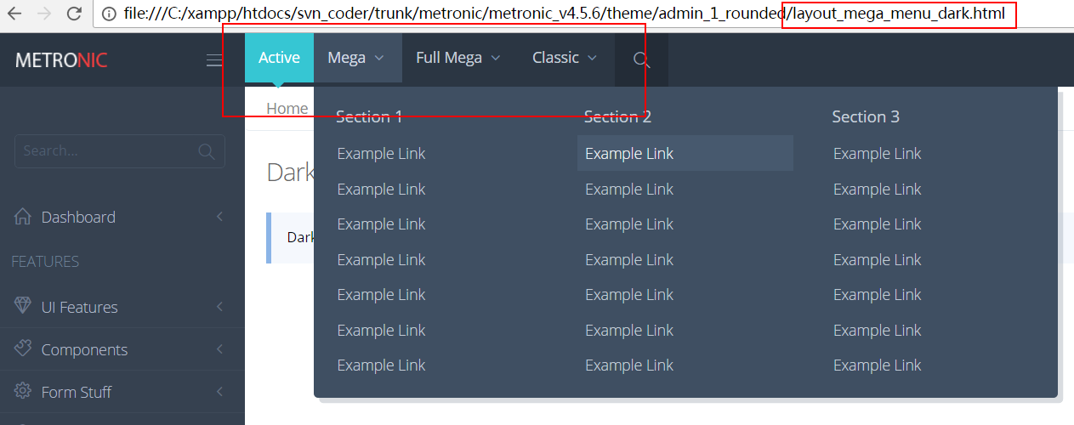

4、按钮弹出 YES/NO 选择按钮 ，demo： ui_confirmations.html
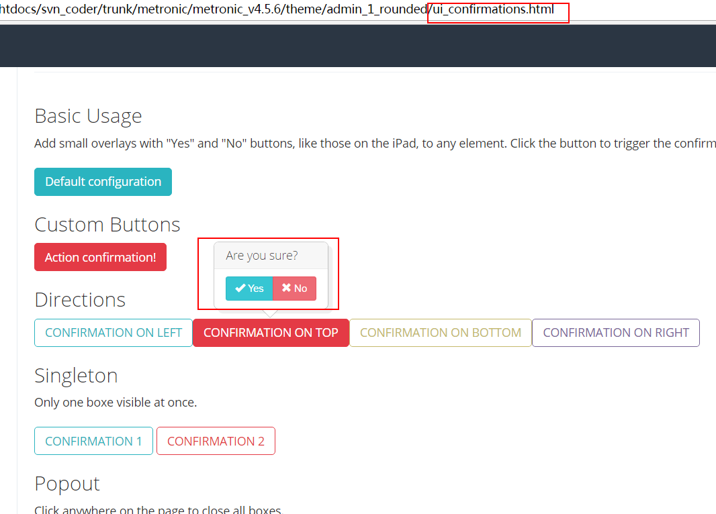

- 色块展示 ui_titles.html
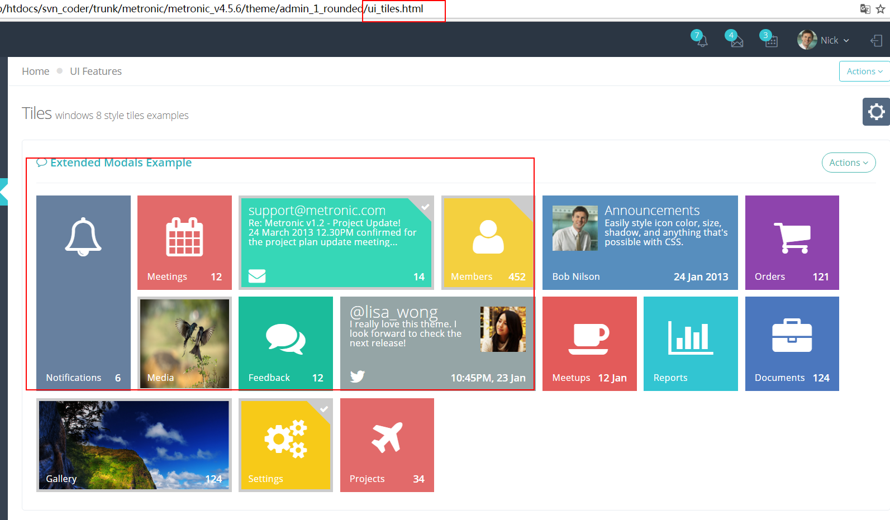

初步参考实现效果：
