F1 TELEMETRY ANALYSIS
2024 Season — Full Findings Report

01 Telemetry Overview
Lap times, speed traces, braking & throttle — 2024 Bahrain GP
02 Lap Time Prediction Model
Gradient boosting model trained on 3,482 laps. MAE 0.38s, R² 0.78
03 Driver vs Car Analysis
97% car / 3% driver. Teammate gap decomposition across 4 races
04 Weather & Temperature
Rain races (Canada, Britain, Brazil) — wet rankings, temp windows
05 Sector Time Analysis
Where drivers gain time — 15,898 laps across 16 circuits

Python • FastF1 • scikit-learn • pandas • matplotlib
github.com/bobsterbeat/f1-analysis

01 Telemetry Overview
A first look at what FastF1 provides: real lap times, speed traces, and driver inputs at 10Hz resolution across a full race. Comparing Verstappen and Hamilton at Bahrain.

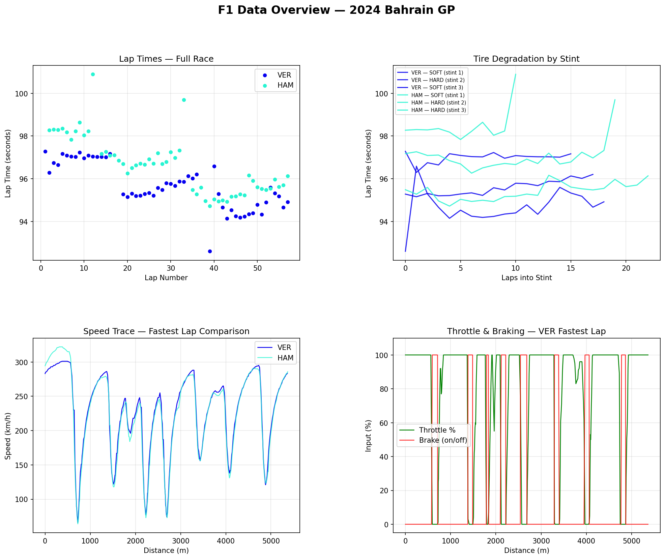

What each panel shows
• Top left — Lap times across the race. Both drivers improve as fuel burns off; VER consistently 1–2 sec faster each lap.
• Top right — Tyre degradation by stint. Soft tyres fast but fade; both switch to Hard mid-race. HAM's Hard stint degrades more steeply.
• Bottom left — Speed trace on fastest lap. Same circuit sections, different peak speeds on the straights and different braking points into corners (the dips).
• Bottom right — Throttle and braking inputs. Full throttle zones (green flat at 100%), hard braking events (red spikes). VER carries throttle slightly earlier out of slow corners.

02 Lap Time Prediction Model
A Gradient Boosting model trained on 3,482 laps across 5 races (Bahrain, Saudi Arabia, Australia, Japan, China) to predict lap time from physical inputs. Target variable: delta from circuit median to remove between-circuit baseline differences.

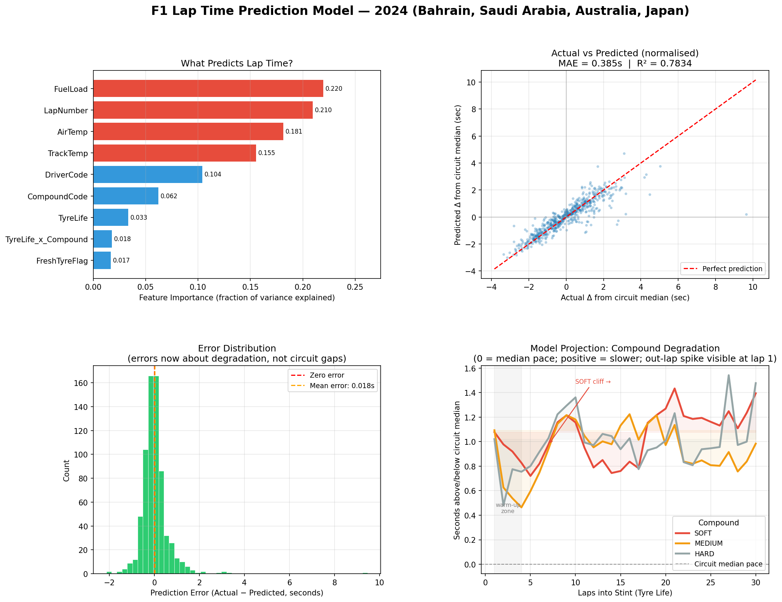

Feature importance — what actually drives lap time variation within a race
Feature | Importance | What it means
Fuel load | 22% | ~110 kg at race start, burns ~1.6 kg/lap. Up to 5–7 sec improvement across the race just from weight loss.
Lap number | 21% | Correlated with fuel load, plus track rubber build-up and safety car timing.
Air temperature | 18% | Governs how quickly tyres reach their grip window. Hot air accelerates overheating.
Track temperature | 15% | Surface grip changes through the day. 40–45°C is the sweet spot for all slick compounds.
Driver | 10% | Pace differences and tyre management style between drivers in the same car.
Tyre compound | 6% | SOFT vs MEDIUM vs HARD baseline pace difference.
Tyre life | 3.3% | Laps on current set — the actual degradation signal.
Compound × tyre life | 1.8% | Whether degradation rate differs between compounds.
Out-lap flag | 1.7% | First lap of every stint — cold rubber on cooling tarmac.

The fuel finding
A car at race start weighs ~200 kg more than at the end including fuel. Every 10 kg costs ~0.35 sec/lap. Fuel load alone accounts for 5–7 seconds of improvement across a race — from the car simply getting lighter, with nothing else changing.
This is why lap times improve through the first 20–30 laps even as tyres degrade. The two effects oppose each other: lighter car (faster), wearing tyres (slower). Strategy engineers balance both simultaneously.
Tyre life at 3.3% — small percentage, real absolute effect
3.3% of within-race variation is tyre life. In absolute terms a tyre going from lap 1 to lap 30 can add 1–2 sec per lap — an enormous strategic cost. The percentage is small because fuel burn is the bigger source of lap-to-lap variation, not because tyre management is unimportant.

03 Driver vs Car
Teammates share the same car, tyres, and conditions. Any consistent lap time gap between them is driver, not machinery. Car pace = average of both teammates, cancelling driver effects entirely.

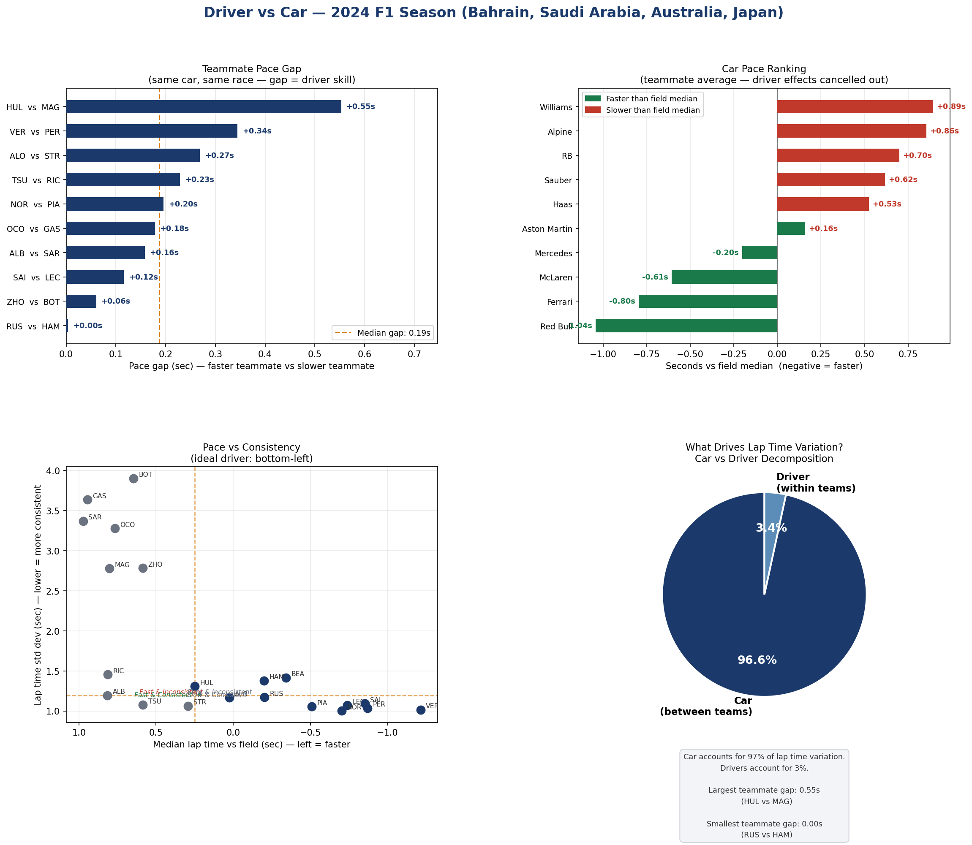

The headline: 97% car, 3% driver
Of all lap time variation across 4 races, 96.6% is explained by which car you are in. Only 3.4% comes from the driver. This quantifies a well-known engineering truth: the single most impactful decision a driver makes is which contract they sign.
Teammate gaps (identical machinery)
Team | Faster | Slower | Gap | Car pace vs field median
Red Bull | VER | PER | +0.34s | -1.04s ← fastest car on grid
Ferrari | SAI | LEC | +0.12s | -0.80s
McLaren | NOR | PIA | +0.20s | -0.61s
Mercedes | RUS | HAM | +0.00s | -0.20s ← closest pair (4 ms)
Aston Martin | ALO | STR | +0.27s | +0.16s
Haas | HUL | MAG | +0.55s | +0.53s ← largest driver gap
Sauber | ZHO | BOT | +0.06s | +0.62s
RB | TSU | RIC | +0.23s | +0.70s
Alpine | OCO | GAS | +0.18s | +0.86s
Williams | ALB | SAR | +0.16s | +0.89s ← slowest car

Notable findings
• Mercedes RUS vs HAM: +0.004s — four milliseconds across four races. Two elite drivers, statistically identical.
• Haas HUL vs MAG: +0.55s — largest gap on grid. Hulkenberg significantly outperforming his machinery.
• Red Bull has the fastest car by 0.4s over Ferrari (-1.04s vs -0.80s vs median). Verstappen extracts an additional 0.34s from it that Perez cannot.

04 Weather & Temperature
Three 2024 races had significant rainfall: Canada, Britain, Brazil. Combined with 13 dry races covering the full track temperature range (17°C Las Vegas night race to 55°C Italian GP), this gives a rich dataset for weather effects.

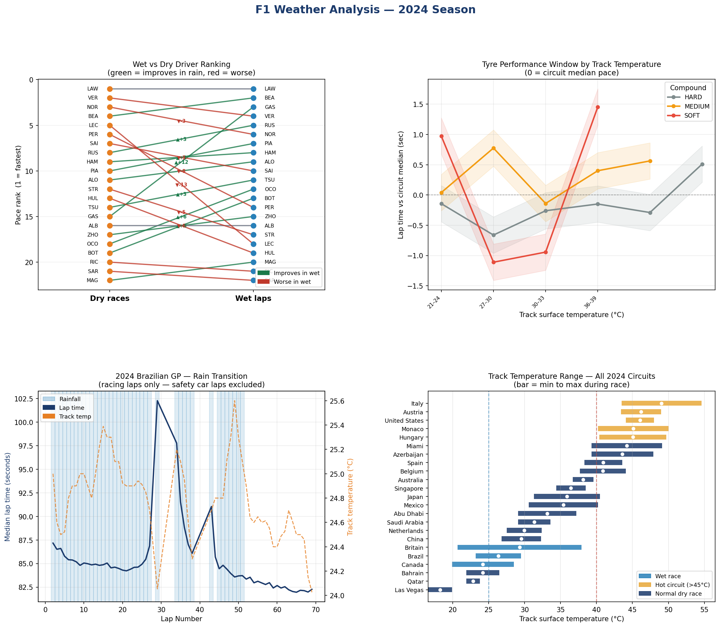

Wet vs dry ranking shifts — selected drivers
Driver | Dry rank | Wet rank | Change | Interpretation
GAS | 15 | 3 | ▲ +12 | Massive wet specialist — gains almost entirely in S2 (technical corners)
OCO | 18 | 12 | ▲ +6 | Consistent wet improvement, particularly in medium-speed sections
BOT | 19 | 13 | ▲ +6 | Wet conditions suit his measured, smooth style
RUS | 8 | 5 | ▲ +3 | Already fast in dry, still improves relatively in wet
HAM | 9 | 8 | ▲ +1 | Reputation as wet specialist not reflected in 2024 data — essentially flat
VER | 2 | 4 | ▼ -2 | Red Bull 2024 highly optimised for dry; wet conditions reduce car advantage
NOR | 3 | 6 | ▼ -3 | McLaren's mechanical grip advantage less pronounced in wet
PER | 6 | 14 | ▼ -8 | Significant wet-weather weakness; car and driver both contributing
LEC | 5 | 18 | ▼ -13 | Largest drop on grid; Ferrari's wet setup and LEC's style compound each other

Temperature and tyre grip window
• 38–45°C track surface: sweet spot for all three slick compounds — all converge near median pace.
• Below 30°C (Canada, Britain, Las Vegas): tyres struggle to generate heat. Lap times are variable and unpredictable.
• Above 50°C (Italy, Monaco): soft compound degrades rapidly. Teams avoid soft tyres in race trim at hot circuits.
• Las Vegas is an outlier — only night race, November desert, 17°C track surface. Tyre warm-up was a dominant strategic factor.
Brazil rain transition
With safety car laps excluded, the spread in racing pace during rainfall was ~20 seconds — from ~82s (dry laps) to ~102s at peak rainfall. The chart shows track temperature dropping with rain and recovering slowly, compounding the grip loss from wet tarmac.

05 Sector Time Analysis
Breaking lap times into three sectors reveals where each driver makes their time — and which part of a circuit suits each car. Built from 15,898 laps across 16 circuits, 24 drivers.

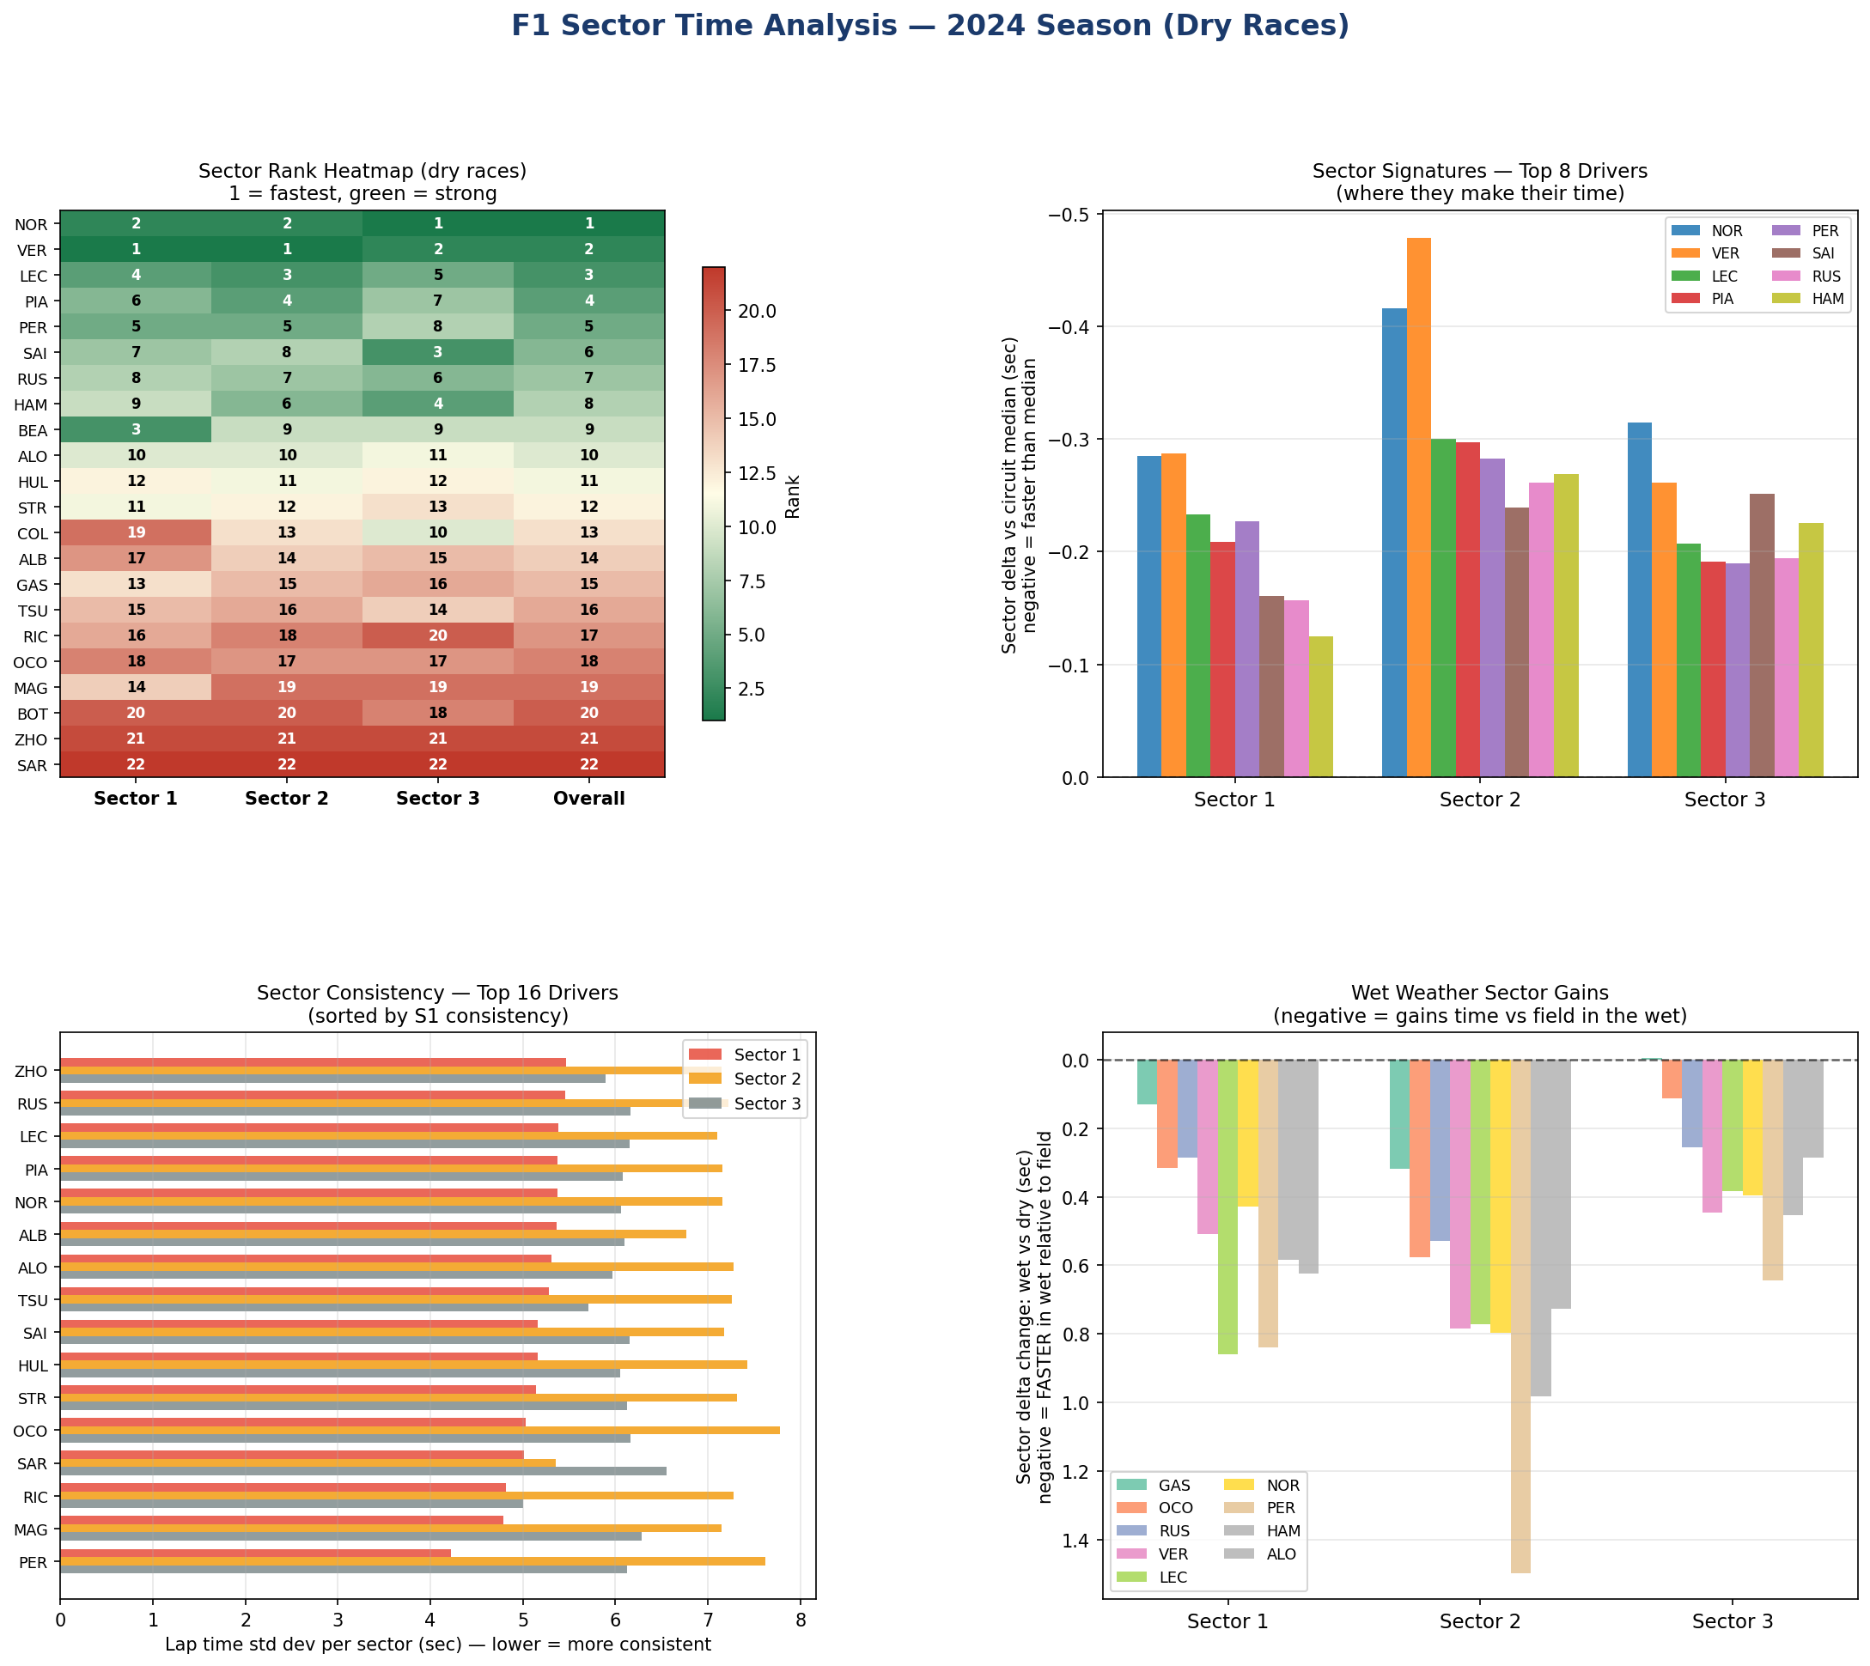

Sector heatmap — key findings
• Verstappen vs Norris: VER fastest in S1 (high-speed corners), NOR leads in S3 (braking and traction). Real car characteristics: Red Bull aero dominance in fast corners; McLaren mechanical grip in slow/technical sections.
• Leclerc vs Sainz: same car, 3rd vs 6th overall, but opposite sectors. LEC gains in S1 and S2; SAI in S3. Same machinery, completely different driving styles.
• Hamilton: 8th overall but 4th in S3 specifically — outstanding in braking zones and traction. Loses ground to top four in high-speed S1, consistent with Mercedes' 2024 high-speed aero limitations.
Consistency — sector standard deviation
• Zhou (ZHO): most consistent driver on the grid lap-to-lap. Not fast (20th) but extremely repeatable — tight standard deviation across all three sectors.
• Perez (PER): widest bars — high variance across all three sectors. Reflects well-documented inconsistency in 2024 and mirrors the large teammate gap vs Verstappen.
Where wet-weather specialists gain (S2 is the key)
• Gasly's +12 position wet ranking gain is almost entirely Sector 2 — medium-speed technical corners where smooth throttle and brake control under low grip dominates.
• Leclerc's -13 drop is also S2-concentrated. Ferrari's wet setup sensitivity and LEC's aggressive style amplify each other in precisely the corners where wet conditions matter most.
• S1 (high-speed) and S3 (traction) show much smaller wet vs dry shifts across all drivers — the rain effect is specific to technical mid-speed sections.

