**Module 7: Standard Errors and Confidence Intervals**

Reporting Statistical Error

When we sample from a population and use  to estimate μ, it is extremely unlikely that  will be exactly the same as μ. Why?

Fortunately however, the astonishing fact tells us that

P(μ − 2σ/ ≤  ≤ μ + 2σ/) ≈

which means that  will be within 2σ/of μ about _____% of the time.

It would seem, however, that this is not useful whenever σ is unknown

(which is almost always the case).The Standard Error of 

A Powerful Idea:

Since s estimates σ, we can use  to estimate σ  = (σ /)

 is called the *standard error* of .

 is an estimate of the standard deviation of the sampling distribution of .

 is often reported along with  to indicate its precision.

# Example: Returns on Microsoft Stock

For the returns on Microsoft during 2004-2007, we estimated μ by  = .00048 and estimated σ by *s* = .0120 with *n* = 1,006 observations.

Here, the standard error of  is 0.012/√1006 = .00038.

What does this standard error convey?

The previous JMP output for the GM92 returns reports the standard error of .

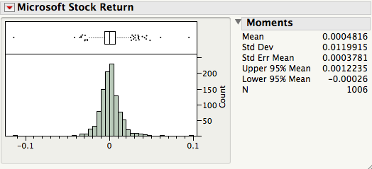

# The Standard Error of the M&M’s Estimates

We saw in Module 6 that the standard deviation of the class estimates was

Bad news: we used all the class samples to calculate this number. This is useless when we only have one sample.

Good news: an effective alternative is the standard error  and it can be calculated from a single sample!

Using one bag of M&M’s, we obtain[1]

 = and s / =

Is this close to our class findings?

# A 95% Confidence Interval for μ

A convenient way to convey the precision of a statistical estimate is to report a range of “probable” values of the parameter. This is done by reporting a *confidence interval*.

When x1,…, x*n* is an iid sample from a population,



is called a 95% confidence interval (CI) for the population mean μ.[2]

The “95%” part of this name is known as the *confidence level* of the interval.

# Example

For the returns on Microsoft,  = .00048, *s* = .0120, and *n* = 1,006

The resulting (approximate) 95% CI for μ is

[0.00048 – 2(0.0120/√1006), 0.00048 + 2(0.0120/√1006) = (-.0003, .0012).

Key property: 95% CIs contain the population mean μ for 95% of samples.

To see why, recall from page 6-18 that 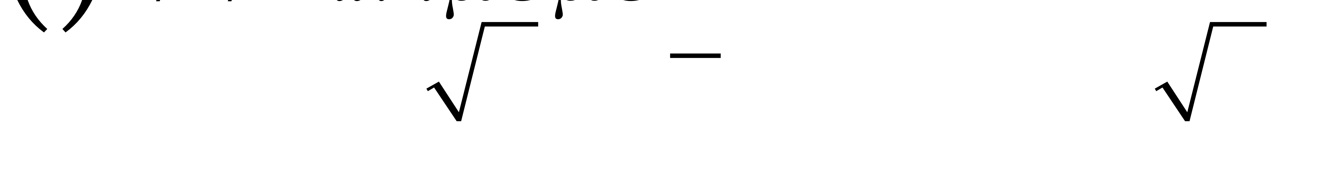 ≈ 95%

so that if we estimate σ by *s*, and

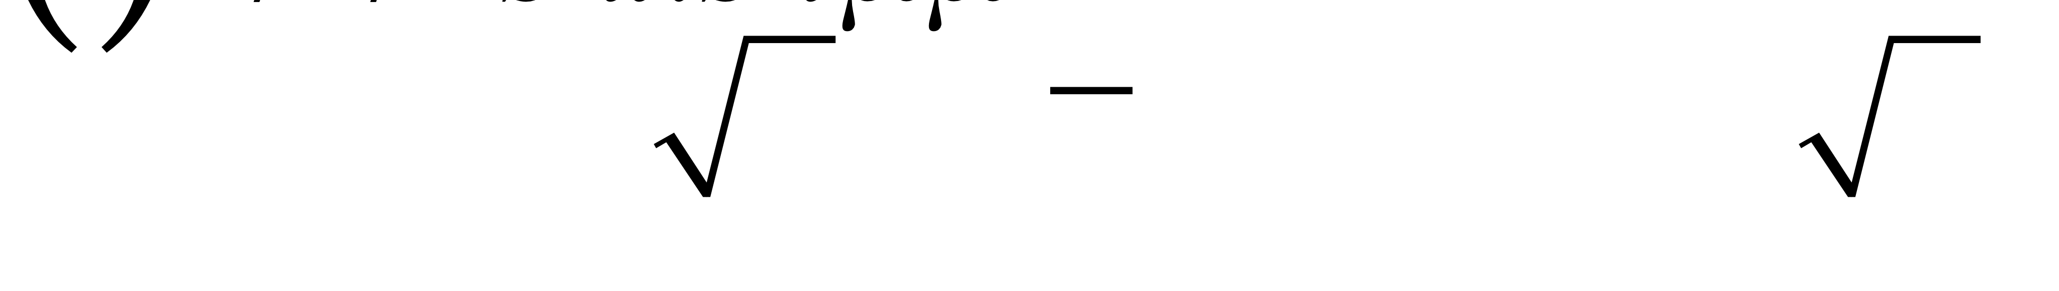 ≈ 95%.

Thus, 95% of samples have the property that  is within 2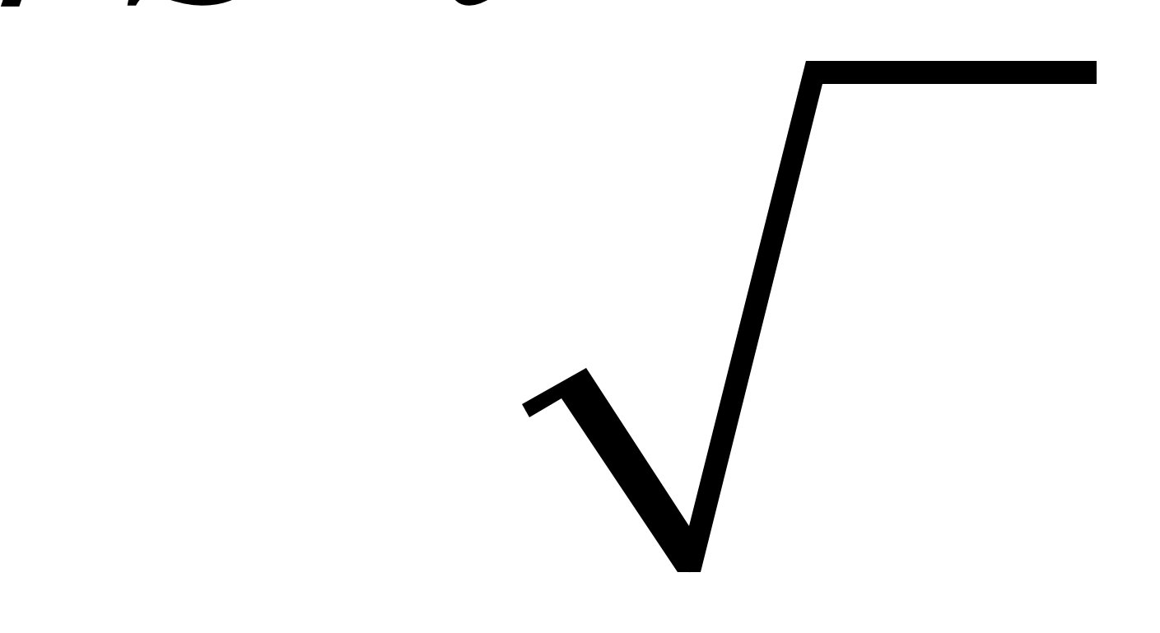 of *μ*, or equivalently that *  *is contained in .

# Exact Confidence Intervals For μ

When x1,…, x*n* iid ~ N(μ,σ2), exact confidence intervals for μ take the form

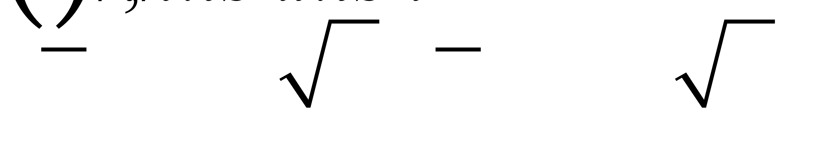

where *t* is a predetermined constant that depends on the sample size *n* and the desired confidence level (again, this is usually 95%).

For example, if *n* = 20, we can see the “price” of not knowing σ and having to estimate it from the data. The confidence interval is longer.

*t* = 2.09 yields a 95% CI and *t* = 1.72 yields a 90% CI

Good news: JMP provides[3] exact 95% CI limits for μ.

Example: we can now explain the diamond that JMP shows by default in the boxplot. It’s the 95% CI for μ. For the returns on Microsoft, we get this summary:

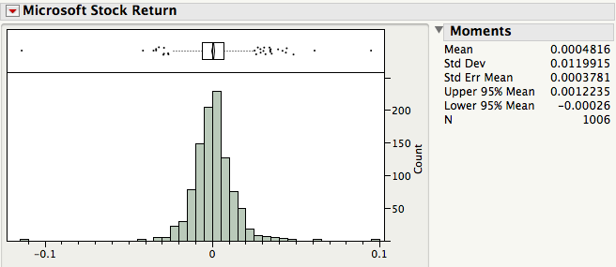

The 95% CI for μ here uses the exact procedure. How does it compare with the approximate interval (-.0002, .0034) on page 7-2?

# The "±2 Standard Error" Rule of Thumb

Unless *n* is small (≤ 30) and precise confidence is needed, the approximate 95% CI bounds given by 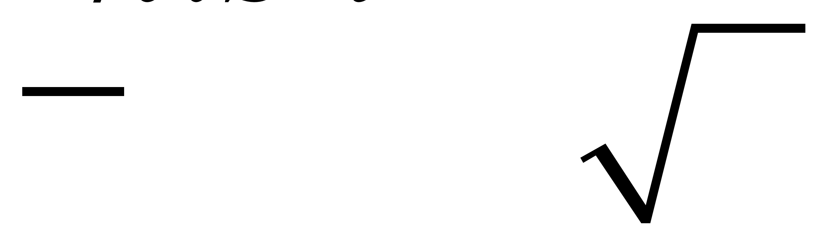 are fine.

# Confidence Intervals are not Prediction Intervals!

When x1,…, xn are iid ~ N(μ,σ2), an (approximate) 95% *prediction interval* [4] for a future draw from this population is defined as

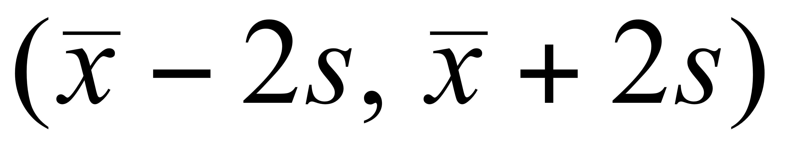.

Careful!This is *not* the (approximate) 95% CI for the population mean μ.



The prediction interval is wider because individual values are more variable than averages.

Example: let’s revisit the 400 observations of motor shaft diameters in *ShaftXtr.JMP* (BBS, p.97).[5]



A 95% CI for the mean of the shaft-making process is (814.90, 815.08).

Assuming the process remains in control (recall control charts, as shown on BBS p.75), an approximate 95% tolerance interval for the diameter of a future shaft is (814.99 – 2(.93), 814.99 + 2(.93)) = (813.13, 816.85).

Which interval is wider? Why?

# The Effect of the Sample Size

The width of the 95% CI for the mean of the motor shaft process is (using all of the data) 815.1–814.9 = 0.2 (p 7-6). What would happen to the width of the 95% CI for the mean if the sample size *n* was larger?

Using the ±2 standard error rule of thumb, the width of a 95% CI for the mean is

Width = 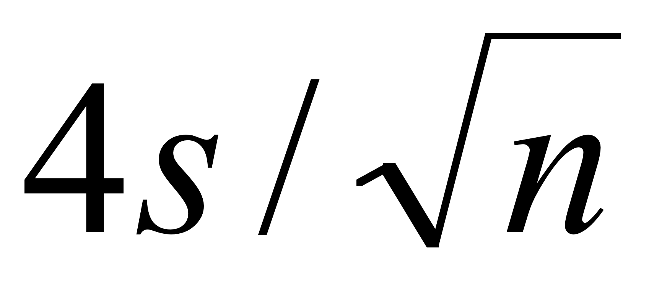.

Suppose we doubled the sample size from *n* to 2*n*. What would happen to the width of the interval?

The *margin of error* of an estimate  reported in the media is usually half the width of the 95% CI, namely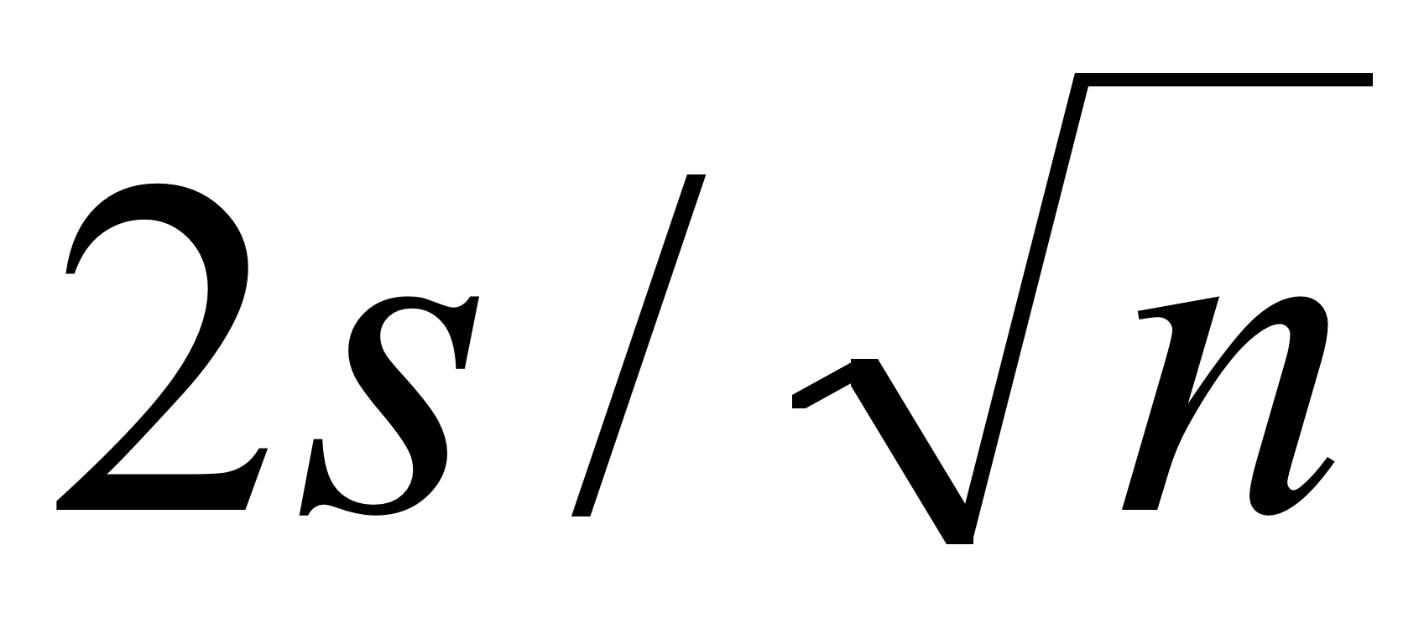.

When estimating a population proportion such as in a political poll, the maximum margin of error for the 95% confidence interval is approximately 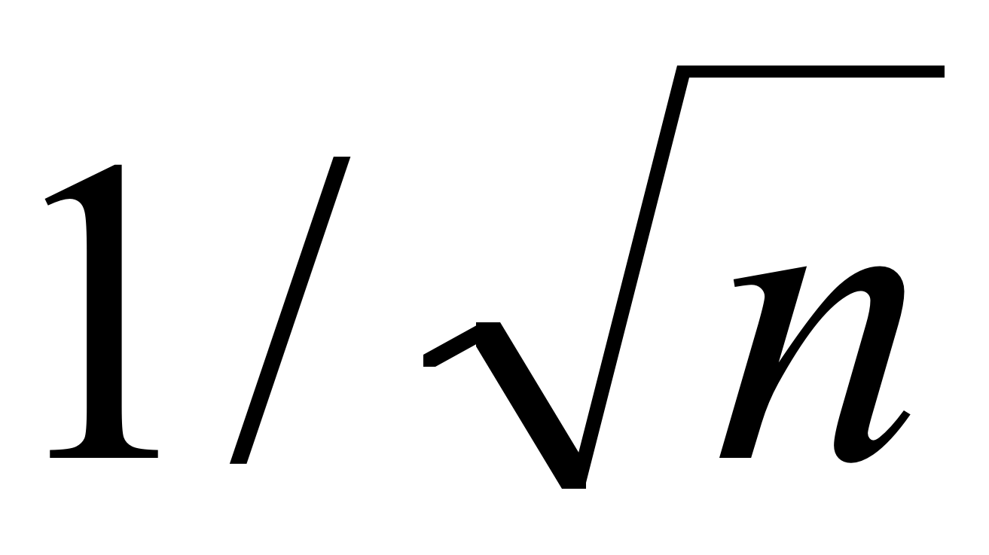. This can be used to choose the sample size *n* needed to guarantee a 95% level of accuracy for a desired margin of error.

# An Intent to Purchase Survey (BBS, p.104)

A manufacturer of consumer electronics would like to know how many households intend to purchase a computer next year. The file *CompPur.JMP* contains the yes or no responses of 100 households.

The JMP summary[6] for the nominal yes-no variable Intend_to_Purchase



Management hopes that the proportion is at least 25% in order to justify sales projections.

Does the survey dash their hopes?

Assuming the survey has truly sampled the population of interest, the issue here is:

Can the difference between 14% and 25% reasonably be attributed to chance (i.e., to sampling variation)?

To answer this question with a confidence interval, we transform the variable Intend_to_Purchase to a numerical variable Intend:[7]

Intend = 0 if Intend_to_Purchase = No

Intend = 1 if Intend_to_Purchase = Yes

Because Intend is numerical, the JMP summary provides moments and the 95% CI for the (unknown) population proportion.



Note that the sample proportion 14% is the mean  of Intend.

Do management’s hopes now seem reasonable?

# Take-Away Review

A confidence interval is a range of plausible values for the population parameter. The confidence level of the interval indicates just how plausible this range is.

Most of the confidence intervals that we use are 95% confidence intervals.

To form a 95% confidence interval for the population mean, we can use the exact interval or the approximate “back of the envelope” interval

.

This form is typical of most of the CIs we will use in this course and Stat 621, namely

(estimated value ± 2 SE(estimated value)).

# Next Module

If a value lies outside of the confidence interval, our analysis today suggests that “it’s not plausible” at some level of confidence. But once a value lies out of the interval, that’s about all we can say.

Statistical tests take this idea further and directly measure the reasonableness of a hypothesized population value.

1. An easily computed approximation to s in this context is 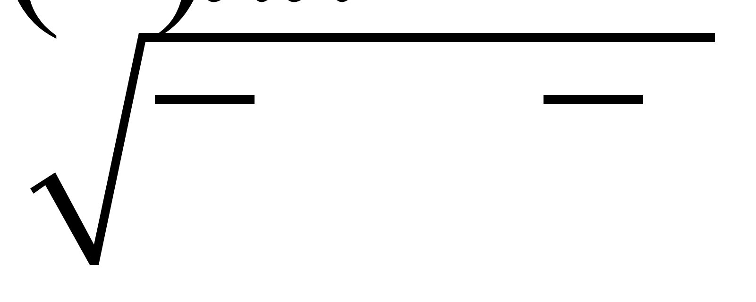.
2. Technically, this interval is an approximate 95% interval because we use 2 and estimate σ, the population SD, by *s*, the sample SD. By varying the number of standard errors, we can obtain confidence intervals with different confidence levels.
3. Using Analyze > Distribution, it is listed in the Moments output.
4. In the context of statistical process control, prediction intervalsare sometimes called tolerance intervals.
5. Many of the examples that we use in these notes appear with further discussion in the Basic Business Statistics (BBS) casebook.
6. Using Analyze > Distribution, the output for a categorical variable takes this form.
7. 0/1 encodings of a categorical variable will be common in Stat 621. They’re known as dummy variables.