Module 2: Finding Structure in Data

Discovery with Statistical Tools
Just looking at raw numbers reveals little, especially for large data sets.

Graphical and numerical summaries narrow the focus to essential features of data.

Finding a revealing view of the data is the key to effective statistical explorations.

Summarization can be very useful in forming a decision. In order to make use of data,
we can often make a better choice if we can summarize the information.

To motivate and illustrate such methods, we’ll study four data sets using JMP.

GMAT Scores (BBS, p. 9)
The analysis of data depends on the nature of your question. Managers have different questions and so, will often approach a task differently.

For this example, consider the questions that might be asked about GMAT scores at Wharton.

Student:
Where do I place in the class of Wharton MBA students?

Vice-Dean:
How does the entering class compare to those at other programs?
How have scores trended over time?

Effective statistical summaries can make it easy to answer both types of questions much more precisely and concisely than from the raw scores themselves.
The first column of the Excel file GMAT05.XLS consists of the GMAT test scores of 799 members of the Wharton MBA, Class of 2005. That’s one variable with 799 observations, one row for each of these students. Let’s open this file with JMP.

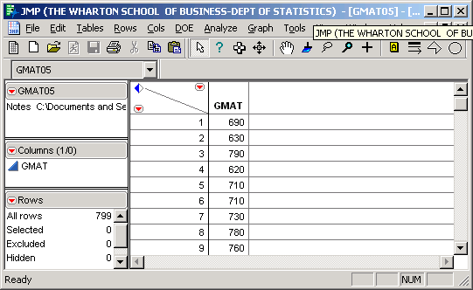

What do you learn by looking directly at this column of 799 numbers?
JMP provides graphical and numerical summaries of the 799 observations of the variable named GMAT.

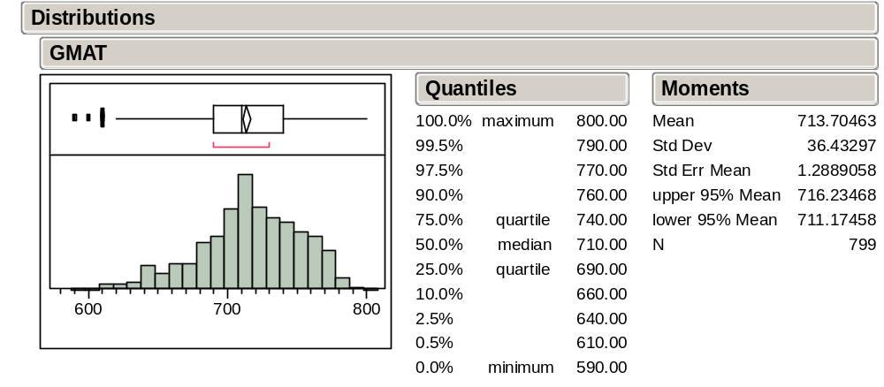

On the left are two graphical summaries of the data—a boxplot and a histogram. On the right are numerical summaries—various quantiles and moments.

Let’s consider these one at a time and link the numerical summaries to the picture.

Histogram
A histogram is a visual display that reveals the location, dispersion, and shape of the data distribution.

The basic idea is that the area of each rectangle is proportional to the number of values (frequency) in each interval or bin.

Although programs such as JMP automatically pick a reasonable number of intervals for the histogram, it is sometimes useful to consider an alternative number of intervals.

What is gained and lost by decreasing the number of intervals? Are the modes found in the histogram on the right meaningful or just artifacts of a subjective choice?

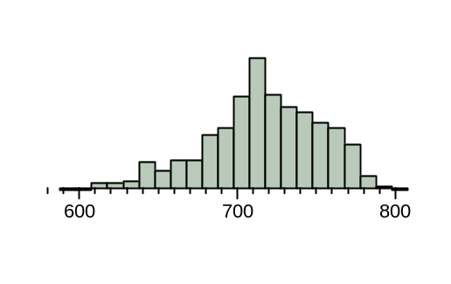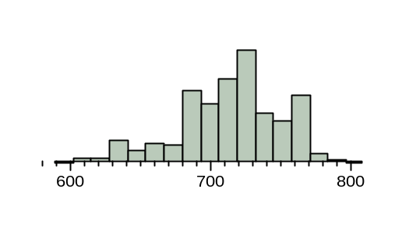
General shape characteristics to look for: symmetry, left skewness, and right skewness.

Moments
Moments are average quantities of interest.

The mean and standard deviation (SD) are the two most basic and commonly used moments.

The (sample) mean, denoted by 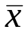, is defined as

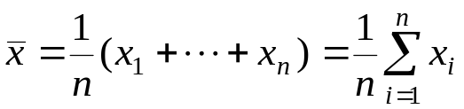

where x₁,…, x_{n} stands for the n data values of the variable x. Note that is simply the average of the data values.

From the JMP summary for the GMAT data, the mean =

What aspect of the data is captured by the mean?
The mean is the “balancing point” on the histogram. A piece of wood of constant thickness shaped like the histogram would balance at the mean.

The (sample) variance, denoted by s², is defined as

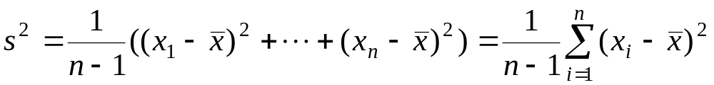.

Note that s² is simply the average of the n squared deviations from the mean, which are represented above by 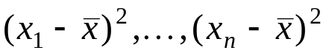.

The (sample) standard deviation, denoted by s, is defined as

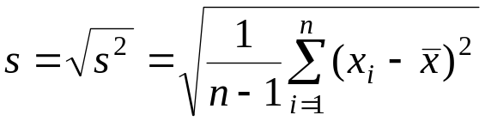

which is just the square root of the variance.
From the JMP summary for the GMAT data, the standard deviation s =

From this we can deduce that the variance s² =

Note that since one can easily obtain the standard deviation from the variance, and vice-versa, it suffices to report only one of them.

Which of the following set of five values will have a larger variance and standard deviation? Why?

-2, -1, 0, 1, 2 or -4, -2, 0, 2, 4

What aspect of the data is captured by the variance and the standard deviation?

What units ought to be attached to the variance?
to the standard deviation?

Which of the variance and standard deviation seems more understandable?

Quantiles
Quantiles are derived from the ordered data values. The k% quantile (also called the k^{th} percentile) is a value that separates the bottom k percent of the ordered data from the top.

Quantiles can be used both to capture the location of the data (instead of the mean), as well as measure the spread of data (instead of the standard deviation).

The most commonly used quantiles are the median (50th percentile), the first quartile Q1 (25th percentile), and the third quartile Q3 (75th percentile). How do these divide up the area on a histogram?

Which is a more appropriate measure of the center of data, the mean or the median?

For a right skewed distribution, which is larger, the mean or the median?

An alternative to the standard deviation as a measure of spread is the Interquartile Range, defined as IQR = Q3 – Q1, which for the GMAT data is

What aspect of data is captured by the IQR?

Boxplots
A boxplot is a visual summary of the data based on quantiles. A boxplot makes it easy to relate the quantiles to the histogram.

The main features of a boxplot identify the median, Q1, and Q3.

These are displayed as follows (BBS, p. 12).

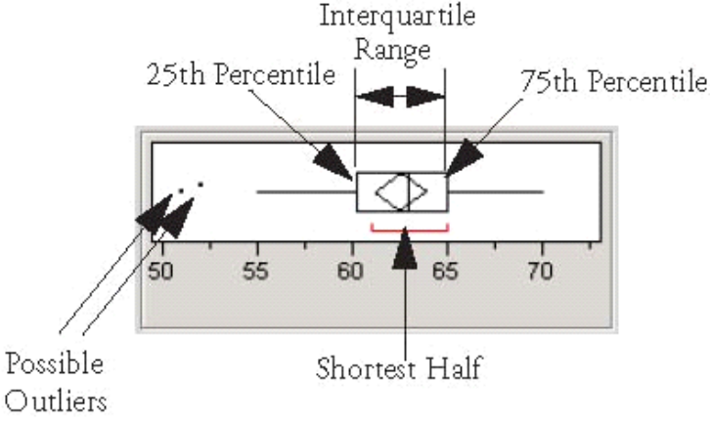

Remark: JMP calls this an “outlier boxplot.” JMP also provides a “quantile boxplot” which is similar.

Prices of GM Stock (BBS, p. 23)
Question: What is the risk associated with owning a stock like that of GM?

The Excel file GM.XLS contains daily closing prices on a share of GM stock. The worksheet GM92 contains 1992-1993 data and GM87 contains 1987-1988 data.

Let’s use the JMP command Open to select GM92 and study the variable Price.

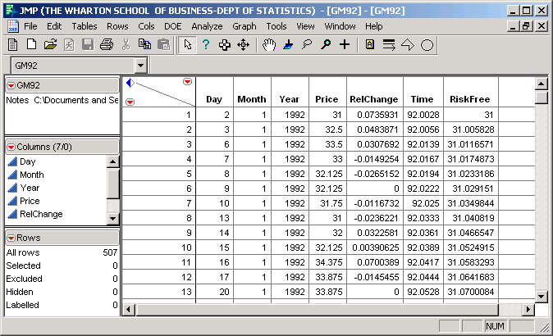
Because the prices form a time series (i.e., a sequence of observations that are ordered in time), we begin with a time series plot (BBS, pp. 24-25).

GM Daily Price 1992-1993
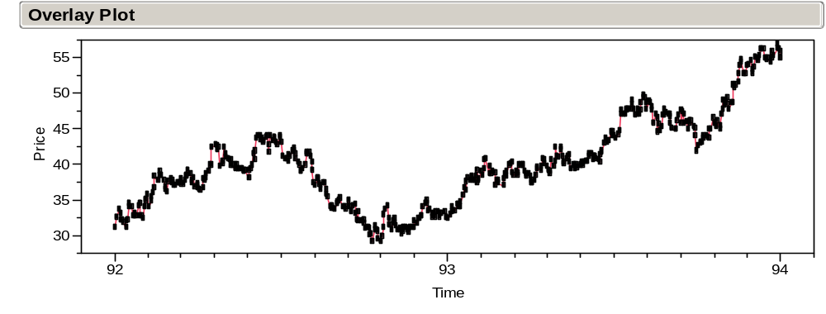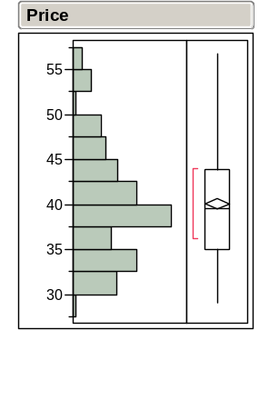
Note the meandering behavior of this time series.

Successive draws do not stray too far from each other. This is a manifestation of sequential dependence. The price each day depends on the price the previous day.

Does the histogram provide an adequate summary of a variable with this sort of dependence? What does it hide?
A sequence of independent random draws from a population (i.e., a random sample) would not manifest such meandering behavior. The ordering would not affect our understanding of the variance of the data.

To get some insight into what a sequence of independent draws might look like, let’s randomly shuffle the order of Price. A time series plot of Shuffled Price looks like

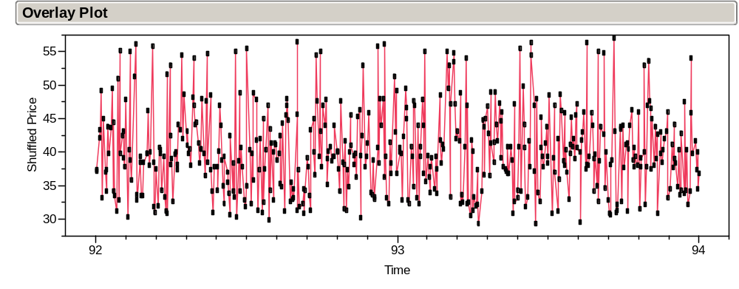

The sequential variation patterns of Price and Shuffled Price are so different; it is implausible that the Price values are a sequence of independent draws from a population.

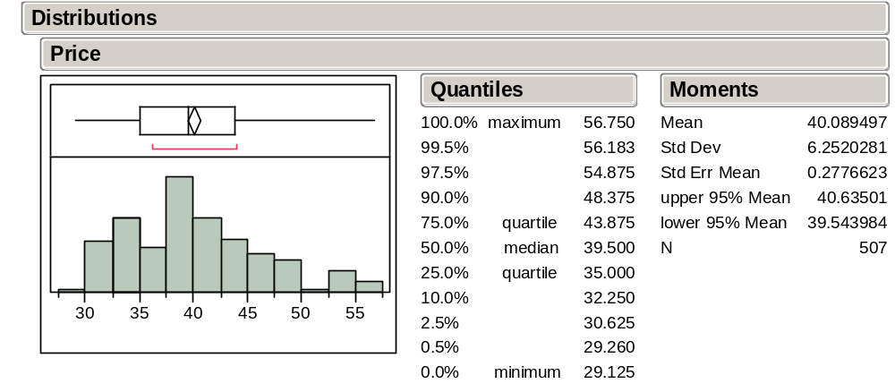

Note that both the histogram and summary statistics conceal the meandering behavior.

If you only saw this output, you wouldn’t be able to recover the sequential dependence that is such a dominant feature of the time series plot.

As a summary of the variation, a histogram is misleading. This histogram does not distinguish between a plot of the data without patterns like that on pp. 2-14 (after scrambling the order) and the smooth, meandering patterns seen in the sequence plot of the returns on pp. 2-13.

Letting p_{t} denote the price of GM at time t, a different perspective is obtained by focusing on the successive daily relative changes or net returns (BBS, pp. 26-27).

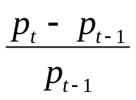

The time series plot of RelChange looks much more like a sequence of independent draws from a population. The meandering pattern has disappeared.

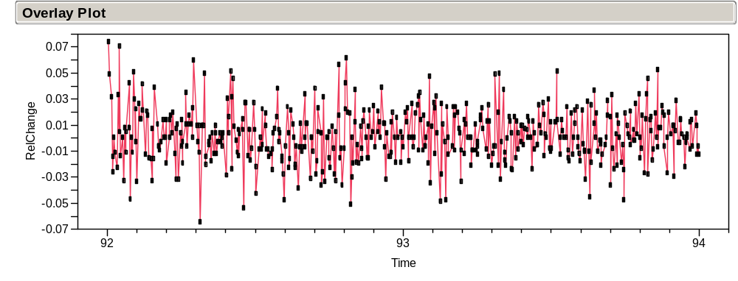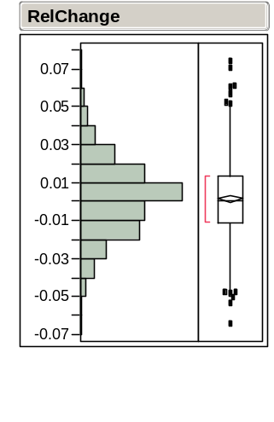
This is confirmed by the following time series plot of the randomly shuffled values of RelChange.
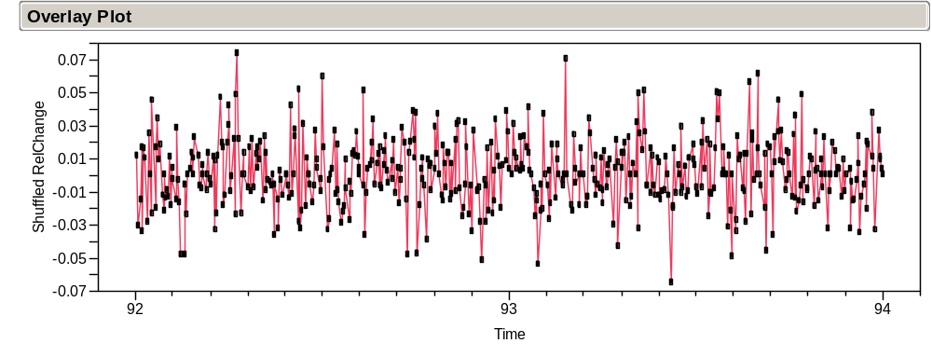

Note the similarity of the variation patterns of RelChange and Shuffled RelChange.

And since RelChange lacks the sequential dependence seen in Price, the histogram is not hiding much from us.
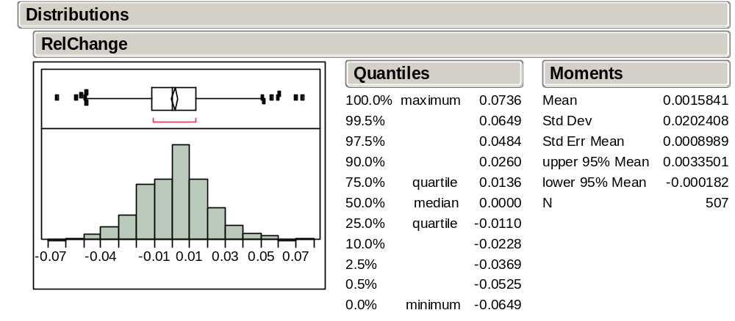

The RelChange histogram shows that the data appears to have a “bell-shaped” distribution in the middle.

This is what you would probably see when sampling from a normal population.

This bell-shape tendency is also evident, though perhaps not so clearly, in the histogram of the GMAT scores and many other phenomena.

The Normal Distribution
The normal distribution is the ideal “bell-shaped” distribution.

This ideal often approximates the shape of histograms of many data sets that occur naturally.

A picture of a normal distribution:

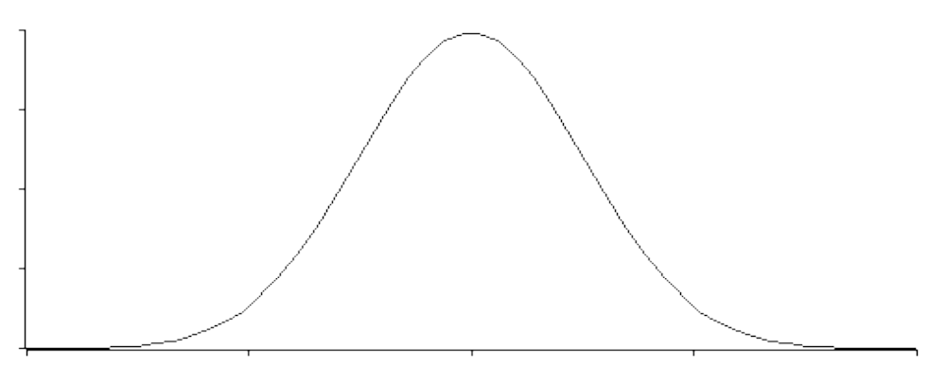

The normal distribution may be thought of as a refined histogram of a very, very large data set.
The mean and standard deviation of a normal distribution are denoted by μ and σ respectively.

Important characteristics of a normal distribution are:

- Bell-shaped and symmetric about its mean μ.

- About 68% (actually .6827) of the area lies within (μ – σ , μ + σ ).

- About 95% (actually .9545) of the area lies within (μ – 2σ , μ + 2σ ).

- Almost 99.7% (actually .9973) of the area lies within (μ – 3σ , μ + 3σ ).

Note that the standard deviation σ is a natural unit of distance for the normal distribution.

Normality of Data
Using the refined histogram interpretation, the relative area under the curve over an interval can be associated with

The relative frequency of values in the interval.
The probability that a randomly drawn observation falls within the interval.

Let us see how well the normal distribution approximates the GM92 data. Here, 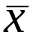 ≈ .00158 and s ≈ .02024 so that:

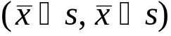 ≈ (-0.0187, 0.0218)
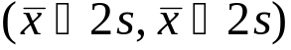 ≈ (-0.0389, 0.0421)
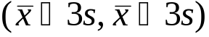 ≈ (-0.0591, 0.0623)

For each of these intervals, it turns out that:

366/507 ≈ 72.19% of the observations fall within s of .
481/507 ≈ 94.9% of the observations fall within 2s of .
504/507 ≈ 99.4% of the observations fall within 3s of .

Key point

This approximate agreement between the normal distribution and data is sometimes called the empirical rule. Since the empirical rule seems to hold here, we can concisely summarize the 507 relative changes observed in GM92 with just a mean and SD. The empirical rule translates these two summary statistics into statements about where the values concentrate.

A cool thing about normally distributed data is that the mean and standard deviation summarize all we may need to know about the dataset.

Why this bell-shape and not another?

If the data values arise as the sums of many small random effects, then a histogram of the data will resemble the normal distribution—the mathematical formalization of this is the Central Limit Theorem (CLT) (to be discussed in Module 6).

Normal Quantile Plot
Normality is a powerful assumption; we need a diagnostic to check for normality that works better than looking at the histogram. Most of our diagnostics come in the form of a plot that requires us to judge how well the data match our assumptions.

To judge if a histogram of data is close to the ideal normal distribution—so that the data can be treated as a sample from a normal population—use a normal quantile plot.

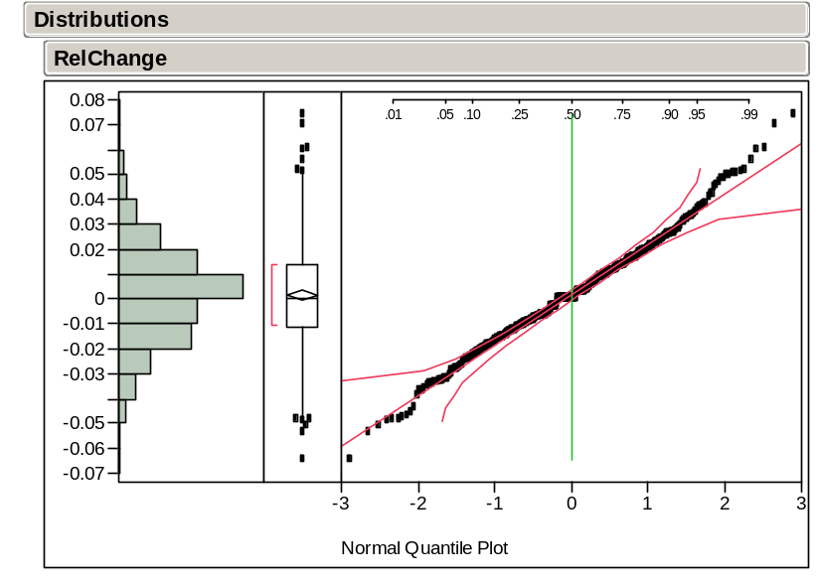
How it works:

If the histogram is close to the ideal normal shape, then all the points will lie between the two dashed lines on either side of the diagonal (BBS, pp. 18-19).

What conclusion would you draw about the GM92 data (BBS, p 28)?

Why it works:

The y-axis of the normal quantile plot shows the data.

The x-axis shows the distance from μ in units of σ for the ideal normal quantile associated with each value.

Under this rescaling of the x-axis, a “perfect” normal sample would fall along the straight line y = x.

What causes the small anomaly around 0 in the GM92 normal quantile plot? Did you notice this feature of the data in other plots or did it only become apparent now?

Executive Compensation Data (BBS, p. 34)
Not all data is normally distributed.

The JMP file CEO_Comp_03.JMP contains the annual compensation of 1,495 executives in 2003. The JMP summary of TotalComp (total compensation) is obtained as

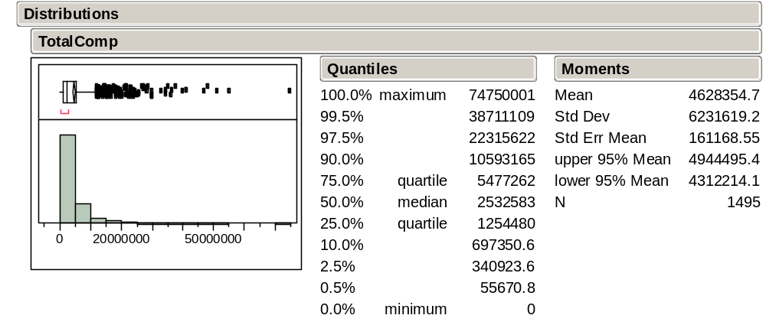

Someone made nearly $75,000,000! Who was it?
Extreme values dominate the output and make it difficult to see the rest of the distribution.

Let’s exclude the five largest values and see what happens.

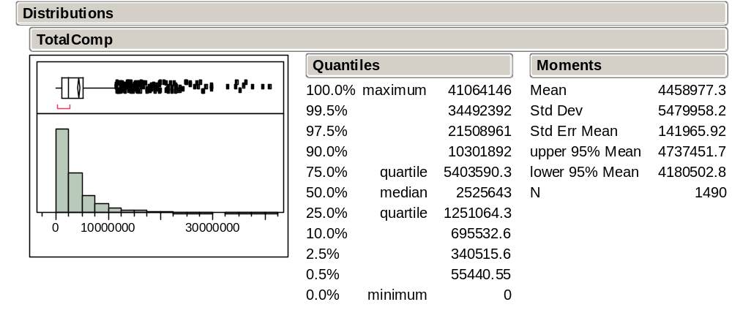

That doesn’t help much. The compensations of a relatively small number of executives continue to dominate the plot (BBS, pp. 36-37).

The Effect of Outliers on Summary Statistics
Even though these 5 executives make up only 1/3 of 1% of the cases, the mean dropped from $4.63 million to $4.45 million and the standard deviation dropped from $6.2 million to $5.5 million.

These five large salaries are very influential. Note that the mean and, especially, the SD change dramatically when adding or removing points that are far away from the others. In contrast, the median and interquartile range change very little.

Look what happens if we remove all cases for which TotalComp > $10 million. What’s going on?
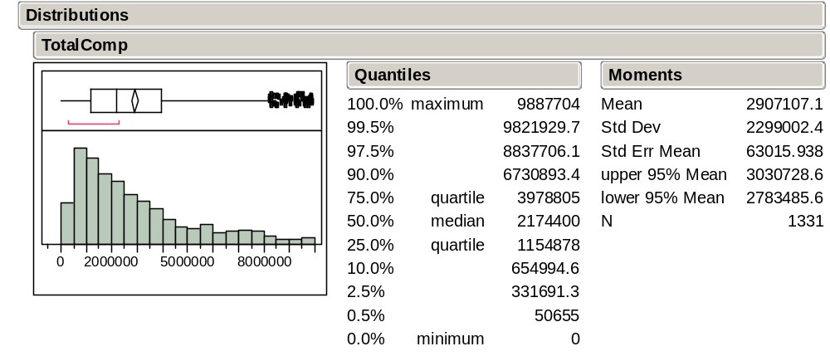

Transforming Data
An alternative way of looking at the big picture is to transform the data to a different scale. For these data, let’s consider the log transformation:

y = log₁₀ x

If we use base 10, then the logs of the compensations essentially count the number of digits (minus 1 since, for example, log₁₀ 100 = 2 and log₁₀ 1000 = 3).

Note that log(y/x) = log y – log x so that multiplicative increases in the original scale correspond to additive increases on the log scale. Thus

changes on a log scale are related to percentage changes.

Question: Which is larger:

[log $11,000 – log $10,000] or [log $1,001,000 – log $1,000,000] ?

For the CEO_Comp_03 data, let’s create the new variable

Log10TotalComp = log₁₀ TotalComp

A summary of these logged compensation values is revealing:

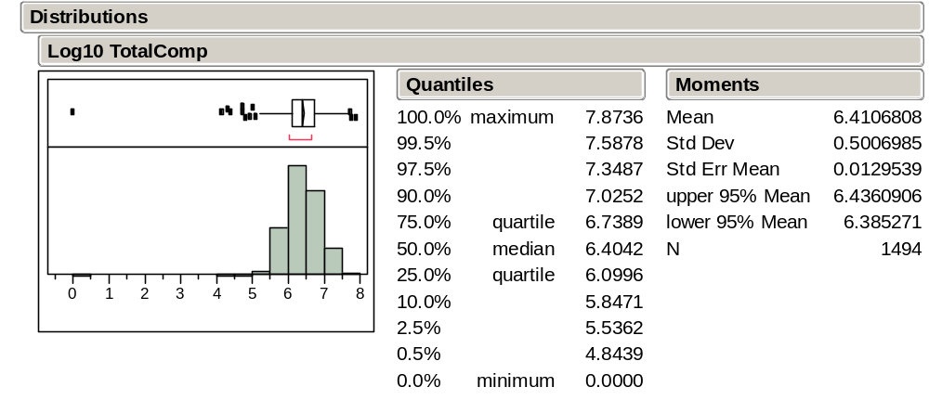

Wow! The transformation has revealed an unusually small extreme value. Who is it?

Let’s exclude this point to get a better picture of the distribution of Log10TotalComp.

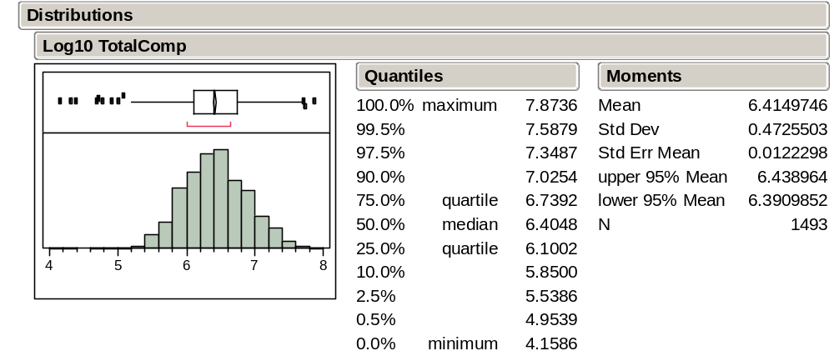

By transforming, we can see the variation that distinguishes the compensation of more of the executives rather than just singling out those that make much more than the rest.

The log transformation has done this by pulling in the large values and stretched out the small values. It has transformed right skewed data into more normal data.

Is any information lost by transforming the data?

Is the average of the logs equal to the log of the average?
Given one, can you find the other?

Finding Sources of Variation (BBS, p. 45)
A question of interest: Are executives in some industries more highly paid than those in others? Do we want to find the “stars” or identify industries that pay higher salaries on average?

Let’s first obtain summaries of the two variables: Industry and Log10TotalComp.

Goal is to compare compensation among industries.

JMP summaries reveal the variation of each of these variables.

Should we use the “raw” compensation or use compensation on the log scale?
Which question are we trying to answer?

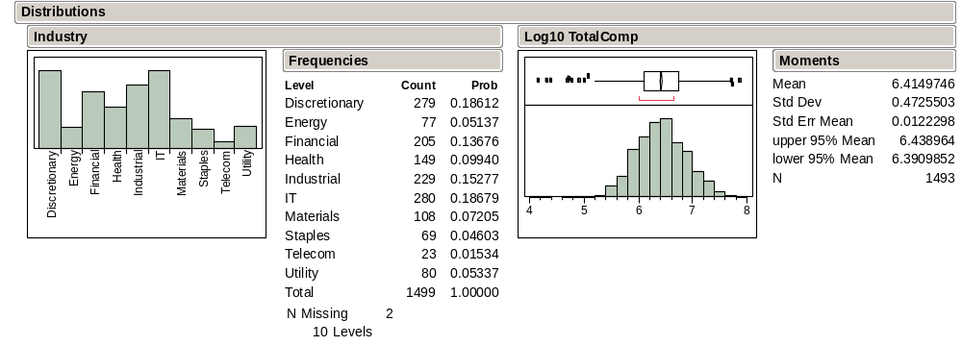

What about the relationship between the category of the industry and total compensation?

Can we tell from these summaries if executives in some industries are consistently higher paid that those in other industries?
To get some sense of the relationship between them, we can highlight industries such as financial or IT. Plot linking in JMP highlights the associated values of Log10TotalComp.
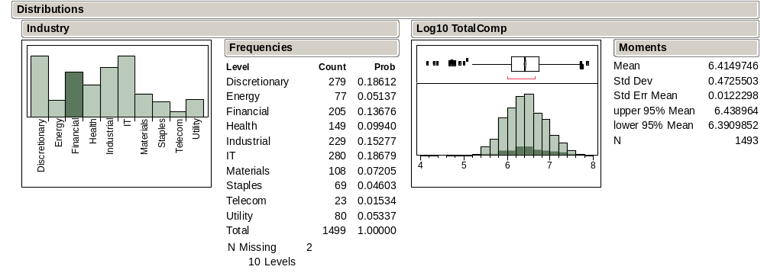
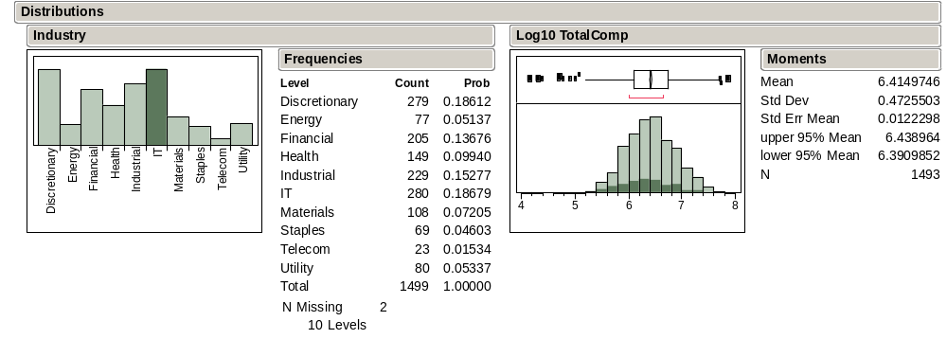
Does it look like financial or IT executives are paid differently? Are the differences small, happening just for one or two, or more general?

Comparison Boxplots
Another useful approach for comparison is to look at comparison boxplots.

Comparison boxplots provide a plot that captures differences that we might discover from plot linking in a single, static image.

Each boxplot summarizes compensation within an industry. The plots are shown parallel to each other on the same scale. What can we say about the executive compensation differences across these industries (BBS, p. 48)?

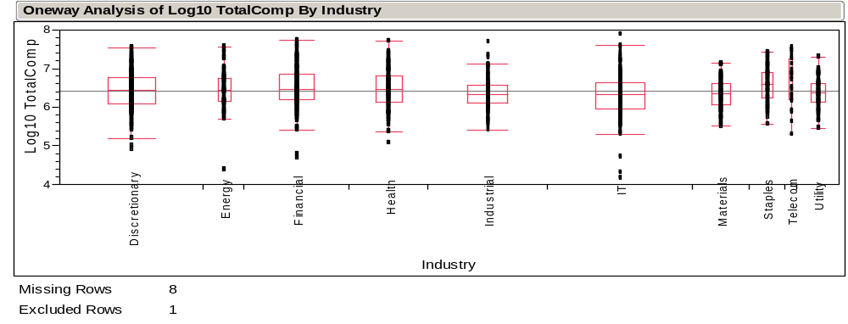

Statistics and Variation
In many ways, statistics can be seen as the study of variation in data.

Basically, we would like to “explain” the variation in data. Why? If we can identify what causes the data to vary, we might be able to control this variation to our benefit.

At a minimum, we would like to understand why our data vary. The reasons for variation are what we’ll call the “sources of variation.”

For the executive compensation data we just studied, to what extent is the salary variation explained by industry? Is it major?

In the following example, we look for sources of variation in the sales of a growth industry.

Predicting Airline Passenger Demand (BBS, p. 50)
A question of interest: How might one go about predicting future demand in a growth industry?

By understanding the variation in demand, we can both

get a useful prediction of future demand,

and provide a range that indicates the accuracy of our prediction.

The file IntlAir.JMP contains monthly passenger data from 1949 to 1960—a period of rapid growth.

To anticipate demand, let’s use this data to predict the number of passengers in January, 1961.

Since this is time series data, we’ll start by looking at a time series plot, just as we did with the GM data.

Does the data look like a random sample or does it show the meandering appearance of dependence?

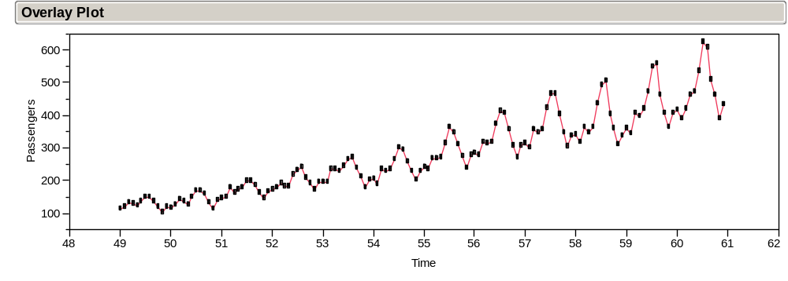

These data show a complex pattern. How would you describe the variation in passenger level over time?

What might explain the changes in this series?

Here is the summary of the distribution of Passengers.

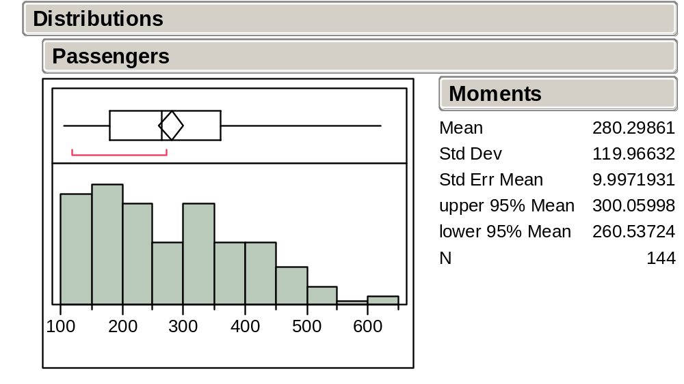

Should we use the mean of about 280,000 per month to predict January, 1961, or does this histogram and the accompanying numerical summary hide (ignore) too much?

What would be better?

Working with Relative Changes
Let’s instead look at the successive monthly relative changes, just as we did with the time series that gave prices of GM stock data,

where p_{t} is the value of Passengers in month t.

Here is the corresponding time series plot (BBS, p.52):

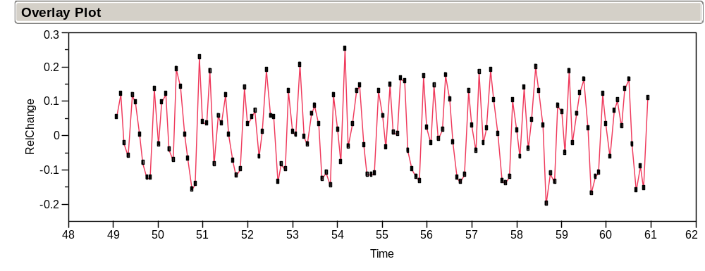

along with the summary of the distribution of the relative changes:
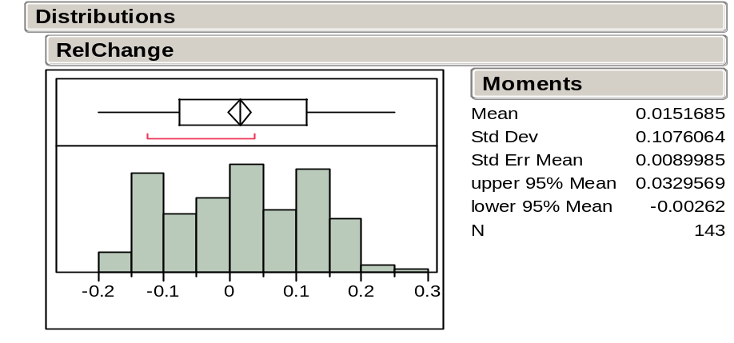
What happened to the upward trend?

What happened to the increasing variation?

At first glance, it appears that the mean relative change, about 1.5%, is about the same throughout.

Thus, we might predict the January, 1961 value as 1.5% more than in December:

432,000 x 1.015 ≈ 438,000,

where 432 thousand is the December, 1960 value. This prediction is certainly better than the mean of 280,000, but the sequence plot on pp. 2-39 suggests this estimate will not be very precise.
We can do better! Let’s highlight the September values (BBS, pp. 52-53):

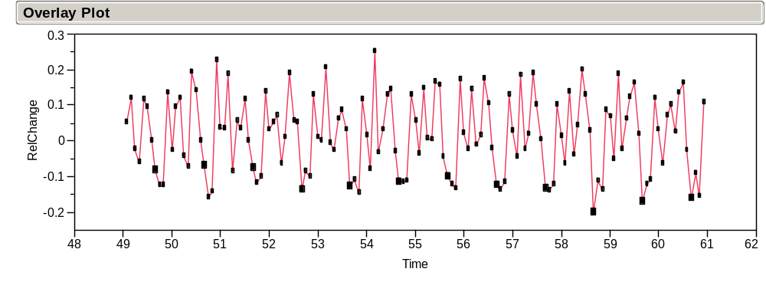
and then highlight the December values:

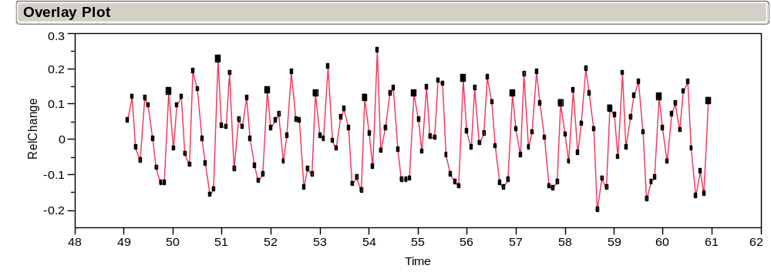
What’s going on?

Seasonality
A more complete picture of this month-to-month variation, called seasonality, is given by comparison boxplots organized by month (BBS, p.53).

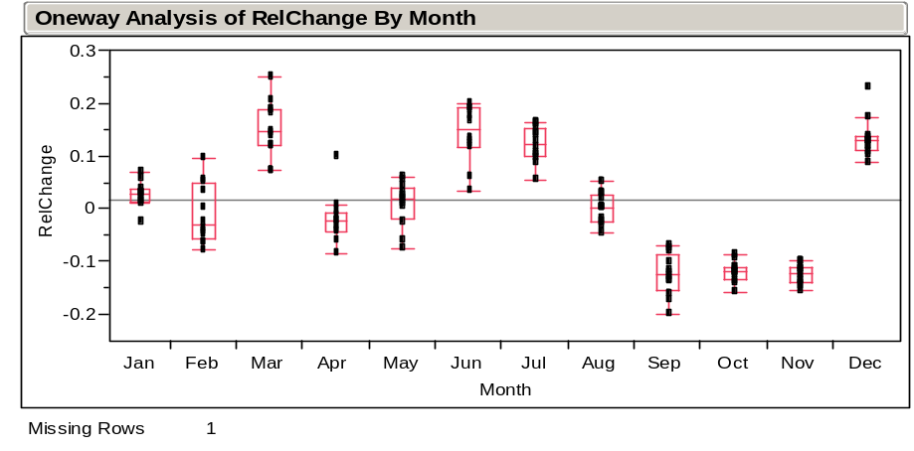

Note that months March, June, July, and December tend to be systematically high, and months September through November tend to be systematically low. This seasonal effect drives the replicating pattern that we observed in the original time series plot.

The mean change from December to January is about 2.6%. Hence, a more appealing estimate of demand for the next January is 432,000 × 1.026 ≈ 443,000. How accurate is this prediction?

Take Away Review
Statistical summaries of data, both graphical (e.g., histogram and boxplot) and numerical (e.g., mean and standard deviation)

Normality and the shape of a histogram

Characterized by a mean and standard deviation. Use of normal quantile plot

Transforming data to remove skewness

Using statistical methods to understand sources of variation

Comparison boxplots may reveal underlying sources of variation such as:

- Variation due to clustering or grouping.
- Variation determined by systematic effects over time.

Next Module
Probability models for random variation.

Many of the examples that we use in these notes appear with further discussion in the Basic Business Statistics (BBS) casebook. In some cases, the casebook uses the same data that we consider in class and in others, like this one, the casebook considers a similar data set.
Open GMAT.XLS with the JMP command File > Open. Select file type as Excel files (*.XLS)—since the column is labeled GMAT in Excel, we select “Always enforce Excel Row 1 as a label” in the JM dialogue box. By saving this file as GMAT05.JMP, you can then open it by simply clicking on the GMAT05.JMP file.
Use Analyze > Distribution with GMAT selected as the Y column. To get the horizontal layout shown next, right-click on GMAT and then select Display Options > Horizontal Layout. Note sometimes the histogram won’t initially have contiguous rectangles. To fix this, you need to click on the hand tool (which changes the cursor to look like a hand) and then drag the “hand” downwards on the histogram.
In JMP, this can be done interactively with the hand tool.
Why are these things called moments? In physics, moments of inertia describe physical properties of an object—where it balances or how hard it is to spin. It turns out that statistical moments capture analogous features of data.
What’s a sample? For now, a sample simply refers to a collection of values. Later on, we’ll define samples and populations more carefully. We typically use n to stand for the number of observations of a variable.
We typically use n to stand for the number of observations of a variable.
Remember the connection between statistics and physics? The mean is just the first moment of inertia of the histogram, the balancing point if we think of the histogram as a solid thing sitting on a see-saw.
Why divide by (n - 1) rather than n? An honest answer requires some details that we will not come to until later. For now, just think of the variance as the average squared deviation.
You might wonder why we define both s and s² since they are redundant for each other. As we’ll see later, there are contexts where each turns out to be of direct interest.
Some business schools summarize the range of GMAT scores in the form of the 20% and 80% values. That range is almost the Interquartile Range, which is just the gap between the 25% score and the 75% score.
This time series plot was obtained with the command Graph > Overlay Plot. Select Price as Y and Time as X and right-click on Overlay Plot bar to select Y Options > Connect Points.
A more precise characterization of meandering is positive autocorrelation, which we will discuss towards the end of STAT 621. For now, it is most helpful to simply recognize meandering behavior as the data “following itself,” much like a meandering river.
To do this in JMP, select Cols > New Column and name the new variable Shuffled Price. Next, select Formula under New Property. In the Formula Editor Window, select Price under Table Columns, select Row > Subscript under Functions, select Random > ColShuffle under Functions, and click OK. Again use Overlay Plot to create the time series plot. Note the value of connecting the points in order to see the variation.
Of course, the histogram does hide the timing of the events. But when the observations of a variable are independent, can we really anticipate the timing of the next large value?
When the data is a random sample from a population, the shape of the histogram tends to mimic the shape of the population distribution. We’ll discuss random sampling in more depth later.
These values are also tabled in the text, BBS, p. 17.
To generate a quantile plot in JMP, you first need to be looking at a histogram. Then use right-click on the RelChange bar and select Normal Quantile Plot. Select Fit Distribution > Normal to get the normal overlay curve on the histogram.
More precisely, 95% of the time, a random sample from a normal distribution will lie between the two dashed lines.
Some variables have numeric values (e.g., TotalComp) and other variables (e.g., Industry) have character values. JMP denotes numerical variables with a blue triangle and the latter with a red histogram. JMP procedures often treat these types in different ways. We obtained these data from Wharton Research Data Service (WRDS).
To identify points by a variable, highlight the variable’s column and then select Cols > Label/Unlabel. Try it here with the variable CEO and then notice what happens when you point to the extreme value. For a similar example, see BBS, p. 35.
To exclude these points, first select them or their corresponding rows in the data table. Then select Exclude/Unexclude from the Rows menu.
To select these points, use Rows > Row Selection > Select Where, enter the condition “TotalComp is greater than 10,000,000.” Then choose Exclude/Unexclude from the Rows menu to exclude these cases from the analysis. You can also use Rows > Data Filter.
This is true for any base.
To do this in JMP, select Cols > New Column, name the new variable Log10TotalComp, and select Formula under New Property. In the Formula Editor Window, select Transcendental Functions and then Log10. Select TotalComp under Table Columns and click OK.
Again use Analyze > Distribution. Note that because Industry is a categorical variable (a column with text data that identify groups of observations), JMP automatically provides the summaries in terms of counts and proportions.
The plots on the left of these images are bar charts, counting the number of companies in each industry. A bar chart is used to summarize the variation in a categorical variable, such as the one telling us the industry for each CEO. The charts on the right are histograms.
The JMP software shows a bar chart for categorical data such as the industry codes, rather than a histogram.
The following plot is obtained using Analyze > Fit Y by X, selecting Log10TotalComp as Y and Industry as X. To show the boxplots, right-click on the title bar and select Boxplots under Display Options. The widths are proportional to the frequency.
To do this in JMP, use plot linking with Analyze > Distribution of Month on JMP.
This can be obtained using Analyze > Distribution with RelChange selected as Y and Month selected for By.

