Module 3: Probability Models

Application: Pricing a Digital Option
Many investors place some of their assets in stocks, such as purchasing an index fund.

The history of the stock market in the U.S. reveals that these investors face risks. Although the market has headed up for most of its history, some months have shown very large declines. The file S&P85-04.JMP contains the following monthly returns on the S&P index. Do you recognize some of these dates?

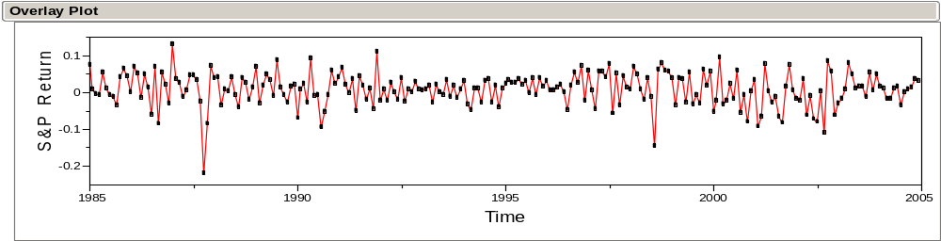
We can summarize these data with a histogram that shows the distribution of the monthly returns over these years.

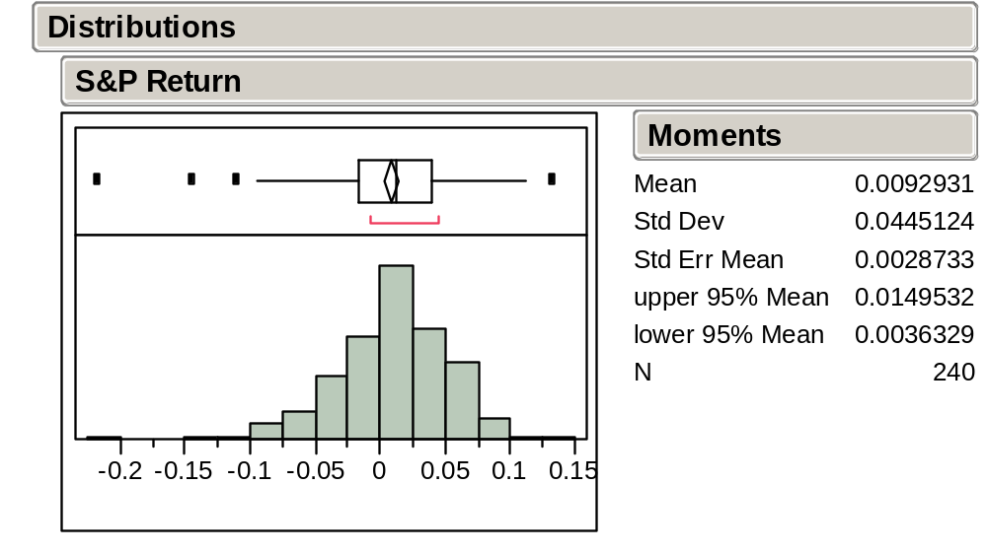

The average monthly return is .93% with standard deviation 4.45%. What do these mean?

Investors with large positions in the stock market might want to avoid some of these risks. Rather than selling their stocks and paying all of those fees, investors can purchase a type of insurance in the form of an option.

We’ll consider a very special type of option known as a digital option. These can be used to construct more complicated derivatives; an asset, such as an option that derives its value from another asset, is known as a derivative.

The question of interest:
To insure yourself against a large drop in the Standard & Poors (S&P) index, how much should you expect to pay for a digital option that pays $1 if the S&P index drops by more than 10% next month?

The price for one option is not so interesting. But consider an investor who wants to buy 1,000,000 of these options.

What’s a good price for the option from the point of view of the investor? From the point of view of the bank that offers the option?

The complicating factor:
We need to anticipate what might happen in a future month. All we have to go on is what has happened in the past. An abstraction that we’ll use to think carefully about such problems is known as a random variable.

Random Variables
A random variable (rv) (e.g., X, Y, Z, etc.) represents the uncertain numerical outcome of an experiment or process that has yet to occur.

A random variable associates a number between 0 and 1 with each possible outcome of an experiment or random process. This number is called the probability of the outcome.

Useful Notation: If X is a random variable, then

P(X = x) is the probability that X will take on the value x.

P(x₁ ≤ X ≤ x₂) is the probability that X will take on a value in the interval [x₁, x₂].

The Long Run Manifestation of Probability: intuitively, P(X = x) is the proportion of times X = x over an “infinitely” long sequence of repetitions of the experiment.

In this sense, a graph of P(X = x) is the histogram of the outcomes in this long sequence.

Example: Toss a Fair Coin
Random variable: X Possible outcomes: 1 if heads, 0 if tails

Probabilities: P(X = 1) = 1/2 P(X = 0) = 1/2

Example: Play Roulette
38 slots labeled 00, 0, 1, 2, , 36

1-36 colored Red (if even) and Black (if odd)

For $1, place a bet on Red

Pays you $2 if randomly selected slot is Red

Random variable: R = Net winnings Possible outcomes: -1 and 1

Probabilities: P(R = -1) = 20/38, P(R = 1) = 18/38

Example: Play the Lottery
For $1, buy a lottery ticket numbered from 000 to 999.
Pays you $500 if ticket matches randomly selected number.

Random variable: D = Net winnings Possible outcomes: -1 and 499

Probabilities: P(D = -1) = 999/1000 P(D = 499) = 1/1000

Example: Pick a Chip
Randomly draw a chip from a bowl containing 10,000 chips with these values:

5,000 $1 chips
3,000 $5 chips
1,000 $10 chips
1,000 $20 chips

Random variable: X = value of the drawn chip Possible Outcomes: 1, 5, 10, and 20

Probabilities: P(X = 1) = 5/10, P(X = 5) = 3/10, P(X = 10) = 1/10, and P(X = 20) = 1/10
For convenience, we often write p(x) = P(X = x), so that

p(1) = 5/10 p(5) = 3/10 p(10) = 1/10 p(20) = 1/10

The function p(x) is called the probability distribution of X.

Note that:
p(x) = 0 for x ≠ 1,5,10,20

p(1) + p(5) + p(10) + p(20) = 1

The probability of any event concerning X can be computed from p(x). For example:

P(X ≤ 5) = 5/10 + 3/10 = 8/10

P(5 ≤ X ≤ 10) = 3/10 + 1/10 = 4/10

P(X is an even number) = 1/10 + 1/10 = 2/10
Let’s draw a histogram of the population of chips in the bowl:

How does this shape compare to the shape of the probability distribution?

This bowl of chips can be thought of as a population from which the chip was drawn.

Useful interpretation: the outcome of random variable with probability distribution p(x) can always be interpreted as a random selection from a p(x) shaped population distribution.

Let’s now compute the mean of the chip histogram above.

The Expected Value of a Random Variable
Suppose the N possible outcomes of a rv X are:

x₁, x₂,…, x_{N}.

The expected value of X, denoted by E[X], is defined as a weighted sum of the possible outcomes of X:
E[X] = x₁ p(x₁) + x₂ p(x₂) + … + x_{N} p(x_{N}) = 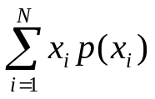

Sometimes the expected value of X is called the mean of X and is denoted by the Greek letter μ. This is the same as the average value in the population from which X is drawn. For example, for the chips we find the average value is:

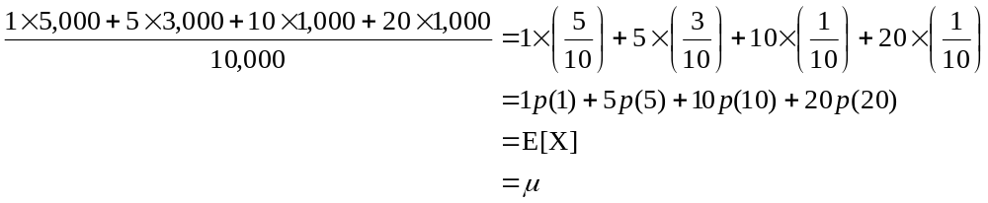




Examples
Example: R = Winnings in Roulette

E[R] = -1 p(-1) + 1 p(1) = -20/38 + 18/38 = -1/19

Example: D = Winnings in Daily Numbers Lottery

E[D] = -1 p(-1) + 499 p(499) = -999/1000 + 499/1000 = -0.5

Example: X = Value of the Drawn Chip

μ = 1 p(1) + 5 p(5) + 10 p(10) + 20 p(20) = 5/10 + 15/10 + 10/10 + 20/10 = 5

Interpretations of the Expected Value or Mean
Probability-weighted average of possible outcomes

Center of the probability distribution of X

Mean of the population from which the rv is drawn

Long-run average over “infinitely” many repetitions of X

“Fair value” of a gamble

Jargon
μ is sometimes called the population mean

to distinguish it from , the sample mean.

Variance and Standard Deviation of a Random Variable
As with our descriptions of a histogram, it’s not enough to only know the mean value. We also need a summary of the variation of a random variable as well.

Suppose the possible outcomes of a rv X are

x₁, x₂,…,x_{N}.

Then the variance of X, denoted Var[X] or σ², is

Var[X] = σ² = (x₁ − μ)² p(x₁) + … + (x_{N} − μ)² p(x_{N}) = 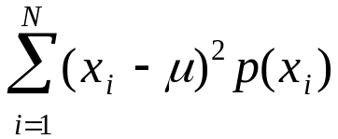

An equivalent and slicker definition is

Var[X] = σ² = E[(X− μ)² ]

The standard deviation of X, denoted SD[X] or σ, is the square root of the variance.

Examples
Example: R = Net Winnings in Roulette

Var[R] = (-1-(-1/19))² p(-1) + (1-(-1/19))² p (1) = 0.9972

SD[R] = 0.9986

Example: D = Net Winnings in Daily Numbers Lottery

Var[D] = (-1-(-0.5))² p(-1) + (499-(-0.5))² p(499) = 249.75

SD[D] = 15.80

Example: X = Value of the Drawn Chip

σ² = (1-5)² p(1) + (5-5)² p(5) + (10-5)² p(10) + (20-5)² p(20) = 33

σ = 5.744

Interpretations of the Variance
Probability-weighted average squared deviation

Dispersion of the probability distribution of X about μ

Variance of the population from which the rv is drawn

Long run average squared deviation over “infinitely” many repetitions of X

“Risk” of a gamble (more coming in Module 4)

Jargon
σ² and σ are sometimes called the population variance and the population standard deviation

to distinguish them from s² and s, the sample variance and the sample standard deviation.

Continuous Random Variables
As opposed to the random variables we have considered, some random variables represent draws from a population of values so dense that it is easier to model the shape of the population by a smooth continuous function.

Example: A Normal Random Variable
X = value drawn randomly from a normal population with mean μ and st dev σ.

Often abbreviated as X ~ N(μ, σ²)

Population shape: 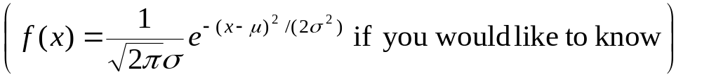
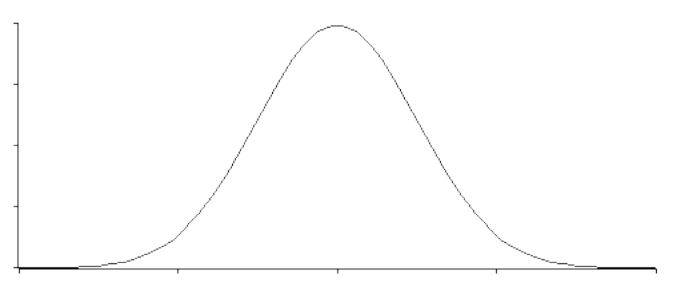

Useful Interpretation: for such a random variable, P(x₁ ≤ X ≤ x₂) is given by the area under the continuous curve between x₁ and x₂.

Some familiar probabilities:

P(μ − σ ≤ X ≤ μ + σ) ≈ 68%

P(μ − 2σ ≤ X ≤ μ + 2σ) ≈ 95%

P(μ − σ ≤ X ≤ μ + 2σ) ≈ 81.5%

P(−∞ < X < ∞) = 1

More generally, normal probabilities for any given values of μ and σ can be computed using the Normal Distribution probability formula in JMP.

For example, when X ~ N(0.5, 1.8²),

P(X ≤ 0.8) = 0.566 and P(0.8 ≤ X ≤ 1.4) = 0.125.

Application: Pricing a Digital Option
Let X = the return on the S&P index next month

Suppose you had strong enough evidence to assume that X was a normal random variable with mean .0093 and standard deviation .0445.

These values for the mean and SD match the month-to-month performance of the stock market from January 1985 to December 2004.

Let’s return to the our question on p. 3-3: how much should you pay for a digital option that pays $1 if the S&P drops by more than 10% next month?

Random variables provide a precise way to find the value of the option. We can express the value of such an option by defining a new, discrete random variable Y whose values are determined by X, with

Y = $1 if X < –.10
= $0 otherwise

A fair price for the option would then be E[Y] = P[Y = 1] = P[X < –.10] = .0070

The Normal Distribution as a Model
The value of E[Y] in the previous example depends strongly on P[X < –.10] = .0070 which we obtained by assuming that X would be a draw from a particular normal distribution.

An outline of the steps used to make such an assumption:
- Verify that the behavior of the time series of past monthly S&P returns is consistent with assuming a sequence of independent draws from the same population.
- Verify that the histogram and a normal quantile plot of the past monthly returns is consistent with assuming a normal population.
- Estimate μ and σ² of the population by the values of and s² for the past monthly returns.

Alternatively, a “common sense” procedure is to estimate P[X < –.10] directly from the data: use the proportion of prior months that the S&P fell below –.10. What is the drawback of such an approach?

Compared to this simplistic procedure, the normal assumption allows us to use the data to extrapolate more efficiently.

The (Student) t Distributions
The t distributions are a family of continuous probability distributions that resemble normal distributions.

They are symmetric and bell-shaped, but have heavier or fatter tails.

Because of their heavier tails, extreme observations are more likely with draws from a t distribution.

Each t distribution is identified by 3 parameters: μ, σ², and a shape parameter called the degrees of freedom (df). df is always positive. As df gets larger, t distributions more closely approximate normal distributions.

t distribution probabilities can be obtained by the probability function t distribution on the JMP calculator.
If we treat X as having a t-distribution that is matched to the market during the 1985-2004 period, we obtain:
P(X < –.10) ≈ .05
Why does this probability differ so much—it’s much larger—from the previous normal probability calculation?

Quantile plots can also be used as a diagnostic check for t distribution assumptions.

Key point:
In this example, we have two different models for the data. Both describe the data reasonably well, so that the data are not clear about which model is better.
The model matters: different models produce different prices for the options.
In cases like this, we need to be sensitive to the consequences of our assumptions. We may never know which model is “right,” but we should be aware of the alternatives.

Take-Away Review
Random variables provide a useful notation for describing problems that have uncertain outcomes.

The outcomes of a random variable can be associated with probabilities.
The expected value is the average of the outcomes, weighted by probabilities. The variance is the probability weighted average squared deviation.

If we match a random variable to features of a sample, we can use that random variable to model the underlying process.

But, the results we obtain are sensitive to the model that we use. Check the assumptions of your model.

Next Module
Random variables and returns on investments.

Alas, Dilbert is not a statistician. You want the expected value of each project, not each outcome!
In JMP, the probability P(X < a) when X ~ N(μ, σ²) is obtained with the JMP formula Normal Distribution(a, μ, σ). The calculation here is illustrated in the file Norm Prob.JMP.
The calculation of this probability is illustrated in the file Option Prob.JMP.
Be careful, however! Other models may give rather different prices. Although normal distributions approximate many distributions that naturally occur, important alternatives may also be considered. Some are hard to tell from the normal.
These alternative quantile plots are not in the version of JMP we are using. The plots would look like normal quantile plots, but the reference model would be something other than the normal, such as one of the t-distributions.

