Module 4: Variance and the Volatility of Investments

Random Variables in Finance
Random variables are used in finance to represent returns on investments.

Variance of such random variables measures the volatility (risk) of the investment.

Example
Let Green, Red, and White denote three hypothetical investments with these probability distributions for their annual gross returns R.

Die value | 1 | 2 | 3 | 4 | 5 | 6
Probability | 1/6 | 1/6 | 1/6 | 1/6 | 1/6 | 1/6
Green | 0.8 | 0.9 | 1.1 | 1.1 | 1.2 | 1.4
Red | 0.06 | 0.2 | 1 | 3 | 3 | 3
White | 0.95 | 1 | 1 | 1 | 1 | 1.1

What do you learn from looking at the probability distributions of these random variables?

Summaries
The expected values and standard deviations of the annual gross returns for each of these random variables are

Investment | Expected R | StDev of R
Green | 1.083 | 0.20
Red | 1.710 | 1.32
White | 1.008 | 0.04

Are these more useful than the probability distributions?
Less useful?

Which of these investments is most appealing? What tradeoffs did you consider?

A Simulation Experiment
Suppose you begin with a $1,000 investment in each of Green, Red, and White.

The outcome from rolling three dice determines the annual outcome of the investment of matching color.

The value of the investment changes according to the gross return given in the appropriate column of the table.

For example, suppose that on the first roll of all three dice, you obtain

(Green 2) (Red 5) (White 3)

Then the values of the investments after the first year are

Green: $1,000 · 0.9 = $900
Red: $1,000 · 3 = $3000
White: $1,000 · 1 = $1000

Die value | 1 | 2 | 3 | 4 | 5 | 6
Green | 0.8 | 0.9 | 1.1 | 1.1 | 1.2 | 1.4
Red | 0.06 | 0.2 | 1 | 3 | 3 | 3
White | 0.95 | 1 | 1 | 1 | 1 | 1.1

Suppose the second roll gives

(Green 4) (Red 2) (White 6)

By compounding, you get
Green: $900 · 1.1 = $990
Red: $3000 · 0.2 = $600
White: $1000 · 1.1 = $1100

Die value | 1 | 2 | 3 | 4 | 5 | 6
Green | 0.8 | 0.9 | 1.1 | 1.1 | 1.2 | 1.4
Red | 0.06 | 0.2 | 1 | 3 | 3 | 3
White | 0.95 | 1 | 1 | 1 | 1 | 1.1

Note that Green went down by 10% and then up by 10%, but ended up losing value.

Why does that happen?

A Class Experiment
Form teams of 3 to 4 students.

Start with $1,000 in each investment and carry out the simulation for 20 years of returns. Each roll of all three dice represents one year.

Roles for team members:

“Nature” rolls the dice.
“Market” finds the dice and records outcome.
“Accountant” keeps track of what happens.
Others manage and keep the rest making progress.

Record the sequence of results on the results form as shown on the next page.

We’ve filled in the first two rounds to match the previous two outcomes to illustrate the calculations. Use the outcomes from rolling the dice to determine what happens to your investments.

Round | Green | Red | White
Starting value | $1,000 | $1,000 | $1,000
gross return₁ | 0.9 | 3 | 1
value₁ | 900 | 3,000 | 1,000
gross return₂ | 1.1 | 0.2 | 1.1
value₂ | 990 | 600 | 1,100
gross return₃
value₃
gross return₄

What happened?

Are you surprised?

A Hybrid Investment
Consider a fourth investment which puts half in Red and half in White—call it Pink.
The gross return on Pink is just the average of the gross return in each round on Red and White. So you can find out what happens to Pink without needing to roll the dice further.

For example, for the first round illustrated on p 4-7, the gross return on Pink is the average of the gross return on Red and White, namely (3+1)/2 = 2.

Pink: $1,000 · 2 = $2,000

In the second round, the gross return on Pink would be (0.2 + 1.1)/2 = 0.65 yielding

Pink: $2,000 · 0.65 = $1,300

How does Pink fare in your simulation?

No more dice tossing. Just compute the gross returns using the information recorded on your data sheet.

Performing the Simulation on a Computer
The file dicesim.JMP is set up to perform the simulation in JMP. Opening the file and adding 20 rows yields:

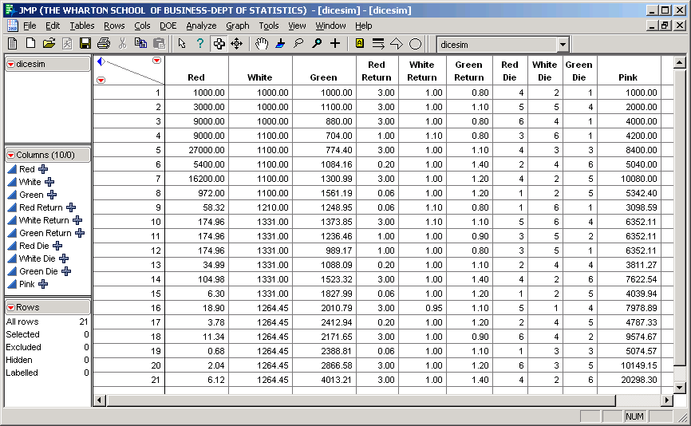

Essentially, the computer “rolls the dice” in the three columns: Red Die, White Die, and Green Die.
Note the persistent behavior of each of these four investments, especially if you let the computer do a few more rounds. Which investment consistently wins?

Variances and Volatility Drag
Let’s turn to understanding the simulation results.

Example: your starting salary was $100,000. You received a salary increase of 10% and then a salary reduction of 10%. What is your current salary?

What would happen to your salary if this up/down bounce was repeated over and over?

Volatility hurts by eating away at the average rate of return.

As we will see on p 4-15, it turns out that

Long-run gross return ≈ Expected gross return – Variance/2.

The quantity Variance/2 is called “volatility drag.”

Applied to annual returns on Green, Red, and White, we obtain (with more digits shown)

Investment | Mean | StDev | Var | Mean–Var/2
Green | 1.083 | .195 | .038 | 1.064
Red | 1.710 | 1.32 | 1.755 | 0.833
White | 1.008 | .045 | .002 | 1.007

It is now clear why Red is a loser!

But why did Pink do so well?

Analyzing a Mixed Investment
Pink is itself a random variable with a probability distribution. Using our previous formulas, we can directly calculate

Investment | Mean | StDev | Var | Mean–Var/2
Pink | 1.359 | 0.662 | .439 | 1.140

Wow! Even though Red is a big loser and White is pretty poor, mixing the two losers yields Pink, a big winner. What’s going on?

We also could use some help to find these means and variances. Direct calculation of the mean and variance is really tedious:
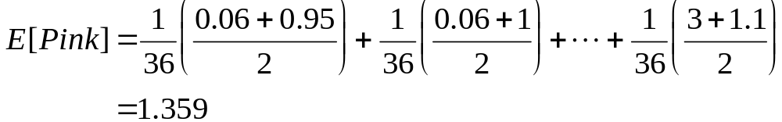

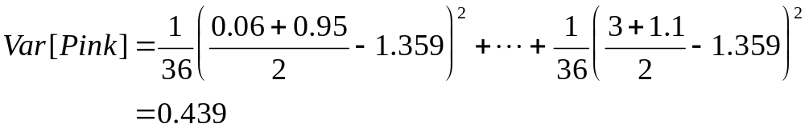

An Easier Way to Calculate E(Pink) and Var(Pink)
As we will see in Module 5, we can obtain E(Pink) and Var(Pink) using the formulas

E(Pink) = .5 E(Red) + .5 E(White) = 1.359

Var(Pink) = .5² Var(Red) + .5² Var(White) = .439

Note that the first formula makes perfect sense: the average of averages is itself an average.

Justification for the Volatility Drag Adjustment
Suppose our initial wealth at time 0 is W₀ and the gross return from period t-1 to period t is R_{t}.

Our total gross return at the end of T periods is then

W_{T} /W₀ = R₁R₂ ⋅⋅⋅ R_{T}

The nominal annual percentage rate (APR) that achieves the same gross return when continuously compounded is the value r that satisfies the equation:

e^{rT} = R₁R₂ ⋅⋅⋅ R_{T}

If we take logarithms of both sides, we can solve for r:

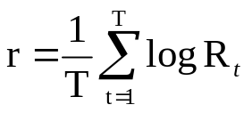

As the number of time points T increases, r gets closer to the expected log return, namely E[log R_{t}], which is the long-run net return. Here is where the Volatility Drag enters.
Calculus produces the Taylor series approximation log(1+x) ≈ x – x²/2 which works well when x is close to zero.

As long as the average gross returns are close to 1, we obtain (writing the gross return as R_{t} = 1 + r_{t}),

E log R_{t} = E log (1+r_{t})
≈ E (r_{t} – r_{t}²/2)
≈ E (r_{t} ) – Var(r_{t})/2

Thus the long run gross return, namely 1+ E log R_{t}, is approximately E(R_{t} ) – Var(R_{t})/2, the expected gross return minus the volatility drag.

Background
The choices of the means and variances for two of these investments come from things that you can buy. Green matches the long-run historical performance of the U.S. stock market, as reflected by the value-weighted index since 1925, adjusted for inflation.

We calibrated White to approximate the historical performance of 30-day Treasury bills (T-bills), also adjusted for inflation.

Notice how closely the means and standard deviations of Green, and White match those of the annual gross returns of the Stocks and T-bills.

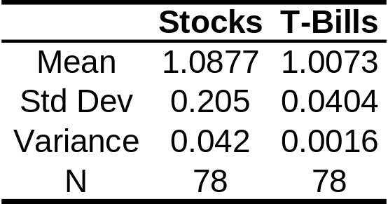

We made up Red. That’s too bad!

The data for these indexes is contained in annual_markets.JMP.

The following Overlay Plot shows the performance through 2004 of these two indexes on the log scale (BBS, pp.188-191).
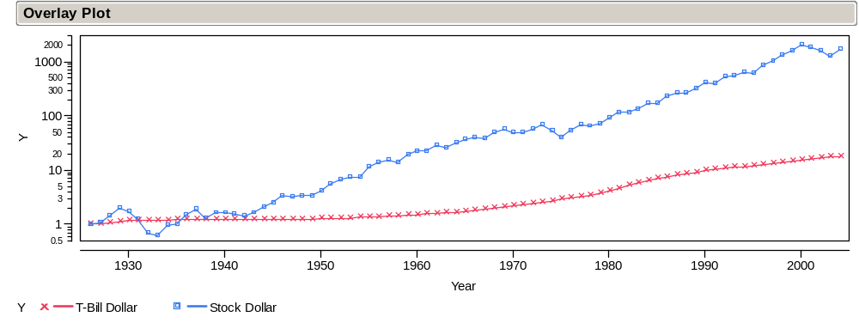
The following plot (using the same scale), shows the indexes adjusted for inflation. Note that T-bills no longer appear to be so “risk-free.”
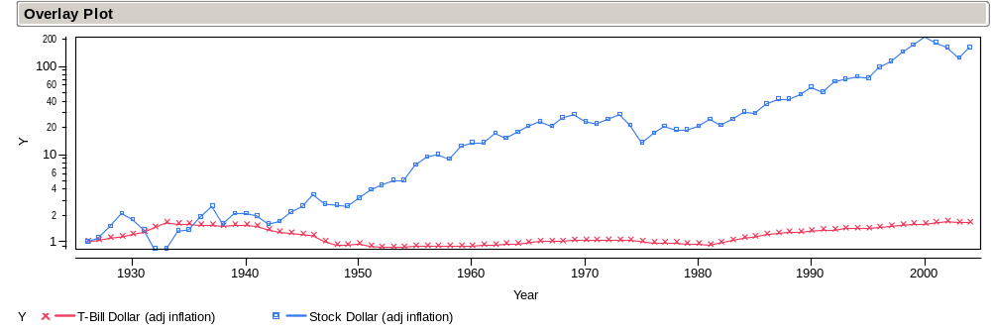

Take-Away Review
Random variables are used to model the returns on investments in finance.

The long-term value of an investment depends upon its average rate of return and its volatility.

Volatility is another name for the variance of the return.

Variance eats away the return via the volatility drag.

Mixing investments is a means to achieving better investments with higher long-term returns.

Next Module
Portfolios and covariance: how to mix investments to reduce risk while preserving returns. The simulation has two artificial aspects:

(1) We made up Red.
(2) The returns on each investment are independent of each other.

The next module shows how to make portfolios like Pink from real stock returns.

The value of an asset at the end of a year is the product of the gross return and the value at the start of the year. If you start with S dollars and finish with F dollars, then the gross return is R =F/S. We denote gross returns by “big R” to distinguish them from “little r” returns (p. 2-15). These types of returns are related by R = (1+ r). “Little r” returns, sometimes called net returns, become percent changes when multiplied by 100.
For example, to find the expected return on Green, we computed E[Green] = (1/6)0.8 + (1/6)0.9 + (2/6)1.1 + (1/6)1.2 + (1/6)1.4 = 1.083 as shown in this summary. Similar calculations produce the standard deviations.
To recalculate these, click the Apply button in the Formula Editor Window for each die column.
OK, we agree, the second one is not so obvious. We’ll save it for Module 5.
Many of the examples that we use in these notes appear with further discussion in the Basic Business Statistics (BBS) casebook

