Module 5: Covariance and Portfolios

Dependence and Independence
In many situations, we are interested in the simultaneous outcomes of two or more random variables.

For a randomly chosen person, we could define X = height and Y = weight.
For a randomly selected store selling a particular product, X = price and Y = sales.
For next January, X = return on Disney and Y = return on McDonald’s.

We can think of each of these pairs as a draw from a population of (x,y) values.

Definition: if knowing the outcome of X changes the probability distribution of Y (or vice-versa), then the rv's X and Y are said to be dependent. Otherwise, X and Y are said to be independent.
Example: dice outcomes in simulation of Module 4 are independent of one another.
Specific definition of independence: P(X=x,Y=y) = P(X=x) × P(Y=y).

Are the above pairs of rv's dependent? How?

Linear Association
Suppose that we repeat the process that attaches values to X and Y, and then plot the joint outcomes. The plot might resemble one of the following:

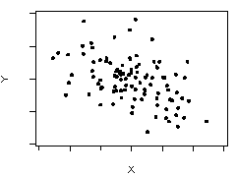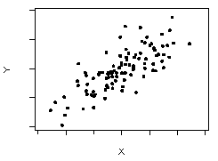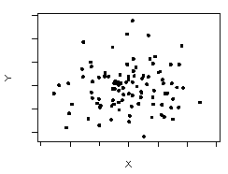

Note that X and Y vary together along the diagonals in the first two plots.

Which of these would you associate with the previous X,Y pairs?

The tendency to cluster along the diagonals (seen in the first two plots) is called linear association.

Does linear association imply dependence?

Does dependence imply linear association?

Covariance and Correlation
Covariance and correlation measure linear association between two sets of measurements that we denote by the n pairs of observations (x₁,y₁),…,(x_{n},y_{n}).

Examples:

For n individuals, x_{i} = height and y_{i} = weight.

For n days, x_{i} = return on Disney and y_{i} = return on McDonald’s.

Covariance
The sample covariance between these two sets of measurements is defined as the average cross product
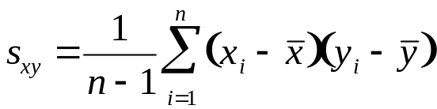

Notice in the product, pairs with both values above (or below) the mean contribute positive values to the sum. Pairs with one value above the mean and another below contribute negative values to the sum.

Bad news: covariance depends on the units in which X and Y are measured.

Correlation
The sample correlation between X and Y is defined as

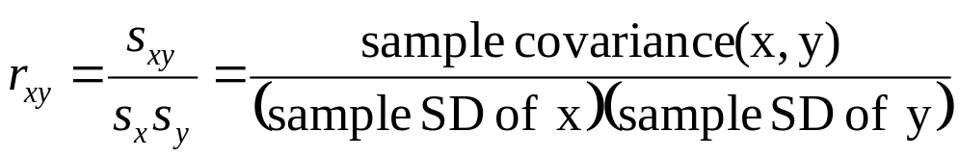

Good news: r_{XY} is unit-free. It measures linear association.

r_{XY} has the same sign as s_{XY} but satisfies −1 ≤ r_{XY} ≤ 1.

s_{XY} > 0 and r_{XY} > 0 indicate positive linear association.

s_{XY} < 0 and r_{XY} < 0 indicate negative linear association.

s_{XY} = 0 and r_{XY} = 0 indicate no linear association.

r_{XY} = 1 (or −1) indicate perfect positive (or negative) linear association.

What are the signs of s_{XY} and r_{XY} in the three plots on page 5-2?

Population Parameters
We have seen sample means and population means, sample variances and population variances. We also have population covariances and correlations. They are obtained as follows.

Let μ_{X}, μ_{Y}, σ_{X}, and σ_{Y} denote the population means and standard deviations of X and Y, respectively. Then, analogous to the sample value (which is the average product)

Cov(X,Y) = E[(X− μ_{X})(Y−μ_{Y})]

Intuition: (When you see “E,” think “on average.”)

When (X− μ_{X}) and (Y−μ_{Y}) have the same sign, the contribution of
[(X− μ_{X}) (Y−μ_{Y})] to Cov(X,Y) is positive; otherwise it is negative.

Similarly, the population correlation is

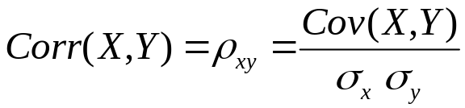

Correlation and Independence
Cov(X,Y) ≠ 0 or ρ_{XY} ≠ 0 implies that X and Y are dependent.

ρ_{XY} ≠ 0 implies Dependence

X and Y independent implies Cov(X,Y) = 0 and ρ_{XY} = 0.

Independence implies ρ_{XY} = 0

Careful!
Cov(X,Y) = 0 or ρ_{XY} = 0 does not imply independence. Why?

Think of a plot of data that has ρ_{XY} = 0, but is not independent. Think: dependence means knowing the position along the x-axis helps you to predict the position along the y-axis.

Weighted Sums of Random Variables
A weighted sum of random variables X and Y is

a X + b Y

where a and b stand for fixed numbers that are not random.

Jargon - weighted sums such as these are often called linear combinations.

Key application:
Portfolios of investments are weighted sums with the random variables denoting the returns on the component investments.

Example: from Module 4, Pink = .5 Red + .5 White

We will now see how

E(a X + b Y) can be easily expressed in terms of E(X) and E(Y).

Var(a X + b Y) can be easily expressed in terms of Var(X), Var(Y), and Cov(X,Y).

FACT #1
For any weighted sum of random variables

E(a X + b Y) = a E(X) + b E(Y)

In Module 4 (p. 4-13), we saw a special case of this formula

E(Pink) =E(.5 Red + .5 White)

= .5 E(Red) + .5 E(White)

= .5 (1.71) + .5 (1.008) = 1.359

FACT #2
For any weighted sum of random variables, such as real stocks that are dependent,

Var(a X + b Y) = a² Var(X) + b² Var(Y) + 2ab Cov(X,Y)
In Module 4 (p. 4-13), we saw a special case of this formula

Var(Pink) = Var(.5 Red + .5 White)

= .52 Var(Red) + .52 Var(White) + 2(.5)(.5)Cov(Red,White)

= .52 (1.755) + .52 (.002) = .439

Some useful special cases of these facts:

E(a X) = a E(X), Var (a X) = a² Var(X), and SD(a X) = |a| SD (X)

For independent X and Y, the variance of a sum is the sum of the variances

Var (X +Y) = Var (X) + Var (Y) and SD(X + Y) = 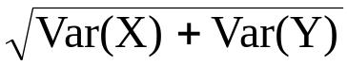

The same applies to differences of independent random variables

Var (X – Y) = Var (X) + Var (Y) and SD(X – Y) =

The Mean and Variance of Some Real Portfolios
Let’s now move beyond the Pink portfolio and consider portfolios of real stocks. Two new aspects need to be considered:

1) Returns on the individual investments are typically not independent of each other.

2) The probability distributions of the returns on the individual investments are unknown.

Thus,

1) We cannot assume independence.

2) The unknown characteristics must be estimated from data.

Stock Market Data Files
StockReturns.JMP contains the monthly (net) returns on the stocks of 35 companies from 1975-1999. StockReturnsSummary.JMP contains a summary of these returns. These data were obtained from the Center for Research in Security Prices (CRSP), which is available to you on Wharton Research Data Services (WRDS). Another analysis of stocks appears in Basic Business Statistics (BBS), pp. 197-204.

The 35 companies were chosen as the dominant companies in 7 industries in December 1974. Only 22 firms have data that spanned the entire 300 month period. The following output summarizes the volatility-adjusted returns for all 35 stocks. The highlighted stocks lasted less than 200 months during 1975-1999.

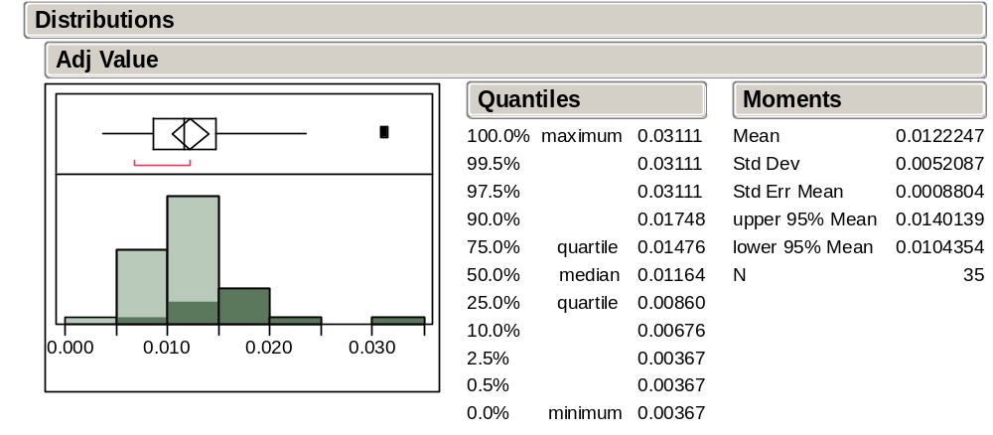
What happened to the firms that dropped out of the sample?

Of the stocks that survived the whole 25 years (300 months), Disney had the highest volatility-adjusted return 0.0149. Exxon was a close second with adjusted return 0.0148.

Let’s combine these into the equally-weighted portfolio DisExx= .5 Disney + .5 Exxon.

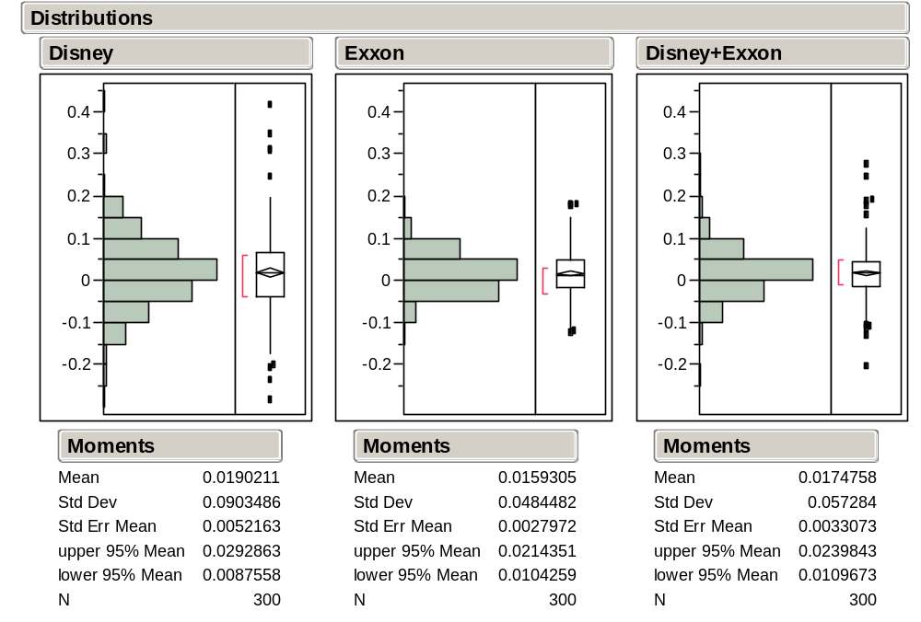

From these summaries we obtain the volatility-adjusted returns as follows:

Investment | Average | Variance | Avg – Var/2
Disney | .0190 | .0082 | .0149
Exxon | .0159 | .0023 | .0148
DisExx | .0174 | .0033 | .0158

Once again, a portfolio offers an improvement in long-term gains over investing 100% in either of the individual investments.

In looking to form a portfolio to get higher returns, why should we:

Use these companies?

Use these weights (50/50)?

Use only two companies?

Role of Covariance
For the equally-weighted portfolio of Disney and Exxon stocks, the return on the portfolio is just the average of the returns on the two stocks

Avg(DisExx) = .01774 = .5(.0190) + .5(.0159)

but for the variance we find

Var(DisExx) = .0033 ≠ .5²(.0082) + .5²(.0023)

which was the formula we used for Pink. What’s missing?

Using the complete formula for the variance of a weighted sum (Fact #2, p. 5-9), the value of Var(DisExx) implies

.0033 = .5²(.0082) + .5²(.0023) + 2(.5)(.5)Cov(Dis, Exx)

Solving for the Cov term, we can calculate that the covariance between Disney and Exxon is Cov(Dis, Exx) = .00131. What would be a preferable covariance value?

We can see that returns on Disney and Exxon are related, though only weakly.

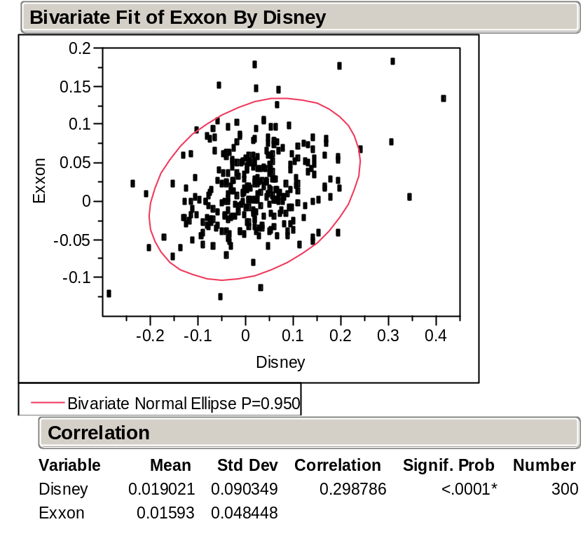

The sample correlation between Disney and Exxon is .298 [= .00131/(.090)(.0484)].

Let’s now consider pairing Disney with McDonald’s which had the third largest volatility adjusted return, at .0142.

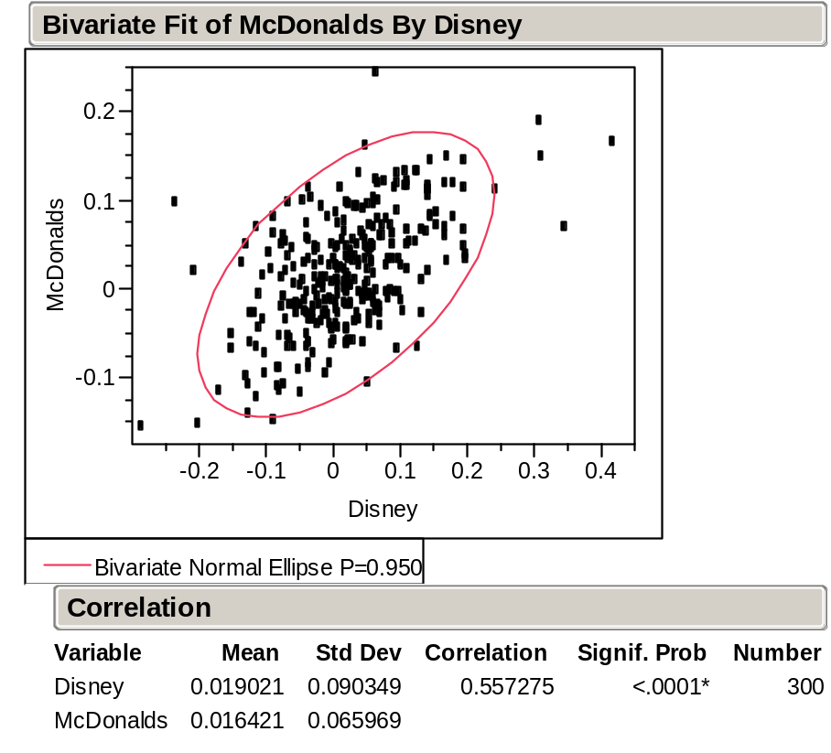

Compared to Exxon, McDonald’s has a larger average return .0164, but McDonald’s also has a larger variance (.0044) and a higher correlation (.557) with Disney. The plot confirms the stronger positive relationship (notice the more flattened elliptical shape).
For the equally-weighted portfolio of Disney and McDonald’s, we obtain

Investment | Average | Variance | Avg – Var/2
Disney | .0190 | .0082 | .0149
McDonald’s | .0164 | .0044 | .0142
DisMcD | .0177 | .0048 | .0153

The portfolio DisMcD does not outperform DisExx. Why?

Constructing an “Optimal” Portfolio
The pairwise portfolios that we have considered thus far put equal weight on the two stocks in the portfolio.

More generally, for two investments with returns X and Y, we could consider portfolios of the form
Z = p X + (1-p) Y

where p is the proportion of the total invested in X.

Given the means, variances, and covariance between X and Y, we can use our previous facts to obtain

E(Z) = p E(X) + (1-p) E(Y)

Var(Z) = p² Var(X) + (1-p)² Var(Y) + 2p(1-p) Cov(X,Y)

An “optimal” portfolio can then be obtained by choosing the value of p which maximizes the volatility adjusted return, E(Z) – Var(Z)/2.

This problem can be solved with the Solver in Excel.

For example, the optimal Disney-Exxon portfolio is .52 Disney + .48 Exxon yielding a volatility adjusted return of .0158 (only a small improvement).

The optimal Disney-McDonald’s portfolio is .62 Disney + .38 McDonald’s yielding a volatility adjusted return of .0154 (again only a small improvement).

Larger Portfolios
More importantly, why restrict portfolios to only two investments?

More generally, for K investments X₁,…,X_{K} and weights p₁,…,p_{K} (that sum to 1), the general form of a portfolio is given by (another linear combination, just bigger)

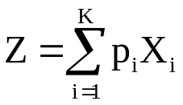

The mean and variance of Z are given by the formulas

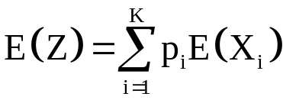
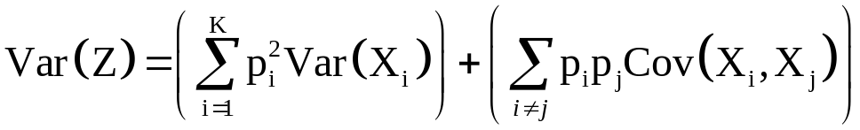

Remain calm – these formulas are just straightforward generalizations of the two variable formulas.

As before, an “optimal” portfolio might then be obtained by choosing the values of p₁,…,p_{K} which maximize the volatility adjusted return E(Z) – Var(Z)/2.

Another strategy that is sometimes considered fixes the “risk” of the portfolio (its variance) and then chooses the values mixture weights p₁,…,p_{K} that maximize the expected return.

For example, using the Solver in Excel we find that for a portfolio of a subset of our 35 stocks
Var(Z) | Maximum E(Z) | E(Z) - Var(Z)/2
0.00135 | 0.0139 | 0.013225
0.00140 | 0.0149 | 0.014200
0.00150 | 0.0161 | 0.015350
0.00200 | 0.0191 | 0.018100
0.00300 | 0.0225 | 0.021000
0.00400 | 0.0250 | 0.023000
0.00500 | 0.0271 | 0.024600

Note how increased volatility allows for increased expected returns.
For our previous two stock portfolios we found

Investment | Average | Variance | Avg – Var/2
DisMcD | .0177 | .0048 | .0153
DisExx | .0174 | .0033 | .0158

How do the larger portfolios compare to these?

Caveat!
The means, variances, and covariances may change in the future. Remember Long-Term Capital Management?

Take-Away Review
Portfolios can be represented as weighted sums of random variables, allowing us to study methods for optimizing the performance of a portfolio.

Finding the variance of such a portfolio requires that we know the covariances among the different investments.

Covariance and correlation measure the strength of linear association between pairs of random variables.

Cov(X,Y) ≠ 0 implies dependence, but
Cov(X,Y) = 0 does not imply independence.

Covariance is more useful for working with portfolios, but correlation will become more useful in Stat 621.

Next Module
Samples and populations are key ideas in inferential statistics, and we next take a closer look at these concepts.

This fact becomes a lot more natural if you think about it like this; how is the average of a sum related to the sum of the averages? They are the same, right? This fact just takes that notion a little farther.
It seems natural that the variance of a sum might be the sum of the variances. But why should the variance of the difference also be the sum of the variances? It might help to think of Var(X-Y) as Var(X+[–Y]) = Var(X) + Var(–Y). Changing the sign of Y does not change its variance, Var(Y) = Var(–Y).
As in the dice simulation, this portfolio rebalances after each month so that half of the value of the portfolio is kept in Disney and the other half in Exxon.
We can get the variance by simply squaring the SD that appears in the output. You can also ask JMP to give you the variance, as well. You do this by adding “more moments” to the output of the description command.
The volatility adjusted return formula for gross returns from Module 4 (p. 4-11) also holds for net returns.
This output is obtained using Analyze > Fit Y by X with Exxon as Y and Disney as X, right-clicking on the Bivariate Fit title bar, and selecting Density Ellipse .95. The more “tilted” the football shape of the ellipse, the more linearly dependent the pair of measurements.
Ordinarily, p is chosen between 0 and 1. However, negative values could be used to represent short selling.
The Excel files portfolio1.XLS and portfolio2.XLS are set up to do the Solver optimization for the Disney-McDonald’s, and the Disney-Exxon portfolios. Just select Solver from the Tools menu.
At least remain calm for now. You’ll see them again in finance. They really like these formulas!
At some point, however, accepting more risk will not lead to higher volatility adjusted returns. You’ll see more of this concept when you study the “efficient frontier” in finance.

