Module 6: Sampling, Sampling Distributions, and Standard Errors

The Population-Sample Paradigm
Treat the observed data as a sample from a population.

Use sample characteristics to make inferences about population characteristics.

Some Managerial Examples Where Sampling is Useful
Operations: manufacturer estimates proportion of defectives in a shipment.
Marketing: retailer estimates share of executives shopping in outlets.
Economics: questionnaire measures effect of price on customer purchasing.

HR: personnel manager estimates variability of hourly wages across an industry.

Target Population Versus Sampling Frame
Sample | Target Pop’n | Sampling Frame
100 Incomes | U.S. Incomes
Political Poll | Actual Voters
CNN Poll of Callers | U.S. Opinions
Sample 10 Goats | All Goats

Sampling bias is a mismatch between the target population and the sampling frame.

Typical causes of sampling bias: self selection, non-response, incentives to answer, interviewer characteristics, formulation of questions, and sensitivity of questions (see BBS, p. 108).

Hypothetical Populations
Suppose a genetic scientist at an agricultural company harvests 200 oranges, the first of a new variety. Are these a sample from a population of interest?

From which populations might the following be considered a sample?

The 507 daily returns in GM92.JMP (Module 2)

A bag of M&M’s candies

(Simple) Random Sampling
Random Sampling - every possible subset of a given size has an equal chance of being drawn.

Can be obtained as a sequence of individual random draws from the population.

Sampling without replacement - items can only be selected once
Sampling with replacement - items can be selected repeatedly

When will sampling with replacement be virtually the same as sampling without replacement?

Random sampling should be done with a device that provides random selection.
Careful! Haphazard ≠ Random.

Other Sampling Designs - systematic sampling, stratified sampling, cluster sampling, and multistage sampling.

iid Sampling
We shall be especially interested in simple random samples obtained by sampling from a population of a conceptually infinite size.

Real populations have finite size, but it’s often reasonable to treat them as infinite when the size of the sample is small relative to the size of the population.

In this case, the data x₁,…,x_{n} can be thought of as

n independent draws from the same population.

Such samples are called iid samples:

iid = independent and identically distributed.

Notation: We’ll use

x₁,…,x_{n} iid ~ N(μ,σ²)

to denote data obtained as an iid sample from the normal distribution N(μ,σ²).

What aspects of the GM 92 daily returns (pp. 2-15 and BBS pp. 27-28)
support an assumption that
x₁,…,x₅₀₇ iid ~ N(μ,σ²)?

Key benefit: statistical theory shows that characteristics of iid samples tend to emulate population characteristics.

Example 1: simulating x₁,…,x₅₀ iid selections with Chipsim.JMP from the chip distribution p(1) = .5, p(5) = .3, p(10) = .1, and p(20) = .1. Recall μ = 5 (pp. 3-11) and
σ = 5.744 (pp. 3-14).

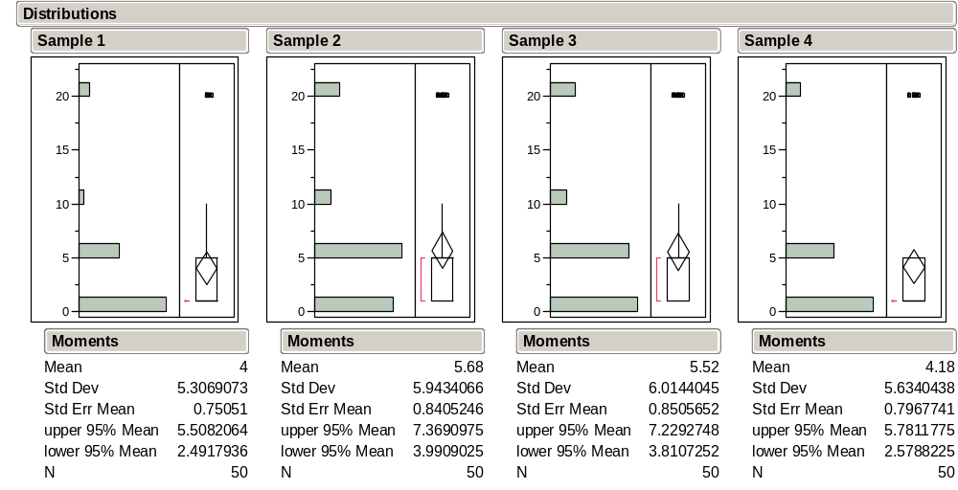

Example 2: simulating x₁,…,x₅₀₇ iid ~ N(0, .02²) with Normsim.JMP.

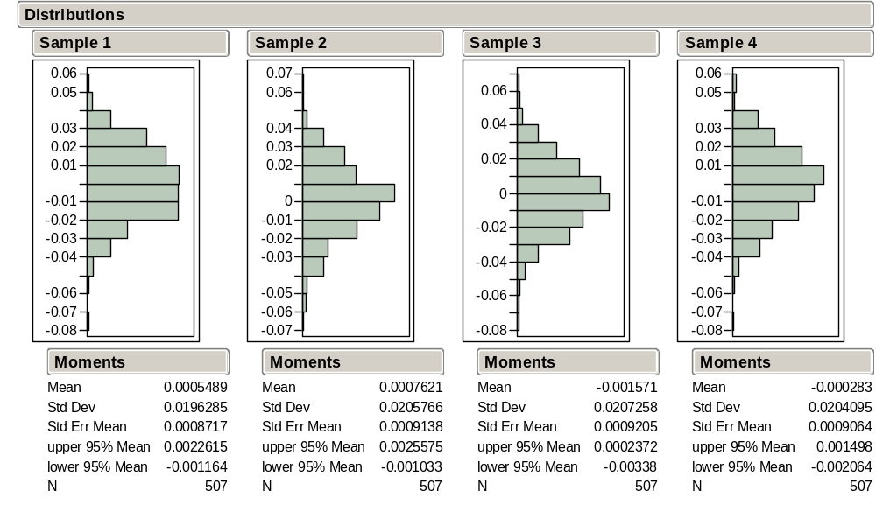

Sample Estimates of Population Parameters
Simulation examples are artificial because we know population features such as μ, and σ². If we know the population, it’s easy to simulate samples. But what about the other direction? What can we learn about a population, or infer from a sample?

In real problems, these population features—called parameters—are not known and must be estimated from data.

The sample statistics, s², and s are typically used to estimate μ, σ², and σ.

For the GM92 returns data, we computed = .00158 and s = .0202.

Based on our normal simulation results, does it seem plausible that μ = 0 and σ = .02 are in the GM92 population?

A Class Experiment
Organize into teams of 2 or 3 students.

Every team will receive a bag of M&M’s candies.

Is it reasonable to treat the contents of your bag as an iid sample from a population?
Which population?

Estimate the population proportion of blue M&M’s using only the information in your sample.

Will every team come up with the same estimate? Why not?

Note that a sample proportion is a special case of 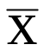. Why?

The Sampling Distribution of a Statistic
As previous examples show, sample estimates such as or s, do not match μ and σ, and vary from sample to sample. Once we admit that we would have gotten a different value if we had gotten a different sample, we need to describe just how different the result might have been.

To quantify this sample-to-sample variation, we introduce two new populations:

The population of samples – the set of all possible samples of size n that could be drawn from the original population.
The population of values of the sample statistic– the set of all possible values of the sample statistic—one for each sample.

Definition: the population of sample statistic values is called the sampling distribution of the statistic.

Example: For the Class M&M’s Experiment
What is the population of samples? What is the population of sample statistic values?
How do the class samples and estimates relate to these populations?

The Sampling Distribution of
Astonishing Fact: for x₁,…, x_{n} iid from any population with mean μ and standard deviation σ, the sampling distribution of

a) is approximately normal when n is large, and so is essentially determined by the mean μ and standard deviation σ.
b) has mean μ = μ.
c) has standard deviation σ = (σ / 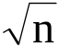).

We can use this fact to quantify the amount of sampling variation of from the information in just one sample.

Remarks:

This is known as the Central Limit Theorem (CLT). For practical purposes, normality can be assumed when n ≥ 15.

When the original population is exactly normal, then the sampling distribution of will also be exactly normal.

The Astonishing Fact says that the sampling distribution of the sample mean is always approximately N( , ).

Pictorially:

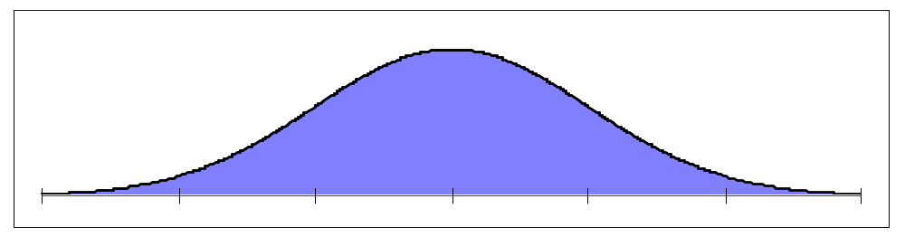

The Astonishing Fact in Action!
The following slide shows the exact sampling distribution of 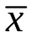 for three different populations and various values of n. Regardless of the shape of the population, the sampling distribution of the average gets closer and closer to a normal distribution.

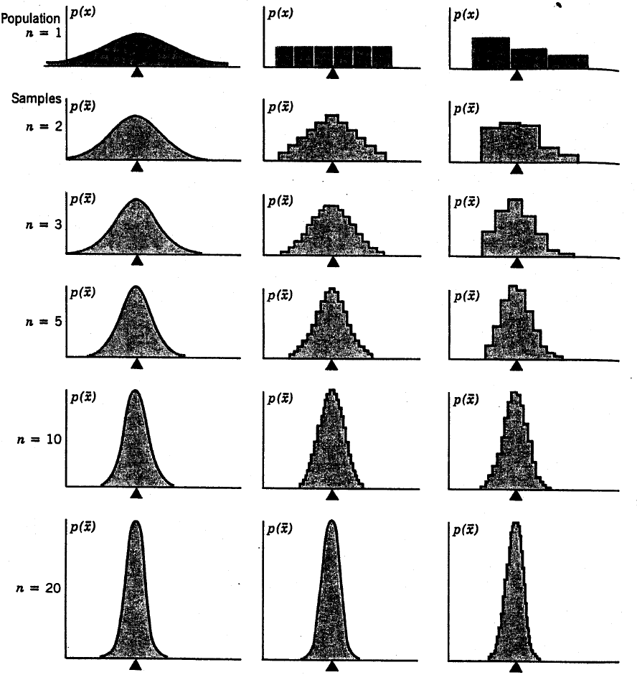

Motor Shaft Data (BBS, p. 68)
A quality control application provides another chance for us to see the sample-to-sample variation of the average. The file ShaftXtr.JMP contains 400 observations of diameters (in thousands of an inch) of motor shafts produced at a manufacturing plant. Five observations were taken per day for 16 weeks.

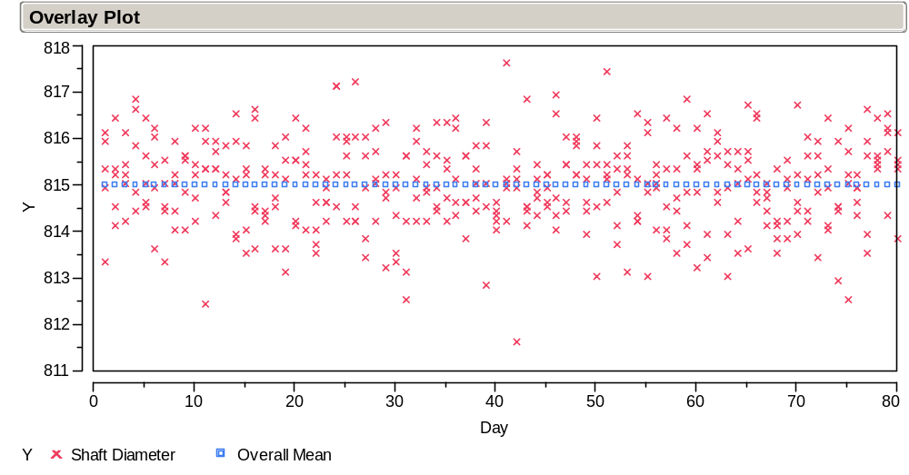

Look what happens when we plot daily means and weekly means instead.

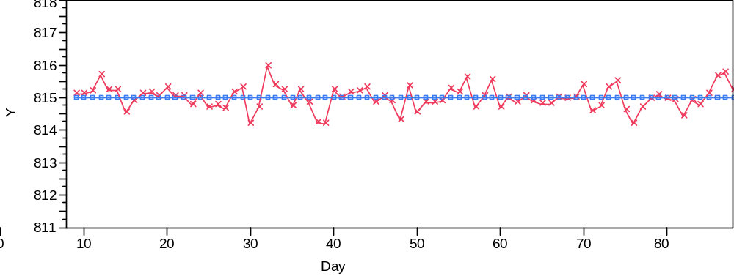

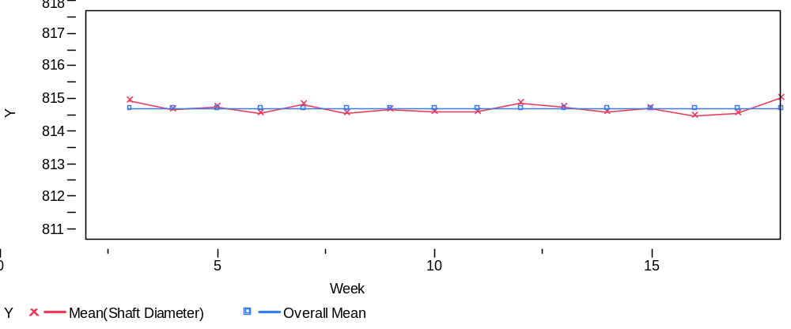

The individual diameters can be considered as sample means for samples of size n = 1.
The daily averages can be considered as sample means for samples of size n = 5.
The weekly averages can be considered as sample means for samples of size n = 25.
Summaries of the individual, daily, and weekly means (BBS, p. 69) show the effects of larger and larger samples on the variation of the average.

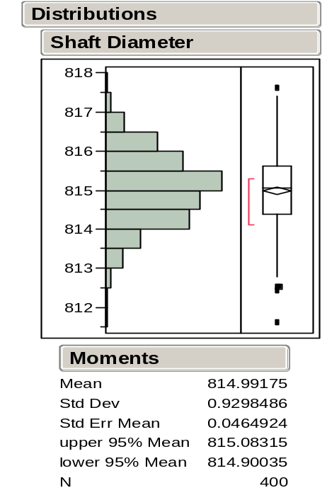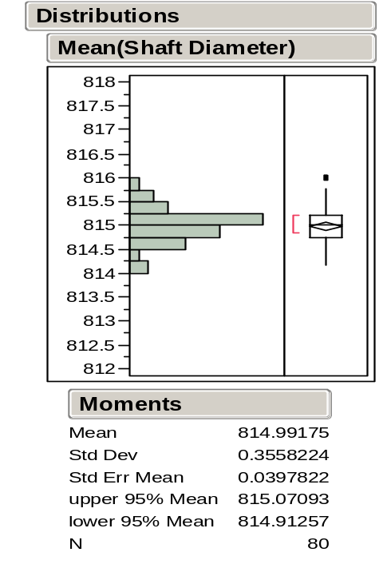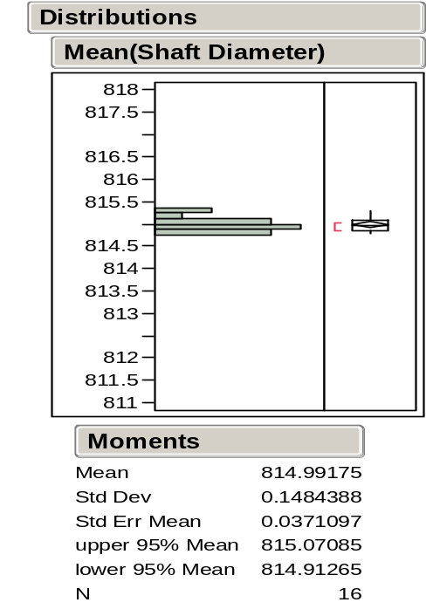

Notice that the averages concentrate closer and closer around the overall mean as n, and the number averaged gets larger.

The Standard Error of
The reason that we care about the sampling variation of is that we can use this property of the statistic to find out how close we are to the population mean. The astonishing fact about the sampling distribution of enables us to make general statements like

P(μ − 2σ/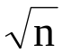 ≤ ≤ μ + 2σ/) ≈

What does this convey about the proximity of to μ?

Because σ = (σ /) is unknown in practice, it is usually estimated by

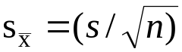,

which is called the standard error of .

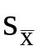 is an estimate of the standard deviation of the sampling distribution of .

should be reported along with to indicate its precision.

Example: Returns on GM Stock
For the GM92 data, we estimated μ by = .00158 and estimated σ by s = .0202 with n = 507 observations.

Here, the standard error of is 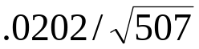 = .00090.

What does this standard error convey?

The previous JMP output for the GM92 returns reports the standard error of .

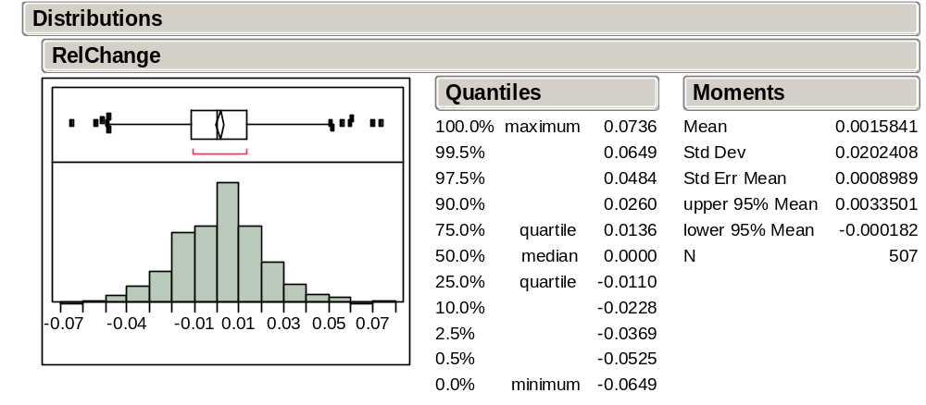

The Standard Error of the M&M’s Estimates
We saw before that the standard deviation of the class estimates was

Bad news: we needed all the class samples to calculate this number. This is useless when we only have one sample.

Good news: an effective alternative is the standard error 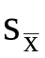 = (s /) and it can be calculated from a single sample!
Using one bag of M&M’s, we obtain

= and s / =

Is this close to our class findings?

Take-Away Review
The information in iid samples allows us to

Estimate population parameters, such as μ and σ², by their corresponding sample statistics, and s.

as well as to

Estimate how close the sample statistics are likely to come to the corresponding population parameters. The key ingredient is the standard error of the statistic.

The standard error of is s/ and can be estimated from the same sample used to calculate . It estimates σ/, the standard deviation of the sampling distribution of .

Next Module
When we combine standard error with the implications of the Central Limit Theorem, we can make profound statements about features of the population with confidence intervals.

Many of the examples that we use in these notes appear with further discussion in the Basic Business Statistics (BBS) casebook. In some cases, the casebook uses the same data that we consider in class and in others, like this one, the casebook considers a similar data set.
A sequence of independent draws from specified probability distributions can be obtained with JMP. From the list of “random” functions, consider choices such as random uniform or random normal.
An alternative, artificial way to avoid the complications of sampling from a finite population is to assume that we sample with replacement. If we put them back, the result of one case does not influence other cases.
An easily computed approximation to s in this context is 

