Module 7: Confidence Intervals

A 95% Confidence Interval for μ
A convenient way to convey the precision of a statistical estimate is to report a range of “probable” values of the parameter. This is done by reporting a confidence interval.

When x₁,…, x_{n} is an iid sample from a population,

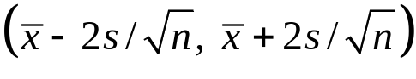

is called a 95% confidence interval (CI) for the population mean μ.

The “95%” part of this name is known as the confidence level of the interval.

Example
For the stock prices of General Motors (GM92), 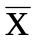 = .0016, s = .0202, and n = 507

The resulting (approximate) 95% CI for μ is

= (-.0002, .0034).

Key property: 95% CIs contain the population mean μ “about 95% of the time.”

To see why, recall from pages 6-18 that

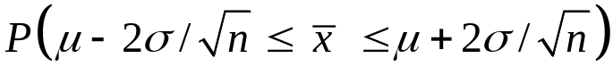 ≈ 95%

so if we estimate σ by s, then

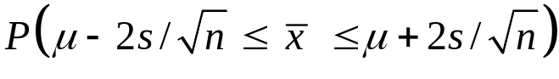 ≈ 95%.

Thus, is within 2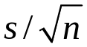 of μ for about 95 % of samples. Ninety-five percent of samples have the property that the average of that sample lies within about 2s/√n of μ.

Exact Confidence Intervals For μ
When x₁,…, x_{n} iid ~ N(μ,σ²), exact confidence intervals for μ take the form

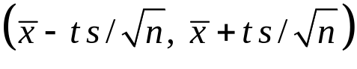

where t is a predetermined constant that depends on the sample size n and the desired confidence level (again, this is usually 95%).

For example, if n = 20, we can see the “price” of not knowing σ and having to estimate it from the data. The confidence interval is longer.

t = 2.09 yields a 95% CI and t = 1.72 yields a 90% CI

Good news: JMP provides exact 95% CI limits for μ.

Example: we can at last explain the diamond in the boxplot. It’s the 95% CI for μ. For the GM92 returns, we get this summary:

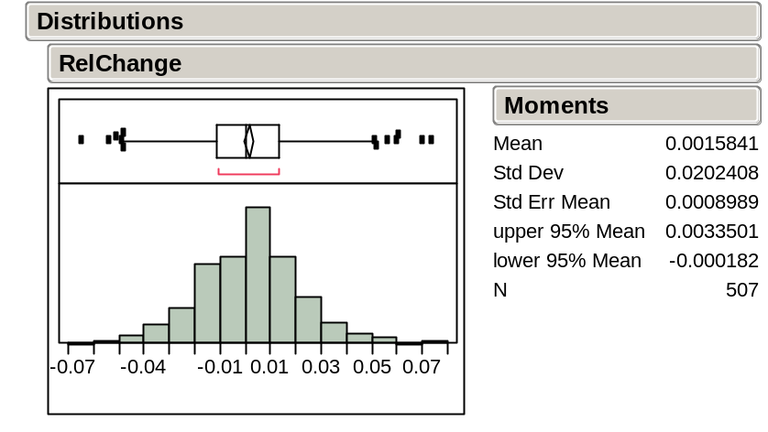

The 95% CI for μ here uses the exact procedure. How does it compare with the approximate interval (-.0002, .0034) on page 8-2?

The "±2 Standard Error" Rule of Thumb
Unless n is small (≤ 30) and precise confidence is needed, the approximate
95% CI bounds given by 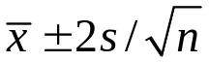 are fine.

Confidence Intervals are not Tolerance Intervals!
When x₁,…, x_{n} are iid ~ N(μ,σ²), the (approximate) 95% tolerance interval for a future draw from this population is defined as

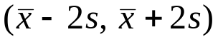.

Careful! This is not the (approximate) 95% CI for the population mean μ.

The tolerance interval is wider because individual values are more variable than averages.

Example: let’s revisit the 400 observations of motor shaft diameters in ShaftXtr.JMP (BBS, p.97).

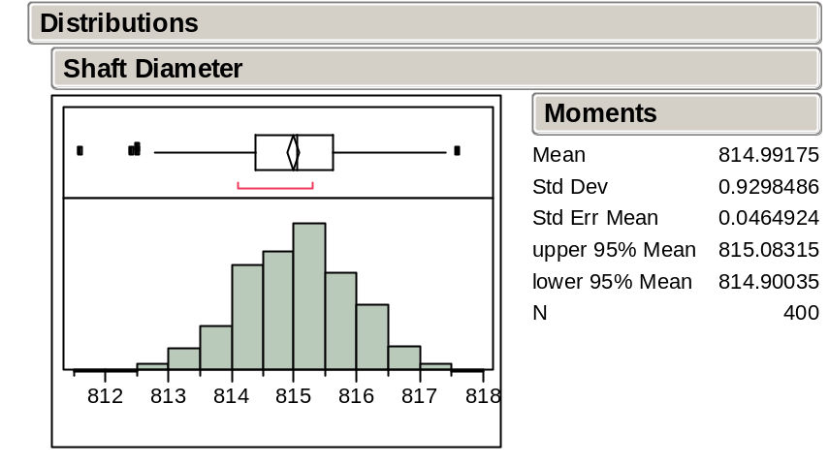

A 95% CI for the mean of the shaft-making process is (814.90, 815.08).

Assuming the process remains in control (recall control charts, as shown on BBS p.75), an approximate 95% tolerance interval for the diameter of a future shaft is

(814.99 – 2(.93), 814.99 + 2(.93)) = (813.13, 816.85).

Which interval is wider? Why?

The Effect of the Sample Size
The width of the 95% CI for the mean of the motor shaft process is (using all of the data) 815.1–814.9 = 0.2 (p 7-6). What would happen to the width of the 95% CI for the mean if the sample size n was larger?

Using the ±2 standard error rule of thumb, the width of a 95% CI for the mean is

Width = 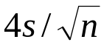.

Suppose we doubled the sample size from n to 2n. What would happen to the width of the interval?

The margin of error of an estimate reported in the media is usually half the width of the 95% CI, namely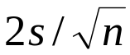.

When estimating a population proportion such as in a political poll, the maximum margin of error for the 95% confidence interval is approximately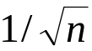. This can be used to choose the sample size n needed to guarantee a 95% level of accuracy for a desired margin of error.

An Intent to Purchase Survey (BBS, p.104)
A manufacturer of consumer electronics would like to know how many households intend to purchase a computer next year. The file CompPur.JMP contains the yes or no responses of 100 households.

The JMP summary for the nominal yes-no variable Intend_to_Purchase

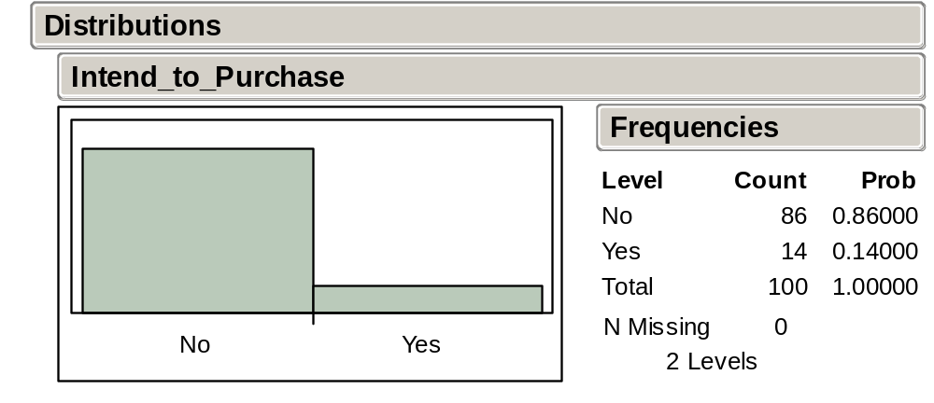

Management hopes that the proportion is at least 25% in order to justify sales projections.
Does the survey dash their hopes?

Assuming the survey has truly sampled the population of interest, the issue here is:

Can the difference between 14% and 25% reasonably be attributed to chance
(i.e., to sampling variation)?

To answer this question with a confidence interval, we transform the variable Intend_to_Purchase to a numerical variable Intend:

Intend = 0 if Intend_to_Purchase = No
Intend = 1 if Intend_to_Purchase = Yes

Because Intend is numerical, the JMP summary provides moments and the 95% CI for the (unknown) population proportion.

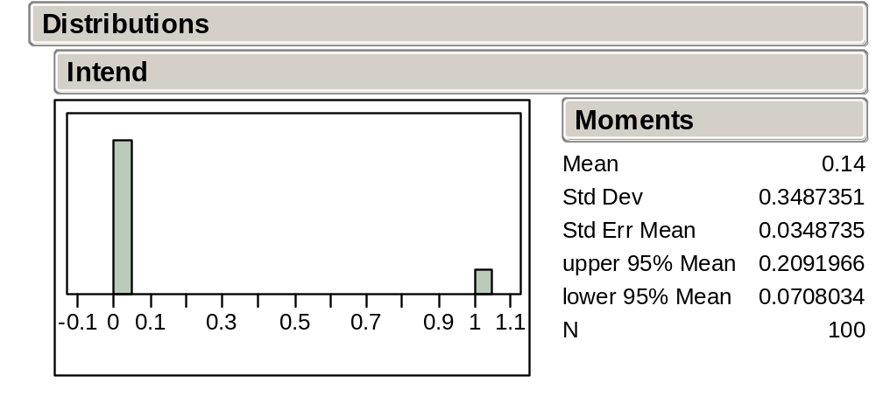

Note that the sample proportion 14% is the mean of Intend.

Do management’s hopes now seem reasonable?

Take-Away Review
A confidence interval is a range of plausible values for the population parameter. The confidence level of the interval indicates just how plausible this range is.

Most of the confidence intervals that we’ll use are 95% confidence intervals.

To form a 95% confidence interval for the population mean, we can use the exact interval or the approximate “back of the envelope” interval
.

This form is typical of most of the CIs we will use in this course and Stat 621, namely
(estimated value ± 2 SE(estimated value)).

Next Module
If a value lies outside of the confidence interval, our analysis today suggests that “it’s not plausible” at some level of confidence. But once a value lies out of the interval, that’s about all we can say.

Statistical tests take this idea further and directly measure the reasonableness of a hypothesized population value.

Technically, this interval is an approximate 95% interval because we use 2 and estimate σ, the population SD, by s, the sample SD. By varying the number of standard errors, we can obtain confidence intervals with different confidence levels.
Using Analyze > Distribution, it is listed in the Moments output.
Tolerance intervals are closely related to the prediction intervals that we’ll see in Stat 621.
Many of the examples that we use in these notes appear with further discussion in the Basic Business Statistics (BBS) casebook.
Using Analyze > Distribution, the output for a categorical variable takes this form.
0/1 encodings of a categorical variable will be common in Stat 621. They’re known as dummy variables.

