Module 8: Statistical Hypothesis Testing

Setting up a Hypothesis Test
Recall the intent to purchase example from Module 7.

The status quo belief of management is that 25% of a population of consumers intends to purchase a computer. A new sample seems to contradict that claim; only 14% in this sample intend to purchase a computer. Management needs to decide whether to reject the claim based on the new evidence.

The general problem of statistical hypothesis testing concerns using data to make a decision. In this setting, the decision is whether a hypothesis of interest should be rejected.

Jargon:

The hypothesis to be tested is called the null hypothesis and is denoted H₀.

A second hypothesis, denoted H_{a}, is often considered as an alternative to H₀.

In the intent to purchase example, these two hypotheses can be expressed as

H₀: μ = .25 versus H_{a}: μ ≠ .25

where μ denotes the unknown true population proportion.

Don’t take such hypotheses too literally. If μ =.2500001, it makes sense to retain H₀ because it remains a rather good description of the population. Instead, think of the null here as saying “It’s reasonable to treat the mean of the population as .25.”

The One-Sample t Test
Suppose we have a random sample 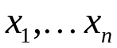 from a population with unknown mean μ.
A common hypothesis that is often considered for this setup is

H₀: μ = μ₀ versus H_{a}: μ ≠ μ₀

Note that the intent to purchase hypotheses is the special case with μ₀ = .25.

The key quantity for testing these hypotheses
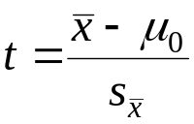
is called a t statistic or a t ratio.

The t statistic counts the number of standard errors between the observed statistic (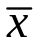) and the hypothesized population parameter (μ₀).

Intuition: a large t statistic implies that the data are implausible if the null hypothesis is true. We interpret a large t statistic as evidence against H₀.

Example: Testing the intent to purchase hypotheses H₀: μ = .25 vs. H_{a}: μ ≠ .25.

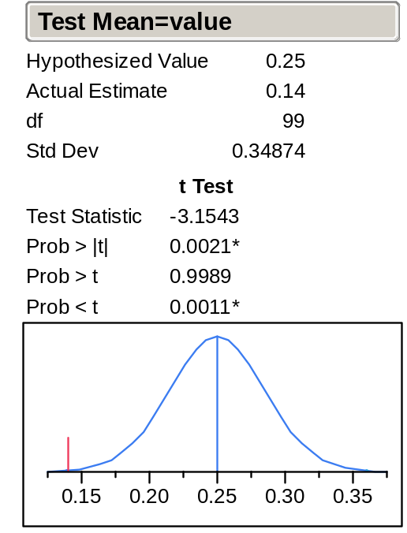

The estimate of the unknown proportion μ is the sample proportion = .14.

In units of standard errors, how far is .14 from the hypothesized value μ₀ = .25?

The p-value: How Extreme is Enough to Reject H₀?
Key issue: How large should t be in magnitude (positive or negative) in order to convince us to reject H₀ and declare a “statistically significant” result?

To answer this question in the previous example, JMP provides the quantity:

Prob > | t | = .0021

which is the probability of observing a t statistic more extreme than -3.15 (positive or negative) if in fact
H₀: μ = .25 is true.

Thus, if μ were .25, a |t-statistic| larger than 3.15 would occur only 0.21% of the time!

The quantity Prob > | t | = .0021 is called a p-value and it measures the rarity of the data when H₀ is true.

“Small” p-values indicate one of two things: either H₀ is false or else something very unusual has happened.

Faced with these two choices, statistical practice is to reject H₀ when the p-value is “small” enough.

The “Official” Rules for hypothesis Testing
Procedure to test a pair of hypotheses is:

1) Pick a value α called the significance level (traditionally α = .05 or .01).

2) If the p-value ≤ α, reject H₀ and report the result as statistically significant (at the α level of significance).

3) Otherwise, if the p-value > α, the result is said to be not statistically significant.

Should the intent to purchase hypothesis H₀: μ = .25 be rejected at the .05 level of significance? At the .01 level of significance?

Example: GM92 data

Suppose you want to test the following pair of hypotheses about returns on GM stock using this two years of data
H0: μ = 0 versus Ha: μ ≠ 0
where μ is the unknown mean of the population of GM daily returns. JMP yields

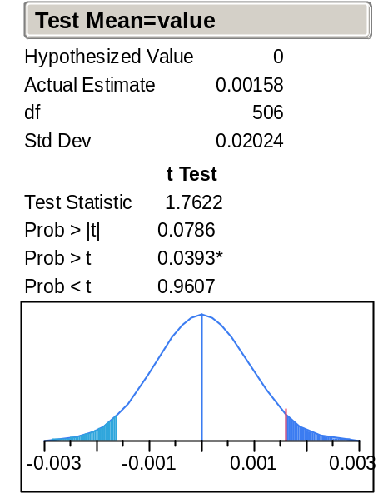
Can H₀ be rejected at the .05 level of significance?
If you don’t reject H₀, does that mean it’s true?

The "2 Standard Error" Rule of Thumb
For practical purposes, a good approximate test of

H₀: μ = μ₀ versus H_{a}: μ ≠ μ₀

is to

reject H₀: μ = μ₀ at the α=.05 level when |t-statistic| ≥ 2

(i.e., reject H₀ when is more than 2 standard errors away from the hypothesized value μ₀₎.

Using Confidence Intervals to Test Hypotheses
The traditional choice of the significance level of a test is α = 5%. Also, the traditional choice of the level of confidence of a confidence interval is 95% (= 100% - 5%).

This correspondence is not accidental!

An alternative way to test H₀: μ = μ₀ versus H_{a}: μ ≠ μ₀ at the α =.05 level of significance uses a confidence interval:

Reject H₀: μ = μ₀ when μ₀ lies outside the 95% CI for μ

For example, for the intent to purchase example, the 95% CI for the population proportion is (.07, .21).

Because the conjectured value 0.25 does not lie inside the confidence interval, we can reject H₀: μ = .25 at the α =.05 level since μ₀ = .25 is not contained in (.07, .21).

This seems reasonable since a confidence interval is the set of plausible values for μ given the data.

Summary of Testing H₀: μ = μ₀
The following conditions are equivalent.

(a) The 95% confidence interval does not contain μ_{0.}
(b) The absolute value of the t-statistic is larger than 2 (i.e., |t| > 2).
(c) The p-value is less than 0.05.

In each case, we reject H₀: μ = μ₀.

The Two-Sample t Test
Suppose we have two independent random samples:

x₁,…,x_{n} from a population with unknown mean μ_{x}
y₁,…,y_{n} from a population with unknown mean μ_{y}

and we want to test the null hypothesis that the means of the populations are the same

H₀: μ_{x} = μ_{y} versus H_{a}: μ_{x} ≠ μ_{y}

These hypotheses can also be written as

H₀: μ_{x} – μ_{y} = 0 versus H_{a}μ_{x} – μ_{y} ≠ 0

To test this hypothesis, the test statistic of interest is the two-sample t statistic

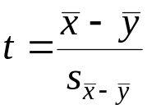

which measures the distance between and 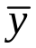 in units of standard errors.

Associated with this t statistic is a p-value. The p-value is the probability (under H₀) of observing a larger t statistic (positive or negative) than the observed t.

The test proceeds just as before:
If p-value ≤ α, reject H₀ and report the difference as statistically significant (at the α level of significance).

Alternatively, we can perform the test with a confidence interval:
Reject H₀ if 0 lies outside the 95% confidence interval for the difference in the two means.

Example
A car manufacturer uses the price of used cars to determine the initial cost charged to customers who lease its automobiles.

The file used_carsJMP contains the prices of 155 used BMW automobiles divisions. Some are the xi model (4-wheel drive) and the others are the standard i model.

Comparison boxplots of the prices of the two types of cars show considerable overlap.

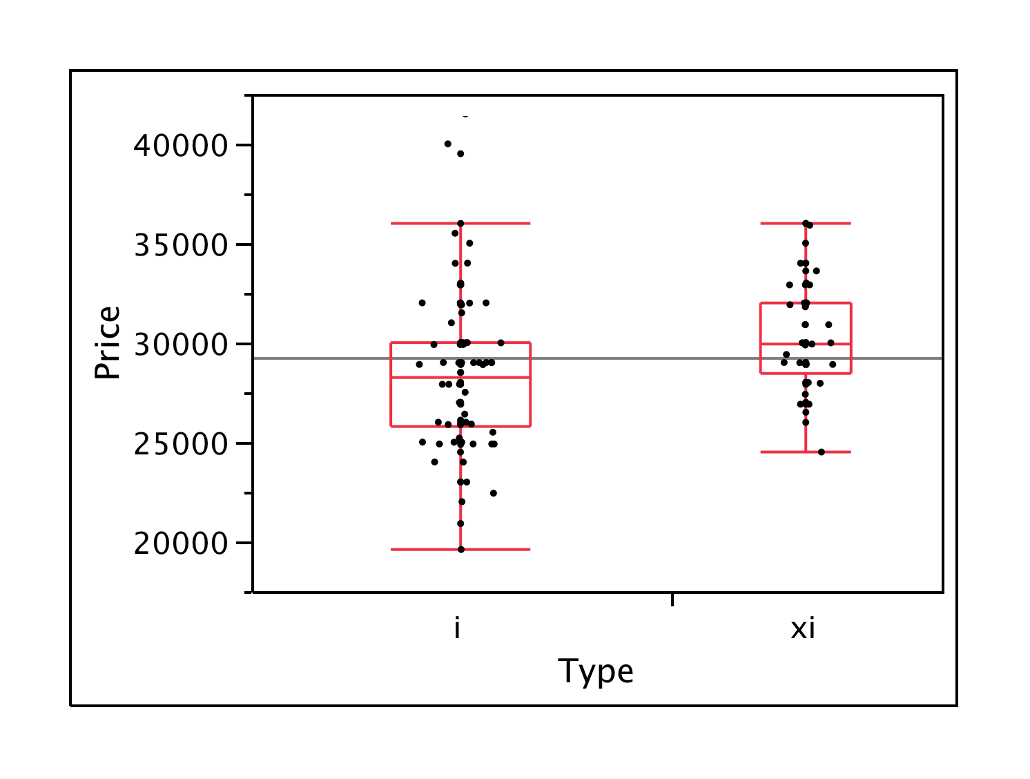

To visually judge if the population means differ, it is useful to compare the 95% confidence intervals for μ_{BW} and μ_{GL} (BBS, p.164).

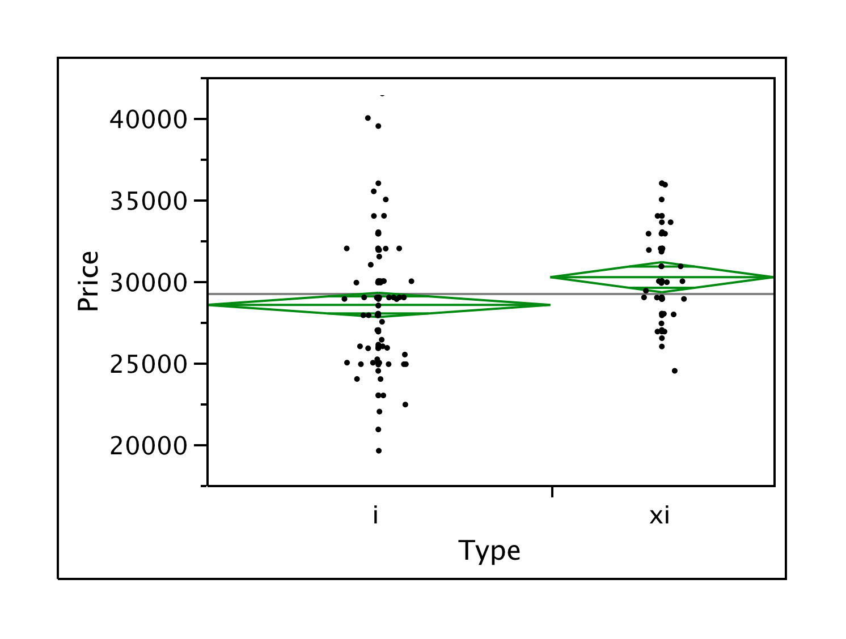

If these intervals do not intersect, we are assured that the difference between the means is significantly different from zero. These very nearly overlap, so there does appear to be a significant difference.

We can confirm these results (and get a more detailed comparison) with the two-sample test.

A two-sample t test of the hypotheses (BBS, p.164)

H₀: μ_{i} = μ_{xi} versus H_{a}: μ_{i} ≠ μ_{xi}
yields.
t Test

Difference | 1698.95 | t Ratio | 3.106932
Std Err Dif | 546.82 | DF | 152.9635
Upper CL Dif | 2779.25 | Prob > |t| | 0.0023
Lower CL Dif | 618.64 | Prob > t | 0.0011
Confidence | 0.95 | Prob < t | 0.9989

The t statistic here is 3.11 and the two-sided p-value is 0.0023.

This result is statistically significant because the absolute value of the t statistic is more than 2 and the p-value is less than 0.05. Thus, we can reject H₀ at the .05 level.

Note that we can also reach this conclusion by noting that the 95% CI contains 0.

The Paired t Test
When comparing the population means of two samples, say x₁,…,x_{n} and y₁,…,y_{n}, it is sometimes useful to consider the paired differences 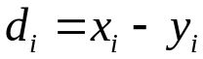, and treat d₁,…,d_{n} as a random sample from a population with unknown mean μ_{d}. When might such pairings be natural?

In this case, testing

H₀: μ_{x} = μ_{y} versus H_{a}: μ_{x} ≠ μ_{y}

is equivalent to testing

H₀: μ_{d} = 0 versus H_{a}: μ_{d} ≠ 0

This can then be tested using the one-sample t test.

Example
Management of a newly merged pharmaceutical company needs to reduce its sales force. Does the sales force from the “GL” division differ from the sales force from the “BW” division. Careful thought reveals a natural pairing within each sales district. Thus, we can create a new variable: Differences = BW – GL in each of the 20 districts. The hypothesis H: μ_{BW} = μ_{GL} is equivalent to H: μ_{d} = 0. What should we conclude?

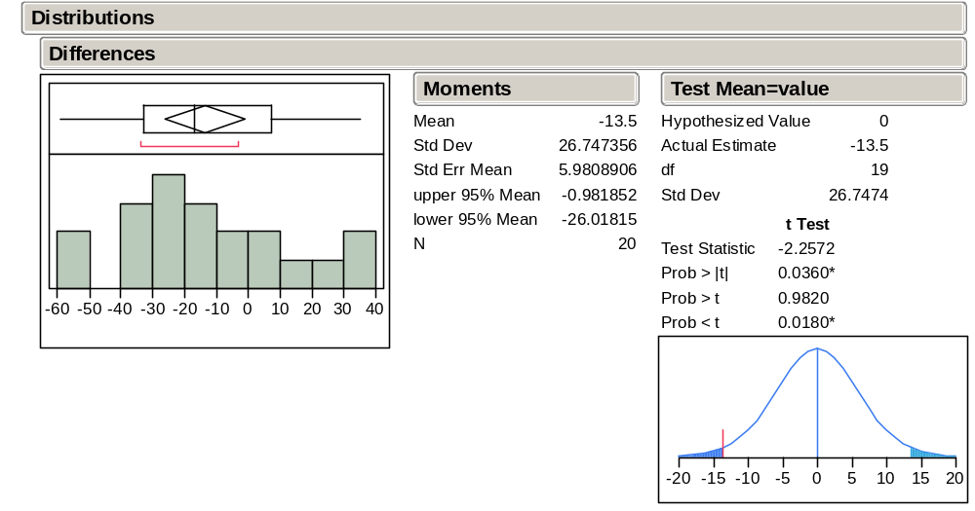

Testing Other Statistical Hypotheses
Many other hypotheses are of interest in statistical analysis.

For example, useful null hypotheses make claims about other features of populations. Hypothesis testing is not restricted to statements about mean values alone.

H₀: population is normal
H₀: population correlation is 0
H₀: two populations are identical
H₀: time series is iid

In all of these settings, conventional statistical practice proceeds as follows:

1) Calculate a p-value for the disparity between the null hypothesis H₀ and the data.
2) If p-value ≤ α, reject H₀ and report the result as statistically significant (at the α level of significance).
3) If p-value > α, the result is not statistically significant.

We will describe some of these tests in more detail in Stat 621. See you in September!

What You Will Need to Know
Graphical tools - Histogram, boxplot, comparison boxplots, and scatterplot.

Mean, variance and correlation - Mean is the average value. Variance is the average squared deviation from mean. Correlation measures the strength of linear association.

Normal distribution - 95% of the distribution lies within μ ± 2σ. Normal quantile plot as a diagnostic.

Sampling Distributions - Random Sampling; iid samples. Sample-to-sample variation of a statistic. Standard Error - SE() = s/√n .

Confidence interval - 95% CI - Estimate ± 2 SE(Estimate). Interpretation.

Hypothesis test - t-statistic/t-ratio counts the SE’s from conjectured value.
p-value measures “plausibility” of H₀. p-value < 0.05 <=> reject H₀ at the .05 significance level <=> | t-statistic| > 2 <=> hypothesized value lies outside 95% CI.

JMP Software

Some textbooks denote the alternative hypothesis as H₁ rather than H_{a}. Conventions adopted for the notation of hypothesis testing vary from author to author.
Hypotheses of this form are sometimes called “two-sided” hypotheses to distinguish them from hypotheses of the form H₀: μ ≥ μ₀ vs. H_{a}: μ < μ₀ or H₀: μ ≤ μ₀ vs H_{a}: μ > μ₀, which are called “one-sided.” Such refinements of the hypotheses are used in certain situations. We’ll stick to two-sided methods here.
For the data in CompPur.JMP, apply Analyze > Distribution to the column Intend, select Test Mean after clicking on the title bar, and enter .25 for the Hypothesized Mean to obtain this output.
For testing the hypotheses H₀: μ ≤ .25 versus H_{a}: μ > .25, JMP reports the p-value of = .14 as Prob > t = .9989. For testing the hypotheses H₀: μ ≥.25 versus H_{a}: μ < .25, JMP reports the p-value of = .14 as Prob < t = .0011.
Again, use the Test Mean command with Analyze > Distribution.
The correspondence described here works for “two-sided” hypotheses. See the Basic Business Statistics (BBS) casebook (BBS), pp. 102-103.
This equivalence assumes that the sample size is large enough so that we can use the form ±2 SE to form a 95% interval. For small samples with t-statistics close to ±2, use the p-value rather than the empirical rule.
For inferential purposes, the ideal method for getting two independent samples is from a randomized experiment as done in the pharmaceutical industry to show the value of a new drug. Otherwise, we must sort out the possibility of confounding (BBS, Class 9).
It would be pretty rare to find two populations with exactly the same mean, measured to infinite precision. As before, interpret H₀ as saying that the means are close and offer a description of the populations that is consistent with the data.
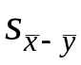 stands for the standard error of 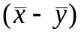 which has a formula that you can safely ignore. If you are interested, it is found in precisely the same way that we found the variance of portfolios. See BBS, p 212. Now you can see the benefit of being able to assume independence; the covariance between independent samples is zero. So, the variance of the difference of the two means is the sum of the variances.
The algebra for this claim appears in BBS, p.145. If the intervals don’t overlap, the difference is significant. If they overlap, you need to be more careful.
Use the JMP Fit Y by X command, then right-click on the title bar and select t Test. If you have good reason to justify assuming the two populations have equal variances, you can get a bit more precision by selecting the Means/Anova/Pooled t.
Using the Tables > Split command, we create a new file Pharmsal-split.JMP and create the variable Differences, the pairwise differences of BW and GL across the 20 districts.
An inappropriate two-sample test fails to find a significant difference. Use Analyze >Distribution and select Test Mean to obtain these results. JMP also offers a specific method for paired comparisons (see BBS pp.165-166). The test yields the same result.

