Department of Statistics

The Wharton School

University of Pennsylvania

Winter Welcome February 13, 2009

Making Investment Decisions

Let’s consider the 2004 performance of EBAY and OSIP.

Which of these investments would have been better to hold from 1/02/2004 thru 8/31/2004?

Date | EBAY | OSIP
1/02/2004 | 63.00 | 32.62
8/31/2004 | 86.54 | 59.59
Caution about looking at compounded values…

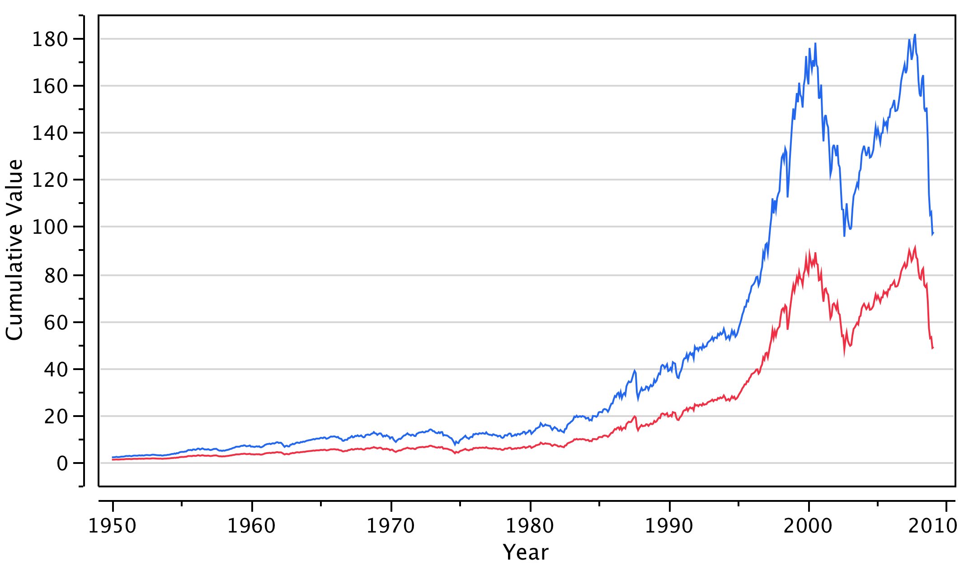

The blue investment seems to be doing so much better than the red investment, but is it?
Instead, a better yardstick is to base the comparison on the returns (basically percentage changes) for this period.

Date | EBAY | OSIP
1/02/2004 | 63.00 | 32.62
8/31/2004 | 86.54 | 59.59
Return | 37% | 83%

Which of EBAY or OSIP would be better investment for the future?

Is this enough information to make a choice?

Would you like to know more? What?

The JMP file “EBAY & OSIP 2004 Thru Aug.JMP” contains the 2004 daily prices and returns thru 8/31/2004.

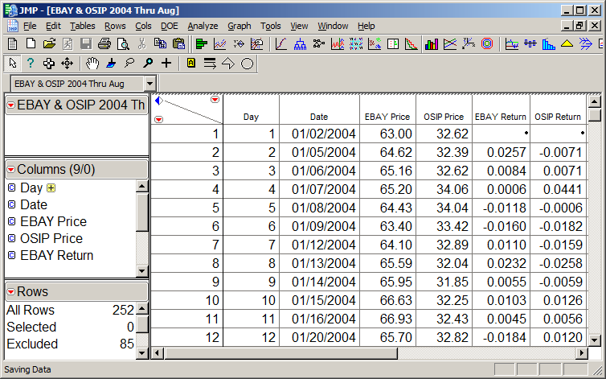
JMP software provides the following plots of the daily prices.

Which of EBAY or OSIP would be better investment for the future?

To answer such questions, we study the daily returns rather than the prices.

Returns are more stable, and so are more useful for prediction.

Which series is less volatile?
JMP is easily used to obtain graphical comparisons of the two sets of returns:

How do the returns on the two assets compare?
JMP is also easily used to obtain numerical summary comparisons the two sets of returns:

Mean – the average of the returns

St Dev – a measure of the variation of the returns

How do the returns on the two assets compare?
We have seen that compared to EBAY, OSIP yielded a higher return on average but was also more volatile.

Volatility eats away at the long run return

To see why, consider the following intuitive example:

Your starting salary was $200,000. You received a salary increase of 10% and then a salary reduction of 10%. What is your current salary?

What would happen to your salary if this up/down bounce was repeated over and over?

As you will see in Statistics 603, variation diminishes the long run return by an amount that we can quantify

Fact: The long run return of a stock is approximated by

Mean – (Standard Deviation)²/2

Applying this formula to EBAY and OSIP we compute

EBAY adjusted average daily return ≈ .00191
OSIP adjusted average daily return ≈ .00093

So this risk-adjusted view suggests to invest in EBAY

Look what happened for the rest of the year.

Date | EBAY | OSIP
8/31/2004 | 86.54 | 59.59
12/31/2004 | 116.34 | 74.85
Return | 34% | 26%

Instead of putting all our money in EBAY or OSIP, we might even consider an equally weighted portfolio of partial investments in EBAY and OSIP. For a $1 investment in each of the three options, we would obtain

Date | EBAY | OSIP | 50-50 Portfolio
1/02/2004 | 63.00 | 32.62 | 1.00
8/31/2004 | 86.54 | 59.59 | 1.78
Return | 37% | 83% | 78%

EBAY adjusted average daily return ≈ .00191
OSIP adjusted average daily return ≈ .00093
Portfolio adjusted average daily return ≈ .00303

It looks like the portfolio is a better investment.
Look what happened for the rest of the year.

Date | EBAY | OSIP | 50-50 Portfolio
8/31/2004 | 86.54 | 59.59 | 1.78
12/31/2004 | 116.34 | 74.85 | 2.38
Return | 34% | 26% | 34%

Here is what happened to a $1 investment on 9/1/2004:

EBAY operates an online market place. OSIP discovers, develops and markets anti-cancer products.
This data was downloaded from the CRSP database on WRDS, and then stored in the JMP file.
As of 2/15/08, OSIP was trading at $38.47 with EBAY at $27.86. Why might OSIP now be selling for a higher price. How could you tell? (Hint: Peek at the number of available shares in each, found in the expanded data set.)

