Solutions, Statistics Waiver Exam

August 3, 2013

1. A
2. A
3. C
4. B
5. C
6. D
7. E
8. D
9. B
10. E
11. C
12. C
13. E
14. A
15. B
16. E
17. A Estimated intercept
18. C twice the slope is 2*2349
19. A The estimated slope is less than 2 standard errors from the claim.
20. D (data-fit)/RMSE = (21000-(22390-2*2349))/3255 ≈ 1
21. C
22. B
23. D
24. E
25. E
26. C 22.639-4.874
27. B 33.541+22.639*4
28. B E.g.,33.541+22.639*6≈$169 vs. (33.541+22.639)+(22.639-4.874)*6≈$163
29. D
30. B Coupon use and household size are correlated.
31. A exp(*b*0+*b*1*(q+1))/exp(*b*0 +*b*1*q) = exp(*b*1) ≈ 1+*b*1
32. E exp(5.8283+0.090567*41 ± 2*.79878) ≈ 2818.576 to 68810.182
33. C
34. D
35. A
36. E [(162.409-16.028)+2105.522/3000+(12.28-9.275)*3+(1.515-1.989)*1]*3000
37. C
38. B 1.505-1.097 > 0
39. A
40. C sqrt(0.85) ≈ 0.92
41. B
42. D
43. A
44. E
45. Given a home has 3,000 square feet with 3 bathrooms, the estimated fit of this model implies that increasing the distance from the nearest school
46. **Increases the average price per square foot in a suburban location.**
47. Decreases the average price per square foot in a suburban location.
48. Has no effect on the average price per square foot in any location.
49. Decreases the average price per square foot in a suburban location.
50. Increases the average price per square foot in a rural location.
51. Within this collection of homes, homes that are farther from schools tend to be larger, with more bathrooms (corr(*Number Baths*, *Distance*) ≈ 0.5). This property of the data implies that
52. **Collinarity increases standard errors of the slopes in the fitted model.**
53. These data violate the assumption of independent in the MRM.
54. The data should be separated based on location and modeled separately.
55. Either *Number Baths* or *Distance* should be removed from the fitted model.
56. The error variation will increase for larger homes.
57. The value of the *R*2 statistic implies that
58. The model accurately predicts about 85% of the home prices.
59. The model poorly predicts about 85% of the home prices.
60. **The correlation between predicted and actual prices is about 0.92.**
61. The prices of 85% of homes are within ±2 RMSE of the predicted prices.
62. Removing 15% of the homes would produce a perfect fit.

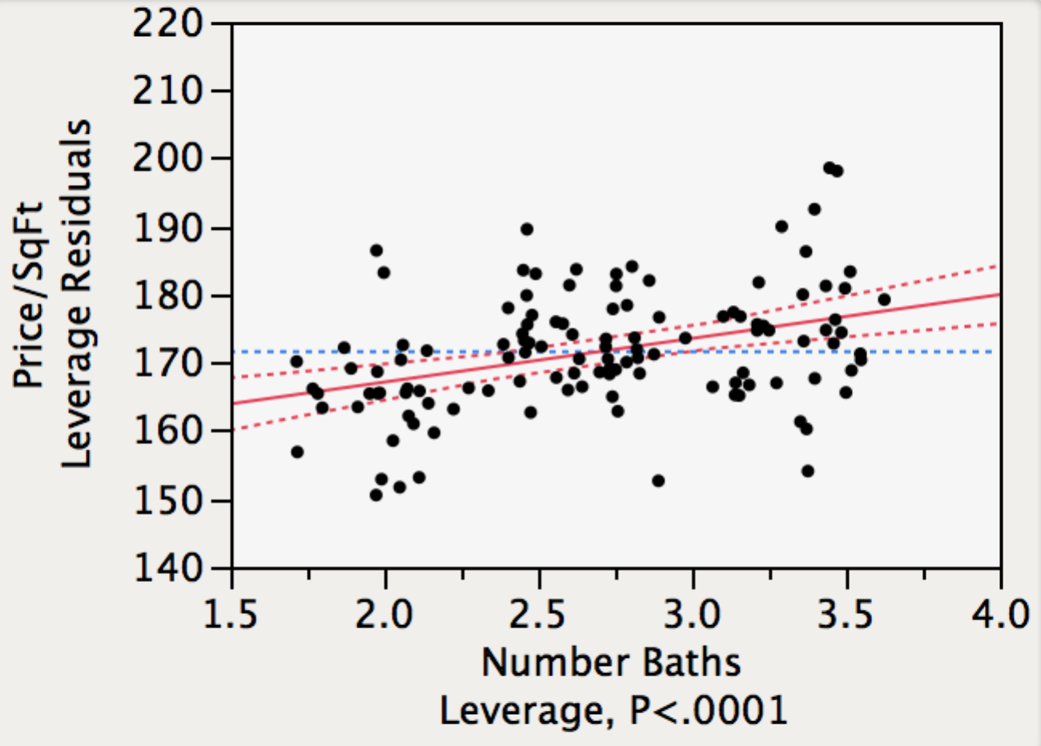

1. The leverage plot shown to the right indicates that
2. The model requires an interaction term.
3. **The partial slope for *Number Baths* is significant.**
4. *Number Baths* should be transformed.
5. A leveraged outlier has reduced the partial slope.
6. The model omits a 3-level categorical variable.
7. A homeowner is considering converting an extra room in a home into an extra bathroom. Assuming the conditions of the MRM, this model implies that this conversion will
8. Not significantly increase the selling price.
9. Significantly increase the selling price, but only in the city.
10. Significantly increase the selling price, but only in suburban locations.
11. **Significantly increase the selling price, with an amount varying by location.**
12. Significantly increase the selling price, but only in rural locations.

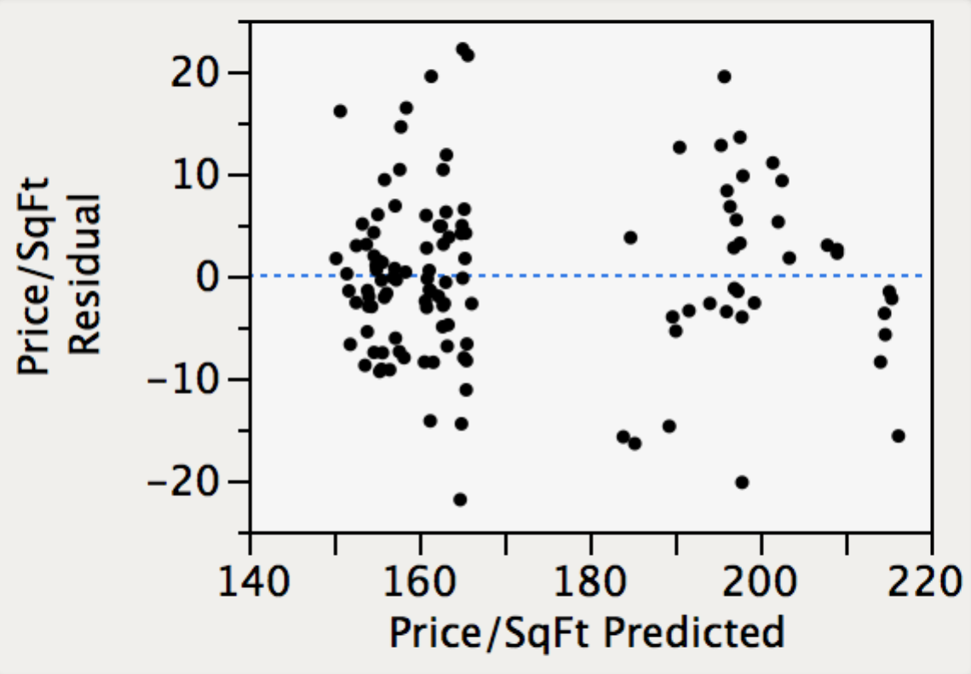

1. The plot of the residuals from this model shown above indicates that this model
2. **Predicts higher prices per square foot for suburban homes than in other locations.**
3. Predicts higher prices per square foot for rural homes than in other locations.
4. Produces residuals that lack constant variation.
5. Predicts that suburban homes have more bathrooms than in other locations.
6. Violates the assumption of independent observations.
7. A reasonable next step in building a model for the price per square foot would be to
8. Remove both interactions to simplify the interpretation of the model.
9. Remove the categorical variable *City*.
10. Remove the component, *Distance*\**Location*[*City*].
11. Remove the categorical variable *Location*.
12. **Remove the interaction *Distance*\**Location*.**
13. The ndicates
14. assumptions.