**Real Estate Example**

**Bivariate Fit of Renttotal By Sqft**

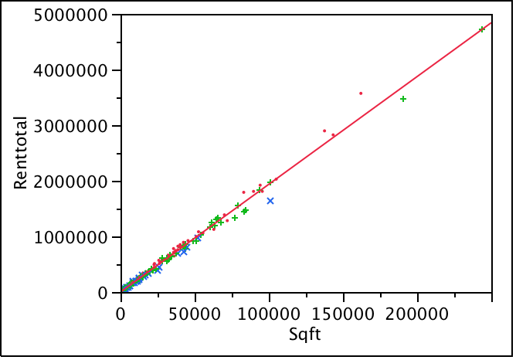

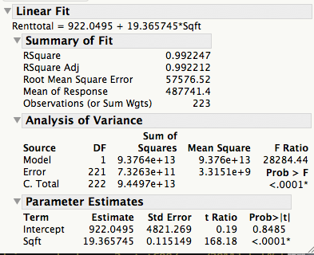

**Bivariate Fit of AveCost By 1/Sqft**

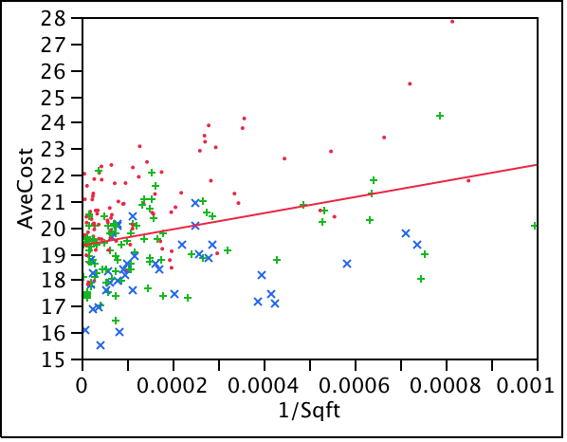

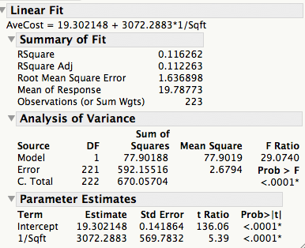

**Regression Plot**

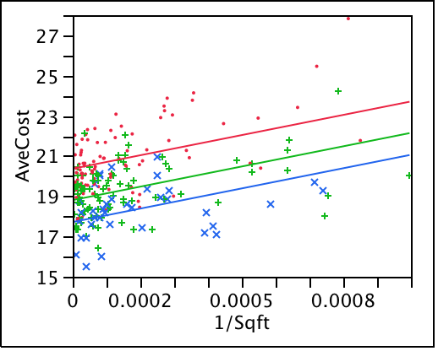

**Summary of Fit**

|  |  |
| --- | --- |
| RSquare | 0.44092 |
| RSquare Adj | 0.433261 |
| Root Mean Square Error | 1.307889 |
| Mean of Response | 19.78773 |
| Observations (or Sum Wgts) | 223 |

**Analysis of Variance**

| **Source** | **DF** | **Sum of Squares** | **Mean Square** | **F Ratio** |
| --- | --- | --- | --- | --- |
| Model | 3 | 295.44129 | 98.4804 | 57.5716 |
| Error | 219 | 374.61575 | 1.7106 | **Prob > F** |
| C. Total | 222 | 670.05704 |  | <.0001* |

**Effect Tests**

| **Source** | **Nparm** | **DF** | **Sum of Squares** | **F Ratio** | **Prob > F** |  |
| --- | --- | --- | --- | --- | --- | --- |
| 1/Sqft | 1 | 1 | 91.71131 | 53.6143 | <.0001* |  |
| Location | 2 | 2 | 217.53941 | 63.5867 | <.0001* |  |

**Indicator Function Parameterization**

| **Term** | **Estimate** | **Std Error** | **DFDen** | **t Ratio** | **Prob>|t|** |
| --- | --- | --- | --- | --- | --- |
| Intercept | 17.720281 | 0.232273 | 219.00 | 76.29 | <.0001* |
| 1/Sqft | 3344.1111 | 456.7097 | 219.00 | 7.32 | <.0001* |
| Location[CITY] | 2.6503686 | 0.256084 | 219.00 | 10.35 | <.0001* |
| Location[SUBNEW] | 1.0900274 | 0.253801 | 219.00 | 4.29 | <.0001* |

**Summary of Fit**

|  |  |
| --- | --- |
| RSquare | 0.594061 |
| RSquare Adj | 0.578885 |
| Root Mean Square Error | 1.127404 |
| Mean of Response | 19.78773 |
| Observations (or Sum Wgts) | 223 |

**Analysis of Variance**

| **Source** | **DF** | **Sum of Squares** | **Mean Square** | **F Ratio** |
| --- | --- | --- | --- | --- |
| Model | 8 | 398.05456 | 49.7568 | 39.1466 |
| Error | 214 | 272.00248 | 1.2710 | **Prob > F** |
| C. Total | 222 | 670.05704 |  | <.0001* |

**Effect Tests**

| **Source** | **Nparm** | **DF** | **Sum of Squares** | **F Ratio** | **Prob > F** |  |
| --- | --- | --- | --- | --- | --- | --- |
| 1/Sqft | 1 | 1 | 5.926289 | 4.6626 | 0.0319* |  |
| Location | 2 | 2 | 64.077113 | 25.2066 | <.0001* |  |
| 1/Sqft*Location | 2 | 2 | 0.026132 | 0.0103 | 0.9898 |  |
| Parking/Sqft | 1 | 1 | 28.935285 | 22.7651 | <.0001* |  |
| Parking/Sqft*Location | 2 | 2 | 6.619268 | 2.6039 | 0.0763 |  |

**Indicator Function Parameterization**

| **Term** | **Estimate** | **Std Error** | **DFDen** | **t Ratio** | **Prob>|t|** |
| --- | --- | --- | --- | --- | --- |
| Intercept | 17.972143 | 0.277276 | 214.00 | 64.82 | <.0001* |
| 1/Sqft | 1081.0501 | 1136.691 | 214.00 | 0.95 | 0.3427 |
| Location[CITY] | 2.0181896 | 0.317487 | 214.00 | 6.36 | <.0001* |
| Location[SUBNEW] | 0.9122433 | 0.312964 | 214.00 | 2.91 | 0.0039* |
| 1/Sqft*Location[CITY] | 15.546661 | 1437.123 | 214.00 | 0.01 | 0.9914 |
| 1/Sqft*Location[SUBNEW] | 145.67712 | 1308.608 | 214.00 | 0.11 | 0.9115 |
| Parking/Sqft | 604.51903 | 617.4953 | 214.00 | 0.98 | 0.3287 |
| Parking/Sqft*Location[CITY] | 1172.6916 | 666.3977 | 214.00 | 1.76 | 0.0799 |
| Parking/Sqft*Location[SUBNEW] | 472.44936 | 680.2169 | 214.00 | 0.69 | 0.4881 |