

**Laboratory work №3**

***On ICT discipline***

**Performed by**

***Zhanibekova Assel***

***Auk 21-5***

**Step 1.**

*To save the file , I selected the option in the line.htm, for example 1_name.htm . To close the document, I found its icon in the My computer window or in the Explorer window***.**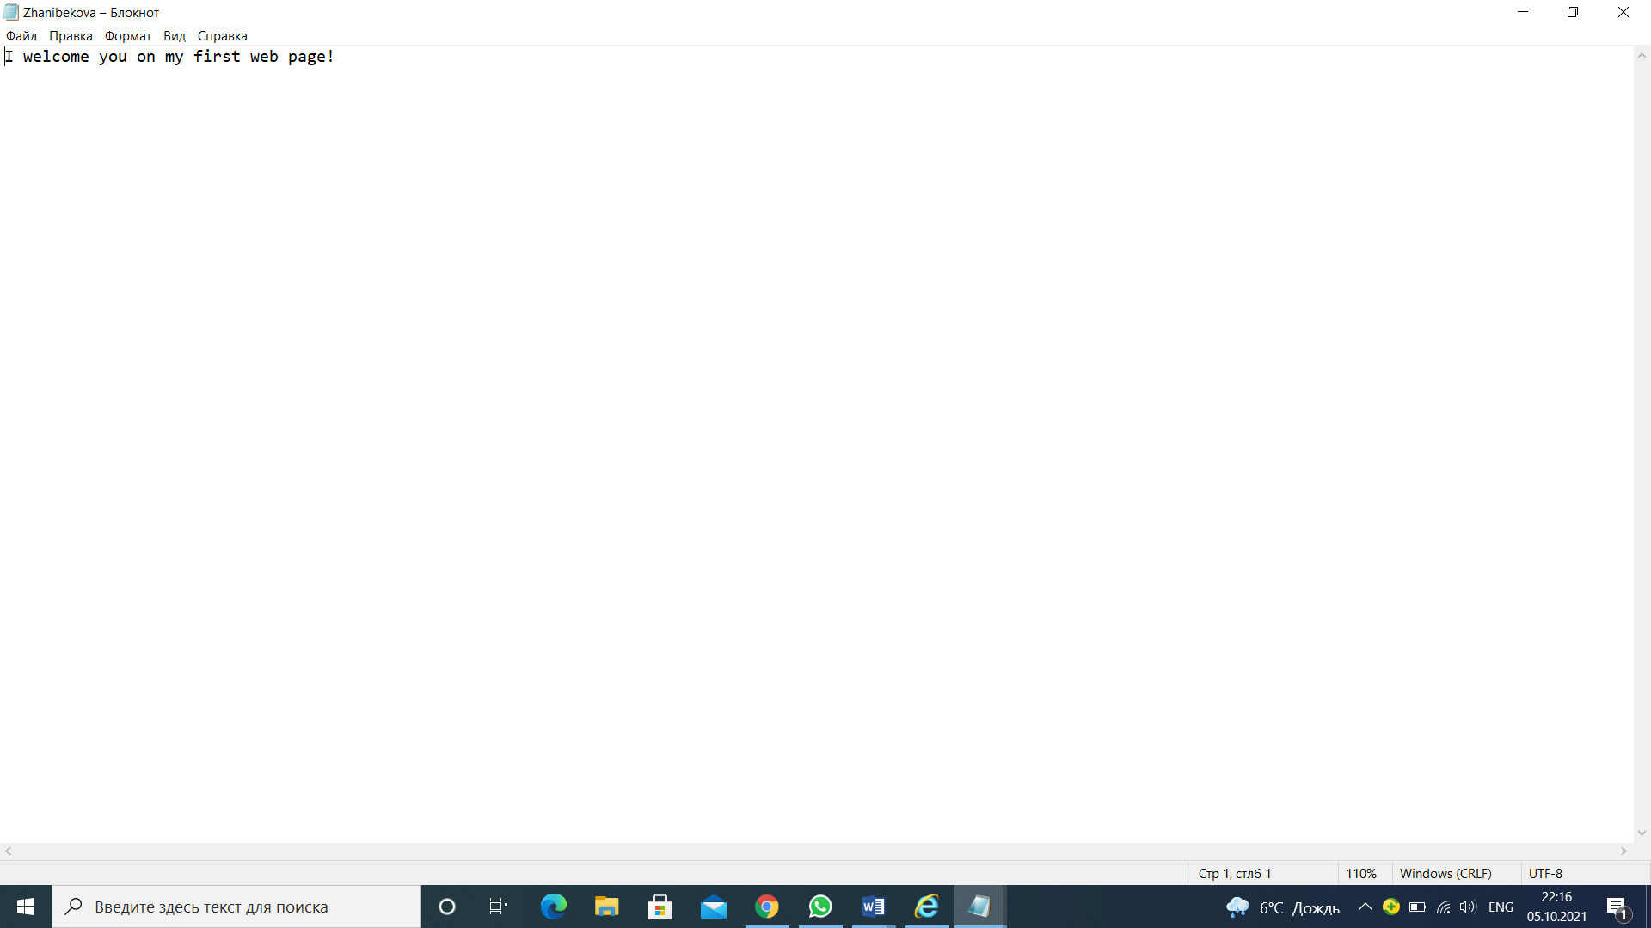

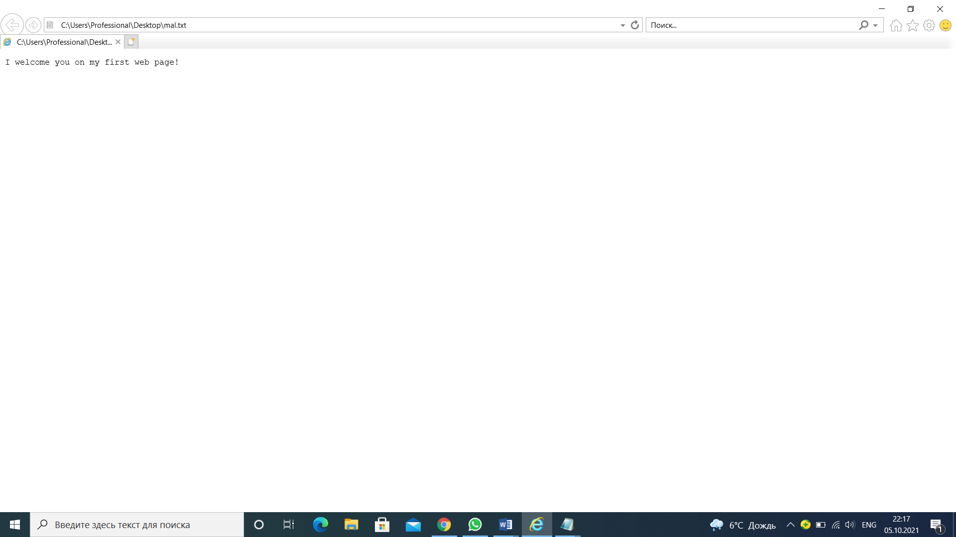

**Step 2.**

*Using the context menu, I opened the file using a gear notepad. To enter the tags given below, in the document header section (between ), I specified the last name*

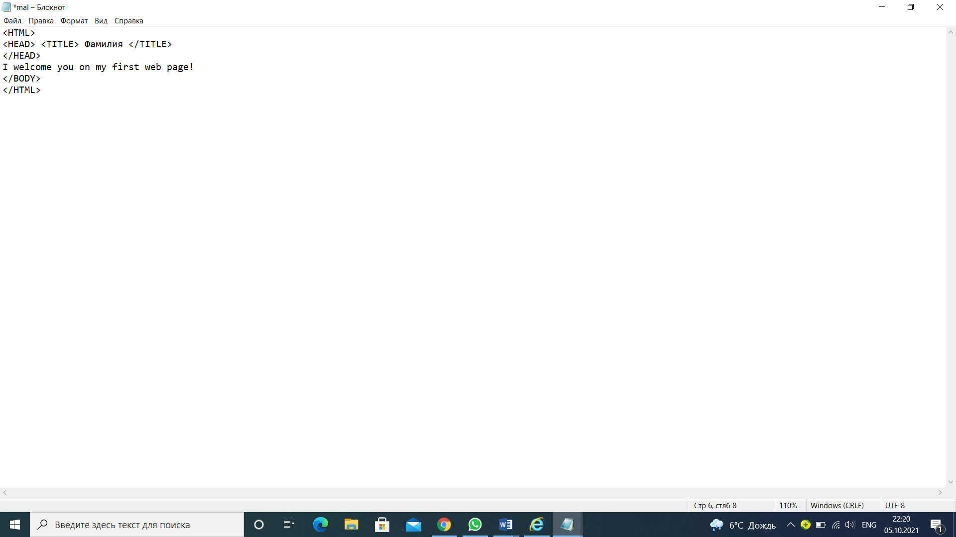

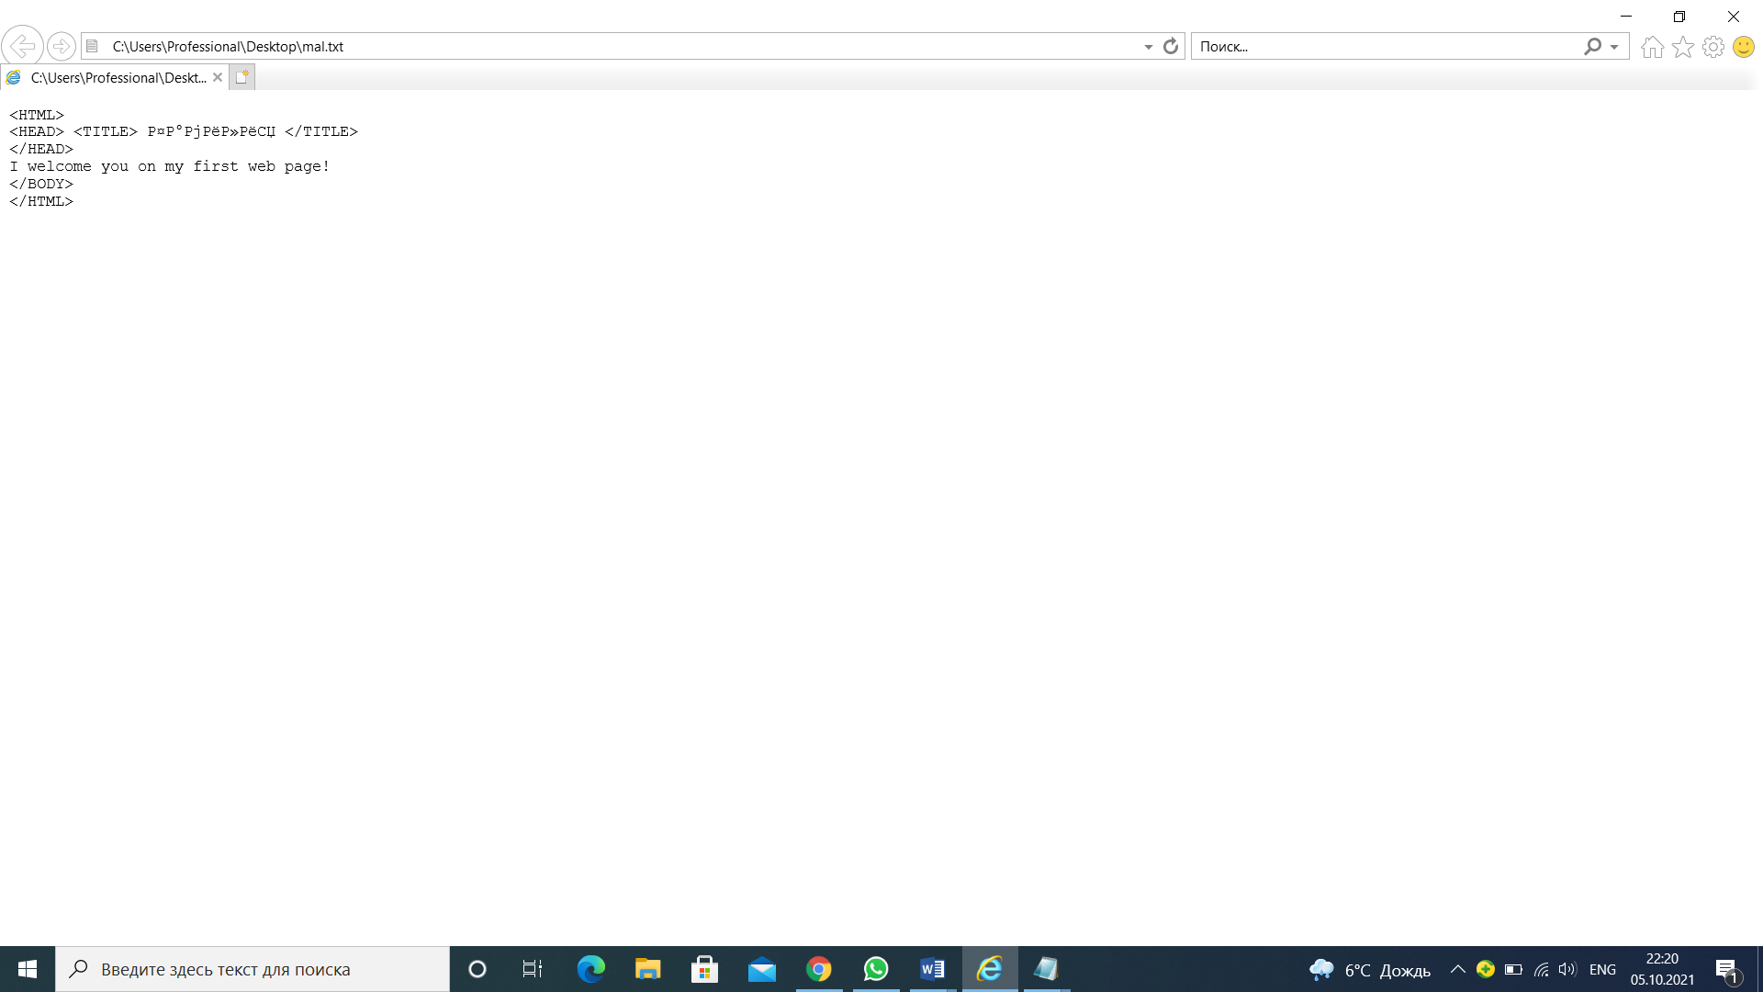

**Step 3.**

*To edit the document*

*• * * Opened the browser menu, looked at the code and added after the text "I welcome you to my first web page!" also,*

*I entered my group and Last name*

*I kept saving the document and updating the browser all the time.*

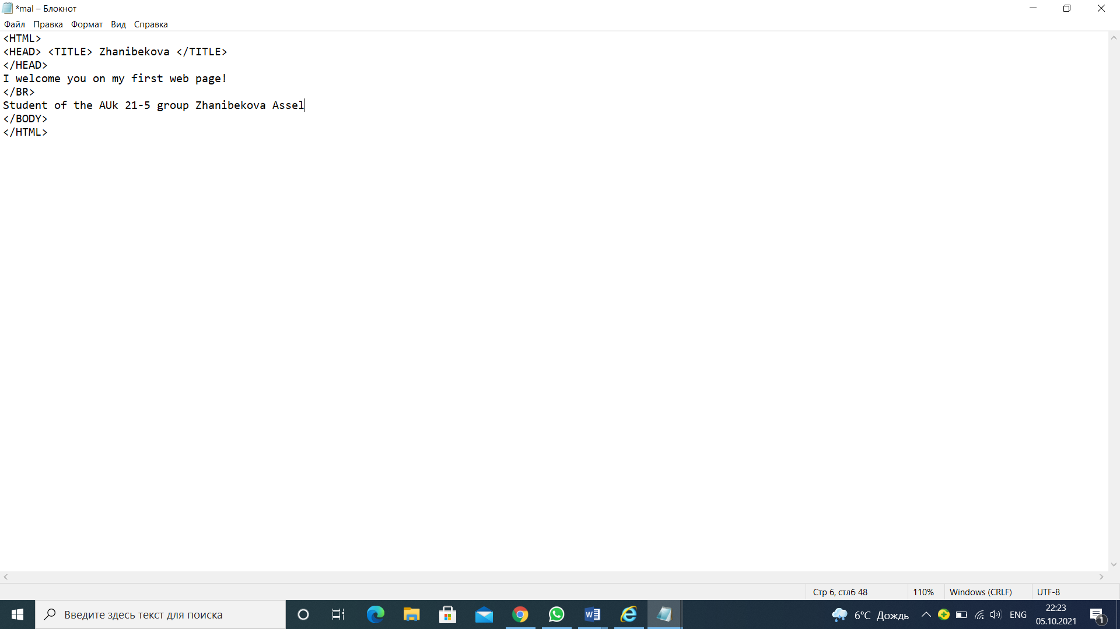

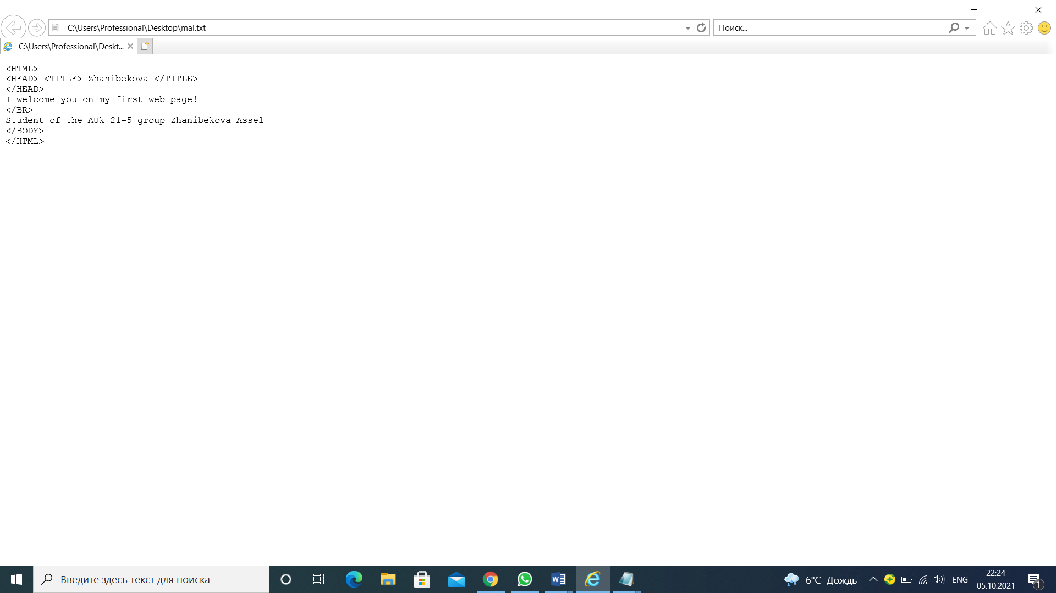

**Step 4.**

*Designed the first line of the document with a level 1 style header using a paired <h1> tag... </h1>*

*.Then I designed the second line as a Level 6 Header, and the third as a Level 4 Header.*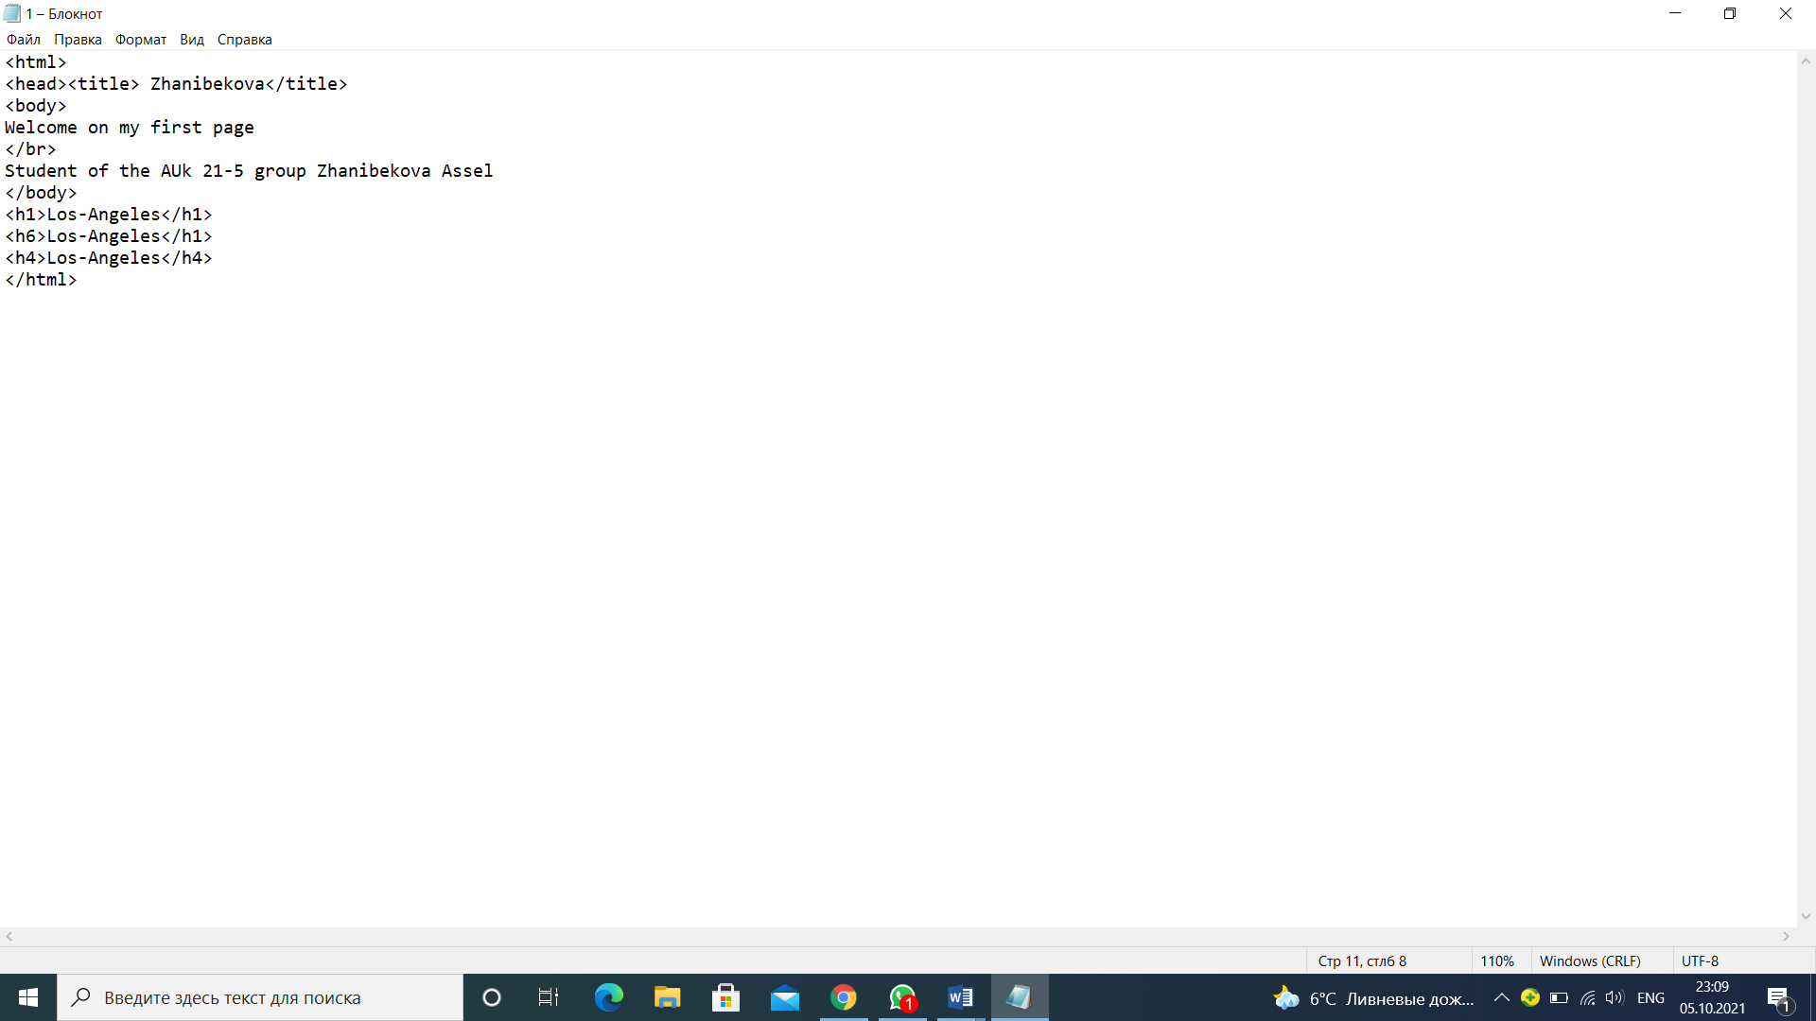

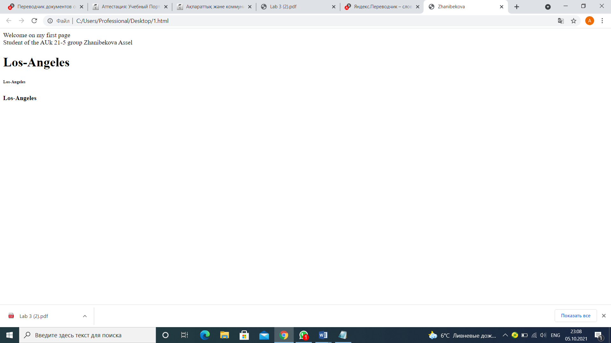

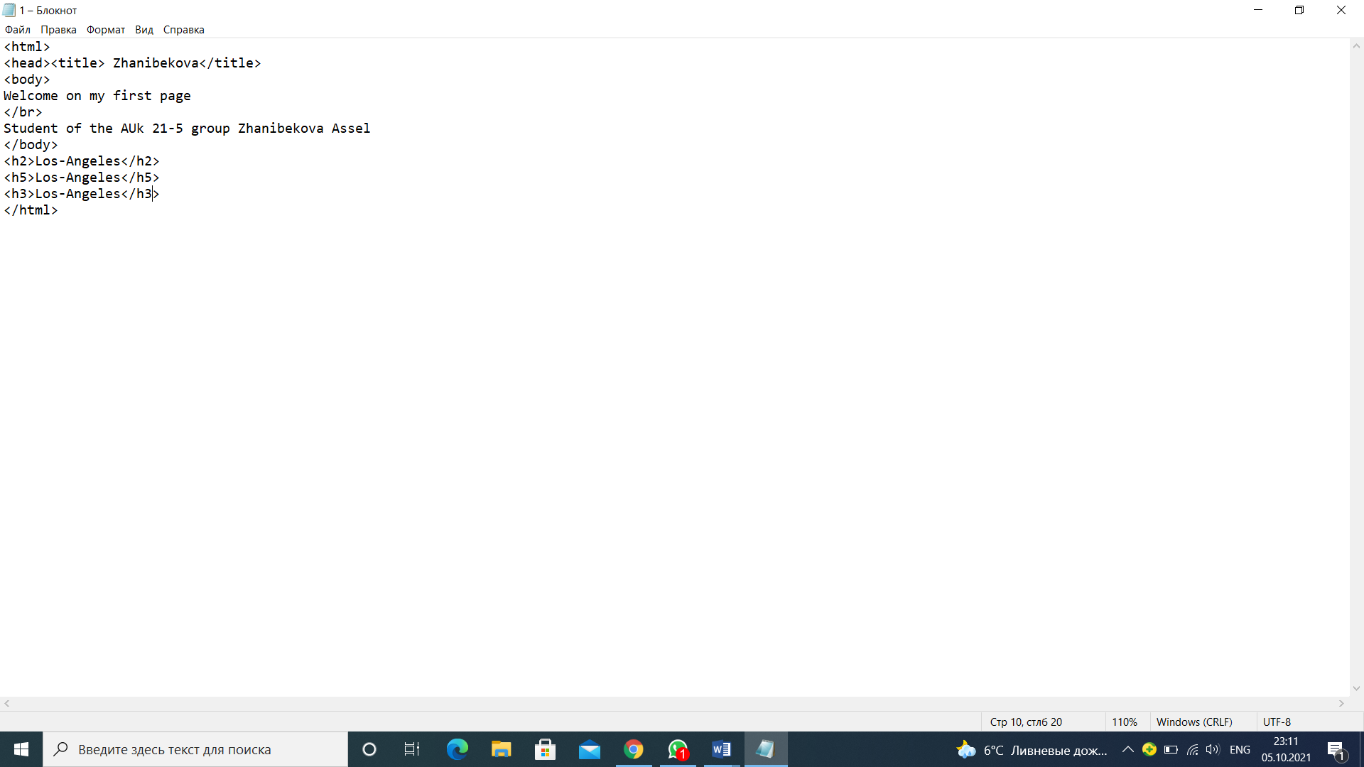

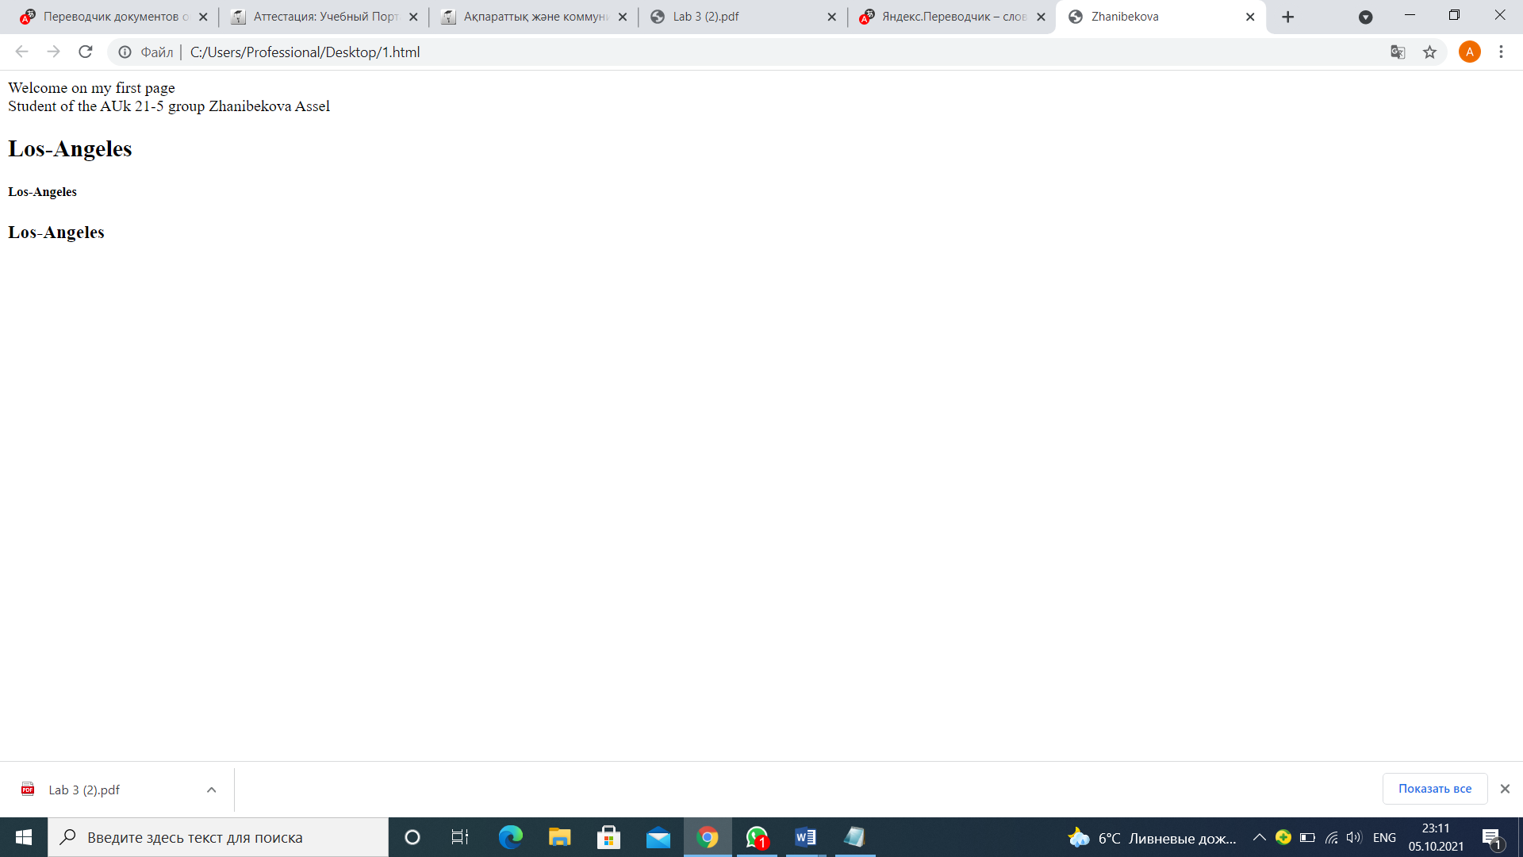

**Step 5.**

*To perform font formatting:*

*• After the Last Name line, I added another line of text*

*The morning greets us with coolness*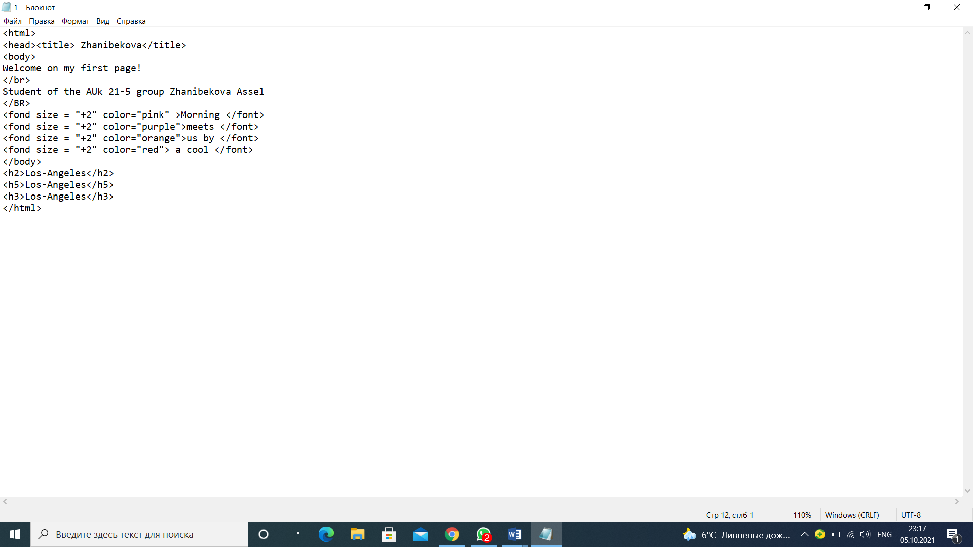

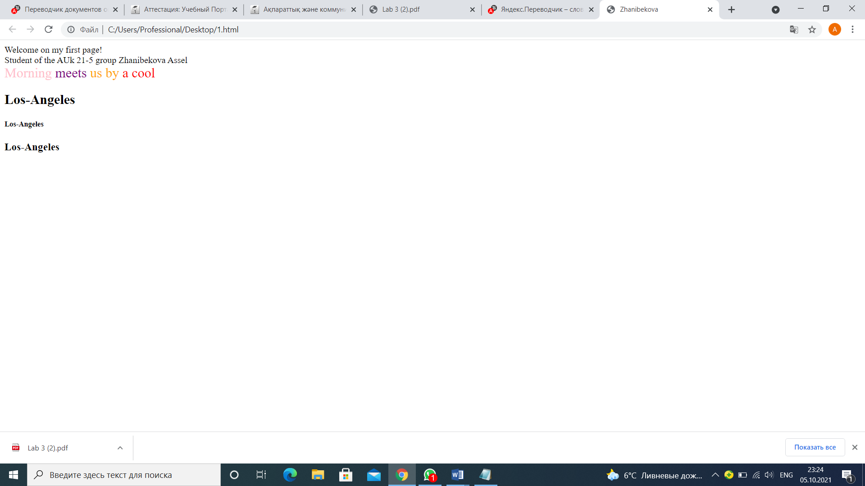

**Step 6.**

*To execute formatting of paragraphs:*

*• To create the new document 2_name.htm, to keep it in the same working folder*

*• To enter the text (to use copying of the text from the document 1_name.htm)*

*To align the text to the center.*

*• To enter the text: To be or not to be - here in what a question. That it is more noble: to take down blows of violent destiny - or against the sea of adversities to arm, engage. And all to finish at once...*

*• To issue alignment of the paragraph on width.*

*• To limit the paragraph to horizontal dividing lines from above and from below, using the* <HR*> tag.*

*• To copy a monologue and to break it into paragraphs. To align to the center. To be or not to be - here in what a question. That it is more noble: to take down blows Violent destiny - or against the sea Adversities to arm, engage And all to finish at once...*

*• To keep the document.*

*• To check the document in a browser window, changing the window size.*

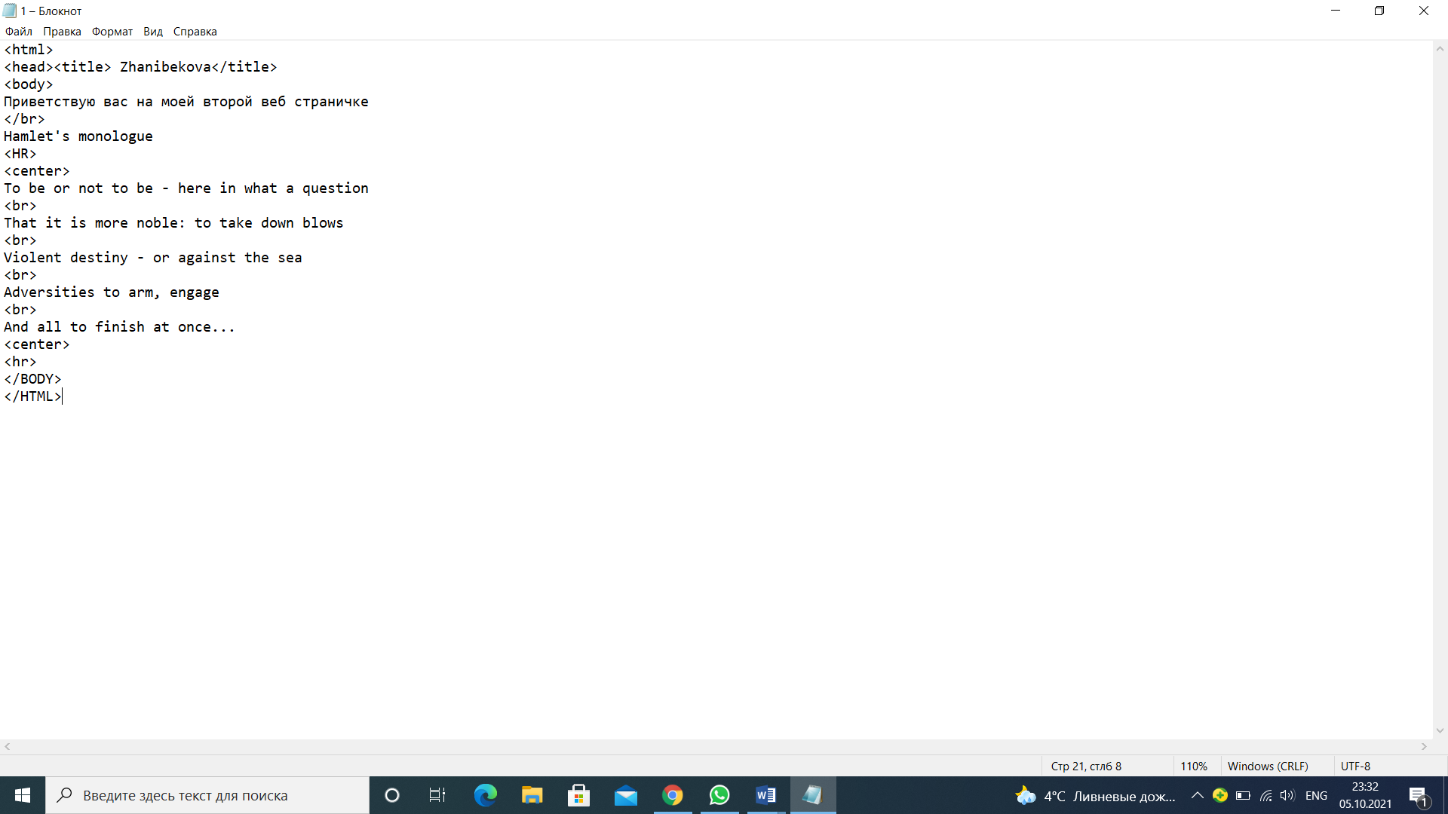

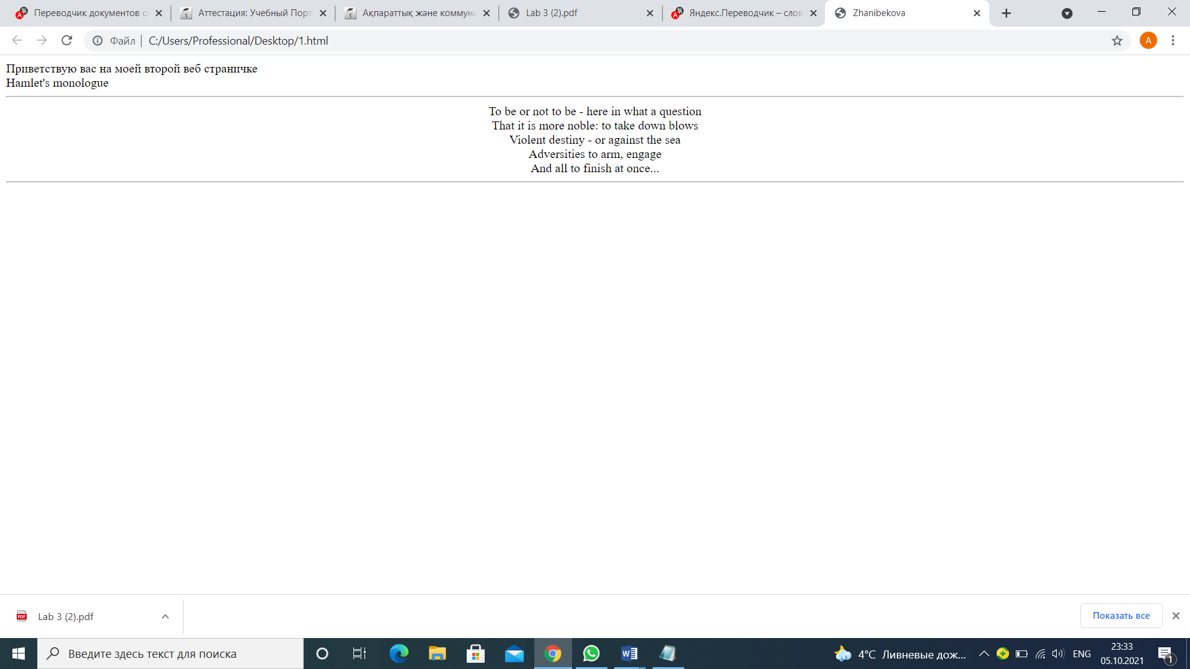

*Step 7.*

*• To create another new document 3_name.htm , saved it in the same working folder of the hard drive.*

*• For text input*

*To add the text of the document, enter the following text*

*to arrange the last three lines as an indexed list. To do this, use the following tag construction*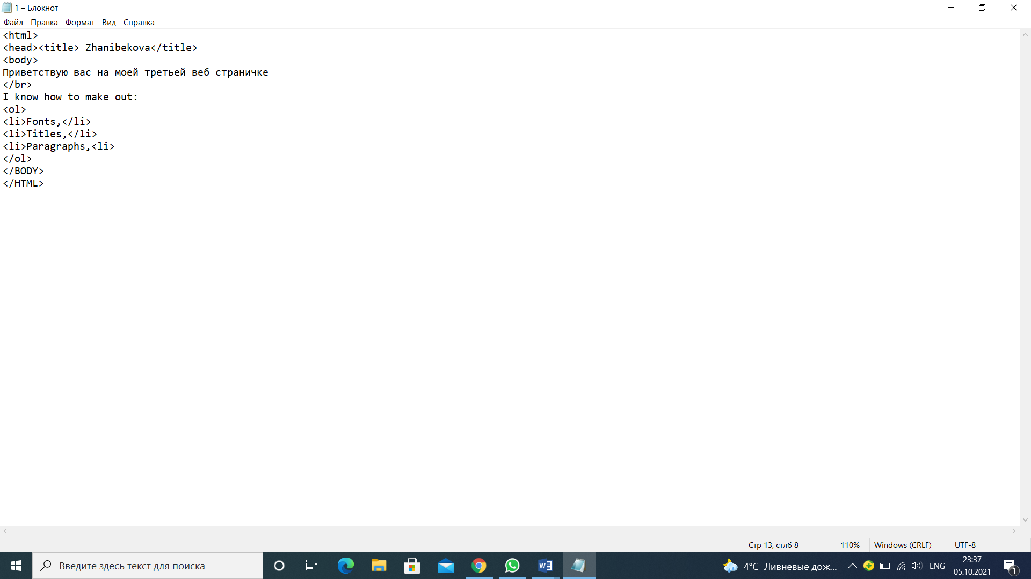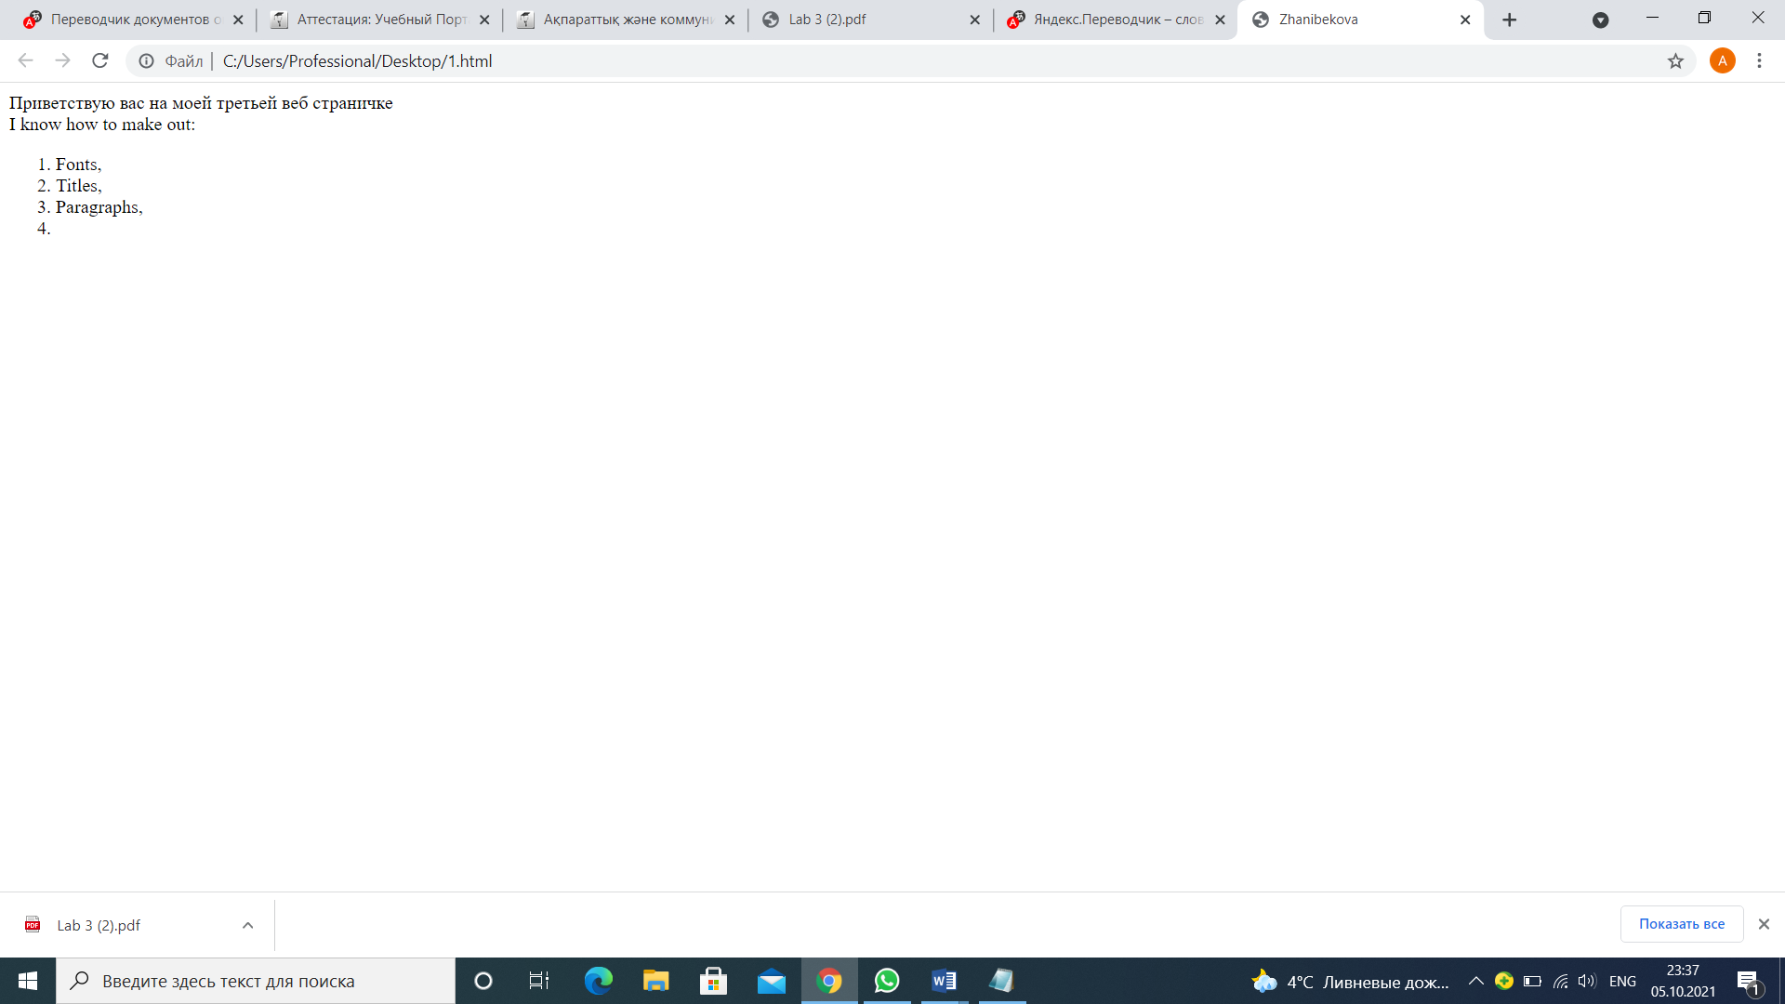

*• To change execution of the list for the list marked. To use the tags* <ul>,</ul>

*• To create the "mixed" list*

***Step 8***

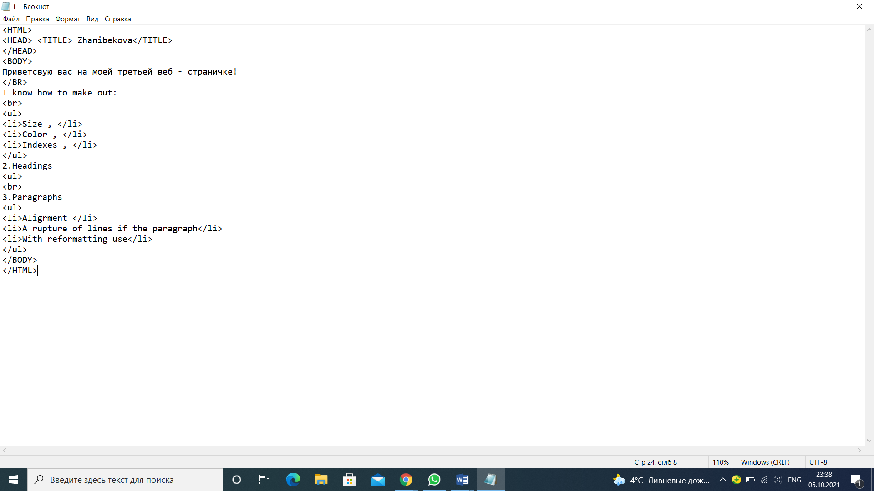

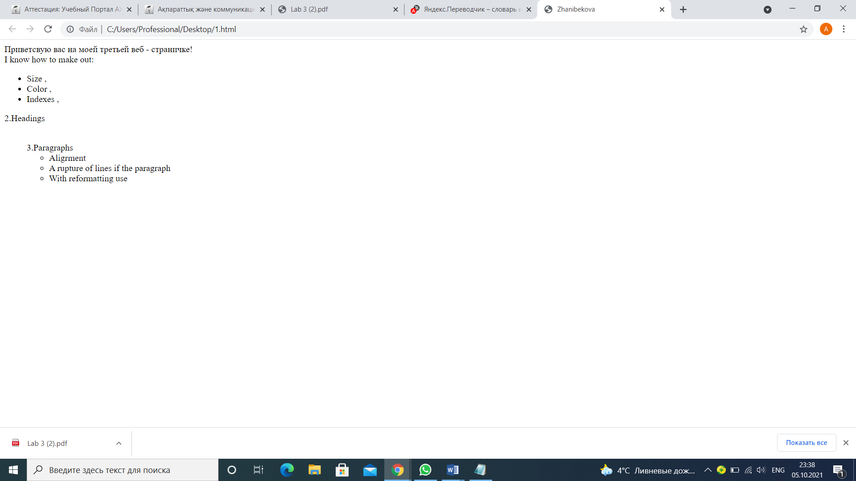

**Step 9.**

*To copy from the Internet or any folder in a personal folder files three graphic files*

*To be convinced that the documents 1_name.htm, 2_name.htm and 3_name.htm created earlier also are in your folder on a hard drive.*

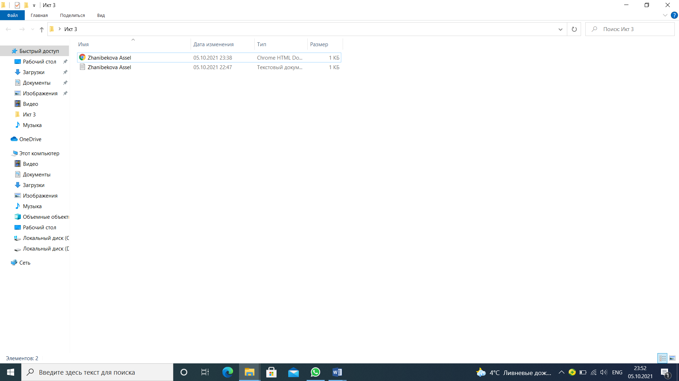

**Step 10.**

*An insert of drawings in the document*

*• To open the document 2_name.htm in the Notebook.*

*• To insert the drawing Arrows1.wmf into the beginning of the document 2_name.htm. For an insert to use the IMG tag with the WIDTH and HEIGHT parameters for installation of the sizes of the drawing of 50 pixels across and down.*

*• To keep the document under a name 4_name.htm.*

*• To see the received result in a browser.*

*• To enter into the tag of the drawing the ALIGN parameter for alignment of the drawing on the right edge. To see result in a browser.*

*• To insert the drawing Arrows2.wmf into the end of the document 4_name.htm before, to pick up type of alignment of the drawing on the discretion. To establish the size of the drawing of 100 pixels across and down. By means of the ALT parameter to create the emerging hint "Figure 2" appearing at guidance of the cursor of a mouse on the drawing.*

*• To see the received result in a browser.*



