**ҒҰМАРБЕК ДАУКЕЕВ АТЫНДАҒЫ**

**АЛМАТЫ ЭНЕРГЕТИКА ЖӘНЕ БАЙЛАНЫС УНИВЕРСИТЕТІ**



**Laboratory work №4**

**Development of database structure, creation of tables and requests**

**Performed by**

**Zhanibekova Assel**

**AUk 21-5**

__________ _________ “____” __________2020 ж.

(assessment) (signature)

Almaty, 2020

Exit Design mode by saving the table under the name "Employees"; do not specify any key fields.

Figure 1.1- Table-Employees

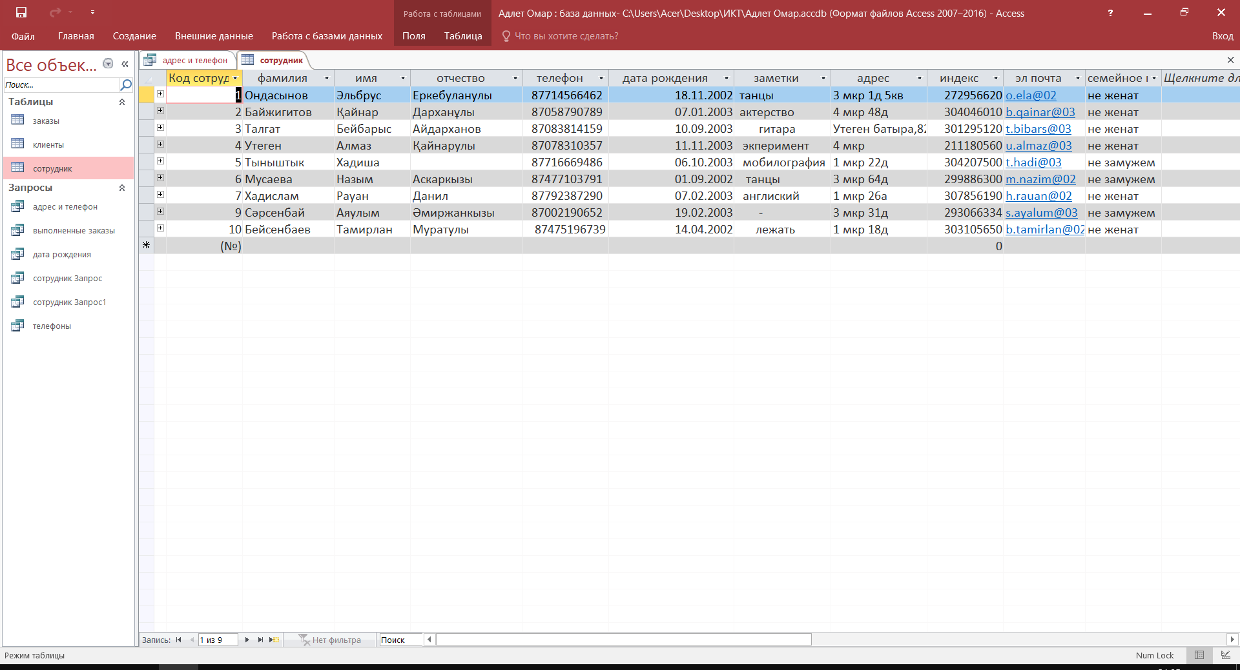

Thus, 2 more tables need to be created: Customers and Orders with the following details

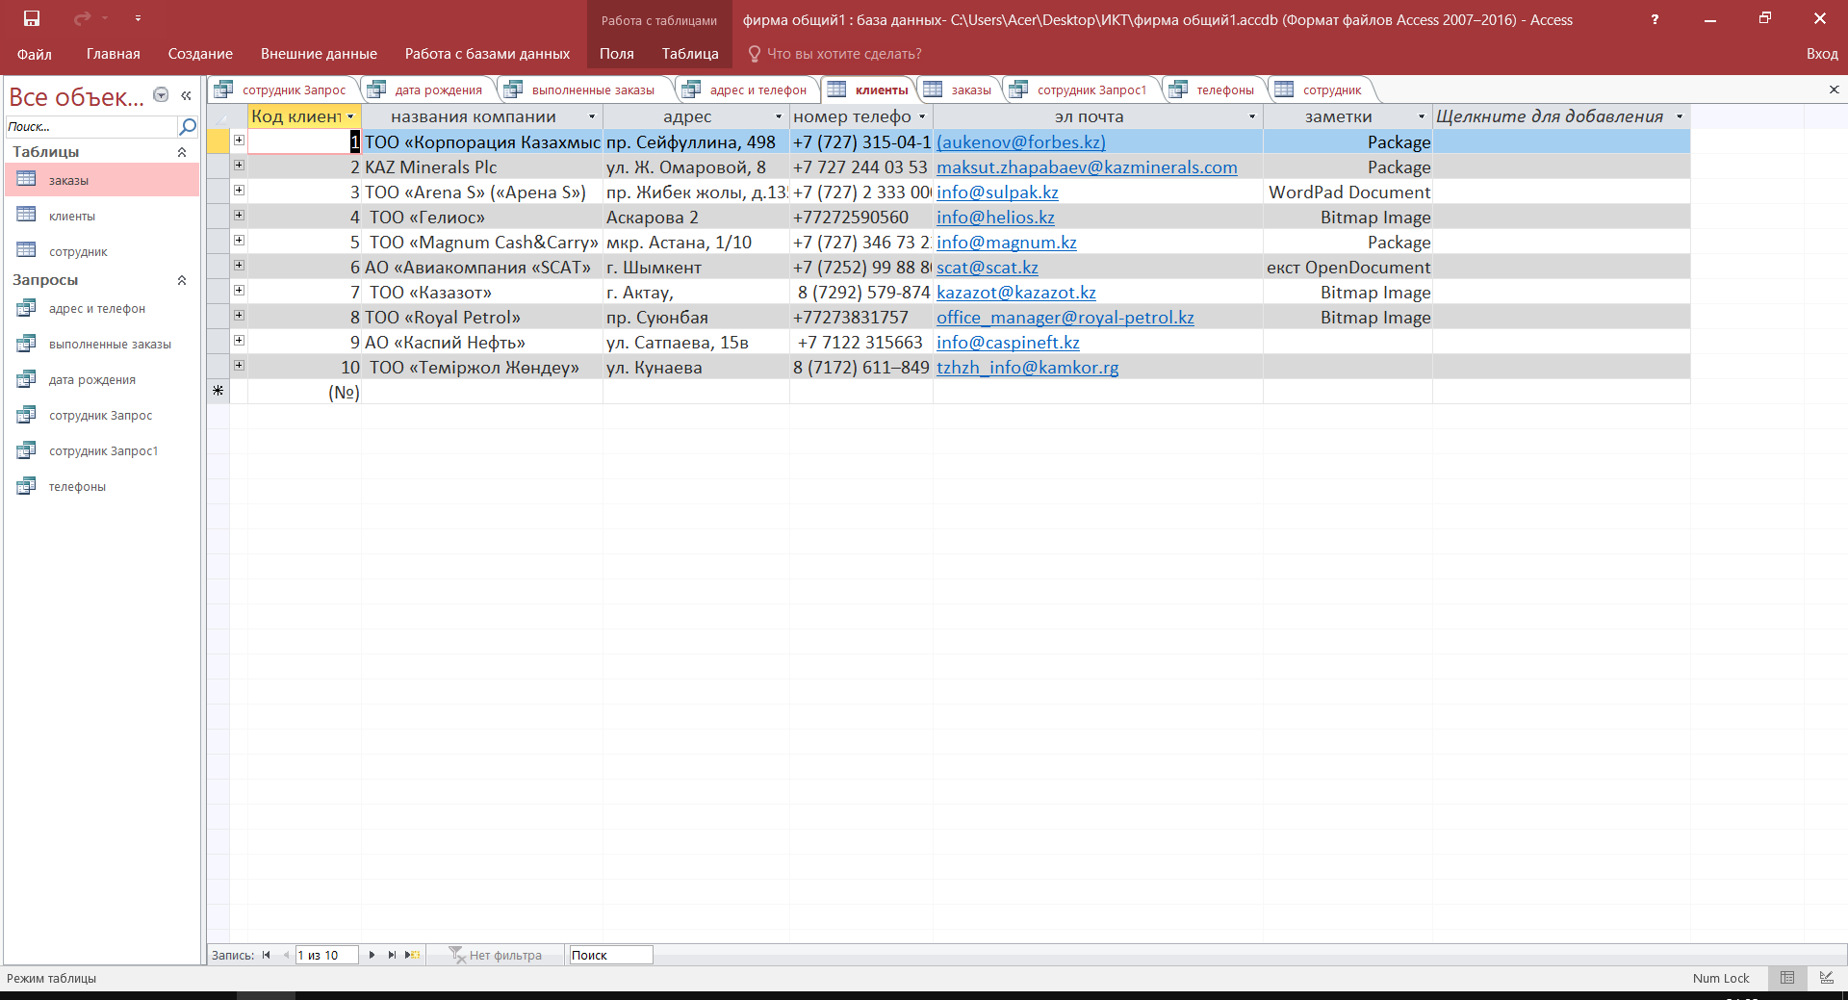

**Figure 1.2- Table-Customers**

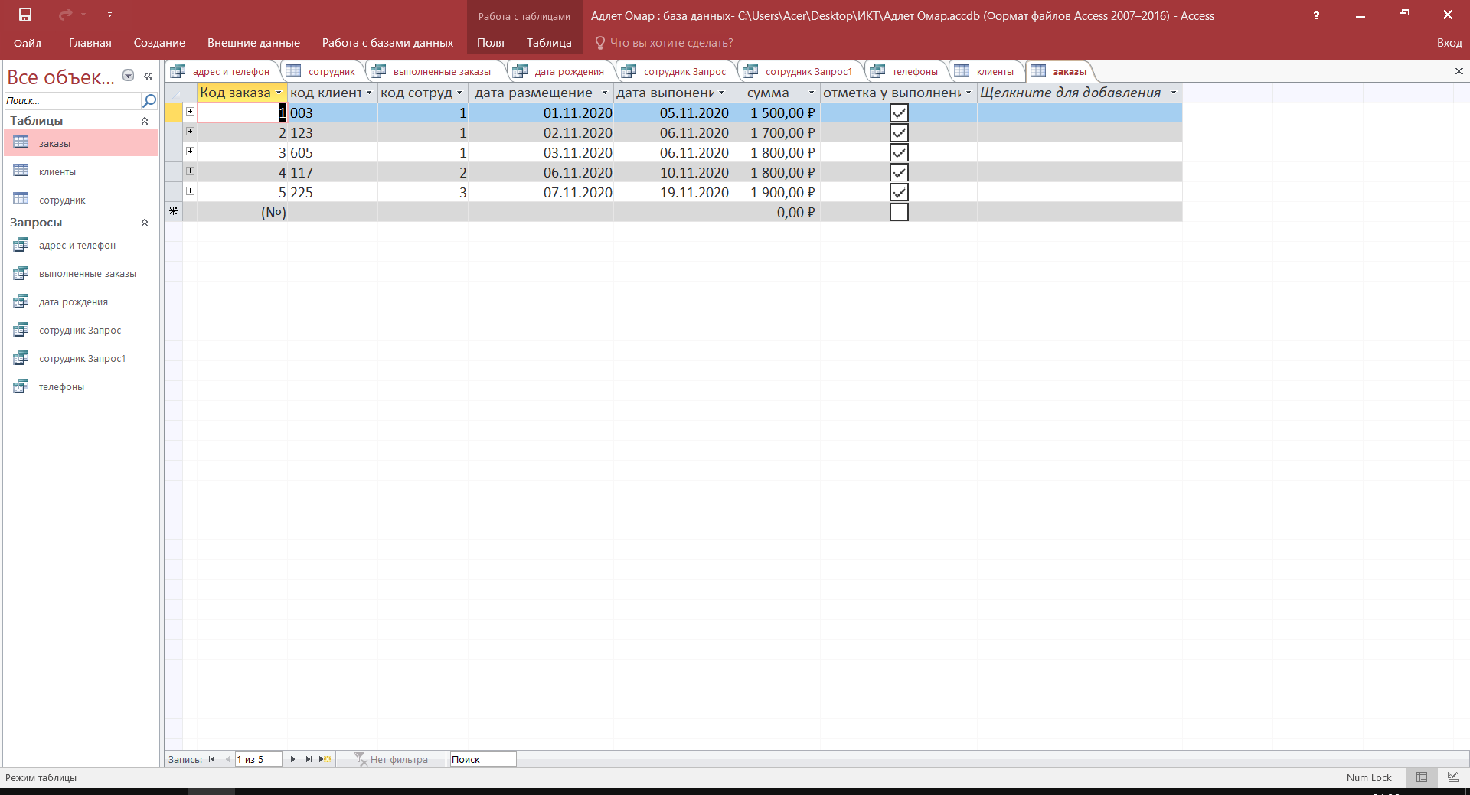

**Figure 1.3- Table-Orders**

Establish a relationship between the "Employees" and "Orders" tables, for this select the "Employee Code" field in the "Employees" table and drag it to the corresponding field in the "Orders" table.

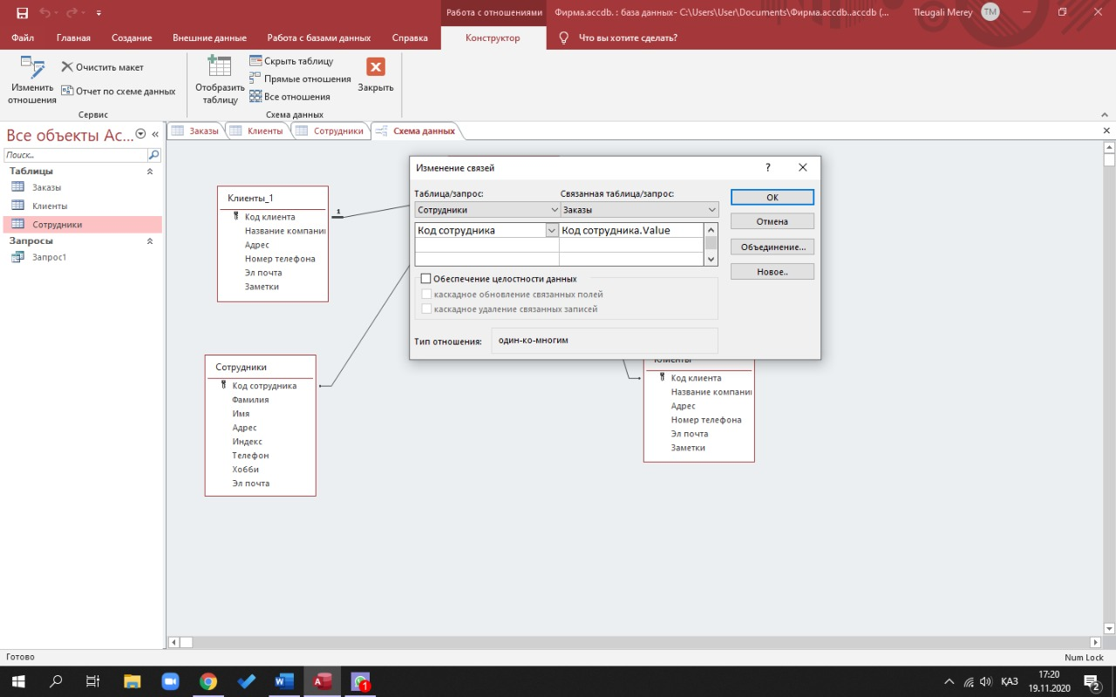

Figure 2-Creating links between tables

Establish the relationship between the tables "Customers" and "Orders" yourself.

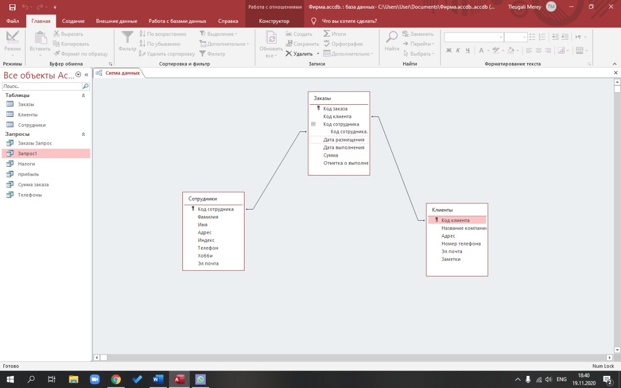

Figure 3-Data schema

Run the command: ribbon tab New -> Query Wizard -> Simple Query

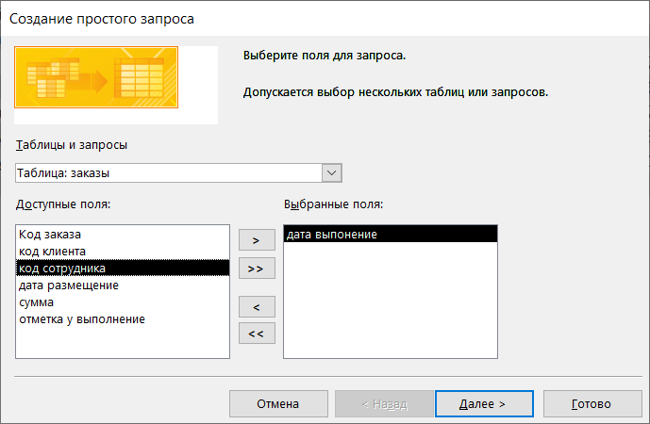

Figure 4 - Creating a simple query

To transfer the required fields to the request form, you must double-click on them with the left mouse button

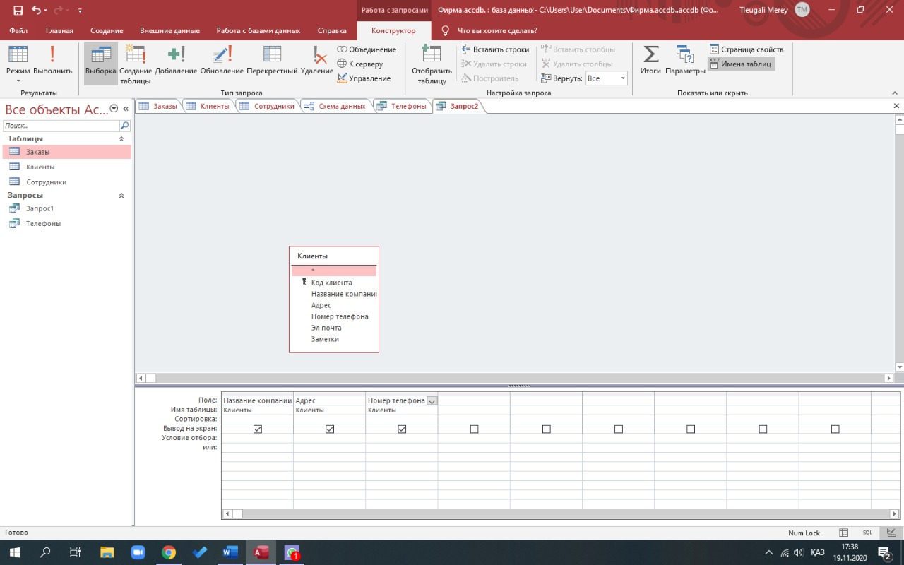

Figure 5- Creating a query in Design mode

In the list on the left, open the "Requests" folder and select the request

"Order price". In the middle list, select the "Amount" field and press the "Insert" button. The identifier for this field will appear in the "Builder" expression field. Click on the * button and enter 0.13 (Figure 6). Thus, we will calculate the income tax of 13%.

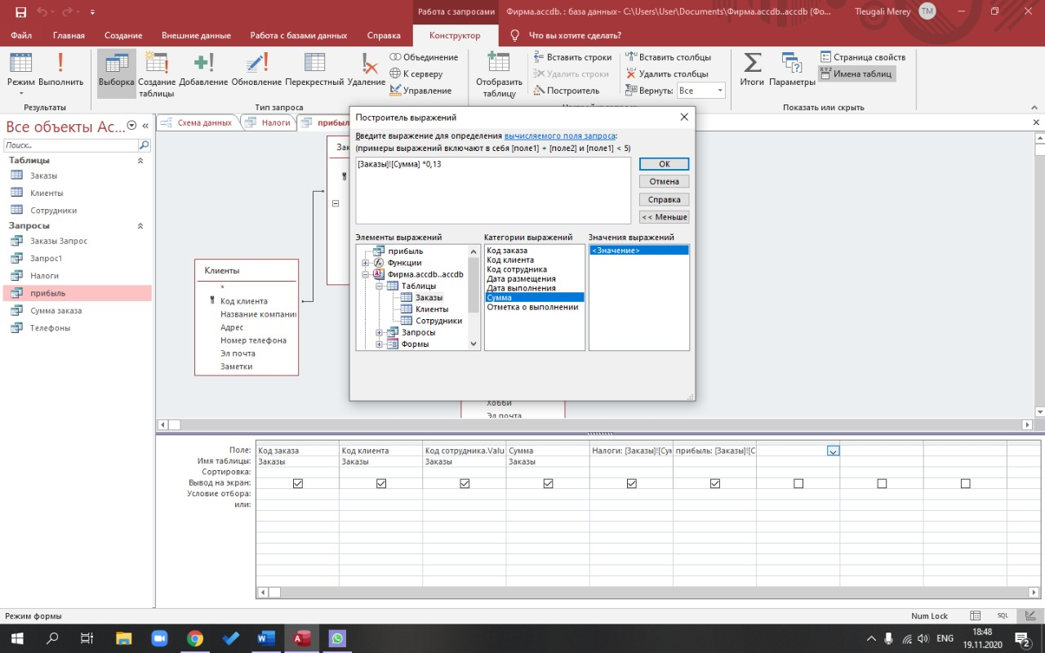

Figure 6- Expression Builder

**Conclusion**

In Microsoft Access 2019 learned earn, how to create a table with the help of templates and tables Designer tables, , learned how to perform the sorting of records in the table.