Upload

Bob Upshaw

Dec 2, 2019

# Overview

There are a few tasks that run on the Pacific Masters servers that require human supplied input. Except for the need of human interaction to supply data these tasks are fully automated. In order to simplify the human effort required to supply those data the Update application was developed. This document will describe the maintenance and use of the Update application.

At the time of this writing the “almost” automated tasks are:

* AGSOTY - Age Group Swimmer Of The Year calculations and web page generation and serving.
* Accumulated Points - Open Water points calculation and web page generation and serving.

The Upload application is split up into a few sub-applications, each specific to the type of data it supports. Currently there are two sub-applications:

* RSIND Upload - Uploads and distributes a current RSIND file (described in an appendix below.)
* OW Upload - Uploads and distributes open water result files.

# Invoking an Upload Application

It’s important that only authorized people be allowed to upload data used by our automated tasks. For example, a hack allowing an unauthorized RSIND file to be uploaded and used by AGSOTY could result in the wrong person being declared swimmer of the year. For this reason an Upload application can only be executed by a valid user of our development webserver. Such a user will log in using their credentials here: <https://pacmdev.org/user> . However, that user must also have the permission to act in one or more of the following roles:

* RSIND Manager - allowed to upload an RSIND file
* OW Results Manager - allowed to upload open water results

Once logged in the authorized manager will be able to use the Admin menu to perform the upload. In general they will go to

Admin > Admin Tasks > Data Upload > RSIND UPLOAD

or

Admin > Admin Tasks > Data Upload > OW RESULTS

They will only see the options for which they have permissions.

# RSIND Upload

When an authorized user requests RSIND UPLOAD the user will be presented with a page that looks like this:

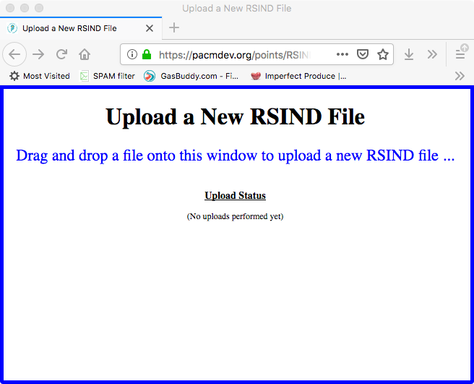

To perform the upload just do what it says: drop an RSIND file onto the window. Either the RSIND file will be uploaded successfully and distributed to the appropriate locations to be used by both AGSOTY and Accumulated Points, or an error will occur. In either case an email will be sent to “[uploads@pacificmasters.org](mailto:uploads@pacificmasters.org)” which is an email group maintained by our webmaster.

If an upload is successful the result will look something like this:

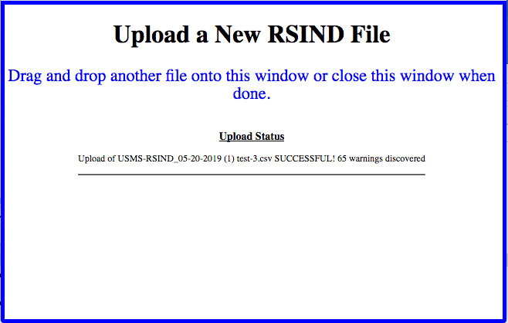

In the above example you can view the warnings by clicking on the status line and it will drop down more messages. Clicking on the line again will hide them.

Here is an example of an error:

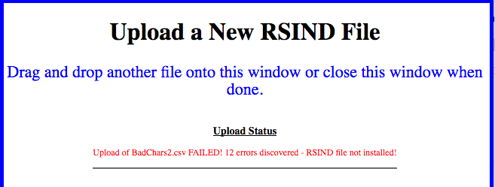

Clicking on the status line will allow you to see the errors. In this case the RSIND file was uploaded but NOT distributed to the applications.

Some notes:

* The same RSIND file can not be uploaded twice. If there is an error with a file and it’s corrected the file name of the file must be changed in order to attempt the upload again.
* An RSIND file will be processed looking for possible data errors. For large files this can take a few seconds.
* To prevent someone from guessing or giving out the URL to the Upload a New RSIND File page there are protections in place. For this reason you can’t refresh the page and you can’t use the back button. If you want to go back to the dev web site you’ll have to go back two or more pages.
* There are some special situations that affect the operation of an RSIND upload. See the appendix below.

# 

# OW Upload

The uploading of open water results is a bit more complicated. Not implemented yet.

# Upload Maintenance

The code supporting the Upload mechanism runs on our development server. This is due to the fact that both AGSOTY and Accumulated Points runs on our development server. They run there so they don’t consume resources from our production environment. Neither of these applications require our production infrastructure.

Since our Upload mechanism requires a secure access we use the Drupal security model already present on our development server. This is discussed in detail above. Since we need to tie into Drupal that requires part of the Upload implementation to be Drupal specific. For security reasons other parts of the implementation is kept out of the web tree. Here is a graphic showing the pieces of the Upload implementation and how they relate:

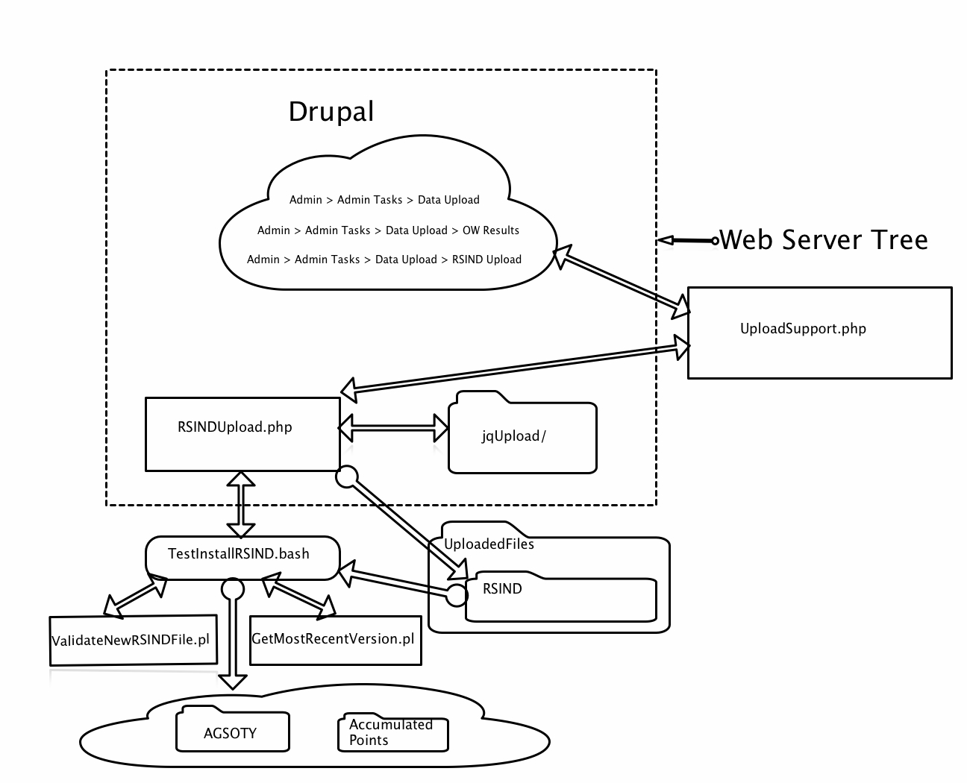

The objects inside the dashed box are contained within the web server tree, thus exposed if someone hacks our web server. The other pieces are contained inside the ~/Automation/PMSUpload/ tree and therefore are (theoretically) more secure. Here is a short explanation of each of the objects shown above:

Inside the web server tree:

* The Drupal cloud: this is a collection of Drupal basic pages. Log into the Drupal engine and take a look at the following pages: (If they are not there see Appendix 3 below.)
  + Data Upload - A landing page that explains the other two.
  + RSIND Upload - invoked if 'Admin > Admin Tasks > Data Upload > RSIND Upload' is selected.
  + OW Results Upload - Invoked if 'Admin > Admin Tasks > Data Upload > OW Results' is selected.
* RSINDUpload.php: invoked via the RSIND Upload Drupal page. It is the main user interface, displaying the drop area and handling dropped files. Examples of the drop area are shown above.
* jqUpload: a directory containing an open source .css and javascript library used to support drag and drop web page functionality.

Outside the web server tree (all rooted in ~/Automation/PMSUpload/):

* UploadSupport.php: a PHP library used to implement security for the RSINDUpload.php page. Basically it is used to generate a key by the code in the Drupal cloud and then that key is validated when RSINDUpload.php is invoked. This prevents unauthorized access to that .php page by requiring the user to go through Drupal security.
* TestInstallRSIND.bash: a BASH script that is exec’ed by RSINDUpload.php for the purpose of:
  + Validate the uploaded RSIND file, and
  + Distribute the uploaded RSIND file to its final destinations (if no errors).
* UploadedFiles: a folder containing:
  + RSIND: a folder holding the RSIND file uploaded by RSINDUpload.php. It’s held there until validated and (possibly) copied by TestInstallRSIND.bash. Files stored in this directory remain until they are “old”, thus preventing the accidental upload of the same file twice.
* ValidateNewRSINDFile.pl: a PERL program executed by TestInstallRSIND.bash to validate the newly uploaded RSIND file. It uses library code also used by AGSOTY and Accumulated Points (not shown).
* GetMostRecentVersion.pl: a PERL program executed by TestInstallRSIND.bash in order to find the last version of an RSIND file uploaded. This is the RSIND file being replaced by the newly uploaded RSIND file.
* AGSOTY and Accumulated Points directories: the home directories of these two programs. A newly uploaded RSIND file *may be* stored in a specific subdirectory of these two directories if the RSIND file is valid and the date uploaded allows it. (See RSIND Upload Special Cases below.)

# Appendix 1: RSIND file

A RSIND file is a .csv file representing a membership database for Pacific Masters. This database is needed by programs that must authenticate and/or recognize Pacific Masters swimmers in various reports.

For example, an open water result file reports on the results of an open water race, and it may contain the results of swimmers who are not members of Pacific Masters. For open water points calculations it is important to weed out non-Pacific Masters swimmers since open water points are only awarded to swimmers in our own LMSC. The RSIND file allows the Accumulated Points task to recognize Pacific Masters swimmers.

# Appendix 2: RSIND Upload Special Cases

When a (valid, error free) RSIND file is uploaded it is usually distributed for use by both Accumulated Points and AGSOTY. However, the date that the upload occurs affects exactly what happens:

* January 1 - May 31: The RSIND file is distributed to AGSOTY and Accumulated Points for the current year.
* June 1- October 15: The RSIND file is distributed to AGSOTY and Accumulated Points for the current year, and also for AGSOTY for the next year since June 1 is the beginning of the “next year’s” SCY season.
* October 16 - December 31: On or around November 1 the generation of a RSIND file will create a file with NEXT YEAR’S registered swimmers only, where those swimmers are automatically registered for THIS YEAR! So we need to be very careful what we do with RSIND files around that time. We start looking for this situation after October 15. To determine whether or not a RSIND file applies to THIS YEAR or NEXT YEAR we look at the size of the file. If it’s “significantly” smaller than the previously uploaded RSIND file then we’ll assume it’s NEXT YEAR’S file.
  + For AGSOTY: If the newly uploaded RSIND file is significantly smaller than the previously installed RSIND file then merge the two RSIND files and distribute that one for both this year and next year.
  + For Accumulated Points: Since the open water season is over we do not distribute this RSIND file.

# Appendix 3: Set Up the Drupal Side

1. Go to <https://pacmdev.org/user> and log in with your Drupal account for this server. If you don’t have one talk to the webmaster. You need permission to update the Admin menu.
2. Create this menu item below Admin > Admin Tasks:
   1. Data Upload
3. Create these two menu items below Admin > Admin Tasks > Data Upload:
   1. RSIND Upload
   2. OW Results Upload
4. Go to the People Drupal menu and click on the Permissions tab, then on that page click on the Roles button (far upper right hand side.)
   1. If necessary create the two roles “RSIND Manager” and “OW Results Manager”.
5. Edit the Operations for Data Upload:
   1. Check the “Enabled” box
   2. Check the “Show as expanded” box
   3. Show/Hide menu for specific roles:
      1. RSIND Manager
      2. OW Results Manager
      3. Administrator
6. Edit the Operations for RSIND Upload:
   1. Check the “Enabled” box
   2. Show/Hide menu for specific roles:
      1. RSIND Manager
7. Edit the Operations for OW Results Upload:
   1. Check the “Enabled” box
   2. Show/Hide menu for specific roles:
      1. OW Results Manager
8. … etc…to be filled in….
9. Go to the People Drupal menu.
   1. Select the people who need one or both of the above roles and give it to them.

(this needs more work)