Endovascular therapy for WNBAs. [wide-neck bifurcation aneurysms]
Different types of stenting for WNBA

The simple technique. Coils easily deviate into the parent vessel | 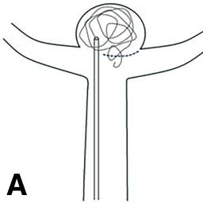
Y-SAC. Y-configuration double stent protects the parent artery and both side branches | 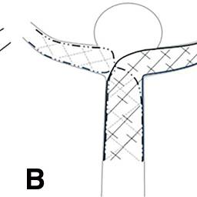
Single-stent placement from the basilar artery to the right or left PCA | 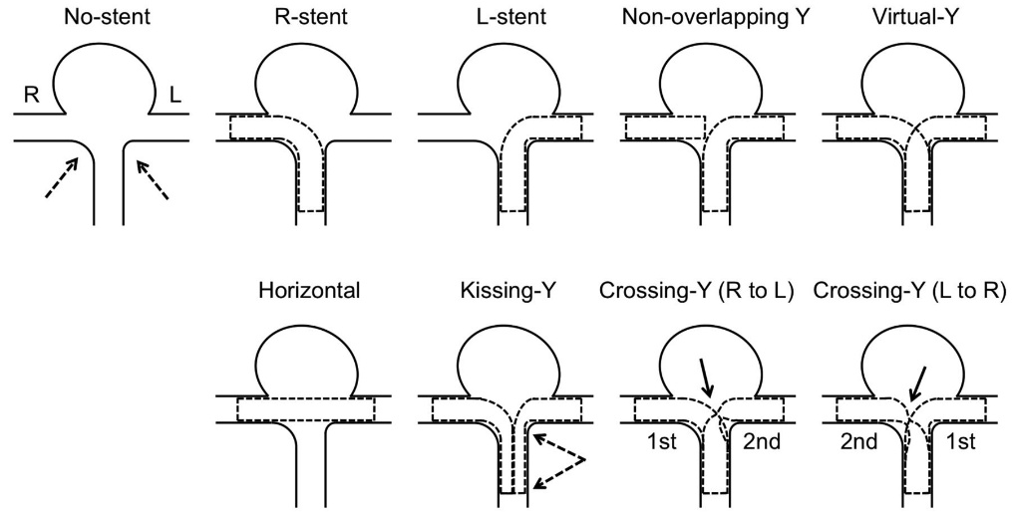
Horizontal stent across the neck | 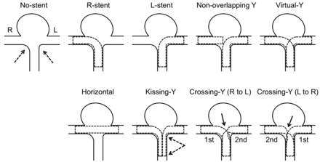
Kissing Y | 
Crossing Y | 
Double catheter technique. Simultaneous or alternating coil placement from two catheters allows coils to remain in the aneurysmal sac. | 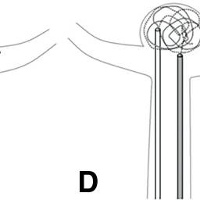
pCONUS2. The distal crown and six petals provide a bridging structure at the neck. | 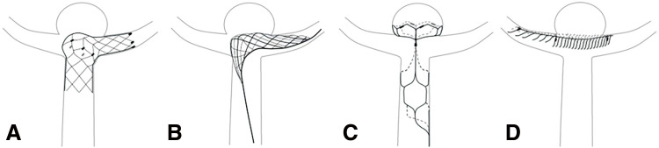
eCLIPs. Low-density ribs are anchored in the side branch, and higher-density ribs cover the aneurysm neck. WNBAs: wide-neck bifurcation aneurysms. | 
T-stent technique or Non-overlapping Y stent  (A) Schema showing the partial deployment of two stents in the parent artery and other branch.  (B) Schema showing full deployment of the stents without overlapping after partial or full coil embolization | 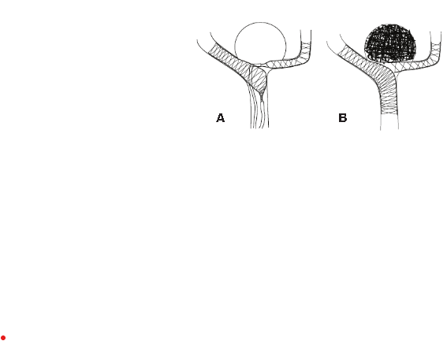
Half T stent  (C) Schema showing partial deployment of  the stent through the non-main branch of the bifurcation.  (D) Schema  showing full deployment of the stent without bridging of the parent  artery after partial or full coil embolization | 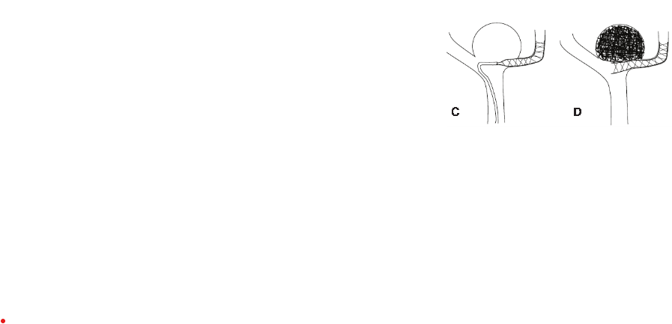
Coil-through struts technique;  the stent is fully deployed across the neck of the aneurysm and the microcatheter is navigated through the struts to detach coils into the sac of the aneurysm. | 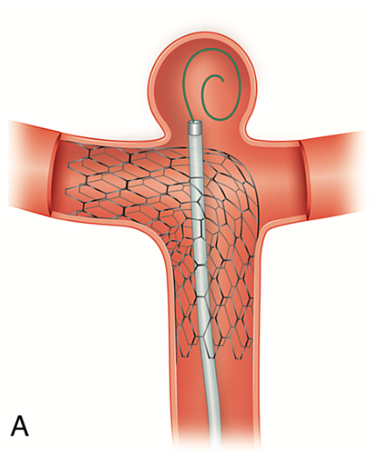
Jailing technique; the sent is deployed after the microcatheter is placed inside the sac of the aneurysm and coiling detachment is performed once the stent is in place. | 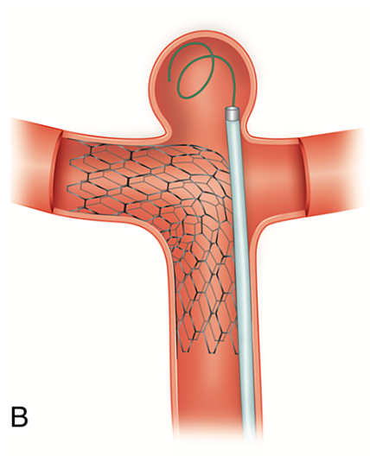
The 'semi-jailing' technique with a partially deployed stent. | 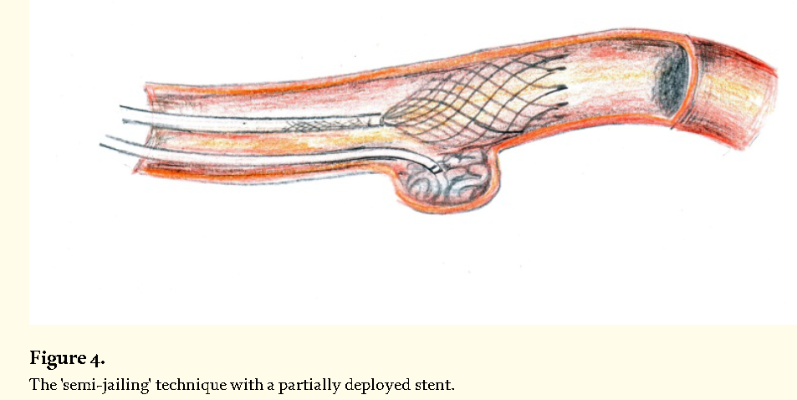
The 'Y' Stent Technique. With an Open + closed cell stent  A, A basilar tip aneurysm.  B, An open-cell stent is deployed into the basilar artery and right posterior cerebral artery, but is not sufficient to provide adequate protection against coil herniation or migration.  C. A second (closed-cell) stent is placed in the basilar artery (concentric to the first stent) and left posterior cerebral artery.  D. A microcatheter is positioned inside the aneurysm sac, which is treated with coils. | 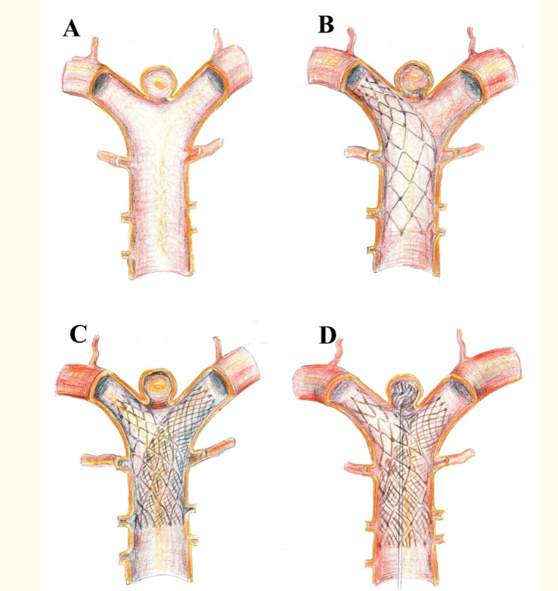
H stenting | 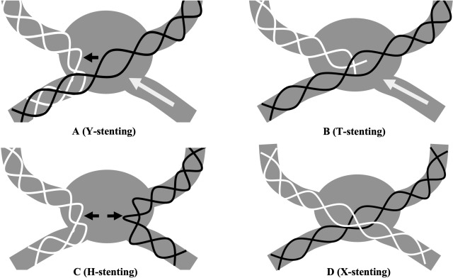
X-stenting | 
A com aneurysms  Stent may be deployed from ipsilateral A1 to contralateral A2 | 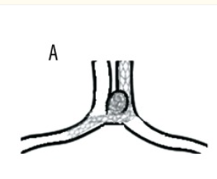
Stent may be deployed from ipsilateral A1 ipsilateral A2 | 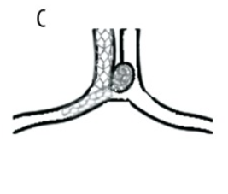
Ipsilateral A1 to contralateral A1. | 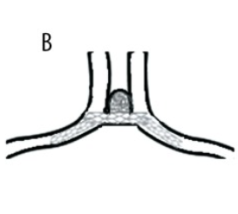
Waffle-cone” technique;  The distal end of a stent is placed into the aneurysm lumen and the proximal end of a stent is left in the afferent vessel (intra/extra-aneurysmal placement). This method allows for preservation of the parent artery patency.  Coiling is done through the cone-shaped distal end of the stent. The waffle cone technique may be a good alternative to dual stent placement in case of aneurysms incorporating bilateral A2 segments or involving the AcomA or if there is a difficulty in selecting a distal major vessel due to acute angles between the parent and distal arteries.  However, this technique carries a potential risk of aneurysm perforation, especially in freshly ruptured or smaller (<4 mm) aneurysms and the rate of recanalization due to flow direction in the aneurysm may be higher | 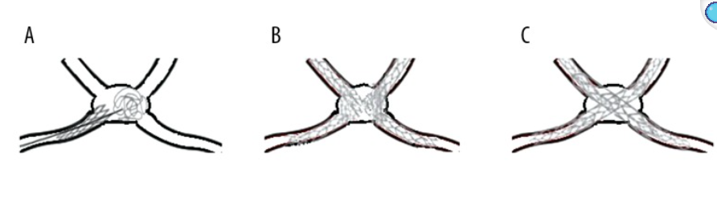
X-configured dual stent placement in the kissing technique; | 
 | 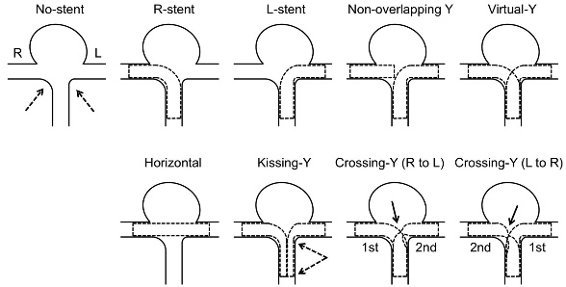
Temporary stenting with a Solitaire AB device.  A, The microcatheter is positioned inside the aneurysm.  B, The microcatheter is 'jailed' in the aneurysm by the Solitaire AB stent, which is completely deployed but not detached.  C, The aneurysm is treated with coils.  D, The Solitaire AB device is retrieved.  E, Final result, no stent is left in the parent vessel. | 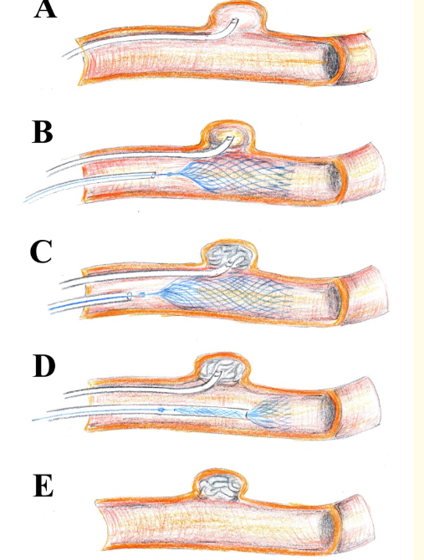
Flow diversion  A, Aspect of blood flow before and after placement of the device. B, Final result with thrombosis of the aneurysm. Note the higher density of the mesh near the aneurysm neck, which can be obtained with proper deployment technique. | 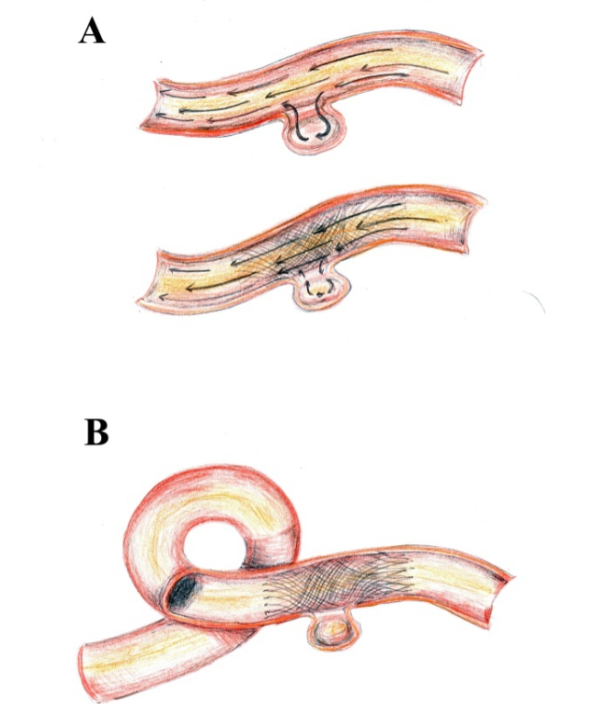
Flow- T stenting -assisted coiling technique. (A) Microcatheter deployed into aneurysms and bilateral posterior cerebral arteries. (B) Pipeline embolization device deployed into PCA and coils deployed through microcatheters in the aneurysm. (C) Stent placed in a T shape after the aneurysm is embolized.  Or Open cell deployed 1st and FD in branch | 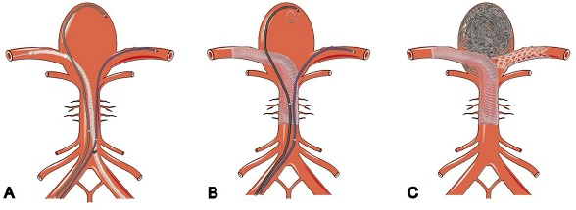
 | 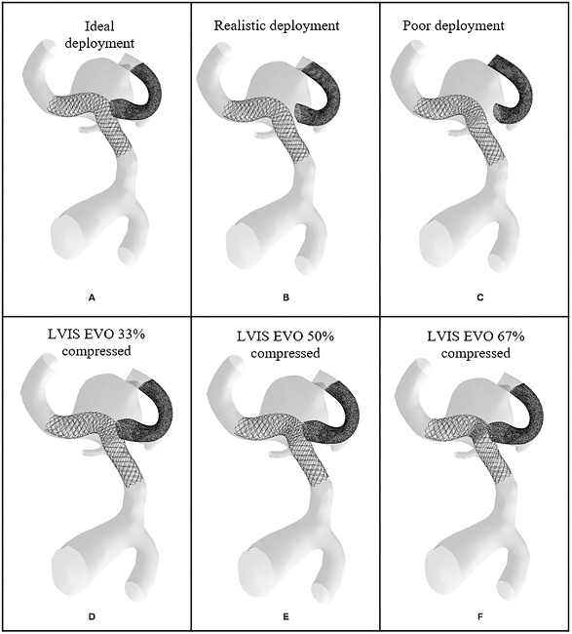
FD with coils- Belt & suspenders technique
Shelf technique
All LVIS EVO stents were deployed through a dedicated 0.01700 microcatheter (Headway) using a triaxial guide-catheter system.
At ﬁrst, the microcatheter was navigated to a distal artery beyond the bifurcation. The choice of the
branch artery was left to the operator and was dependent on
vessel diameter, the bearing of the aneurysm entrance and angle between afferent and distal artery. In cases of codominant branches, the artery was used which mainly incorporated the aneurysm. Otherwise, the dominant branch arterywas accessed.
Then, a second microcatheter was “jailed” within the aneurysm. Subsequently, the stent was deployed with the “shelf” technique.
The key of the technique is to apply forward tension intermittently on the stent pusher wire and microcatheter during stent deployment after half of the aneurysm neck is covered.
This leads to a further opening with expanding of the stent beyond the maximum unconstrained diameter forming a “shelf” at the entry level of the aneurysm, which prevents
coil prolapse. In our experience, a stent should be chosen, which is slightly over-dimensioned to enable forming of an optimal buttress. After complete deployment of the stent, the aneurysm is occluded by the use of detachable coil
Balloon assisted coiling | 



