**RemoteMD**

* **Project description**

RemoteMD is a web application interface that helps a remote doctor to communicate with his patient via a robot.

The doctor can keep tracking his patient by moving the robot around the patient's home or by receiving updates from the robot.

* **Installation - NodeJS:**

1. Windows:
   1. Download NodeJS installer: <https://nodejs.org/en/download/>
   2. Run the installer and follow instructions.
2. Linux (Ubuntu):
   1. 'sudo apt-get install nodejs'
   2. 'sudo apt-get install npm'
3. Ensure NodeJS has been installed: run 'node -v' in your cmd.
4. Update version of npm: 'npm install npm --global'
5. Create package.json file: 'npm init' and follow instructions.
6. Install packages: 'npm install <package name>'
   1. in Robot: express, ws, spawn-handler, readline.
   2. in Cloud: express, http, ws, fs.

* **Running the project**

1. The Robot: in the folder contains robot_app.js file run   
   'node robot_app.js'
2. The cloud (website): in the folder contains cloud_app.js file run   
   'node cloud_app.js'

* **Files description**

1. views folder:
   1. index.html & index.css – contains the homepage content: login page.
   2. doctor.html & doctor.css – the doctor's page: choosing a Robot.
   3. navigation.html & navigation.css – navigation page: contains navigation control buttons and the Robot's state window.
   4. script.js – JavaScript code for navigation page.
   5. Icons folder – icons images.
2. routes folder:
   1. index.js – manages routing.
3. cloud_app.js – manages a web server: handles user's requests and manages log files.
4. robot_app.js – manages the Robot's server.

* **How is it works?**

The connection between the browser and the cloud, and between the cloud and the robot established by Websockets.  
The cloud and the Robot are **Websocket servers –** simply a TCP application listening on any port.  
In out case, the cloud listening on port 80 and the Robot on port 8080.  
The browser and the cloud are **Websocket clients –** application that use the websocket API to communicate with websocket server.

Further reading: <https://developer.mozilla.org/en-US/docs/Web/API/WebSockets_API>

* **The Robot**

The Robot consists of a Arduino board and a LIDAR.   
 Arduino and LIDAR code runs by a C++ program named MAPING.exe, and our Robot's server runs MAPING.exe by a NodeJS module (named spawn).  
through this module we are passing commands to the program and passing back indications (confirmation/success/failure).

* 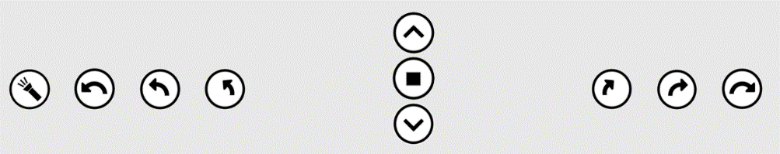**Commands and Responses**

|  |  |  |  |  |
| --- | --- | --- | --- | --- |
| **Commands** | | **Responses** | | |
| **description** | **Representation** | **Confirmation** | **Success** | **failure** |
| Flashlight ON/OFF | FL_1 / FL_0 | C_FL_1 / C_FL_0 | S_FL_1 / S_FL_0 | F_FL_1 / F_FL_0 |
| Turning <num> degrees left.  Num: {20, 45, 90} | TU_- <num> | C_TU_- <num> | S_TU_- <num> | F_TU_- <num> |
| Moving forward (30 cm) | FO_30 | C_FO_30 | S_FO_30 | F_FO_30 |
| Stop | ST | C_ST | S_ST | F_ST |
| Moving backwards (30 cm) | FO_-30 | C_FO_-30 | S_FO_-30 | F_FO_-30 |
| Turning <num> degrees right.  Num: {20, 45, 90} | TU_<num> | C_TU_<num> | S_TU_<num> | F_TU_<num> |

* The Robot sending response in JSON form: { conf: <msg> }
* Responses appears in the Robot's state window.
* **Robot's state**

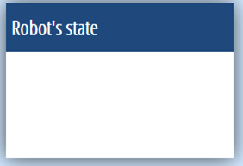

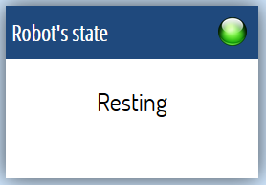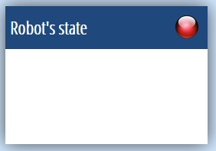

* The Robot has 3 states: connected, closed and error.
* The cloud informs the browser by sending JSON: { robot_conn: <state> }